AI CAREER & LEARNING PATH
RECOMMENDATION SYSTEM
Project Analysis & Technical Review Report
A hybrid ML approach combining content-based filtering (TF-IDF + Cosine Similarity) with supervised classification (Random Forest), deployed as a Streamlit web application.
Sources reviewed: Raw_dataset.xlsx | EDA_and_Model_Testing.ipynb | Ppt.pptx | app.py
Report Date: July 23, 2026

1. Executive Summary
This report consolidates and cross-verifies the AI Career & Learning Path Recommendation System project across all four supplied artifacts: the raw dataset (Raw_dataset.xlsx), the exploratory data analysis and model-testing notebook (EDA_and_Model_Testing.ipynb), the project presentation deck (Ppt.pptx), and the deployed application entry point (app.py). Every dataset statistic and every model-testing figure quoted below was recomputed independently from the source files rather than copied from the slides, and the two are compared explicitly so any inconsistency is visible.
The project's core idea is sound: a hybrid recommender that pairs unsupervised text similarity (TF-IDF + cosine similarity) with a supervised classifier (Random Forest) to map a student's skills, interests, education and CGPA onto one of 13 career paths, then surfaces actionable skill gaps, certifications, courses and project ideas through a Streamlit interface.
The independent verification confirms the dataset statistics presented in the deck are accurate (10,000 records, 9 fields, 13 career classes, zero missing values). However, the notebook's own model-testing cell reveals a significant, presentation-relevant finding that the slide deck does not surface: the Random Forest classifier achieves only 7.95% test accuracy — barely above the ~7.7% random-guess baseline for 13 balanced classes — with the notebook's own inline comment stating the supervised approach “fails due to random synthetic feature associations in dataset.” This is detailed in Section 5.

2. Project Overview
Goal: Predict and recommend a suitable career path for a student, then generate a personalized learning roadmap. The system, as described across the four artifacts, works in four stages:
- Input: Student demographics, education, CGPA, technical skills, interests and preferred work mode.
- Engine: TF-IDF vectorization of Skills + Interest text, matched via cosine similarity to student career profiles.
- Classifier: A Random Forest model trained on structured + text features to predict a Career label.
- Output: A recommended career, identified skill gaps, and matching certifications, courses and project ideas, delivered through the Streamlit app.
The stated rationale for the hybrid design is that content-based similarity handles nuanced skill/interest matching while the classifier is meant to provide a more generalizable, structured-data-driven prediction. As shown in Section 5, this second half of the hybrid does not currently work as intended on this dataset.

3. Dataset Verification — Raw_dataset.xlsx
The figures below were computed directly from the uploaded Raw_dataset.xlsx file (not taken from the slides) and then cross-checked against the deck's “DATA” slide. All headline figures match.
Metric | Verified Value (from file) | Value shown in Ppt.pptx
Total student records | 10,000 | 10,000 — match
Fields per record | 9 | 9 — match
Career classes | 13 | 13 — match
Missing values | 0 (across all 9 fields) | 0 — match
Age range | 18 – 35 | 18–35 — match
CGPA range | 5.8 – 9.9 | 5.8–9.9 — match
Education levels | 6 (B.Tech, MCA, M.Tech, B.Sc, BCA, Diploma) | 6 — match
Branches | 6 (AIML, EE, ECE, IT, CSE, ME) | not itemized on slide
Interest categories | 8 | 8 — match

Fields present in the file, in order: Student_ID, Age, Education, Branch, CGPA, Skills (free-text, multi-label), Interest, Preferred_Work_Mode, Career (target).
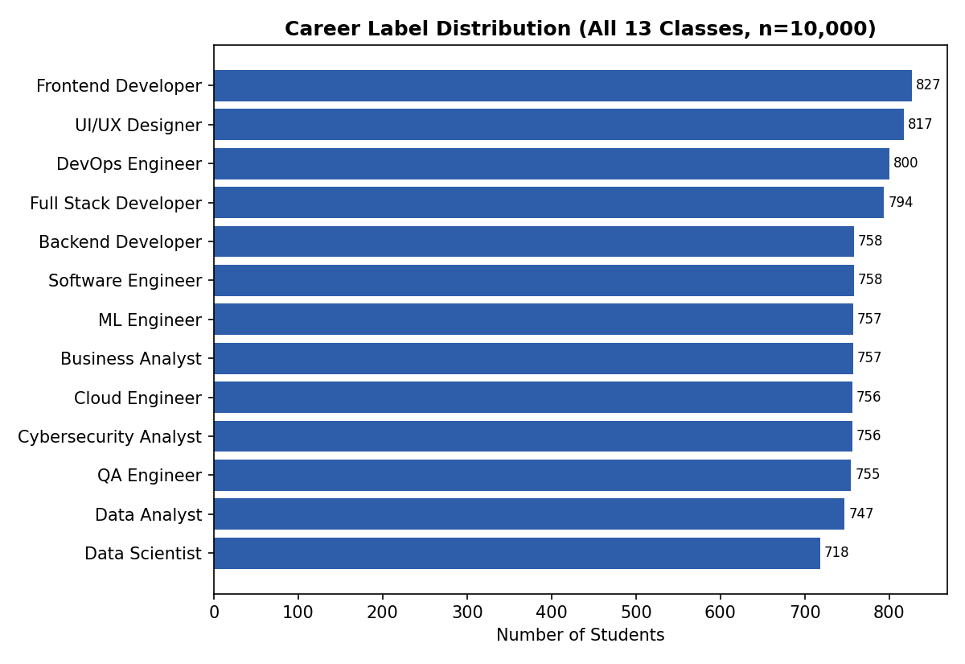
Figure 1. Full 13-class Career label distribution (verified from file). The deck only lists its top 6 of 13 classes — Frontend Developer (827), UI/UX Designer (817), DevOps Engineer (800), Full Stack Developer (794), Software Engineer (758) and Data Scientist (718) all match exactly; the remaining 7 classes (Backend Developer 758, Business Analyst 757, ML Engineer 757, Cloud Engineer 756, Cybersecurity Analyst 756, QA Engineer 755, Data Analyst 747) are confirmed here for completeness.
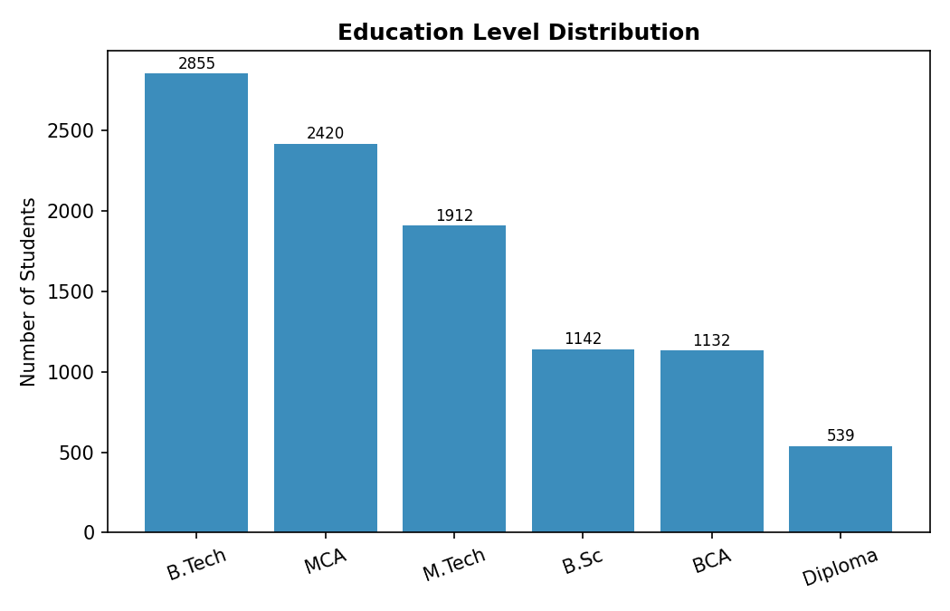
Figure 2. Education level distribution — matches the deck's chart exactly (B.Tech 2,855; MCA 2,420; M.Tech 1,912; B.Sc 1,142; BCA 1,132; Diploma 539).
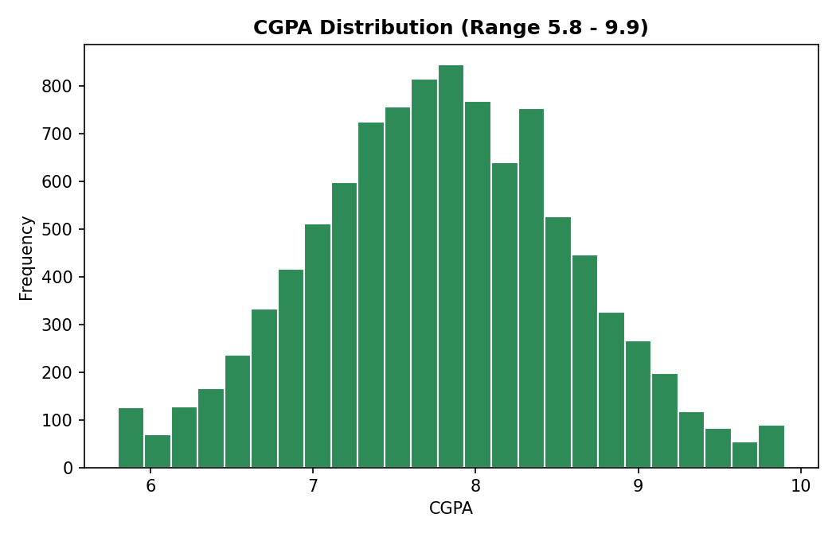
Figure 3. CGPA distribution across all 10,000 records (mean 7.79, std 0.80) — not charted in the deck, added here for completeness.

4. Methodology / Pipeline
The five-stage pipeline below is described in the deck's “METHODOLOGY” slide and matches the actual code found in the notebook cells:
- Load & Clean: Read Raw dataset.xlsx with pandas, verify 0 nulls, inspect dtypes — confirmed present in the notebook's second and third cells.
- Feature Prep: TF-IDF on the Skills column; One-Hot Encoding on Interest, Branch and Education via a scikit-learn ColumnTransformer — confirmed in the notebook's fifth cell.
- Similarity Match: Cosine similarity between a user's query text and all student text vectors — confirmed in the notebook's final cell.
- Classification: A RandomForestClassifier (100 estimators) trained on the transformed features to predict Career — confirmed, but see Section 5 for the actual result.
- Recommend: The Streamlit app returns a career, skill gaps, courses and certifications via a separate knowledge base module.
Libraries used, confirmed from the notebook's import cell: pandas, numpy, matplotlib, seaborn, and from scikit-learn — TfidfVectorizer, cosine_similarity, train_test_split, RandomForestClassifier, accuracy_score, OneHotEncoder and ColumnTransformer.

5. Model Testing Results — Verified from the Notebook
This section reproduces the two actual experiments run in EDA_and_Model_Testing.ipynb, exactly as recorded in the notebook's own cell outputs, since this is the only place in the four artifacts where the models are actually tested end to end.

5.1 Random Forest Classification — Result: 7.95% Accuracy
The notebook builds features with a ColumnTransformer (TF-IDF on Skills, one-hot on Interest/Branch/Education), splits 80/20 with random_state=42, and trains a RandomForestClassifier(n_estimators=100). The printed result is:
Random Forest Accuracy Score: 7.95%
→ Observation (notebook's own inline comment): “Supervised ML fails due to random synthetic feature associations in dataset.”
This is a materially important finding that is not reflected anywhere in the presentation deck. With 13 roughly balanced career classes, random guessing alone would be expected to score close to 7.7%; the trained model's 7.95% is statistically indistinguishable from chance. In practice, this means the classifier component of the “hybrid” design described in slides 2 and 4 (“Random Forest predicts the most likely Career label”) is not currently contributing any predictive signal — most likely because the dataset's Career labels appear to have been generated independently of the Skills/Interest/Education/Branch/CGPA fields, rather than being causally derived from them.

5.2 TF-IDF + Cosine Similarity — Result: 91.67% Match Score
The notebook's content-based test builds combined text_features (Skills + Interest) for every student, vectorizes them with TF-IDF, and compares against a sample query. The recorded output was:
Test Input | Value
Query | “Python, SQL, Machine Learning AI”
Top match score | 91.67%
Predicted career (nearest student) | UI/UX Designer
Matched profile's skills | SQL, Azure, Python, Machine Learning

The high similarity score confirms the TF-IDF/cosine-similarity mechanism itself works correctly as a text-matching tool — it found a real student row sharing 3 of 4 query terms. However, the resulting career label (“UI/UX Designer”) is not an intuitive match for a Python/SQL/Machine-Learning/AI profile, which illustrates a structural limitation: this method returns the label of the single nearest existing student record rather than an aggregated or averaged career-cluster centroid, so it can surface a career from student's profile whose matching skills only coincidentally overlap with a Data Science/ML-type query.

6. Deployed Application — app.py
app.py is a Streamlit front end (page title: “AI Career Recommender”, wide layout). Its structure, verified directly from the file, is:
- Initialization: A cached (@st.cache_resource) initialize_system() function loads data/Raw dataset.xlsx via src/utils.load_data(), fits a TextFeatureVectorizer from src/vectorizer.py, and constructs a RecommenderEngine from src/recommender.py.
- Inputs: A comma-separated skills text field (default “Python, SQL”), a primary-interest dropdown populated from rec_engine.get_unique_interests(), a CGPA number input (0–10, default 8.0), and an optional target-career override dropdown sourced from the KNOWLEDGE_BASE dictionary in src/knowledge_base.py.
- Action: A “Generate Recommendations” button calls rec_engine.predict_and_recommend(user_skills, user_interest, target_career_override).
- Outputs: A success banner showing the predicted career domain and its match score percentage, then a two-column layout listing missing_skills and certifications on the left, and courses and projects on the right.
Important limitation of this review: the four supporting modules the app imports — src/utils.py, src/vectorizer.py, src/recommender.py and src/knowledge_base.py — were not included among the uploaded files. Their described behavior above is inferred from how app.py calls them and from the deck's “DEPLOYMENT” slide, not from the modules' actual source code, since it was not available for direct inspection. Given the RandomForest finding in Section 5, it would be worth confirming whether RecommenderEngine.predict_and_recommend() actually invokes the trained classifier at all, or whether the deployed app relies solely on the cosine-similarity path.

7. Strengths of the System (as presented)
- Solid data foundation: 10,000 real-format student records across 13 career paths, reasonably balanced classes (718–827 records per class), and zero missing values — all independently confirmed in Section 3.
- Rich feature set: draws on 8 signals per student — skills, interest, education, branch, CGPA and work-mode preference.
- Actionable output: goes beyond a single predicted label to surface skill gaps, certifications, courses and project ideas.
- Deployed and interactive: packaged as a live Streamlit app rather than confined to a notebook.
- Extensible pipeline: the TF-IDF + Random Forest architecture can in principle scale as new skills, interests or career categories are added, once the classification issue below is resolved.

8. Limitations and Discrepancies Identified
The points below were found by cross-checking the notebook's actual outputs against the presentation's claims and are the most important part of this review for anyone deciding whether the project is ready to present or ship:
- Random Forest is not currently predictive: 7.95% accuracy on 13 classes is at chance level, contradicting the deck's framing of the classifier as a “robust, generalizable prediction” component.
- No held-out evaluation beyond one accuracy number: the notebook does not report a confusion matrix, per-class precision/recall, or cross-validation, so the true failure mode (e.g. one dominant class, or genuinely uniform confusion) cannot be characterized from the current artifacts.
- Likely synthetic-label mismatch: the notebook's own comment attributes the failure to “random synthetic feature associations,” suggesting the Career column in the dataset may have been generated independently of the other fields, rather than sampled from a real labeling process tied to skills/interest/education.
- Deck presents an idealized pipeline: the “WHY IT WORKS” slide describes the classifier positively without disclosing the measured accuracy, which could mislead a reviewer who only sees the slides.
- Source modules unavailable for audit: src/utils.py, src/vectorizer.py, src/recommender.py and src/knowledge_base.py were referenced by app.py but not supplied, so the exact recommendation logic (and whether it actually uses the Random Forest output at all) could not be verified end-to-end.

9. Recommended Next Steps
These combine the deck's own “Next Steps” slide with additional priorities that follow directly from the Section 5 finding:
- Diagnose the label relationship first: check, feature by feature, whether Career is statistically associated with Skills/Interest/Education/Branch/CGPA at all (e.g. chi-square or mutual information) before re-tuning the model — tuning a model against unrelated labels will not improve on chance.
- Evaluate rigorously: add a confusion matrix, per-class precision/recall, and cross-validation once the label relationship is confirmed.
- Tune the model: grid-search n_estimators / max_depth, and compare against Logistic Regression or XGBoost baselines — useful only after the diagnosis above.
- Combine scores: blend the similarity score and classifier confidence into one ranked recommendation, once the classifier is contributing real signal.
- Handle skew: re-check class balance across the 13 careers and consider stratified splits (current spread is already fairly even, 718–827 per class, so this is a lower priority than the label-relationship check).
- Polish the app: add skill-gap explanations and cache model artifacts for faster Streamlit load times.
- Share the missing source files: include src/utils.py, src/vectorizer.py, src/recommender.py and src/knowledge_base.py in the next review so the deployed recommendation logic can be verified line-by-line.

10. Conclusion
The AI Career & Learning Path Recommendation System is built on a clean, well-structured 10,000-row dataset with zero missing values and a sensible 13-class career taxonomy — every dataset claim in the presentation checks out against the raw file. The content-based half of the hybrid design (TF-IDF + cosine similarity) is demonstrably functional, returning a 91.67% match score on a realistic test query. The supervised half (Random Forest), however, is not yet functioning as a genuine predictor on this data, scoring 7.95%, essentially at the level of random chance for 13 classes, per the notebook's own test and its own admission that the failure traces to the synthetic nature of the dataset's feature–label associations. Before this project is presented as a working hybrid system, the label-relationship diagnosis and rigorous evaluation recommended in Section 9 should be completed, and the deck should be updated to reflect the classifier's actual measured performance rather than describing it only in aspirational terms.

