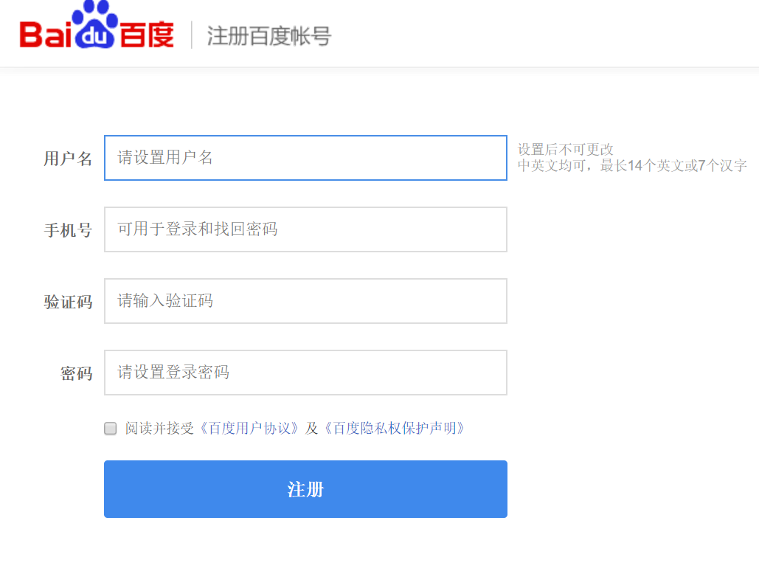

<https://passport.baidu.com/v2/?reg&tt=1505286181631&gid=4A933D8-A1B0-45A2-B926-3370632A178C&tpl=mn&u=https%3A%2F%2Fwww.baidu.com%2Fs%3Fie%3Dutf-8%26f%3D3%26rsv_bp%3D1%26rsv_idx%3D1%26tn%3Dbaidu%26wd%3D%25E9%2598%25BF%25E9%2587%258C%25E5%25B7%25B4%25E5%25B7%25B4%25E9%2582%25AE%25E7%25AE%25B1%25E7%2599%25BB%25E9%2599%2586%25E5%2585%25A5%25E5%258F%25A3%26oq%3D%2525E9%252580%252589%2525E9%2525A1%2525B9%2525E5%25258D%2525A1%26rsv_pq%3Db75e75d300013e72%26rsv_t%3D761c%252FzsfYiI3tbTHny8Gk685kbdoLoxLzbVIbkjSIL9zWQ%252BxbZDB08w1kB4%26rqlang%3Dcn%26rsv_enter%3D1%26rsv_sug3%3D36%26rsv_sug1%3D28%26rsv_sug7%3D100%26rsv_sug2%3D1%26prefixsug%3D%2525E9%252598%2525BF%2525E9%252587%25258C%2525E5%2525B7%2525B4%2525E5%2525B7%2525B4%2525E9%252582%2525AE%2525E7%2525AE%2525B1%26rsp%3D0%26inputT%3D686864%26rsv_sug4%3D686864>