**Colonoscopy and Treatment Report**

Examination No.: CJ000206

|  |  |  |  |  |
| --- | --- | --- | --- | --- |
| Name: Wang Yinghui | Sex: Female |  | Age: 59 | Patient No.: 9910896629 |
| Division: | Ward Area: No. 2-09 of General Surgery Department | | Bed No. 09 | Admission No.: 427065 |
| Colonoscopy No.: 3 | Starting time: | 08:30:00 am, Nov. 7, 2016 | Ending time: 08:48 am, Nov. 7, 2016 | Pathological No.: |

**Diagnosis description:** the intestinal tract cleanness was acceptable, the patient was asked to lie on his left side, and the colonoscope was inserted along the enteric cavity smoothly up to the ascending colon.

Obvious stenosis in the whole enteric cavity was observed from the angle of ascending colon. One ulcerative peripheral proliferative bulging lump was seen and occupied the enteric cavity by one circle, and erosion was seen on the surface. The intestinal cavity was narrow which was difficult for the colonoscope to enter. The biopsy was not flexible, and easy to bleeding.

|  |  |  |  |  |
| --- | --- | --- | --- | --- |
| Blood report: ALT: - |  | HbsAg: | Syphilis: | HTV: |
| Method of anesthesia: venous anesthesia |  | | | |

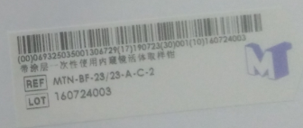Biopsy site: ascending colon *6

Colonoscopic diagnosis: ascending colon carcinoma (with nature to be pathologically confirmed)

Pathological diagnosis:

Suggestions: