**Github Assigment**

**-Shivang Pandey (MSc-GI)**

Github is one of the best places to put one’s project available for everyone. Working on spatial data using is very feasible. In this assignment, we are going to generate a visualization of spatial data like points and we can see changes in polygon shapefiles too.

I have used git on shell because github desktop don’t support on ubuntu operating system.

Step-1: Open Terminal and create directory which you want to use as github repo

**mkdir iirs-assignment**

Step-2: Open qgis and save file as geojson with CRS as EPSG:4326-WGS 84 then it show in geojson file about crs format "crs": { "type": "name", "properties": { "name": "urn:ogc:def:crs:OGC:1.3:CRS84" } }. Currently, GitHub only supports the urn:ogc:def:crs:OGC:1.3:CRS84 projection.

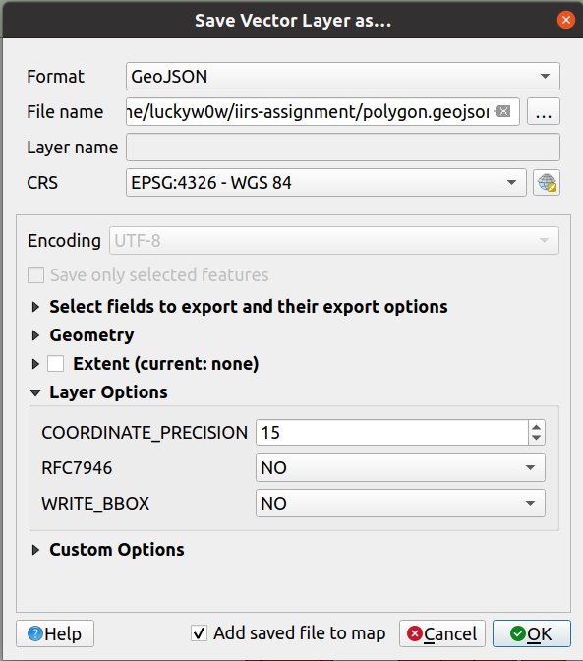

Step-3: Change directory this and paste your shapefile data in the same folder

**cd iirs-assignment**

Step-4: Initialize github and file to repo

**git init**

**git add polygon.geojson**

Step-5: Commit the changes to the repository

**git commit -m "changed polygons"**

Step-6: Push the files to main branch

**git branch -M main**

**git push -u origin main**

Username for 'https://github.com': luckyw0w

Password for 'https://luckyw0w@github.com':

Step-7: Delete some polygonsfrom shapefile and repeat the process again from step-4

Step-8: Go to the file in browser and check history then load the difference with and see rendered data

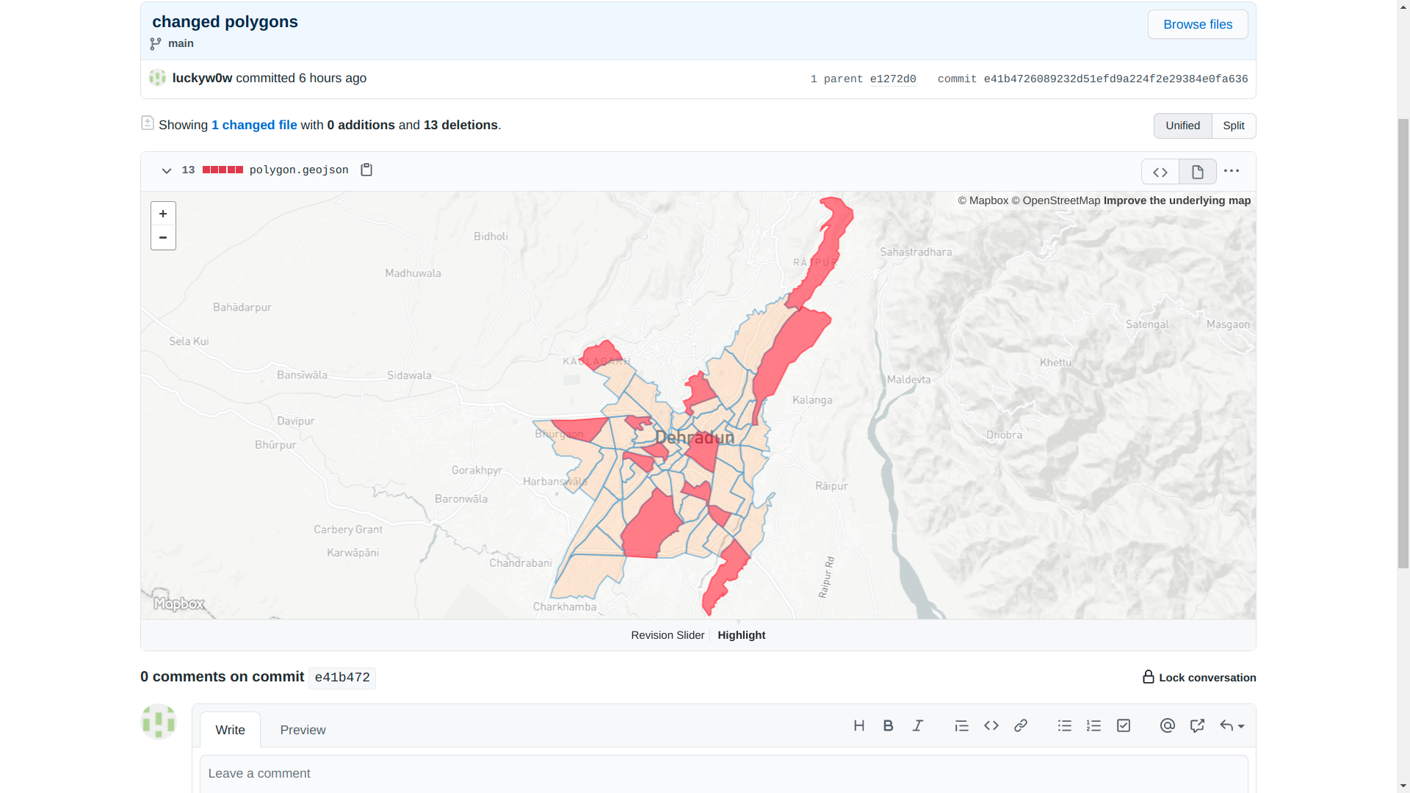

Step-9: open a text file and copy script for to visualize map

<script src="https://embed.github.com/view/geojson/luckyw0w/iirs-assignment/main/polygon.geojson"></script>

Output will be like this:

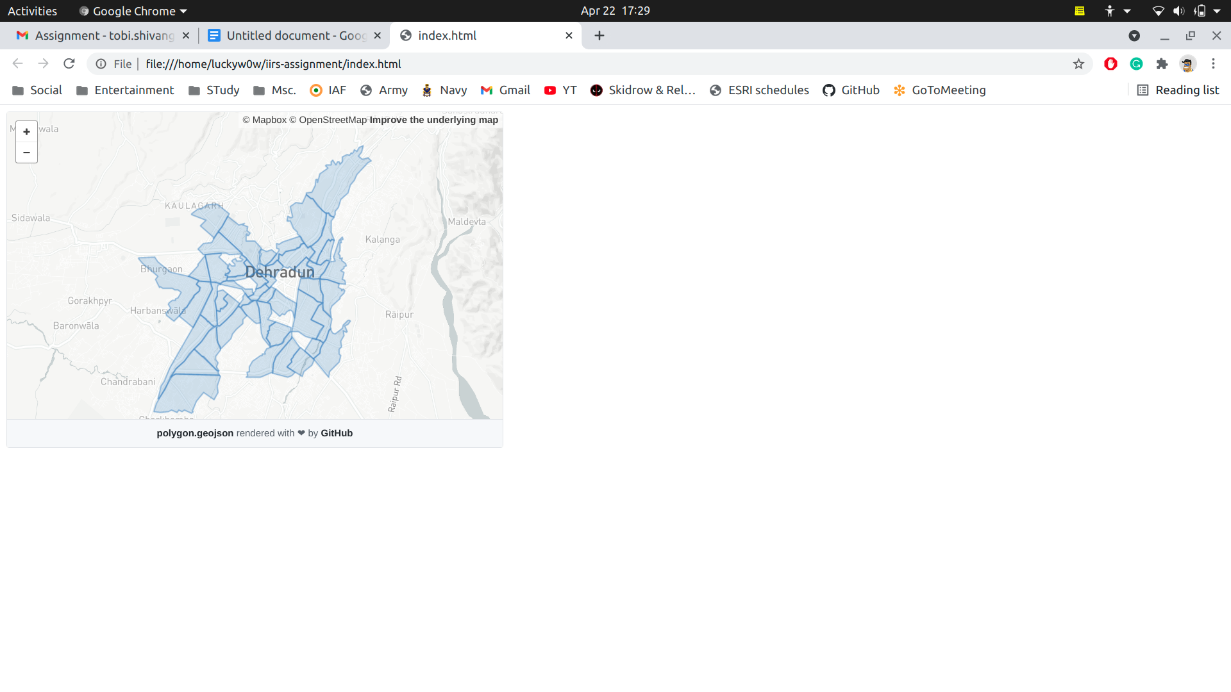

This file and index file along with point_data shape file is also added in repository:

<https://github.com/luckyw0w/iirs-assignment>