**BUSINESS WEBSITE**

**ADITHYA S (REG.NO- 320-20 994 004)**



**UNIVERSITY INSTITUTE OF TECHNOLOGY**

**UNIVERSITY OF KERALA**

**REGIONAL CENTRE MUTHUKULAM**

**MINI PROJECT REPORT**

**2020 - 2023**

**DECLARATION**

We hereby declare that the project Entitled “**BUSSINESS WEBSITE**” has been carried out by us in the partial fulfillment of the requirement of the arrangement of Bachelor Degree in Computer Science from University Institute of Technology, University of Kerala, Regional Centre Muthukulam.

We also declare that the findings in the report are based on the program done and we have not copied from any other report submitted to University of Kerala.

Date:

Place:

**ADITHYA S (REG.NO- 320-20 994 004)**

**ACKNOWLEDGEMENT**

We take this opportunity to thank all those who have been directly or indirectly been involved in our mini project is a success.

First of all, weare grateful to Almighty GOD, for showing all his heavenly blessing upon the successful completion of this work.

We are thankful to **Dr.S Girija Kumari, Principal, UIT Regional Centre Muthukulam**for her legal support and permission to the mini project.

We are thanks to **Smt. Binuja .L, HOD, Department of Computer Science, UIT Regional Centre Muthukulam** for the valuable support in our mini project.

We are thanks to all faculty members of computer science Department in UIT Muthukulam for the immense support in our mini project.

We express my sincere thanks to **Smt. Sarimol Sukumaran, Department of Computer Science, UIT Regional Centre Muthukulam** for guidance and assistance in our mini project work.

We express my sincere thanks to **Smt. DHANYA P PILLAI ,Class Teacher & Department of Computer Science, UIT Regional Centre Muthukulam** for guidance and assistance in our mini project work.

We are deeply thanks to **Our Friends** forhelping in this mini project.

Last but not the least we thank our parents for their moral support and help they have given us and we dedicate this project to all the people who helped us to complete this project.

**ADITHYA S (REG.NO- 320-20 994 004)**

**ABSTRACT**

The goal of this project is to provide an online portal between users and company members of the company. This is a semi-online website. This company is for selling the cloud storage of the users they want. In this website the user must have an account to purchase. The users can visit the visitors page ,without an account they can’t purchase or login into the home page. If any user wants to purchase ,there will open a google form , by entering the details ,the employee will contact with the user in the g-mail. By this ,the user can ask any kind of questions of the product. By this chatting ,the user get an exact details of the product. In this mini project, there are three modules .

1. **Admin Login**
2. **Employee Login**
3. **User Login**

**TABLE OF CONTENTS**

|  |  |  |
| --- | --- | --- |
| **SERIAL NO** | **TITLE** |  |
| **1** | **INTRODUCTION** |  |
| **2**  **3**  **4**  **5**  **6**  **7** | **OBJECTIVE**  **SYSTEM ANALYSIS**  **REQUIREMENT ANALYSIS**  **SYSTEM DESIGN**  **CONCLUSION AND SMAPLE SCREENSHOTS**  **FUTURE ENHANCEMENT** |  |

|  |  |  |  |  |  |  |  |  |  |  |  |  |  |  |  |  |  |  |  |  |
| --- | --- | --- | --- | --- | --- | --- | --- | --- | --- | --- | --- | --- | --- | --- | --- | --- | --- | --- | --- | --- |
|  | |  |  |  | | --- | --- | --- | |  |  |  | |  |  |  | |  |  |  | |  |  |  | |  |  |  | |  |  |  | |  |

**1. INTRODUCTION**

This company website is to visit and purchase the cloud storage. In this ,there are are three modules admin, employee and user .This is a semi-online business website. The admin has the role of inspect the user details that saved in the database. The admin can delete the unwanted users. The admin can also inspect the employees in this company. The employee have the role of contact with the user. The employee will contact the user by mail, by this the user can ask the questions related to the product. After the clear discussion ,the user can purchase the proper product . After the payment session ,the user will get the storage.

**2. OBJECTIVE**

This is a semi-online business website that is used to purchase the cloud storage and visit the home page. The user must create an account to login into the website. Without an account, the user can’t login or purchase the product, they can only access into the visitors page only. By the login details will stored in the database ,the admin will get the notification for every login or newly created account. The user wants to purchase any product, there will pop-up a Google form for fill. By submitting this details, this details will stored in the database and it is redirected to the employee page. The employee will contact the user by g-mail for the further procedures and the user can any kind of questions regarding the product they want to buy. After the confirmation of purchase , the employee will discuss the online payment mode. After the payment ,the employee will get the purchased product to the user.

**3. SYSTEM ANALYSIS**

**PROPOSED SYSTEM**

The proposed system is highly computerised in which the data related to user accounts will be secured high with high accuracy that even reduces the machine damage and human made errors and this existing system is highly efficient to offer best services to the customers as well as banks because it has user friendly access that consumes less time when compared with normal banking system.

**FEASIBILITY STUDY**

Feasibility study is made to see if the project on completion will serve the purpose of the organisation for the amount of work, effort and the time that spend on it. Feasibility study lets the developer foresee the future of the project and the usefulness. A feasibility study of a system proposal is according to its workability, which is the impact on the organisation, ability to meet their user needs and effective use of resources. Thus when a new application is proposed it normally goes through a feasibility study before it is approved for development. The document provide the feasibility of the project that is being designed and lists various areas that were considered very carefully during the feasibility study of this project such as Technical, Economic and Operational feasibilities. The following are its features:

**ECONOMICFEASIBILITY**

This study is carried out to check the economic impact will have on the system will have on the organisation. The amount of fund that the company can pour into the research and development of the system is limited. The expenditures must be justified. Thus the developed system as well within the budget and this was achieved because most of the technologies used are freely available. Only the customised products have to be purchased.

**TECHNICALFEASIBILITY**

This study is carried out to check the technical feasibility, that is, the technical requirements of the system. Any system developed must not have a high demand on the available technical resources. This will lead to high demands being placed on the client. The developed system must have a modest requirement, as only minimal or null changes for the implementing this system.

**OPERATIONALFEASIBILITY**

The aspect of study is to check the level of acceptance of the system by the user. This includes the process of training the user to use the system efficiently. The user must not feel threatened by the system, instead must accept it as a necessity. The level of acceptance by the users solely depends on the methods that are employed to educate the user about the system and to make him familiar with it. His level of confidence must be raised so that he is also able to make some constructive criticism, which is welcomed, as he is the final user of the system.

**SOCIALFEASIBILITY**

The input and output screens are so user friendly such that any novice user could process this application.

**4. REQUIREMENTSPECIFICATION**

**REQUIREMENT INTRODUCTION**

To be used efficiently, all computer software needs certain hardware components or the other software resources to be present on a computer. These pre-requisites are known as(computer) system requirements and are often used as a guideline as opposed to an absolute rule. Most software defines two sets of system requirements: minimum and recommended. With increasing demand for higher processing power and resources in newer versions of software, system requirements tend to increase over time. Industry analysts suggest that this trend plays a bigger part in driving upgrades to existing computer systems than technological advancements.

**HARDWARE REQUIREMENTS**

The most common set of requirements defined by any operating system or software application is the physical computer resources, also known as hardware. A hardware requirements list is often accompanied by a hardware compatibility list (HCL), especially in case of operating systems. An HCL lists tested, compatibility and sometimes incompatible hardware devices for a particular operating system or application. The following sub-sections discuss the various aspects of hardware requirements.

**Hardware Requirements for Present Project**

PROCESSOR : Intel dual Core, i3,i5

RAM : 4 GB

HARD DISK : 500 GB

**SOFTWARE REQUIREMENTS**

Software Requirements deal with defining software resource requirements and pre-requisites that need to be installed on a computer to provide optimal functioning of an application. These requirements or pre-requisites are generally not included in the software installation package and need to be installed separately before the software is installed.

**SOFTWARE SPECIFICATION**

**Software Requirements for Present Project**:

Front End/Language : HTML

Back End/Database : MYSQL,PHP

Additional Tools : XAMPP Server, Notepad++

Operating System : Windows 7, 8, 10,11, XP

**5. SYSTEM DESIGN**

**DATA FLOW DIAGRAMS**

The first step is to draw a data flow diagram (DFD). The DFD was first developed by Larry Constantine as a way of expressing system requirements in graphical form. A DFD also known as a “bubble chart” has the purpose of clarifying system requirements and identifying major transformations that will become programs in system design. This is the starting point of the design phase that functionally decomposes the requirements specifications down to the lowest level of detail. A DFD consists of series of bubbles join by the data flows in the system.

The purpose of data flow diagrams is to provide a semantic bridge between users and developers.

• Graphical, eliminating thousands of words;

• Hierarchical, showing systems at any level of detail; and

• Jargon less, allowing user understanding and reviewing.

Data flow diagrams are supported by other techniques of structured systems analysis such as data structure diagrams, data dictionaries, and procedure-representing techniques. The goal of data flow diagram is to have a commonly understood of a system. In Data flow diagram, the entire concept of the system is provided and drawn in flow chart.

**Symbols Used In Data Flow Diagrams**

* **External Entity**

A rectangle( ) creates any external entity to the system being modeled.

* **Process**

Bubbled or circle ( ) are used to indicate where incoming data

flows are proposed and then transformed into outgoing data flow.

* **Data Flow**

The arrow ( ) marking is the movement of data through the system

indicates data flow.

* **Data Store**

Open rectangles ( ) are used to identify holding points for data.

* **Output Symbol**

The hard copy is produced using the output ( ) and the user of the copies cannot be clearly specified or three or several users of the output.

**LEVEL: O DFD**

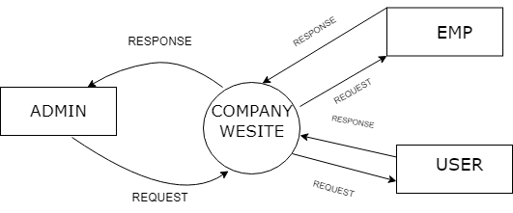

**LEVEL: 1 DFD**

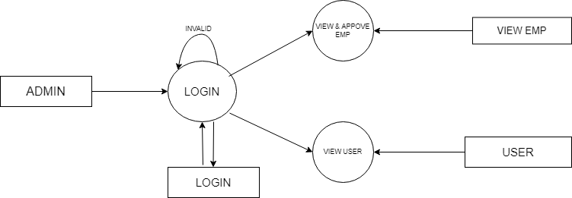

**LEVEL: 2 DFD**

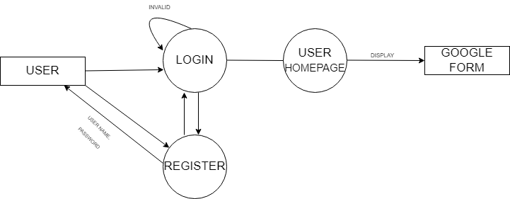

**LEVEL: 3 DFD**

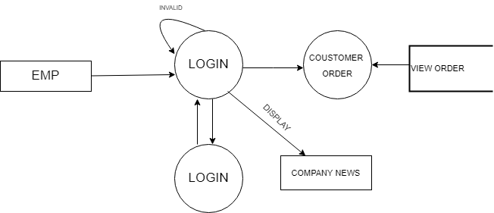

**ENTITY RELATIONSHIP DIAGRAM**

An Entity Relationship (ER) Diagram is a type of flowchart that illustrates how “entities” such as people, objects or concepts relate to each other within a system. ER Diagrams are most often used to design or debug relational databases in the fields of software engineering, business information systems, education and research. Also known as ERDs or ER Models, they use a defined set of symbols such as rectangles, diamonds, ovals and connecting lines to depict the interconnectedness of entities, relationships and their attributes.

There are different type of attributes .They are**:-**

* Single value and multi valued
* Simple or composite
* Null attributes

Different model are used for designing a database they are**:-**

* Relational model
* Hierarchical model
* Network model

In addition to this model there are other model, they are**:-**

* Entity relationship model
* Object oriented data model
* Semi structured mode

**ER DIAGRAM**

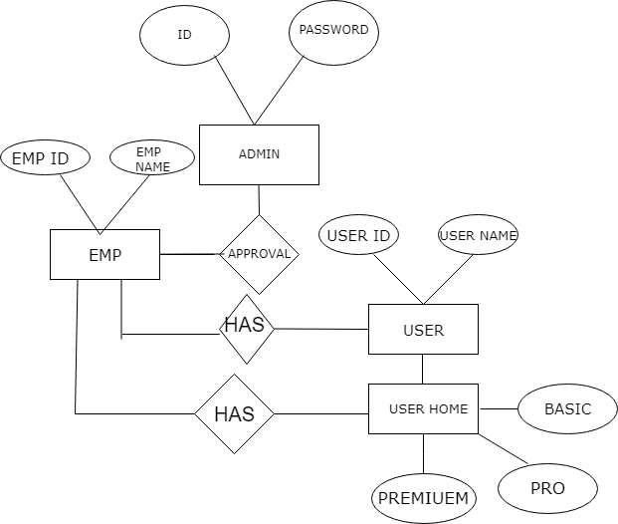

**GANTT CHART**

The Gantt chart was developed by Henry Gantt. Those are used in software project management and enhanced version of standard Gantt chart. These are mainly allocating resources to activities. It is a special type of bar chart. Each bar represents an activity. Bars are drawn alone a time line. Length of each bar is proportional to duration of time planned for corresponding activity.

**TABLE DESIGN**

**TABLE NAME: ADMIN**

|  |  |  |  |
| --- | --- | --- | --- |
| **FIELD NAME** | **TYPE/LENGTH** | **CONSTRAINTS** | **DESCRIPTION** |
| ID | BIGINT(30) | PRIMARY KEY | ID |
| USER_ID | BIGINT(30) |  | USERID |
| USER_NAME | VARCHAR(100) |  | USERNAME |
| PASSWORD | VARCHAR(100) |  | PASSWORD |
| DATE | TIMESTAMP(5) |  | DATE |

**TABLE NAME: EMPLOYEE**

|  |  |  |  |
| --- | --- | --- | --- |
| **FIELD NAME** | **TYPE/LENGTH** | **CONSTRAINTS** | **DESCRIPTION** |
| ID | BIGINT(30) | PRIMARY KEY | ID |
| USER_ID | BIGINT(30) |  | USERID |
| USER_NAME | VARCHAR(100) |  | USERNAME |
| PASSWORD | VARCHAR(100) |  | PASSWORD |
| DATE | TIMESTAMP(5) |  | DATE |

**TABLE NAME: USER**

|  |  |  |  |
| --- | --- | --- | --- |
| **FIELD NAME** | **TYPE/LENGTH** | **CONSTRAINTS** | **DESCRIPTION** |
| ID | BIGINT(30) | PRIMARY KEY | ID |
| USER_ID | BIGINT(30) |  | USERID |
| USER_NAME | VARCHAR(100) |  | USERNAME |
| PASSWORD | VARCHAR(100) |  | PASSWORD |
| DATE | TIMESTAMP(5) |  | DATE |

**6. TESTING**

**INTRTODUCTION**

Software testing is an investigation conducted to provide stakeholders with information about the [quality](https://en.wikipedia.org/wiki/Software_quality) of the [software](https://en.wikipedia.org/wiki/Software) product or service under test.[[1]](https://en.wikipedia.org/wiki/Software_testing#cite_note-Kaner_1-1) Software testing can also provide an objective, independent view of the software to allow the business to appreciate and understand the risks of software implementation. Test techniques include the process of executing a program or application with the intent of finding [software bugs](https://en.wikipedia.org/wiki/Software_bug) (errors or other defects), and verifying that the software product is fit for use.

Software testing involves the execution of a software component or system component to evaluate one or more properties of interest. In general, these properties indicate the extent to which the component or system under test:

* meets the requirements that guided its design and development,
* responds correctly to all kinds of inputs,
* performs its functions within an acceptable time,
* it is sufficiently usable,
* can be installed and run in its intended [environments](https://en.wikipedia.org/wiki/Operating_environment), and
* Achieves the general result its stakeholder’s desire.

**TESTING METHODS**

This is the key factor of success of any system. Testing is done by constantly keeping in touch with the prospective system at the time of development and making changes whenever required. This is done with regard to the input screen design and output screen design.

**UNIT TESTING**

Unit testing focuses verification efforts even in the smallest unit of software design in each module. This is known as “Module testing”. The modules of the system are testing separately. Unit testing is essential for the verification of the code produced during the code phase, and hence the goal is to test the internal logic of the module. It is typically done by the programmer of the module.

**INTEGRATION TESTING**

Integration testing is the systematic testing to uncover the errors within the interface. This testing is done with simple data and the developed system has run successfully with simple data. In this many unit tested modules are combined into subsystems, which are then tested. The goal here is to see if the modules can be integrated properly.

**SYSTEM TESTING**

System testing is designed to uncover weakness that was not found in earlier tests. This included forced system failure and validation of the total system.

7**. SYSTEM IMPLEMENTATION**

**INTRODUCTION**

In [computer science](https://en.wikipedia.org/wiki/Computer_science), an implementation is a realisation of a [technical specification](https://en.wikipedia.org/wiki/Technical_specification) or algorithm as a [program](https://en.wikipedia.org/wiki/Computer_program), [software component](https://en.wikipedia.org/wiki/Software_component), or other [computer system](https://en.wikipedia.org/wiki/Computer_system) through [computer programming](https://en.wikipedia.org/wiki/Computer_programming) and [deployment](https://en.wikipedia.org/wiki/Software_deployment). Many implementations may exist for a given specification or standard. For example, [web browsers](https://en.wikipedia.org/wiki/Web_browser) contain implementations of [World Wide Web Consortium](https://en.wikipedia.org/wiki/World_Wide_Web_Consortium)-recommended specifications, and software development tools contain implementations of [programming languages](https://en.wikipedia.org/wiki/Programming_languages).

A special case occurs in [object-oriented programming](https://en.wikipedia.org/wiki/Object-oriented_programming), when a [concrete](https://en.wikipedia.org/wiki/Concrete_class) [class](https://en.wikipedia.org/wiki/Class_(object-oriented_programming)) implements an [interface](https://en.wikipedia.org/wiki/Interface_(object-oriented_programming)); in this case the concrete class is an implementation of the interface and it includes methods which are implementations of those [methods](https://en.wikipedia.org/wiki/Method_(object-oriented_programming)) specified by the interface.

**SAMPLE CODES**

1. **HOME PAGE**

**<!DOCTYPE html>**

**<html>**

**<head>**

**<title>WELCOME</title>**

**<meta charset="UTF-8">**

**<meta name="viewport" content="width=device-width, initial-scale=1">**

**<link rel="stylesheet" href="https://www.w3schools.com/w3css/4/w3.css">**

**<link rel="stylesheet" href="https://fonts.googleapis.com/css?family=Raleway">**

**<link rel="stylesheet" href="https://cdnjs.cloudflare.com/ajax/libs/font-awesome/4.7.0/css/font-awesome.min.css">**

**<style>**

**body,h1,h2,h3,h4,h5,h6 {font-family: "Raleway", sans-serif}**

**body, html {**

**height: 100%;**

**line-height: 1.8;**

**}**

**/* Full height image header */**

**.bgimg-1 {**

**background-position: center;**

**background-size: cover;**

**background-image: url("/w3images/mac.jpg");**

**min-height: 100%;**

**}**

**.w3-bar .w3-button {**

**padding: 16px;**

**}**

**</style>**

**</head>**

**<body>**

**Navbar (sit on top)**

**<div class="w3-top">**

**<div class="w3-bar w3-white w3-card" id="myNavbar">**

**<a href="test.php" class="w3-bar-item w3-button w3-wide">LOGIN</a>**

**<!-- Right-sided navbar links -->**

**<div class="w3-right w3-hide-small">**

**<a href="#about" class="w3-bar-item w3-button">ABOUT</a>**

**<a href="#team" class="w3-bar-item w3-button"><i class="fa fa-user"></i> TEAM</a>**

**<a href="#work" class="w3-bar-item w3-button"><i class="fa fa-th"></i> WORK</a>**

**<!-- <a href="#pricing" class="w3-bar-item w3-button"><i class="fa fa-usd"></i> PRICING</a>-->**

**<a href="#contact" class="w3-bar-item w3-button"><i class="fa fa-envelope"></i> CONTACT</a>**

**</div>**

**<!-- Hide right-floated links on small screens and replace them with a menu icon -->**

**<a href="javascript:void(0)" class="w3-bar-item w3-button w3-right w3-hide-large w3-hide-medium" onclick="w3_open()">**

**<i class="fa fa-bars"></i>**

**</a>**

**</div>**

**</div>**

**<!-- Sidebar on small screens when clicking the menu icon -->**

**<nav class="w3-sidebar w3-bar-block w3-black w3-card w3-animate-left w3-hide-medium w3-hide-large" style="display:none" id="mySidebar">**

**<a href="javascript:void(0)" onclick="w3_close()" class="w3-bar-item w3-button w3-large w3-padding-16">Close ×</a>**

**<a href="#about" onclick="w3_close()" class="w3-bar-item w3-button">ABOUT</a>**

**<a href="#team" onclick="w3_close()" class="w3-bar-item w3-button">TEAM</a>**

**<a href="#work" onclick="w3_close()" class="w3-bar-item w3-button">WORK</a>**

**<a href="#pricing" onclick="w3_close()" class="w3-bar-item w3-button">PRICING</a>**

**<a href="#contact" onclick="w3_close()" class="w3-bar-item w3-button">CONTACT</a>**

**</nav>**

**<!-- Header with full-height image -->**

**<header class="bgimg-1 w3-display-container w3-grayscale-min" id="home">**

**<div class="w3-display-bottomleft w3-text-grey w3-large" style="padding:24px 48px">**

**<i class="fa fa-facebook-official w3-hover-opacity"></i>**

**<i class="fa fa-instagram w3-hover-opacity"></i>**

**<i class="fa fa-snapchat w3-hover-opacity"></i>**

**<i class="fa fa-pinterest-p w3-hover-opacity"></i>**

**<i class="fa fa-twitter w3-hover-opacity"></i>**

**<i class="fa fa-linkedin w3-hover-opacity"></i>**

**</div>**

**</header>**

**<!-- About Section -->**

**<div class="w3-container" style="padding:128px 16px" id="about">**

**<h3 class="w3-center">ABOUT THE COMPANY</h3>**

**<p class="w3-center w3-large">Key features of our company</p>**

**<div class="w3-row-padding w3-center" style="margin-top:64px">**

**<div class="w3-quarter">**

**<i class="fa fa-desktop w3-margin-bottom w3-jumbo w3-center"></i>**

**<p class="w3-large">Responsive</p>**

**<p>will be updated soon.</p>**

**</div>**

**<div class="w3-quarter">**

**<i class="fa fa-heart w3-margin-bottom w3-jumbo"></i>**

**<p class="w3-large">Passion</p>**

**<p>will be updated soon.</p>**

**</div>**

**<div class="w3-quarter">**

**<i class="fa fa-diamond w3-margin-bottom w3-jumbo"></i>**

**<p class="w3-large">Design</p>**

**<p>will be updated soon.</p>**

**</div>**

**<div class="w3-quarter">**

**<i class="fa fa-cog w3-margin-bottom w3-jumbo"></i>**

**<p class="w3-large">Support</p>**

**<p>will be updated soon.</p>**

**</div>**

**</div>**

**</div>**

**<!-- Promo Section - "We know design" -->**

**<div class="w3-container w3-light-grey" style="padding:128px 16px">**

**<div class="w3-row-padding">**

**<div class="w3-col m6">**

**<h3>We know design.</h3>**

**<p>Lorem ipsum dolor sit amet, consectetur adipiscing elit, sed do eiusmod<br>tempor incididunt ut labore et dolore.</p>**

**<p><a href="#work" class="w3-button w3-black"><i class="fa fa-th"> </i> View Our Works</a></p>**

**</div>**

**<div class="w3-col m6">**

**<img class="w3-image w3-round-large" src="pic.png" alt="Buildings" width="700" height="394">**

**</div>**

**</div>**

**</div>**

**<!-- Team Section -->**

**<div class="w3-container" style="padding:128px 16px" id="team">**

**<h3 class="w3-center">THE TEAM</h3>**

**<p class="w3-center w3-large">The ones who runs this company</p>**

**<div class="w3-row-padding w3-grayscale" style="margin-top:64px">**

**<div class="w3-col l4 m6 w3-margin-bottom">**

**<div class="w3-card">**

**<img src="athul.jpg" alt="John" style="width:100%">**

**<div class="w3-container">**

**<h3>Athul S Nath</h3>**

**<p class="w3-opacity">CEO & Founder</p>**

**<p>Phasellus eget enim eu lectus faucibus vestibulum. Suspendisse sodales pellentesque elementum.</p>**

**<p><button class="w3-button w3-light-grey w3-block"><i class="fa fa-envelope"></i> Contact</button></p>**

**</div>**

**</div>**

**</div>**

**<div class="w3-col l4 m6 w3-margin-bottom">**

**<div class="w3-card">**

**<img src="IMG-20220707-WA0001.jpg" alt="Jane" style="width:100%">**

**<div class="w3-container">**

**<h3>Adithya S</h3>**

**<p class="w3-opacity">Art Director</p>**

**<p>Phasellus eget enim eu lectus faucibus vestibulum. Suspendisse sodales pellentesque elementum.</p>**

**<p><button class="w3-button w3-light-grey w3-block"><i class="fa fa-envelope"></i> Contact</button></p>**

**</div>**

**</div>**

**</div>**

**<div class="w3-col l4 m6 w3-margin-bottom">**

**<div class="w3-card">**

**<img src="noble.jpg" alt="Mike" style="width:100%">**

**<div class="w3-container">**

**<h3>Noble S</h3>**

**<p class="w3-opacity">Web Designer</p>**

**<p>Phasellus eget enim eu lectus faucibus vestibulum. Suspendisse sodales pellentesque elementum.</p>**

**<p><button class="w3-button w3-light-grey w3-block"><i class="fa fa-envelope"></i> Contact</button></p>**

**</div>**

**</div>**

**</div>**

**</div>**

**</div>**

**<!-- Promo Section "Statistics" -->**

**<div class="w3-container w3-row w3-center w3-dark-grey w3-padding-64">**

**<div class="w3-quarter">**

**<span class="w3-xxlarge">14+</span>**

**<br>Partners**

**</div>**

**<div class="w3-quarter">**

**<span class="w3-xxlarge">55+</span>**

**<br>Projects Done**

**</div>**

**<div class="w3-quarter">**

**<span class="w3-xxlarge">89+</span>**

**<br>Happy Clients**

**</div>**

**<div class="w3-quarter">**

**<span class="w3-xxlarge">150+</span>**

**<br>Meetings**

**</div>**

**</div>**

**<!-- Work Section -->**

**<div class="w3-container" style="padding:128px 16px" id="work">**

**<h3 class="w3-center">OUR WORK</h3>**

**<p class="w3-center w3-large">What we've done for people</p>**

**<div class="w3-row-padding" style="margin-top:64px">**

**<div class="w3-col l3 m6">**

**<img src="mike.jpg" style="width:100%" onclick="onClick(this)" class="w3-hover-opacity" alt="A microphone">**

**</div>**

**<div class="w3-col l3 m6">**

**<img src="drone.jpeg" style="width:100%" onclick="onClick(this)" class="w3-hover-opacity" alt="A drone">**

**</div>**

**<div class="w3-row-padding w3-section">**

**<div class="w3-col l3 m6">**

**<img src="tab.jpg" style="width:100%" onclick="onClick(this)" class="w3-hover-opacity" alt="A tablet">**

**</div>**

**</div>**

**</div>**

**<!-- Modal for full size images on click-->**

**<div id="modal01" class="w3-modal w3-black" onclick="this.style.display='none'">**

**<span class="w3-button w3-xxlarge w3-black w3-padding-large w3-display-topright" title="Close Modal Image">×</span>**

**<div class="w3-modal-content w3-animate-zoom w3-center w3-transparent w3-padding-64">**

**<img id="img01" class="w3-image">**

**<p id="caption" class="w3-opacity w3-large"></p>**

**</div>**

**</div>**

**<!-- Skills Section -->**

**<div class="w3-container w3-light-grey w3-padding-64">**

**<div class="w3-row-padding">**

**<div class="w3-col m6">**

**<h3>Our Skills.</h3>**

**<p>Lorem ipsum dolor sit amet, consectetur adipiscing elit, sed do eiusmod<br>**

**tempor incididunt ut labore et dolore.</p>**

**<p>Lorem ipsum dolor sit amet, consectetur adipiscing elit, sed do eiusmod<br>**

**tempor incididunt ut labore et dolore.</p>**

**</div>**

**<div class="w3-col m6">**

**<p class="w3-wide"><i class="fa fa-camera w3-margin-right"></i>Photography</p>**

**<div class="w3-grey">**

**<div class="w3-container w3-dark-grey w3-center" style="width:90%">90%</div>**

**</div>**

**<p class="w3-wide"><i class="fa fa-desktop w3-margin-right"></i>Web Design</p>**

**<div class="w3-grey">**

**<div class="w3-container w3-dark-grey w3-center" style="width:85%">85%</div>**

**</div>**

**<p class="w3-wide"><i class="fa fa-photo w3-margin-right"></i>Photoshop</p>**

**<div class="w3-grey">**

**<div class="w3-container w3-dark-grey w3-center" style="width:75%">75%</div>**

**</div>**

**</div>**

**</div>**

**</div>**

**<!-- Contact Section -->**

**<div class="w3-container w3-light-grey" style="padding:128px 16px" id="contact">**

**<h3 class="w3-center">CONTACT</h3>**

**<p class="w3-center w3-large">Lets get in touch. Send us a message:</p>**

**<div style="margin-top:48px">**

**<p><i class="fa fa-map-marker fa-fw w3-xxlarge w3-margin-right"></i> KERALA, INDIA</p>**

**<p><i class="fa fa-phone fa-fw w3-xxlarge w3-margin-right"></i> Phone: +0479 2357425</p>**

**<p><i class="fa fa-envelope fa-fw w3-xxlarge w3-margin-right"> </i> Email: bigtech@mail.com</p>**

**<br>**

**<form action="/action_page.php" target="_blank">**

**<p><input class="w3-input w3-border" type="text" placeholder="Name" required name="Name"></p>**

**<p><input class="w3-input w3-border" type="text" placeholder="Email" required name="Email"></p>**

**<p><input class="w3-input w3-border" type="text" placeholder="Subject" required name="Subject"></p>**

**<p><input class="w3-input w3-border" type="text" placeholder="Message" required name="Message"></p>**

**<p>**

**<button class="w3-button w3-black" type="submit">**

**<i class="fa fa-paper-plane"></i> SEND MESSAGE**

**</button>**

**</p>**

**</form>**

**<!-- Image of location/map -->**

**<img src="map.png" class="" style="width:100%;margin-top:48px">**

**</div>**

**</div>**

**<!-- Footer -->**

**<footer class="w3-center w3-black w3-padding-64">**

**<a href="#home" class="w3-button w3-light-grey"><i class="fa fa-arrow-up w3-margin-right"></i>To the top</a>**

**<div class="w3-xlarge w3-section">**

**<i class="fa fa-facebook-official w3-hover-opacity"></i>**

**<i class="fa fa-instagram w3-hover-opacity"></i>**

**<i class="fa fa-snapchat w3-hover-opacity"></i>**

**<i class="fa fa-pinterest-p w3-hover-opacity"></i>**

**<i class="fa fa-twitter w3-hover-opacity"></i>**

**<i class="fa fa-linkedin w3-hover-opacity"></i>**

**</div>**

**</footer>**

**<script>**

**// Modal Image Gallery**

**function onClick(element) {**

**document.getElementById("img01").src = element.src;**

**document.getElementById("modal01").style.display = "block";**

**var captionText = document.getElementById("caption");**

**captionText.innerHTML = element.alt;**

**}**

**// Toggle between showing and hiding the sidebar when clicking the menu icon**

**var mySidebar = document.getElementById("mySidebar");**

**function w3_open() {**

**if (mySidebar.style.display === 'block') {**

**mySidebar.style.display = 'none';**

**} else {**

**mySidebar.style.display = 'block';**

**}**

**}**

**// Close the sidebar with the close button**

**function w3_close() {**

**mySidebar.style.display = "none";**

**}**

**</script>**

**</body>**

**</html>**

1. **ADMIN HOME**

**<!DOCTYPE html>**

**<html lang="en">**

**<head>**

**<title>ADMIN HOME</title>**

**<meta charset="UTF-8">**

**<meta name="viewport" content="width=device-width, initial-scale=1">**

**<link rel="stylesheet" href="https://www.w3schools.com/w3css/4/w3.css">**

**<link rel="stylesheet" href="https://fonts.googleapis.com/css?family=Lato">**

**<link rel="stylesheet" href="https://cdnjs.cloudflare.com/ajax/libs/font-awesome/4.7.0/css/font-awesome.min.css">**

**<style>**

**body {font-family: "Lato", sans-serif}**

**.mySlides {display: none}**

**</style>**

**</head>**

**<body>**

**<!-- Page content -->**

**<div class="w3-content" style="max-width:2000px;margin-top:46px">**

**<!-- The Tour Section -->**

**<div class="w3-black" id="tour">**

**<div class="w3-container w3-content w3-padding-64" style="max-width:800px">**

**<ul class="w3-ul w3-border w3-white w3-text-grey">**

**<html>**

**<head>**

**<meta name="viewport" content="width=device-width, initial-scale=1">**

**<title> Login Page </title>**

**<style>**

**p {**

**background-image: url('beautiful-fast-river-mountain-forest-sunrise-beautiful-fast-river-flows-mountain-forest-sunrise-106852764.jpg');**

**}**

**Body {**

**font-family: Calibri, Helvetica, sans-serif;**

**background-color: white;**

**}**

**button {**

**background-color: white ;**

**width: 20%;**

**color: black;**

**padding: 20px;**

**margin: 8px 0px;**

**border: none;**

**cursor: pointer;**

**}**

**form {**

**border: 3px solid #f1f1f1;**

**}**

**input[type=text], input[type=password] {**

**width: 30%;**

**margin: 8px 0;**

**padding: 12px 20px;**

**display: inline-block;**

**border: 2px black;**

**box-sizing: border-box;**

**}**

**button:hover {**

**opacity: 1.7;**

**}**

**sign in {**

**width: auto;**

**padding: 10px 18px;**

**margin: 10px 5px;**

**}**

**.container {**

**padding: 25px;**

**background-color: white;**

**}**

**</style>**

**</head>**

**<body>**

**<center> <h1> ADMIN </h1>**

**<a href="logout1.php">Logout</a>**

**<br>**

**Hello, <?php echo $user_data['user_name']; ?>**

**<form action="admin.php" target="_blank">**

**<button class="w3-button w3-black w3-margin-BOTTOM" onclick="document.getElementById('EMPLOYE').style.display='block'">EMPLOYE</button>**

**</form>**

**<form action="users5.php" target="_blank">**

**<button class="w3-button w3-black w3-margin-BOTTOM" onclick="document.getElementById('USERS').style.display='block'">USERS</button>**

**</form>**

**<form method="post">**

**<a href="signup1.php">Add Employee</a><br><br>**

**<a href="signup3.php">GIVE ADMIN ACESS</a><br><br>**

**</form>**

**</center>**

**</body>**

**</html>**

**<script>**

**// Used to toggle the menu on small screens when clicking on the menu button**

**function myFunction() {**

**var x = document.getElementById("navDemo");**

**if (x.className.indexOf("w3-show") == -1) {**

**x.className += " w3-show";**

**} else {**

**x.className = x.className.replace(" w3-show", "");**

**}**

**}**

**// When the user clicks anywhere outside of the modal, close it**

**var modal = document.getElementById('donate');**

**window.onclick = function(event) {**

**if (event.target == modal) {**

**modal.style.display = "none";**

**}**

**}**

**</script>**

**</body>**

**</html>**

1. **LOGIN**

**<?php**

**session_start();**

**include("connection.php");**

**include("functions3.php");**

**if($_SERVER['REQUEST_METHOD'] == "POST")**

**{**

**//something was posted**

**$user_name = $_POST['user_name'];**

**$password = $_POST['password'];**

**if(!empty($user_name) && !empty($password) && !is_numeric($user_name))**

**{**

**//read from database**

**$query = "select * from admin1 where user_name = '$user_name' limit 1";**

**$result = mysqli_query($con, $query);**

**if($result)**

**{**

**if($result && mysqli_num_rows($result) > 0)**

**{**

**$user_data = mysqli_fetch_assoc($result);**

**if($user_data['password'] === $password)**

**{**

**$_SESSION['user_id'] = $user_data['user_id'];**

**header("Location: index3.php");**

**die;**

**}**

**}**

**}**

**echo "wrong username or password!";**

**}else**

**{**

**echo "wrong username or password!";**

**}**

**}**

**?>**

**<!DOCTYPE html>**

**<html>**

**<head>**

**<title>Login</title>**

**</head>**

**<body>**

**<style type="text/css">**

**#text{**

**height: 25px;**

**border-radius: 5px;**

**padding: 4px;**

**border: solid thin #aaa;**

**width: 100%;**

**}**

**#button{**

**padding: 10px;**

**width: 100px;**

**color: white;**

**background-color: lightblue;**

**border: none;**

**}**

**#box{**

**background-color: grey;**

**margin: auto;**

**width: 300px;**

**padding: 20px;**

**}**

**</style>**

**<div id="box">**

**<form method="post">**

**<div style="font-size: 20px;margin: 10px;color: white;">Login</div>**

**<input id="text" type="text" name="user_name"><br><br>**

**<input id="text" type="password" name="password"><br><br>**

**<input id="button" type="submit" value="Login"><br><br>**

**<!--<a href="signup3.php">Click to Signup</a><br><br>-->**

**</form>**

**</div>**

**</body>**

**</html>**

1. **ADMIN HOME PAGE**

**<!DOCTYPE html>**

**<html lang="en">**

**<head>**

**<title>ADMIN HOME</title>**

**<meta charset="UTF-8">**

**<meta name="viewport" content="width=device-width, initial-scale=1">**

**<link rel="stylesheet" href="https://www.w3schools.com/w3css/4/w3.css">**

**<link rel="stylesheet" href="https://fonts.googleapis.com/css?family=Lato">**

**<link rel="stylesheet" href="https://cdnjs.cloudflare.com/ajax/libs/font-awesome/4.7.0/css/font-awesome.min.css">**

**<style>**

**body {font-family: "Lato", sans-serif}**

**.mySlides {display: none}**

**</style>**

**</head>**

**<body>**

**<!-- Page content -->**

**<div class="w3-content" style="max-width:2000px;margin-top:46px">**

**<!-- The Tour Section -->**

**<div class="w3-black" id="tour">**

**<div class="w3-container w3-content w3-padding-64" style="max-width:800px">**

**<ul class="w3-ul w3-border w3-white w3-text-grey">**

**<html>**

**<head>**

**<meta name="viewport" content="width=device-width, initial-scale=1">**

**<title> Login Page </title>**

**<style>**

**p {**

**background-image: url('beautiful-fast-river-mountain-forest-sunrise-beautiful-fast-river-flows-mountain-forest-sunrise-106852764.jpg');**

**}**

**Body {**

**font-family: Calibri, Helvetica, sans-serif;**

**background-color: white;**

**}**

**button {**

**background-color: white ;**

**width: 20%;**

**color: black;**

**padding: 20px;**

**margin: 8px 0px;**

**border: none;**

**cursor: pointer;**

**}**

**form {**

**border: 3px solid #f1f1f1;**

**}**

**input[type=text], input[type=password] {**

**width: 30%;**

**margin: 8px 0;**

**padding: 12px 20px;**

**display: inline-block;**

**border: 2px black;**

**box-sizing: border-box;**

**}**

**button:hover {**

**opacity: 1.7;**

**}**

**sign in {**

**width: auto;**

**padding: 10px 18px;**

**margin: 10px 5px;**

**}**

**.container {**

**padding: 25px;**

**background-color: white;**

**}**

**</style>**

**</head>**

**<body>**

**<center> <h1> ADMIN </h1>**

**<a href="logout1.php">Logout</a>**

**<br>**

**Hello, <?php echo $user_data['user_name']; ?>**

**<form action="admin.php" target="_blank">**

**<button class="w3-button w3-black w3-margin-BOTTOM" onclick="document.getElementById('EMPLOYE').style.display='block'">EMPLOYE</button>**

**</form>**

**<form action="users5.php" target="_blank">**

**<button class="w3-button w3-black w3-margin-BOTTOM" onclick="document.getElementById('USERS').style.display='block'">USERS</button>**

**</form>**

**<form method="post">**

**<a href="signup1.php">Add Employee</a><br><br>**

**<a href="signup3.php">GIVE ADMIN ACESS</a><br><br>**

**</form>**

**</center>**

**</body>**

**</html>**

**<script>**

**// Used to toggle the menu on small screens when clicking on the menu button**

**function myFunction() {**

**var x = document.getElementById("navDemo");**

**if (x.className.indexOf("w3-show") == -1) {**

**x.className += " w3-show";**

**} else {**

**x.className = x.className.replace(" w3-show", "");**

**}**

**}**

**// When the user clicks anywhere outside of the modal, close it**

**var modal = document.getElementById('donate');**

**window.onclick = function(event) {**

**if (event.target == modal) {**

**modal.style.display = "none";**

**}**

**}**

**</script>**

**</body>**

**</html>**

1. **EMPLOYEE HOME PAGE**

**<!DOCTYPE html>**

**<html lang="en">**

**<head>**

**<title>EMPLOYE HOME</title>**

**<meta charset="UTF-8">**

**<meta name="viewport" content="width=device-width, initial-scale=1">**

**<link rel="stylesheet" href="https://www.w3schools.com/w3css/4/w3.css">**

**<link rel="stylesheet" href="https://fonts.googleapis.com/css?family=Lato">**

**<link rel="stylesheet" href="https://cdnjs.cloudflare.com/ajax/libs/font-awesome/4.7.0/css/font-awesome.min.css">**

**<style>**

**body {font-family: "Lato", sans-serif}**

**.mySlides {display: none}**

**</style>**

**</head>**

**<body>**

**<!-- Page content -->**

**<div class="w3-content" style="max-width:2000px;margin-top:46px">**

**<!-- The Tour Section -->**

**<div class="w3-black" id="tour">**

**<div class="w3-container w3-content w3-padding-64" style="max-width:800px">**

**<ul class="w3-ul w3-border w3-white w3-text-grey">**

**<html>**

**<head>**

**<meta name="viewport" content="width=device-width, initial-scale=1">**

**<title> Login Page </title>**

**<style>**

**p {**

**background-image: url('beautiful-fast-river-mountain-forest-sunrise-beautiful-fast-river-flows-mountain-forest-sunrise-106852764.jpg');**

**}**

**Body {**

**font-family: Calibri, Helvetica, sans-serif;**

**background-color: white;**

**}**

**button {**

**background-color: white ;**

**width: 20%;**

**color: black;**

**padding: 20px;**

**margin: 8px 0px;**

**border: none;**

**cursor: pointer;**

**}**

**form {**

**border: 3px solid #f1f1f1;**

**}**

**input[type=text], input[type=password] {**

**width: 30%;**

**margin: 8px 0;**

**padding: 12px 20px;**

**display: inline-block;**

**border: 2px black;**

**box-sizing: border-box;**

**}**

**button:hover {**

**opacity: 1.7;**

**}**

**sign in {**

**width: auto;**

**padding: 10px 18px;**

**margin: 10px 5px;**

**}**

**.container {**

**padding: 25px;**

**background-color: white;**

**}**

**</style>**

**</head>**

**<body>**

**<center> <h1> WORK </h1>**

**<a href="logout1.php">Logout</a>**

**<br>**

**Hello, <?php echo $user_data['user_name']; ?>**

**<form action="https://docs.google.com/spreadsheets/d/1Wj0qUKL1UzmE-3J83l9I3UvLf3GIpwz_q9UygoyfkBA/edit?usp=sharing" target="_blank">**

**<button class="w3-button w3-black w3-margin-BOTTOM" onclick="document.getElementById('COSTUMER_ORDER').style.display='block'">COSTUMER_ORDER</button>**

**</form>**

**<form action="news.php" target="_blank">**

**<button class="w3-button w3-black w3-margin-BOTTOM" onclick="document.getElementById('NEWS').style.display='block'">COMPANY NEWS</button>**

**</form>**

**</center>**

**</body>**

**</html>**

**<script>**

**// Used to toggle the menu on small screens when clicking on the menu button**

**function myFunction() {**

**var x = document.getElementById("navDemo");**

**if (x.className.indexOf("w3-show") == -1) {**

**x.className += " w3-show";**

**} else {**

**x.className = x.className.replace(" w3-show", "");**

**}**

**}**

**// When the user clicks anywhere outside of the modal, close it**

**var modal = document.getElementById('donate');**

**window.onclick = function(event) {**

**if (event.target == modal) {**

**modal.style.display = "none";**

**}**

**}**

**</script>**

**</body>**

**</html>**

1. **USER HOME**

**<!DOCTYPE html>**

**<html>**

**<head>**

**<title></title>**

**<meta name="viewport" content="width=device-width, initial-scale=1">**

**<meta charset="UTF-8">**

**<meta name="viewport" content="width=device-width, initial-scale=1">**

**<link rel="stylesheet" href="https://www.w3schools.com/w3css/4/w3.css">**

**<link rel="stylesheet" href="https://fonts.googleapis.com/css?family=Raleway">**

**<link rel="stylesheet" href="https://cdnjs.cloudflare.com/ajax/libs/font-awesome/4.7.0/css/font-awesome.min.css">**

**<style>**

**body {font-family: Arial, Helvetica, sans-serif;}**

**body,h1,h2,h3,h4,h5,h6 {font-family: "Raleway", sans-serif}**

**body, html {**

**height: 100%;**

**line-height: 1.8;**

**}**

**/* Full height image header */**

**.bgimg-1 {**

**background-position: center;**

**background-size: cover;**

**background-image: url("back.png");**

**min-height: 100%;**

**}**

**.w3-bar .w3-button {**

**padding: 16px;**

**}**

**input[type=text], input[type=password] {**

**width: 100%;**

**padding: 12px 20px;**

**margin: 8px 0;**

**display: inline-block;**

**border: 1px solid #ccc;**

**box-sizing: border-box;**

**}**

**/* Set a style for all buttons */**

**button {**

**background-color: #04AA6D;**

**color: white;**

**padding: 14px 20px;**

**margin: 8px 0;**

**border: none;**

**cursor: pointer;**

**width: 100%;**

**}**

**button:hover {**

**opacity: 0.8;**

**}**

**/* Extra styles for the cancel button */**

**.cancelbtn {**

**width: auto;**

**padding: 10px 18px;**

**background-color: #f44336;**

**}**

**/* Center the image and position the close button */**

**.imgcontainer {**

**text-align: center;**

**margin: 24px 0 12px 0;**

**position: relative;**

**}**

**img.avatar {**

**width: 40%;**

**border-radius: 50%;**

**}**

**.container {**

**padding: 16px;**

**}**

**span.psw {**

**float: right;**

**padding-top: 16px;**

**}**

**/* The Modal (background) */**

**.modal {**

**display: none; /* Hidden by default */**

**position: fixed; /* Stay in place */**

**z-index: 1; /* Sit on top */**

**left: 0;**

**top: 0;**

**width: 100%; /* Full width */**

**height: 100%; /* Full height */**

**overflow: auto; /* Enable scroll if needed */**

**background-color: rgb(0,0,0); /* Fallback color */**

**background-color: rgba(0,0,0,0.4); /* Black w/ opacity */**

**padding-top: 60px;**

**}**

**/* Modal Content/Box */**

**.modal-content {**

**background-color: #fefefe;**

**margin: 5% auto 15% auto; /* 5% from the top, 15% from the bottom and centered */**

**border: 1px solid #888;**

**width: 80%; /* Could be more or less, depending on screen size */**

**}**

**/* The Close Button (x) */**

**.close {**

**position: absolute;**

**right: 25px;**

**top: 0;**

**color: #000;**

**font-size: 35px;**

**font-weight: bold;**

**}**

**.close:hover,**

**.close:focus {**

**color: red;**

**cursor: pointer;**

**}**

**/* Add Zoom Animation */**

**.animate {**

**-webkit-animation: animatezoom 0.6s;**

**animation: animatezoom 0.6s**

**}**

**@-webkit-keyframes animatezoom {**

**from {-webkit-transform: scale(0)}**

**to {-webkit-transform: scale(1)}**

**}**

**@keyframes animatezoom {**

**from {transform: scale(0)}**

**to {transform: scale(1)}**

**}**

**/* Change styles for span and cancel button on extra small screens */**

**@media screen and (max-width: 300px) {**

**span.psw {**

**display: block;**

**float: none;**

**}**

**.cancelbtn {**

**width: 100%;**

**}**

**}**

**</style>**

**</head>**

**<body>**

**<a href="logout.php">Logout</a>**

**<br>**

**Hello, <?php echo $user_data['user_name']; ?>**

**Pricing Section**

**<div class="w3-container w3-center w3-dark-grey" style="padding:128px 16px" id="pricing">**

**<h3>PRICING</h3>**

**<p class="w3-large">Choose a pricing plan that fits your needs.</p>**

**<div class="w3-row-padding" style="margin-top:64px">**

**<div class="w3-third w3-section">**

**<ul class="w3-ul w3-white w3-hover-shadow">**

**<li class="w3-black w3-xlarge w3-padding-32">Basic</li>**

**<li class="w3-padding-16"><b>10GB</b> Storage</li>**

**<li class="w3-padding-16"><b>10</b> Emails</li>**

**<li class="w3-padding-16"><b>10</b> Domains</li>**

**<li class="w3-padding-16"><b>Endless</b> Support</li>**

**<li class="w3-padding-16">**

**<h2 class="w3-wide">$ 10</h2>**

**<span class="w3-opacity">per month</span>**

**</li>**

**<li class="w3-light-grey w3-padding-24">**

**<form action="basic.html" method="post">**

**<button class="w3-button w3-black w3-padding-large">Submit</button>**

**</form>**

**</li>**

**</ul>**

**</div>**

**<div class="w3-third">**

**<ul class="w3-ul w3-white w3-hover-shadow">**

**<li class="w3-red w3-xlarge w3-padding-48">Pro</li>**

**<li class="w3-padding-16"><b>25GB</b> Storage</li>**

**<li class="w3-padding-16"><b>25</b> Emails</li>**

**<li class="w3-padding-16"><b>25</b> Domains</li>**

**<li class="w3-padding-16"><b>Endless</b> Support</li>**

**<li class="w3-padding-16">**

**<h2 class="w3-wide">$ 25</h2>**

**<span class="w3-opacity">per month</span>**

**</li>**

**<li class="w3-light-grey w3-padding-24">**

**<form action="pro.html" method="post">**

**<button class="w3-button w3-black w3-padding-large">Submit</button>**

**</form>**

**</li>**

**</ul>**

**</div>**

**<div class="w3-third w3-section">**

**<ul class="w3-ul w3-white w3-hover-shadow">**

**<li class="w3-black w3-xlarge w3-padding-32">Premium</li>**

**<li class="w3-padding-16"><b>50GB</b> Storage</li>**

**<li class="w3-padding-16"><b>50</b> Emails</li>**

**<li class="w3-padding-16"><b>50</b> Domains</li>**

**<li class="w3-padding-16"><b>Endless</b> Support</li>**

**<li class="w3-padding-16">**

**<h2 class="w3-wide">$ 50</h2>**

**<span class="w3-opacity">per month</span>**

**</li>**

**<li class="w3-light-grey w3-padding-24">**

**<form action="premium.html" method="post">**

**<button class="w3-button w3-black w3-padding-large">Submit</button>**

**</form>**

**</li>**

**</ul>**

**</div>**

**</div>**

**</div>**

**<!--<p>Powered by <a href=**[**https://www.w3schools.com/w3css/default.asp**](https://www.w3schools.com/w3css/default.asp) **title="W3.CSS" target="_blank" class="w3-hover-text-green">w3.css</a></p>-->**

**</footer>**

**<script>**

**// Modal Image Gallery**

**function onClick(element) {**

**document.getElementById("img01").src = element.src;**

**document.getElementById("modal01").style.display = "block";**

**var captionText = document.getElementById("caption");**

**captionText.innerHTML = element.alt;**

**}**

**// Toggle between showing and hiding the sidebar when clicking the menu icon**

**var mySidebar = document.getElementById("mySidebar");**

**function w3_open() {**

**if (mySidebar.style.display === 'block') {**

**mySidebar.style.display = 'none';**

**} else {**

**mySidebar.style.display = 'block';**

**}**

**}**

**// Close the sidebar with the close button**

**function w3_close() {**

**mySidebar.style.display = "none";**

**}**

**</script>**

**</body>**

**</html>**

**8. SAMPLE SCREENSHOT**

1. **HOME PAGE**

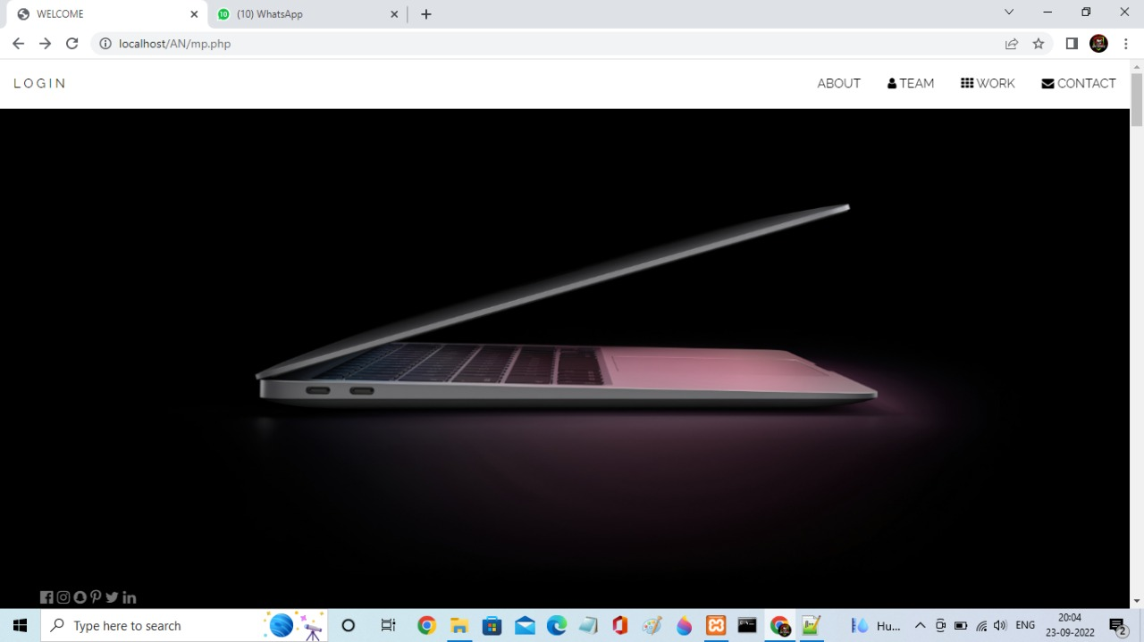

1. **LOGIN**

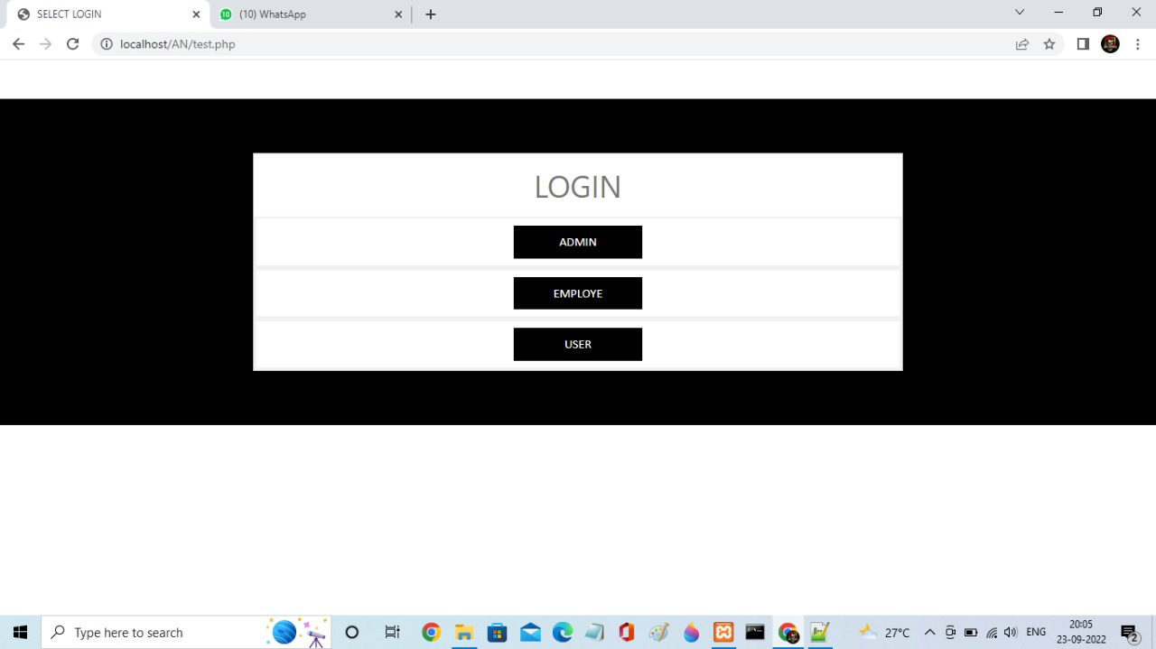

1. **USER PAGE**

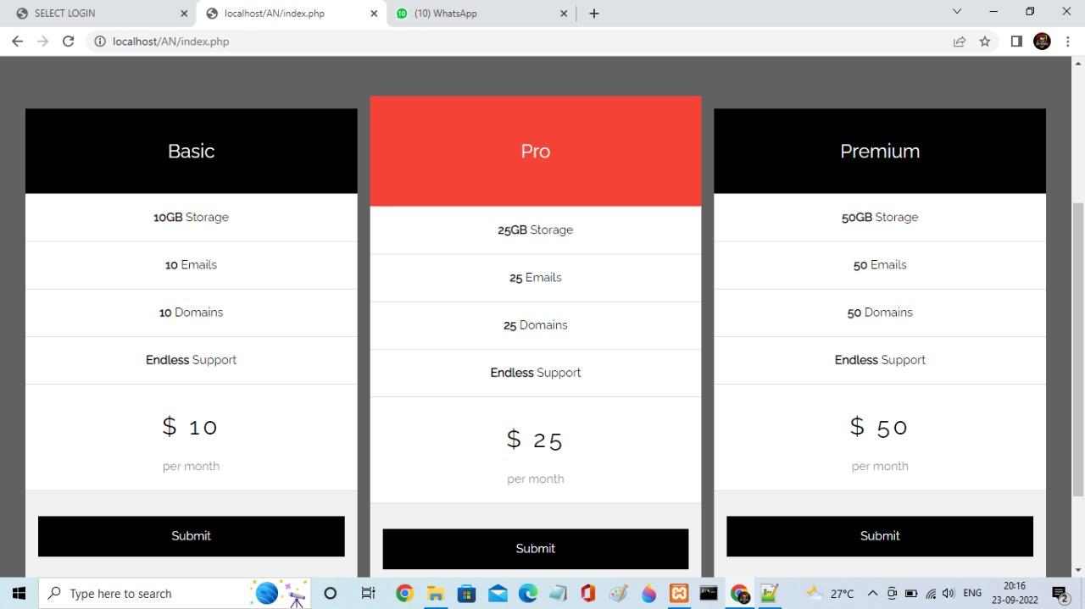

1. **SIGNUP PAGE**

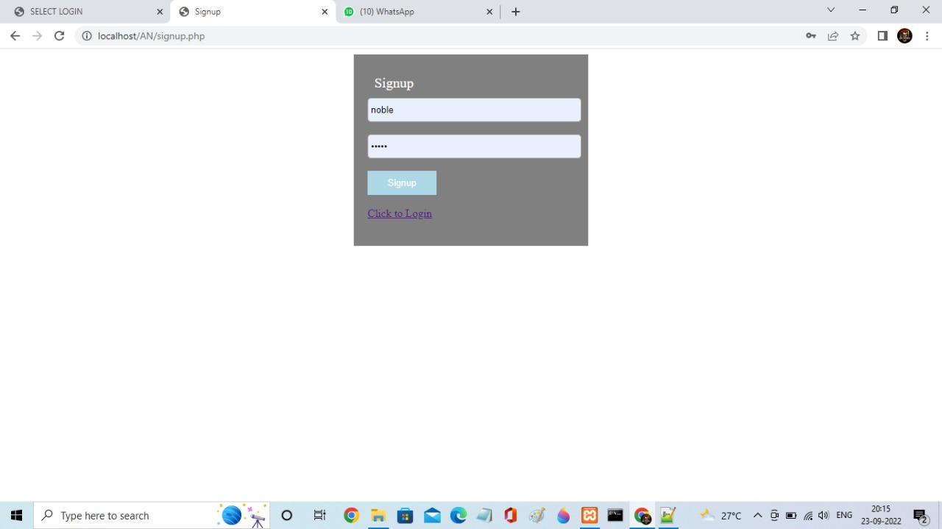

1. **EMPLOYEE PAGE**

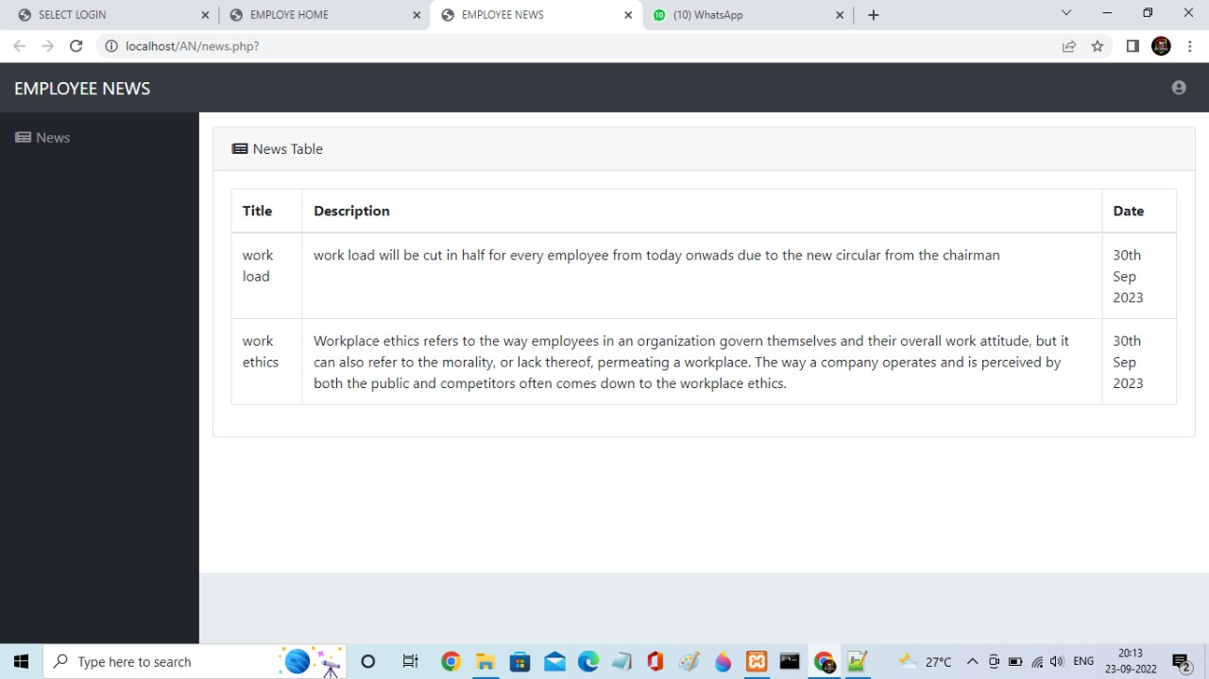

1. **FORM PAGE**

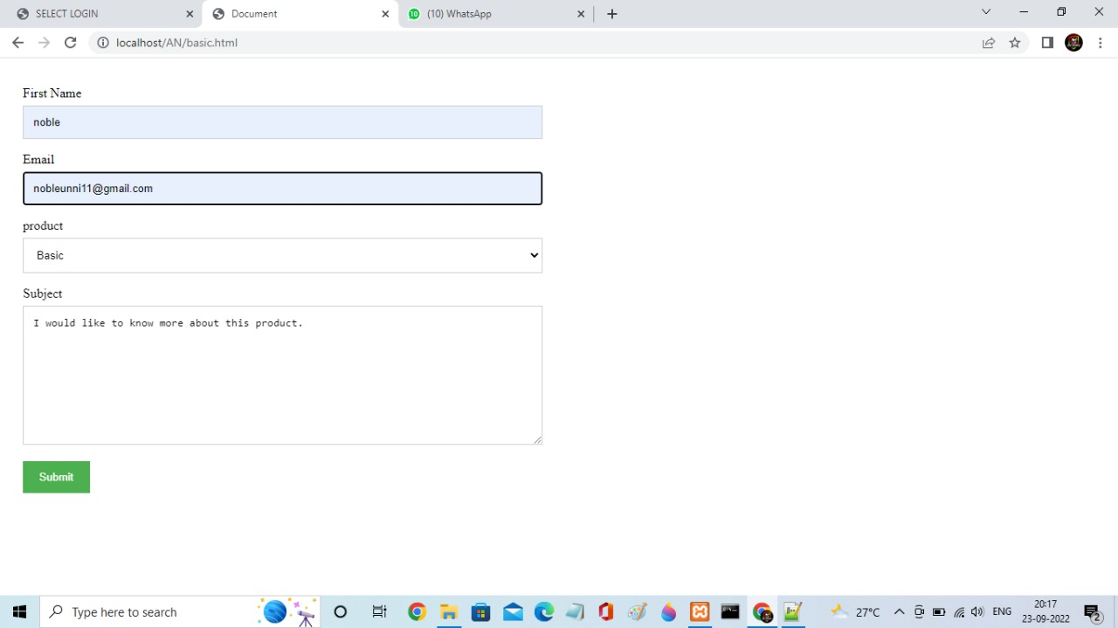

1. **DATABASE**

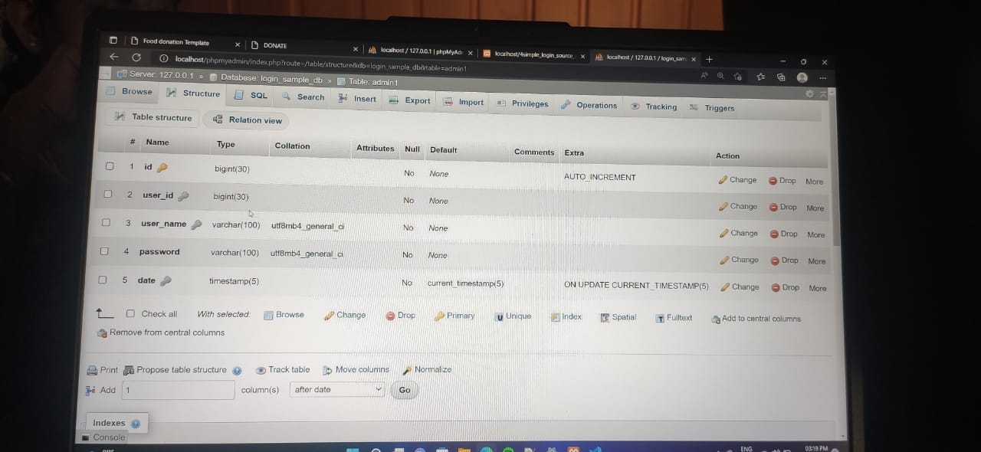

1. **SIGNUP PAGE**



**9. FUTURE ENHANCEMENT**

**CONCLUSION**

The software developed has fulfilled the necessary requirements as required by the user. It is ensured that all the programs are working properly in **“BUSINESS WEBSITE**”. The system is used to design to operate in a user friendly manner. Proper documentation done from different areas, without difficulty and provides smooth running of all the operations. The system that has been developed in PHP is to improve more user interactivity. This project avoids errors.The system has achieved the objective of being information system for auctioning purposes. This project has been implemented and tested.

**FUTURE ENHANCEMENT**

Since every application should expand and it should provide a way for the updating the system have been developed.

Every module in this system have been developed carefully such that future enhancement do no affect the basic performance of the system. Through the current system in suitable the customer can be eager to use the most recent available development the system is faster and better than the existing once.

In future, we can incorporate “**BUSINESS WEBSITE**” with newer facility. So as to make it more attractive and ease to be used by the client.