|  |  |
| --- | --- |
| Realtime Weather | |
| Yida Huang **2015014357** | Feilong Zuo **2015014267** |

# Project Description

Real Time Weather is a mobile app which can show the current weather situation according to the users’ location. We can also choose the location by searching.

# Project Design At the beginning of the project , I had taken sample from the weather app which is widely used in our daily life. And I found that simplicity is the main theme among weather apps. So we decided to design a clear and concise appearance.

# Application Instructions

Explain each of the features from a user perspective and write a short set of user instructions

User instruction:

Our app contains three main page, the home page ,the citylist page ,the search page.

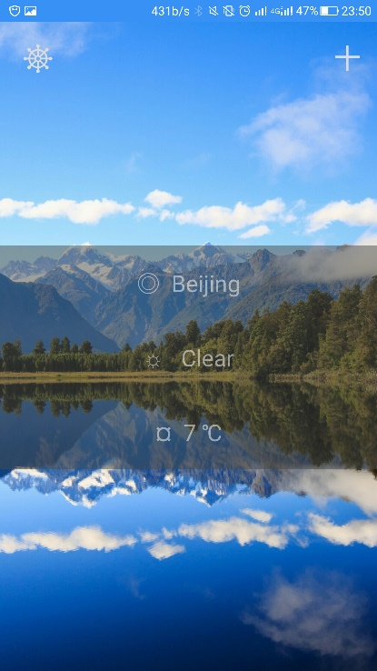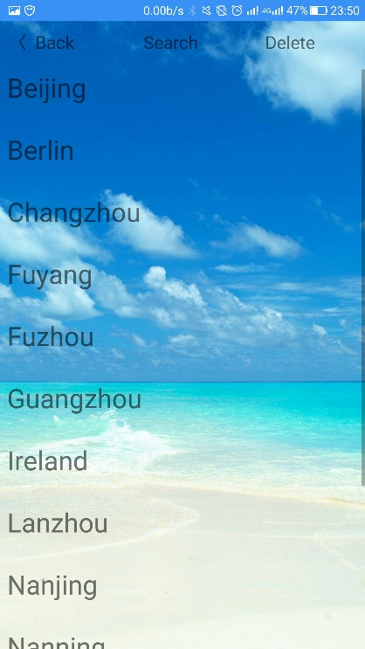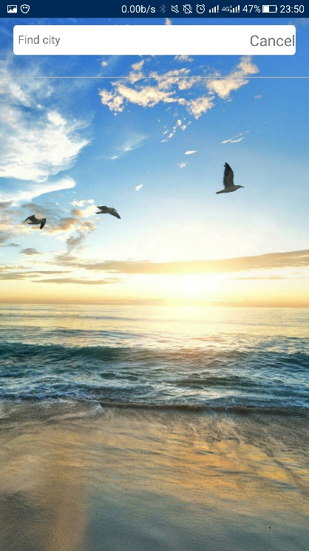

The home page includes the weather information of the city.We can choose the city by locating or searching. The left button which is on the top of the screen can get our location as the city. The right button can take us to the next page which contains our citylist.

The citylist page has a citylist.We can choose a city on the screen.Then we will return to the home page and show the weather of the city. The search button will help us add a city to the citylist. The delete button will help us delete a city from the citylist.

The search page can help us search the city which we want to add to the list. The result of searching will be shown on the page, we can check it to achieve our adding operation.

# Development Notes:

Discuss the most complex part of your project and highlight any difficulties you encountered and how you resolved them. Explain exactly what development you have completed.

**The development I have completed:**

Yida Huang

1. the view of the search page and citylist page.
2. the navigator which is hidden as some buttons.
3. the search function which is achieved by fetch the api and inputtext.
4. the local storage which is achieved by AsyncStorage component.
5. The search page which is achieved by Modal component.
6. The Forecast component which show the information of weather.
7. Adding function and delete function which is used to the citylist.

Feilong Zuo

1. The design of the home page which shows the weather information and the functional buttons.
2. The location function and the use of ‘Geolocation’ including adding the right of using GPS for the app on the android devices and the geolocation asking, also the handling of the GPS response JSON.
3. The searching and choosing for the UI background images and the special characters using in the UI Frame
4. The realization of the background and the function that the background image can change by the current weather.
5. The realization of successfully fetching weather API and dealing with the response JSON

**Difficulties:**

1. the navigator is a new concept to us ,we have to learn to know it by the blog on the internet.
2. The AsyncStorage component can only save string element by key, we have to make our designs adapt to the feature.
3. The flexbox layout must be designed carefully so that the app can have less bugs.
4. The use of modal is a new concept for us , the date in the state must be taken care so that the ‘citylist’ will shown correctly.
5. The using of Geolocation. To get the current weather information of the user’s place, we must use geolocation API to get the position. However, to use it ,we must add the right for the app to use GPS. We must add

‘ <uses-permission android:name="android.permission.ACCESS_FINE_LOCATION" />’ to some file named ‘AndroidManifest.xml’ (not just one such file in the project ) and give the emulator the virtual GPS data. This do give we much difficulties.

# Testing

Explain your testing approach: What tests did you plan and execute, what were the use cases you considered. List the test cases you ran.

We test the app function after we complete the code of each part.

For example, when we finish the Geolocation use, we set the virtual GPS information:’lat:41,lon:116’ and see if the geolocation response same with it by using the remote debug on chrome.

When we realize the AsyncStorage component , we use the search page and citylist to test the AsyncStorage .First ,we add a city to the list. Then , we return to the home page and reload the app. After that, we go to the citylist page and find that the city we added exists. That proves the AsyncStorage component is used successfully.

# Issues

The first If we have more time the most important thing is to consummate the search function , I want to finish it by string matching rather than the fetch function.

Another facet is the view of the citylist , in my opinion ,we can have a more beautiful view if we have more time . at least the element of the list can have a more beautiful view according to the city’s weather.

What’s more, We also want to add more information to the weather app, not just the three information we got now, such as the weather of the near day, the highest and the lowest temperature today.

# Extra Credit

Identify what part of the project you think is worth extra credit. Justify your answer.

1. AsyncStorage .A new component which can be used to do local storage. It is portable and useful.
2. Geolocation. It is do useful and also a little bit difficult.
3. Modal . A component which can be use to cover the screen. It makes the function realized easily
4. Navigitor. A component which can be used to do interface jump. It enrich our apps and make our apps beautiful.

# Conclusion and future improvements

Reflect on your project, identifying what you thought went well and what enhancements you would like to make to the application and explain how you might code them.

During this project, we two cooperate greatly with each other and it is really a fantastic experience. We use new features and meet up with new difficulties and just work hard to realize them. And finally, we are all very pleased that we get this lovely app, clear and useful.

Thanks to all teachers that you give we this chance to attend to this react-native project.

Future improvements:

1. String matching for the city search
2. Better view of the UI
3. More information of the weather.