Comp 120

Lab 5 report

Luke Colvin

Code Version 2

**Functional Specifications**

This code and report is a remix of last lab to include functions in the code.

This program determines the number of and amount of daily sales and gives the average daily sales for each day along with the total sales. The program will prompt the user to enter the sales of each day, repeating until a -1 is entered. It will sum the values and print each separately along with the average and total sales.

**Technical Specifications**

This program uses six functions to keep the original functionality of the program while making the program easier to read and debug. First there is the inputSales() function which creates a list for sales and gets the input for sales until a -1 is entered at which time it breaks the loop. It also appends the sales to the list of sales. The next function is calculateTotalSales() which inits a variable for totalSales and then runs through the list to calculate the total of the sales ending in a return for totalSales. The calculateAverageSales() function takes totalSales and days as variables then creates a new variable averageSales by dividing totalSales by days. I kept the rounding function I added in the first version to round to the hundredths place. The outputSales() function prints the sales from the list. OutputTotalSales() prints the total sales for the period from the calculateTotalSales() function. OutputAverageSales prints the average sales from the calculateAverageSales() function. The main program then runs calling the funtions.

**Flow Chart**

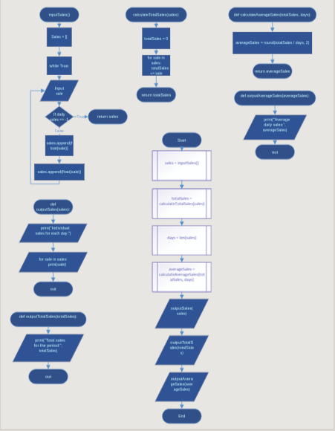

**Source Code**

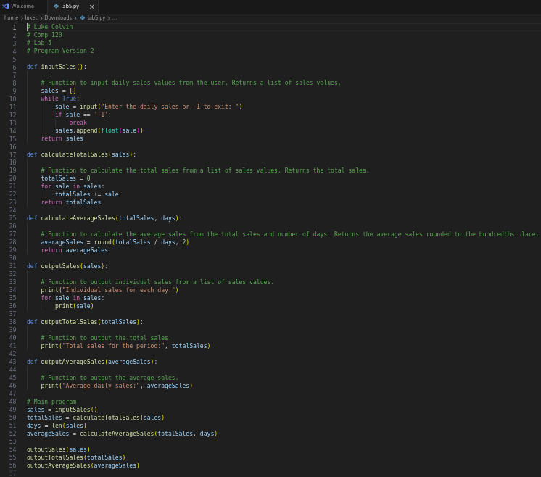

**Program Execution**

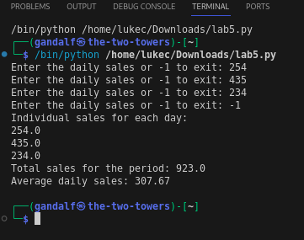

**Comments**

This re-write to functions actually went way better than I expected I just had a couple issues with making the order correctly but thats it.

The estimated time for me to complete this project was approximately 100 minutes.