## Modscan Arduino Connection Test

* Execute ModScan64.exe and click Cancel

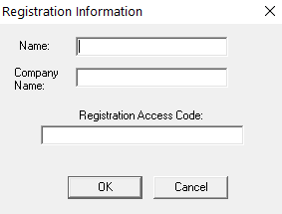

* Ok

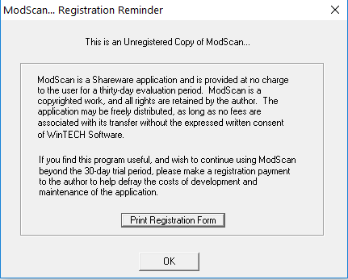

* Ok



* Connect

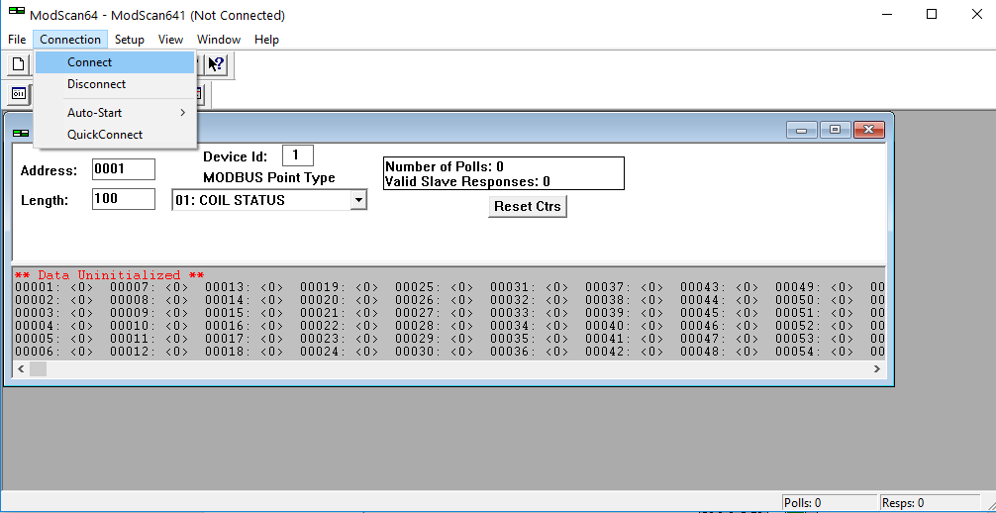

* Select COM port. i.e. COM8

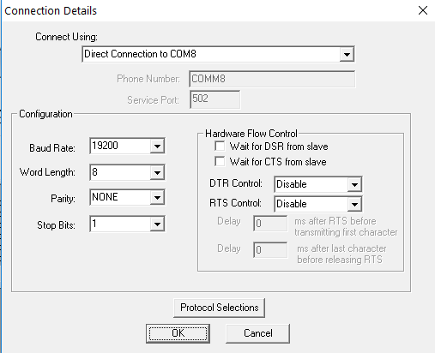

* Ok

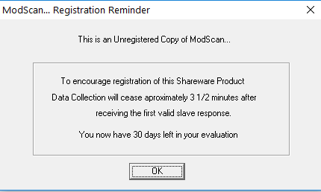

* Select “HOLDING REGISTER” and “LENGTH”. i.e. 9 for au16data[8] arduido array

