2025-26

MY
VET

MyVet
ISPW PROJECT - University of Rome Tor Vergata
LUCREZIA ANGELINI

MyVet Project Documentation

Table of contents
1. Software Requirement Specification (SRS) | 3
1.1 Introduction | 3
1.2 User Stories | 5
1.3 Functional Requirements | 5
1.4 Use Cases | 6
2. Storyboards | 8
3. Design | 10
3.1 BCE/MVC Class Structure | 10
3.2 Design Patterns | 12
3.3 Activity Diagram | 13
3.4 Sequence Diagram | 14
3.5 State Diagram | 15
4. Testing | 16
5. Code and Execution | 17

1. Software Requirement Specification (SRS)

1.1 Introduction

1.1.1 Aim of the Document
The purpose of this document is to present the functional and non-functional requirements of MyVet, a project developed for the Software Engineering and Web Design course, Academic Year 2025-2026.
The document provides an overview of the system objectives, core functionalities and design choices in order to guide the development process.

1.1.2 Overview of the Defined System
MyVet is a Java 17 application structured according to the MVC/MVP architectural approach and built with Maven.
The system supports modern veterinary appointment management and centralizes essential information about pets and their healthcare,, including the following functionalities:
- Pet Owner authentication and session management.
- Pet registration and consultation.
- Veterinarian search by specialization, postal-code area and city fallback.
- Appointment booking, cancellation and status management.
- First-compatible-availability search.
- Owner booking history and Veterinarian agenda.
- Digital Pet Health Passport records.
- Care reminders and simulated email notifications.
MyVet does not use GPS or external map services. The Pet Owner's area is identified by the area or postal code stored in the profile; if no compatible Veterinarian is found, the search is extended to the city.

1.1.3 Hardware and Software Requirements
Execution environment
Software | Java 17+, Maven 3.8+, JUnit 5, IntelliJ IDEA or Eclipse
Optional | MySQL Server 8.0+ for a future persistent DAO implementation
CPU | Dual-Core 2.0 GHz or better
RAM | 4 GB recommended; 2 GB minimum
Disk | 1 GB free space
OS | Windows, macOS or Linux with Java 17+
Network | Required only when a real email provider replaces the demo service

1.1.4 Related Systems - Pros and Cons
Comparison
PetDesk - Pros | Appointment scheduling, reminders and clinic-oriented workflows.
PetDesk - Cons | Limited unified owner-controlled health passport and local search model.
Vetstoria - Pros | Online appointment booking and practice-management integrations.
Vetstoria - Cons | Primarily focused on scheduling; limited centralized pet history.
Google Maps - Pros | Accurate maps, distance calculation and navigation.
Google Maps - Cons | No appointment workflow, pet records or healthcare reminders.
MyVet | Combines local veterinarian discovery, appointments, health records and reminders without payments or geolocation dependencies.

1.2 User Stories
- As a Pet Owner, I want to search for Veterinarians by specialization and area, so that I can find appropriate care near my registered location.
- As a Pet Owner, I want to book and cancel appointments, so that I can manage my pet's visits.
- As a Pet Owner, I want to find the first available appointment, so that I can receive care sooner.
- As a Veterinarian, I want to consult my agenda and update appointment states, so that I can organize my work.
- As a Veterinarian, I want to update a pet's Digital Health Passport, so that its medical history remains current.
- As a Veterinarian, I want to create care reminders, so that the Pet Owner can follow the prescribed care plan.

1.3 Functional Requirements
- The system shall display available veterinary specializations.
- The system shall search first in the Pet Owner's registered area and then in the city.
- The system shall display available slots for the selected Veterinarian.
- The system shall make a cancelled appointment's slot available again.
- The system shall maintain appointment states and histories.
- The system shall maintain Digital Pet Health Passport records.
- The system shall maintain care reminders and trigger appointment notifications.

Glossary
Area | Postal-code area stored in the Pet Owner and Veterinarian profiles.
Slot | A date and time interval offered by a Veterinarian.
Booking | Association between Pet Owner, pet, Veterinarian and available slot.
Health Passport | Chronological collection of diagnoses, treatments and clinical notes.
Care Reminder | A future healthcare action linked to a registered pet.

1.4 Use Cases

1.4.1 Overview Diagram
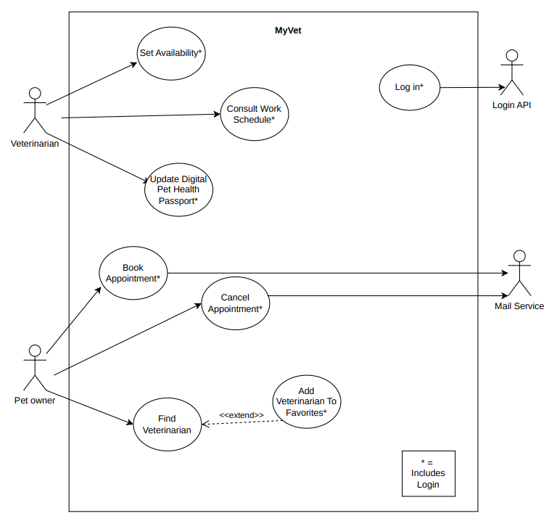
External actor: Email Service. Geolocation is not an external actor because area and city filtering use locally stored profile data.

1.4.2 Internal Steps
Use case: Book Appointment
1.4.2 Internal Steps
Main Flow
- The Pet Owner accesses the appointment booking section via Login
- The system displays the available veterinary specializations.
- The Pet Owner selects a veterinary specialization.
- The system displays the veterinarians matching the selected specialization and operating in the Pet Owner’s area.
- The Pet Owner selects a veterinarian.
- The system displays the available time slots for the selected veterinarian.
- The Pet Owner selects an available time slot.
- The system displays the pets registered by the Pet Owner.
- The Pet Owner selects the pet for which the appointment is being booked.
- The system displays the appointment summary (date, time, veterinarian, pet and clinic address).
- The Pet Owner confirms the appointment.
- The system records the appointment and sends a confirmation email containing the appointment details to both the Pet Owner and the Veterinarian.
Alternative Flow (Extensions):
- 4a. No Veterinarians Available in the Pet Owner’s Area: No veterinarians matching the selected specialization are available in the Pet Owner’s area; the system extends the search to the entire city. If no matching veterinarians are available in the city, the system displays a warning and resumes from step 2.
- 6a. No Available Time Slots: The selected veterinarian has no available time slots; the system displays a warning and redirects the Pet Owner to step 5 to select another veterinarian.
- 8a. No Registered Pets: The Pet Owner has no registered pets; the system displays a warning indicating that a pet must be registered before proceeding with the booking.

2. Storyboards

3. Design

3.1 Class Diagram

3.1.1 VOPC Analysis
BOUNDARY | CLI/JavaFX views; receives input and displays search, slots, summary, history and passport

CONTROL | BookingController; coordinates search, availability, booking, cancellation, history and health operations

ENTITY | User, PetOwner, Veterinarian, Pet, TimeSlot, Booking, HealthRecord, CareReminder

SERVICE / PATTERNS | NotificationService, Session, Observable, BookingConfirmationObserver, BookingCancellationObserver

3.1.2 Design-level Class Diagram
Entity model
User | Abstract base: id, name, surname, email
PetOwner extends User | city, area, pets, favourite Veterinarians
Veterinarian extends User | specialization, city, area, clinic address
Booking | PetOwner + Veterinarian + Pet + TimeSlot + reason + BookingStatus
TimeSlot | date, start, end, availability; reserve() and release()
HealthRecord | pet, Veterinarian, date, diagnosis, treatment, notes
CareReminder | pet, Veterinarian, title, description, due date, completion state

PetOwner 1 | Booking 0..* | Veterinarian 1
Pet 1 | Booking | TimeSlot 1
Pet 1 | HealthRecord 0..* | Veterinarian 1
Pet 1 | CareReminder 0..* | Veterinarian 1

3.2 Design Patterns

1. Singleton - Session
Session uses the Initialization-on-demand Holder idiom to maintain one authenticated user throughout the application. The holder provides lazy initialization and thread-safe construction without explicit synchronization. Role-checking methods centralize access decisions.

2. Observer - Appointment Notifications
Booking extends Observable. BookingConfirmationObserver and BookingCancellationObserver react to state changes and delegate notification delivery to NotificationService. Booking does not directly depend on the notification mechanism, allowing future email, SMS or push implementations.

3. MVC/BCE Separation
Boundary objects collect input and present results. BookingController implements application coordination. Entities protect state transitions such as slot reservation and booking completion. This separation keeps interface code independent from domain rules.
Pattern responsibilities
Singleton | One shared session; lazy and thread-safe access.
Observer | Notification side effects separated from Booking state changes.
MVC/BCE | Presentation, application logic and domain state remain separated.

3.3 Activity Diagram
START - Authenticated Pet Owner
Select veterinary specialization
Search matching Veterinarians in registered area
[No area results] Extend search to city
Select Veterinarian or request first available appointment
Select available TimeSlot
Select registered Pet and enter visit reason
Verify ownership and slot availability
Create CONFIRMED Booking and reserve slot
Notify Pet Owner and Veterinarian
END - Display booking confirmation

3.4 Sequence Diagram
Pet Owner | Boundary | BookingController | Domain / Notification
selectSpecialization() | searchVeterinarians() | filter area/city | return matches
selectVeterinarian() | getAvailableSlots() | read available slots | return slots
confirm() | book(vet, pet, slot, reason) | reserve slot + confirm | notify observers
view confirmation | return Booking | status CONFIRMED | email simulated
All objects and messages in this representation remain editable Word table content.

3.5 State Diagram
PENDING - Booking created
confirm()
CONFIRMED - Slot reserved and notification sent
cancel() -> CANCELLED - Slot released
complete() -> COMPLETED - Visit performed
markMissed() -> MISSED - Pet did not attend

Transition Rules
- Only a PENDING booking can become CONFIRMED.
- Only a CONFIRMED booking can become CANCELLED, COMPLETED or MISSED.
- Cancellation releases the associated TimeSlot.
- Invalid transitions raise an exception and preserve the current state.

4. Testing
Automated test scenarios
Area-first search | Dermatology returns the matching Veterinarian in the owner's area without city expansion.
City fallback | General Medicine returns a Veterinarian in the same city when the area has no match.
First availability | The earliest compatible future slot is selected.
Booking | A registered pet is associated with the selected Veterinarian and slot; status becomes CONFIRMED.
Cancellation | Status becomes CANCELLED and the slot becomes available again.
Health data | Health Passport entries and Care Reminders are stored and returned for the selected pet.
Veterinarian status | A confirmed appointment can be completed and appears in the Veterinarian agenda.
Verification result: 5 JUnit tests executed, 0 failures, 0 errors, Maven BUILD SUCCESS.

5. Code and Execution

Project Structure
model | Domain entities and appointment states
controller/applicativo | BookingController application logic
pattern/singleton | Authenticated Session
pattern/observer | Booking notification observers
service | Demo NotificationService
bean | Boundary-oriented search result data
test | JUnit tests for core flows

Execution
Open C:\Users\mange\Desktop\MyVet as a Maven project, select JDK 17 or newer, and run it.ispwproject.myvet.Main.
mvn clean test
mvn exec:java

Current Scope
The current application uses in-memory demo data and console output. It requires no MySQL instance, geolocation API, map service or email credentials. Persistence and a graphical Boundary can be added without changing the documented domain rules.

Repository
Local project: C:\Users\mange\Desktop\MyVet

