Luc Rulinda

ME 54600- prof. Hazim El Mounayri

Final Project Report

12/11/2020

NX Final Project

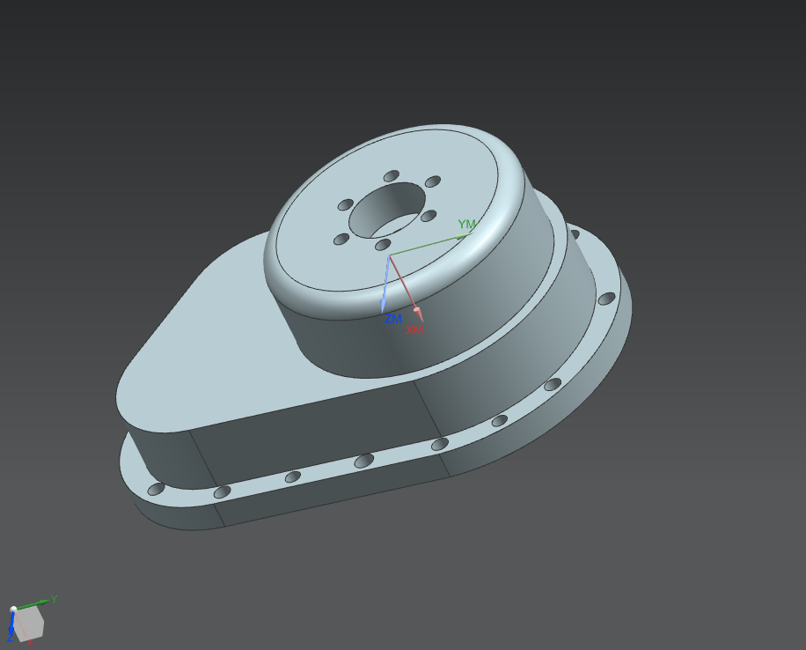

Contents:

1. Design process
2. Machining process
3. Difficulties
4. Screenshots
5. **Design process**

I followed the guidelines given in the assignment files to design Part Cover 1 and Part Cover 2. My design process consisted of sketching and extruding the models individually. In the design process, the pattern feature allowed me to add multiple holes efficiently instead of adding them one-by-one.

1. **Machining process**

In this project I manufactured the bottom part of the Part Model by following the guidelines of the assignment. We used the following processes to obtain our final machined model:

* Face mill sequence
* Planar profile rough sequence
* Planar profile milling sequence
* Cavity milling sequence
* Rest milling sequence
* Hole drilling sequences

Our model had 4 different sets of holes that were mainly punctured with a standard drill, and a Tap drill for the hole set C. To perform a smooth hole drilling, for all the set of holes but set C we operated one halfway drilling using a shorter diameter drilling tool, followed by our desired tool (with the required diameter) that covers the entire depth of the hole. The set of holes C was exempt from this two-fold operation since it was tap drilling sequence.

In the Cavity milling sequence part, we were instructed to use a scan type of follow part, however I used the follow periphery one was used instead because it was the only one that could deliver the desired output. It is also the most efficient one because we would have had to repeat this sequence to use the Follow Part for the desired material removal.

1. **Difficulties**

The difficulties encountered in this project are mainly due to miscommunication: some of the guidelines in the files we were provided with differ from what we went over during the labs. For instance, we were encouraged to perform a two-fold drilling process in our machining, however we are asked to only perform one drilling sequence for each set of holes in the assignment instructions. I used the two-fold drilling process as I was targeting for an effective machining, rather than a fast one.

There was a hole that was omitted in this project because we are not given the instruction to puncture it. This is the big through-body hole inside the top cover that goes through the entire body.

There was no difficulty at all with the design process, the instructions were very clear.

1. **Screenshots**

Part Model 1

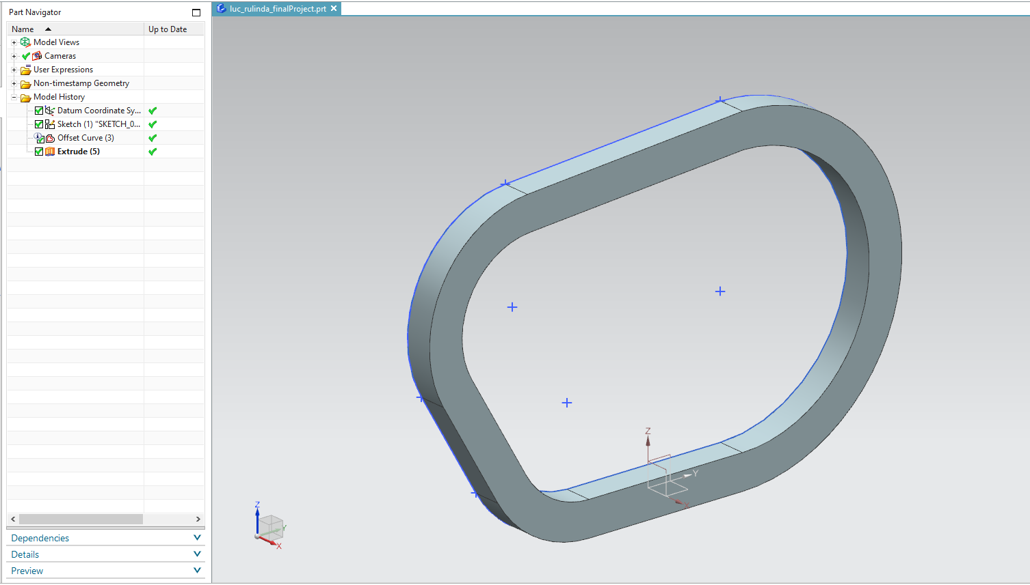

Figure 1: Flange part

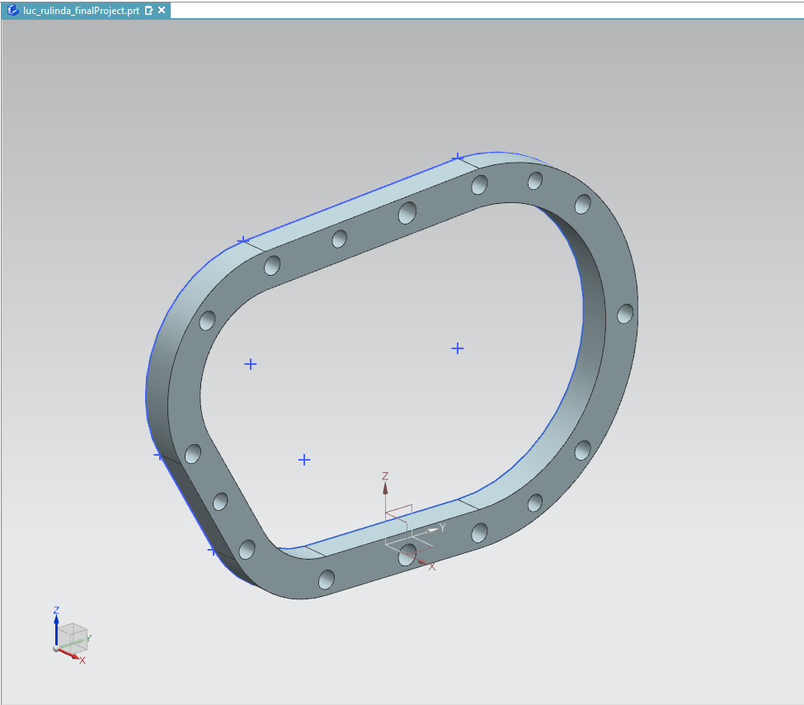

Figure 2: Flange with holes

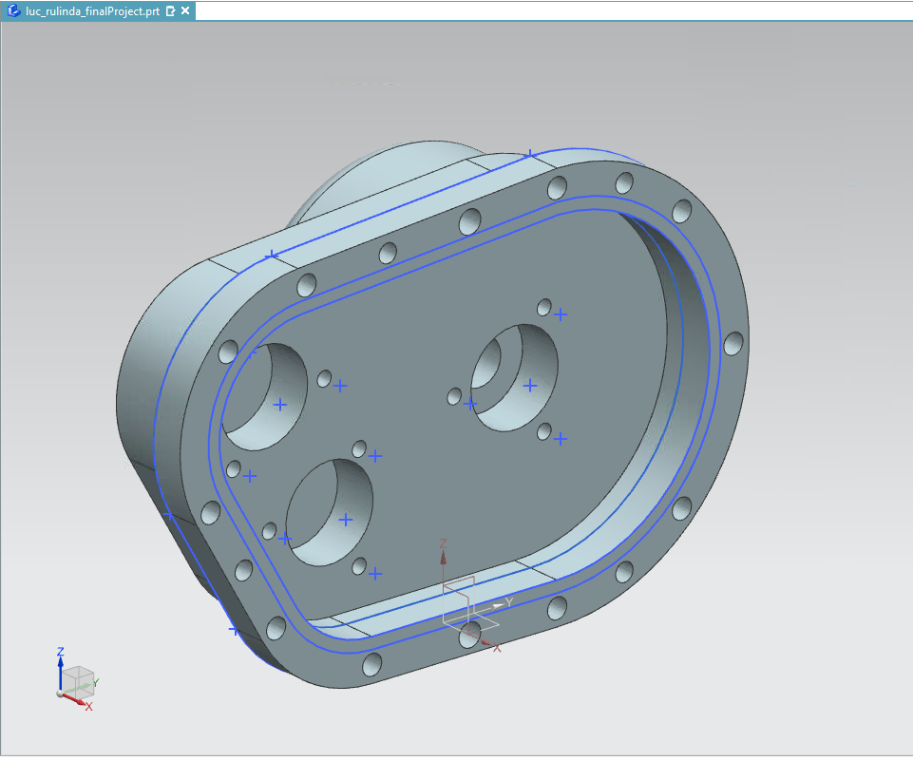

Figure 3: Final Part Cover 1 Model-Front View

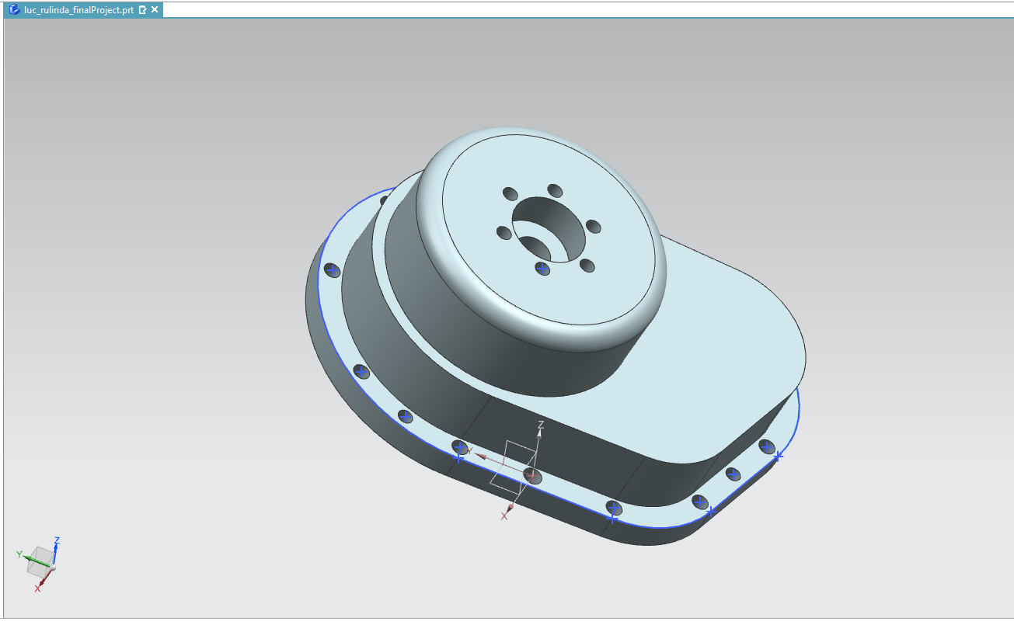

Figure 4: Final Part Cover 1 Model- Top view

Part Cover 2

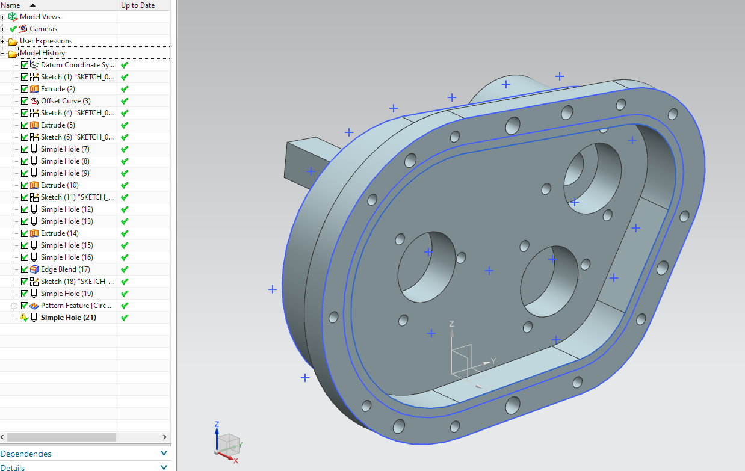

Figure 5: Final Part Cover 2 Model- Side view

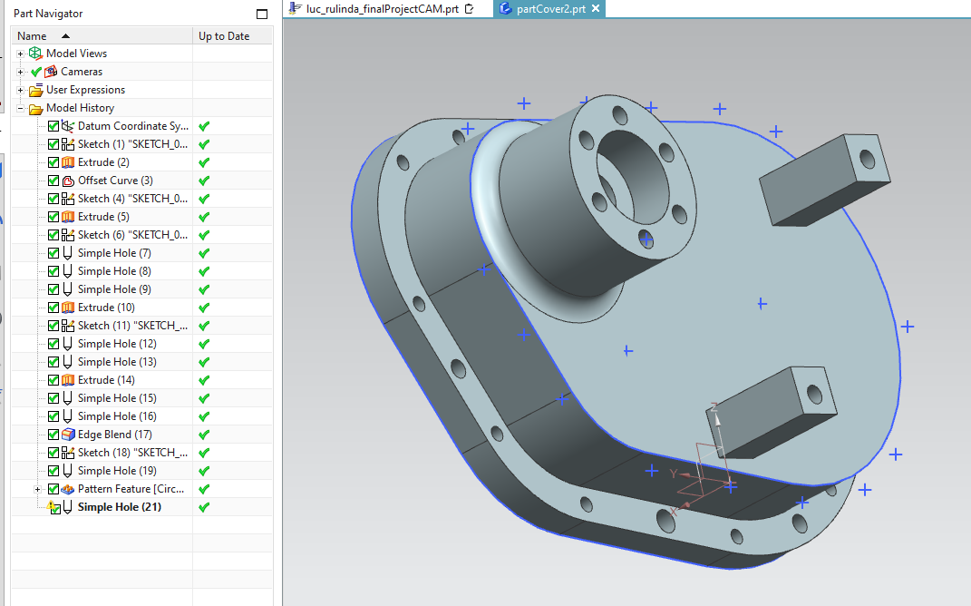

Figure 6: Final Part Cover 2 Model- Front view

Machining process of bottom part of Part Cover 1

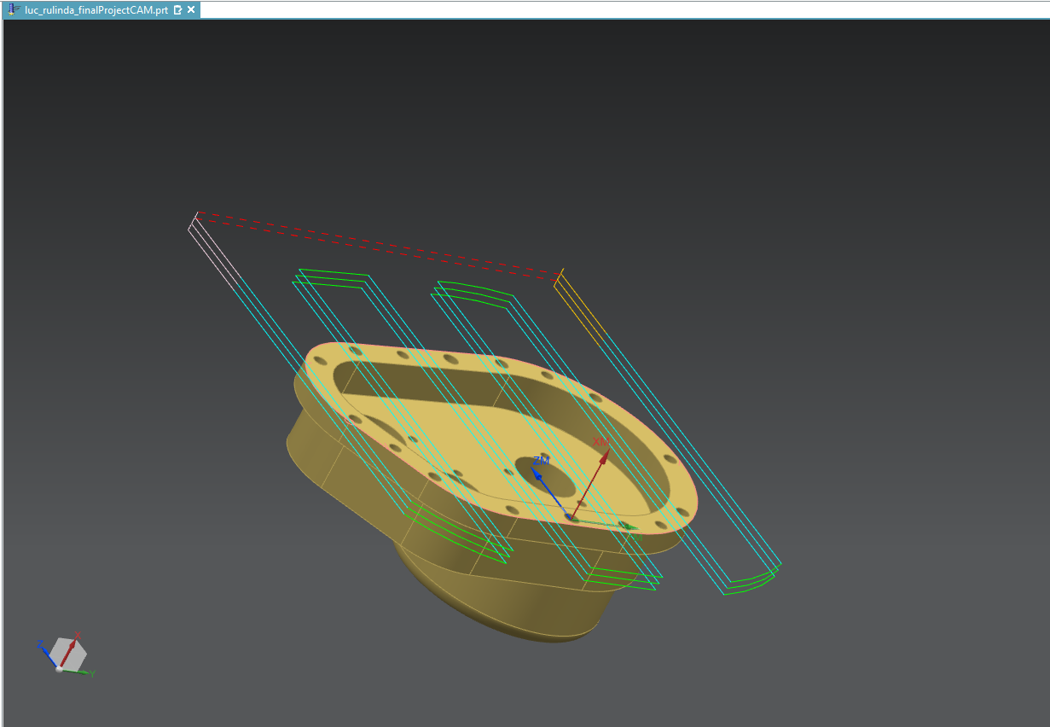

Figure 7: Face milling sequence

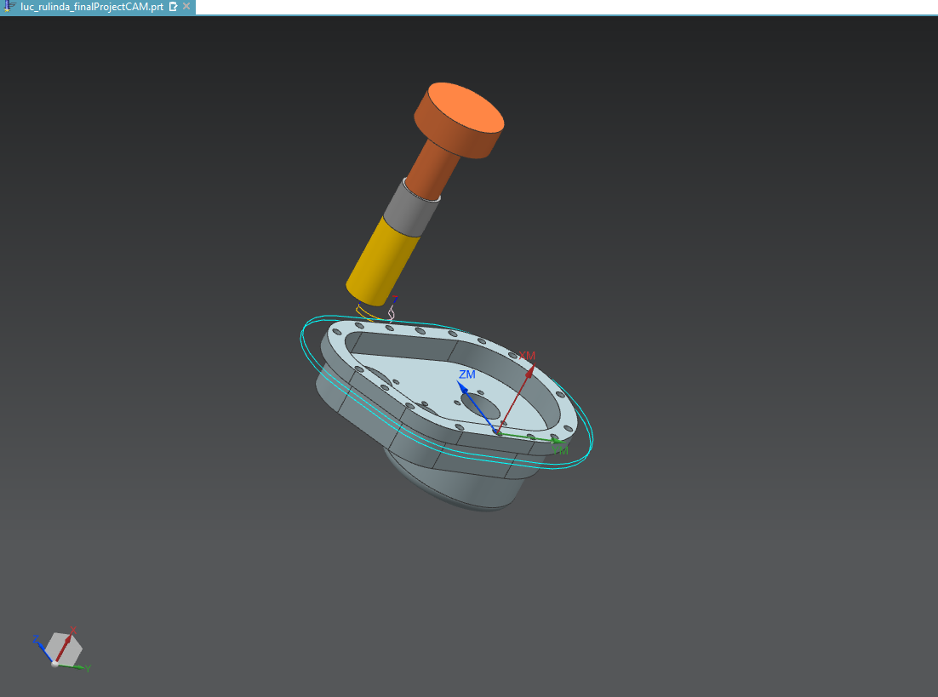

Figure 8: Material removal around the Flange

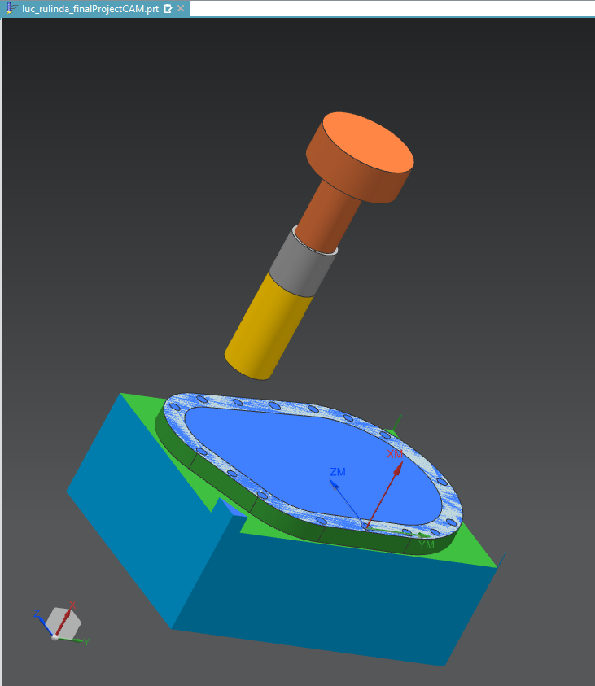

Figure 9: Final Planar Profile Milling sequence

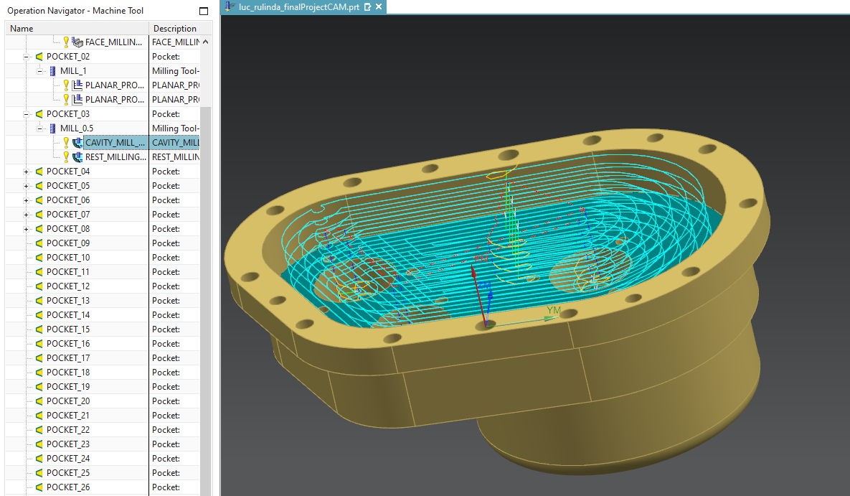

Figure 10: Material removal inside the cover- Cavity Milling

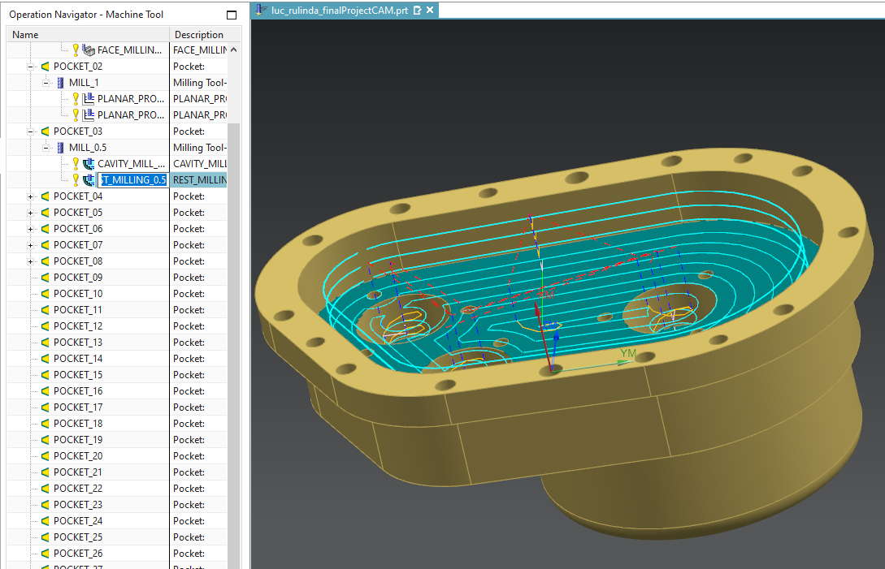

Figure 11: Material removal inside the cover- Finish Rest Mill

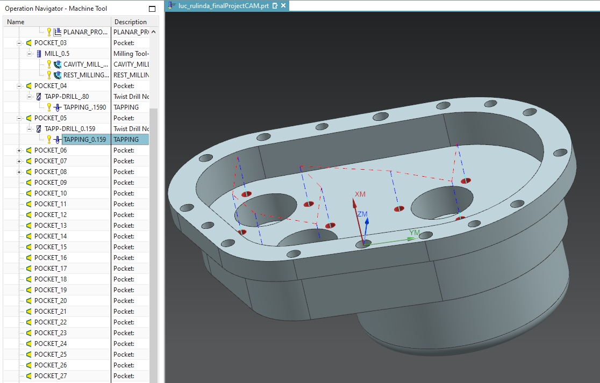

Figure 12: Hole drilling sequence inside the cover

Flange Hole drilling process:

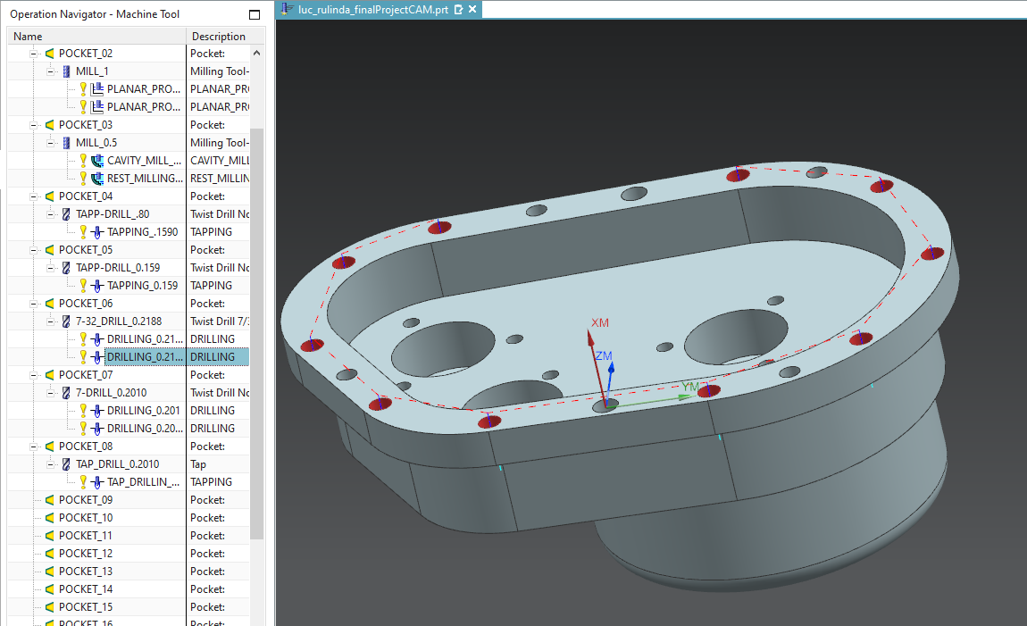

Figure 13: Set A- Hole drilling

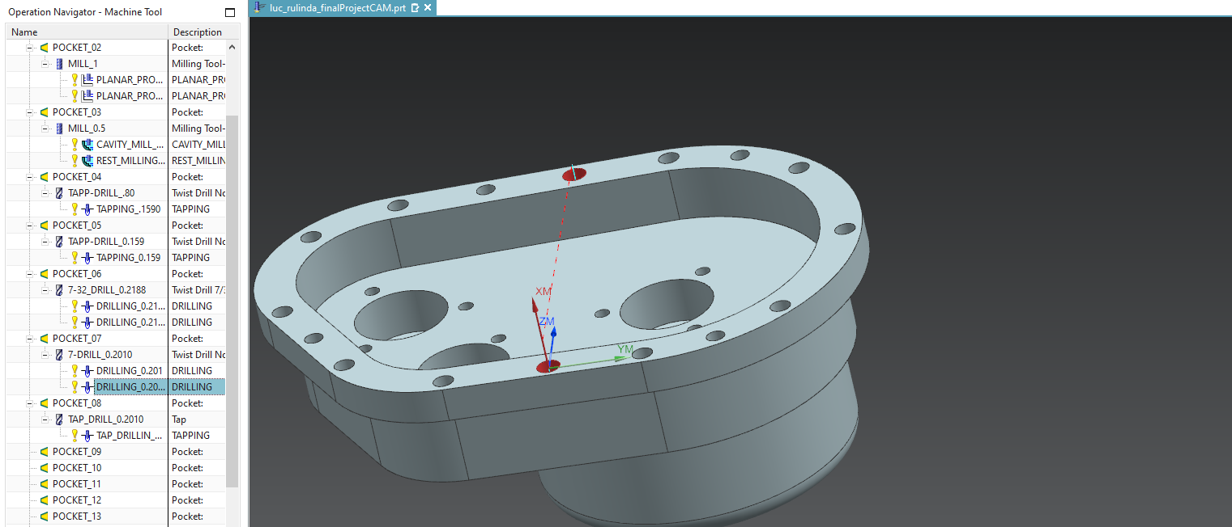

Figure 14: Set B- Hole drilling

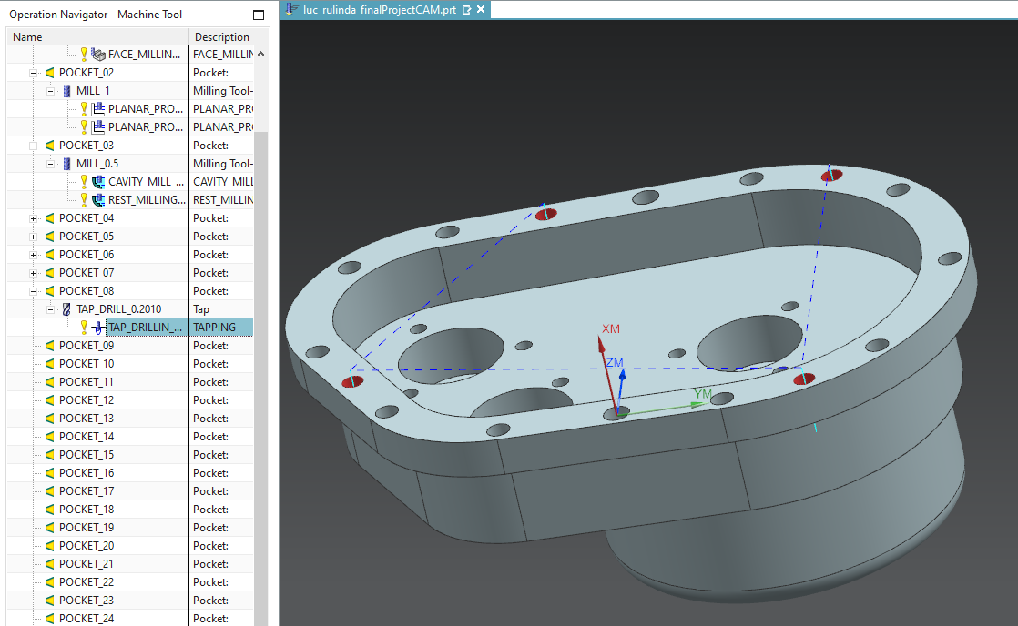

Figure 15: Set C- Tap drilling