My solution to the Knights Tour problem made use of references and pointers for sending the chosen board size to other functions in the program.

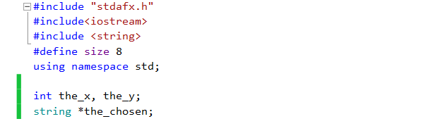

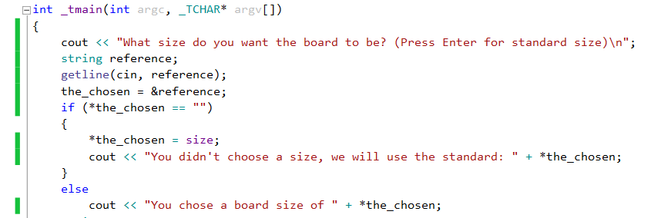

In this code I declared the pointer (*pointer), which I give the address of (reference) the chosen board size. Further down the code I use the *chosen pointer to give feedback to the player. If the player didn’t enter a size, the ‘*the_chosen’-pointer would reference to the ‘size’ integer with a value of 8.

C:\Users\Luc\AppData\Local\Microsoft\Windows\INetCache\Content.Word\New Bitmap Image - Copy.bmp

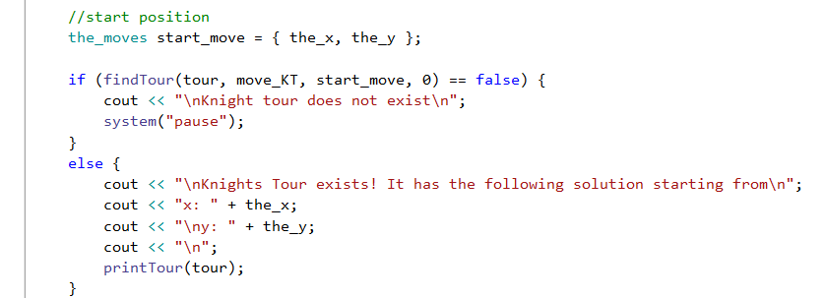

The program asks the user at which position he wants to start, and sets the variable ‘x’ to the input value. After this it checks if the player filled in a position. When the player has, it sets global variable ‘the_x’ to the input value which will be used when it creates the object ‘start_move’. Before looking for a solution the ‘findTour’ function gives feedback to the player about the start position.