**Waterfall Model:**

**1: Define:**

* Waterfall model is a model of software development process.
* This is the first Process Model to be introduced to the public
* The other name is Linear-sequential life cycle model.
* Simple and easy to use.
* Each stage must be fully completed before the next stage can begin.
* In software testing this model only starts after the development process is complete.

**2: Phrases of waterfall model:**

* Determine requirement
* Design
* Build
* Link
* Testing and edit
* Setting
* Maintenance
* Xác định yêu cầu
* Thiết kế
* Xây dựng (hay "triển khai", "mã hóa", "viết mã")
* Liên kết
* Kiểm thử và Chỉnh sửa (hay «kiểm nghiệm»)
* Cài đặt
* Bảo trì

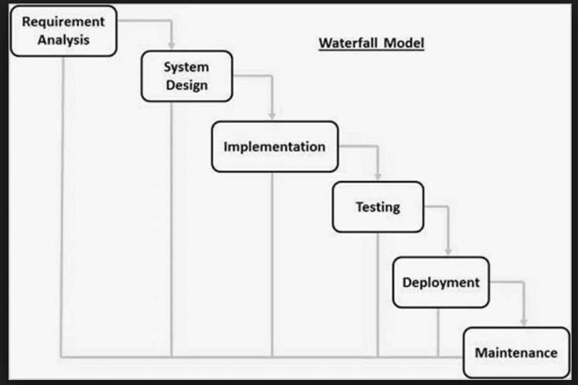

**3: Advantages and disadvantages of waterfall model:**

* Advantages:

+ Simple, easy to understand and use it.

+ Easy to manage because each phase has specific deliverables and a review process.

+ Phases are processed and completed one at a time and do not overlap.

+ Work well for smaller projects where requirements are very well understood.

* Disadvantages:

+ Difficult to go back and change something that was not well-thought out in the concept stage.

+ High amounts of risk and uncertainty.

+ Not a good model for complex and object-oriented projects.

+ Not suitable for the projects where requirements are at a moderate to high risk of changing.

**4: When to use waterfall model:**

* The project is short.
* There are no ambiguous requirements.
* This model is used only when the requirements are very well known, clear and fixed.