No Reference Visual Degradation Detection and Concealment in the Pixel Domain

Introduction
- H.264 over unreliable networks
- Joint Source-channel decoding
- Visual degradation
- No reference visual degradation detection
  - Superiori's approach (voting on block energy and subtraction blockiness)
  - Debono's approach (svm, with 8 params)
- Error concealment
  - whole frame approaches
  - border matching algorithms
- Bit-stream independent approach
- Good for a detection context (miranda) and concealment (post decoding)

Temporal blockiness
- Limitations of subtraction, blockiness and motion compensation.
  - Subtraction will detect image edges
  - Blockiness does not consider texture
  - Motion compensation will not detect frame freeze
- Temporal blockiness solves all three
  - image edges and texture are removed thanks to the temporal aspect
  - frame freeze is detected thanks to the blockiness aspect
- Motion compensation (temporal)
  - Image: Classic motion compensation image Drew p.289
  - Formula: Classic motion compensation formula Drew p.290
- Matching borders between block and motion compensated block (blockiness)
  - Formula: SAD formula enhanced with temporal aspect
Motion compensated delta are added to the difference.

Selective whole frame concealment
- Some erroneous bit-stream offer better PSNR than whole frame concealment
- Whole frame concealment includes but is not limited to frame copy and motion copy.
  - Frame copy explained
  - Motion copy explained
- How to use temporal blockiness information to determine if the erroneous frame is better than concealment.
  - Formula: if statement with condition to use the erroneous frame and when to use whole frame concealment

Region matching concealment
- The temporal blockiness information can be used for more than just whole frame concealment
- Regions matching is like border matching but with regions instead of blocks
  - Regions are contiguous erroneous blocks
- Error map from temporal blockiness

- Regions are determined with a queue-based flood fill algorithm.
- Regions boundaries are obtained via morphological operators

    - Where RnB is the set of blocks that compose the nth region.
- Border search
  - formula: Similar to motion compensation formula but only for borders.

Experimental results

Decodable corrupted sequences
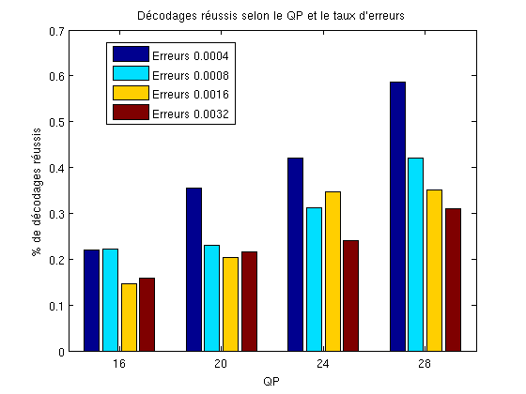

Frame copy vs Selective frame copy
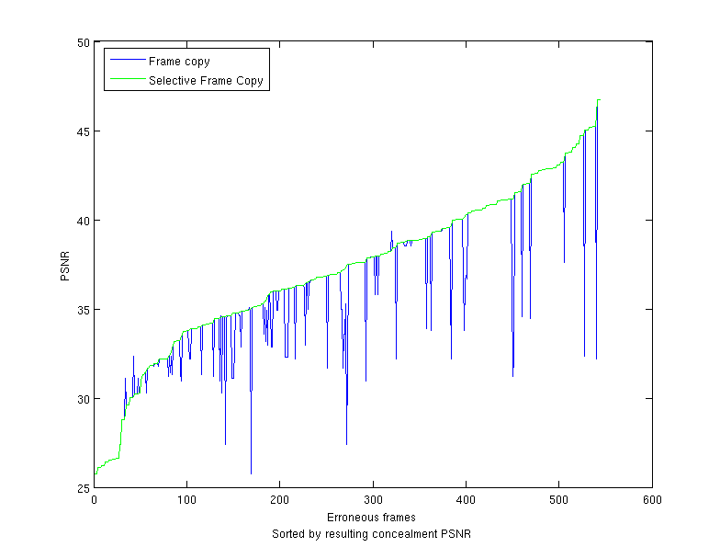

Selective frame copy vs region matching concealment
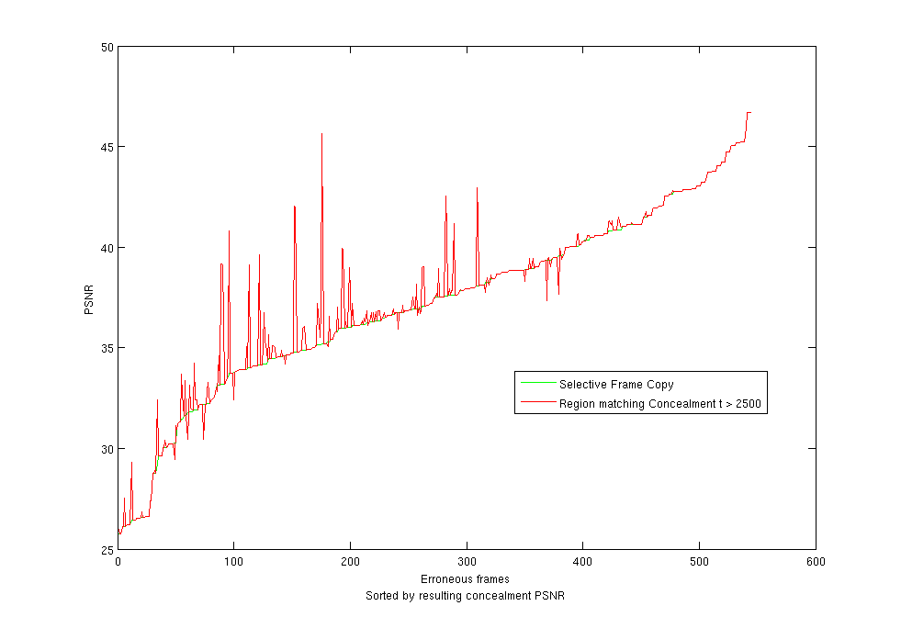

Frame PSNR Histogram
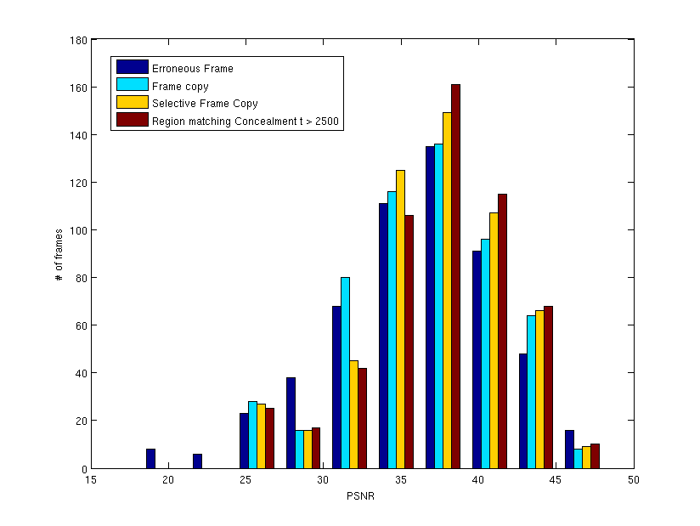

Discussion
- Selective frame copy is simple to implement and can produce interesting results
- Proving that the gain is not just PSNR but also perceivable quality gain.
  - Not just hiding the worst error and leaving the rest.

Conclusion
- Novel innovative approach
- Solution offers better results overall
- Resume article content
- Future considerations
    - (TSS, PMVFast, ...) for motion compensation
    - bit-stream dependant improvements (existing motion vectors)
  - Concealment improvements

Reference

