OTH Housing Tool

System Architecture Design Documentation

Table of Contents
OTH Housing Tool 1
System Architecture Design Documentation 1
1- Introduction 2
2. Software Architecture 3
2.1. System Scope 3
2.2 Technology Stack 3
2.3 Core functionality 4
2.4 Architecture Design Pattern 4
3. Software Design & Data Model 5
3.1 Entity Relationship Diagram Overview 5
3.2 Class Diagram Overview 6
3.3 REST API Endpoint Specifications 6
4. Core Feature Specifications 7
4.1 Housing Listing Workflow 7
4.2 Accommodation Application Workflow 8
5. Build and Run Instructions 9

1- Introduction
This document describes the system architecture of the OTH Housing Matching Tool.
OTH Housing Tool is a full-stack housing matching platform tailored for students and staff members of OTH Regensburg. The system streamlines the process of listing accommodations (Sublet, Next tenant, Couchsurfing) and allows students to browse, filter, apply for listings, and communicate directly with listing owners.

2. Software Architecture

2.1. System Scope
The system consists of:
- Frontend Single Page Application (SPA): Built with React, TypeScript, Tailwind CSS.

- Backend REST API: Built with Spring Boot 3, Java 17+, Spring Data JPA, and Spring Security.

- Database Management System: PostgreSQL storing user data, offers, apartments, applications, and system notifications.

2.2 Technology Stack

- Frontend Framework: React, TypeScript, Vite
- Styling & UI: Tailwind CSS, Lucide Icons, Sonner Toasts
- State Management: React Context API
- Backend Framework: Spring Boot 3, Java 17+
- Persistence / ORM: Spring Data JPA, Hibernate, Lombok
- Database: PostgreSQL
- API Documentation: Springdoc OpenAPI / Swagger UI

2.3 Core functionality
The system manages key core functionalities:
- User Authentication & Authorization
- Listing Management: interface to create, update, and publish room/apartment to rent.
- Filter & Search: filtering by stay type, rent cost.
- Application: application to available listings.
- Application status: pending / declined / approved.
- Communication Workflow: direct interaction through chat between candidates and listing owners.
- Notification system: automated notification to people who have / have not been selected.

2.4 Architecture Design Pattern
The application is implemented using a Model-View-Controller (M(S)VC) with Service Layer pattern as describe in the Figure 1 below:

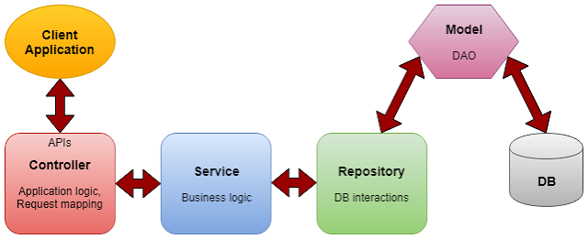

Figure 1 – MVC(S) Pattern

3. Software Design & Data Model

3.1 Entity Relationship Diagram Overview

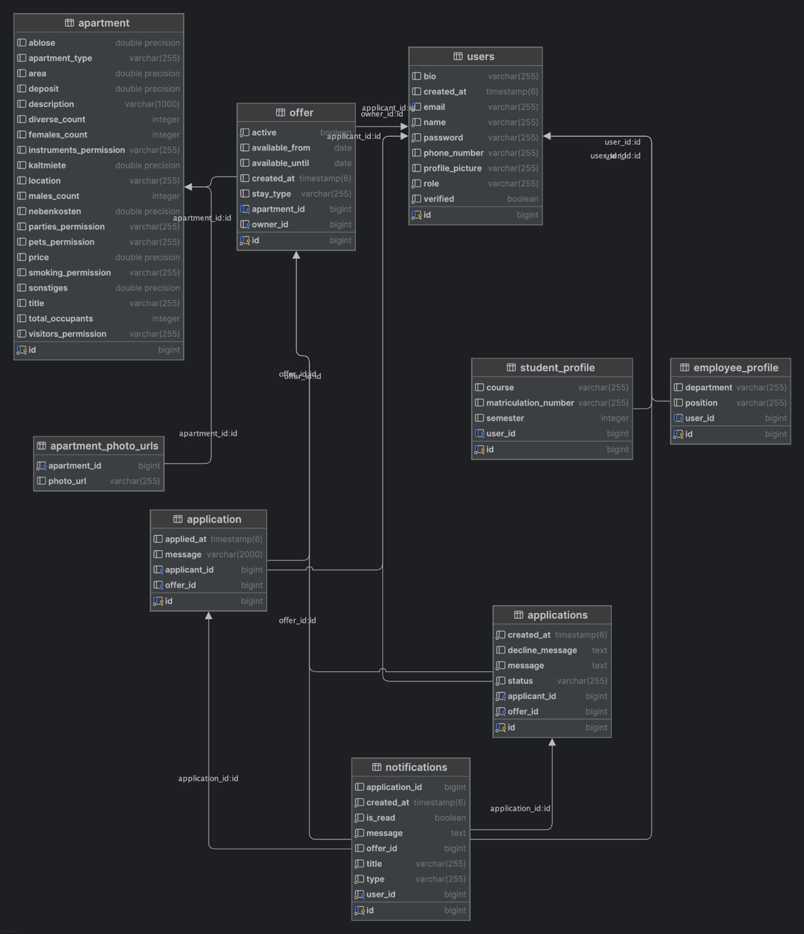
Figure 2- Entity Relationship Diagram Overview

3.2 Class Diagram Overview

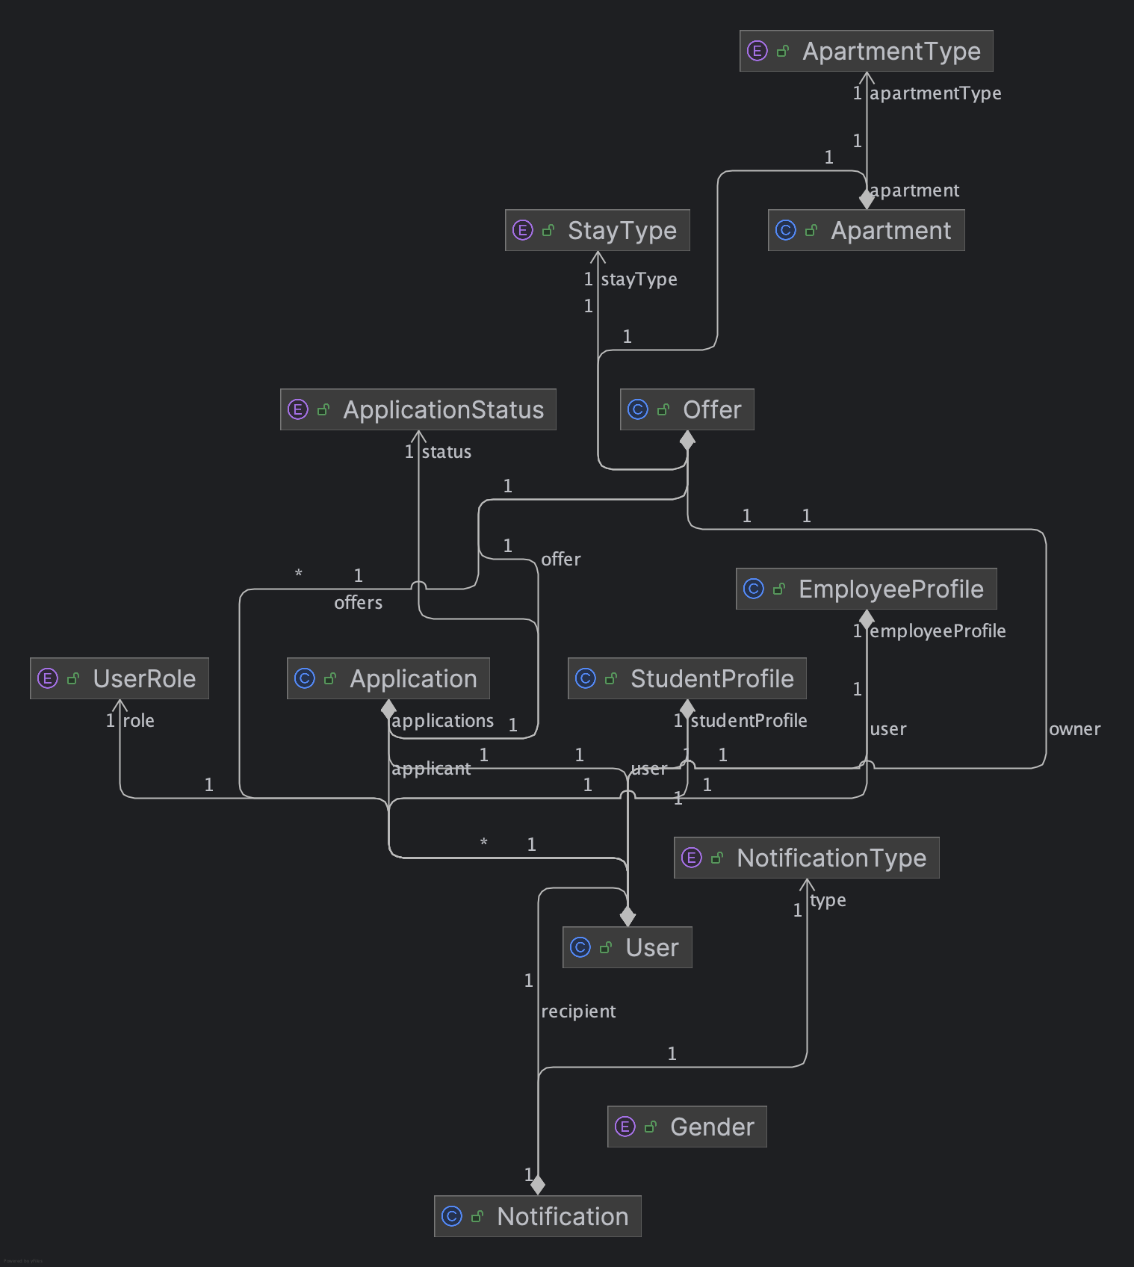
Figure 3- Class Diagram Overview

3.3 REST API Endpoint Specifications
Access API Documentation at http://localhost:8080/swagger-ui/index.html.

4. Core Feature Specifications

4.1 Housing Listing Workflow
Enables creation of housing offers, editing and publishing them.
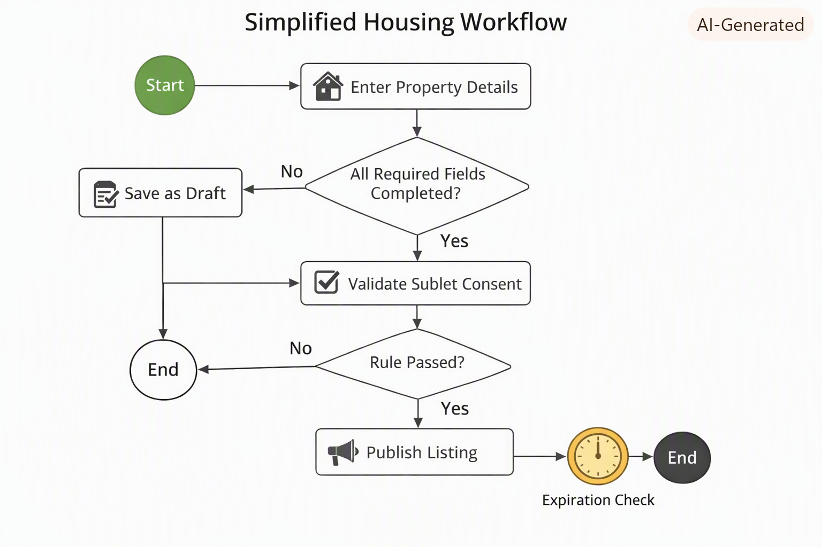

Inputs:
- Property title, description
- Address
- Area
- Available date window
- Monthly rent breakdown
- For a shared apartment – number of tenants and genders of other tenants
- Rules in the apartment (e.g, pets, having people over etc.)
- Uploaded media – images

Business Rules:
- Listings remain in draft until all required fields are completed
- A sublet listing can’t be posted without checking the box, that landlord is aware of the sublet
- Expiration flags automatically deactivate outdated listings

4.2 Accommodation Application Workflow
Allows authenticated users browse and apply to offers. For a given Accomodation previosly searched and selected:
4.2.1 Application Submission
- Clicking “Apply” on the listing triggers a modal window, where the user types a cover message
- After sending the message, the application status is “Pending”

4.2.2 Listing Owner’s Inbox Management
- User receives a notification when someone applies and is able to view Applications Management Page
- Applications are categorized into Pending, Approved, and Declined sections

4.2.3 Approval Lifecycle
- Listing owner clicks Approve and is able to start a chat with a candidate
- Status updates to Approved
- A notification is created for the applicant
- Chat feature is connecting both users

4.2.4 Decline Flow
- Listing owner clicks Decline
- A modal window shows up, and the listing owner is able to give feedback, which is optional
- Status updates to Declined
- A notification is generated for the applicant
- Pending applications expire and status is updated to Declined after 2 weeks of not responding

5. Build and Run Instructions
- Clone the repository: git clone https://github.com/atharvagrwal/OTH-Wohnung-Matching-Tool.git
- Navigate to the projects folder: cd OTH-Wohnung-Matching-Tool
- Install dependencies: npm install
- Start the backend server
- Navigate to frontend folder: cd frontend
- Run frontend: npm run dev

