UNICEF Coverage Report: Antenatal Care and Skilled Birth Attendance (2018–2022)

UNICEF D&A Education Team

**About this Submission**  
This technical report supports the application to the following UNICEF D&A consultancy positions:  
– Learning and Skills Data Analyst Consultant (#581598)  
– Household Survey Data Analyst Consultant (#581656)  
– Administrative Data Analyst Consultant (#581696)  
– Microdata Harmonization Consultant (#581699)

# 1. Context, Objectives and Methodology

**About this Report**  
This technical note summarizes coverage of maternal health services across UNICEF-focus countries. Countries are classified as **on-track** or **off-track** based on under-five mortality status (U5MR), aligned with **SDG 3.2**. The indicators analyzed — ANC4 and SBA — are key components of the maternal care continuum and contribute to the achievement of **SDG 3.1**.

### Context

Reducing **under-five mortality** remains a global priority — particularly in countries where maternal health services are limited or inequitable. To assess readiness and identify service gaps, UNICEF monitors two critical indicators of maternal care:

* **ANC4**: Percentage of women (aged 15–49) receiving at least **four antenatal care visits**.
* **SBA**: Percentage of births attended by **skilled health personnel**.

These indicators reflect **early engagement** in pregnancy and **safe delivery**, both essential to reducing maternal and neonatal mortality. Together, they form a core part of the continuum of care.

To contextualize coverage performance, countries are grouped using the latest **under-five mortality rate (U5MR) classification**:

* **On-track**: U5MR is *achieved* or *on-track* to meet **SDG target 3.2**.
* **Off-track**: U5MR status is *acceleration needed*.

This classification provides a framework to assess how service coverage aligns with child survival progress and helps inform areas where additional attention may be needed to meet **SDG target 3.2** on ending preventable child deaths.

### Methodology

#### 1. Data Preparation

* **ANC4** and **SBA** coverage data were retrieved from the  
  [UNICEF Global Data Repository](https://data.unicef.org/resources/data_explorer/unicef_f/?ag=UNICEF&df=GLOBAL_DATAFLOW&ver=1.0&dq=.MNCH_ANC4+MNCH_SAB.&startPeriod=2018&endPeriod=2022)  
  for all available countries between **2018 and 2022**.
* For each country, the **most recent coverage estimate** within this period was retained.
* **Under-five mortality classification** (on-track / off-track) was assigned using the  
  file On-track and off-track countries.xlsx, based on U5MR status:
  + *On-track* = “achieved” or “on-track”
  + *Off-track* = “acceleration needed”
* All datasets were merged using standardized **ISO3 country codes**.

#### 2. Population-Weighted Averages

* **Birth projections for 2022** were sourced from the UN World Population Prospects:  
  WPP2022_GEN_F01_DEMOGRAPHIC_INDICATORS_COMPACT_REV1.xlsx.
* For each group (on-track and off-track), **weighted means** were computed for ANC4 and SBA using birth counts as weights.
* Countries with missing coverage data were excluded from group-level weighted statistics.

**Data Sources and Limitations**  
- **Date of extraction and processing**: July 2025  
- **Inputs**:  
- ANC4 and SBA indicators from the [UNICEF Global Data Repository](https://data.unicef.org/resources/data_explorer/unicef_f/?ag=UNICEF&df=GLOBAL_DATAFLOW&ver=1.0&dq=.MNCH_ANC4+MNCH_SAB.&startPeriod=2018&endPeriod=2022)  
- Birth projections from the *UN World Population Prospects 2022*  
- U5MR groupings from UNICEF’s official classification

Several countries were **excluded or only partially included** due to missing data (e.g., births, U5MR status, ANC4 or SBA coverage).  
These limitations were accounted for in the weighted analysis and are examined in detail in **Section 2.2 on data completeness**.

# 2. Analysis of Coverage and Gaps

This section presents group-level and country-level results for ANC4 and SBA coverage, highlighting disparities, data quality issues, and patterns relevant for maternal health programming.

### 2.1 Summary coverage statistics by group

Coverage Summary by Group

Group

# Countries

Avg. ANC4

Avg. SBA

Missing ANC4

Missing SBA

off-track

46

61.3

76.3

4

2

on-track

102

85.4

97.9

62

1

**Interpretation**  
This table shows the average ANC4 and SBA coverage for on-track and off-track countries, along with the number of countries and missing values.

Key insights include: - SBA coverage is consistently high across both groups. - ANC4 coverage is lower and more variable, especially in off-track countries. - Over 60% of on-track countries have no ANC4 data, limiting comparability.

### 2.2 Data completeness by indicator

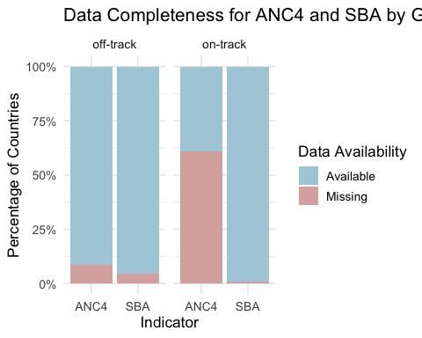

**Interpretation**  
- Over 60% of on-track countries lack ANC4 data, weakening group-level reliability. - SBA data is nearly complete, enabling stronger comparisons. - *27.4%* of countries were fully excluded due to missing group, births, or both indicators. - Others were partially included, lacking ANC4 but contributing SBA data — highlighting antenatal reporting gaps. - The table below outlines missing data patterns to guide data system improvements.

Missing data patterns

Exclusion Reason

# Countries

Share (%)

Missing ANC4 only

67

42.1

Missing ANC4 and SBA

45

28.3

Missing U5MR group, ANC4, and SBA

38

23.9

Missing SBA only

4

2.5

Missing group

4

2.5

Missing U5MR group, ANC4, SBA, and births

1

0.6

### 2.3 Country-Level coverage: interactive view

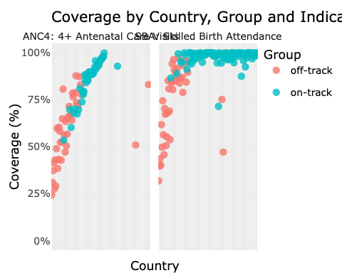

**Interpretation**  
This graph highlights the contrast between **ANC4** and **SBA** coverage by country group:

* **SBA coverage** is consistently high, with most countries reaching or exceeding **80%**.
* **ANC4 coverage**, however, is more variable — particularly in *off-track* countries, where it often falls **below 60%**.

➡️ *See Section 2.4 for summary distributions.*

**Note**: Best viewed in HTML for tooltip interactivity.

### 2.4 Coverage distribution by group

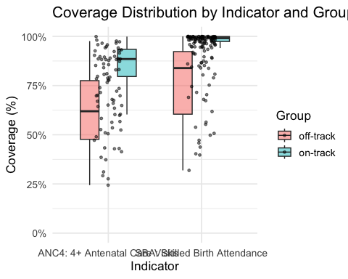

**Interpretation**  
This distribution plot shows the **range and central tendency** of ANC4 and SBA coverage by country group. The **median SBA is high** for both groups, while **ANC4 coverage is lower and more dispersed**, especially in off-track settings. On-track countries appear to perform slightly better in ANC4, but many are missing data, as noted earlier.

The wider spread in ANC4 for off-track countries also highlights **greater inequality in antenatal care access**, pointing to **potential structural or systemic challenges** in reaching women early in pregnancy.

### 2.5 ANC4 vs SBA Scatterplot

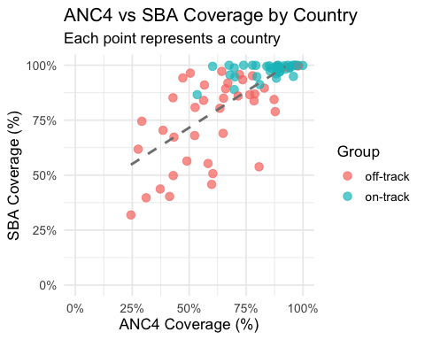

**Interpretation**  
This scatterplot highlights the relationship between ANC4 and SBA coverage across countries. While many countries show a positive correlation, a significant cluster of off-track countries exhibit high SBA coverage but low ANC4, indicating that women are receiving delivery care without adequate antenatal follow-up.

**Key Summary Insight (applies across Sections 2.1–2.5):**  
**SBA coverage is consistently strong**, indicating widespread access to delivery care. In contrast, **ANC4 coverage remains limited or missing**, especially in off-track countries and many on-track countries. This imbalance reveals critical gaps in early maternal engagement and system continuity.

### 2.6 Countries with lowest ANC4 coverage

Top 10 Countries with Lowest Combined ANC4 and SBA Coverage

Country

Group

ANC4 Coverage (%)

SBA Coverage (%)

Somalia

off-track

24.4

31.9

South Sudan

off-track

31.1

39.7

Niger

off-track

37.3

43.7

Central African Republic

off-track

41.4

40.3

Afghanistan

off-track

27.6

61.8

Ethiopia

off-track

43.0

49.8

Senegal

off-track

29.2

74.5

Papua New Guinea

off-track

49.0

56.4

Madagascar

off-track

59.9

45.8

Mauritania

off-track

38.5

70.4

These countries face compounded vulnerabilities in both antenatal and delivery services. Addressing gaps in the full maternal health continuum is essential for reducing preventable maternal and neonatal deaths.

# 3. Interpretation

The results highlights **strong skilled birth attendance (SBA)** across all countries, but also reveals **significant challenges with antenatal care coverage (ANC4)**, particularly in **off-track countries** and in **on-track countries** where data is missing or incomplete. This imbalance raises concerns about the **continuity of maternal care**, a key element for achieving **SDG targets 3.1 and 3.2**.

#### **Coverage comparison by country group**

| **Metric** | **On-Track Countries** | **Off-Track Countries** |
| --- | --- | --- |
| **SBA coverage** | High, with little variation | Also high and relatively stable |
| **ANC4 coverage** | More heterogeneous | Often low, typically < 60% |
| **ANC4 data completeness** | Poor: ~60% of countries missing | Good: Nearly all countries reported |

These results suggest that while many women receive skilled support during delivery, antenatal engagement remains limited in several contexts — either due to insufficient coverage or the absence of reliable data.

### **Why is ANC4 Low or Missing?**

ANC4 is inherently **more difficult to capture and deliver** than SBA. Unlike delivery, which is a single event often occurring in a facility, ANC4 requires **multiple visits**, spread over months. Several factors contribute to low uptake or missing data:

* **Economic barriers** (e.g., transport costs, informal fees)
* **Time constraints** (especially for women with household or work responsibilities)
* **Distance and infrastructure**
* **Lack of awareness or trust in health systems**

In contrast, SBA, a one-time event, is easier to track and often better integrated into health systems.

Several of the **lowest-performing countries** , including *Somalia, South Sudan, Niger, Central African Republic*, and *Afghanistan* — report **ANC4 and SBA coverage both below 50%**. These countries represent **critical gaps in maternal care** that affect both early and delivery-stage interventions. Others, such as *Senegal* and *Mauritania*, show **moderate SBA coverage but extremely low ANC4 uptake**, pointing to a **breakdown in continuity of care** during pregnancy. All countries in this list are **off-track** in under-five mortality, reinforcing the urgency of targeted action.

# 4 Strategic Recommendations

#### **For On-Track Countries**

* **Close the ANC4 data gap**:
  + Improve antenatal data availability through routine health information systems and survey coverage.
  + When unavailable, triangulate ANC4 estimates using facility, insurance, or digital health records.
* **Ensure quality beyond SBA**:
  + Validate success with maternal care: High SBA alone isn’t sufficient. Without ANC4, risks remain high. Ensure “on-track” status includes quality and continuity of care.

#### **For Off-Track Countries**

* **Invest in antenatal access**:
  + Address **geographic, economic, and sociocultural barriers** to early pregnancy care.
  + Use **mobile clinics, community health workers**, and local outreach to reach underserved women.
  + *Note: Countries with both low ANC4 and SBA (e.g.,* ***Somalia****,* ***South Sudan****,* ***Niger****,* ***CAR****) require foundational investment in access and coverage.*
* **Correct the care imbalance**:
  + In countries with high SBA but low ANC4 (e.g., **Senegal**, **Mauritania**), encourage early pregnancy contact through targeted interventions and communication strategies.

#### **For All Countries**

* **Enhance equity and targeting**:
  + Disaggregate ANC4/SBA coverage by **age, location, wealth, and parity** to uncover hidden gaps.
* **Institutionalize annual monitoring**:
  + Align ANC4/SBA tracking with DHS/MICS cycles and integrate indicators into national dashboards.
* **Commission deeper research**
  + A **targeted study is needed** to understand low ANC4 uptake, combining **demand-side factors** (awareness, distance, cost) with **supply-side barriers** (health system reach, data gaps).

# 5. Sources

* WHO Indicator Metadata:
  + [ANC4](https://www.who.int/data/gho/indicator-metadata-registry/imr-details/80)
  + [SBA](https://data.who.int/indicators/i/F835E3B/1772666)
* [UNICEF Under-Five Mortality (U5MR) Overview](https://data.unicef.org/topic/child-survival/under-five-mortality/) – used to define on-track and off-track country groupings.
* UN SDG Indicator Metadata:
  + [SDG 3.1.1 – Maternal Mortality](https://unstats.un.org/sdgs/metadata/files/Metadata-03-01-01.pdf)
  + [SDG 3.1.2 – Skilled Birth Attendance (SBA)](https://unstats.un.org/sdgs/metadata/files/Metadata-03-01-02.pdf)
  + [SDG 3.2.1 – Under-Five Mortality](https://unstats.un.org/sdgs/metadata/files/Metadata-03-02-01.pdf)
  + [SDG 3.2.2 – Neonatal Mortality](https://unstats.un.org/sdgs/metadata/files/Metadata-03-02-02.pdf)
* Data derived from analytical script 02_analysis.R (consultancy assessment deliverable)