Status of Benzene Emissions and Monitoring in the UK
Lucy Webster
Table of contents

Total Emissions
The UK National Atmospheric Emissions Inventory (NAEI) produce annual estimates of the emissions of Benzene in the UK. Total emissions have fallen from 60.9 kt in 1990 to 8.0 kt in 2023, a reduction of 87%, see Figure 1. The majority of this reduction happened in the 1990s, as catalytic converters and emission controls applied to the car fleet. The single biggest year-on-year drop was between 1999 and 2000, when emissions fell from 37.8 kt to 22.1 kt. This coincided with the EU Fuel Quality Directive (98/70/EC) reducing the maximum allowable benzene content of petrol from 5% to 1% by volume from January 2000. Since around 2010 annual emissions of benzene have plateaued, and as of 2023 annual emissions were 8.0 kt.
Emissions reported as memo items (including international maritime navigation and international aviation cruise, “z_”) were excluded, consistent with national totals reported under the UNECE Convention on Long-range Transboundary Air Pollution (CLRTAP).
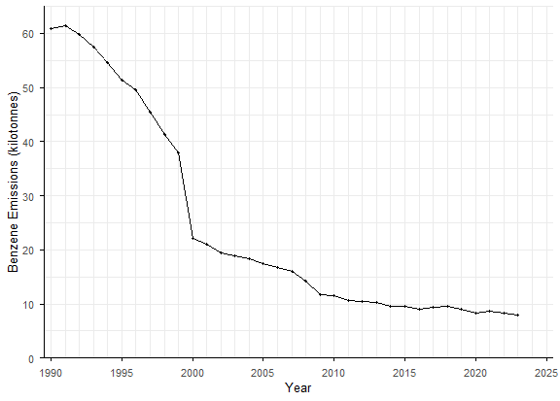
Figure 1: Annual UK benzene emissions, 1990–2023. Excludes memo items (international shipping and international aviation cruise). Source: NAEI.

By Emission Source
The NAEI reports benzene emissions from about 342 individual sources. For this report they have been grouped into seven broad categories (see benzene_source_lookup.csv for the full mapping). The figure below shows each category’s share of the national total in each year.
In 1990, road transport dominated UK benzene emissions and accounted for three-quarters (75%) of the total. Its share has fallen steadily as regulation has been introduced, and by 2023 road transport contributed 12% of the total emissions (0.9 kt, down from 46 kt). No other source have seen similar levels of reduction so the mix of sources now looks different. In 2015, Domestic combustion overtook road transport as the largest single source in 2015 and made up a third (33%) of emissions in 2023. Industry (16%), shipping and other transport (13%) and waste (11%) are now all comparable to or larger than road transport.
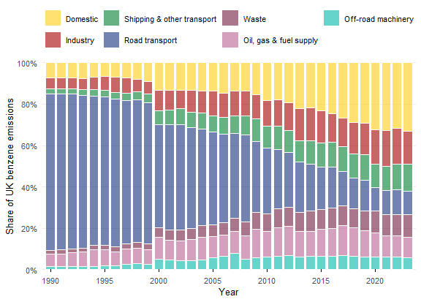
Figure 2: Share of UK benzene emissions by source category, 1990–2023. Sources have been grouped into seven categories (see benzene_source_lookup.csv). Source: NAEI.
However, a rising share does not mean rising emissions. Domestic emissions fell from 4.4 kt in 1990 to 2.6 kt in 2023; they simply fell more slowly than everything else. The next figures show the change in absolute terms. Within the domestic sector, the fuel mix has changed markedly. Coal burning, which produced 1.9 kt in 1990, now produces less than 0.1 kt. Over the same period, emissions from domestic wood burning have roughly tripled, from 0.5 kt to 1.7 kt, and wood is now the main source of domestic benzene. Waste and shipping have also become relatively more important as their emissions have changed little since 1990.

Absolute
Each panel shows benzene emissions from one source category in kilotonnes. Note: Every panel has a separately scaled y-axis.
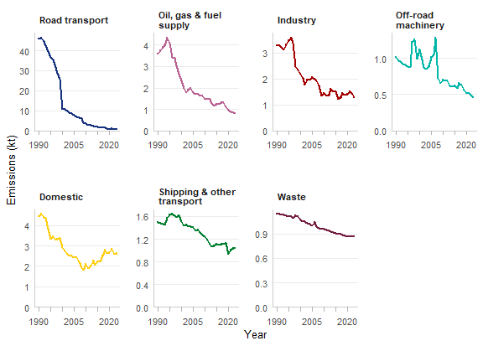
Figure 3: Annual benzene emissions (kt) by source category, 1990–2023. Each panel has its own y-axis scale. Panels are ordered by the reduction since 1990, largest first.

Relative to baseline
Each line shows a category’s emissions as a percentage of the 1990 emissions. Road transport has fallen to 2% of its 1990 level, while waste (76%), shipping and other transport (69%) and domestic combustion (59%) have reduced by a lower fraction. These sources now make up a much bigger share of the total.
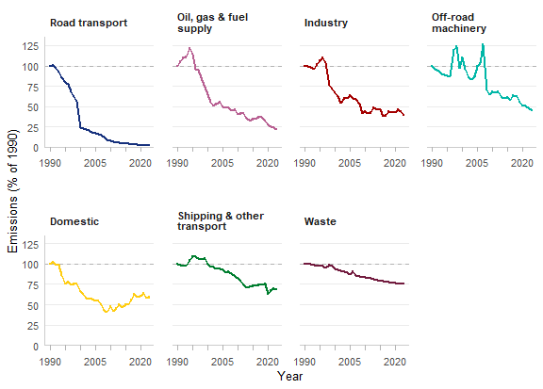
Figure 4: Benzene emissions by source category as a percentage of 1990 emissions. The dashed line marks the 1990 level (100%).
These figures show that UK benzene emissions have changed from being dominated by a mobile distributed source to being spread across several smaller ones. Many of the remaining sources, such as refineries and industrial plants, are located in fixed places rather than spread along the road network. This means national totals may say less about local exposure than they once did, and it motivates looking at where emissions occur and what we are monitoring - discussed in the next section.

Emissions from Point Sources
Point sources are individual facilities, such as refineries, chemical works, steelworks and incinerators, whose emissions are reported to the NAEI at a specific location. Unlike diffuse sources like road traffic or domestic heating, their emissions are concentrated at one site, so they can have a disproportionate effect on air quality in the surrounding communities.
In 2005, point sources accounted for 10.6% of UK benzene emissions (1885 t). As of 2023, point sources accounted for 769 t, representing 9.6% of emissions.
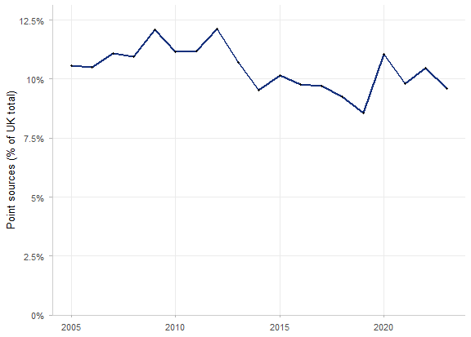
Figure 5: Benzene emissions from point sources as a percentage of total UK emissions, 2005–2023. Source: NAEI point source database and national totals.
Total point-source emissions are dominated by a small number of sites. Of the 2911 sites reporting benzene emissions in 2023, the ten largest account for 57% of point-source emissions.
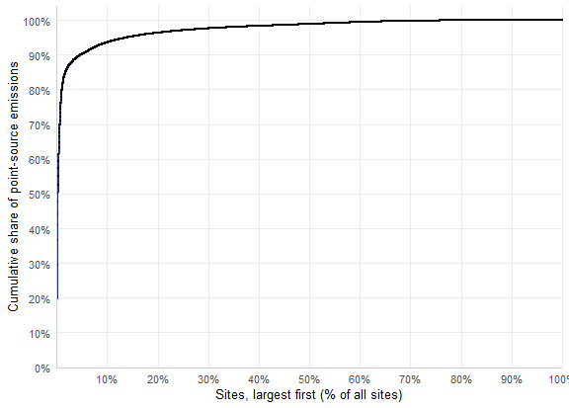
Figure 6: Cumulative share of point-source benzene emissions in 2023, with sites ordered from largest to smallest. A steep early rise means a small number of sites account for most emissions.

Largest point sources
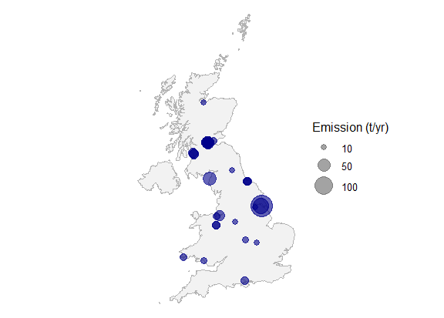
Figure 7: Locations of the largest benzene point sources in 2023. Circle area is proportional to annual emissions (tonnes).

Monitoring
Benzene in ambient air is regulated under the Air Quality Standards Regulations 2010, which set an annual mean limit value of 5 µg m⁻³. Defra monitors it through the UK Hydrocarbons Network, which is made up of two complementary parts: a small number of automatic sites giving high time-resolution data, and a larger network of non-automatic samplers giving wider spatial coverage. In 2023, no UK monitoring site exceeded the limit value.

Automatic Hydrocarbon Network
The Automatic Hydrocarbon Network uses automated gas chromatography to measure 29 volatile organic compounds, including benzene and 1,3-butadiene, every hour. It currently has 5 active sites. The hourly data are valuable for understanding daily cycles and short pollution episodes and for identifying sources. However, with so few sites, the network cannot say much about how concentrations vary across the country.

Non-Automatic Hydrocarbon Network
The Non-Automatic Hydrocarbon Network gives much wider coverage, with 34 active sites. Air is drawn through dual sorbent tubes by a controlled-flow pump. The tubes are changed every two weeks and analysed in the laboratory by thermal desorption and gas chromatography–mass spectrometry. This gives fortnightly averages, not hourly values, but the extra sites cover a far wider range of locations.

Network coverage over time
87 sites have measured benzene in the two networks at some point, and 39 are active today. Coverage peaked in 2012, with 45 sites running.

Sites per year
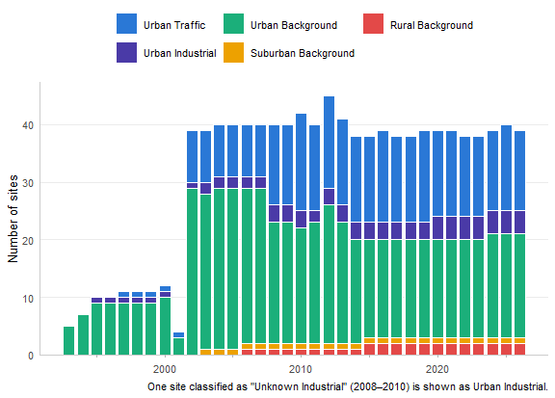
Figure 8: Number of benzene monitoring sites operating each year across the automatic and non-automatic networks, by site type. A site is counted if it operated for any part of the year. One site classified as ‘Unknown Industrial’ (2008–2010) is shown as Urban Industrial.

Active and closed sites
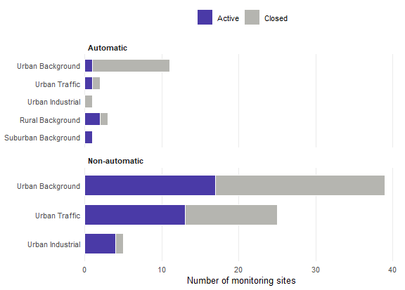
Figure 9: Active and closed benzene monitoring sites in each network, by site type.

Location of Emissions relative to Monitoring
The monitoring networks were largely designed when road transport dominated benzene emissions, so most sites are in urban areas. As the emission profile has shifted towards domestic combustion and industrial point sources, it is worth asking whether the networks still sample the places where people are most exposed.
Of the 10 largest point sources in 2023, 6 have no active benzene monitor within 10 km. The median distance from one of these sites to its nearest active monitor is 26 km.
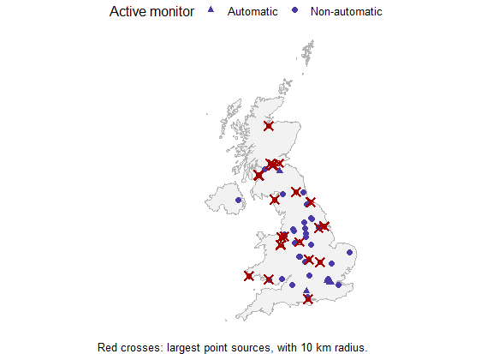
Figure 10: Active benzene monitoring sites and the ten largest point sources in 2023 (red), each shown with a 10 km radius.

Nearest monitor to each major source
Table 1: Nearest active benzene monitor to each of the ten largest point sources in 2023, and the number of active monitors within 10 km.
Point source | Emission (t) | Nearest monitor | Monitor type | Distance (km) | Monitors within 10 km
South Killingholme Refinery | 150.3 | Scunthorpe Town (Non-automatic) | Urban Industrial | 26.5 | 0
Lindsey Oil Refinery | 77.0 | Scunthorpe Town (Non-automatic) | Urban Industrial | 25.8 | 0
Workington Mill | 53.7 | Carlisle Morton A595 (Non-automatic) | Urban Traffic | 44.6 | 0
Grangemouth | 43.8 | Grangemouth (Non-automatic) | Urban Industrial | 0.5 | 1
Stanlow Manufacturing Complex | 33.8 | Liverpool Speke (Non-automatic) | Urban Industrial | 8.5 | 1
Irvine | 26.5 | Glasgow Kerbside (Non-automatic) | Urban Traffic | 37.4 | 0
Wilton | 19.3 | Middlesbrough (Non-automatic) | Urban Background | 6.8 | 1
Fawley Refinery | 18.9 | Southampton Centre (Non-automatic) | Urban Background | 8.5 | 1
Chirk | 17.9 | Liverpool Speke (Non-automatic) | Urban Industrial | 47.5 | 0
Mossmorren | 16.2 | Grangemouth (Non-automatic) | Urban Industrial | 26.1 | 0

Has monitoring kept up with the sources?
The chart below compares each year’s 100 largest point sources with the monitors running in that year. It shows the median distance to the nearest monitor, and the mean weighted by emissions, which gives more influence to the largest sources.
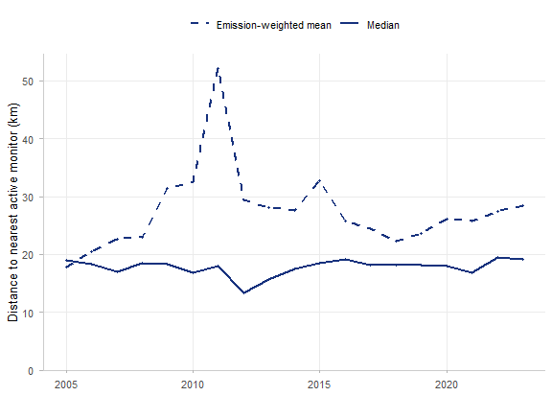
Figure 11: Distance from each year’s 100 largest point sources to the nearest monitor operating in that year. The emission-weighted mean gives more influence to the largest sources.

Comparing automatic and non-automatic measurements
No automatic and non-automatic monitors share a location, so the two methods cannot be compared directly. The table below lists the ten closest pairs of automatic and non-automatic sites that operated in the same years.
Table 2: The ten closest pairs of automatic and non-automatic monitoring sites that operated in the same years.
Automatic site | Type | Non-automatic site | Type | Distance (km) | Years operating together
Edinburgh Med. Sch. | Urban Background | Edinburgh Med. Sch. | Urban Background | 0.0 | 2000–2002 (3 yrs)
Glasgow Kerbside | Urban Traffic | Glasgow Kerbside | Urban Traffic | 0.0 | 2010–2010 (1 yrs)
London Marylebone Road | Urban Traffic | London Bloomsbury | Urban Background | 2.0 | 2002–2026 (25 yrs)
London Marylebone Road | Urban Traffic | Camden Kerbside | Urban Traffic | 2.8 | 2008–2020 (13 yrs)
London Marylebone Road | Urban Traffic | London Farringdon Street | Urban Traffic | 3.6 | 2025–2026 (2 yrs)
London Marylebone Road | Urban Traffic | Tower Hamlets Roadside | Urban Traffic | 7.8 | 2012–2025 (14 yrs)
London Honor Oak Park | Urban Background | Tower Hamlets Roadside | Urban Traffic | 8.1 | 2025–2025 (1 yrs)
London Honor Oak Park | Urban Background | London Farringdon Street | Urban Traffic | 8.6 | 2025–2026 (2 yrs)
London Honor Oak Park | Urban Background | London Bloomsbury | Urban Background | 10.1 | 2025–2026 (2 yrs)
London Marylebone Road | Urban Traffic | Haringey Roadside | Urban Traffic | 10.4 | 2002–2026 (25 yrs)

London Marylebone Road (automatic) was compared with two nearby non-automatic sites: Camden Kerbside, another roadside site, and London Bloomsbury, an urban background site.
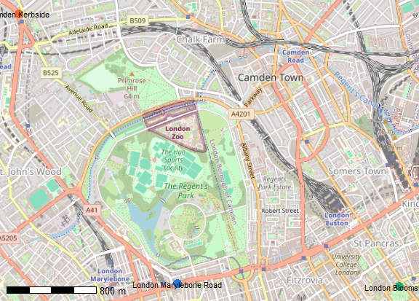
Figure 12: Locations of London Marylebone Road (automatic), Camden Kerbside and London Bloomsbury (non-automatic).
The chart below shows fortnightly benzene concentrations at the three sites. The automatic values are hourly measurements averaged over the same two-week periods as the non-automatic samples.
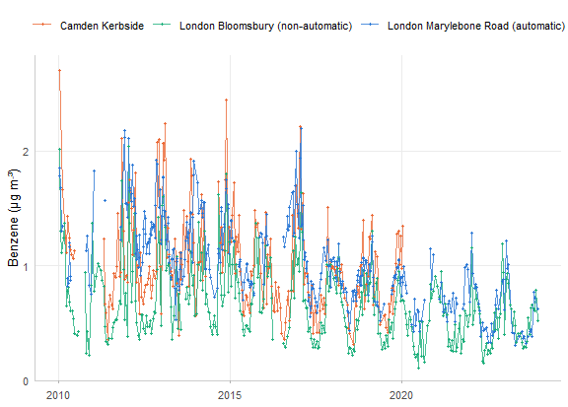
Figure 13: Fortnightly benzene concentrations at London Marylebone Road (automatic, hourly data averaged over each sampling period), Camden Kerbside and London Bloomsbury (non-automatic). Gaps of more than one month are left unjoined.

