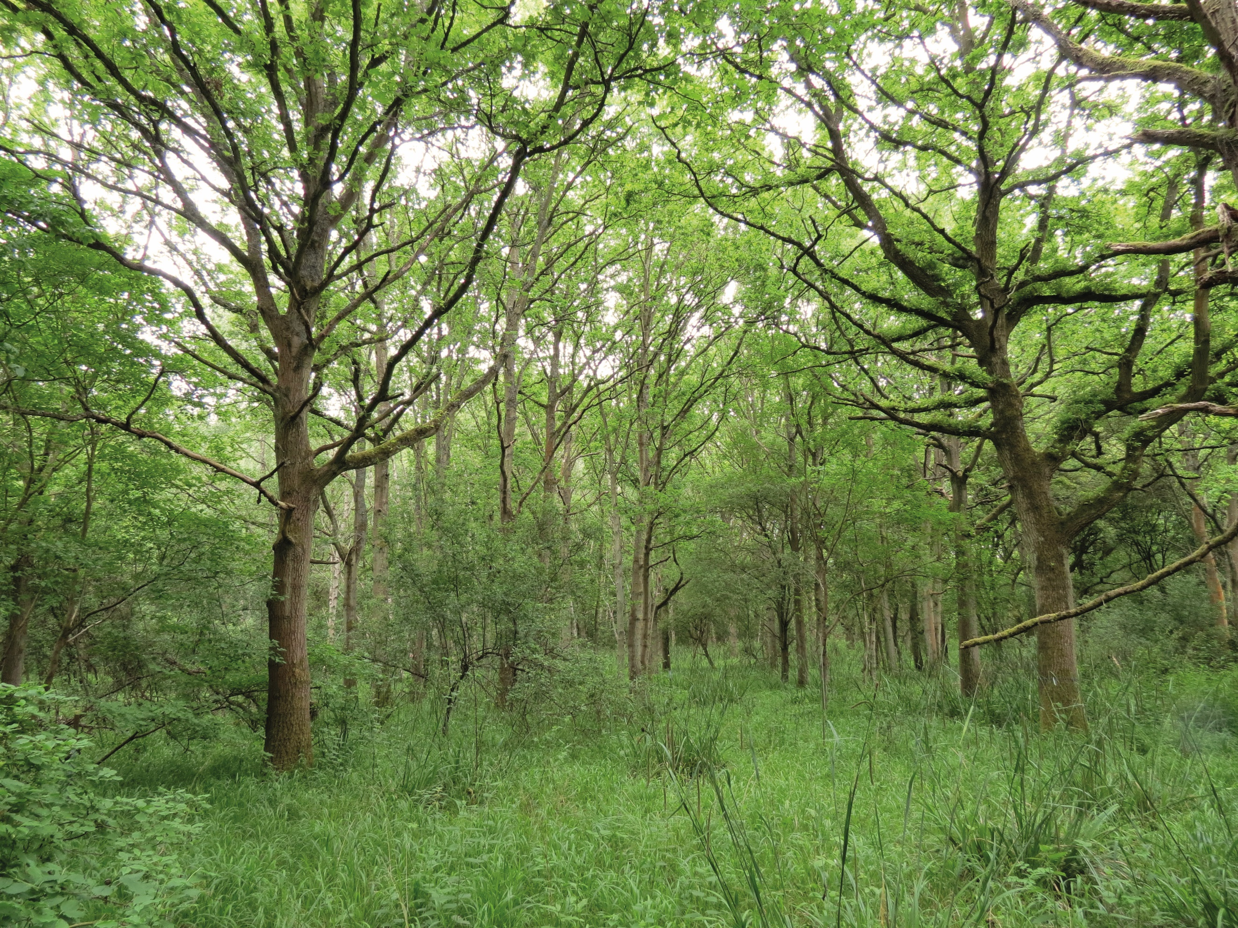

UK gridded population at
1 km resolution for 2021
Estimates based on Census 2021 (2022 for Scotland) and Land Cover Map 2021
Carnell E.J., Tomlinson S.J., Reis S.


Contents
1. Data access and citation details 2
1.1 Experimental design/Sampling regime 2
1.2 Data Sources 3
1.3 Data processing 3
1.4 Quality Control 7
1.5 Details of data structure 8
2. Description 8

Data access and citation details
Cite this dataset as:
Carnell, E.; Tomlinson S.J. and Reis, S. (2025). UK gridded population at 1 km resolution for 2021 based on Census 2021/2022 and Land Cover Map 2021. NERC Environmental Information Data Centre. DOI

Experimental design/Sampling regime
Small area population estimates for the United Kingdom are available from statistical offices in England, Wales, Northern Ireland and Scotland and provided to the public e.g. via the Office for National Statistics (ONS). These estimates are typically provided in tabular form, with accompanying vector files (e.g. ESRI Shapefiles) providing the geographical boundaries (e.g. census Output Areas) needed for analysis in a geographical information system (GIS).

The geographical units reflect administrative boundaries at different levels of detail, from Devolved Administration to Output Areas (OA), wards or intermediate geographies. While the presentation of data on the level of these geographical units is useful for statistical purposes, accounting for spatial variability for instance of environmental determinants of public health requires a more spatially homogeneous population distribution. For this purpose, the dataset presented here combines 2021 UK Census population data (2022 for Scotland) at the Output Area level with Land Cover Map 2021 land-use classes 'Urban' and 'Suburban' to create a consistent and comprehensive gridded population data product at 1 km x 1 km spatial resolution. The mapping product is based on British National Grid (OSGB36 datum).

Data Sources
Residential population estimates by Output Area were downloaded from the following sources:
- England and Wales: https://www.ons.gov.uk/peoplepopulationandcommunity/populationandmigration/populationestimates/bulletins/annualsmallareapopulationestimates/mid2021andmid2022
- Northern Ireland: https://www.nisra.gov.uk/sites/nisra.gov.uk/files/publications/geography-dz2021-geodatabase.zip
- Scotland: https://www.scotlandscensus.gov.uk/documents/2022-output-area-data/

Land Cover Map 2021 data were obtained from the UKCEH EIDC:
- Land Cover Map 2021 for Great Britain (25m rasterised land parcels) https://catalogue.ceh.ac.uk/id/a1f85307-cad7-4e32-a445-84410efdfa70
- Land Cover Map 2021 for Northern Ireland (25m rasterised land parcels) https://catalogue.ceh.ac.uk/id/f3310fe1-a6ea-4cdd-b9f6-f7fc66e4652e

Geographic data of census boundaries were obtained in ESRI Shapefile format from the following sources, at the finest spatial resolution available. For Scotland these are referred to as Data Zones and for the rest of the UK as Output Areas:
- England and Wales Output Areas: https://www.data.gov.uk/dataset/259052b8-8369-42de-a022-b67d0d225dbe/output-areas-december-2021-boundaries-ew-bfc-v8
- Scotland Output Areas: https://www.data.gov.uk/dataset/92d0e6e6-c869-4e17-a8ee-70cd291829fa/census-2022-output-areas
- Northern Ireland Data Zones: https://www.nisra.gov.uk/sites/nisra.gov.uk/files/publications/geography-dz2021-geodatabase.zip

Data processing
- All processing steps were implemented using R Statistical Software (R version 4.4.1, 2024-06-14 ucrt) with the terra (Hijmans 2024) and sf (Pebesma, 2018) packages, in the following steps:

- A 1 x 1 km target grid covering the United Kingdom was created in the British National Grid datum (EPSG 27700).
- The UKCEH LCM2021 was downloaded at a 10 x 10 m grid resolution, with cell values representing the dominant land cover (from 21 land cover classes). The land cover classes include urban and suburban land covers, which we have used as a proxy for residential properties. Grid cells associated with urban and suburban classes were used to create an urban/suburban mask, in which to distribute populations within each OA/DZ. OA/DZs typically represent 40 – 250 households (100 – 625 persons) and are often < 1,000 m² (0.001 km²) in high-density/inner-city zones. As OA/DZs in cities tend to represent small areas, they tend to have near 100 % coverage of urban/suburban land covers (and often are situated within a single 1 x 1 km cell of the reference grid created in Step 1), where constraining population estimates to land classes is less important. However, OA/DZs in rural areas can represent areas > 100 km² and constraining estimates to urban/suburban land classes is more important. The Northern Ireland version of LCM2021 was projected on to the same grid as Great Britain using the “nearest neighbour” method
- A spatial intersection of each census boundary (OAs and DZs, n = 239,023) against the 1 x 1km target grid (generated in step 1) was calculated using the terra package. OAs in Northern Ireland were reprojected from Irish National Grid (TM75) to match the target grid.
For OA/DZs that intersect a single 1 x 1 km cell (n = 89,761, 37.6 % of OA/DZs) of the reference grid, no further processing steps were required and 100 % of the population within the OA/DZ was assigned to that grid square. For all other OA/DZs (spanning multiple 1 x 1 km grid squares), weightings were calculated in Step 4.
- For OAs/DZs, which span multiple 1 x 1 km grid cells (n = 149,262, 62.4 % of OA/DZs), populations were distributed to available urban and suburban land (within each OA/DZ).
A spatial intersection of each OA/DZ boundary and the 10 m x 10 m grid resolution urban/suburban mask (created in Step 2) was performed. Intersecting urban/suburban cells were aggregated/summed to the 1 x 1 km grid (created in Step 1) and converted into a fraction (by dividing by the OA total). A further check was made to ensure that all OA/DZs (spanning multiple 1 x 1 km grid cells) contained at least some urban/suburban land area.
A visualisation of this stage is provided for an Output Area in Northern Ireland (N20002003) in Figure 1, with the tabular output shown in Table 1. This example OA intersects with three 1 x 1 km grid cells (see Step 1), and only two of these cells contain any (10 x 10 m grid cells of) urban/suburban land covers.
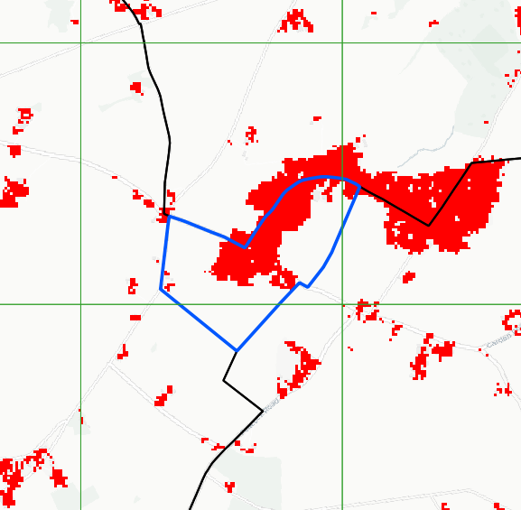
Figure 1: A visualisation of the spatial intersection of an Output Area (OA) in Northern Ireland (N20002003, shown in blue), and urban/suburban land covers (shown in red), with the 1 x 1 km grid cell boundaries (shown in green). Weighting assigned for this example are shown in Table 1.

Table 1: An example of the tabular output created in Step 4 for an Output Area in Northern Ireland (N20002003, as shown in Figure 1). Column Total_10m provides the number of intersecting 10 x 10 m urban/suburban grid cells (from LCM2021) and Weighting provides this number as a fraction of the OA total.
OA_ID | x_1km | y_1km | Total_10m | Weighting
N20002003 | 46500 | 556500 | 0 | 0
N20002003 | 46500 | 557500 | 773 | 0.9508
N20002003 | 47500 | 557500 | 40 | 0.0492

- Population estimates (at the OA or DZ level) were then merged to the output from Step 4 and were multiplied by the weighted fraction column to distribute the total population of each OA/DZ to cells with higher area-coverage and to areas of urban/suburban land. The table was then aggregated to sum weighted population estimates by 1 km x 1 km grid cell. These aggregated values were then reformatted as a raster to generate the final gridded population estimate.
- As a final validation stage, the sum of the raster dataset was calculated and compared to the original population estimates (as presented in Table 2) to check that the totals matched. The final product has been visualised in Figure 2.
Table 2: Sum of the Output Area and Data Zone level population estimates across the UK by country. Totals correspond to those reported in the original source datasets (see Section 1.2).
Country | Total Persons
England | 56,490,284
Wales | 3,107,463
Scotland | 5,440,284
Northern Ireland | 1,903,168
UK | 66,941,199
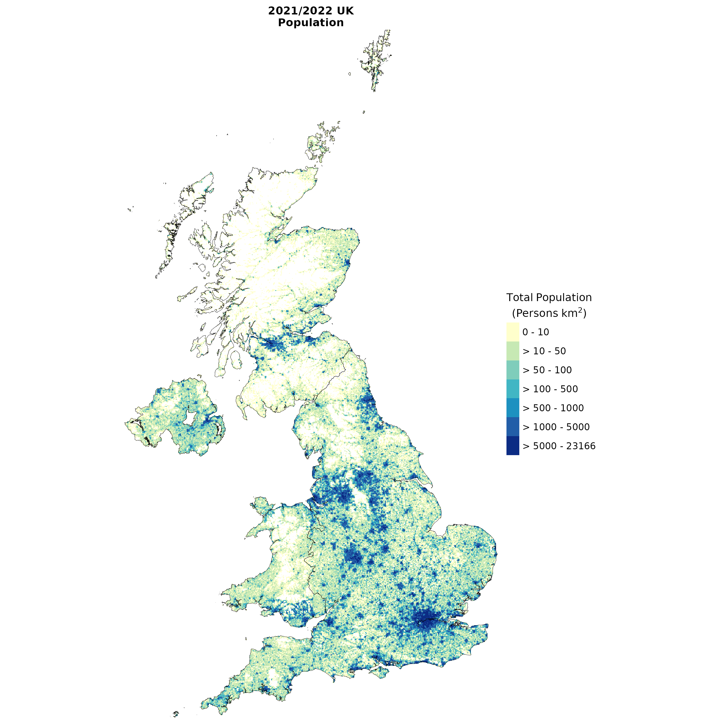
Figure 2: Final 1 x 1 km gridded estimate of UK population (as published) for the census year 2021 (2022 for Scotland).

Quality Control
To ensure consistency of the final product, total population numbers were compared in Steps 4-6 to ensure each OA/DZ estimate was distributed correctly, and consistent with official 2021 Census totals.
The R code has been annotated to ensure transparency and reproducibility of the data pipeline.

Details of data structure
Data outputs are presented as a GeoTiff (*.tif) file, with cell values representing persons km² (/persons grid-cell⁻¹).

Description
This dataset contains gridded human population with a spatial resolution of 1 km x 1 km for the UK based on Census 2021 (Census 2022 for Scotland) and Land Cover Map 2021 input data. Data on population distribution for the United Kingdom is available from statistical offices in England, Wales, Northern Ireland and Scotland and provided to the public e.g. via the Office for National Statistics (ONS). Population data is typically provided in tabular form or, based on a range of different geographical units, in file types for geographical information systems (GIS), for instance as ESRI Shapefiles. The geographical units reflect administrative boundaries at different levels of detail, from Devolved Administration to Output Areas (OA), wards or intermediate geographies. While the presentation of data on the level of these geographical units is useful for statistical purposes, accounting for spatial variability for instance of environmental determinants of public health requires a more spatially homogeneous population distribution. For this purpose, the dataset presented here combines 2021/2022 UK Census population data on Output Area level with Land Cover Map 2021 land-use classes 'urban' and 'suburban' to create a consistent and comprehensive gridded population data product at 1 km x 1 km spatial resolution. The mapping product is based on British National Grid (OSGB36 datum).

Census data from the Office of National Statistics, National Records for Scotland and Northern Ireland Statistics and Research Agency have been downloaded as CSV/Excel files (as outlined in Collection Methods).
To ensure consistency of the final product, total population numbers were compared, at each processing step, with the official 2021/2022 Census totals. As a result, the final output file is consistent with the Census total population for the UK in 2021.

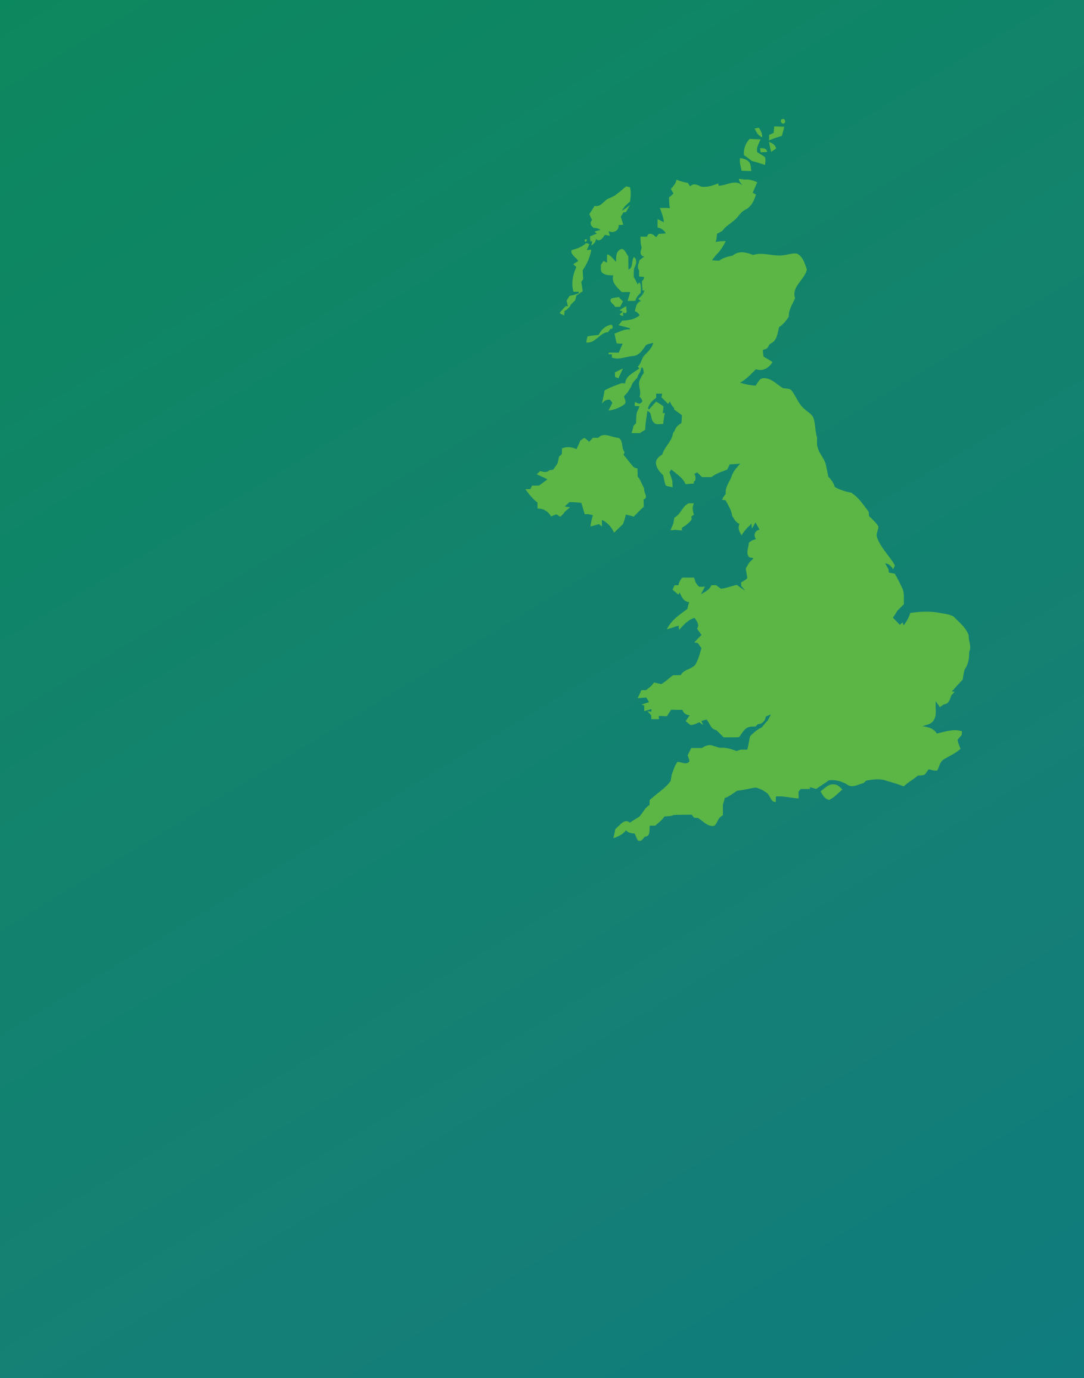
Contact
Edinburgh
Lancaster
Bangor
Wallingford
edcarn@ceh.ac.uk
@UK_CEH
ceh.ac.uk
____

Bangor
UK Centre for Ecology & Hydrology
Environment Centre Wales
Deiniol Road
Bangor
Gwynedd
LL57 2UW
+44 (0)1248 374500

Edinburgh
UK Centre for Ecology & Hydrology
Bush Estate
Penicuik
Midlothian
EH26 0QB
+44 (0)131 4454343

Lancaster  UK Centre for Ecology & Hydrology  Lancaster Environment Centre  Library Avenue  Bailrigg  Lancaster  LA1 4AP  +44 (0)1524 595800 |  | Wallingford (Headquarters)  UK Centre for Ecology & Hydrology  Maclean Building  Benson Lane  Crowmarsh Gifford  Wallingford  Oxfordshire  OX10 8BB  +44 (0)1491 838800
Disclaimer goes here ….

Hijmans R (2024). terra: Spatial Data Analysis. R package version 1.7-78
Edzer Pebesma, 2018. Simple Features for R: Standardized Support for Spatial Vector Data. The R Journal 10:1, 439-446. R package version 1.0-18
https://epsg.io/27700
https://epsg.io/29903

