# About the VT Summer and Winter Session “How-To” Guide

This document provides current Virginia Tech students and visiting/non-degree seeking students with instructions to navigate through Virginia Tech’s course registration for the summer and winter sessions.

Content includes how to look through course offerings, choose classes, register and pay for tuition.

## Current VT Student Registration for Winter or Summer Courses

If you are currently an enrolled student, you can learn how to choose summer and winter classes with the steps below.

To be considered a “currently enrolled student”, you must have already completed the previous term at Virginia Tech or have been enrolled in the previous semester.

### Requirements

* VT PID and password
* Computer connected to Internet
* Completion of any outstanding pre-registration requirements which can be viewed under the “registration and schedule” menu of HokieSpa (see figure 1).

**NOTE**: Green checkmarks indicate completed registration requirements. ALL fields must be green to proceed to the registration steps.

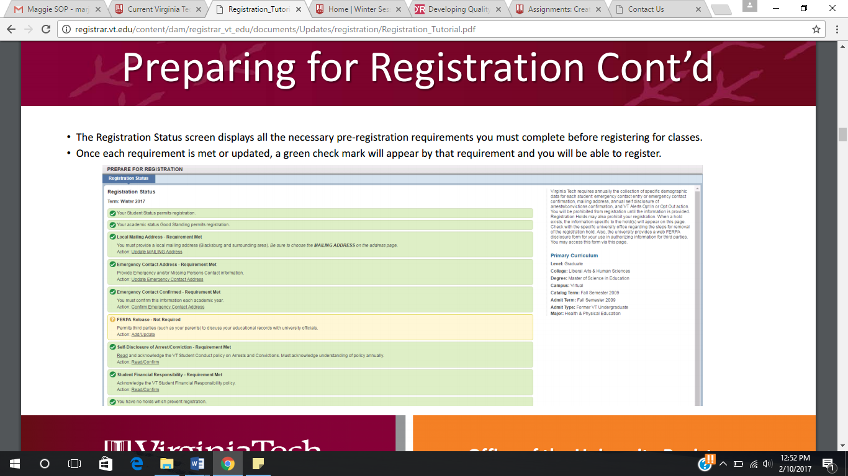

Figure

### Steps

1. Check 2017 summer and winter session schedules to ensure you are applying for the right coursers at the right time

|  |  |
| --- | --- |
| Summer Session 1 | <http://registrar.vt.edu/dates-deadlines-accordion/index1/First-Summer-2017.html> |
| Summer Session 2 | <http://registrar.vt.edu/dates-deadlines-accordion/index1/Second-Summer-2017.html> |
| Winter Session | <http://registrar.vt.edu/dates-deadlines-accordion/index1/Winter-2017.html> |

1. Log in to HokieSpa using your VT PID and password
2. Click “Registration and Schedule” from the main menu of HokieSpa
3. Click “Register for Classes”
4. Select the term you would like to register for (winter or summer) and click “Continue”
5. Read the financial notice pop-up and click “Ok” to continue
6. Search for classes by entering the subject, course number, or key words into the search bar. Select “Advanced Search” to include any further details about the course(s) you are looking for.
7. Click “Search” after filling all desired fields
8. Click “Add” once you have selected which course you want to enroll in. The selected course will appear under “Schedule” and “Summary”
   1. Repeat step 8 to add more than one class to your schedule.

**NOTE**: Be mindful of the minimum and maximum total hours in which you can register. This information is visible at the bottom of your registration summary.

1. Click the “Submit” button to complete the addition to your registration. The course status will change from “Pending” to “Registered”

## Paying for Summer and Winter Session Classes

Payment for summer and winter courses can be done online through HokieSpa porta Virginia Tech will send a notice to the email registered with your HokieSpa account when your electronic bill is ready to pay.

### Requirements

* VT PID and password
* Method of payment (credit card or check)

### Steps

1. Log in to HokieSpa with your VT PID and password
2. Click “University Account Information”
3. Click “View and Pay e-Bill” to be redirected to the payment website
4. Click “View Accounts”
5. Click “Make Payment” from the “Account Action” drop down menu
6. Enter the amount you wish to pay and choose a payment method
7. Click “Continue” to fill in credit card or banking information and contact information
8. Click “Continue” and a confirmation screen will be displayed if the payment was successful

**NOTE**: A confirmation statement will be sent to the email associated with your HokieSpa account.