

HANDOUTS for the IQA COURSE

- Course Outline
- A1A Personal Information Policy
- IV Strategy (PP slide)
- IV Strategy contents list
- Assessor Induction
- Personal Development Planner
- Assessor TNI
- IV Sampling Record example
- Witness Statement
- Candidate Interview
- Observing an Assessment (PP slide)
- Statutory Regs (PP slide)
- “NVQ Code of Practice” – download from the internet
- “Joint Awarding Body Guidance on Internal Verification” – download also
Outline of
RQF IQA Course

Overall Aims
to qualify the course members to the LLUK RQF Internal Quality Assurance (Internal Verifier) Certificate qualification

Aims of Course
to cover internal quality assurance skills, knowledge, and understanding to National Standards so that course members are prepared to internally quality assure a team of Assessors.

Style of the Course
informal and participative. discussion of IQA role in relation to RQFs, QCFs, NVQs, Approved Centre requirements, national guidance on IV, NVQ Code of Practice, specific RQF, QCF, or NVQ.

Introductions and domestics
aims of the programme

Role of the IQA
support and advise Assessors
monitor Assessors and countersign assessments
QA procedures

Supporting and advising Assessors
induction of Assessors, CPD
standardisation, team meetings, guidance, develop and share materials

Monitoring Assessors
JAB checklist, monitoring strategy and recording

Countersigning assessments
valid, sufficient, good quality evidence

Quality Assurance (QCF style)
JAB Guidance, NVQ Code, Centre procedures, RQF, QCF, and NVQ paperwork

Practical monitoring
Professional Discussion following observed monitoring

Portfolio construction
RQF IQA Certificate
Professional Discussion on Knowledge and Understanding for RQF IQA

Action planning for monitoring Assessors and completion of portfolio

Rob Faulkner
Personal Information Policy
for A1 Assessment Ltd

We collect and store Personal Information from our many friends, colleagues, clients, suppliers, contacts, and visitors, and we pride ourselves on taking care with that Information so that it is only used for your benefit.
We are subject to (and registered for) the Data Protection Act and the incoming GDPR (General Data Protection Regulation) which governs all our data handling and we will always inform you why we need that data and how we will use it
You have the right to access the data that we have recorded concerning yourself and have the right to ask us to correct any errors,.limit the useage, or delete that data.
We will ask for your consent if required and you will have the right to withdraw that consent.

Personal Data theft and abuse is a rapidly growing criminal area and the penalties for failing to protect Personal Data adequately are very damaging ~ both financially through the Courts and loss of business, and to our reputation.
All our staff and our visiting QAs have access to this data and are well aware of the increasing threat level. They are constantly aware of and follow our Data Protection measures eg Computer / Program passwords, locking filing cabinets, clearing desks of confidential paperwork, etc

We will regularly review:-
what information we collect
why we need it
how it will be used
how it is protected
when it will be deleted

If we ever suffer from a Data Breach which affects the Personal Information which we hold referring to you, we will inform you immediately and do our best to minimise the impact.

If you wish to see what we have recorded concerning yourself, please apply to the Centre Co-ordinator, Rob Faulkner, and he will make arrangements within one working week. Please note that we reserve the right to charge a small administrative fee for this service.

You are also welcome to a copy of our Briefing Sheet on “Rights, Consent, and Lawful Basis for Processing Data”
Rob Faulkner,
Centre Co-oredinator, A1 Assessment Ltd
SFJA Approved Centre No. 139
reviewed and updated January 2020
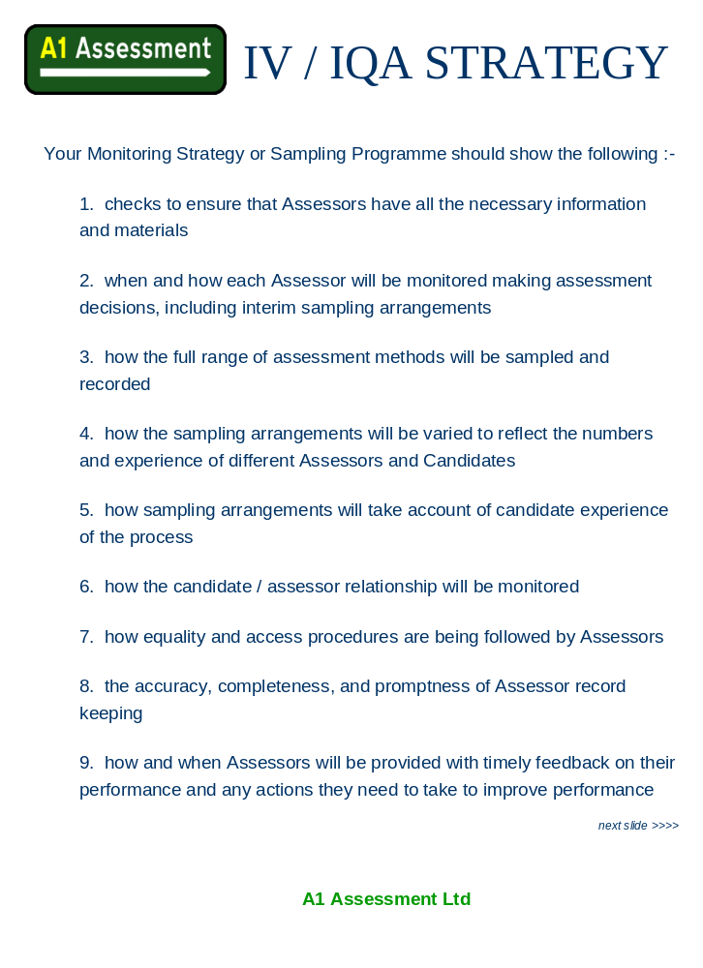

IQA Strategy

Candidates
Initial Assessment and Induction
Training programme
Assessment Plan overall
Portfolio of Evidence
Certification

Assessors
Staff files
Selection and Induction
TNI and CPD
Staff Meetings
Monitoring Observations

Portfolios
Sampling
Interim / formative
Summative and Submission
Storage and Disposal of Portfolios

Documentation
Assessor Induction checklist
Assessor and IQA TIN
Assessor Observation checklist
Portfolio Reports
Assessor
IQA
PTLLS
A&G 3 and 4
Documents issued to every Member of Staff
relevant QCF Handbook
Documents issued to every IQA
NVQ Code of Practice
JAB Guidelines on Internal Verification
Regulatory Arrangements for QCF
Assessor Portfolio Report
IQA Portfolio Report

QCF Assessor Induction Programme

Assessor name…………………………………………………date started……………………….
Assessor
initials
date

I. Initial contact made by the Internal Verifier ( IQA )
2. Production of CV, sample signature and certificates
3. Received the Centre organisation chart
4. Centre documentation, procedures and policies explained and understood (Equal Opps, H&S, Confidentiality)
5. Received Centre assessment and verification documentation
6. Internal quality assurance procedures explained
7. Centre assessment guidance, IV role and monitoring programme explained and understood
8. QCF equal opportunities policy and monitoring procedures explained and understood
9. Received QCF Appeals and Complaints procedure which was explained and understood
10. Aware of QCF resources available
I I. Received personal copy of QCF standards
12. Received Awarding Organisation guidance on occupational competence and CPD
13. EQA and Awarding Organisation informed

Assessor………………………..Internal Verifier …………………………date……………………
Assessor or Verifier name

Assessor and Verifier
Training Needs Identification

How long have you worked for this Organisation ?
How many Candidates have you :-
assessed………….
verified…………….

At what levels ?

...

Give brief details of any qualifications you have

What CPD have you done in the last six months ? ~ list on the back of this form

What in your opinion are your present training needs ?

Can you identify any area of training for the future ?

Any other comments

I certify that this is a true record of our discussion and do not object if this information is discussed with the Centre Manager or the EV

Assessor……………………….……Centre Manager……..…..………………date……………..
Diary of
Continuing Professional Development

date | activity

