GNAR-edge Design & Usage
A data-agnostic network autoregressive model for edge time series

This document accompanies the engineering implementation of the paper The GNAR-edge model (Mantziou et al., 2023, arXiv:2305.16097). The whole codebase is just a handful of classes, with a clear guiding principle: keep the algorithm and the data source fully separate. The algorithm depends only on a minimal, generic interface called EdgeGraph; whether the data is simulated or read from the ONS industry-to-industry payment tables is something the algorithm neither knows nor cares about.

0 Code organization (quick map)
The codebase splits into three groups by responsibility:
Module group | Files | Classes | Role
Core algorithm | BaseEdge.py  BaseEdgeGNAR_edge.py  BaseEdgeGNAR_edge_global.py | EdgeTrainSet, BaseEdgeLearner,  TorchEdgeLearner,  GNAREdgeModule, GNAREdgeLearner,  GNAREdgeGlobalLearner (global-alpha) | The GNAR-edge model and its training framework
Graph interface | edge_graph.py | EdgeGraph (interface), ArrayEdgeGraph (impl) | Decouples the algorithm from any specific data class (TSG/ipg); any data that implements this interface can feed the algorithm
Rolling / Orchestration | RollingEdgePredict.py  orchestration_stl.py  run_*.py | RollingEdgePredict, RollingStepResult | One-step rolling prediction; STL preprocessing; two minimal runnable examples

In one line: the model says "how to compute", the interface says "how data gets in".

1 Directory layout
gnar_edge_en/
|- edge_graph.py (2) Graph interface: EdgeGraph(interface) + ArrayEdgeGraph(impl) + factories
|- BaseEdge.py (3) Algorithm framework: EdgeTrainSet / BaseEdgeLearner / TorchEdgeLearner
|- BaseEdgeGNAR_edge.py (3) Model core: GNAREdgeModule / GNAREdgeLearner
|- BaseEdgeGNAR_edge_global.py (3) Global-alpha variant: GNAREdgeGlobal{Module,Learner}
|- RollingEdgePredict.py (4) Backtest: RollingEdgePredict / RollingStepResult
|- orchestration_stl.py (5) Orchestration: STL preprocessing (NOT part of the algorithm)
|- run_simulated.py (5) Minimal example 1: simulated data (no external data)
`- run_payment_graph.py (5) Minimal example 2: read ONS (uses IndustryPaymentGraph in the parent dir)
The first five files are a self-contained pure-algorithm package (only numpy / torch / statsmodels). run_payment_graph.py imports the ONS data-reading code by adding the parent directory to sys.path - the pure algorithm itself never touches any ONS code.

2 Layered architecture
Four layers, bottom-up. The key line: the algorithm layers (3)(4) depend only on the EdgeGraph interface (2), and are independent of the data source.
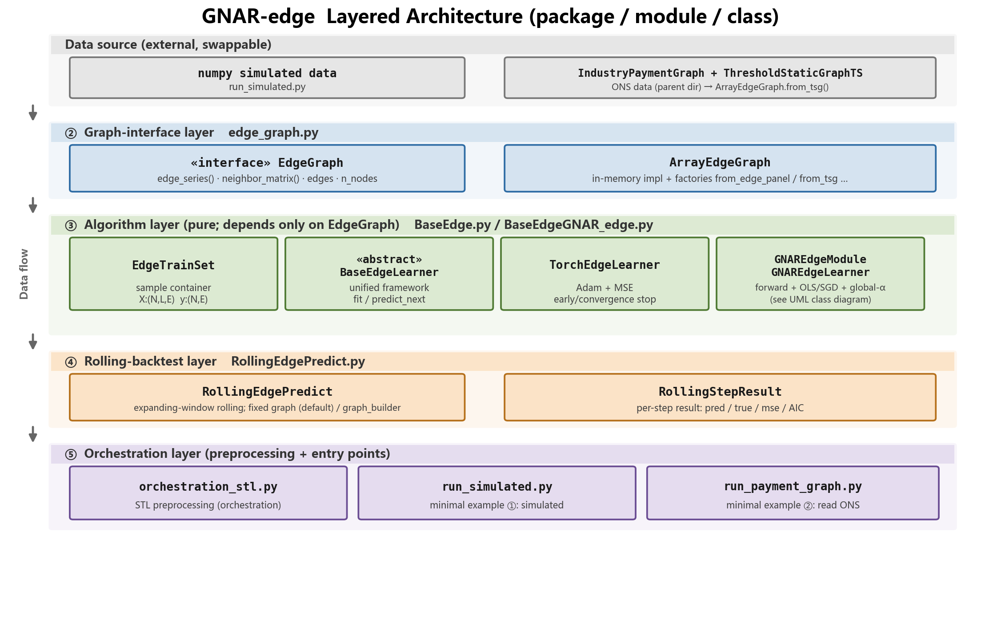
Figure 1 Layered architecture. Left arrows show data flowing top-down; any object implementing EdgeGraph can feed the algorithm.

3 Core idea: decoupling the algorithm from data
Before refactoring, the algorithm depended directly on two very specialised classes - IndustryPaymentGraph (the ONS data container) and ThresholdStaticGraphTS (threshold-based graph construction). That made the algorithm impossible to release standalone or to feed with other data.
After refactoring, the algorithm depends on a single minimal interface, EdgeGraph. It abstracts exactly the four things the algorithm actually needs:
The algorithm needs | The interface provides
Which edges exist, how many nodes, node names | edges / n_nodes / node_labels
What the time axis is | time_index / time_labels
The values for given times x given edges | edge_series(times, edges) -> (T,E)
The r-stage neighbour weight matrix W^(r) | neighbor_matrix(r) -> (E,E)

The ONS ipg/TSG is now just "one source that implements this interface", adapted in via ArrayEdgeGraph.from_tsg(); simulated data comes in via from_edge_panel(). Both are equivalent to the algorithm.

4 UML class diagram and design notation
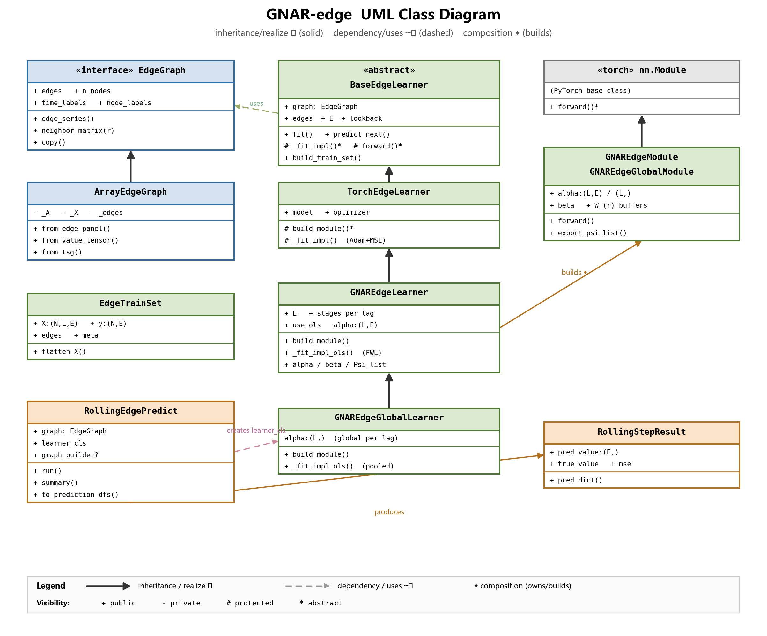
Figure 2 UML class diagram (three columns: left = interface/data, middle = algorithm inheritance chain, right = PyTorch/model).
Notation | Meaning
«interface» | Interface: only method signatures, no implementation (EdgeGraph)
«abstract» | Abstract class: partial implementation + abstract methods (the * ones, left to subclasses)
▷ solid + hollow triangle | Inheritance / realization (child points to parent)
┄▷ dashed arrow | Dependency / uses (A uses B but does not own B)
◆ filled diamond | Composition (A builds and owns B)
+ / - / # / * | public / private / protected / abstract members

5 Class-by-class (what each one does)

5.1 Graph-interface layer (decouples algorithm from data)

EdgeGraph «interface»
Role: The "socket" between the algorithm and the data - a minimal generic interface.
What it does: It defines the few questions that "a fixed graph + edge values that vary over time" must be able to answer. The algorithm takes data only through these methods, and never needs to know whether the data is simulated or from ONS.
Method / property | Question it answers
edges / edge_to_idx | Which directed edges exist, and which column each is
n_nodes / node_labels | How many nodes, and what they are called
time_index / time_labels | The time axis (integer positions 0..T-1, plus optional date labels)
edge_series(times, edges) | Give me values for given times and edges, as a (T,E) matrix
neighbor_matrix(r) | Give me the r-stage neighbour weight matrix W^(r), as (E,E)
copy() | Clone the graph

ArrayEdgeGraph
Role: The default in-memory implementation of EdgeGraph.
What it does: It stores (adjacency A, edge-value panel X[T,E], time labels, node names) directly in memory and implements the methods above; it also provides a set of factory methods to bring data in from various sources.
Factory method | Source it builds from
from_edge_panel(X, edges) | An existing edge list + (T,E) panel
from_value_tensor(V, A=..., edge_selector=...) | A numpy (T,K,K) tensor; use A if given, else build edges by a threshold rule
from_adjacency(A, values) | An explicit adjacency matrix defining the edges
from_files(panel_path, adjacency_path) | Read from Excel / CSV
from_tsg(tsg) | Adapt the ONS ThresholdStaticGraphTS into an EdgeGraph

5.2 Algorithm layer

EdgeTrainSet
Role: A container for one training set (data, not a model).
What it does: It slices the time series into supervised samples and packs them: X of shape (N,L,E) - each sample is "the values of all edges over the past L periods" - and y of shape (N,E) - "the values of all edges next period" - plus edges and metadata.

BaseEdgeLearner «abstract»
Role: The shared skeleton for all "edge time-series" models.
What it does: It defines a common workflow: slice the training set from the graph (build_train_set), a unified training entry (fit), a unified prediction entry (predict_next), and bookkeeping for training time / early stopping. It does not prescribe what the model looks like - it leaves "how to compute one forward pass (forward)" and "how to fit (_fit_impl)" to subclasses. After refactoring it takes data only through EdgeGraph.
Method | Role
build_train_set() | Use graph.edge_series to slice into (N,L,E)->(N,E) samples
fit() / predict_next() | Unified training / prediction entry points
# _fit_impl()* / # forward()* | Abstract methods subclasses must implement (* = abstract)

TorchEdgeLearner
Role: A generic subclass that trains via PyTorch autograd.
What it does: It implements the "fit" left empty by BaseEdgeLearner - mini-batch gradient descent with the Adam optimizer and mean squared error (MSE), with early stopping and convergence stopping. It still leaves the "model structure" empty (build_module) for the concrete model to define.

GNAREdgeModule «nn.Module»
Role: The "forward equation" of GNAR-edge itself (paper eqs. 4/5/6).
What it does: Given the edge values of the past L periods, it computes the next-period prediction by:
X_t = sum_l ( diag(alpha_l) * X_{t-l} + sum_r beta_{l,r} * W^(r) * X_{t-l} )
Here alpha_l is one coefficient per edge (per-edge autoregression), beta_{l,r} is shared network-wide (neighbour effect), and W^(r) is the fixed r-stage neighbour weight matrix (determined by graph structure). forward() computes this equation; export_psi_list() arranges it as Psi_l = diag(alpha_l)+sum_r beta_{l,r}*W^(r).

GNAREdgeLearner
Role: The GNAR-edge learner that plugs GNAREdgeModule into the TorchEdgeLearner framework.
What it does: It uses graph.neighbor_matrix(r) to build the W matrices and assemble a GNAREdgeModule; it offers two ways to fit - closed-form ordinary least squares (OLS via Frisch-Waugh-Lovell partialling-out: first estimate the shared beta, then recover alpha edge by edge, which is fast) or gradient descent; and it can export the fitted parameters alpha/beta/Psi and compute AIC/BIC.
Method | Role
build_module() | Use graph.neighbor_matrix(r) to build W and construct GNAREdgeModule
_fit_impl_ols() | Closed-form joint OLS (FWL): estimate shared beta, then recover alpha per edge
alpha / beta / Psi_list | Export the fitted parameters
calc_aic_bic() | Compute AIC / BIC

Note: this class is pure algorithm and contains no STL. Data preprocessing (STL / growth rates / threshold graph construction) is done in the orchestration layer before feeding an EdgeGraph.

GNAREdgeGlobalLearner (global-alpha variant)
Role: GNAR-edge with global alpha + global beta, i.e. the "global GNAR-edge model" the paper uses in its experiments (paper page 7). Inherits GNAREdgeLearner and is called exactly the same way.
What it does: It shrinks the per-edge alpha:(L,E) to one network-wide scalar per lag, alpha:(L,), cutting the parameter count from L*E+B to L+B. With short samples or many edges the per-edge alpha overfits easily; the global version is its nested special case with lower variance (compare via AIC/BIC).
Overridden method | Change
build_module() | Builds GNAREdgeGlobalModule (alpha shape (L,), scalar broadcast over edges)
_fit_impl_ols() | Pooled OLS: shared coefficients = merged design columns; normal equations are only (L+B)x(L+B), no FWL needed
export_parameters_to_excel() | Compact meta/alpha/beta layout (alpha shape changed)

Verified: on zero-noise simulated data the OLS recovers the planted alpha/beta exactly (~1e-9); unbiased recovery under noise; per-edge training MSE <= global (nesting holds); rolling/SGD/AIC/export all unchanged.

5.3 Rolling-backtest layer

RollingEdgePredict
Role: A rolling backtester that runs the same algorithm independently n times.
What it does: A typical "expanding-window one-step prediction": at step k it trains on data up to now, predicts the next period, and records prediction/ground-truth/error. By default it assumes the graph structure A is fixed (no rebuild, W computed once); if the structure changes or prefix-STL is needed, pass a graph_builder that rebuilds each step.
Parameter / method | Description
graph_builder=None (default) | Fixed graph: A unchanged, not rebuilt, W^(r) computed once
graph_builder(observed)->EdgeGraph | Rebuild each step (structure change / prefix-STL, etc.)
run() / summary() / to_prediction_dfs() | Main loop / summary table / prediction-truth-per-edge R^2

RollingStepResult
Role: A container for one step's backtest result.
What it does: Stores this step's pred_value:(E,), true_value, mse/mae/AIC, and the edges used in this step.

5.4 Orchestration layer
orchestration_stl.py: STL (seasonal-trend) preprocessing. The algorithm contains no STL; here it is treated as data processing done "before feeding an EdgeGraph".
run_simulated.py: Minimal example 1 - generate simulated data with GNAR dynamics and run directly (no external data).
run_payment_graph.py: Minimal example 2 - read the ONS workbook -> MoM growth -> from_tsg -> rolling prediction.

6 End-to-end data flow (with shapes)
Source (numpy simulated / ONS ipg)
| ArrayEdgeGraph.from_edge_panel / from_tsg
v
EdgeGraph edges:(E,) edge_series->(T,E) neighbor_matrix(r)->(E,E)
| GNAREdgeLearner.build_train_set
v
EdgeTrainSet X:(N,L,E) y:(N,E)
| .fit(use_ols / SGD) -> alpha:(L,E), beta:{(l,r)}
v
predict_next -> (E,) called repeatedly by RollingEdgePredict (expanding window)
v
summary() / to_prediction_dfs() -> pred_df / real_df (period x edge), per-edge R^2
Symbols: T = number of months, K = number of nodes, E = number of edges, L = max lag, N = number of samples.

7 Usage

7.1 Run the two minimal examples
cd gnar_edge_en
python run_simulated.py # 1) simulated data, no external data
python run_payment_graph.py # 2) read the parent dir's ONS *.xlsx (filename contains 'ukindustry')

7.2 Minimal API
from edge_graph import ArrayEdgeGraph
from BaseEdgeGNAR_edge import GNAREdgeLearner
from RollingEdgePredict import RollingEdgePredict
g = ArrayEdgeGraph.from_edge_panel(X, edges, n_nodes=K, time_labels=months)
roller = RollingEdgePredict(
graph=g, learner_cls=GNAREdgeLearner,
train_periods=g.time_labels[:-6], val_periods=g.time_labels[-6:],
learner_kwargs=dict(L=3, stages_per_lag=[[1],[1,2],[1,2]], use_ols=True),
fit_kwargs=dict(use_ols=True),
).run()
roller.summary(); roller.to_prediction_dfs()

7.3 Verified output
1) Simulated: simulated EdgeGraph E=10 K=6 T=48, 6 steps with expected_match=True.
2) ONS (2017-2024 workbook): E=4221 K=88 T=95; steps 2024-09/10/11 give mse ~ 0.05.

8 Design notes and invariants
Point | Explanation
edges order is the global alignment axis | edge_series columns / neighbor_matrix rows-cols / alpha columns / prediction components share the same order
Indices are a pure function of the data | node index = rank in sorted(codes); edge index = row-major position in adjacency A
Single source of truth, indexed through it | each graph has one codes/edges list; all arrays index through the derived maps, so they cannot drift
Cross-step alignment by edge tuple | to_prediction_dfs keys on the (u,v) tuple; changing edge counts do not misalign
Fixed graph not rebuilt by default | when A is unchanged, W^(r) is computed once; the n iterations are independent models
alpha per-edge / beta shared | matches the paper's general form (4)(5); the experiments' global-alpha is a special case
STL only in the orchestration layer | the algorithm contains no data preprocessing

-- End of document --

