Hi, KP and all,

For a complete list of projects the Software team has completed or is actively working on since 2010, please visit the new generation SW Team Projects Site: https://atropos.s3.ap-southeast-1.amazonaws.com/wsd.sw/wsd-sw-projects.html
Please use this link to access all 2026 detailed WWL reports @ https://broadcom.ent.box.com/folder/374140322145?s
JIRA SW team @ https://jira.broadcom.net/secure/PortfolioPlanView.jspa?id=59&sid=61&vid=164#plan/backlog
SW Team 3-Year Road Map (Obsolete) @ https://docs.google.com/spreadsheets/d/1pyKKjROeRVSoznPmMpTeJL53qA7cCDT56ULLxOdxrlY/
- The bold BLUE sections highlight all activities that occurred during last week.
- The bold RED sections highlight topics with issue, concern or need clarification.
- Completed Projects
  - AI-Friendly Schema-Driven Migration (I) - Feeder & Scheduler & CI/CD
  - Urgent PPYCC Financial Upgrade “Y048 - PPYCC Financial Portal - FBAR FTC ML Cost Adder”
- Completed Supports
  - Support Request “INR Becketts Incorrect DateTime & missing raw data file Re-Processing”
  - Enable ATA Utilization Report
  - Support Request “Add AOD into WSD Snowflake Enterprise Access”
- Active Supports
  - SW Team Tech Direction Discussion W/ Infra APIs Consolidation
  - Mythos Finding Fix w/ GitHub (Non-SW) & GitLab (FtC)
  - Support GTO Request "WSD - Prisma - critical & High alerts"
  - Update WUDAS Non-Fbar WaferCriteria Pass Bin
  - WUDAS Python package Upgrade to V3.13
  - Set up JIRA “WSD SW Team Agile Support” Category
  - WSD @ Vectarag: (1) Clotho; (2) PRA; (3) MARA; (4) QRE Tzero; (5) FtC RAG-VectorDB Searching; (6) INFICON FabTime Co-pilot; (7) Seoul Issue Tracking Mgmt
  - WSD @ Maverick: (1) DIY; (2) Auto-Grader; (3) FBar Design Analysis (4) SW Team Jira Workload Dashboard
  - WSD GenAI Non-AI-CodeAssistant Non-Vectara Non-Maverick Activities
  - WSD ClaudeCode Integration
  - WSD Codex Integration
  - WSD Cursor Sunset Plan
- Active Developments
  - Secure Vectara/GTO Production Environment
  - Wafer pCD-V/U-Portal/Clotho-VII
  - WSD Open Computation Framework - POC (ATA/FCM/Reporting)
  - AI-Friendly Schema-Driven Migration (II) - Transfer & CI/CD
  - Spotfire Upgrade to LTS V14.6 Due to EOS (End of Support)
  - Module Testing C-Aggregation (Consolidation) Enhancement by Switching to 2DID
  - AI-Friendly Schema-Driven Migration (II) - Transfer & CI/CD
  - AI-Friendly Schema-Driven Migration (III) - CLEADA Details Stitcher & CI/CD
  - Golden-Dictionary NXG-WUDAS Ecosystem
  - NXG WUDAS - CAQ (Custom Analysis Query)
  - NXG WSD Cloud Data Pipeline
  - Cloud SFTP Family Phase2- Internal Wafer Planning Enhancement
  - FCM-Analyzer: Sunset Plan
- In Queue Items (35x Topics)
  - …

Section 1: Completed Projects
- (KinLum/Tingyu/Ken) AI-Friendly Schema-Driven Migration (I) - Feeder & Scheduler & CI/CD (Complete)
  - Target Date: 10/20/2026
    - Completed @ 10/13/2026
  - Scope:
    - Proposed by Kin Lum to build a NXG framework based on Schema-driven concept, apply to both transfer, feeder, and (CLEADA Details Table) stitcher categories.
    - For the “Feeder” category, potentially to cover Data types
      - 1, 13, 14, 25, 26, 29, 49, 50, 51, 56, 58, 61 (Savi), 62 (Smeta)
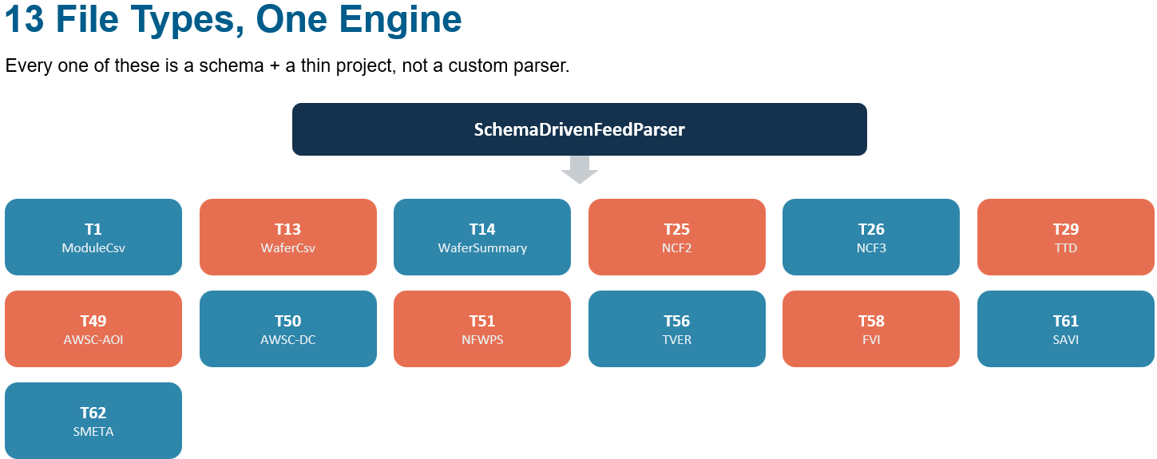
  - Goal:
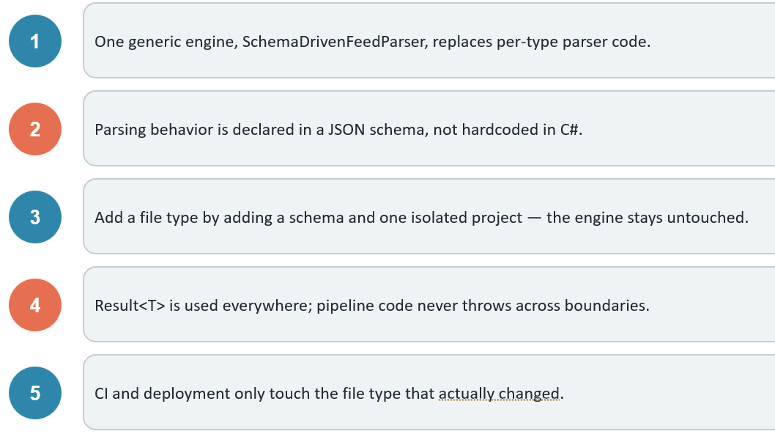
  - SDD draft
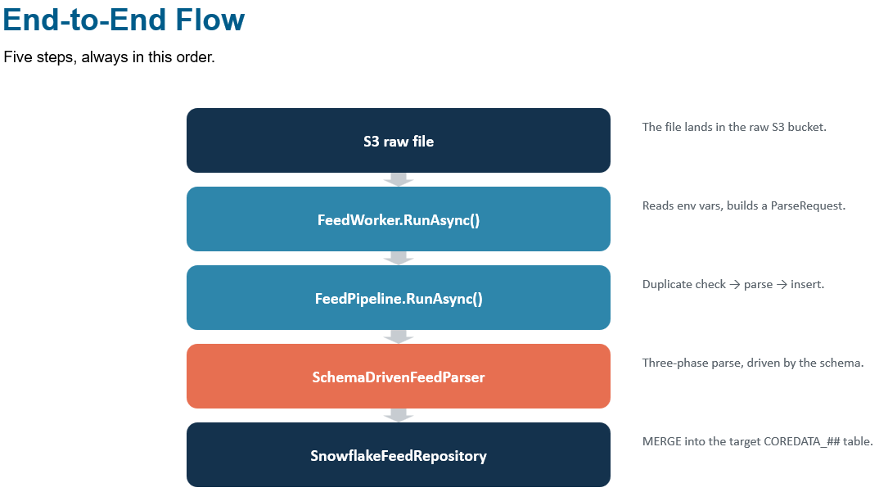
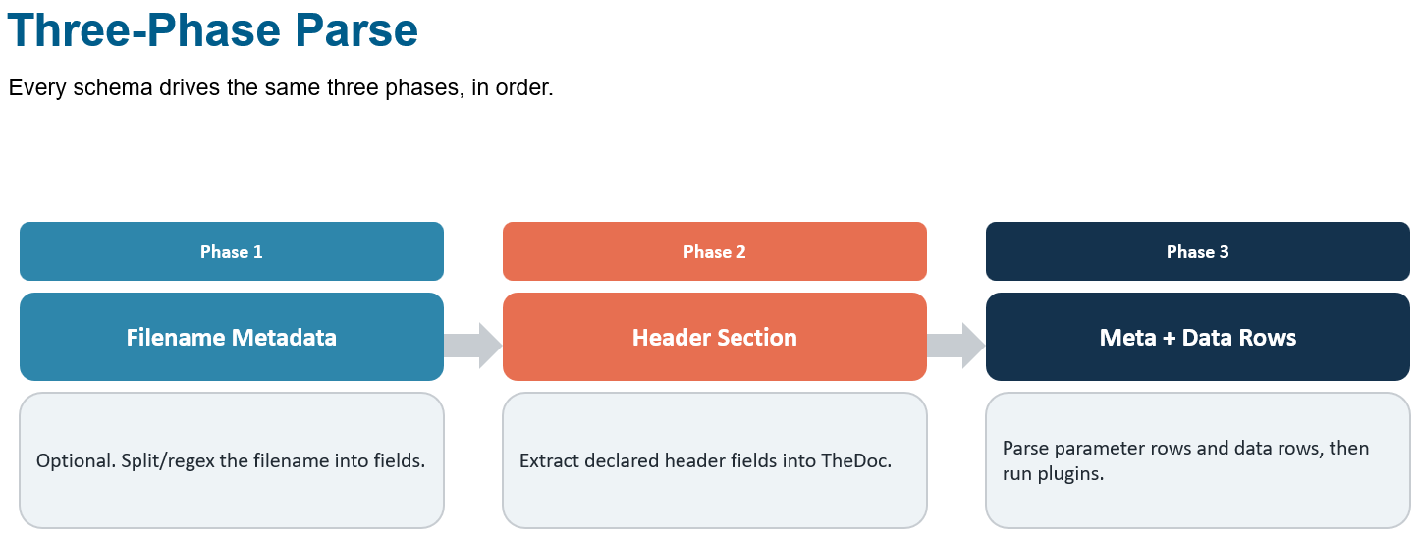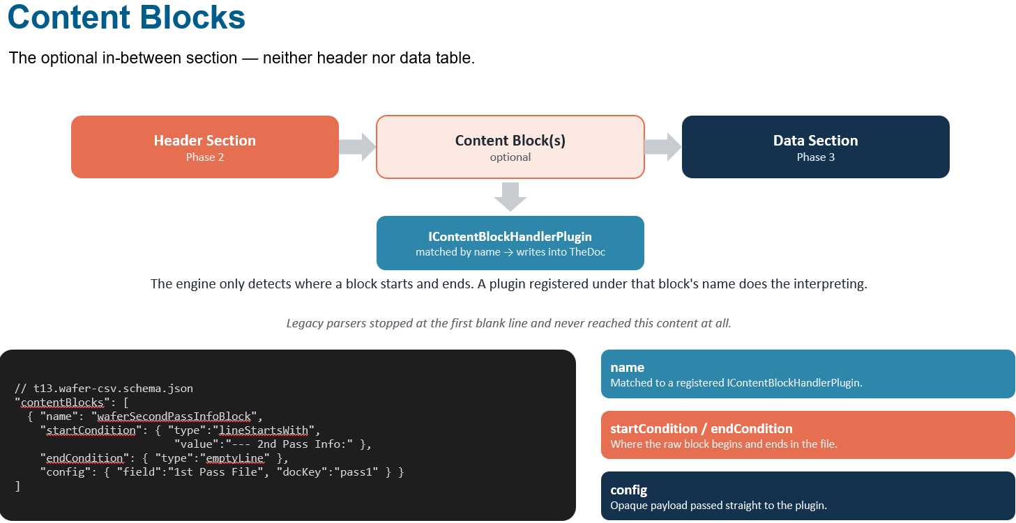
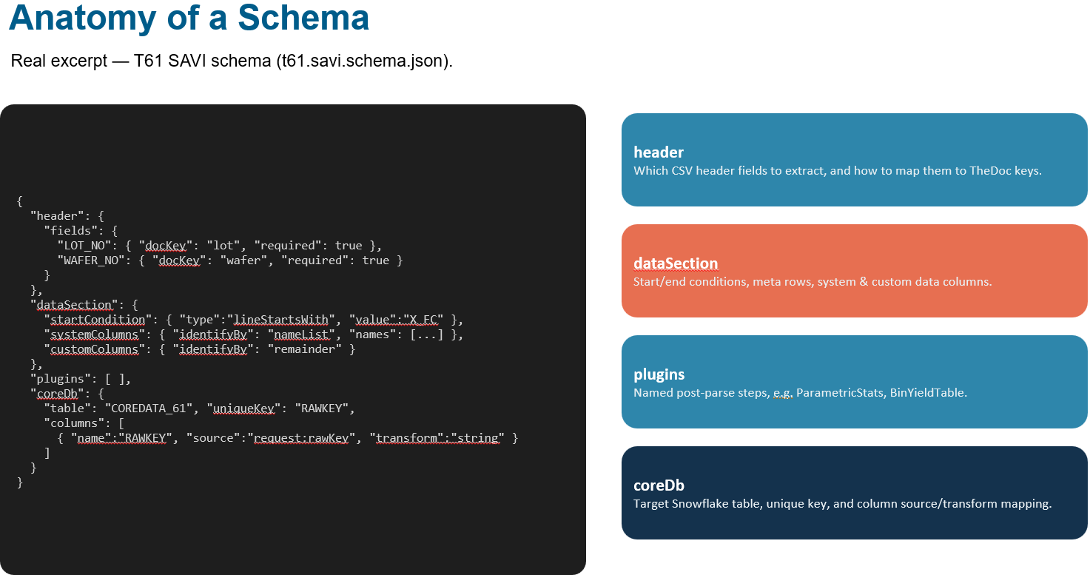
// Development, Architecture, CI/CD, Production (Deployment & Execution)
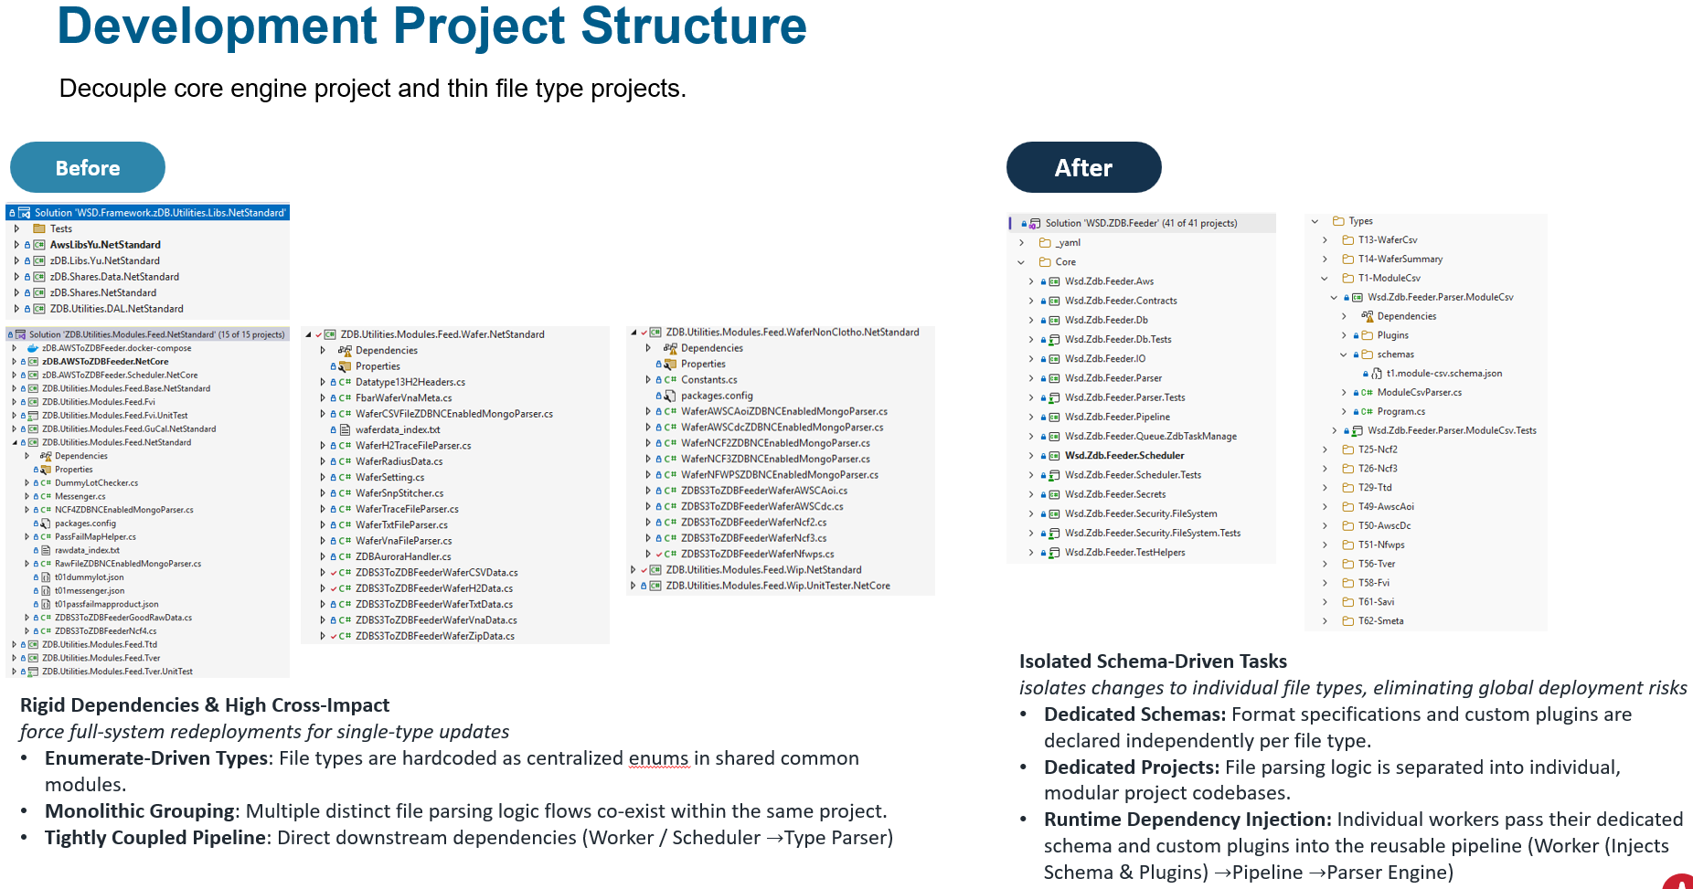
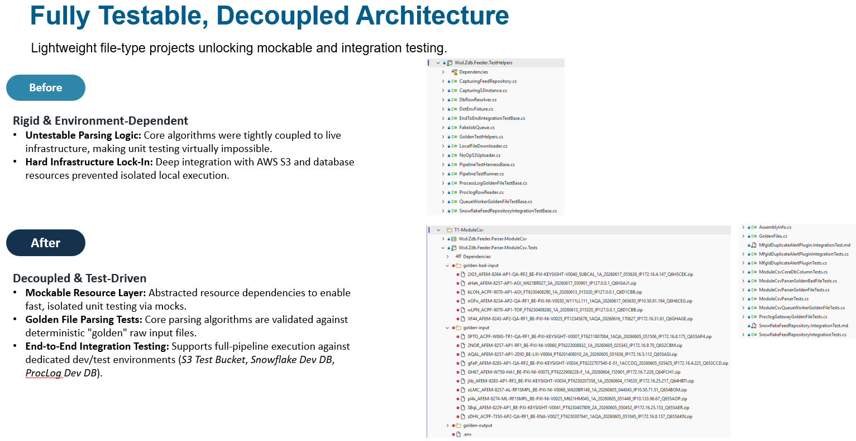
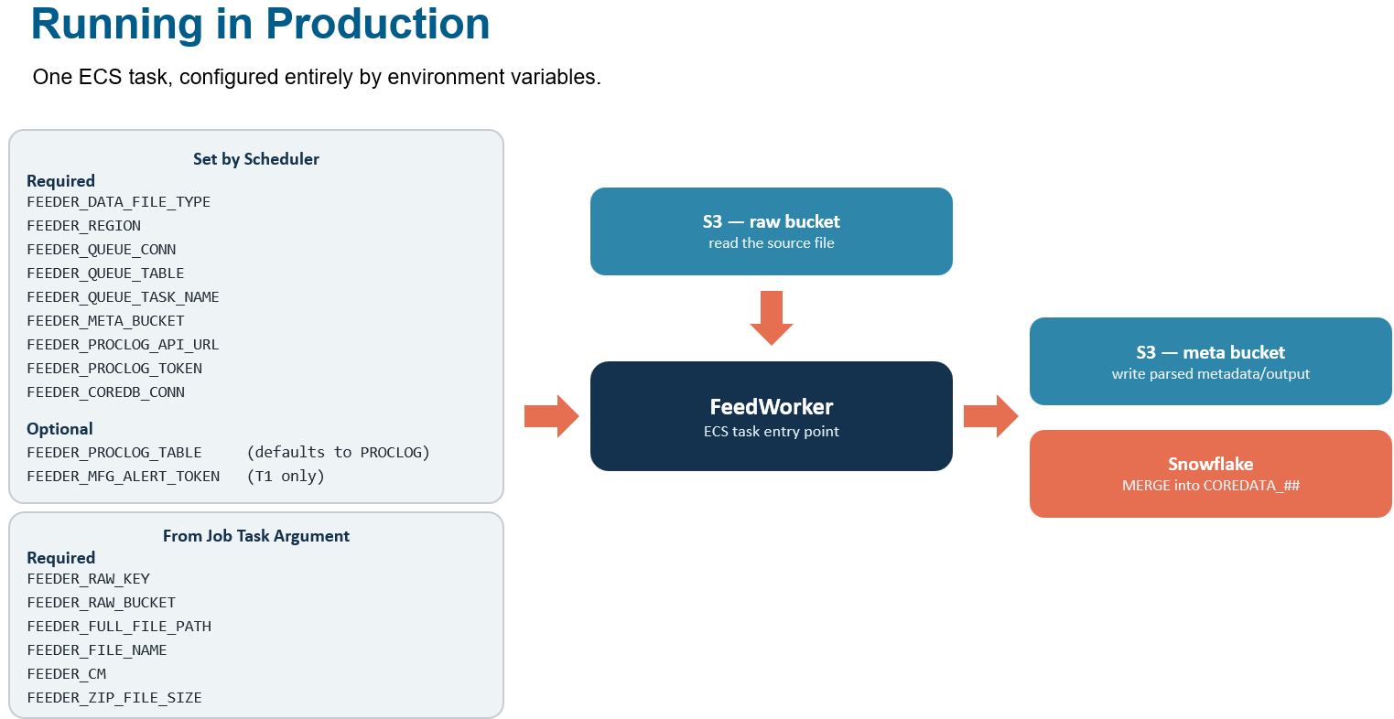

  - Type 61/62 Vehicle
    - 1st Vehicle project is “(Tingyu/KinLum) Enable Sawnics AVI and Metapulse (zDB Type 61/62) Collection and Access”
  - Latest Status
    - 08/04/2026:
      - Kin Lum shared Sample Feeder Schema @ https://github.com/wsd-broadcom/WSD.Zdb.Feeder/blob/reinv/_doc/reference/feeder-worker-schema.md

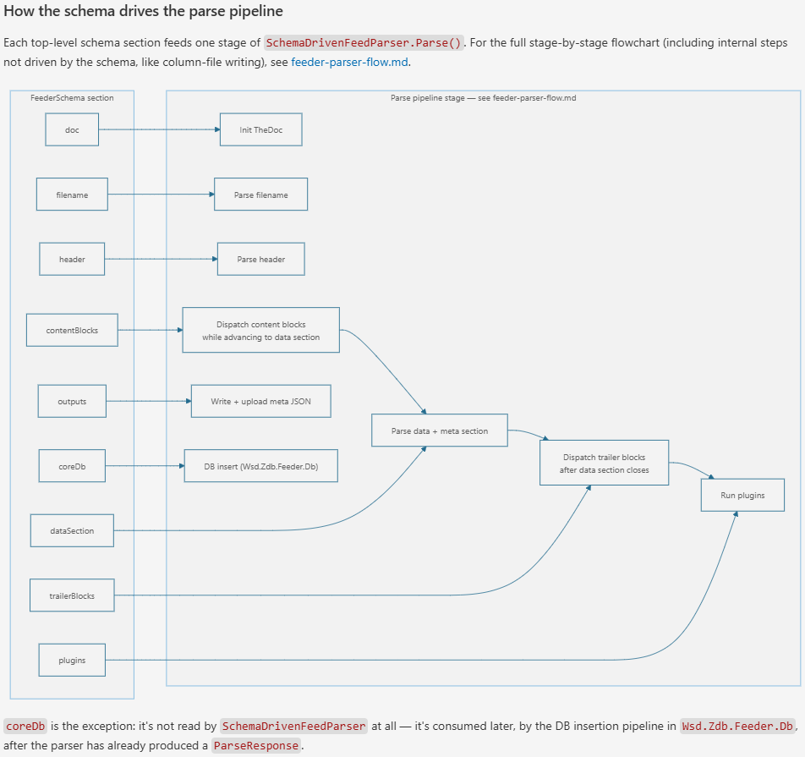
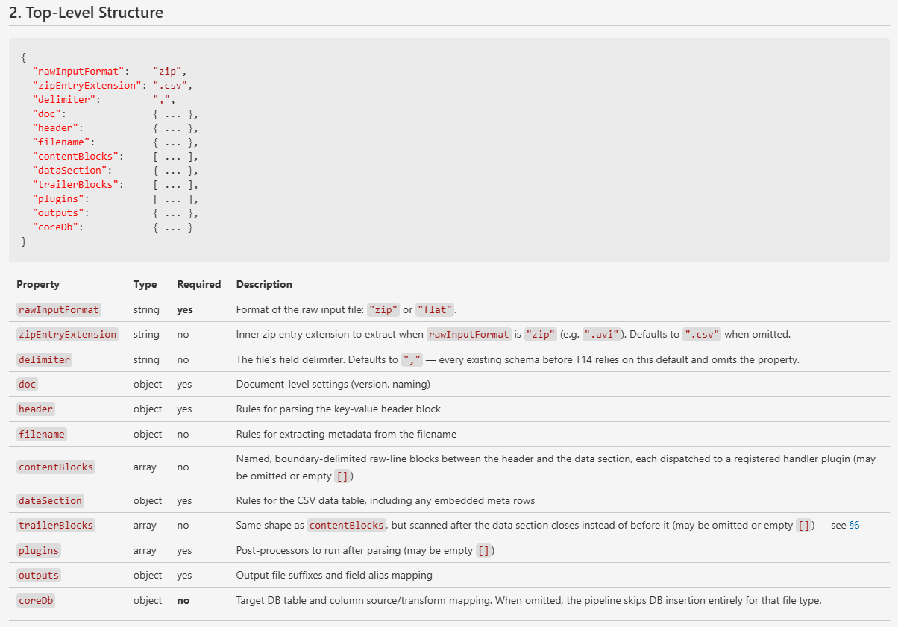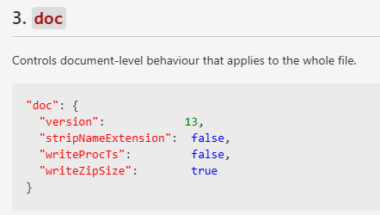
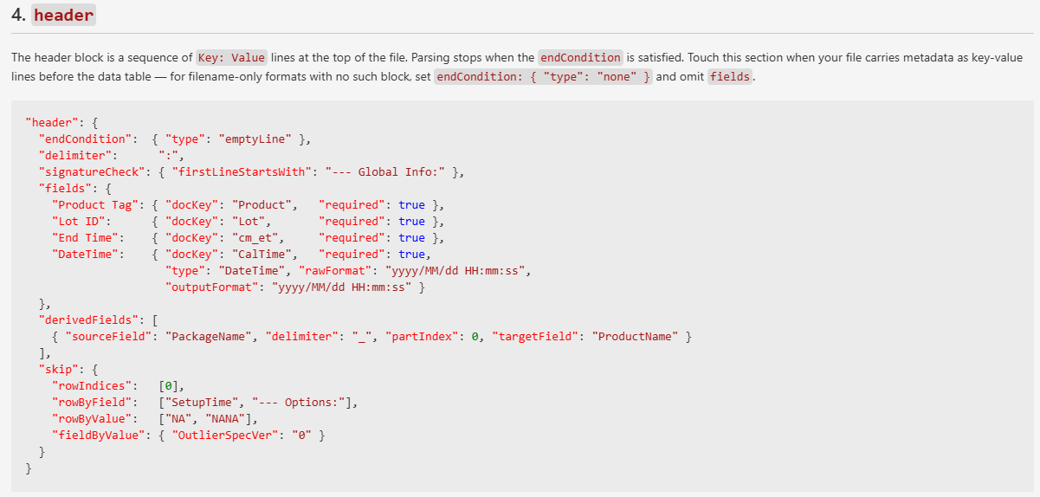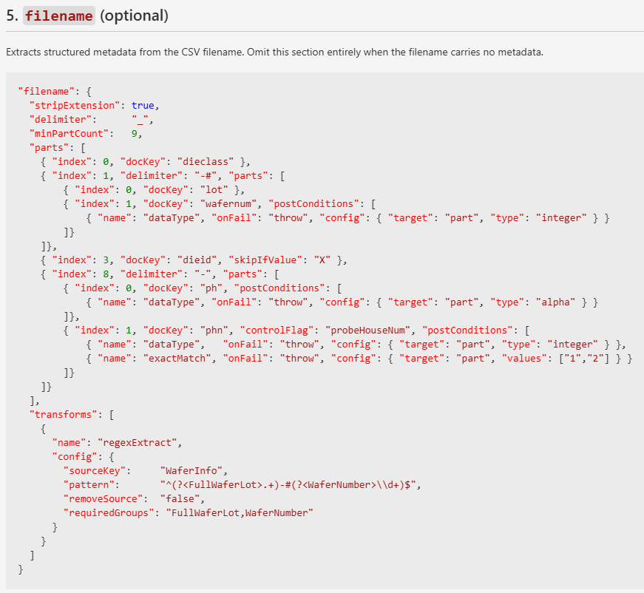
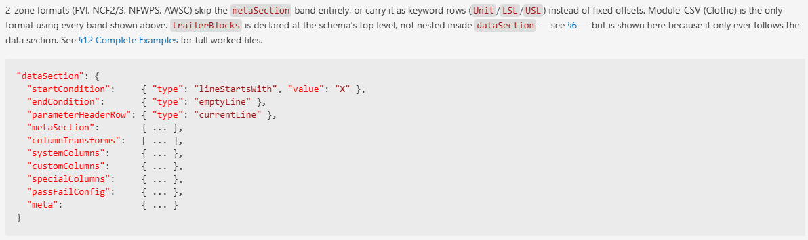
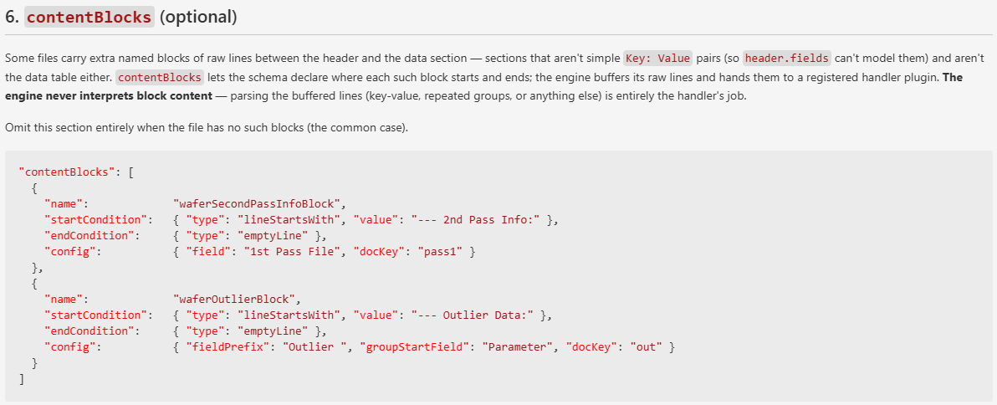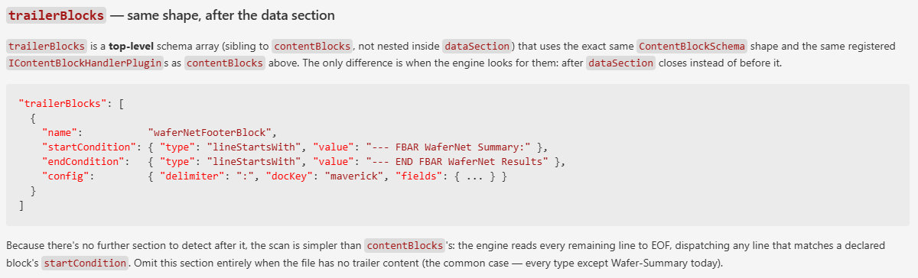
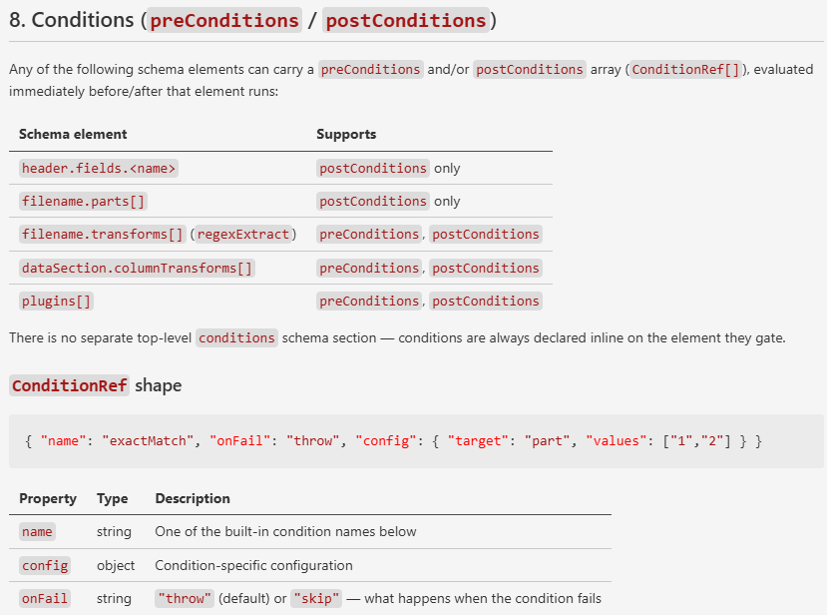

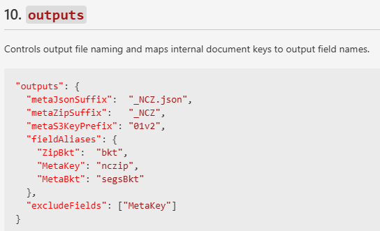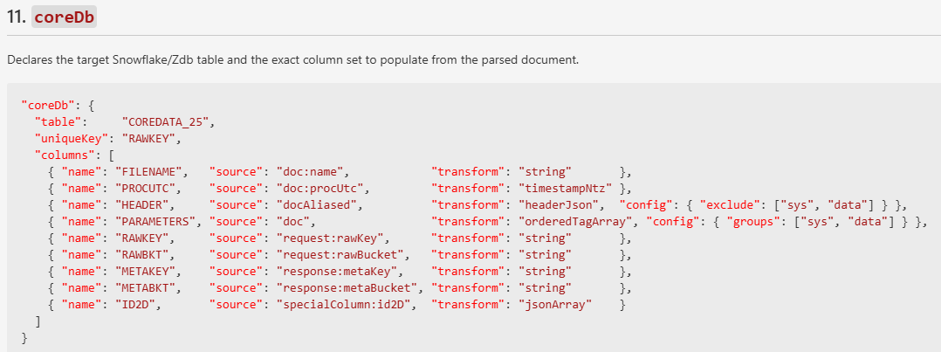
    - 08/18/2026:
      - (Kin Lum) Feeder scheduler: https://github.com/wsd-broadcom/WSD.Zdb.Feeder/blob/reinv/_doc/reference/feeder-scheduler-schema.md
    - 10/06/2026:
      - Schema-Driven Feeder Internal Review
        - https://broadcom.ent.box.com/file/2413646362928
      - Roll out gradually by file type from the least to the highest production impact. We will closely monitor each release deployment for approximately 1 week before moving to the next file types.
        - Development & Deployment (POC)
          - Type 61-savi / 62-smeta (completed)
            - Deployed, and released to production.
        - Development
          - Schema-based migration (12 of 12 file types completed):
            - WW35
        - Deployment
          - Type 25-ncf2 / 26-ncf3 / 27-PcbImpedance / 49-AwscAoi / 50-AwscDc / 51-Nfwps (completed)
            - WW36
          - Type 56-Tver / 58-Fvi (completed)
            - WW37
          - Type 14-WaferSummary / 29-Ttd (completed)
            - WW38
          - Type 13-WaferCsv (completed)
            - WW38
          - Type 1-ModuleCsv (completed)
            - WW39
    - 10/13/2026:
      - Monitor 1 more week without issue
    - Mark as completion

- (Choo-Yau/Chao) Urgent PPYCC Financial Upgrade “Y048 - PPYCC Financial Portal - FBAR FTC ML Cost Adder” (Completed)
  - Target Date: 10/15/2026
  - Scope:
    - Addd in ML (MassLoad) cost adder for FTC FBAR wafer rate in PPYCC financial. Impacted are:
      - BOM Input (UI)
      - Financial Rate Entry (UI)
      - Wafer P/N Setup (UI)
      - Project_Input sheet (Excel report)
      - Financial sheet (Excel report)
      - Summary sheet (Excel report)
  - SOW:
    - https://docs.google.com/presentation/d/1O3HGTj16MREVsYzpv11HC2HL0J-NrNXNqtUhjfhS0Vc/edit?usp=sharing
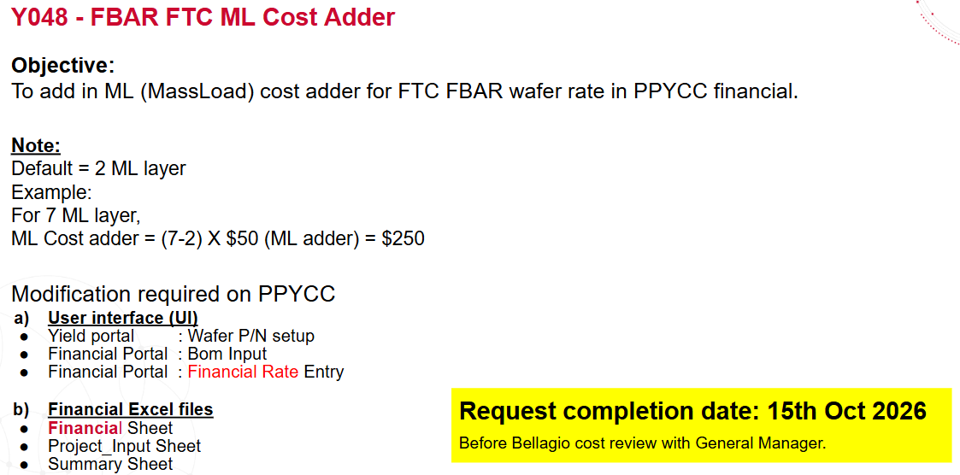

  - Latest Status
    - 09/28/2026:
      - Start executing as urgent request project
    - 10/08/2026:
      - (ChooYau) Web UI development (Completed)
        - Financial BOM Input
        - Financial Input
        - Wafer P/N Setup
      - (Chao) Report development (Completed)
        - Project_Input sheet (Excel report)
        - Financial sheet (Excel report)
        - Summary sheet (Excel report)
    - 10/09/2026:
      - Kok Kit confirmed the buy-off
    - Mark as Completion.
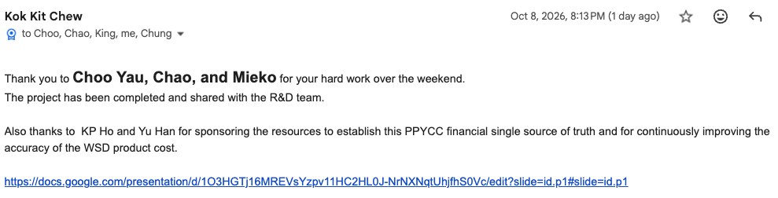

Section 2: Completed/Closed Supports

- (Kin Lum) Support Request “INR Becketts Incorrect DateTime & missing raw data file Re-Processing” (Completed)
  - 09/27/2026:
    - Requested by chun-hao.quah@broadcom.com
    - INARI has resolved this issue for all upcoming lot testing onwards. However, how will we correct the "year 2036" on lots that have already been processed & uploaded? Not sure if this is workable on your end, but can we ask INARI to manually correct the raw data file and upload it again so your team can reprocess the data for these few lots? Or do you have a better suggestion on how we should proceed with these few lots?

  - 09/28/2026:
    - Response from Kin Lum
  - 10/07/2026:
    - chun-hao.quah@broadcom.com officially request to reset then reload “correct new”
      - … understand and agree that this should not be a continuous support and Inari is implementing preventative action to resolve this issue in the future as well.
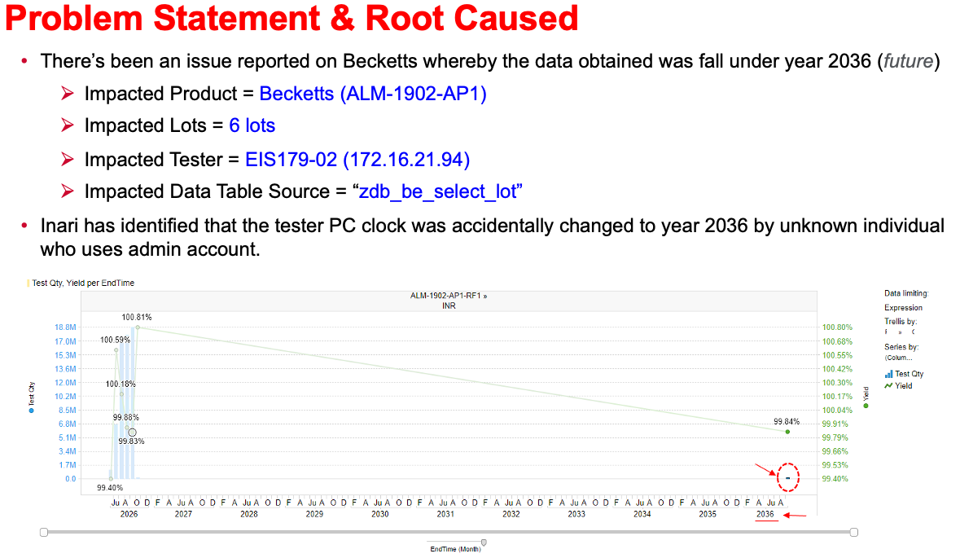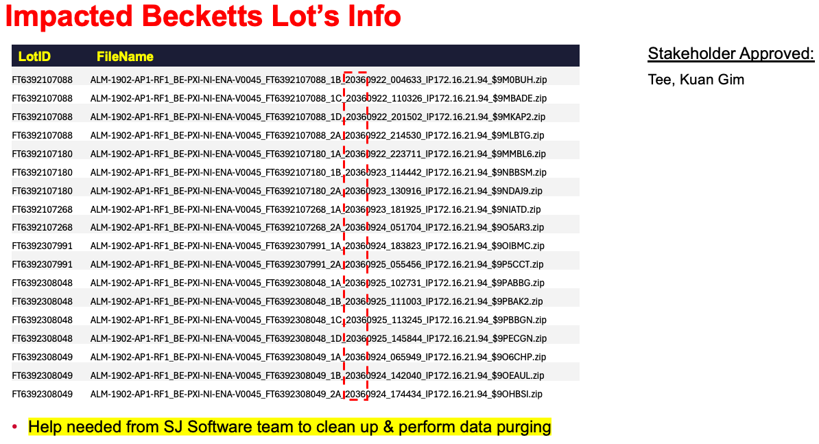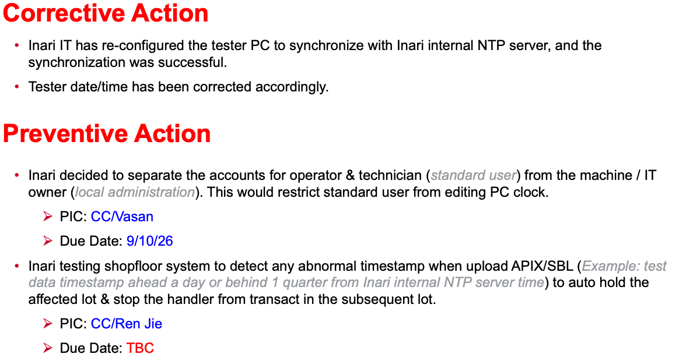

    - Kin Lum share the re-parsing raw path
      - Use option #2 to handle
      - Ask Inari to place the files in the following folder:
        - \\172.16.11.14\zDB\ZDBFolder_REQ\20261007_ChunHao

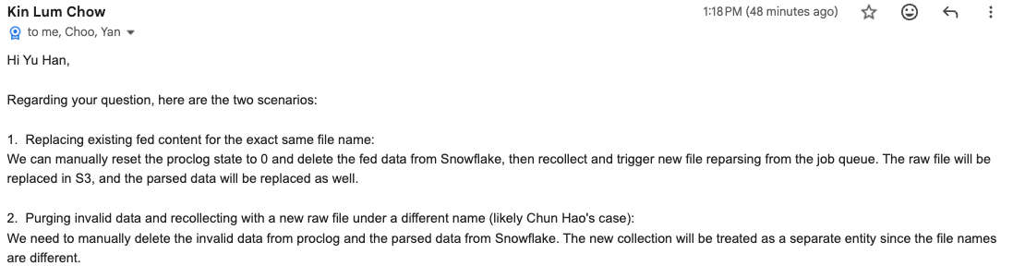
    - (Kin Lum) Clean up and Recollect (completed)
      - Files collected and parsing completed
      - Data of those incorrect files are removed
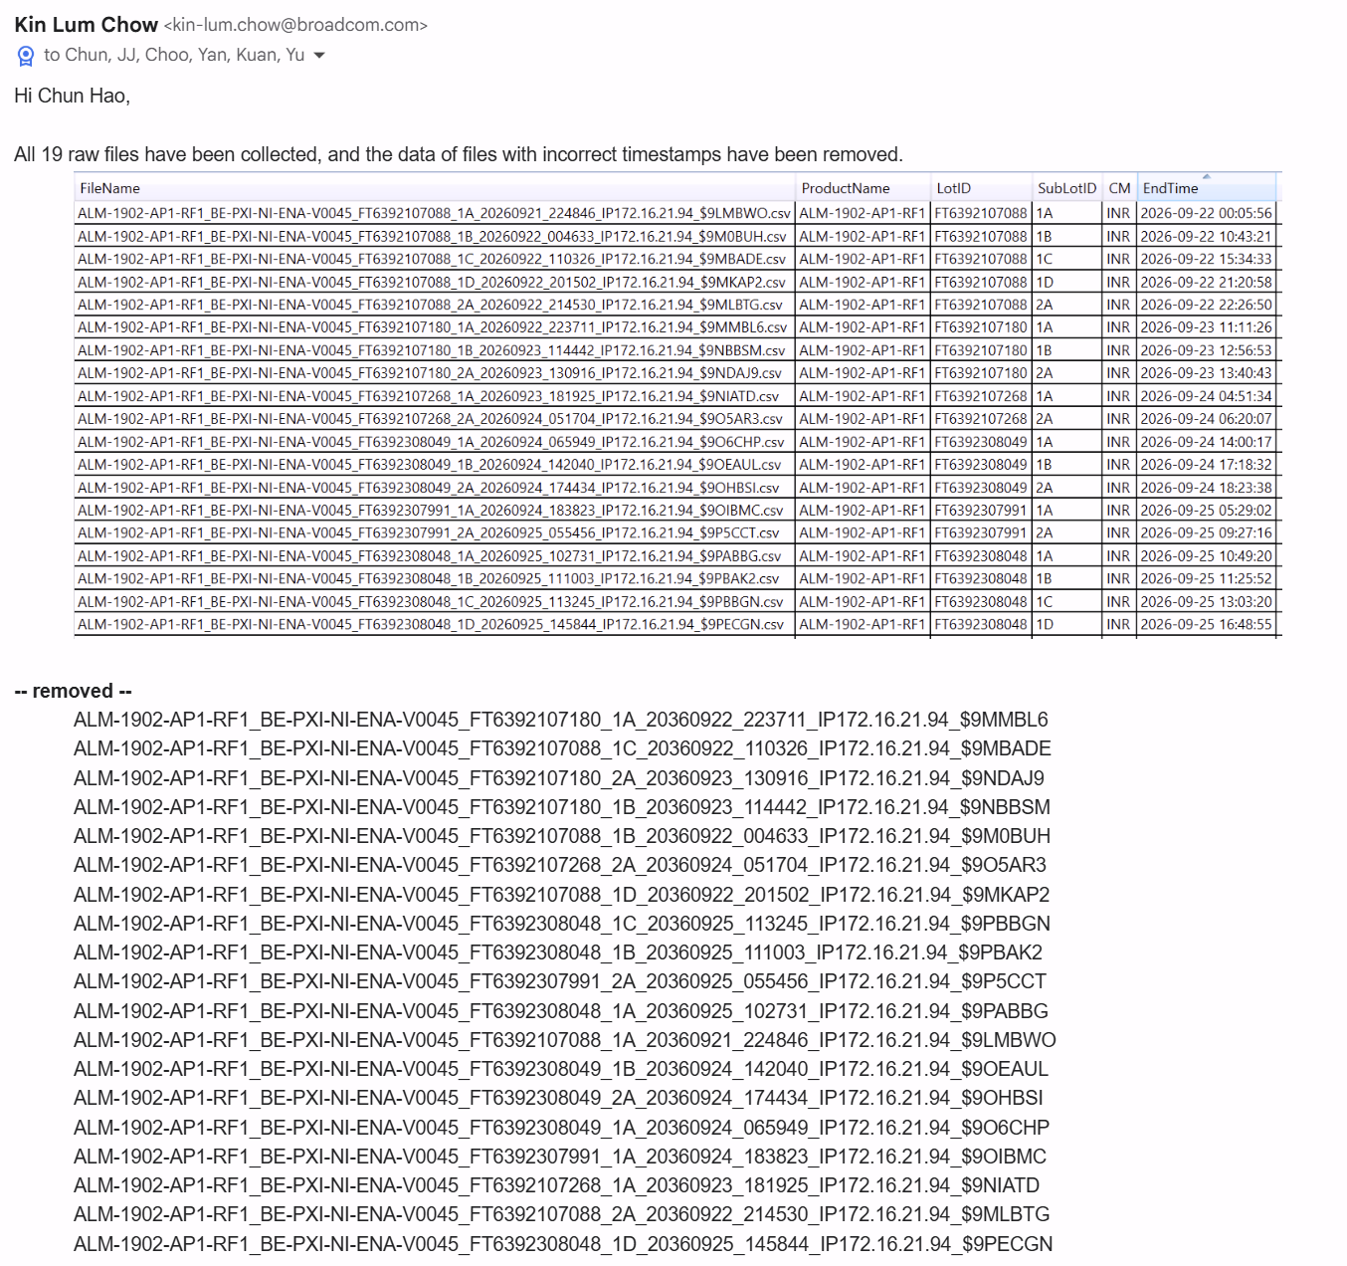
  - 10/12/2026:
    - Chun Hao bought off, mark as completion.

- (Choo-Yau/YK) Enable ATA Utilization Report (Complete)
  - One of SW team's mid/long-term goals is NXG ATA (need to rename the project, e.g., WCCF (WSD Custom Large Computation Framework)).
  - Enable report is the pre-condition, Need provide stat reports similar as TUDAS/WUDAS reports
  - Two goals so far for NXG ATA or WCCF:
    - Support both Python and C# => Container?
    - Expand from support PE/NPI WUDAS/gDB based computation with additional FCM relevant custom computation (outlier removal, e.g.) by integrating with TUDAS
      - Chao will start FCM Custom Computation Requests negotiation from Oct 2, 2026

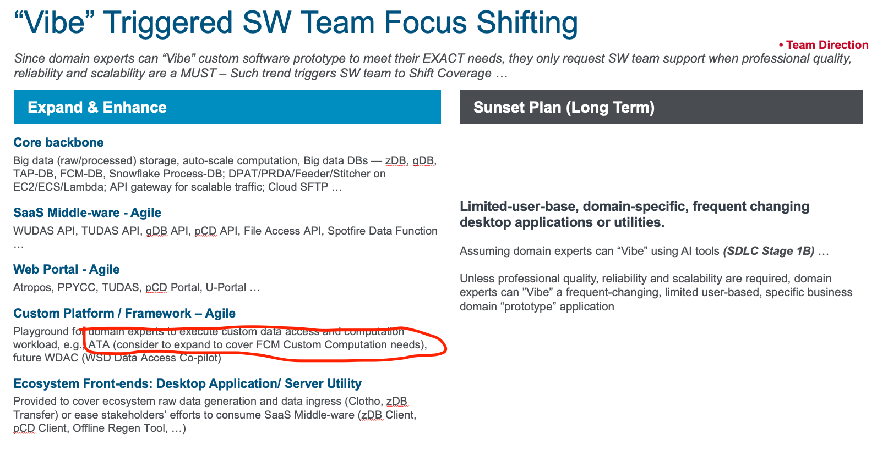
  - 09/29/2026:
    - Created utilization report (draft V1) for review - based on data up to 2026-09-17.
      - NOTE current custom auto-scaling EC2 set up can’t provide EC2 level CPU or memory history
        - Link: https://broadcom.ent.box.com/file/2487113378071
  - 10/13/2026:
    - V2 report segregates ATA and Spotfire stats
    - Load real data from DB and enable Monthly distribution
      - ATA: https://broadcom.ent.box.com/file/2515285052593
    - Very unbalanced workload

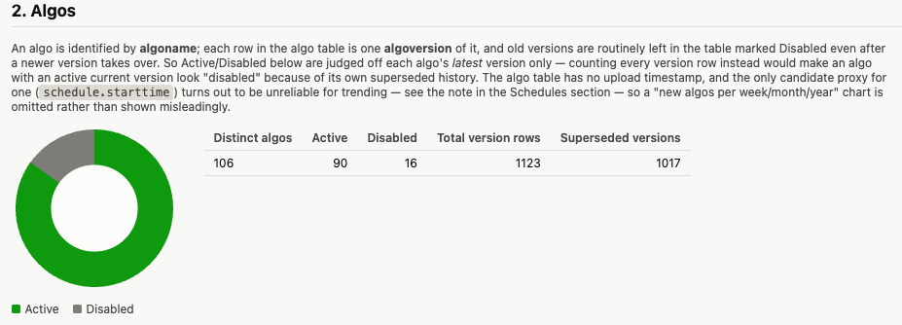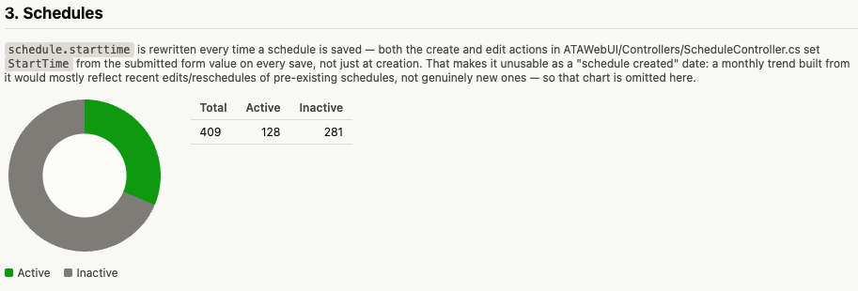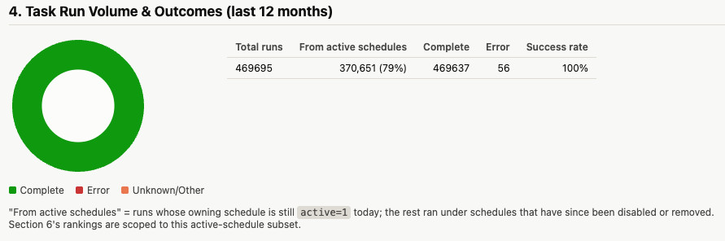
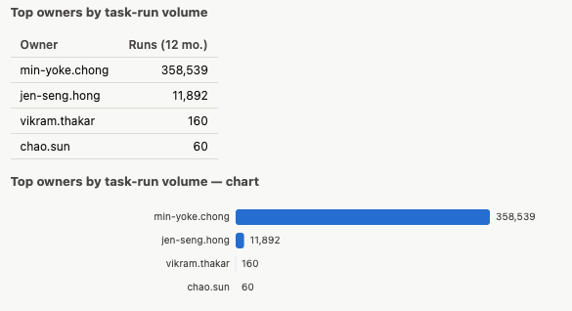

      - Spotfire: https://broadcom.ent.box.com/file/2515281373625
    - (Ken) Integrated and scheduled every Wednesday 9:00AM
    - Mark as Completion

- (Chao) Support Request “Add AOD into WSD Snowflake Enterprise Access” (Complete)
  - 09/22/2026:
    - Requested by AOD, contact richard.kao@broadcom.com and jeff.atime@broadcom.com
    - Context as clarified
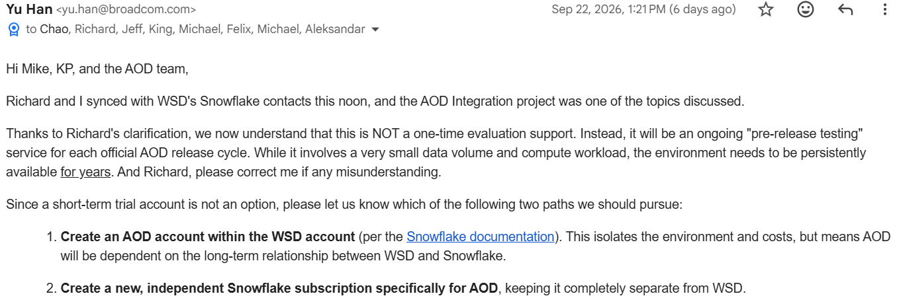
  - 09//28/2026
    - AOD picked Option 1
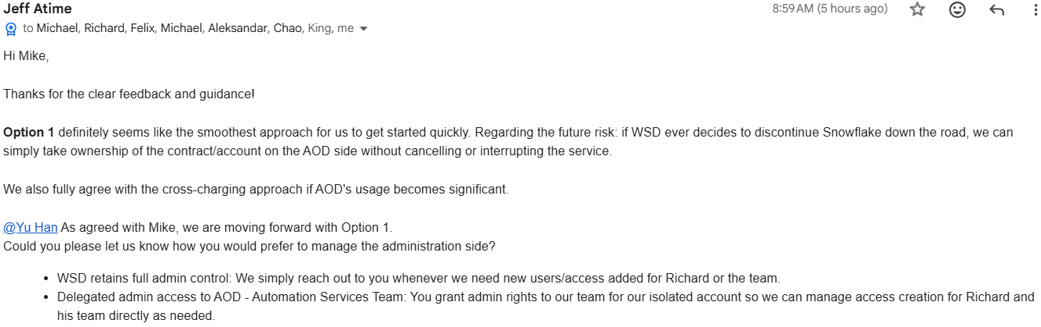
  - 10/06/2026:
    - AOD, Snowflake and WSD work together to enable the set up
    - AOD sub-account usage/spending will show up under the locator 'NM20055' subheading
    - AOD request GCP deployment
      - CREATE ACCOUNT AOD_SNOWFLAKE
      - ADMIN_NAME = 'richardkao'
      - ADMIN_PASSWORD = '##############'
      - EMAIL = 'richard.kao@broadcom.com'
      - EDITION = ENTERPRISE
      - REGION = gcp_us_central1;

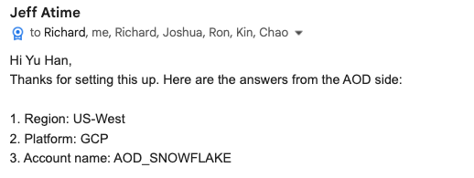
  - 10/07/2026:
    - AOD confirmed access OK. Mark this as completion.

Section 3: Active Support (30%)
- (SW Team) SW Team Tech Direction Discussion W/ Infra APIs Consolidation (In Progress)
  - Tech Direction
    - https://docs.google.com/spreadsheets/d/1kC_PGeLxi3rE6_p0khHW-CswN3n1z_vNfMSRqplVg_I/edit?gid=1754030132#gid=1754030132
  - WSW SW Infra API Collections Summarize (21 Families)
    - https://docs.google.com/spreadsheets/d/1kC_PGeLxi3rE6_p0khHW-CswN3n1z_vNfMSRqplVg_I/edit?gid=771614178#gid=771614178

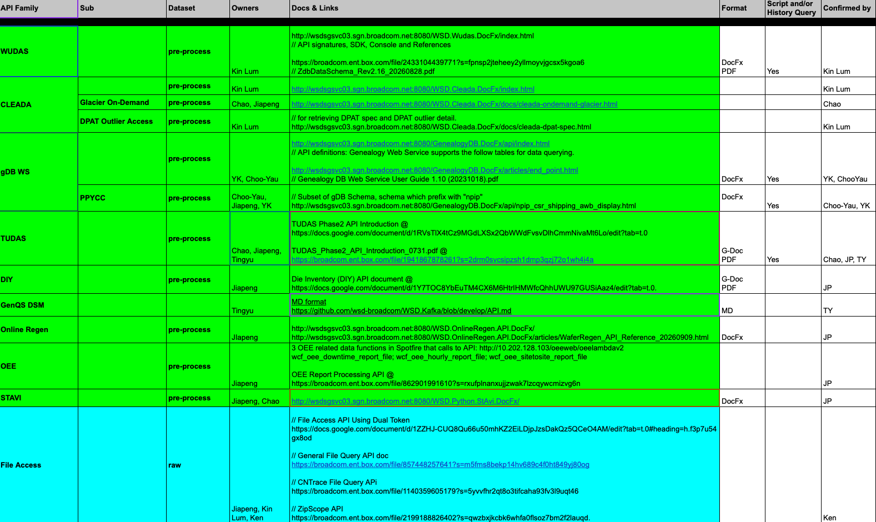
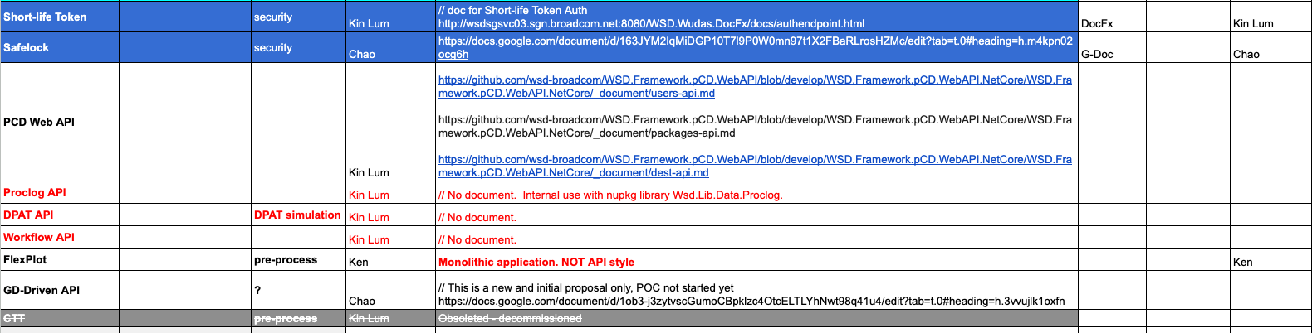

- (Chao/Ken) Mythos Finding Fix w/ GitHub (Non-SW) & GitLab (FtC) (In Progress)
  - Overall
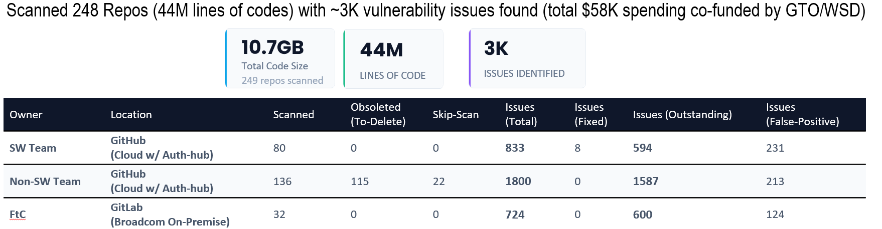
  - GitLab FtC Teams
    - https://docs.google.com/spreadsheets/d/1IGfZNBVW4Bm8o27tm8wGvZBemMr8mw_wyt7QwcvFRPU/edit?gid=0#gid=0
    - “Fix Request” Notification to Repo Owners
    - Follow-up Tracking
      - Skip for now per FtC management request
  - Mythos Report to GTO (In Progress)
    - For Pre 06/15/2026
    - For Post 06/15/2026
      - https://docs.google.com/spreadsheets/d/1xy3wbkciN568fdB3-Qe6fbFdVvRFpz4O66MqUu7Z6mk/edit?gid=0#gid=0
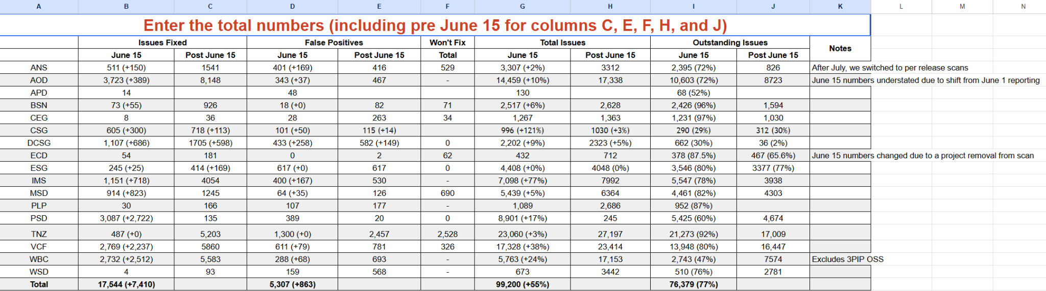
    - For 08/27/2026 Update (Cumulative)
      - https://docs.google.com/presentation/d/1-lB4JOmyZRGHb0VuN-y4zPQsXTxjAbjNOMTAQj80ndk/edit?slide=id.g3fad6eed5c4_0_348#slide=id.g3fad6eed5c4_0_348
    - For 10/06/2026 Update (Cumulative)
      - https://docs.google.com/spreadsheets/d/129ePsh0J8c0skPZpO9PHIvucpN60XL-EIrRHkFToJz4/edit?gid=1128192444#gid=1128192444
  - GitHub Non-SW Teams: 10/13/2026:
    - Round 1 Fix Feedback
      - https://docs.google.com/spreadsheets/d/1ApY-GOefRjnBACgMvTFdBvQVfVDf82f3bftY2NujSy4/edit?gid=1664259783&utm_source=gemini#gid=1664259783
    - Box of Findings for GitHub wsd-non-swteam-repos-mythos-findings
      - https://broadcom.ent.box.com/folder/392862476770
    - Total 139 Repos
      - (92x) Yellow: Requested Exception to Skip

      - (19x) Red: Delete
        - https://docs.google.com/spreadsheets/d/1ApY-GOefRjnBACgMvTFdBvQVfVDf82f3bftY2NujSy4/edit?gid=532952304&utm_source=gemini#gid=532952304
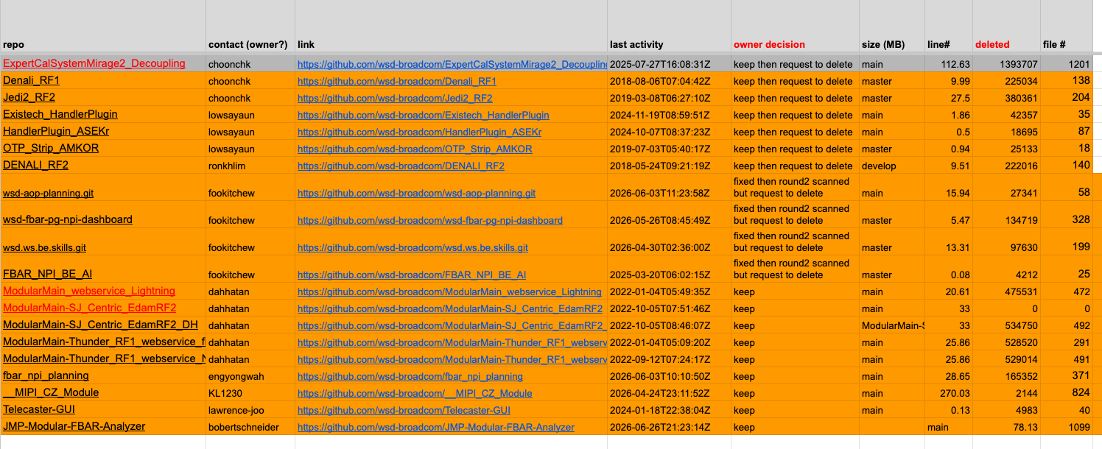
      - (27x) Green: Completed Round 2 scan
        - https://docs.google.com/spreadsheets/d/1ApY-GOefRjnBACgMvTFdBvQVfVDf82f3bftY2NujSy4/edit?gid=249046848&utm_source=gemini#gid=249046848
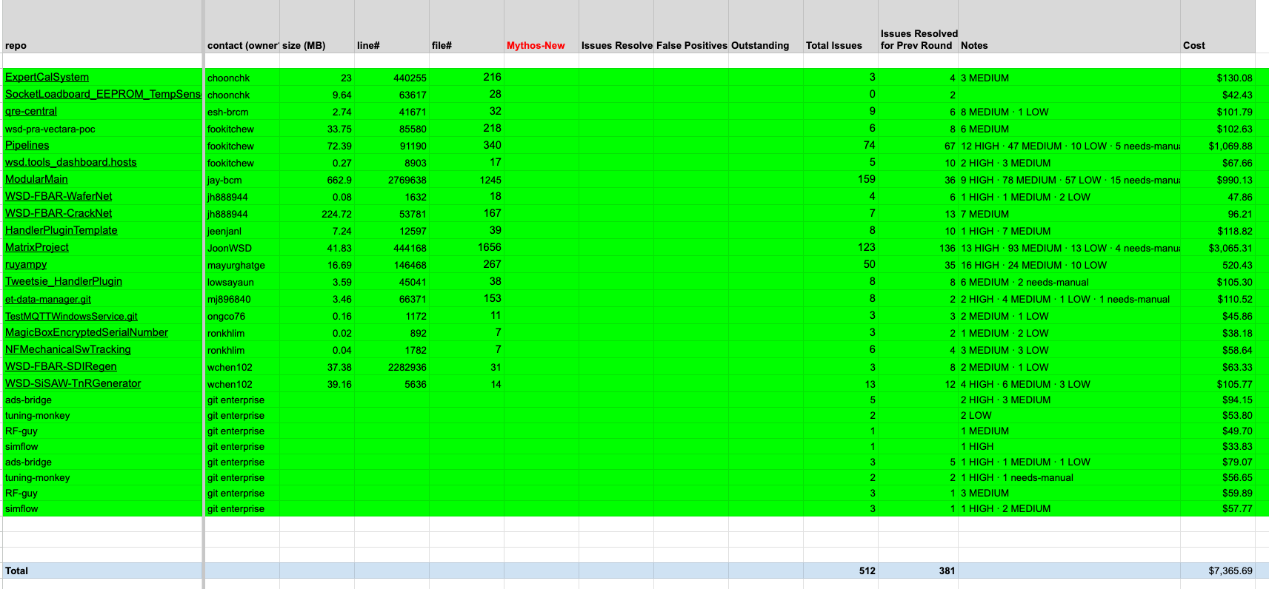
    - (1x) Pending for Round 2 scan
  - Cost Tracking @ https://platform.claude.com/workspaces/wrkspc_01AmQbPuRoyB1nM6j33HXgX2/cost
    - GTO offered to cover WSD’s Mythos scanning cost until 10/01/2026, so push the fix before SW team can execute the issues verification scan

- (SW Team) Support GTO Request "WSD - Prisma - critical & High alerts" (In Progress)
  - 08/06/2026:
    - Per request form GTO anjan.konedena@broadcom.com
    - Two items-to-do:
      - ECS cluster hasn’t installed Prisma Agent (easy)
      - 427 scanned Critical/High security alerts follow-up
    - List to do:
      - Clusters with no prisma defender agent installed:
        - https://ent.box.com/s/yu9v48kjrzsbszo87y45500kdd104x5e
      - PFA list of critical and High cloud security misconfigurations (427x)
      - Link to raise an exception for Prisma Defender agent installation
        - https://broadcomitsm.wolkenservicedesk.com/wolken-support/item_details?itemId=2819
      - Link to raise access request for Prisma portal.
        - https://broadcomitsm.wolkenservicedesk.com/wolken-support/item_details?itemId=2318
  - 09/15/2026:
    - (Kin Lum/Ken) Use GTO (Anjan) provided link to raise exception for Prisma Defender agent installation @ WSD’s ECS clusters since all ECS tasks are active for only a few minutes or hours
      - https://broadcomitsm.wolkenservicedesk.com/wolken-support/item_details?itemId=2819
      - Ticket#SR3157517} ##{Approval#791224}## PAN Prisma Cloud
        - Request Defender Agent Installation Exemption and GTO approved.
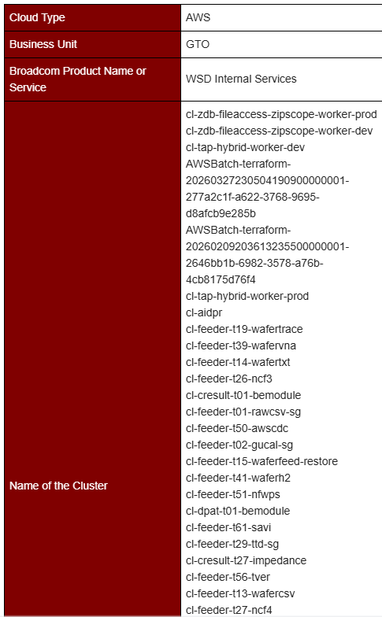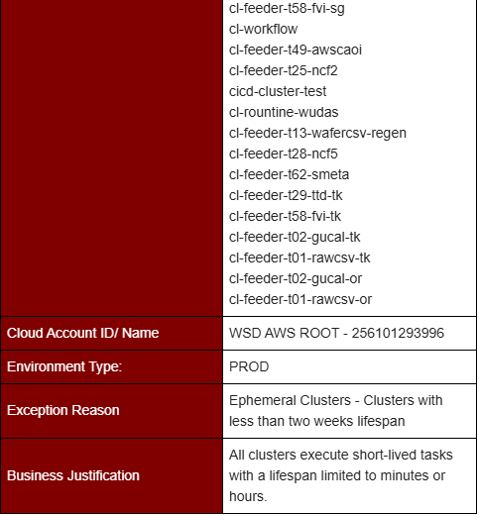
  - 10/13/2026:
    - (Ken) Completed “IAM access key rotation hygiene”
      - Pending update to GTO
    - (Kin Lum) Confirmed Aurora DB w/ security groups only granting specific inbound IPs.
      - Pending sync with GTO to get link to raise exception for this item

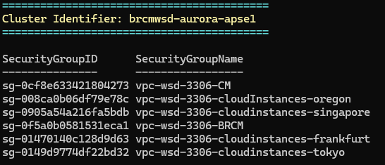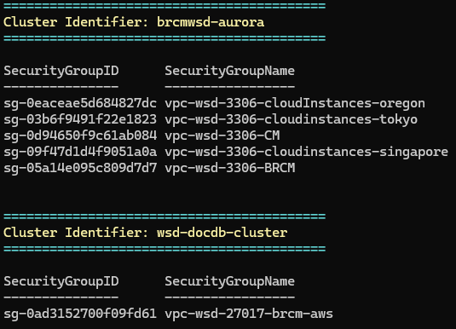

    - (Kin Lum) Check and update owned EC2 instances with IMDSv2 (in progress)
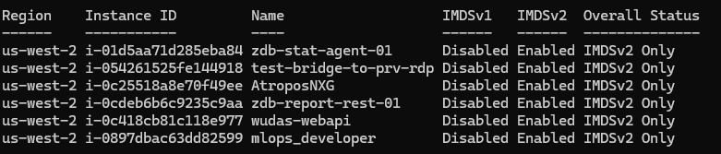
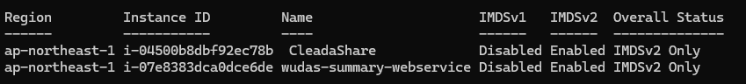
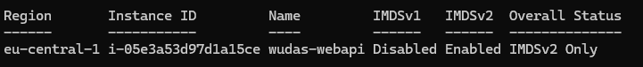
    - SW Team Internal tracking based on CC summary
      - https://docs.google.com/spreadsheets/d/1RJO9aF9AfkWXdTGbtYsljm0gqcPWe7yz2lL3wRMCrcs/edit?gid=1783897259#gid=1783897259

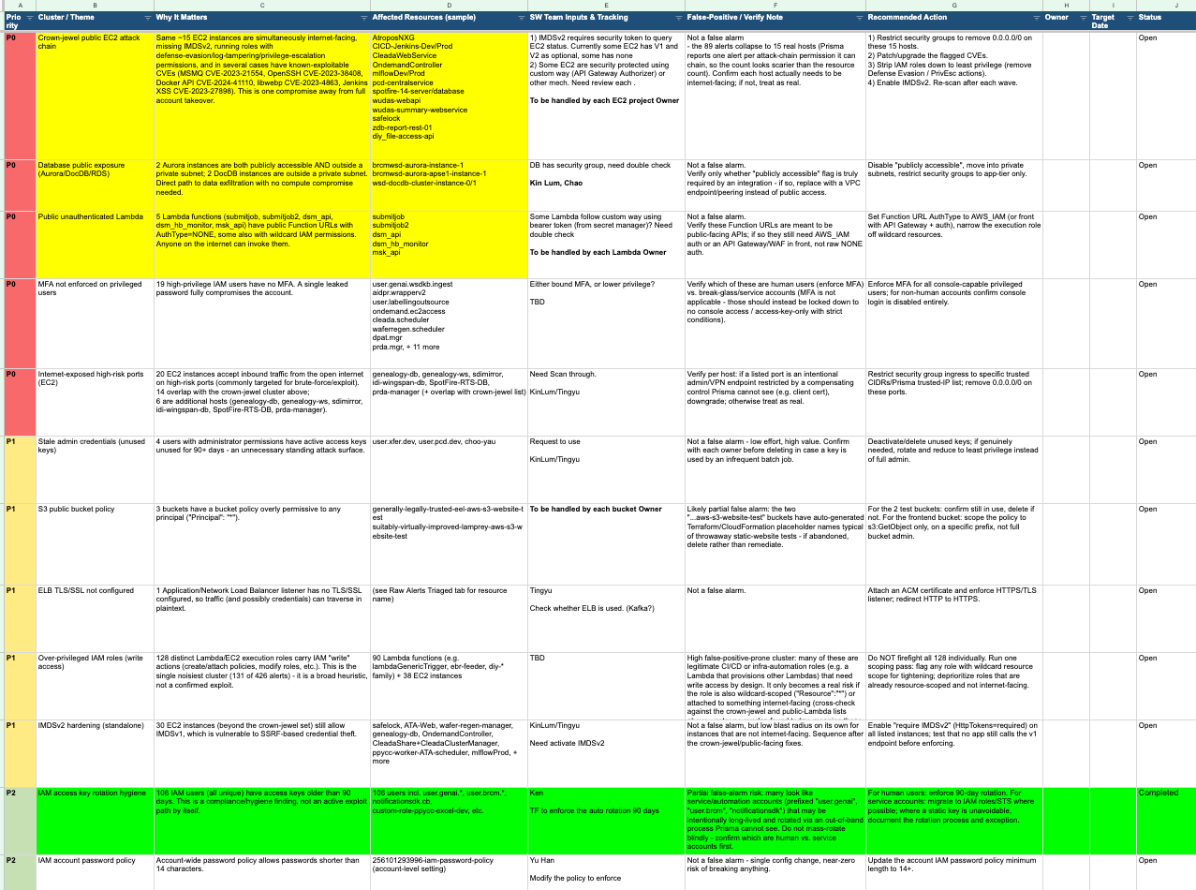

- (Ken) Update WUDAS Non-Fbar Wafer Pass Bin Criteria (In Progress)
  - Per request by Min Yoke
    - Special handling update pass bin for t25(ncf2), t51(nfwps)
      - ncf2 pass value: {0, 1} -> {1, 81, 82, 83, 84, 85, 86, 87, 88, 89}
      - nfwps pass value: {1} -> {1, 81, 82, 83, 84, 85, 86, 87, 88, 89}
      - ncf3, awscaoi, awscdc pass value: {0, 1} (no change)
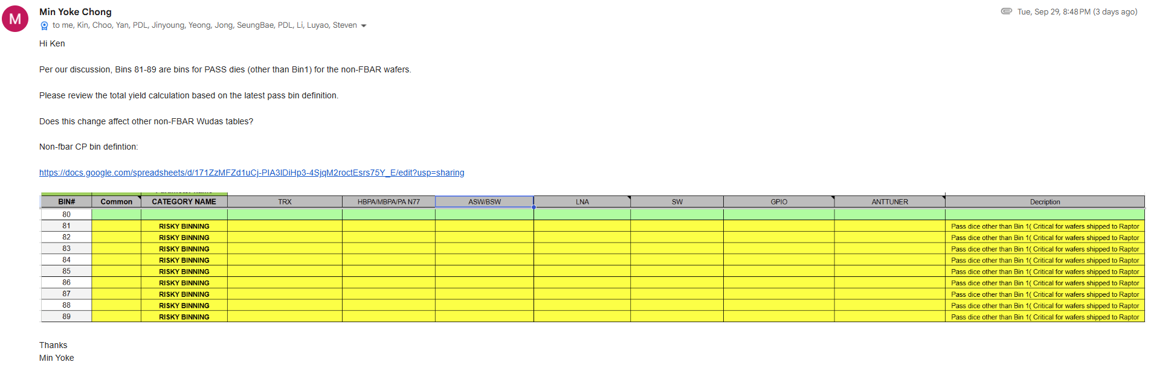
  - Updated and deployed with new Zdb.Feeder schema
  - Pending for Min Yoke buy-off

- (Kin Lum) WUDAS Python package Upgrade to V3.13 (In Progress)
  - 09/18/2026:
    - Requested by gerd.meisl@broadcom.com
    - Our team has been using the Python WUDAS API and put together some helpful fixes and improvements. We wanted to check whether these fixes and improvements should be merged into the main branch. We also noticed a few deprecation warnings and would really appreciate your thoughts on the best way to handle them. Please refer to the attachments for more details.
  - 09/20/2026:
    - Updated by Kin Lum
    - Since Python 3.10 reaches end-of-life in October 2026, could you let us know which Python version your team is currently using? Please also let us know if upgrading to Python 3.13, 3.14, or the upcoming release 3.15 would work for you.
  - 09/29/2026:
    - Gerd: confirm on using Python 3.13
  - 10/13/2026:
    - Kin Lum is working on the upgrade (in progress)

- (Yu Han) Set up JIRA “WSD SW Team Agile Support” Category (In Progress)
  - AI acceleration makes “Agile” possible
  - Proposed workflow
  - 09/29/2026:
    - Complete the topics list and ownership
  - Proposed Topics (49x)
    - https://docs.google.com/spreadsheets/d/1kC_PGeLxi3rE6_p0khHW-CswN3n1z_vNfMSRqplVg_I/edit?gid=504829157#gid=504829157
    - Use Topic to Auto Route to Domain Owner
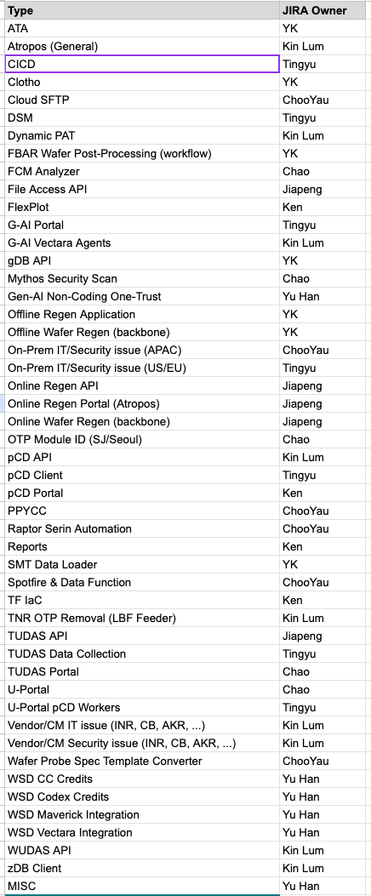
  - 10/07/2026:
    - (Aruna) Jira WSDSWS Project has been created and all the related changes have been made. Automation to assign the owner depending on the Support type has also been setup.
      - https://jira.broadcom.net/projects/WSDSWS/summary
      - Under “Support Type”
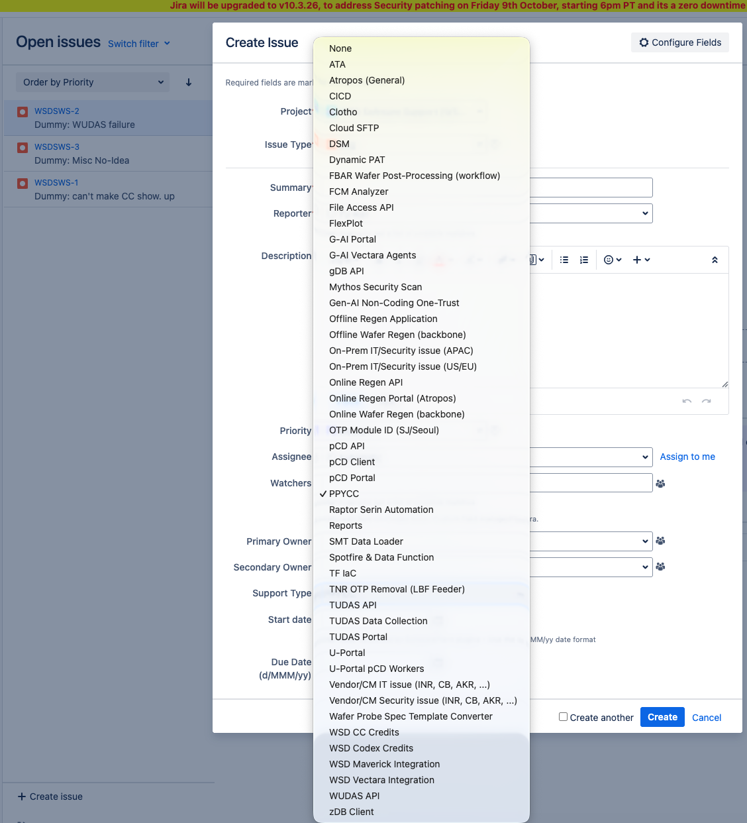
  - 10/13/2026:
    - Trial runs this system for 2 weeks to confirm all working before marked as Completion.

- (Yu Han) WSD @ Vectarag: (1) Clotho; (2) PRA; (3) MARA; (4) QRE Tzero; (5) FtC RAG-VectorDB Searching; (6) INFICON FabTime Co-pilot; (7) Seoul Issue Tracking Mgmt (In Progress)
  - Brain summarize the whole process:
    - A coding exercise or web-gui process primarily. Vectara makes it pretty easy to get setup with either process @ https://vectara.lvn.broadcom.net/docs/rest-api/
    - You need to build an ingestion process - use the vectara container for rapid startup, or drag and drop directly into the web app some example documents.
    - You need to build an agent and configure its profile - needs prompt, tooling, etc. This can be done with a python script or through the web app.
    - After that, if satisfied with the agent, share the agent id with Tingyu for posting it to the gAI portal.
    - Example @ https://gitlab.ftc.broadcom.net/fdc/rag/marahttps://gitlab.ftc.broadcom.net/fdc/rag/mara
  - WSD Infra
    - WSD G-AI Portal as Unified Front End to all Vectara Agents (Completed)
      - https://gai.wsd.sgn.broadcom.net/
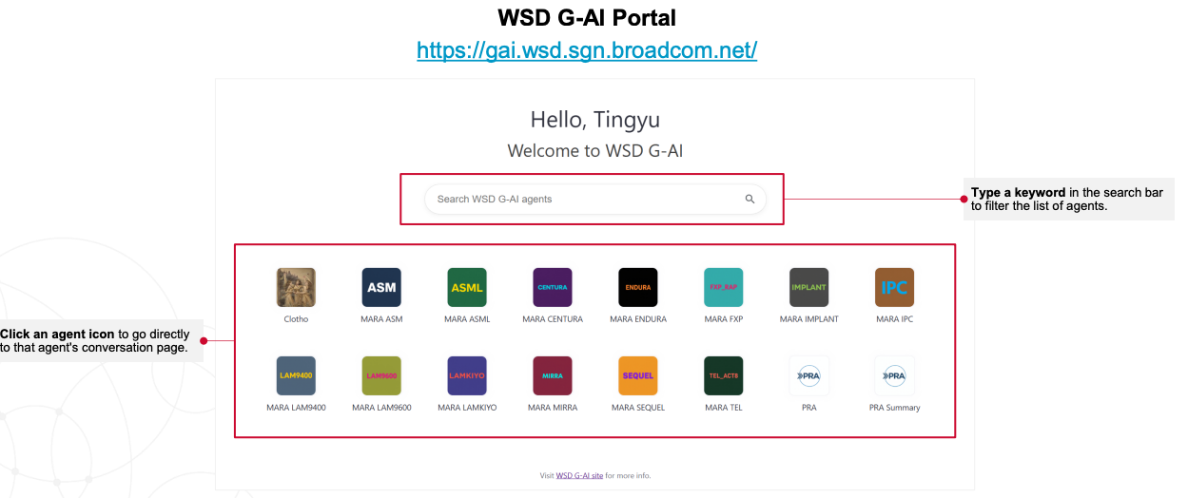
    - WSD Auto-Grader (In Progress)
      - Refer to Project item “Secure Vectara/GTO Production Environment ”
      - LM Studio Deployment
        - Completed
        - All agents completed integration
        - Working but performance @ ETX is a bottleneck
      - Maverick Deployment
        - In evaluation
  - OneTrust both POC and Production approved and deployed
    - (1) Clotho Full History RAG Agent
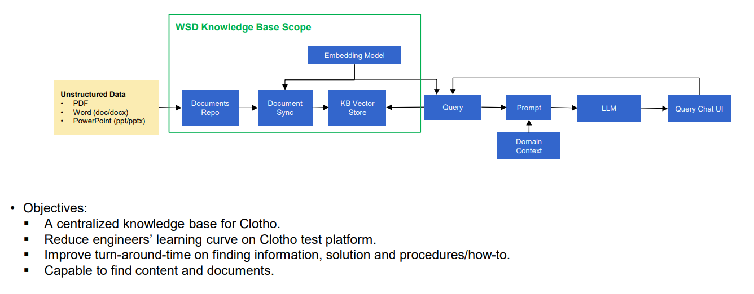
    - (2) PRA Agent

  - OneTrust both POC and Production approved, develop done, not Production Deployed yet
    - (3) MARA
      - Coding done. In production floor safety guideline definition
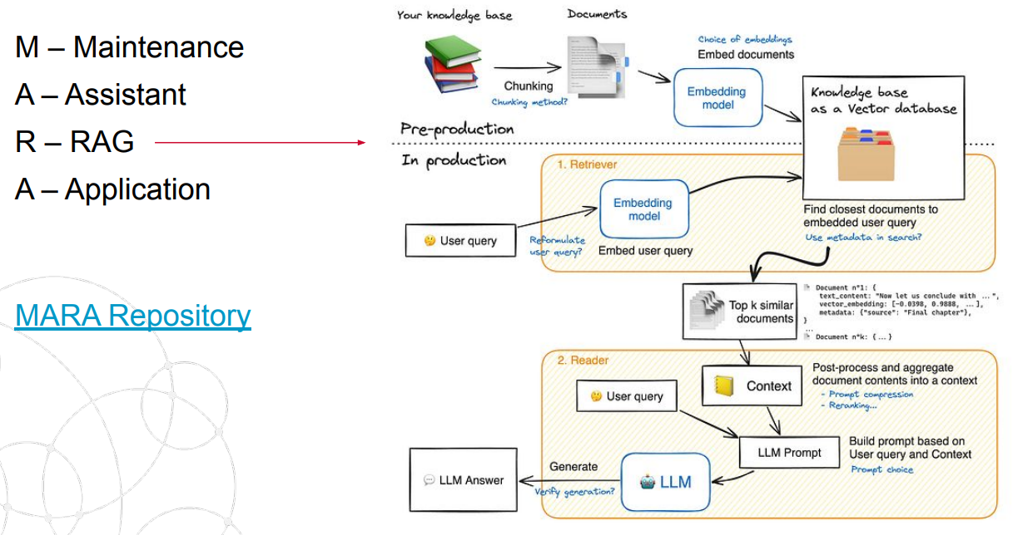
  - OneTrust POC approved and in development
    - (4) (Penang) QRE TzeroRAG
      - yoke-wai.foo@broadcom.com
      - you-shen.chew@broadcom.com
      - Passed OneTrust POC #47899.
      - The Tzero RAG platform is designed to centralize and query the QRE team’s historical dataset on Tzero compilation. Time loss and information loss may occur when manually searching the records. This platform will provide instant access to technical records, improving engineering efficiency and ensuring that 100% of the historical documentation is leveraged during the information retrieval.
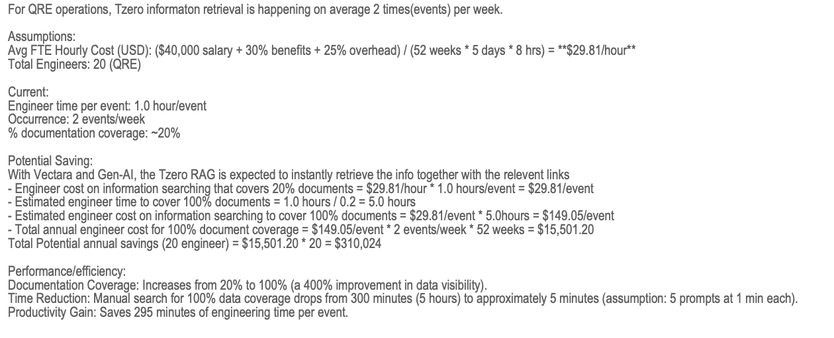
  - Concept investigation
    - (5) FtC RAG-VectorDB Pure Searching (READ-ONLY)
      - scott.lunardini@broadcom.com
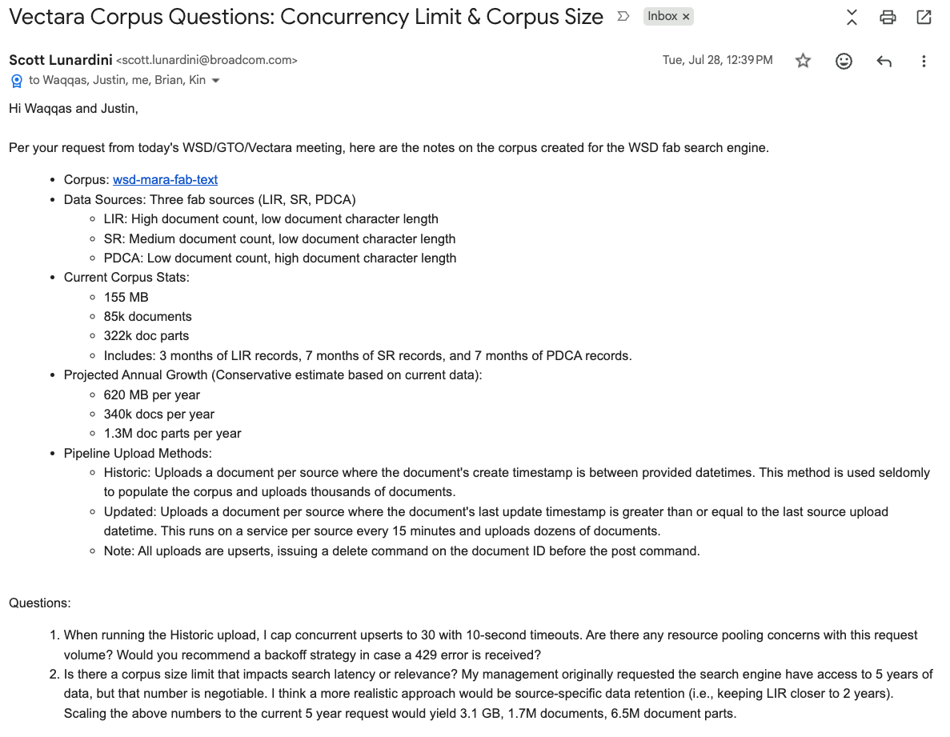

    - (6) (FtC) INFICON FabTime Co-pilot
      - zachary.mainz@broadcom.com
      - Everything deployed on premise, except the call to GCP Vertex AI, consuming Gemini model and Vertex Text Embeddings
      - (09/22/2026) Agreement of Next To-Do
        - WSD will discuss w/ Inficon on using Vectara for RAG this week, provide feedback on results to GTO.
        - Priya will review the Onetrust draft - will send any additional questions/concerns back to WSD for clarification.
        - Erica will give a heads up to GTO management in her discussion w/ them today, share any additional feedback w/ WSD.
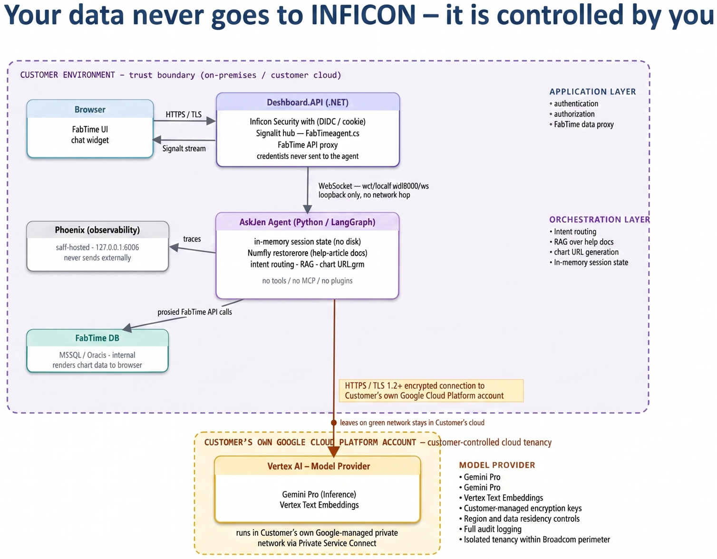
// From GTO
// From FtC
// From Vectara
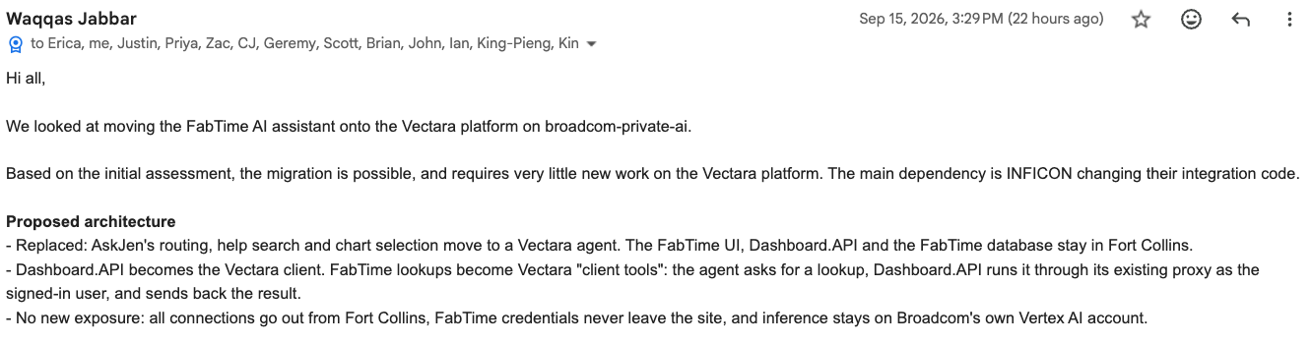
    - (7) (Seoul Design Issue Management Team) RF Power AMP Engineering Knowledge Base
      - lee.yu-seon@broadcom.com
      - 09/22/2026
        - Initial idea in clarification
      - 10/06/2026:
        - (Vectara) Pipelines are used to automate the ingestion of data.
          - https://docs.vectara.com/docs/pipelines/pipeline-concepts

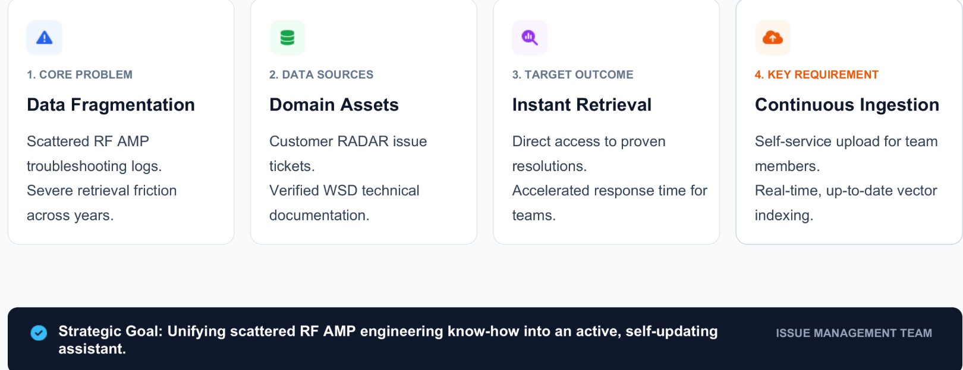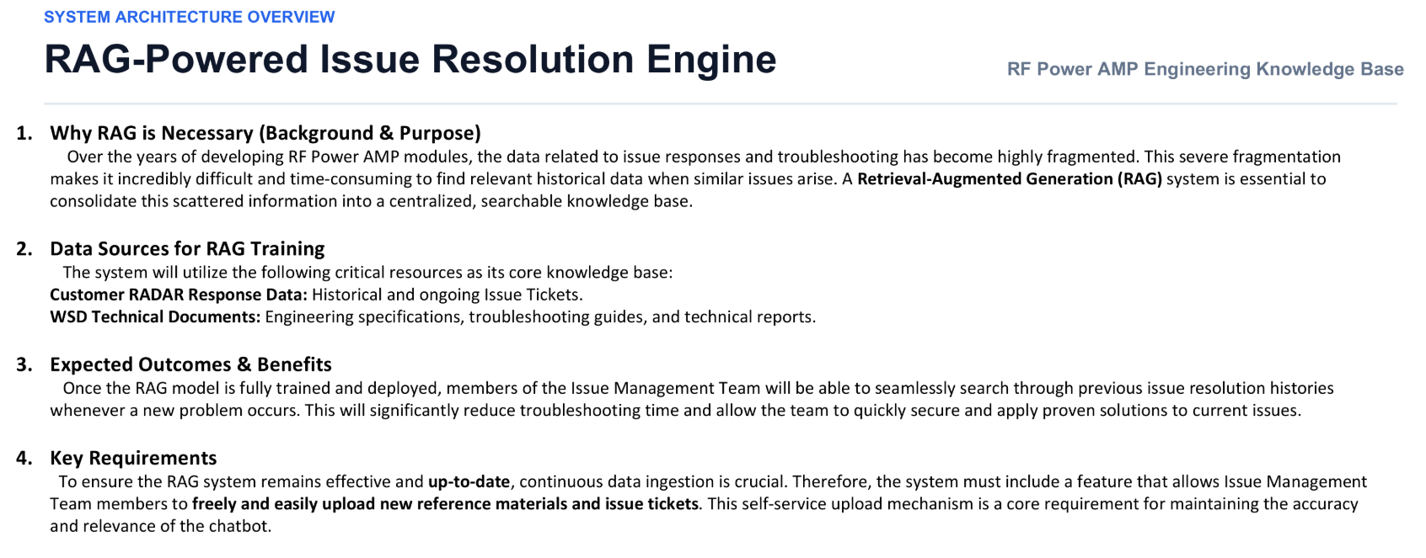

- (Yu Han) WSD @ Maverick: (1) DIY; (2) Auto-Grader; (3) FBar Design Analysis (4) WSD SW Team Jira Analyzer (In Progress)
  - Maverick is Broadcom GTO required Multiple Agent Pipeline Framework
  - OK to do basics without OneTrust. Any major flows should have a OneTrust
  - Container
    - https://dochub.gwd.broadcom.net/cloud-platform-engineering/os-instance-images/index.html
    - https://dochub.gwd.broadcom.net/cloud-platform-engineering/container-registry/index.html
    - https://dochub.gwd.broadcom.net/cloud-platform-engineering/container-registry/programming/python/index.html
  - Documents
    - https://maverick-docs.epc-vks.lvn.broadcom.net/docs/
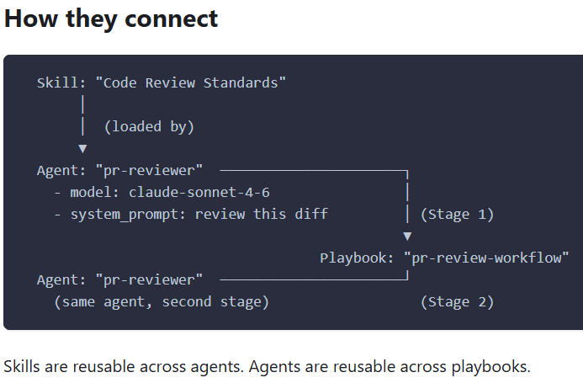
  - Details on how to get the Service Account integrated with Maverick
    - Steps to get new SA for Maverick
      - https://docs.google.com/document/d/1U2tKjP9p2f9gJEPeY0AN62LKzmURb0czn6RM1lcPc1U/edit?usp=sharing
      - https://maverick-docs.epc-vks.lvn.broadcom.net/docs/gui/service-accounts
  - Support Claude-Models for WSD
    - https://bsg-confluence.broadcom.net/pages/viewpage.action?pageId=1268006815&spaceKey=GTOMaverick&title=Model%2BSupport
  - Production Environment
    - https://maverick-wsd.acc.broadcom.net/
  - 06/18/2026:
    - Vectara is the Chatbot solution
    - Tanzu is where GTO hosts models for Vectara and MCPs. There is no direct user interaction for this.
  - 06/25/2026
    - CEG Kerry and Kyle provided intro demo
      - https://broadcom.zoom.us/rec/share/hwhvCCz_GGAu-QVHHKKVlbRfNCFxwY8QcZIPtQEaeZE1rJjZqGeIDXVTCMXdkQwD.k0m2ZYf-Cq72cEFZ
      - Passcode: BtJp.5O@
    - Clarified that Maverick is a Workflow or Pipeline framework, which allow multiple Agents to be orchestrated to achieve a more complex talk
    - 10+ other divisions are evaluating Maverick, mostly SW tasks, while WSD seeks for more hardware or manufacturing workflow cases
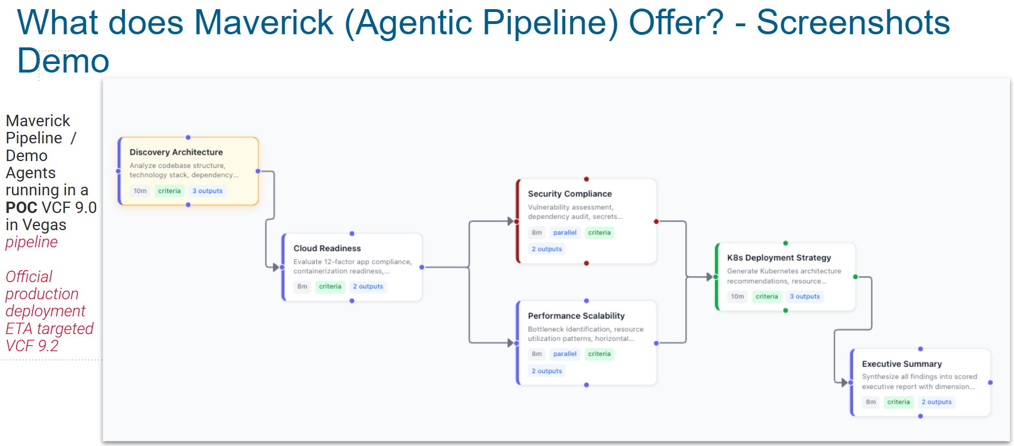
  - 06/30/2026:
    - Key notes:
      - This is a workflow, each node maps to specific Agent (RAG or not)
      - Native Agent still miss RAG support
  - 07/17/2026
    - Internally Yong-Wah/Foo-Kit’s propose 2 projects to work with Maverick team
      - FBAR die inventory agent
        - An agent can be used by proj. manager and circuit lead to have a realtime monitoring of inventory and lot start decisions.
        - Currently, PE and the circuit lead perform this as a semi-automated compilation.
      - FBAR TnR agent (more complex and requires more dev. resources).
        - An agent to interpret and consume the TnR request, and generate the TnR config to be pushed to mapgen4 to generate .a map and push to Inari and CB's TnR API.
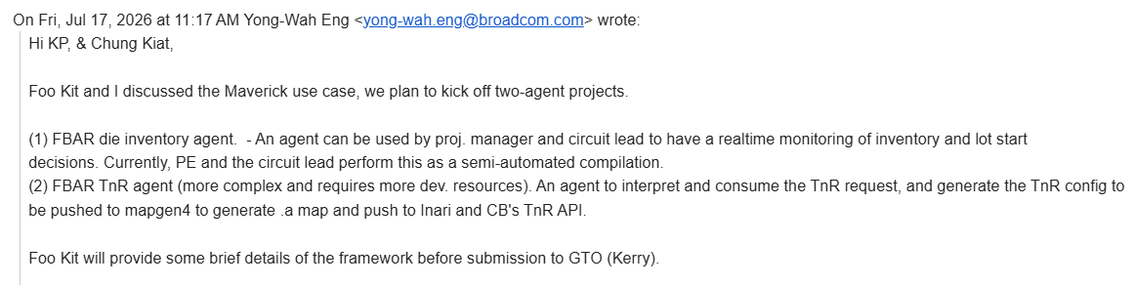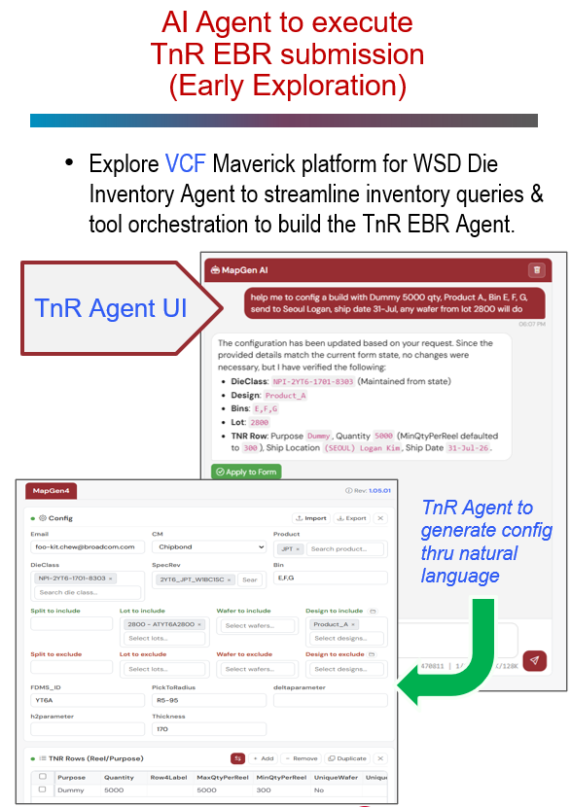

  - (1) DIY Agent
    - foo-kit.chew@broadcom.com
    - 07/24/2026
      - Foo-Kit officially raise support request as WSD AI Agent POC on Maverick, using “Die Inventory Agent”

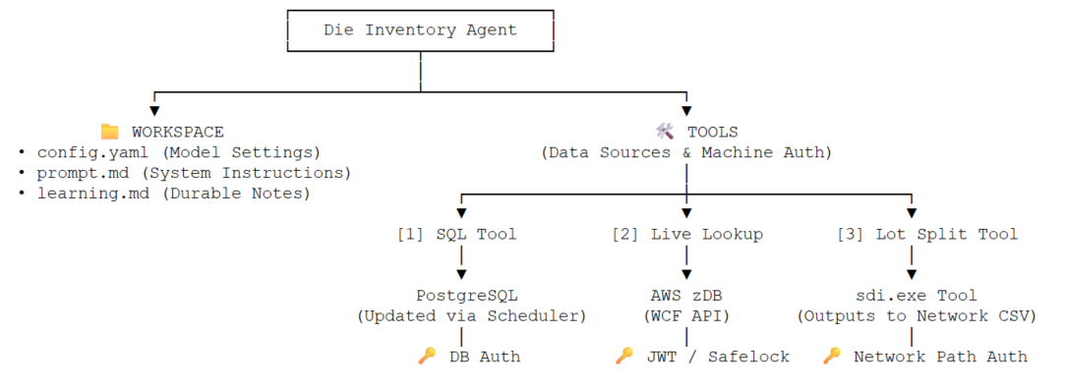
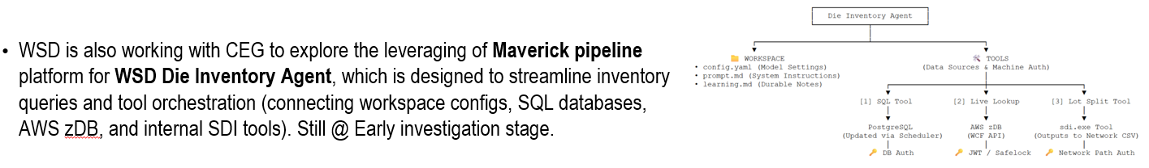
      - Technical specification and architecture @ https://docs.google.com/document/d/13vr0IfhmqFZKbWvZJkPv-GN2LzeK791Y9nRQI2oeJOg/edit?tab=t.h3uw2g23eawn

    - 09/08/2026
      - Foo-Kit update of Status
    - 09/29/2026:
      - Submitted oneTrust case 57517 for the custom MCP
        - Under review.
      - Gain access to upload the built docker image to Jfrog artifactory.
        - Image URL: mavwsd-oci-dev-local.usw2.packages.broadcom.com/mavwsd-docker-dev-local/wsd-mcp-die-inventory:v2.0
        - Service Port: 9085
        - Env token: `WSD_MCP_AUTH_TOKEN=WSDFBARNPI`
      - MCP server spec:
        - https://docs.google.com/document/d/13vr0IfhmqFZKbWvZJkPv-GN2LzeK791Y9nRQI2oeJOg/edit?tab=t.hxmevt4vnq7r
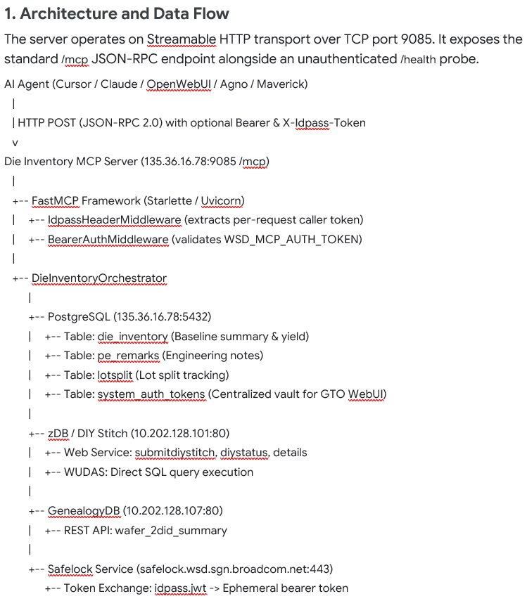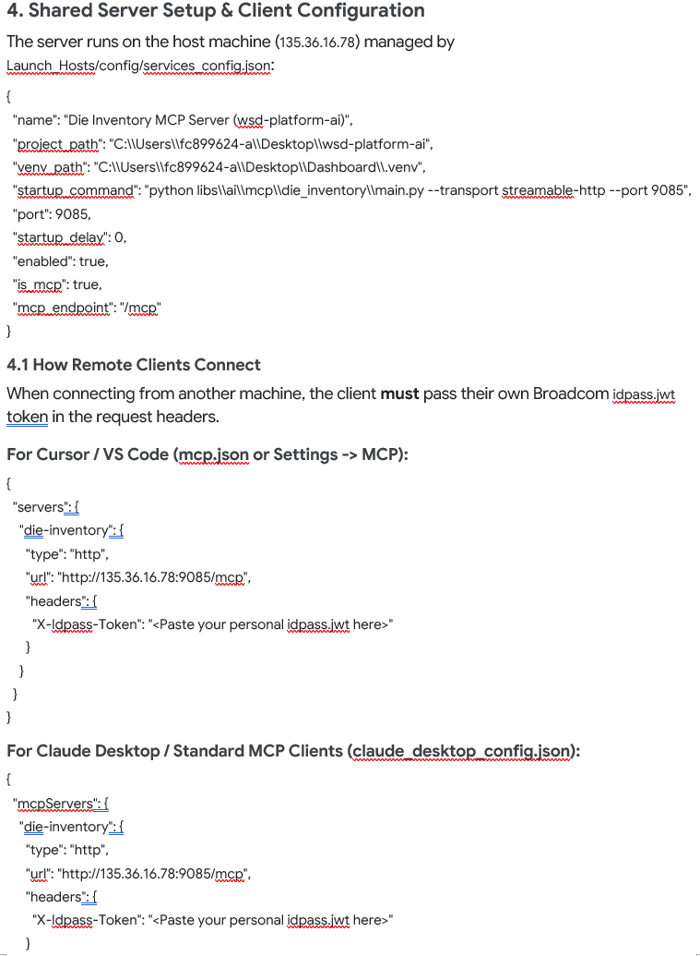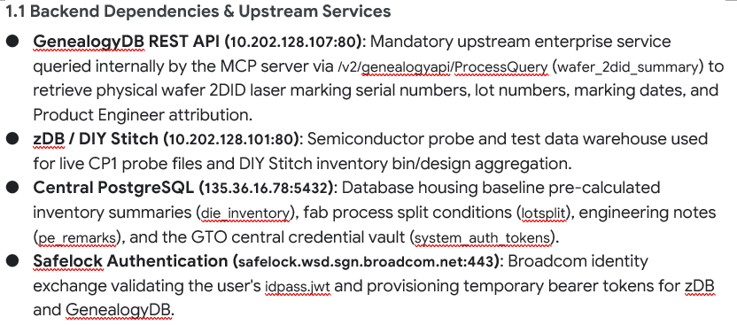

    - 10/06/2026:
      - Onetrust 57517 (FBAR NPI MCP Server) has been fully approved.
      - (Maverick) Since you have already deployed the MCP in your environment and Maverick is able to connect to it, you do not need to deploy the same MCP again within the Maverick environment.
  - (2) FBar Design Analysis
    - jie.zou@broadcom.com
    - myung-soo.kang@broadcom.com
    - Just on-boarded and in concept evaluation
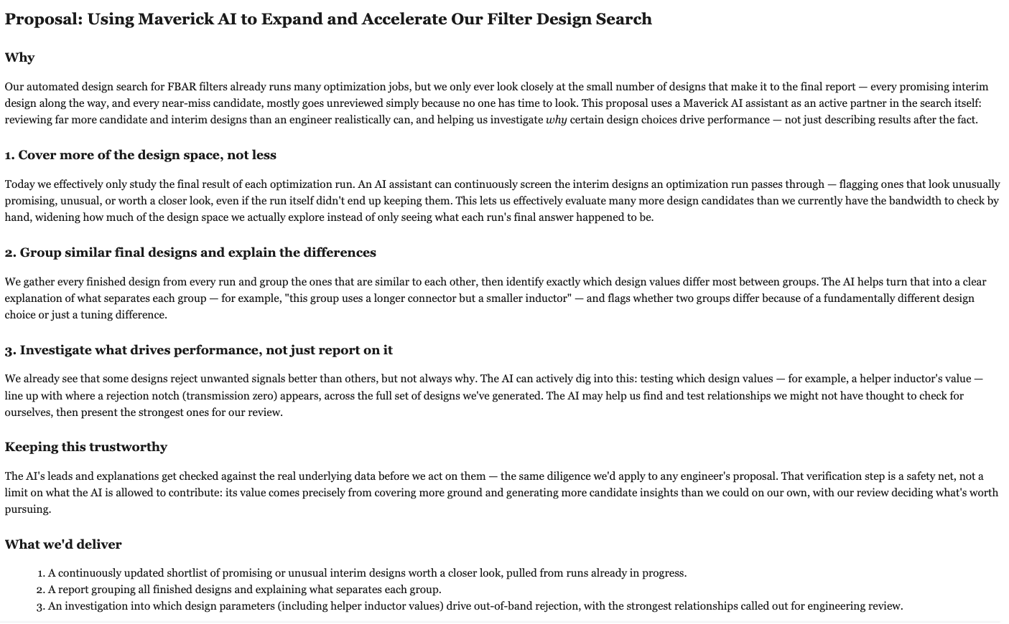
  - (3) MARA × MAVERICK GRADER PILOT
    - Check Maverick as better hosting for Vectara Auto-Grader Agent
    - brian.coss@broadcom.com
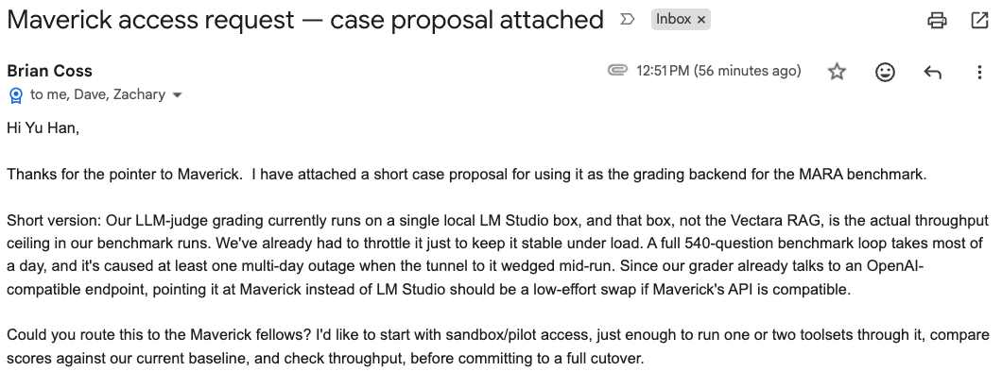
    - Vectara recommend to use Maverick-Grader
      - To do some pre-release checks, that would be the Vectara Eval-Framework. This feature is currently under development. … suggest to use Maverick grader
    - Brain progress update
      - https://docs.google.com/presentation/d/1ra_QHXw3UoPDLVnNqTXVU0zLcAE3ZqedtXDcJd5y1zo/edit?usp=sharing
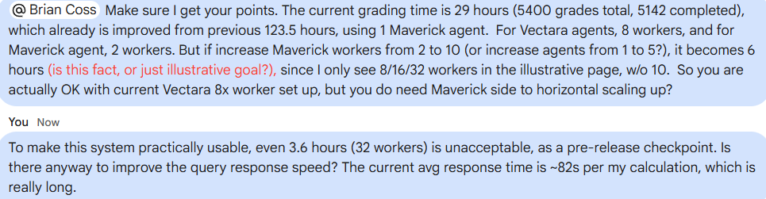
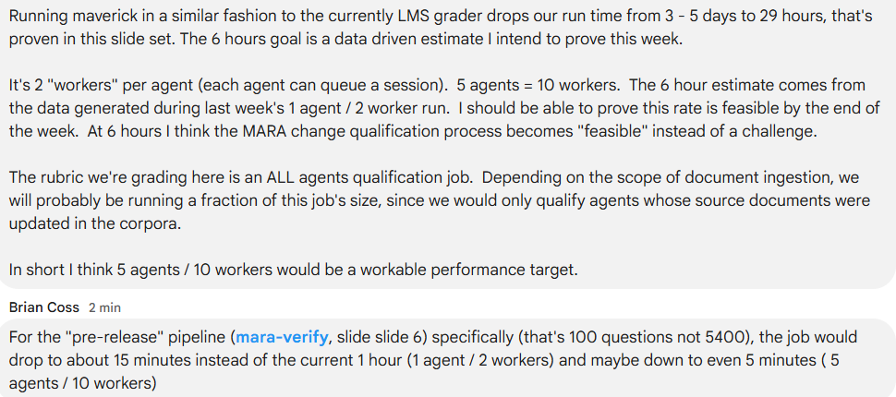
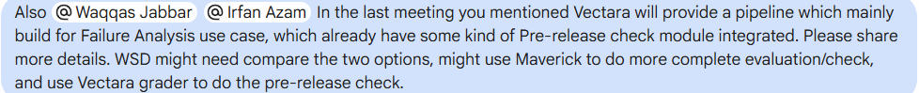
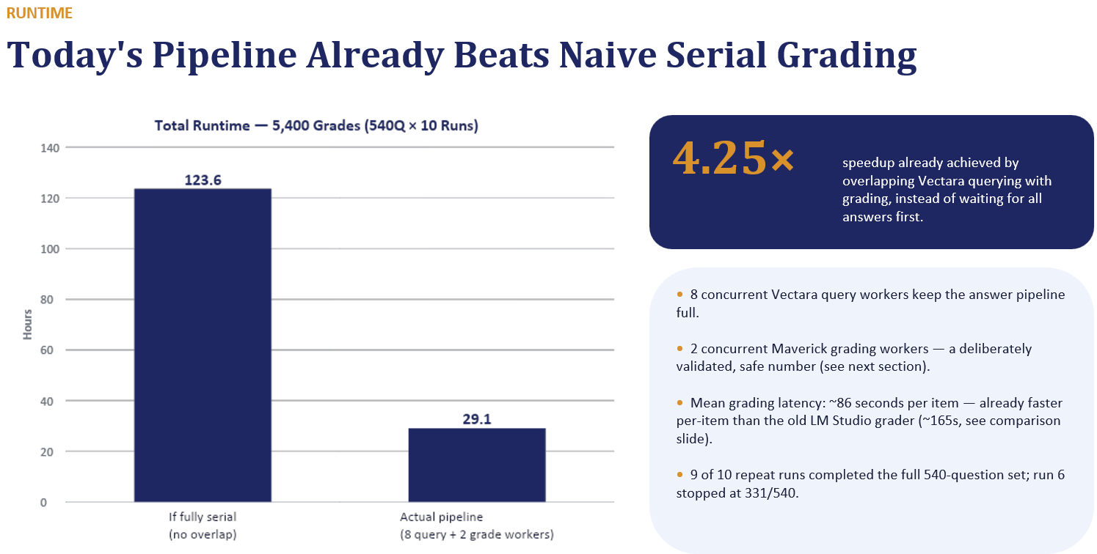
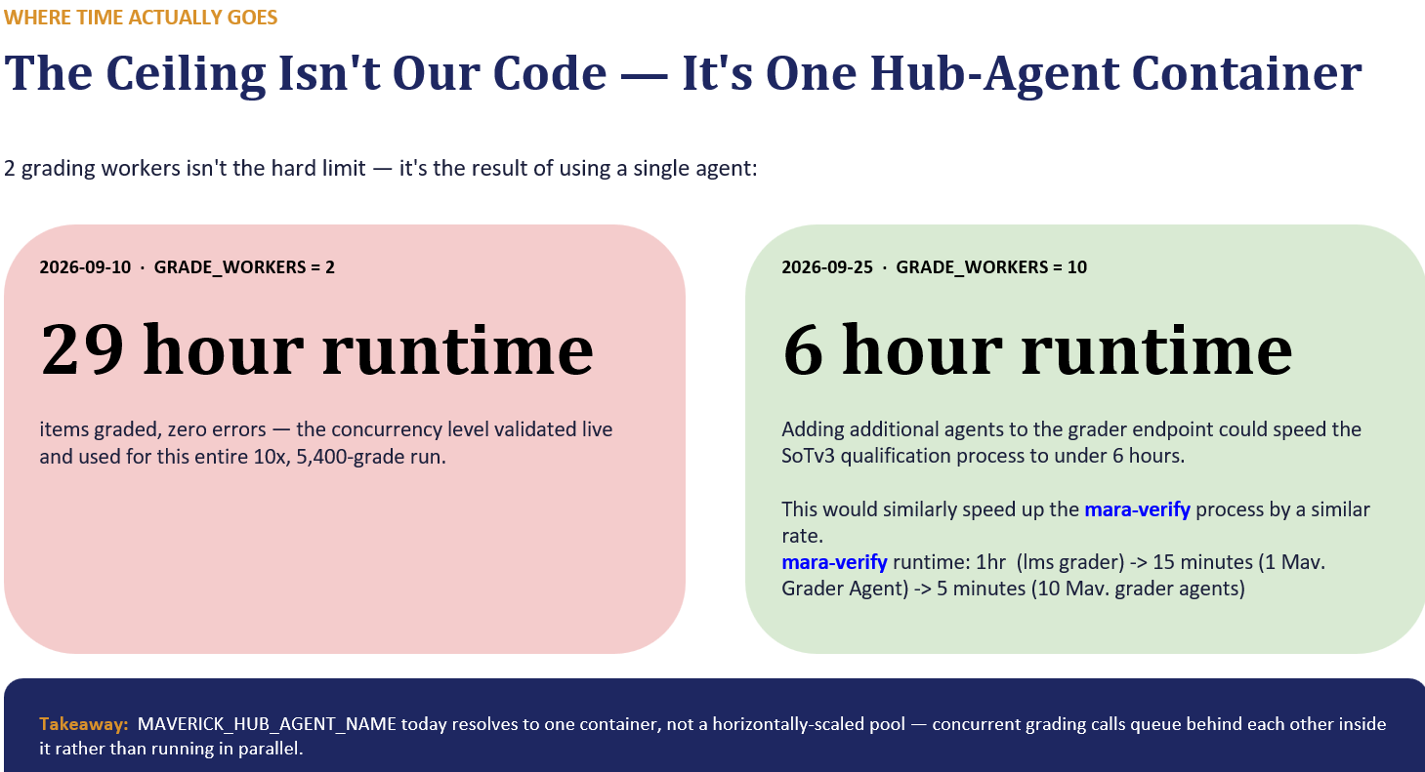
    - Next To-Do:
      - (MUST-HAVE) Request 10 Grade Workers concurrency from Maverick
  - (4) WSD SW Team Jira Analyzer
    - SW team has two JIRA groups
      - WSD Software Support
        - For 49x support topics tracking
        - https://jira.broadcom.net/projects/WSDSWS/summary
        - For topics & owners
        - https://docs.google.com/spreadsheets/d/1kC_PGeLxi3rE6_p0khHW-CswN3n1z_vNfMSRqplVg_I/edit?gid=504829157#gid=504829157
      - WSD SWD Plan
        - For major projects tracking
        - https://jira.broadcom.net/secure/PortfolioPlanView.jspa?id=59&sid=61&vid=164#plan/backlog
    - Together as SW team full workload, as covered in WWL
    - Build a Maverick Agent to analyze both JIRA groups to generate team update and analyze workload

- WSD GenAI Non-AI-CodeAssistant Non-Vectara Non-Maverick Activities (In Progress)
- The umbrella Broadcom Generative AI Portal
  - https://myportal.broadcom.com/group/gto/generative-ai
- Generative AI Usage, Policy and Approval Status for Various AI Tools and Services
  - List what we can use or can not use and how to get approval.
  - https://broadcomitsm.wolkenservicedesk.com/wolken-support/kbsearch/article?articleNumber=KB0023277
- Broadcom Gen AI Approved Use Cases
  - https://myportal.broadcom.com/group/gto/gen-ai-onetrust-requests
- GTO Hosted Gen AI POCs (Including Vectara RAG we are working on)
  - https://myportal.broadcom.com/group/gto/gen-ai-pocs
- Generative AI OneTrust Questionnaire Usage (Use Case Approval)
  - https://broadcomitsm.wolkenservicedesk.com/wolken-support/kbsearch/article?articleNumber=KB0023618
- KB for “On-Prem GTO Model Inferencing” @ https://docs.google.com/document/d/1lDOqe9BUjRnNcl20xP07r3KnEk1K2iin8Z7ve56chVY/edit?tab=t.0
  - mistralai/devstral-small-2505
  - meta-llama/Llama-4-Scout-17B-16E-Instruct
  - openai/gpt-oss-120
  - google/gemma-4-31B
- 07/09/2025: GTO GenAI Champion Updates
  - ALL AI use requires approval
  - Cloud LLM is ONLY for use with NON-critical IP
  - As in the middle of negotiations, GCA enterprise licenses are frozen at this moment.
  - Similar to WSD's feedback, all divisions' Cursor POC feedbacks are very positive, so # of licenses will increase for FY26, but WSD must ensure these are people that will actually use it and will be the “power users”
- 10/07/2025:
  - WSD self-train/Fine-Tune model idea from Rich team
    - In middle of concept eval
- …
- 11/20/2025:
  - Per GTO request and KP’s approval, update WSD GenAI Guideline (Policy) to high-light High Risk IP definition to continue the review process.
- 05/21/2026
  - Clarifying Non-Coding GenAI workload sharing with John Kim per his request
    - John Kim (YELLOW)
      - OneTrust review stage
      - POC Items #6, #8, #9, #10, #11
    - Yu Han (BLUE)
      - Vectara relevant Development stage
      - POC Items #7; Production items #1 and #2
- 10/13/2026:
  - (FtC) Construction project meetings and AI
    - The concern is whether WSD can share data/information to Contractor provided AI, especially w/ WSD FTC fab context
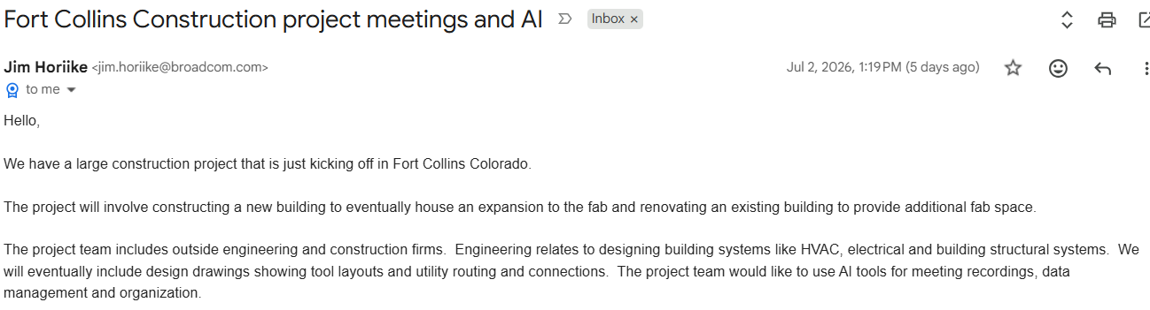
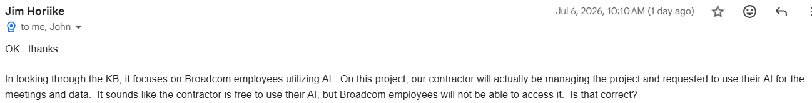

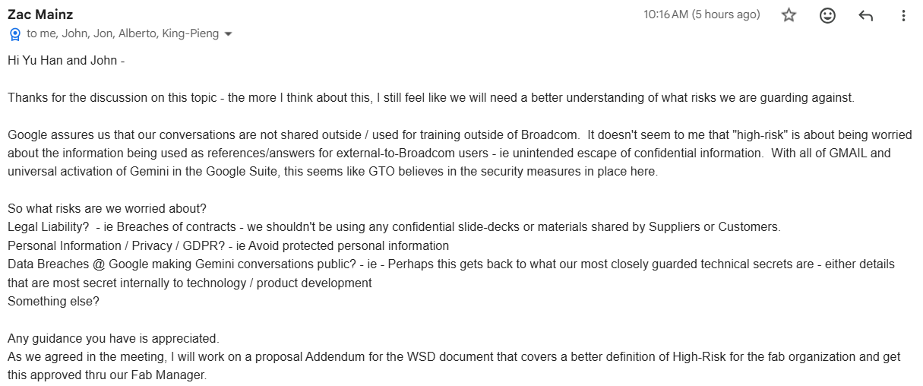
  - (FtC- Brain) “Vertex Inference Expansion” request
    - Mike approved: The ROI calculation based on the direct costs of technician time already show an obvious payback. When you add the value of shortening tool downtime (improving uptime % on our very expensive fleet of fab tools) on top of that, the benefit is huge.
    - In OneTrust review
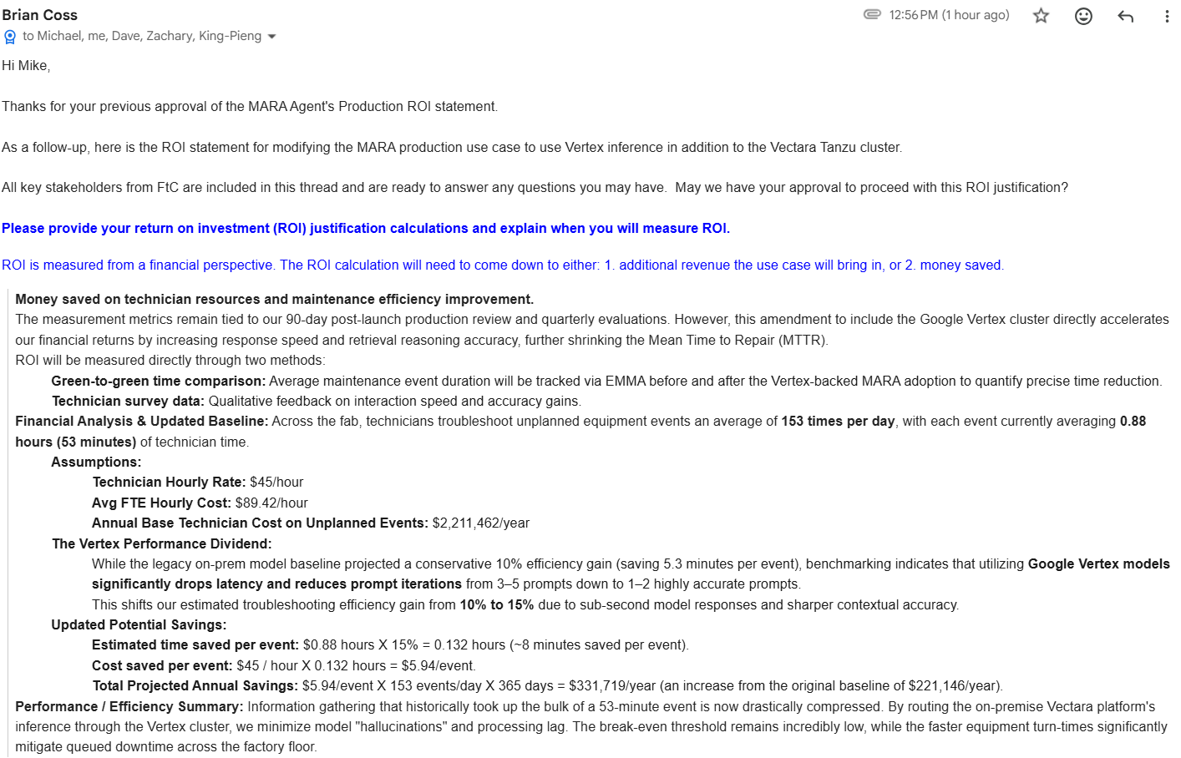

  - FtC “Use of Gemini for Data Extraction”
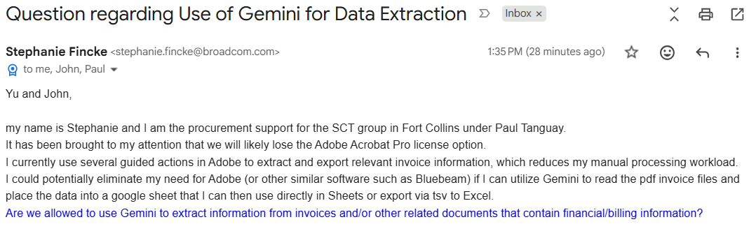
  - (FtC - Zac) Request clarification of “High Risk” approval
    - (Geremy) Highlight that BU OneTrust is still required even GTO already approved
      - Gemini.google.com "could" be used IF WSD submits a OneTrust documenting the use (rules for what files etc) and gets approval from your GM, legal, and security.
      - Cursor and Claude Code are approved by GTO, but approved for your BU because of the OneTrust request.
      - With the exception of 3 tools with low risk use cases: Zoom AI, Box AI, and Google workspace, everything else approved by GTO requires WSD to submit a OneTrust for review and approval.
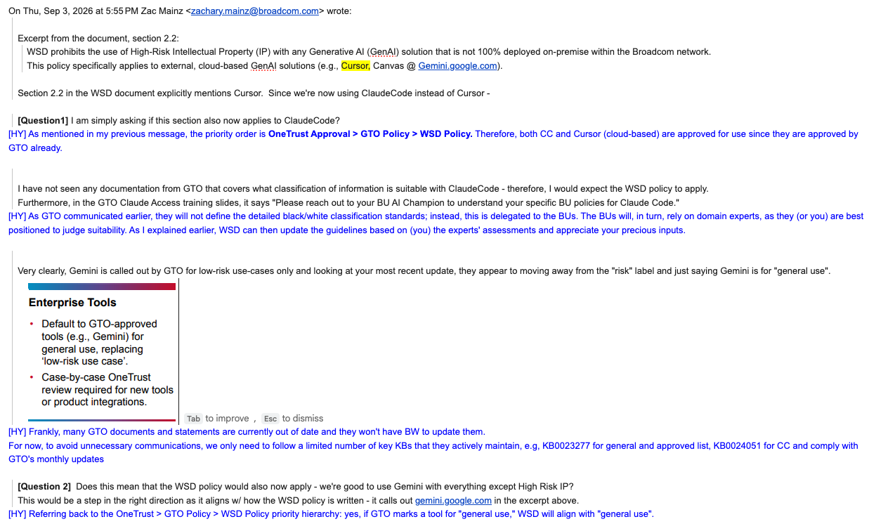
  - (Penang-Chung Sik) Defect Detection using AWS LLM
    - (AWS Bill) Shared technical evaluation result and cost analysis

    - 09/11/2026
        - Per Chung Sik, John Kim and Yu Han sync, decided to move forward for POC
        - Following items need be polished
          - Can’t use Claude model to avoid GTO’s 2P Charging Forbidden policy, need consider another frontier model on Bedrock
          - The key advantage is to avoid additional HC to take care of this 1~10K images classification workload, using LLM to do that job.
            - Monthly <2K
- Aug 2026 GTO GenAI Champion Monthly Update
  - https://broadcom.ent.box.com/folder/376987242791
  - Key notes:
    - …
    - IP and Source Code Definitions:
      - GTO has officially delegated the detailed definition of "IP and Source Code" to the individual divisions. Consequently, we should no longer expect definitive "Yes/No" guidance from GTO on these classifications.
    - Token Optimization:
      - Broadcom is officially rolling out initiatives for token optimization, tracking, and gateways. High-consumption users within WSD need to explore ways to optimize their usage. John and I will be joining the steering committee to ensure WSD aligns with Broadcom’s broader strategy.
    - CAP API Access:
      - In a positive development, GTO/A-Corp will begin offering API access to CAP, in addition to the current rigid portal approach. We hope WSD can leverage this to significantly streamline our token management.
- WSD GenAI Guideline V03 drafting
  - Pending for Mike’s sync with all WSD Design IP core teams to decide how to balance between using AI power vs IP Risk mitigation within WSD
- WSD GenAI Profile (513x members)
  - PDL@ WSD-GENAI-GENERIC,PDL
    - https://groups.google.com/a/broadcom.com/g/wsd-genai-generic.pdl/members
  - Chat Group @ WSD ClaudeCode/Cursor/Gemini User Group
    - https://chat.google.com/app/management/AAQAVZgn7ws
- Overall Summary
  - https://docs.google.com/spreadsheets/d/17sz1-CO1pAqDNc2am-mLUkxsh4fVq3W_cQJ0ew3_D2A/edit?gid=832999636#gid=832999636
  - WSD GenAI OneTrust chat group (17x members)
    - https://mail.google.com/mail/u/0/?pli=1#chat/space/AAQAo1XjpV4/
  - Internal WSD Vectara relevant chat group (12x members)
    - https://mail.google.com/mail/u/0/?pli=1#chat/space/AAQAy-q88DY
  - External WSD-Vectara-Sync chat group (15x members)
    - https://mail.google.com/mail/u/0/?pli=1#chat/space/AAQAE3jSbyk

- WSD ClaudeCode Integration (In Progress)
  - KB for “Generative AI Usage, Policy and Approval Status for Various AI Tools and Services” https://broadcomitsm.wolkenservicedesk.com/wolken-support/kbsearch/article?articleNumber=KB0023277
  - KB for “Generative AI OneTrust Questionnaire Usage (Use Case Approval)” https://broadcomitsm.wolkenservicedesk.com/wolken-support/kbsearch/article?articleNumber=KB0023618
  - WSD GenAI Guideline (Policy) to high-light High Risk IP definition to continue the review process.
  - KB for “Claude Code - FAQs” @ https://broadcomitsm.wolkenservicedesk.com/wolken-support/kbsearch/article?articleNumber=KB0024051
  - About CC Trainings
    - "Anthropic Professional Claude Architect Certification" is currently limited to Anthropic Partners, which Broadcom is not at this time, so the certificate program isn't an option. The only thing we currently have access to is: https://academy.claude.com/
  - Best Practice Guidelines (10+5)
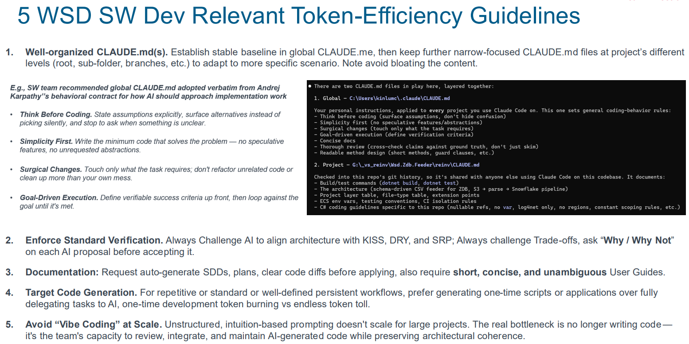

- SW Team Best Practice Guideline Check @ 09/18/2026
- 05/21/2026:
  - Per Greg/Aruna check, Claude CLI is approved while gemini-cli is NOT approved.
- 06/01/2026:
  - WSD 30K Budget (Complete)
    - Negotiated with GTO to increase June CAP from $11,474 to $30K
    - Mike and KP approved, WSD Financial also approved
    - Submitted to GTO and ready for on-boarding
  - CC Early Testing (Complete)
    - Select group of 15 WSD members — top Cursor users — successfully completed the CC early-testing session (May 15 to May 31), refer to https://docs.google.com/spreadsheets/d/1MrP7t0IWm4E_DASzeOc-h875yqfqh8tyaOVH3mtQ11M/edit?usp=sharing
- 06/03/2026:
  - (Yu Han) follow-up with Kushan, Vikram, Zachary, Mayur and Mark to gather feedback and suggestions from top users. Here are the key takeaways:
    - Token Availability:
      - WSD's #1 priority is ensuring that users (especially power users) have access to sufficient or extra tokens when needed for their tasks.
    - Best Practice Optimization
    - Individual Token Caps
    - Knowledge Sharing Sessions
- 06/08/2026
  - On-boarding WSD 125x members
  - Init budget $100 per CC user, extra $200 per Power user
  - Manager can reallocate within the team
- 06/09/2026
  - Shared SW learning with WSD AI community
    - https://ent.box.com/s/fa0sbs9x04d972vspwucfl3tl0uq8x3w
- 06/23/2026
  - Fast growth new users on-boarding, overflood the original CAP $30K
    - 222 trainings completed, 160 on-boarded, 145 received $1000 free credits.
    - Theoretical budget 31200 > 30K
    - Need internal re-route WSD funds to members who has no $1000 free credits.
- 06/26/2026:
  - Broadcom has reached “first 10K user $1K” promotion, new users will no longer get it
- 07/09/2026
  - CC use case and usage analysis shared by Hyun-Ho team (Design)
    - Must-Do: Justify WSD CAP increase to support Heavy Demand (especially from critical design teams, expect $1K/engineer/month)
    - Nice-To-Do: Improve token consumption efficiency
  - CC usage shared by John Kim team (DA)
- 07/10/2026
  - Confirm to cover CC & Mythos-Scan spending using new group #813201, under MU 480046
- 07/15/2026
  - BU GM/Finance approved CC CAP Increase (30K to 100K)
  - Enable HCTG (High Token Consumption Group) Setup
    - https://broadcom.ent.box.com/folder/388643272106?s=g2fnfhiug0i0shxdd874ydkoxf1d4e3f
- 09/01/2026:
  - Usage History and Budget AOP estimate: assume 20% growth until Jan'27, WSD will need ~286K for left over FY26, ~2.1M for FY27
  - Increase CAP from 100K to 150K (Approved by WSD, in Sync with GTO)
  - Clarification by GTO:
    - NO Claude CLI installation @ the “Shared” device
    - Also NOT allowed to install it on Windows servers such as WSD Winserver rdgwinsrv03.ams.broadcom.net, rdgwinsrv04.ams.broadcom.net, rdgwinsrv05.ams.broadcom.net. Need remove it as soon as possible if anyone has installed it there
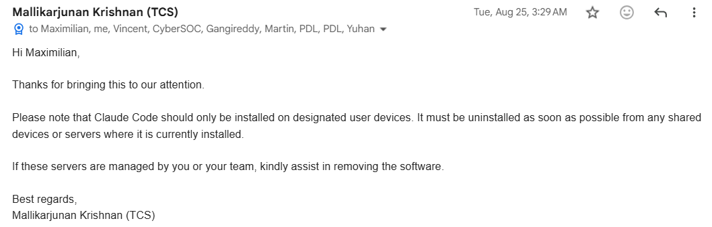
- 10/06/2026
  - Enabled automated credit adjust process (6 times per day, 4 hours gap, starting from PST midnight)
- 10/13/2026:
  - CAP Summary update (309 Active users @ Oct 2026)
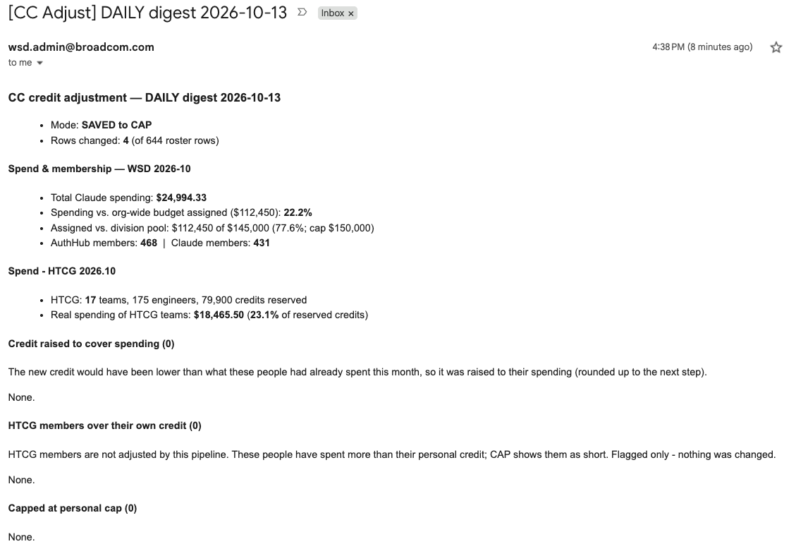
  - HTCG (17 teams, 175 engineers, $79900 reserved)
    - https://docs.google.com/spreadsheets/d/1zSs6Bnej3NtrfjeZujSYjsV9-ojda0MdXDTZPyJj_AU/edit?gid=987278085#gid=987278085
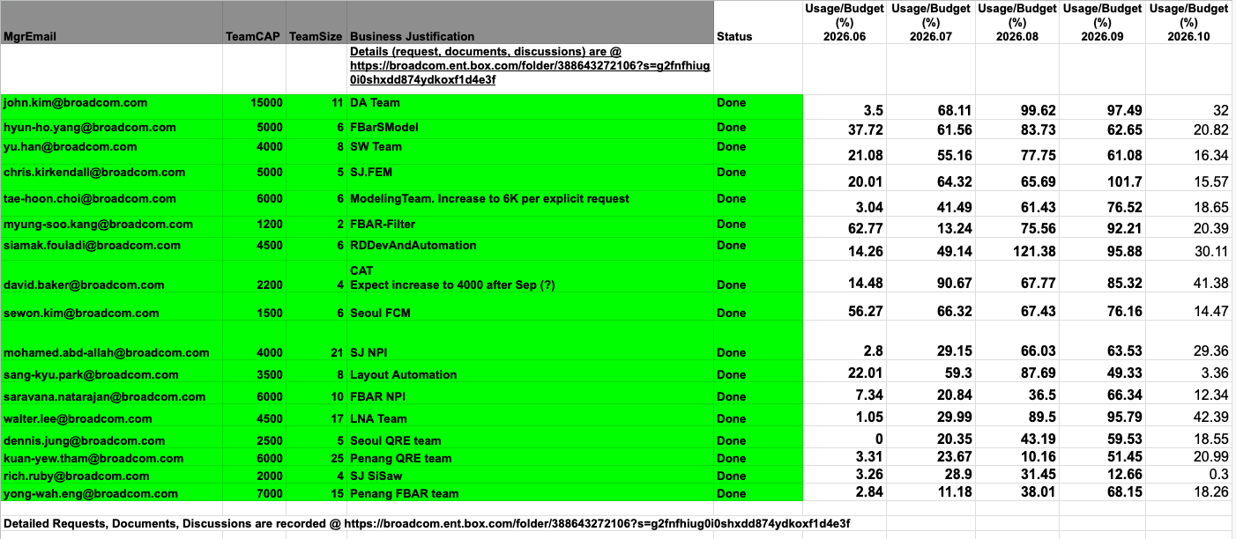
- WSD GenAI Profile (513x members)
  - PDL@ WSD-GENAI-GENERIC,PDL
    - https://groups.google.com/a/broadcom.com/g/wsd-genai-generic.pdl/members
  - Chat Group @ WSD ClaudeCode/Cursor/Gemini User Group
    - https://chat.google.com/app/management/AAQAVZgn7ws
- Summary
  - Overall Status Tracking
    - https://docs.google.com/spreadsheets/d/1zSs6Bnej3NtrfjeZujSYjsV9-ojda0MdXDTZPyJj_AU/edit?gid=51303483#gid=51303483
  - WSD AI Coding Power group (45x members)
    - https://docs.google.com/spreadsheets/d/1zSs6Bnej3NtrfjeZujSYjsV9-ojda0MdXDTZPyJj_AU/edit?gid=2020141767#gid=2020141767

- WSD Codex Integration (In Progress)
  - KB: Generative AI Usage, Policy and Approval Status for Various AI Tools and Services
    - https://broadcomitsm.wolkenservicedesk.com/wolken-support/kbsearch/article?articleNumber=KB0023277
  - KB for “Generative AI OneTrust Questionnaire Usage (Use Case Approval)”
    - https://broadcomitsm.wolkenservicedesk.com/wolken-support/kbsearch/article?articleNumber=KB0023618
  - KB for OpenAI (Codex & ChatGPT)
    - https://broadcomitsm.wolkenservicedesk.com/wolken-support/kbsearch/article?articleNumber=KB0024290
  - GTO published Codex training and initiate pilot process
    - "Introduction to OpenAI’s Codex, ChatGPT, and APIs"
      - https://brocade.csod.com/samldefault.aspx?ouid=12286&returnUrl=%252fDeepLink%252fProcessRedirect.aspx%253fmodule%253dlodetails%2526lo%253dd483add8-30ca-4048-9191-cb6002a09ae1
  - WSD GenAI Guideline (Policy) to high-light High Risk IP definition to continue the review process.
  - 09/27/2026:
    - WSD on-boarded Wave-1 17x members total
  - 09/30/2026
    - Many issues, both access and execution. GTO and Pilot community is trying and fixing.
  - 10/13/2026:
    - GTO expanded On-boarding with Wave-2
    - $550 GTO funded budget apply to both codex and ChatGPT for 2026 Oct spending
  - GTO Chat group:
    - https://chat.google.com/room/AAQAw6TI2bA?cls=7
      - Kin Lum
      - Chao Sun
    - Expect members to run Apple-2-Apple cross-compare

- WSD Cursor Sunset Plan (In Progress)
- KB for “Cursor Code Assist - FAQ” @ “https://broadcomitsm.wolkenservicedesk.com/wolken-support/kbsearch/article?articleNumber=KB0023386”
- KB for “Cursor Code Assist User Onboarding” @ https://broadcomitsm.wolkenservicedesk.com/wolken-support/kbsearch/article?articleNumber=KB0023366
- Trainings:
  - Required training: `Introduction to Cursor Code Assist`
  - Optional (very useful) training: `Cursor Code Assist - Feature and Best Practices`
- How to get support: 1.Support incident using “Generative AI” business service
  - provided OS, Cursor version, Network test, Request ID
- Cursor Deep-Dive
  - Generate a list to track any “interested” Cursor use cases members experienced to recognize high ROI areas and Best Practices – WSD SW Team Cursor "Interested" Case Tracking
    - https://docs.google.com/spreadsheets/d/1BUDpJbpuzRgLuz5oe9lPiVAJTwLb39mZ26bv0jpkt_U/edit?gid=0#gid=0
- Cursor (WSD) Best Practices
  - https://docs.google.com/spreadsheets/d/17sz1-CO1pAqDNc2am-mLUkxsh4fVq3W_cQJ0ew3_D2A/edit?gid=1021676700#gid=1021676700
- Cursor Licenses Control
  - License file @ https://ent.box.com/s/xfspb1csxq0sjpp2ehb50db7lrvp5b91
- 09/23/2025:
  - Cursor POC Complete
    - https://docs.google.com/spreadsheets/d/17sz1-CO1pAqDNc2am-mLUkxsh4fVq3W_cQJ0ew3_D2A/edit?gid=667112441#gid=667112441
  - Cursor Production OneTrust Case (Complete)
    - License fee $32 per user per month.
    - Production OneTrust Case #29279: “[WSD] Production Cursor to Increase Application Development and Delivery Efficiency, Anysphere (Cursor AI)” full passed GTO/Legal/CISO reviews
  - GTO offered monitoring dashboard: OKTA => Incorta GTO DevOps => Cursor Metrics => Usage Stats, Training, Users Tracking
- 11/20/2025:
  - Cursor Licenses Control
    - License file @ https://ent.box.com/s/xfspb1csxq0sjpp2ehb50db7lrvp5b91
    - ALL FY26 quota 120x are assigned.
    - 12/30/2025: Applied 1st rotation with 4 seats swapped
    - 01/13/2026: License control file format adjustment for budget control
    - 01/30/2026: Applied Feb 2026 License Rotation & On-Demand Credits Adjustment
      - User can check usage @ https://cursor.com/dashboard?tab=usage
    - 02/27/2026: Applied March 2026 License Rotation (5 seats) & On-Demand Credits Adjustment
      - User can check usage @ https://cursor.com/dashboard?tab=usage
  - …
  - 03/31/2026: (Yu Han) To prevent users from "burning their full monthly token quota on Day 1"
    - Default to Gemini: Global real-world workloads demonstrate that Gemini performs similarly to Claude in over 90% of scenarios. There is rarely a need to default to the significantly more expensive Claude model just to help their IPO.
    - Optimize Workflow: Use a "Plan with Claude, Build with Gemini" approach if you are Claude-believer. Use the high-cost model for complex architecture and the efficient model for the bulk of the execution.
  - 04/01/2026: Completed rotation in/out 18 seats plus credits adjustment for 04/01 cycle
  - 04/30/2026:
    - WSD Extra funds requests: Mike & KP approved extra 12K funds, on top of GTO’s $4800
    - Rotation: Completed 05/01 rotation with 16x seats swapped
  - 06/23/2026:
    - Skip 06/01 rotation cycle because GTO changed plan to NOT add new users any more
    - GTO request WSD to reduce seats from 120 to 83, starting from 06/25
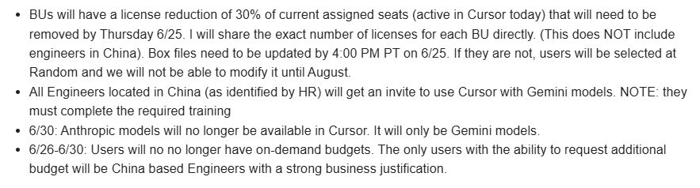
  - 10/13/2026:
    - Add China member qiaolong.lan@broadcom.com into Cursor access
    - Anthropic models no longer available in Cursor
- Cursor Power Group High usage members (45x members)
  - https://docs.google.com/spreadsheets/d/1zSs6Bnej3NtrfjeZujSYjsV9-ojda0MdXDTZPyJj_AU/edit?gid=2020141767#gid=2020141767

Section 4: In-Progress Projects

- Secure Vectara/GTO Production Environment (KinLum/Brian/Foo-Kit/Tingyu)
  - Target Date: 10/27/2026
    - Vectara @ VKS; LLM hosted @ Tanzu
  - Scope & Goal
    - Note this is project is NOT for Vectara Agents development and WSD G-AI portal development, instead it focuses on how to make the Vectara offered service persistent accuracy and high availability plus fast failure detection latency
    - For Vectara Agents relevant activities, refer to the separate support item “WSD @ Vectarag: (1) Clotho; (2) PRA; (3) MARA; (4) QRE Tzero; (5) FtC RAG-VectorDB Searching; (6) NFICON FabTime Co-pilot; (7) Seoul Design Team Issue Tracking Management”

  - WSD “EvalKit” Auto-Grader Mechanism (by Brain)
    - Reusable Evalkit for Automated Grading
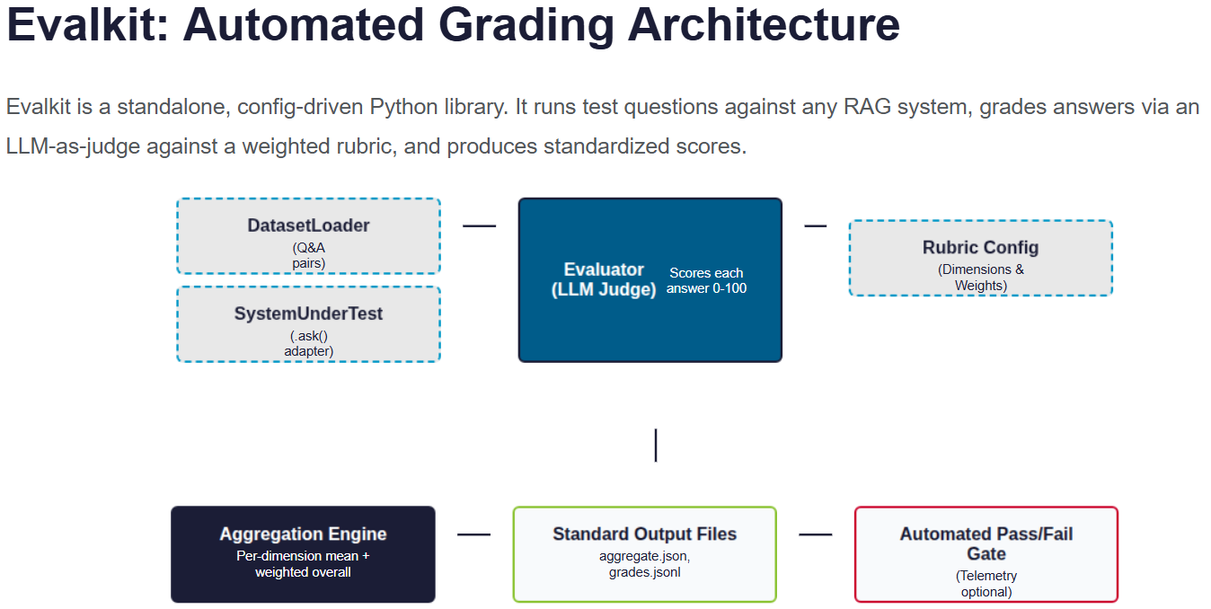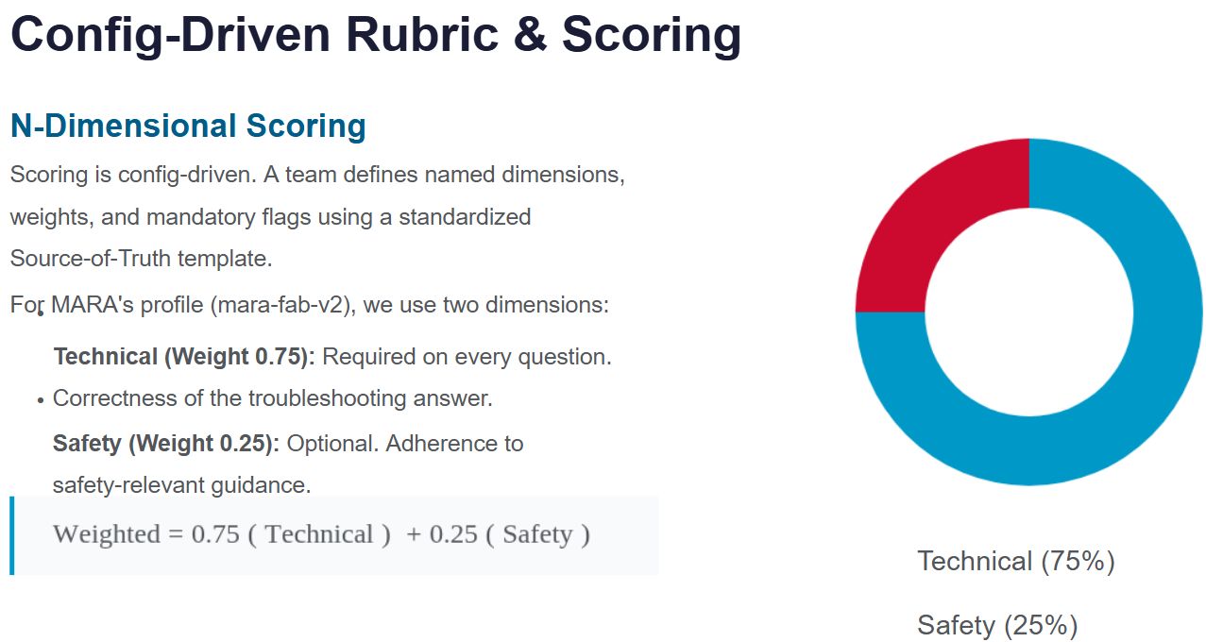
    - Integrate EvalKit w/ MARA and Enterprise Reuse
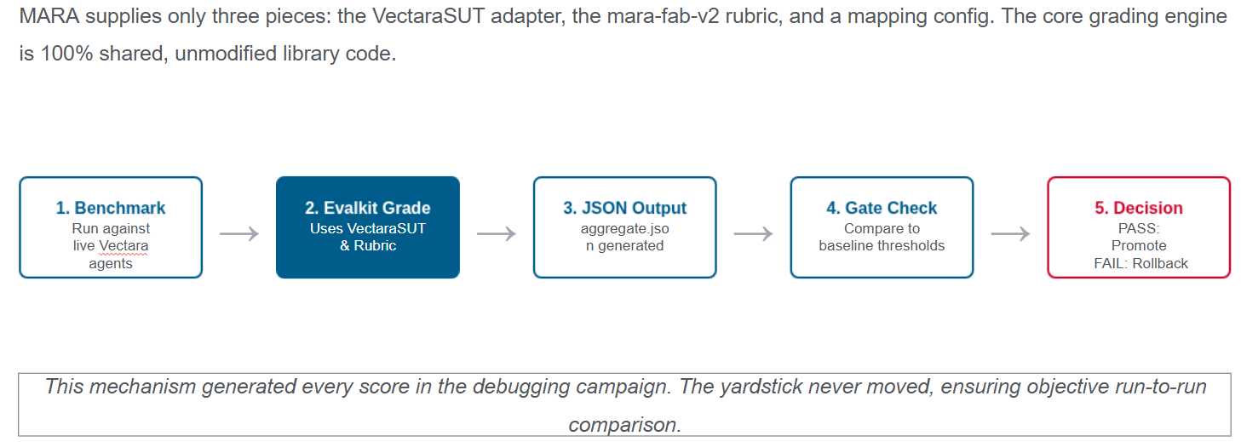
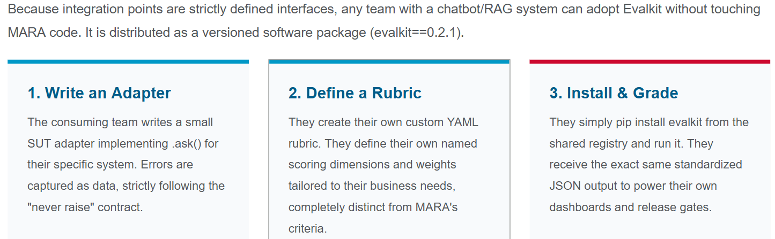
// From Clotho
// From MARA
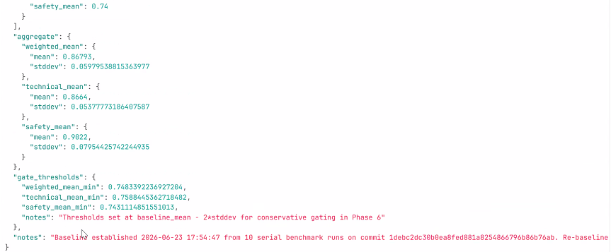
  - (Brain) Highlight Gaps which prevent MARA MR
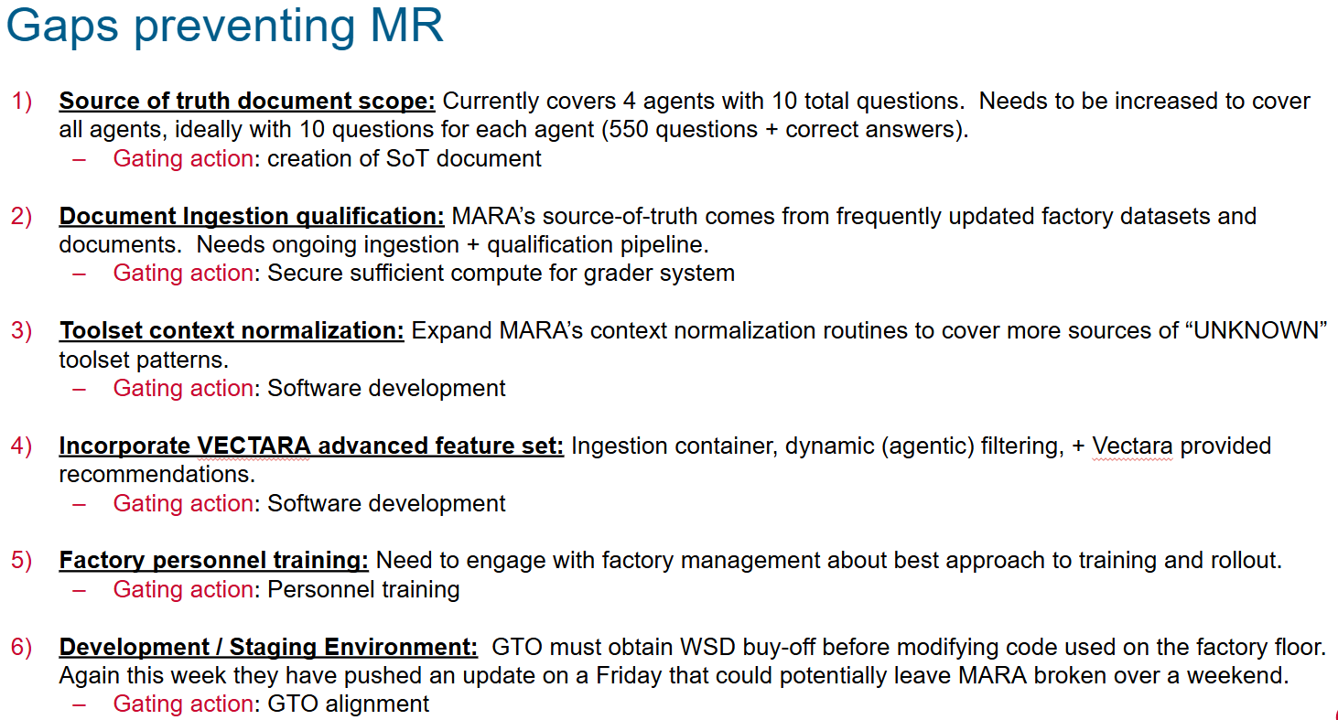
  - 08/18/2026:
    - Brain aligns with Vectara for guideline document
  - 09/01/2026:
    - WSD synced with Vectara/GTO based on KinLum/Tingyu’s workflow integration proposal plus Vectara Waqqas comments:
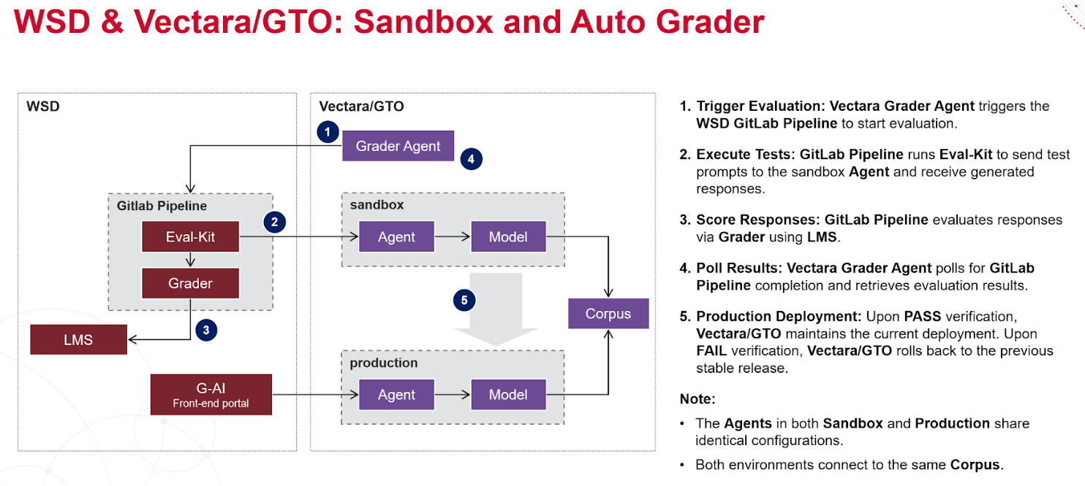
    - (Brain) The verify pipeline is completed and ready for Vectara integration testing.
      - A quick how-to guide.
        - Commit provenance: 2140bcd2a4c08d6a7c889247792c334f8487f9dd
    - (Brain) Confirmed WSD side is done, ready for PRA and Clotho Agents on-boarding
    - (Vectara/Brain) Final sync with live service monitor
  - 10/13/2026:
    - Due to LMStudio @ ETX performance limitation, migrate Auto-Grader to Maverick using Claude model (In Progress)
      - Vectara also recommend WSD to use Maverick-Grader instead of Vectara Eval Grader
    - Brain update
      - https://docs.google.com/presentation/d/1ra_QHXw3UoPDLVnNqTXVU0zLcAE3ZqedtXDcJd5y1zo/edit?usp=sharing
    - On-boarding lee.yu-seon@broadcom.com to Vectara RAG Agent work force to bring up Seoul Issue Tracking Management system
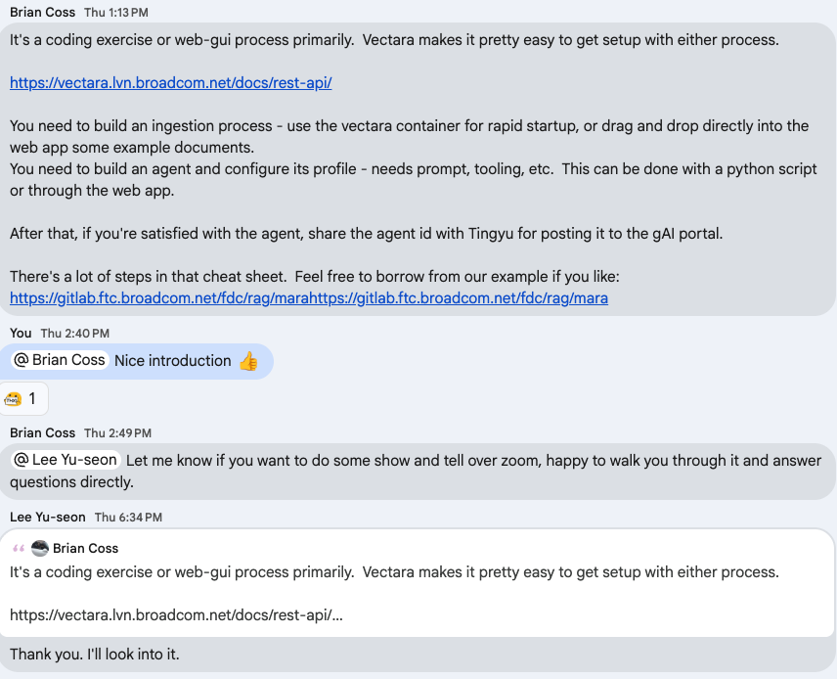
  - Check a better Generating model (through Vertex AI)

- Wafer pCD-V/U-Portal/Clotho-VII (In Progress)
  - Target Date: 12/04/2026
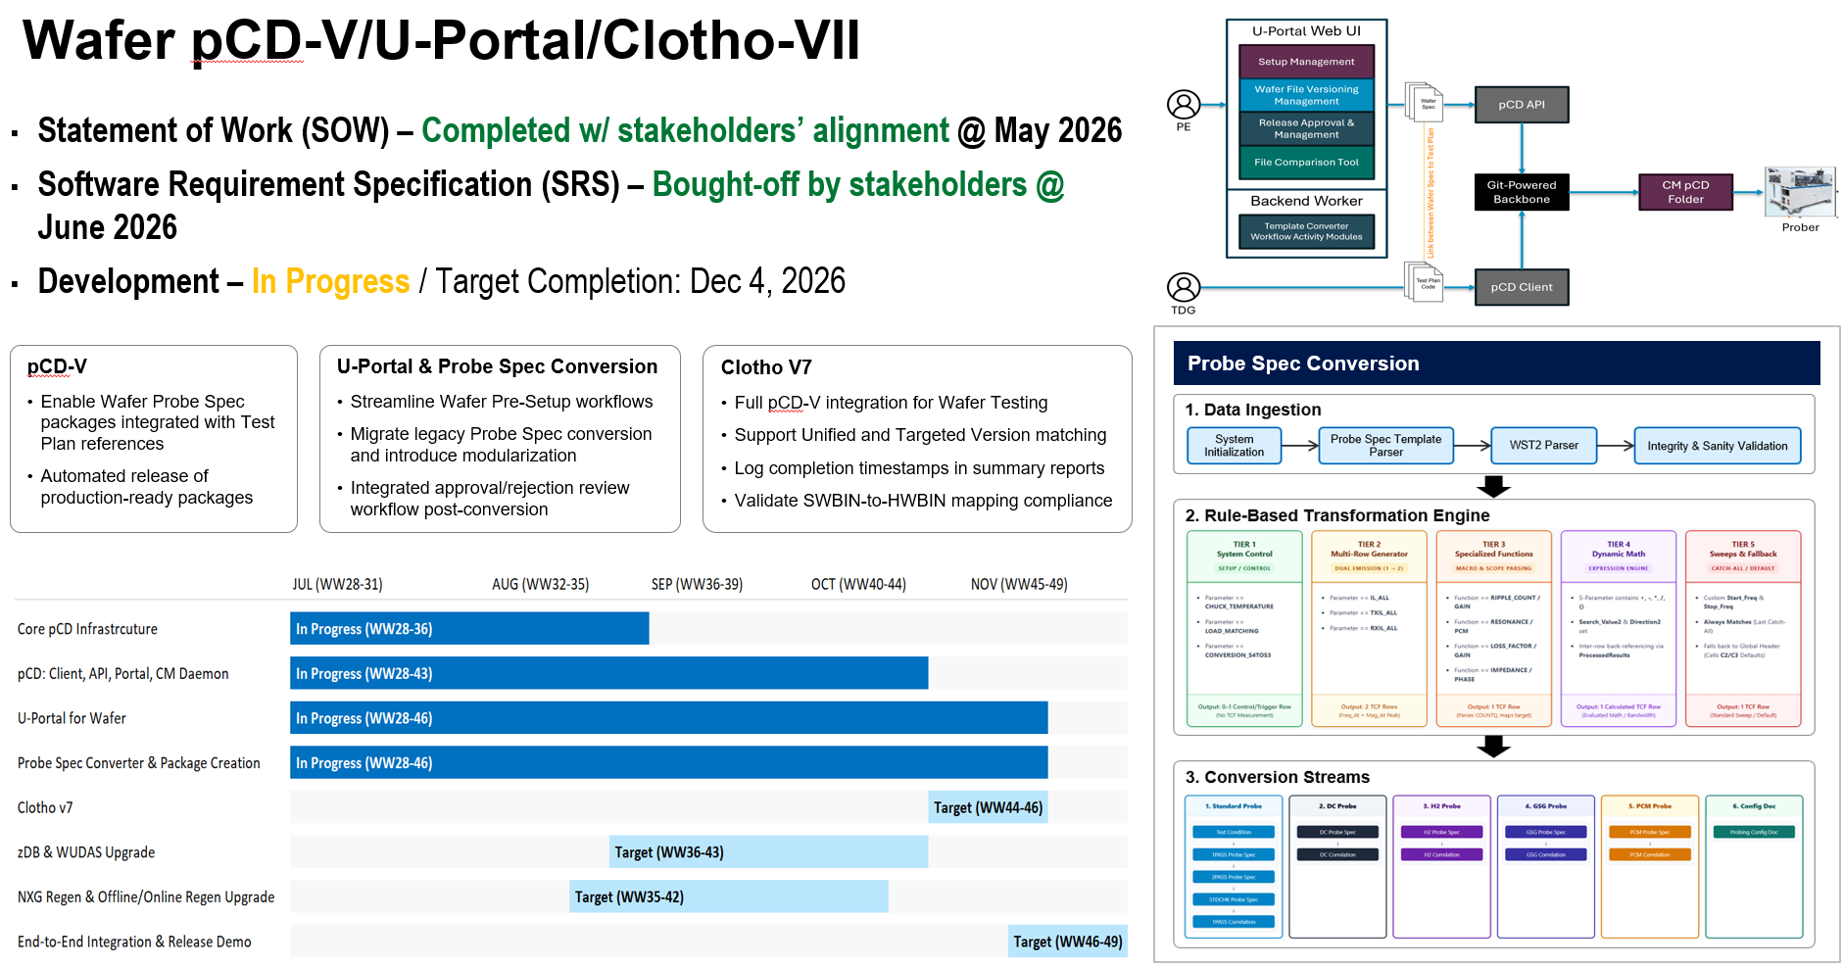
  - SOW (Chung Sik/Kin Lum + Team)
    - https://docs.google.com/document/d/1nMXk7T8CnNnIXg66xPxyIceLyZuKFquiZ61CO6TXbp4/edit?tab=t.0
  - Goal
    - pCD web portal as one-stop-solution for PE to manage probe programs, including to view, update & download any revisions of probe program.
    - Enhancement over current “Probe Spec Template” conversion into probe program package with more checks in place
    - “Hands-free” approach by wafer sort CM, all probe spec revision used for probing / regen will be controlled by Broadcom and well documented.
  - 03/31/2026:
    - Chung Sik will align with stakeholders to provide confirmation on the uncontrolled WST2 and determine whether to collect "cloned/updated" WST2 used by the test plan (In progress)
      - (CS) Yes since in the current process the inputs required to generate the final WST2 file is not available at the moment probe spec is released, we will need to provide the physical file at a custom folder. We will work on improving the checking and validation mechanism to avoid unintended edits. Collecting the cloned/update WST2 files used by test plan will help for this purpose
    - SW Internal (Code reading and researching) :
Wafer Test Plan Code Catch up w/ Optimization | YK, Choo-Yau, Kin Lum, Ken
Wafer Map Control UI Code Catch up w/ Optimization | YK/Choo-Yau, KinLum
    - (SW Team/Wafer Stakeholders) Initial ownerships & contact

 |  | SW Owner | Wafer Contact | Status
1 | pCD (Client Interface + Core Logic) | Tingyu, Kin Lum | KC, Kuok Liang
2 | U-Portal (GUI + Core) | GUI: Chao; Core: Choo-Yau, YK | YC, KC | (Chao/Choo-Yau/YK/Kin Lum) U-Portal Discussion with Wafer Contact (in progress)  03/16/2026 Discussion notes: https://broadcom.ent.box.com/file/2164279646022?s=91j1u83u50z5q11859ox4hcq35j0jfkt
3 | Clotho | YK | Kuok Liang
4 | zDB Feeder | Ken | CS, KC
5 | Offline Wafer Regen Tool | YK/Choo-Yau | Kuok Liang, KC
6 | OnLine Wafer Regen Tool | Kin Lum, Tingyu | Kuok Liang, KC

  - 05/04/2026: U-Portal Discussion with Wafer Contact (Chao/Choo-Yau/YK/Kin Lum) (Temp Hold)
    - Silicon: Sawnics => Chipbond (1 Pass)
    - FBar: FtC (No plan to cover by pCD Wafer) => Chipbond and INR (1 Pass, 2 Pass, H2 etc)
    - Current portal has 3 different spec conversion forms

FAB (SiSaw) Level Program (PCM) | Wafer Sort Probing Program
Sawnics | Chipbond and INR
http://wpdvwsort01.sgn.broadcom.net/cgi-bin/uploadpcmprobespec.cgi | NPI @ http://wpdvwsort01.sgn.broadcom.net/cgi-bin/uploadnpiprobespec.cgi | Production @ https://wpdvwsort02.broadcom.net/prod_prog_generator.html
 | 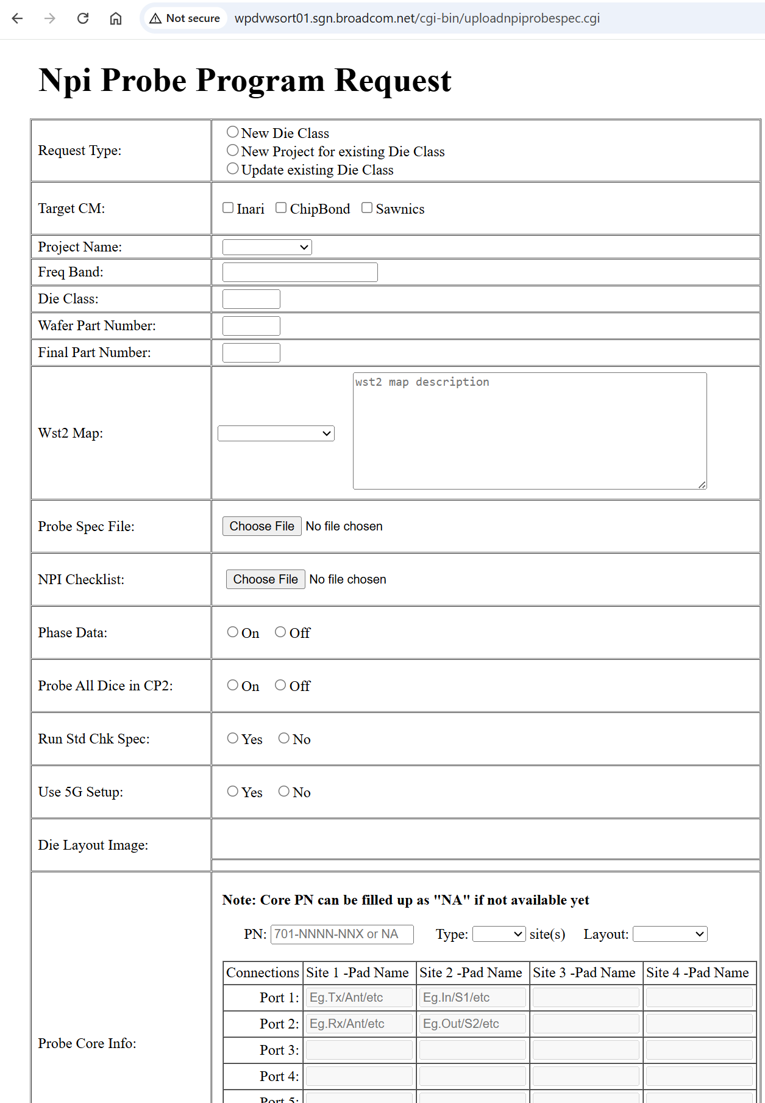 | 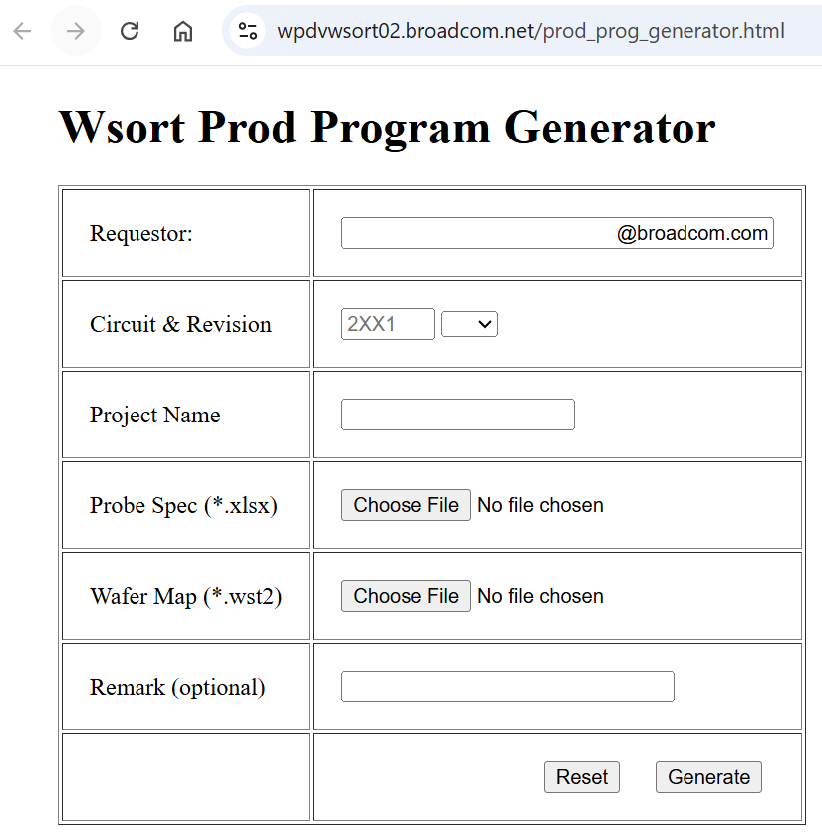

    - (ChungSik) Sync for next to-do plan to resolve the current deadlock
      - … Agreed that the discussion so far have not been as efficient as we'd have like. The thought was that we could get everyone in to live meeting and take part in the project definition, but at times the discussion could have gotten carried away. Based on my discussion with Kin Lum just now, we will try to keep that discussion offline, and only meet to confirm the alignment that we've made offline. I'll try to drive to conclusion with the stakeholders here and work with Kin Lum to make sure all requirements are clear.
  - 05/19/2026
    - (Kin Lum/Chung Sik) Detailed open items for sync and queries to stakeholders.
      - https://broadcom.ent.box.com/file/2230614832699?s=zi1oh59ibg1yc8h1gy4ckid4ytjodxsq
      - Agreed on:
        - Standardize the product tag naming convention between CB & Inari, for both NPI & Production processes.
        - Standardize SAWNIC product tag / wafer ID naming convention (follow FBAR standardization)
        - We agreed to extract the WST2 & Probe Configuration documents to CM shared folders for easier reference during H/W setup. (prior to Clotho loading)
        - Simplify the U-portal interface and move miscellaneous settings and layout information into the wafer probe template file.
        - NPI & Production to align on similar TCF / TSF revision tracking logic
      - Still gaps but not show stopper
        - Probe Spec conversion logic
      - Updated into SOW
        - https://docs.google.com/document/d/1nMXk7T8CnNnIXg66xPxyIceLyZuKFquiZ61CO6TXbp4/edit?usp=sharing
  - 06/15/2026: Requirements clarification
    - SRS (internal review completed):
      - https://ent.box.com/s/pwh0o16odylq4af7cb5nxi0r0ih3j0kc

    - Modules design
      - (Kin Lum/Chao/YK/Choo Yau/Tingyu) U-Portal and Probe Spec conversion design (in progress)
        - https://broadcom.ent.box.com/file/2253251611155
      - (Kin Lum/Ken/YK/Choo Yau/Tingyu) Targeted Version & Unified Version design (in progress)
        - https://github.com/wsd-broadcom/WSD.Framework.pCD.Client/blob/81d4774a1d231ffff12b55209f960a65316ce136/_md/SDD_PCD-V_UnifiedTargetedVersion.md
        - https://github.com/wsd-broadcom/WSD.Framework.pCD.Client/blob/81d4774a1d231ffff12b55209f960a65316ce136/_md/SDD_Wsd.Pcd.VersionResolver.md
      - (Chao/Kin Lum) Getting TCF/TSF from git for compare (in progress)
        - https://github.com/wsd-broadcom/WSD.Framework.pCD.Client/blob/81d4774a1d231ffff12b55209f960a65316ce136/_md/SDD_PCD-V_FileFetcher.md
    - Send SRS draft to stakeholders for review
  - 06/26/2026
    - Received buy-off confirmation from all PE stakeholders. move forward into development stage
      - Chung Sik
      - FBAR NPI - @Kwan Chien Chan
      - FBAR Production - @Zuga Ong
      - FBAR TDG - @Kuok Liang Koh
      - SISAW - @Zachary Schaffer
  - 09/08/2026:
    - (Chao) Migrate current UPortal Website from Kendo UI to React (Completed)
    - (ChooYau/YK) Found PERL script and VB6 script on YC’s portal.
    - (Kin Lum) PCD Web API for reference package (completed)
      - API for Test Plan Reference Package - SDD, IMPL (completed)
      - API for UPortal worker/PCD library for creating package- SDD, IMPL (completed)
    - (Kin Lum) Library for getting package files - for U-Portal and Online Regen - SDD & IMPL, Guide (completed)
    - (Kin Lum) Library for Unified/Targeted Version resolver - SDD, IMPL (completed)
    - (Kin Lum) Upgrade the pCD Daemon endpoint for downloading version matching data - SDD, IMPL (completed)
  - 10/06/2026
    - (ChooYau/YK) Spec Converter Round #1
      - Completed round#1 and send the outputs for stakeholders review - Stakeholder bought-off (Completed)
    - (Tingyu/ChooYau) Probe Spec Converter & pCD package creation worker integration (completed)
    - (Ken) Update zDB Transfer to support pCD-V NPI/Production trace (completed)
      - Not schema driven
    - (Kin Lum) pCD library for loading test plan reference SDD, IMPL, Test (completed)
    - (ChooYau/YK) Spec Converter Round #2 (completed)
  - 10/13/2026
    - (YK/KinLum/KP) Support Kuok Liang’s trial migration of wafer test plan to Clotho V6 (Pending)
      - Kuok Liang plan to start from late Sep
    - (Chao) U-Portal preview released to wafer team to collect feedbacks
      - https://uportal.wsd.sgn.broadcom.net:9001/
// Landing page
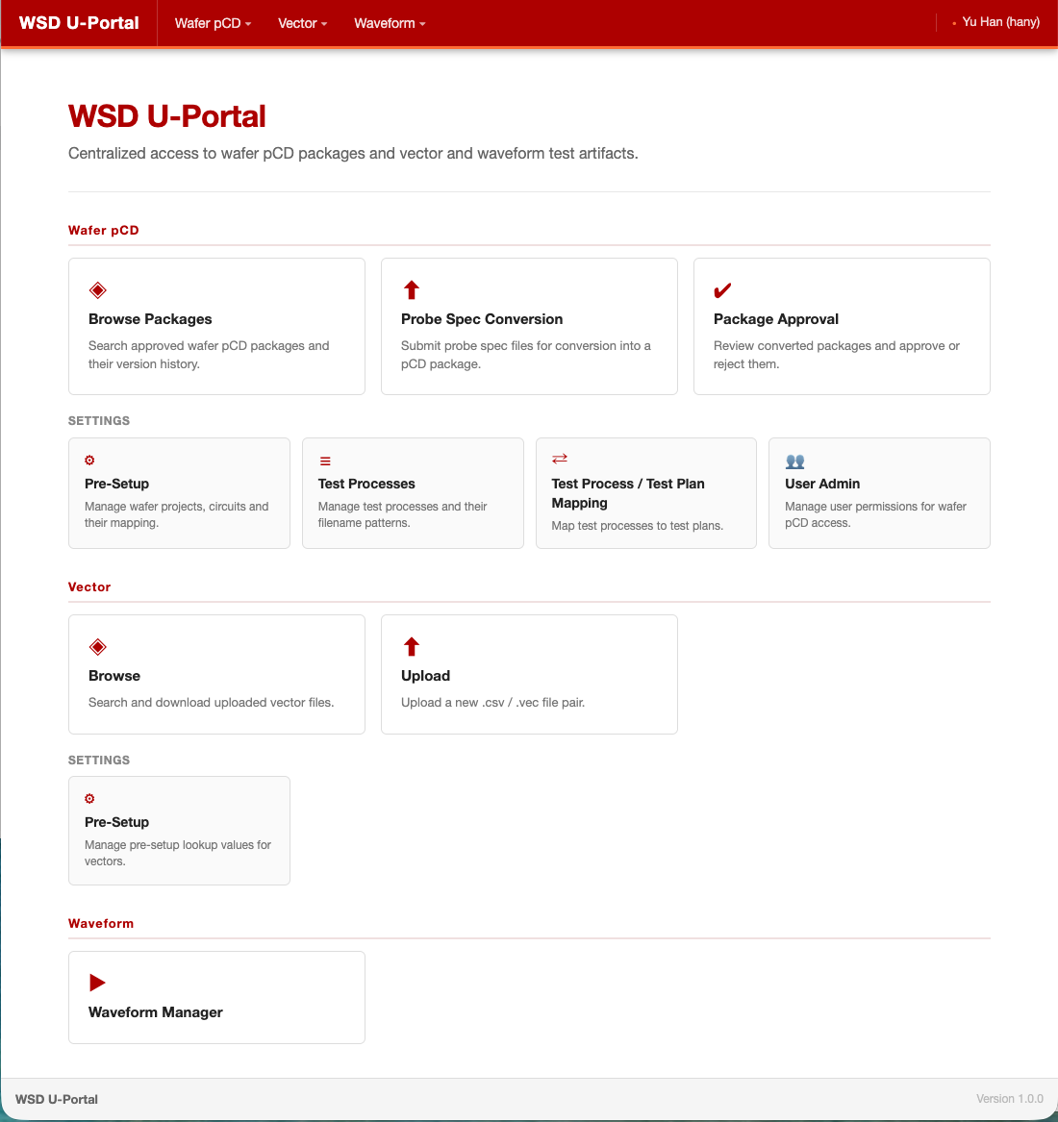

// (I) Browse Package
// (I.1) Package content Diff
// (I.2) Excel Diff
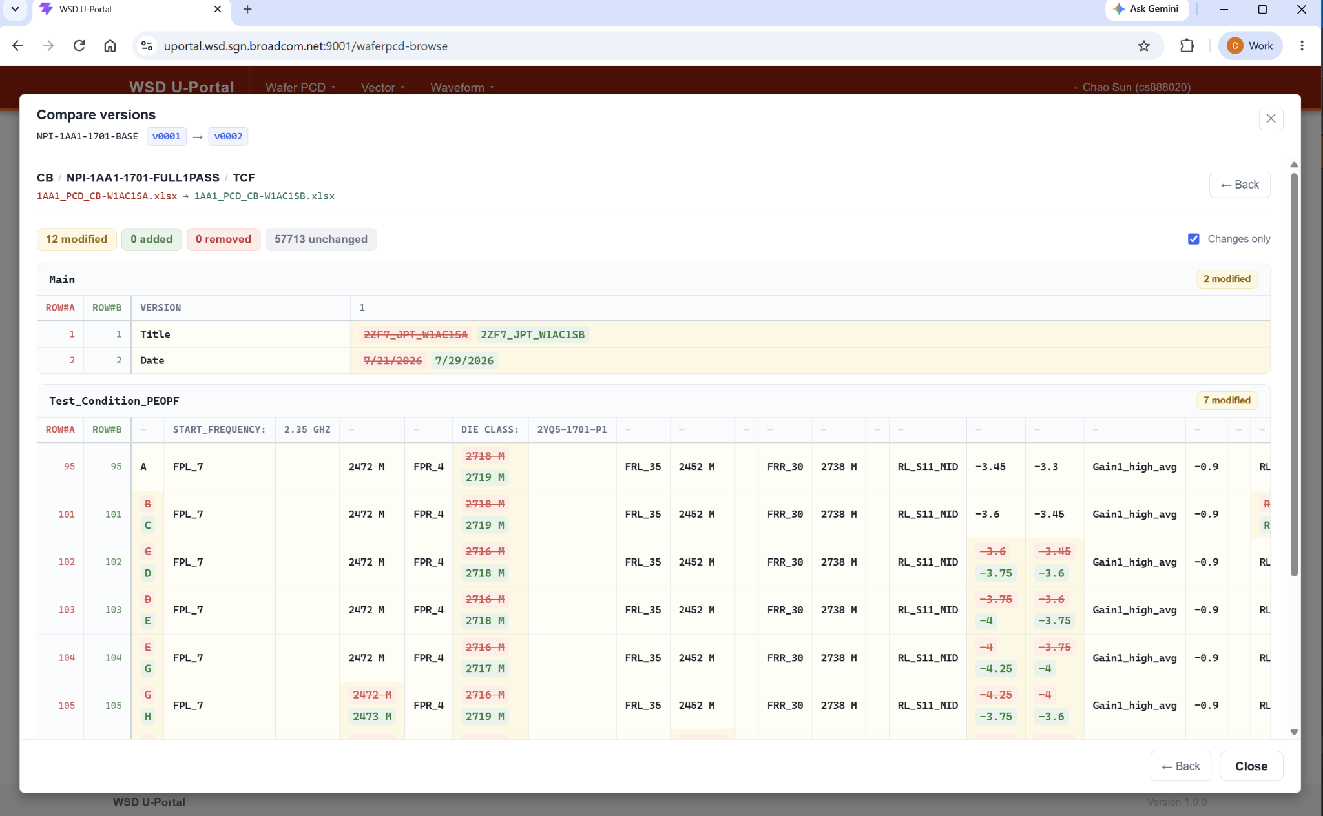
// (II) PCD Package Conversion
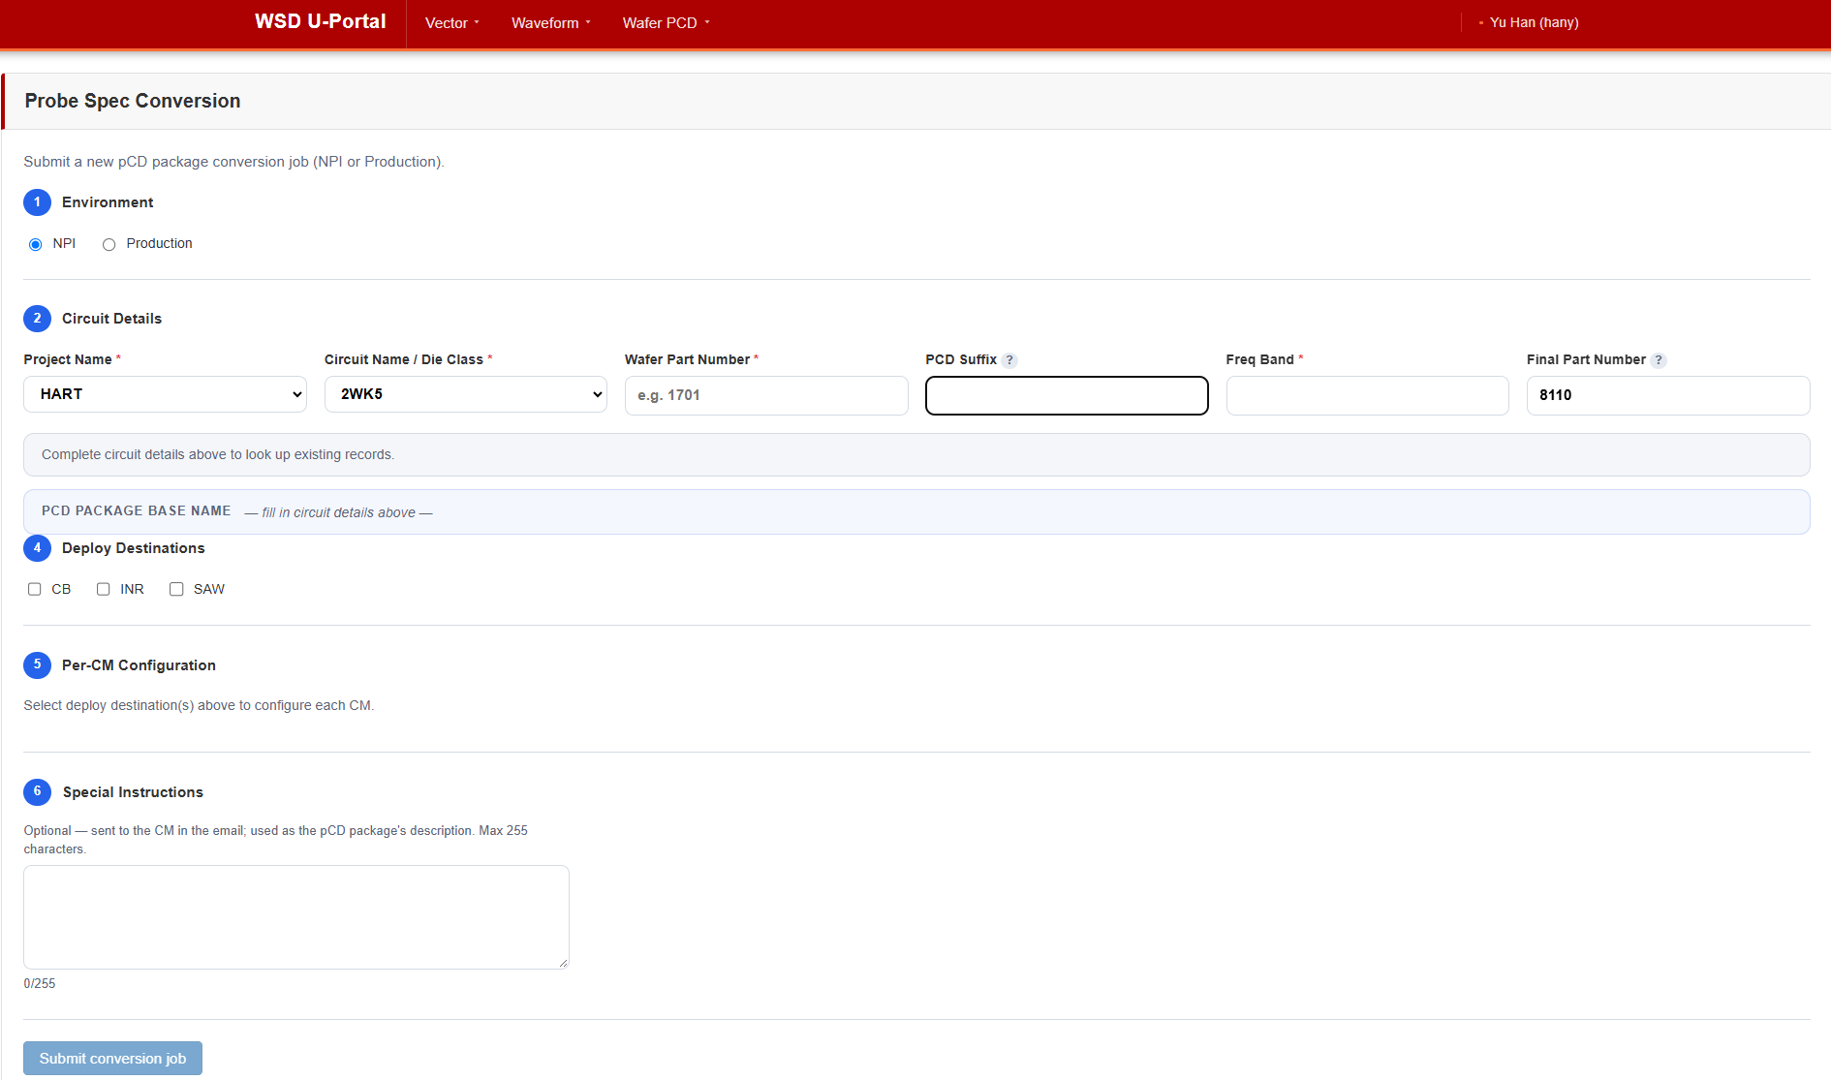

(III) PCD Package Approval
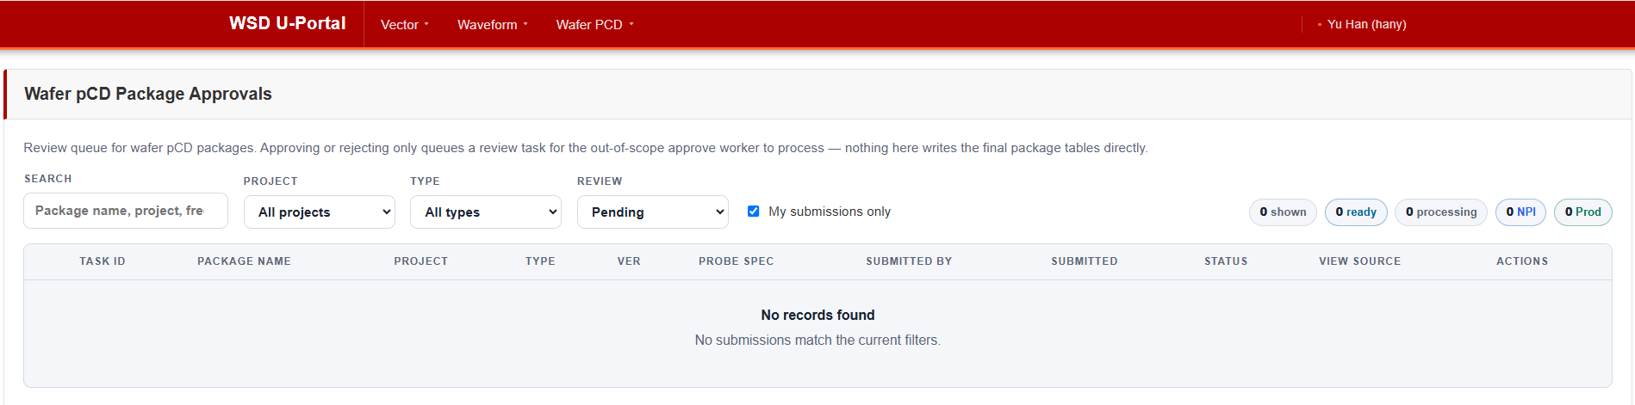
// (IV.1) Pre-Setup (Project-Circuit)
// (IV.2) Wafer Test Process
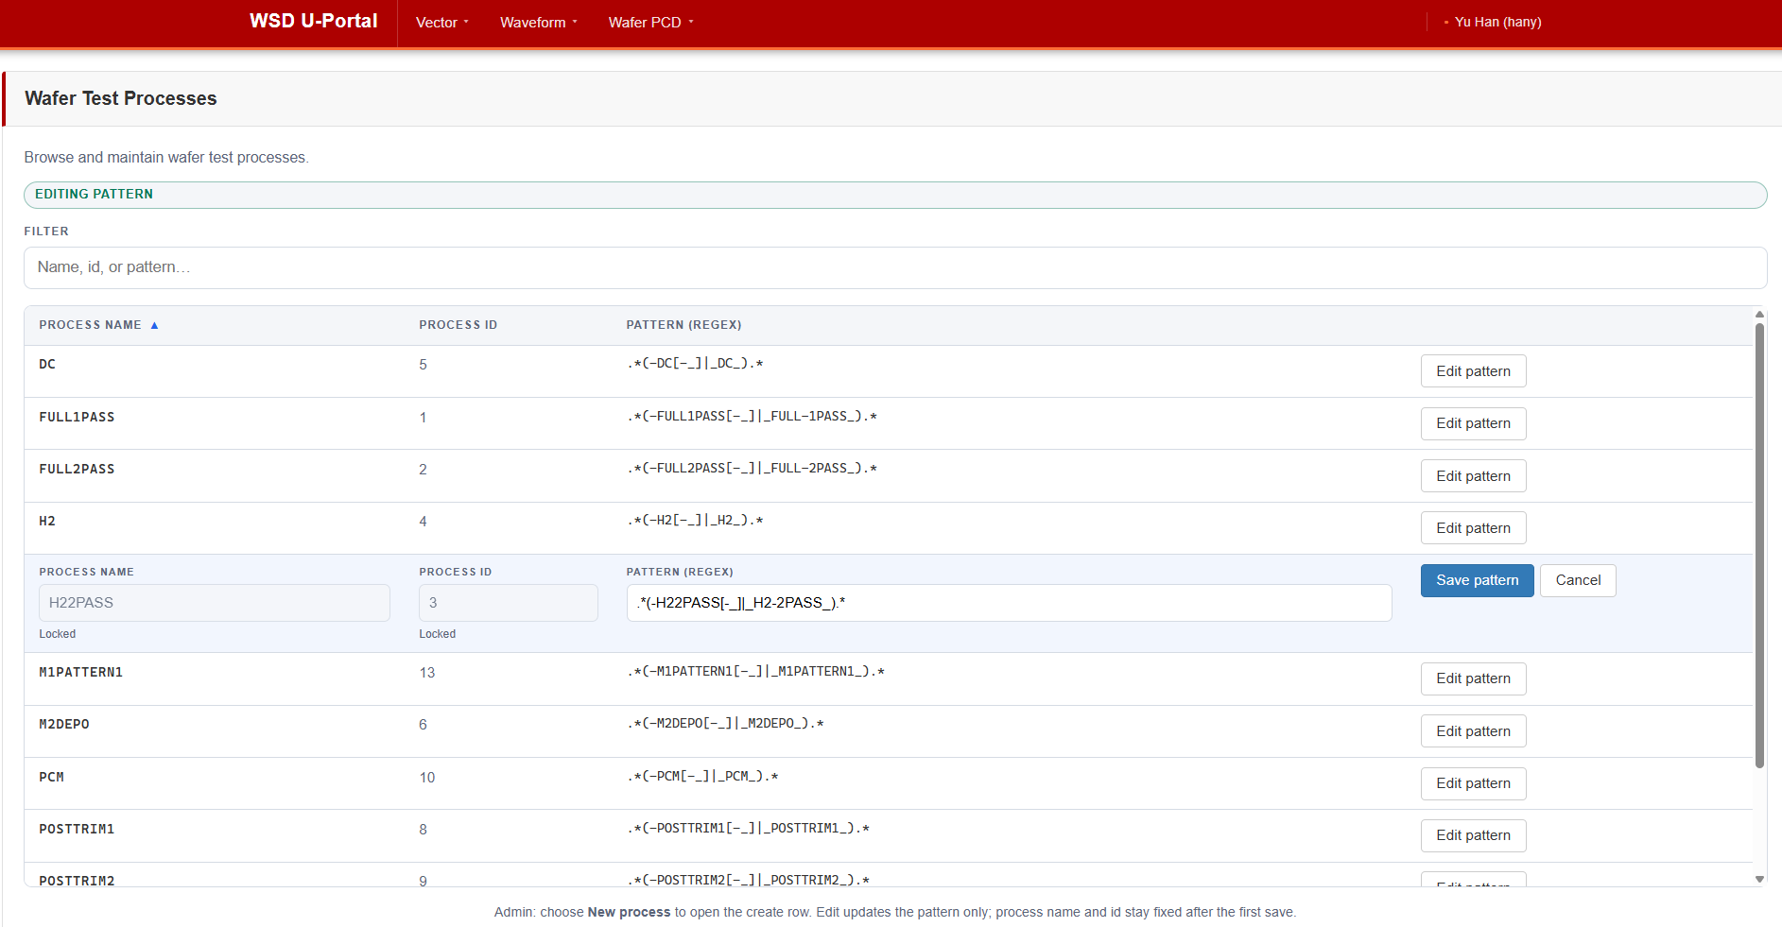
// (IV.3) Wafer Test Process - Test Plan Mapping
// (IV.4) Wafer User Administration

    - (Jiapeng) Support Foot Kit’s Online wafer regen phase 2 API action item (Complete)
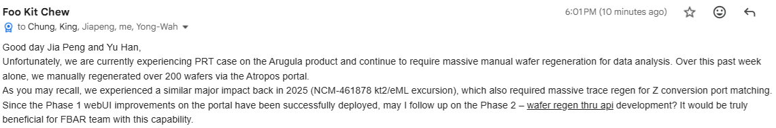
      - Jiapeng Initial estimate (~4 weeks)
      - JWT authentication added to the project for API
      - Plan generated for online wafer regen API
      - Development completed
      - http://wsdsgsvc03.sgn.broadcom.net:8080/WSD.OnlineRegen.API.DocFx/
  - Individual Components Demo (Done)
    - Per Yu Han request, run internal demo of all available components (NOT full end-to-end)
      - Tingyu/Chao
        - U-Portal to submit spec conversion, then approve it
      - Tingyu
        - pCD Client to create Test Plan Reference Package
      - Ken
        - pCD Web to create targeted version
      - Jiapeng
        - online regen to submit regen job (no regen worker - yet to integrate with Regen NXG workflow)
      - KinLum
        - Using Clotho to load Wafer Spec Package (with test plan reference package), and showcase unified version
    - Zoom recording:
      - https://broadcom.zoom.us/rec/share/Yi5ngf2KfdSE2uwa47YP3krmRkrTe7B4upk8TA4L4acn44YhDl3dlYRvcAQmBqjW.Fw3h3hTUqaFzFxBH
    - Passcode: 2#^i7*yt
  - 10/13/2026:
    - (YK/KinLum) Clotho V7
      - Kin Lum is working on Clotho/PCD integration interface (in progress)
      - Clotho integration: IMPL, TEST
    - (YK) Wafer NXG and Offline Regen (in progress)
      - Kin Lum is working on Offline Regen/PCD integration (in progress)
    - Last minute change request from Kuok Liang
      - In clarification, prefer to not-support since conflict with pCD-V working style
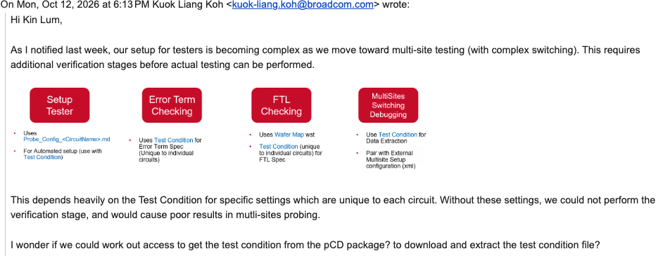
  - Full End-to-End Integration check (in plan)
    - UPortal > Presetup
      - Chao: UPortal
    - UPortal > Spec Conversion
      - Chao: UPortal
      - Tingyu: Worker
      - ChooYau / YK: Spec Converter
    - UPortal > Wafer Spec Approval
      - Chao: UPortal
      - Tingyu: Worker
      - KinLum: pCD Daemon
      - ChooYau: gDB
    - PCD Client > Test Plan Reference Package
      - Tingyu: pCD Client
      - Ken: pCD Web
      - KinLum: pCD Daemon
    - Clotho > Wafer Test Plan / Spec Package Loading (Targeted/Unified version)
      - YK: Clotho
      - KinLum: pCD Library
      - Ken: pCD Web
      - KinLum: pCD Daemon
    - ZDB Transfer
      - Ken: Transfer
    - ZDB Feeder
      - Chao: UPortal Presetup
      - Ken: Feeder
    - Regen
      - YK: Regen Workflow
      - YK: Offline Regen Tool
      - Jiapeng: Online Regen
      - Kin Lum: pCD Library
  - Confirm buy off stakeholders
    - Kuok Liang (Clotho)
    - KC and Chung Sik (everything else)
  - (Kin Lum @ Team) Workload breakdown and schedule
    - https://docs.google.com/spreadsheets/d/1rlZ12Us8Xtn8Uf0MJgs_3dLR2YoS_9gbgmvO79UKYWU

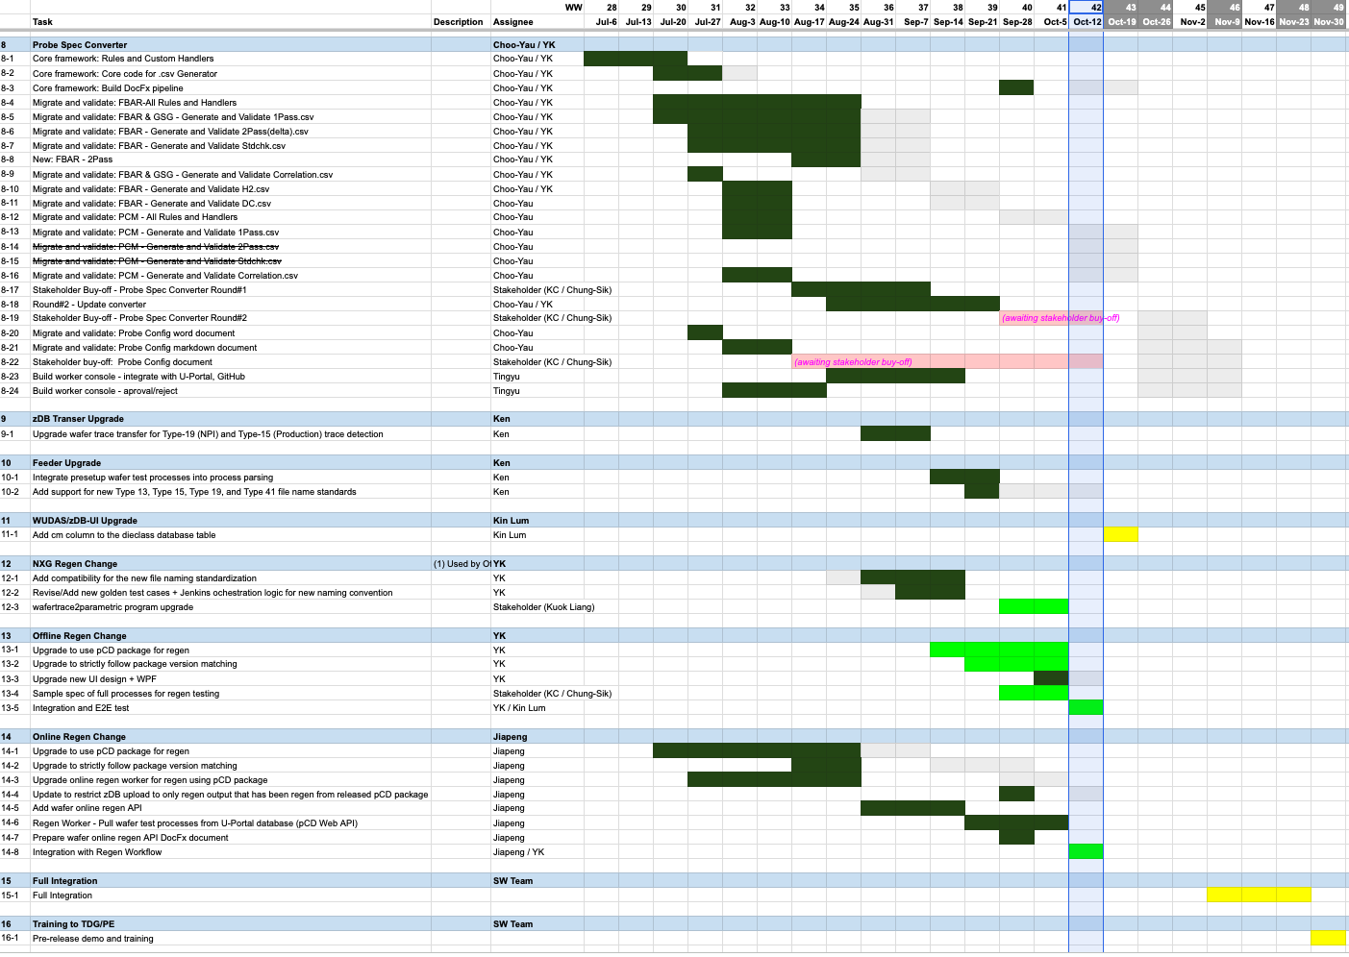

- (Chao/YK/Jiapeng/Ken) WSD Open Computation Framework - POC (ATA/FCM/Reporting)
  - Target Date: ??
  - Goal
    - 3 Vehicle projects
      - NXG ATA Upgrade
      - FCM Custom Computation Support
      - Generic Reporting
    - Docker/Container based (ECS/Lambda/EKS?)
      - Language independent
    - Full CI/CD Pipeline
      - End users only need to check in Git to trigger the deployment, also need support dynamically selecting Resources spec (Memory, e.g.)
  - Scope (SOW)
  - POC Investigation
    - 10/13/2026:
      - (Jiapeng/Chao) Working on design/proposal stage
        - https://github.com/wsd-broadcom/WSD.TapToZdb/tree/tudas-enhance-plugin/doc
      - Merge Jiapeng’s and Chao’s doc into one design doc (in progress)

- (KinLum/Tingyu) AI-Friendly Schema-Driven Migration (II) - Transfer & CI/CD (In Progress)
  - Target Date: ???
  - Scope:
    - Proposed by Kin Lum to build a NXG framework based on Schema-driven concept, apply to both transfer, feeder, and (CLEADA Details Table) stitcher categories.
    - For the “Transfer” category, potentially to cover Data types (wider coverage then “Feeder”)
      - …
  - Latest Status
    - 10/13/2026:
      - Bring this item into active queue as “Feeder” is done

- (Choo-Yau/Chao) Spotfire Upgrade to LTS V14.6 Due to EOS (End of Support)
  - Target Date: ??
  - Goal:
    - …

- (?) Module Testing C-Aggregation (Consolidation) Enhancement by Switching to 2DID (Initiated)
  - Target Date: ???
  - Scope
    - Apply to zDB Type 1 PRDA data processing logic, expect to change behavior in following C-tables;
      - Lot, TopParameter, Csummary, Cstatbin, Cdetail, Cdetailslim, RejectPareto
  - Goal (SOW)
    - From Chung Sik
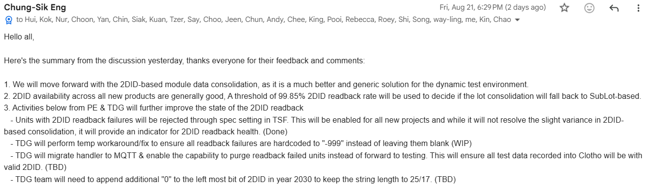
    - SubLot-based aggregation and its disadvantages in special scenarios
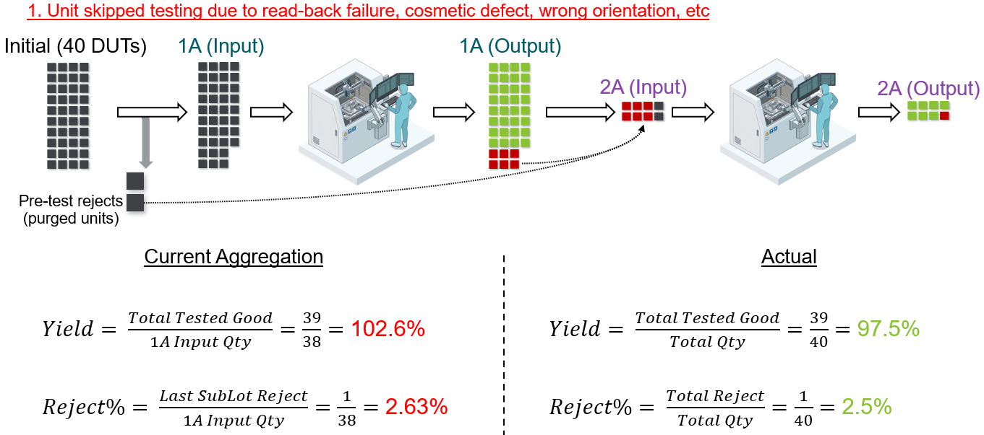
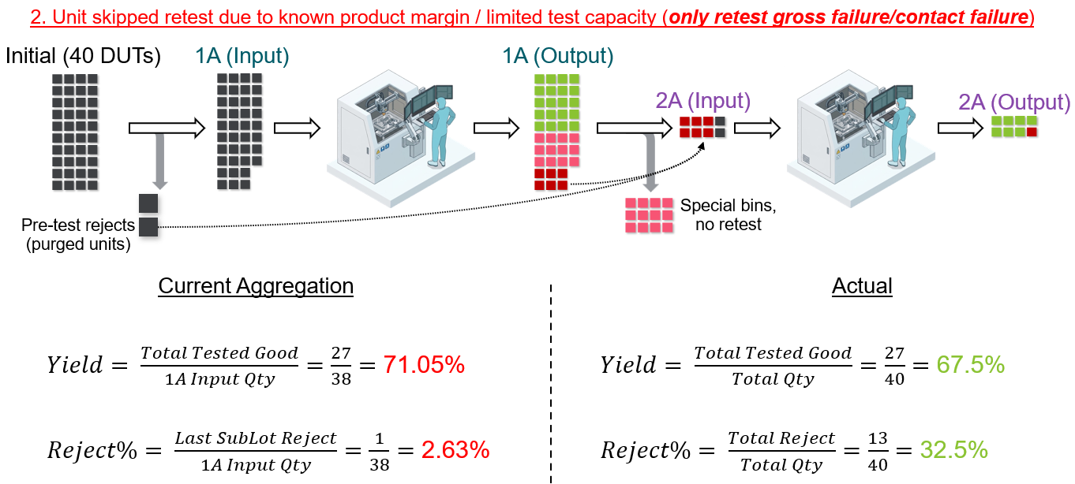
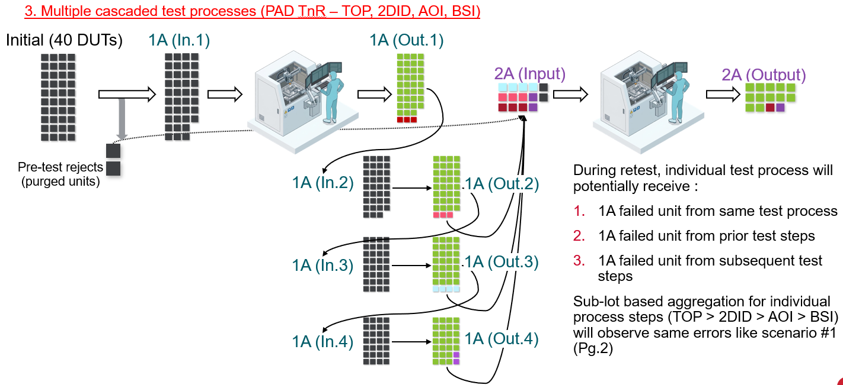
    - New Proposal for 2DID-based consolidation
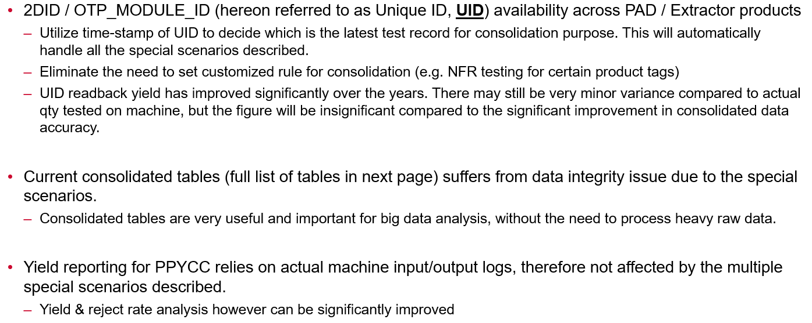
    - Proposed Changes:
  - Latest Status
    - 08/25/2026:
      - Yu Han in further clarification with Chung Sik and wait for answer to Q1 from stakeholders
      - Internal estimate from Kin Lum is < 6 weeks

- (KinLum/Tingyu) AI-Friendly Schema-Driven Migration (III) - CLEADA Details Stitcher & CI/CD (Initiated)
  - Target Date: ???
  - Scope:
    - Proposed by Kin Lum to build a NXG framework based on Schema-driven concept, apply to both transfer, feeder, and (CLEADA Details Table) stitcher categories.
    - For the “Stitchter” category, potentially to cover Data types
      - …
  - Latest Status
    - 08/04/2026:
      - (Kin Lum) Potential schema-based CLEADA detail table stitching (in progress)

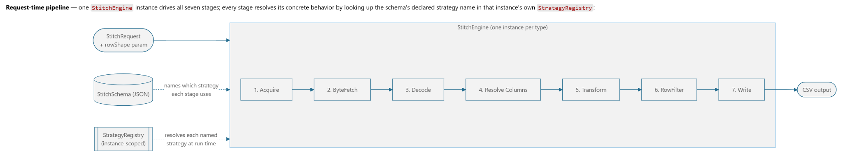
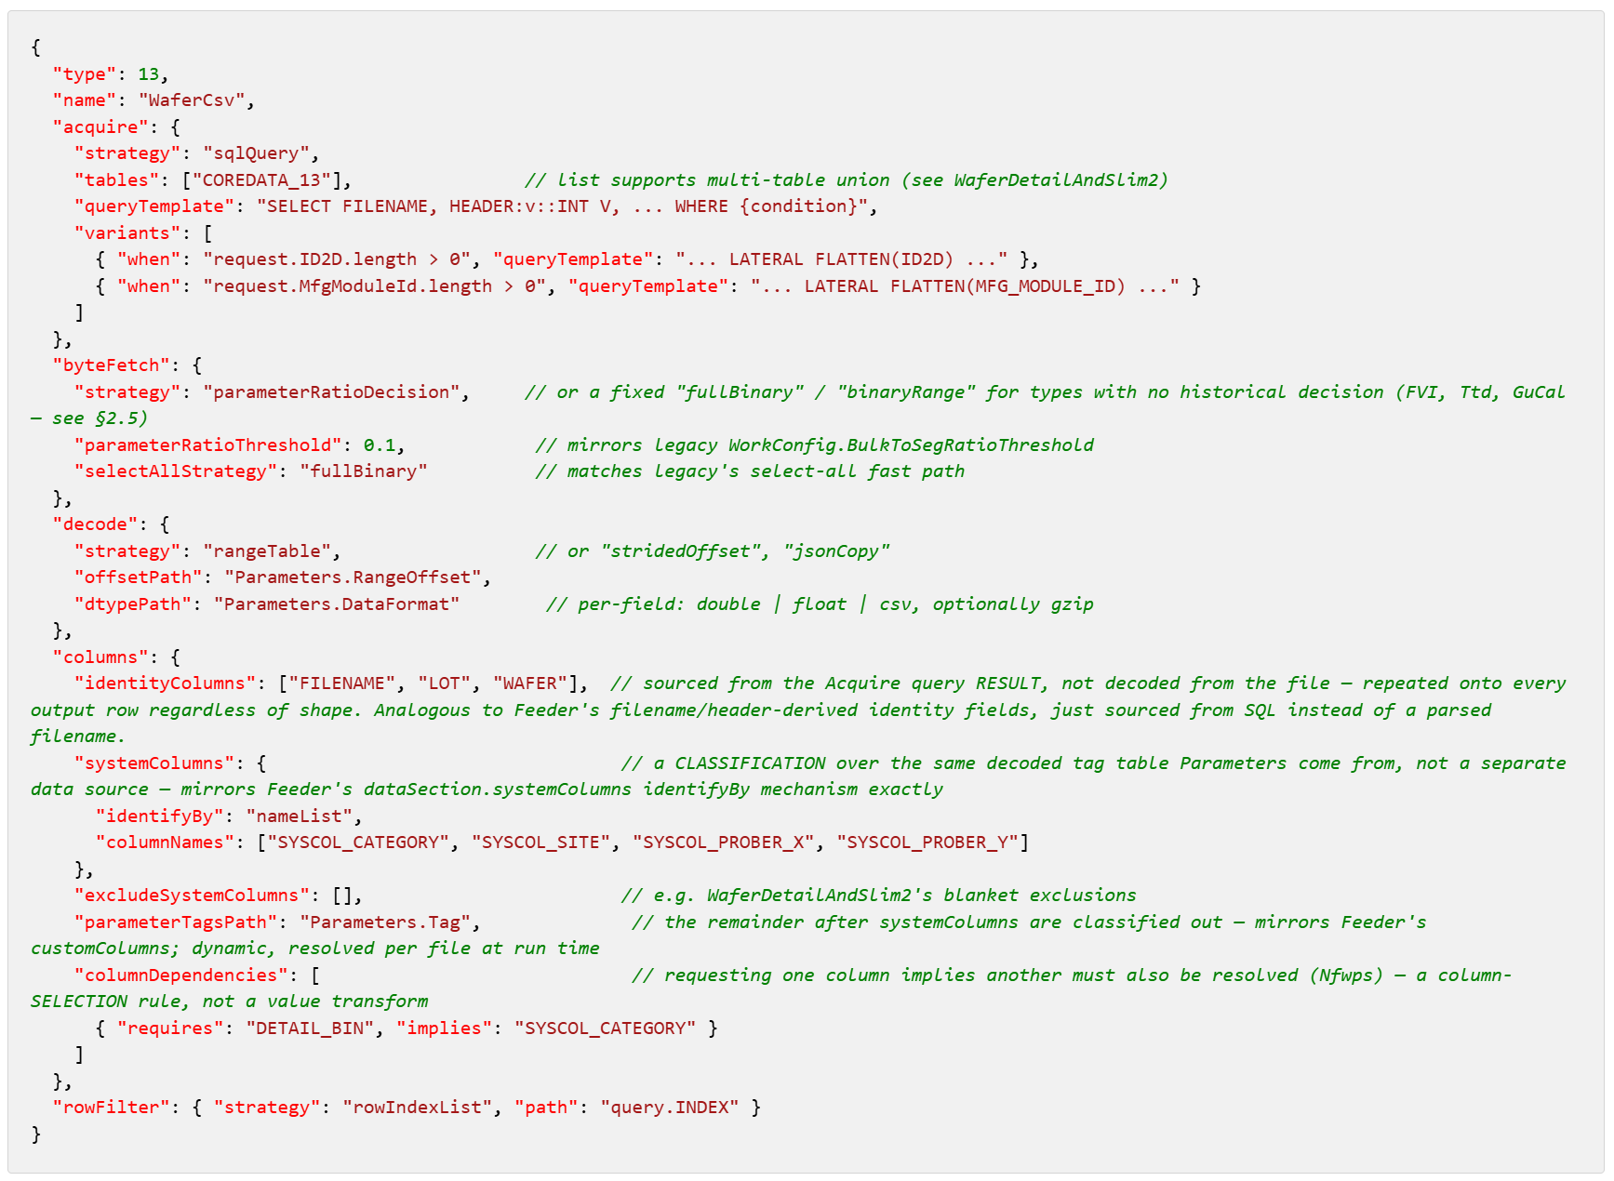
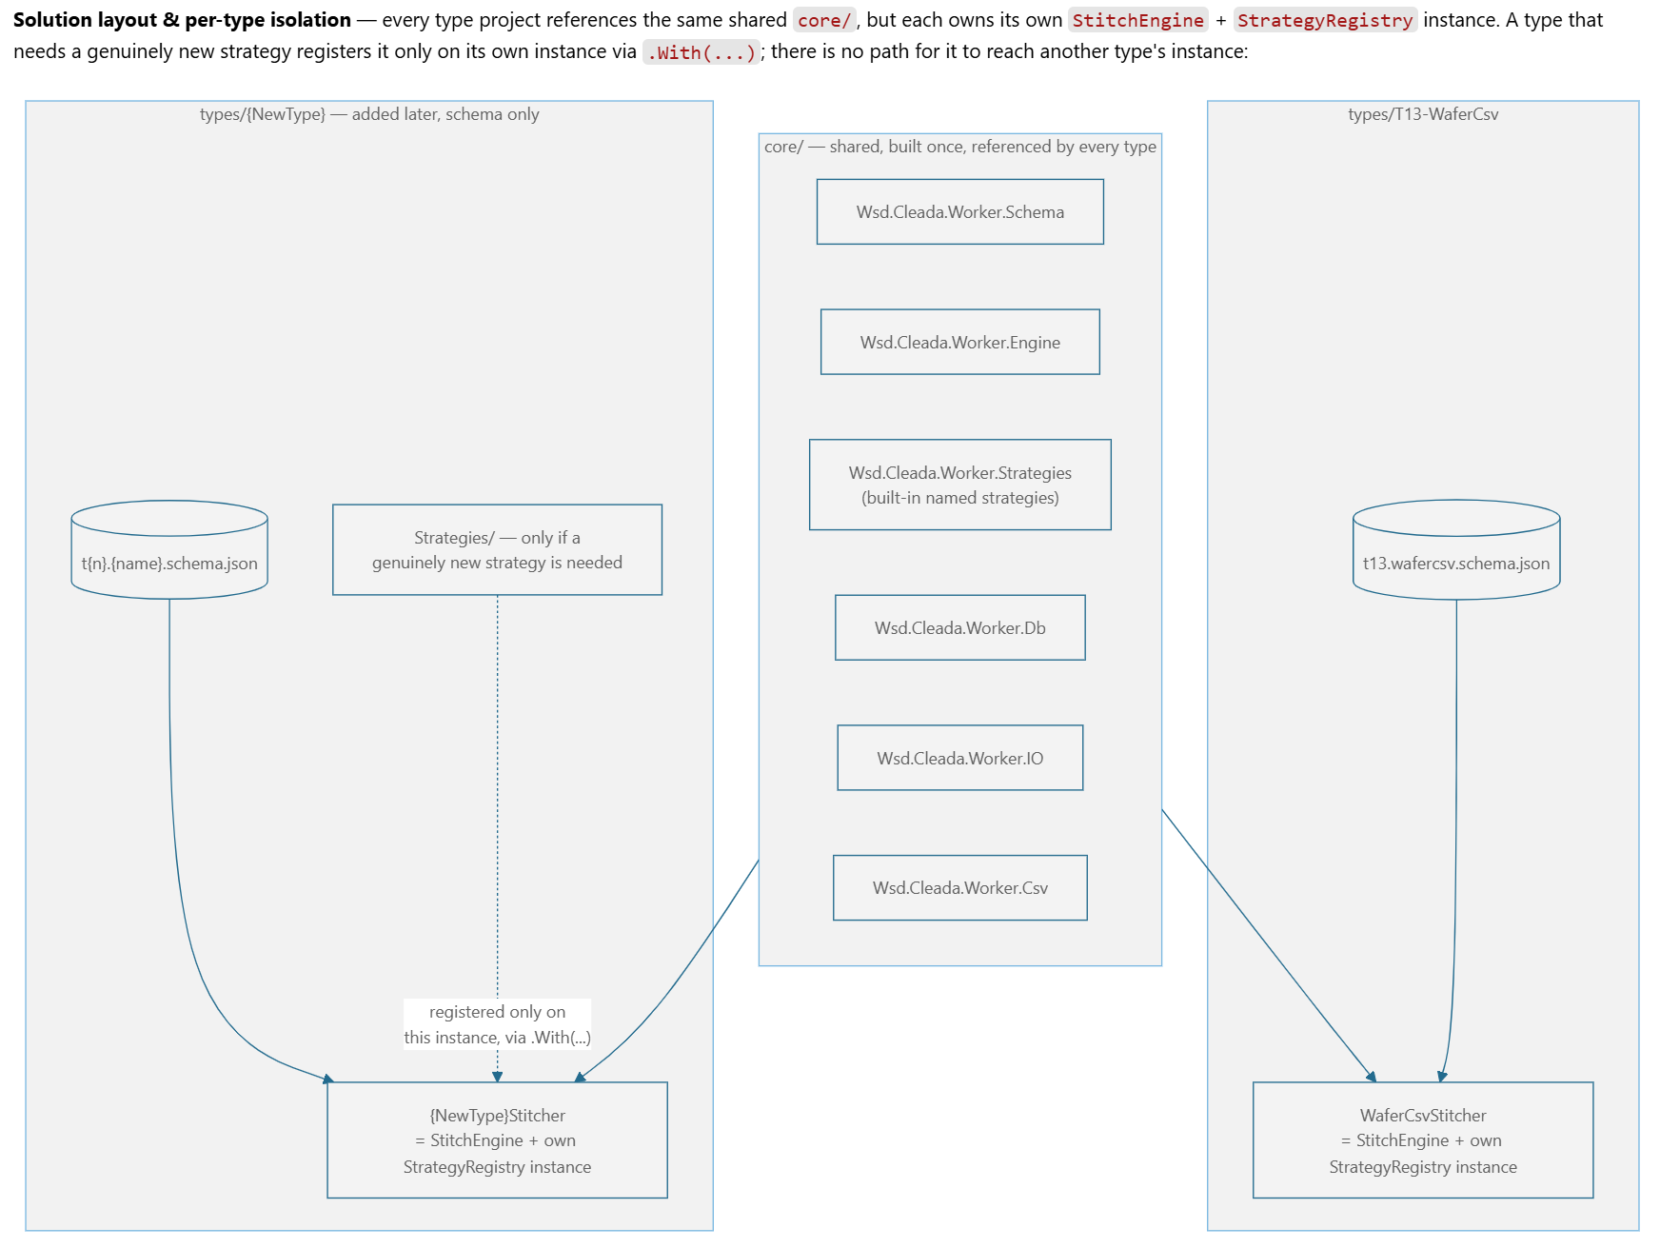

- Golden-Dictionary NXG-WUDAS Ecosystem (KinLum/Chao) (In Progress)
  - Target Date: ??
  - Goal & Scope
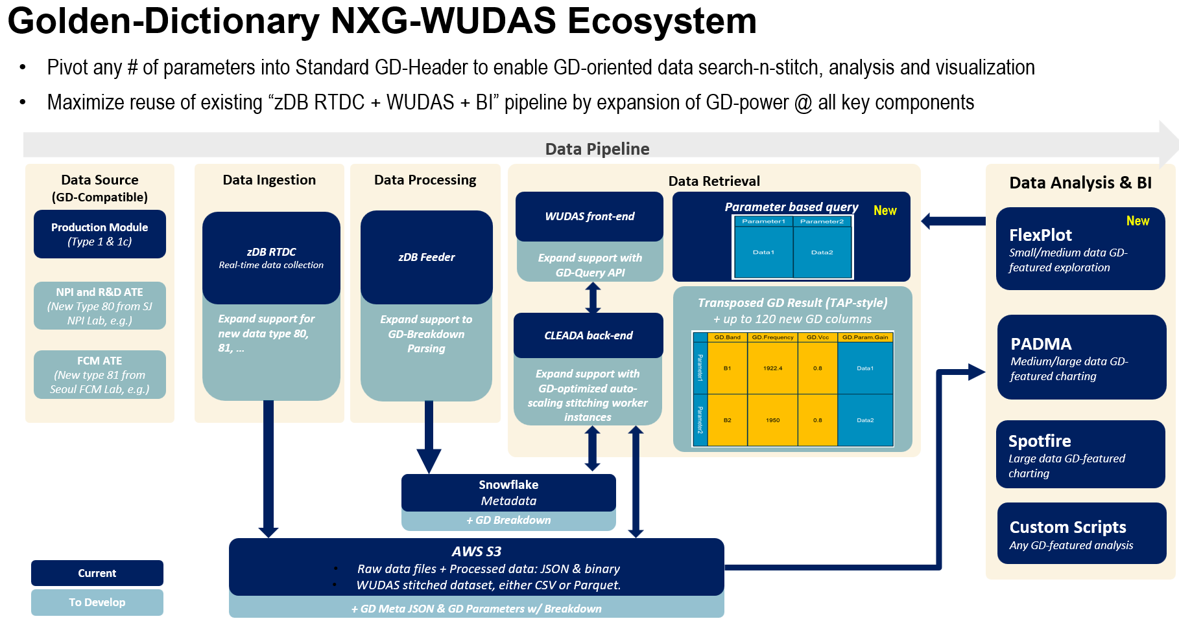
  - Latest Status
    - (Chao) Evalue Snowflake full 14B rows, all 120 columns, processing power
      - Decide to drop Parquent and External Table option, focus on csv format directly into Snowflake, which requires re-parsing
    - To decide the reasonable warehouse size we need prepare and best ROI option
      - https://docs.google.com/spreadsheets/d/1rd2Bpn7iFJ2-2laUc_ZiMuf1Y463ncsr2E-C1Iz9ASs/edit?gid=1993501572#gid=1993501572
    - 04/07/2026: Chao shared draft SOW for internal review
    - 05/11/2026:
      - Kin Lum and Chao updated QBR for Q2’FY26 to clarify the scop e

- NXG WUDAS - CAQ (Custom Analysis Query) (KinLum/Chao) (Hold)
  - Target Date: ???
  - Goal:
    - Offer advanced “Action request” and “Compute data aggregation” style WUDAS SQL query grammar in addition to typical “Data” query
      - No need publish new API signatures, instead only expand SQL grammar
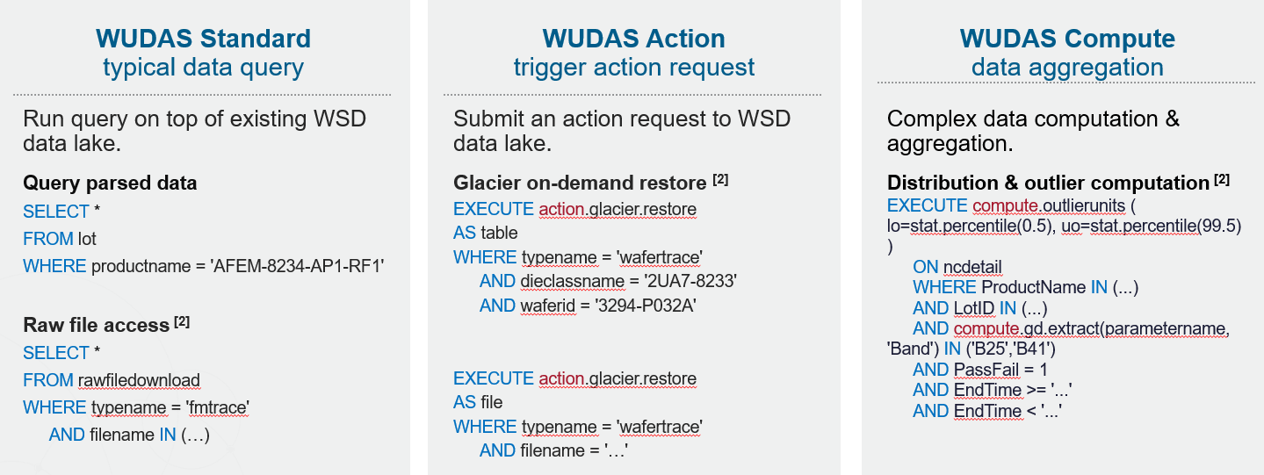
    - Achieving horizontal data access by 2DID or MFG_ID+OTP_MODULE_ID.
      - Enable data lookup by product tag & device unique ID through Snowflake unstructured data query.
    - Query without time-constraint & extracting data from JSON field
    - Better tracking/monitoring by Streamline Usage Report
  - Background:
    - Issue: Current zDB infra allows complete data accessibility but certain use-cases (as data vol involved increases) stretches the limitation of data processing/visualization tools. End users have to work-around/compromise in terms of efficiency. E.g., Reduce data vol count for more manageable data size in exchange for reduce data
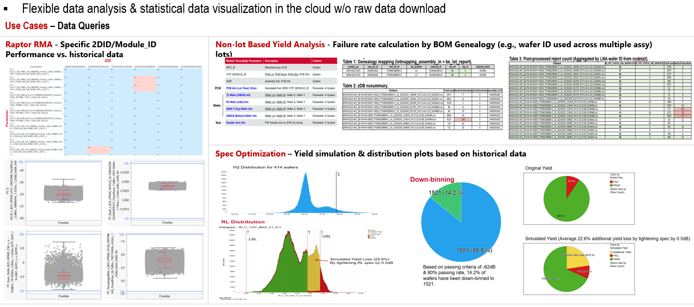
    - Use scenarios:
      - 2DID/OTP_Module_ID distribution check versus historical data
        - Inputs: a list of 2DID (test lot ID) + Raptor failure mode + workweeks period
        - Expected output : Box plot/Distribution plot to show location of selected 2DID within the overall distribution (past 3-months, e.g)
      - Exclusive/Non-Exclusive failure rate calculation by specific system columns
        - Inputs available : List of lots, list of parameters, system column content to filter by
        - Expected output : Excl/NonExcl Failure rate grouped by selected system column content
      - Statistical calculation for performance / yield estimation based on historical data
        - Inputs available : List of lots, list of parameters, system column content to filter by
        - Expected output : waferparameta / ncsummary / ncdetail / waferdetail return based on combination of inputs
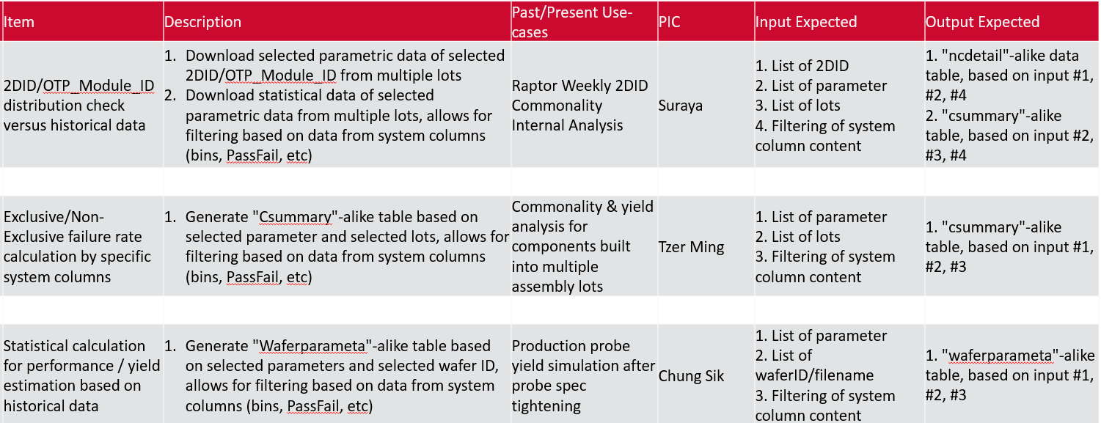
  - Use case #1
    - ReferenceData involved:
      - 3 months’ PassFail=1 data.
      - all product tags: AFEM-8230-AP1-RF1; AFEM-8231-AP1-RF1; AFEM-8230-AP1-NS; AFEM-8231-AP1-NS; AFEM-8230-AP1-RF2; AFEM-8231-AP1-RF2
      - All test parameters.
    - Process Logic
      - Query the UserInput (PassFail=1).
      - Query the ReferenceData (PassFail=1).
      - Compute ReferenceData’s 0.5th and 99.5th percentile.
      - Compare (1) with (3) for each test parameters.
        - To record "YES" if (1) is outside of (3); To record "NO" if (1) is within (3).
      - Store (4) in a query-able database.
    - Output
      - (1) Downloadable ALL parameters, or by keyword selection of paras (e.g. "B25" and/or "B41", etc.)
      - (2) plot 2DID + Reference.
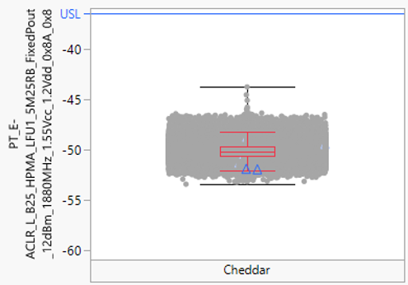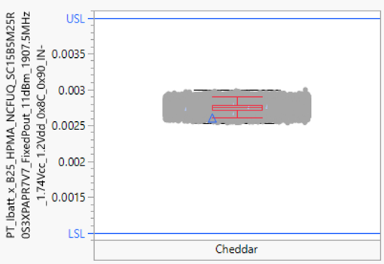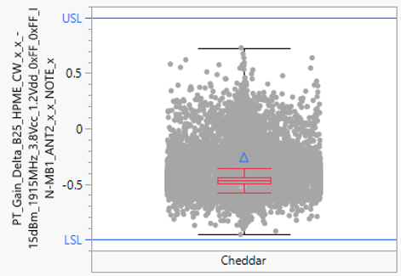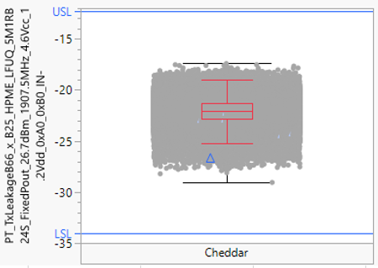
      - (3) to summarize the overall "YES" total units by parameter historically.
  - Use case #2
    - BE module data query methodology based on handle scalable and dynamic pre-processed data which will improve efficiency of overall cloud workload and traffic.
    - To include handler arm, PCB & wafer OTP information to be standardized as part of system column and queryable through zDB.
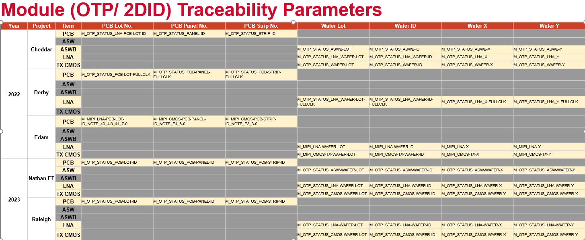
  - Latest Status
    - 01/16/2024:
      - KP approved Snowflake Capacity Contract 2024 expansion to USD $100K plan and kick start of Snowflake Migration, which make NXG WUDAS technically feasible to do
    - 03/22/2026:
      - Add GD topic into NXG WUDAS Scope
      - (Chao/Kin Lum) Initial idea and data prep
      - (Chao) Prepare WUDAS production data for GD Breakdown Use
        - Targeted ~180K files based on past 4 month production data volume
          - 2025/10 - 237K files; 2025/11 - 190K files; 2025/12 - 176K files; 2026/01 - 172K files
      - (Chao) Build GD breakdown worker to process 2026/12/01 to 2026/12/31 + 2026/01 data.
        - Running 3 workers on EC2.
          - by 2026/02/20 processed 107K files; by 2026/02/23 processed 147K files; by 2026/02/24 processed 161K files; by 2026/02/25 processed 167K files; by 2026/02/26 processed 180K files (Complete)
      - (Chao) Sample query and DB optimization (In prep)

- NXG WSD Cloud Data Pipeline (Hold)
  - Target Date: ???
  - Background:
    - Current WSD Cloud “Collection + ETL + Adv Process + Access” pipeline has legacy dependency (grow from scratch during 5 years window), which is kind of over-complicated if considering latest available technology which can replace previous generation technologies. E.g., as Ken mentioned, to complete full “non-FBar wafer” development cycle, at least 16 components are touched, though most of them are simple configuration/setting adjustment, but still are non-value-adding steps and error-prone and require unnecessary engineer’s workload
  - Goal:
    - Simplify ETL Pipeline to minimize engineers dev/deploy/maintain workload, optimize operation cost, and improve performance, especially improve reliability/robustness/availability and lower cost
      - Simplify the overall pipeline stack from 5+ layers to 3-layers
    - Design/Build by using IaC powered Containerization to enable seamless migration and deployment across different environments, especially for multi-layers multi-components complicated pipeline.
  - Scope:
    - Execute ProcLog DB migration from Mongo to Snowflake
      - 09/24/2024: Already covered @ Snowflake Phase 3
    - Execute Feeder task queue migrates to Gen-QS. (Generic Auto-scaling & scheduler for Gen-QS)
    - Execute cascading Transfers/Feeders/Workers upgrade
  - Latest Status
    - Depends on FeederDB Snowflake Migration, GenQS and IaC Migration progress
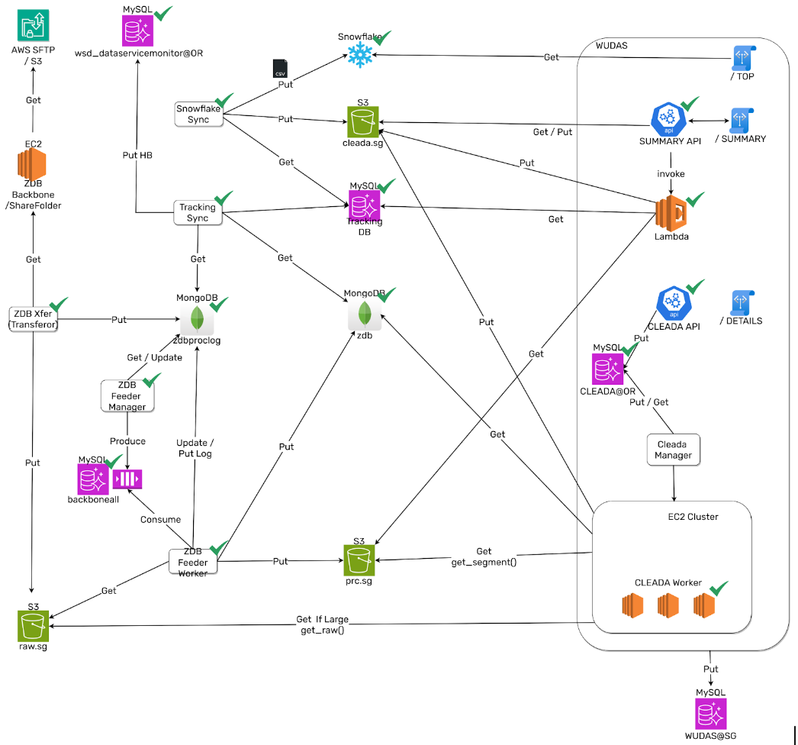
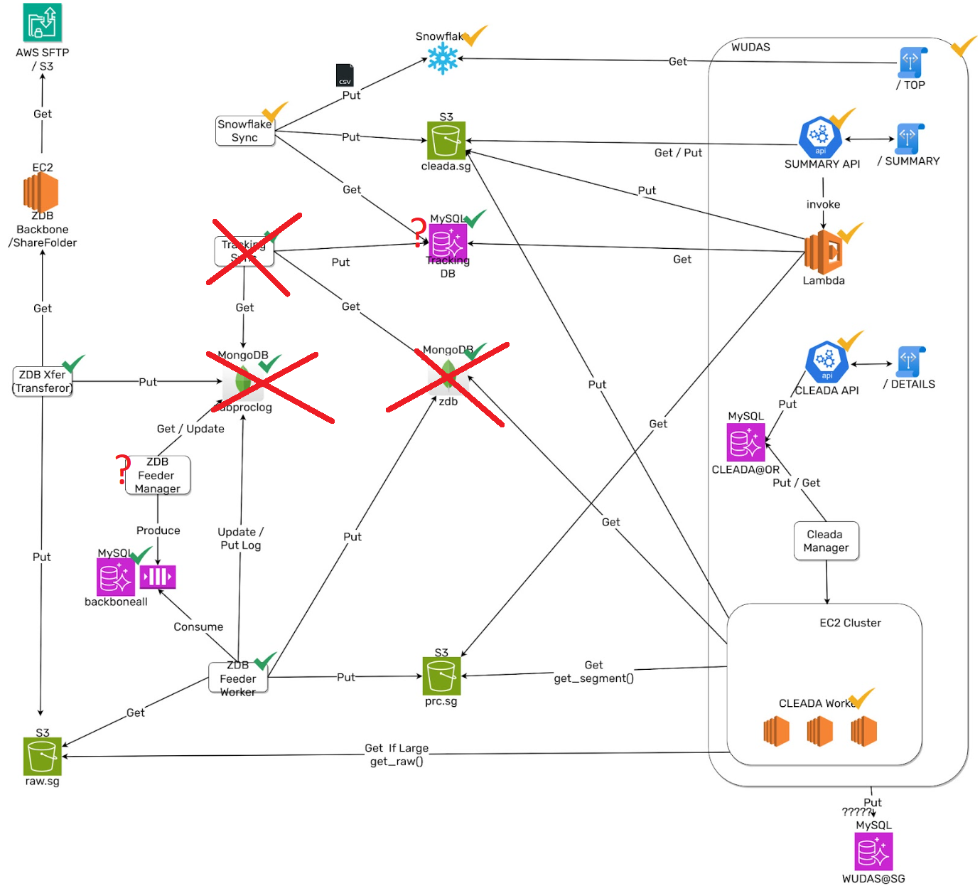

- Cloud SFTP Family Phase2- Internal Wafer Planning Enhancement (Choo-Yau/YK) (In Progress)
  - Target Date: ????
  - Goal & Scope:
    - Per KP request, to clarify whether technic and financial feasible to enable automated file transfer and data parsing for “YELLOW” and “RED” data types. Pending for ROI assessment.
      - Y and R types are NOT in the data types requests from Suraya during Cloud SFTP, including semi-auto/manual source files which are downloaded from Oracle / Incorta / FtC Custom Portal

    - Suraya shared a list of Inventory Planning file types currently in use. Identify file types to work with stakeholders to explore automation feasibility.
      - Link: https://docs.google.com/spreadsheets/d/1Gklw64g53v9yIdy3tQngJHvn4K4qjxBvhzx-NNfUXJo/

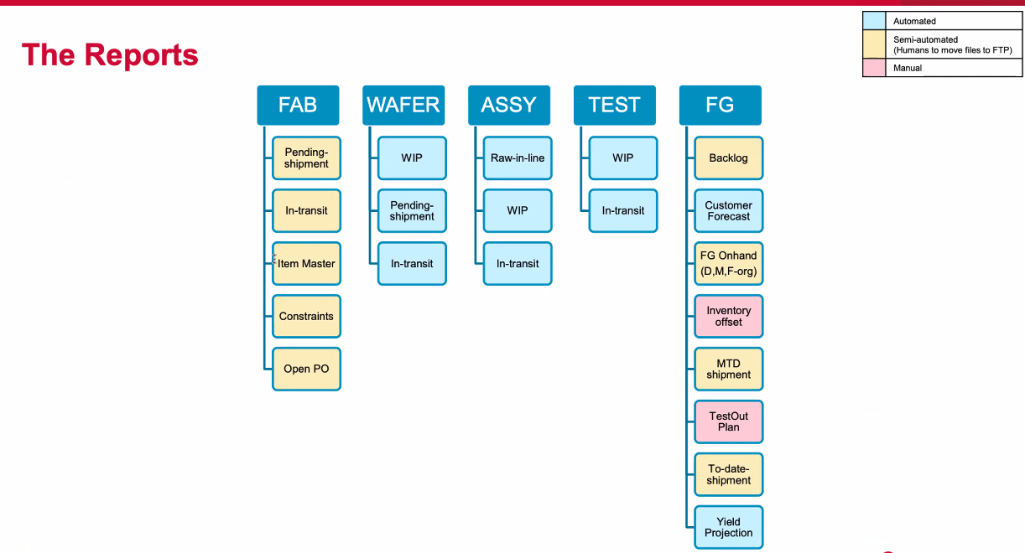
    - Choo-Yau updated with following findings:
      - https://docs.google.com/spreadsheets/d/1Gklw64g53v9yIdy3tQngJHvn4K4qjxBvhzx-NNfUXJo/edit?gid=0#gid=0
      - Those highlighted in yellow are still in manual mode which we need to work with Suraya and application’s owner to figure out how to automate it.

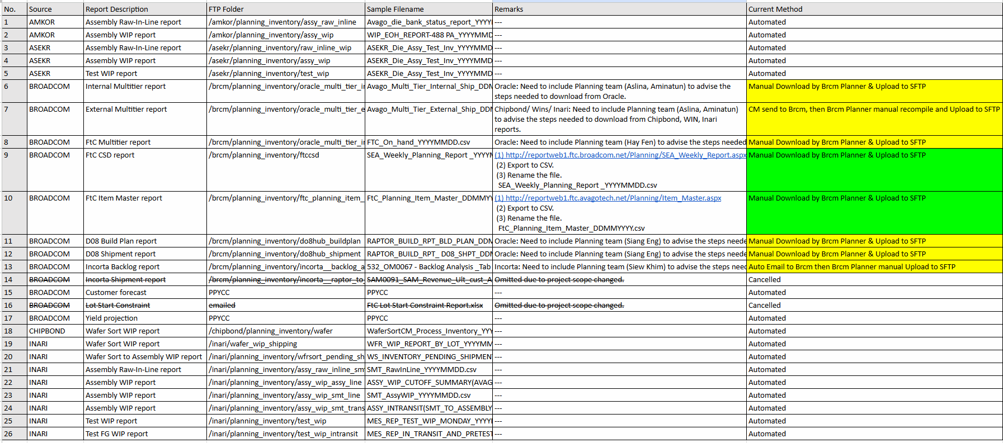

  - Latest Status:
    - 04/22/2025:
      - Work with Suraya to contact each application's owner then figure out how to automate it. For example: web api/ auto email/ direct upload to SFTP.
    - 04/29/2025:
      - Validation on FtC Api Url (Completed)
    - 05/06/2025:
      - Suraya extended the project scope to include some financial data from the Planner team, waiting for Suraya to summarize the final proposal.
    - 05/13/2025:
      - Suraya on-hold the sensitive data processing.
      - Tested to pull FtC data thru API that provided by FtC team, however Suraya verify and the data no tally with the manual download one. Pending feedback from the FTC guys.
    - 07/07/2025:
      - Tested to pull FtC data (FtC Item Master report) thru API that provided by FtC team. Suraya verified and buyoff matching content.
      - FtC team provided the 2nd API for the FtC CSD report, and included missing 2 columns. Suraya verified and buyoff matching content (Completed)
    - 09/30/2025:
      - KP refer a new data source (FormFactor Probe core PB data) to be transferred via SFTP
    - 10/21/2025:
      - SFTP create new CM: FormFactor and On-boarded FormFactor
    - 01/13/2025:
      - FormFactor data upload works well.
      - Requested HockThien(FBAR PE) to come out a proper SOW
    - Pending for Incorta, Oracle (No Update from Suraya)

- (TBD) FCM-Analyzer Utility: Sunset Plan (In Plan)
  - Target date: ??
  - Scope and Goal:
    - As part of WSD's AI assisted coding promotion, in the long term SW team plans to drop or minimize support to “limited users base” desktop application and utility front-end development support, based on the assumption that either
      - Option 1) Domain experts will use CC (AI) to build alternative quick prototype to meet their exact custom needs, as we observed in Design, Production and NPI teams;
      - Or Option 2) Consolidate FCM Analyzer functions into either central TUDAS portal or Spotfire Dashboard
    - For clarification, SW team will invest more on middle-ware (“large users base” centralized portals/interfaces like TUDAS Portal, WUDAS APIs, pCD U-Portal and Spotfire Data Functions) and core backbone (cloud based large scale data access, standard and custom computation) which are used to support both front ends and middle-ware.
    - Again, this is long term, no interference with existing support policies and practices. But instead of support all custom requests autonomously, SW team will treat long term sustainable and valuable action item higher priority
  - Latest Status:
    - 08/18/2026:
      - Shared with FCM team this long term plan based on Mitchell’s Spotfire support request.
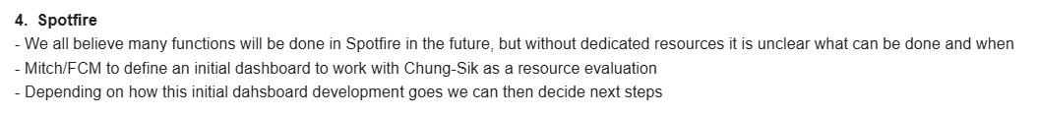

- Telecaster-II: Enable Full Automated Workflow (Chao/Tingyu/Jiapeng) (In Plan)
  - Target Date: ???
  - Roadmap (Obsolete)
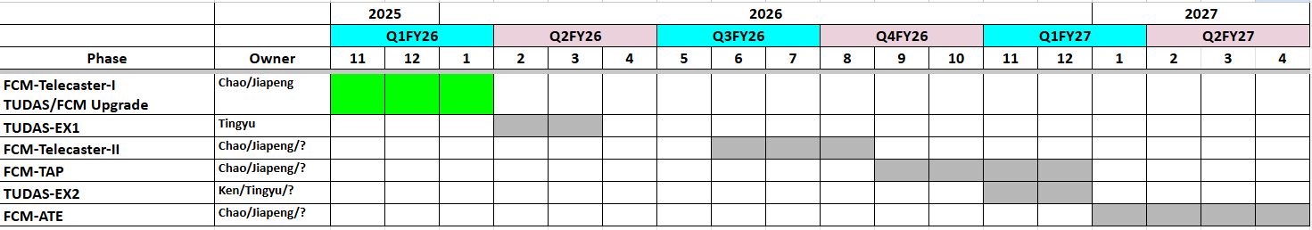
  - Scope (Obsolete):
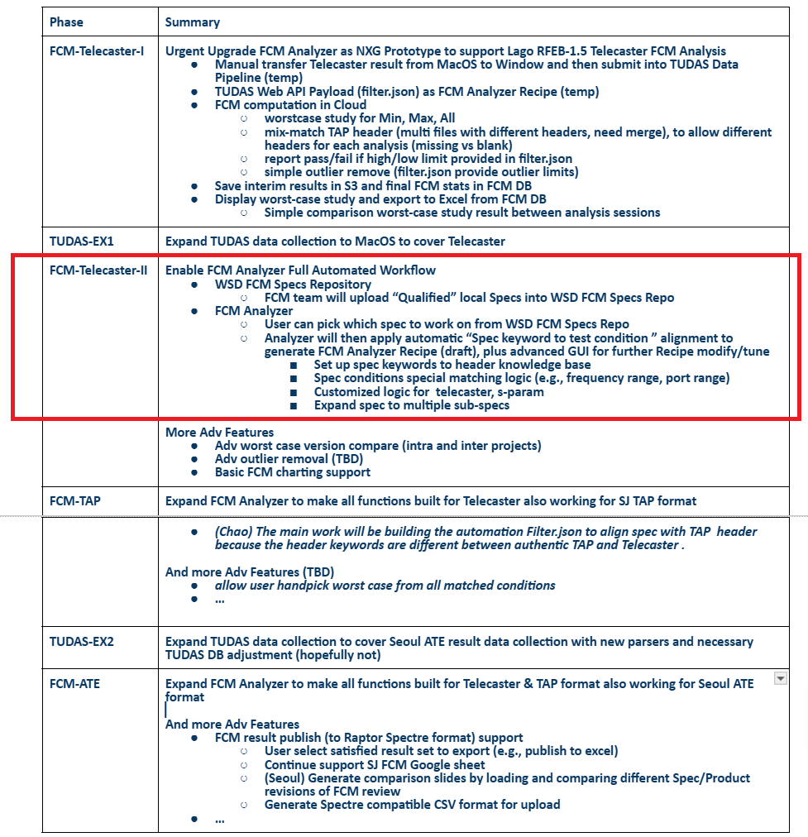
  - Latest Status
    - 07/29/2026:
      - Mitchell and Yu Han synced for next step plan, and SW team is fully committed to providing the FCM team with all the necessary features and functional support exactly when you need them.
      - SW Internal “TUDAS Portal vs FCM Analyzer” coverage split plan
        - Current vs Future
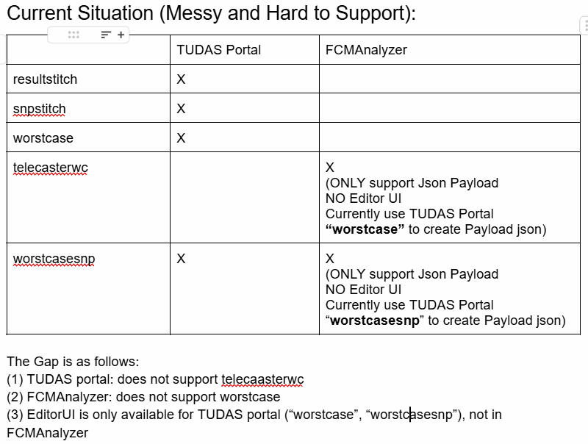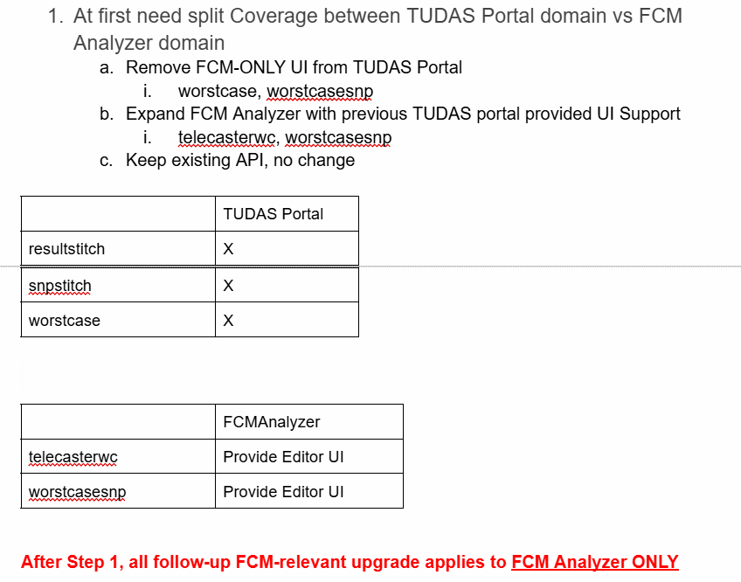
        - Further development options
          - https://docs.google.com/document/d/1ZKRkkwuIutqFFg6PQSj75bunkvZczNbvePnJSDKlfLk/edit?tab=t.0#heading=h.2914n3zgit92
    - 08/11/2026:
      - (Yu Han) Plan to run a sync session with Mitchell team for Proto-2 and EVT needs
      - (MItchell) Shared more details:
        - Calculation types:
          - A solution which allows the user to define formulae. The calculations we need to make change often. Ideally the user should not depend on your team to hard code the formulae. Again, I think we need to discuss this in the 'brainstorming session'.
        - Plot types:
          - A simple box type distribution plot, similar to what Chao had demo'd some time back. The goal is to quickly identify outliers and bimodal distributions during data review.
        - FCM availability for evaluation and buy-off activities:
          - The next major time block when the FCM team has time for a significant evaluation will be from the end of September to the end of October.
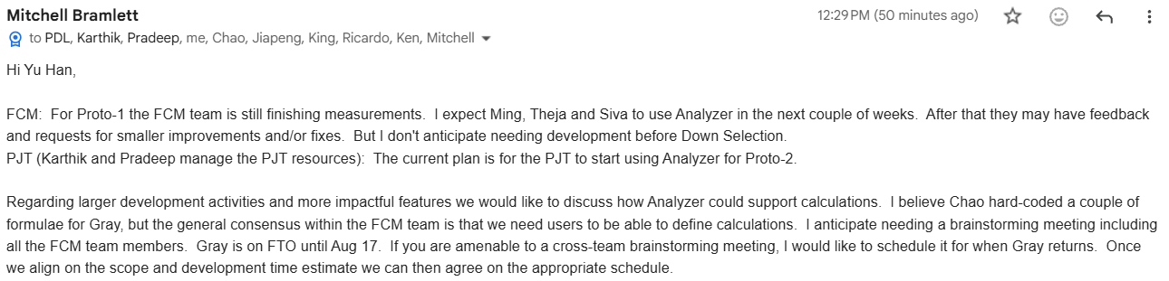
    - 08/17/2026:
      - Run sync session with Mitchell’s team to clarify Next To-Do plan

- NXG FCM Analyzer & TUDAS Expansion to TAP and ATE Formats (Chao/Jiapeng/Tingyu/Ken) (Hold)
  - Target Date: ????
  - Goal & Scope:

Phase | Summary
FCM-TAP | Expand FCM Analyzer to make all functions built for Telecaster also working for SJ TAP format  - (Chao) The main work will be building the automation Filter.json to align spec with TAP header because the header keywords are different between authentic TAP and Telecaster .  And more Adv Features (TBD)  - allow user handpick worst case from all matched conditions  - …
TUDAS-EX2 | Expand TUDAS data collection to cover Seoul ATE result data collection with new parsers and necessary TUDAS DB adjustment (hopefully not)
FCM-ATE | Expand FCM Analyzer to make all functions built for Telecaster & TAP format also working for Seoul ATE format  And more Adv Features  - FCM result publish (to Raptor Spectre format) support  - User select satisfied result set to export (e.g., publish to excel)  - Continue support SJ FCM Google sheet  - (Seoul) Generate comparison slides by loading and comparing different Spec/Product revisions of FCM review  - Generate Spectre compatible CSV format for upload  - …

  - SJ FCM Status
      - Mitchell hosted SJ FCM workflow Demo meeting with SW team
        - https://broadcom.zoom.us/rec/share/V7oIkItQz8bESELtx3d-5LyONRVOkK_3QTvPCG9xotjTwYfsHRXzz4y2zfApJz5a.IHqYyUcjlJv4JS6G
          - Passcode: DZ%H^5M?
    - Phase I:
      - No change to existing G-Sheets.
      - Upgrade FCM Analyzer to integrate with Turker Spec Portal and TUDAS backbone to auto filter-n-align/stitch (from whole data repository) (TAP+Telecaster) data with specific customer spec id (conditions), do necessary pre-processing (outlier removal using predefined algo, e.g.), build TUDAS API payload, file the computation request to TUDAS, present result, maybe provide some standard charting (distribution, …)
      - Then operator will copy result from FCM Analyzer, paste into existing G-Sheets
      - Pre-condition:
        - Existing data formats need to be further standardized (FCM/TAP teams) to make sure possible to auto match to Spec ID
        - Might need to parse Telecaster data format, or re-use existing Penang/Seoul utility to convert Telecaster format into TAP format
      - [Mitchell]: Need to add spec expansions in Phase I. If the plan is to download/import the spec from Turker's Spec Portal directly into FCM Analyzer we will need to add spec expansions within FCM Analyzer. Or if we can upload a spec into FCM Analyzer for which we've added the spec expansions, that is a viable option as well. I am fine with either approach.
    - Phase II:
      - Drop existing G-Sheets practice
      - Bring up a WSD FCM Web Portal (like PPYCC) for a fully controlled “single-source-truth” DB backed collaboration platform.
        - Similar to PPYCC, FCM portal needs to be able to load in customer spec, provide flexible phase configuration (including mCM/FCM, EVT spec proposal, flexible delta …), support Excel sheet format inputs (with format validation), and be able to export “Snapshot” Excel sheets per use case (template, including Raptor Spectre).
        - Potentially be able to check format issue and fix per Spectre rules
        - Note the WRITE operation only occurred through FCM Portal
      - FCM Analyzer still works as the front end custom computation interface, auto publish results into WSD FCM (DB), propagated into FCM Portal.
      - [Mitchell]: This is a very exciting goal and what I believe to be what we want long term. It is important that this FCM Portal has the capability of collaboration such as how we use comments in Google Sheets. I am open to alternative methods, but we need a method to track and communicate action items per spec.
  - MUC+Penang FCM Status
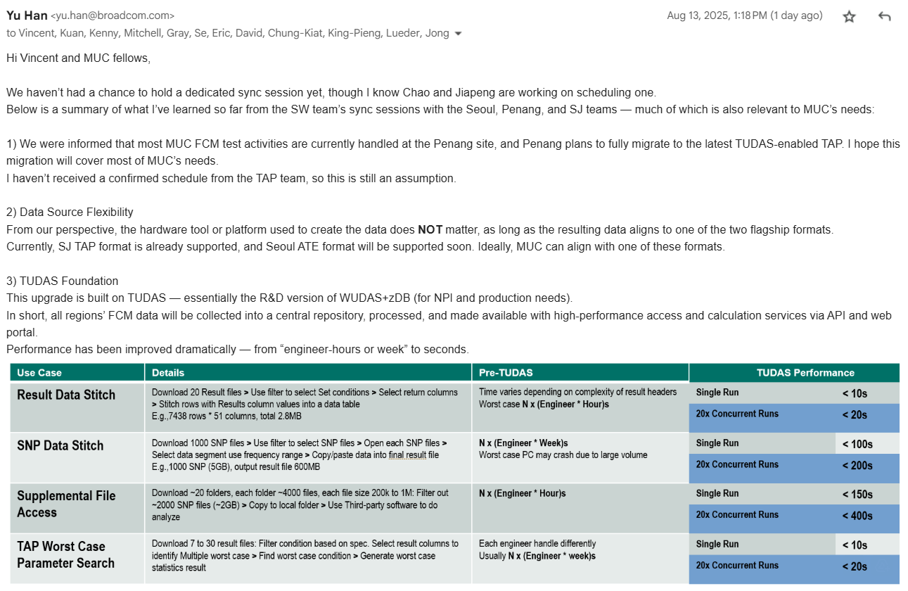

  - Seoul FCM Status
    - Update from Se Won
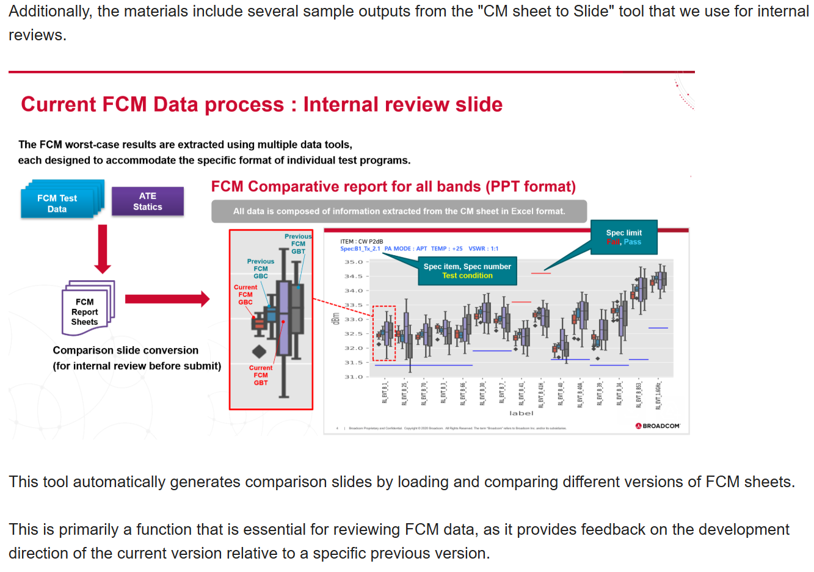
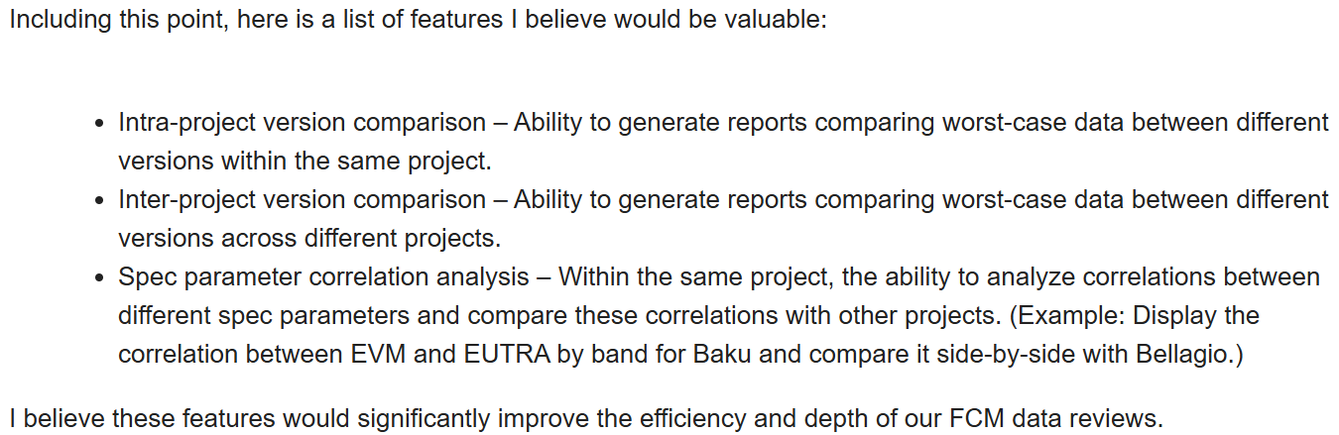
  - Latest Status
    - 08/11/20225:
      - (Yu Han/Chao/Jiapeng) Clarify Option A To-Do proposal draft
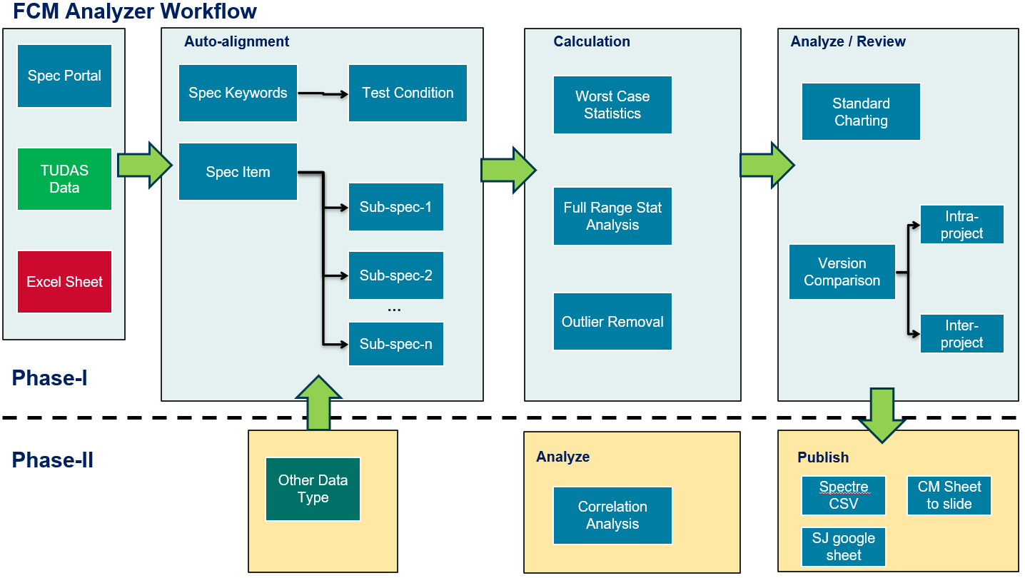
    - 08/13/2025:
      - (Kenny) Confirmed Penang will migrate to full TAP coverage
    - 08/25/2025:
      - (David) We've synced with Kenny regarding converting the last bench to TAP. To accomplish this, we will add support in TAP for the Focus tuner. Kenny is going to ship the tuner to SJ, where Xiaomao will handle the development. We're targeting completing that development by the end of Sept, then working with Kenny to evaluate on his end and bring up a TAP test plan.
    - 08/28/2025:
      - (Kenny) Managed to get 6 out of 7 testers to be connected to TUDAS, we tested and all data are available online, pending the final AMR VSWR tester.
    - 09/02/2025:
      - (Tingyu) Total 47 TAP testers covered,
        - 2 from muc (rootdir like '%MUC%')
        - 8 from penang (pcname like '%PNG%')
        - 37 from san jose
      - (Tingyu) PNG, from 08/01, collected 327 datasets, all collect,xfer,process succeeded. Randomly picked 10 and can see the parsed result
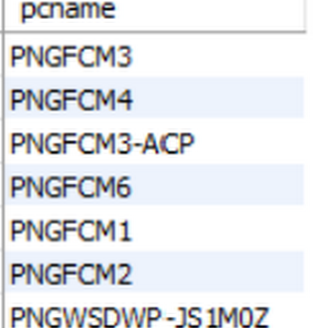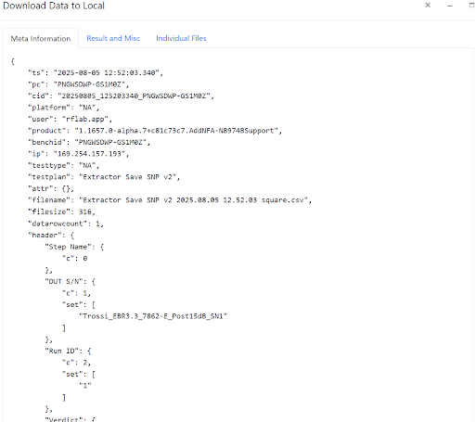

    - 09/16/2025:
      - Meeting with MUC team to finish the MUC use case and workflow understanding, then finalize the SOW/SRS for Analyzer Upgrade
    - 10/10/2025:
      - Mitchell provided a more detailed SOW
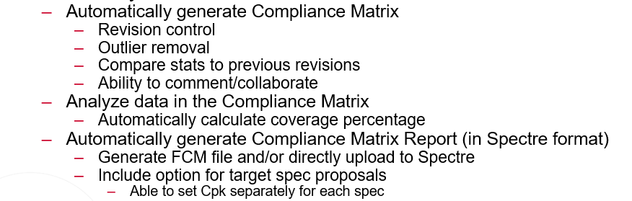
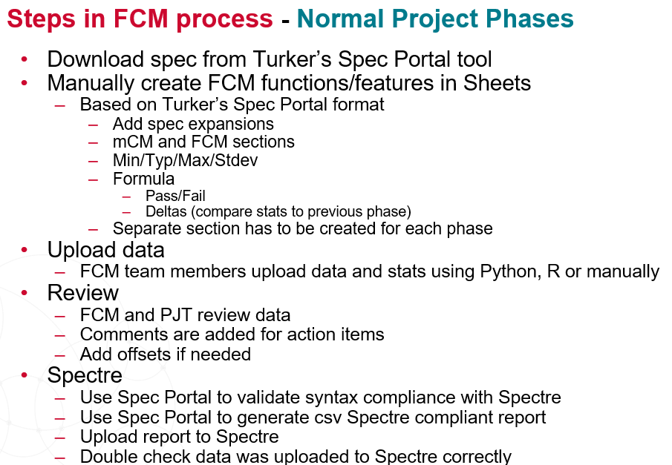
    - 11/13/2025:
      - Mitchell/Chao in sync to clarify the roadmap
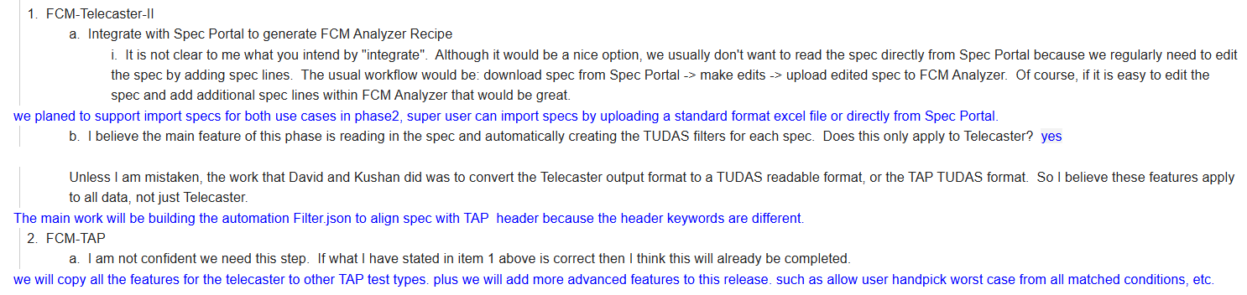

- Production and IT Support
  - (ChooYau/YK) GDB Support
    - GDB Web API new table requested by YC (Completed)
      - Wafer_probe_tnr_header
      - Wafer_probe_tnr_bin
    - GDB SFTP new .ppk key for cmuser.lgit.amkorvn (Completed)
  - (ChooYau/YK) SFTP Uploader
    - Enabled extension for .txt and .csv for type 4 (FBAR_FG) (Completed)
  - (ChooYau/YK) IT Support
    - MS Patches Update for SGN servers (Completed)
      - https://docs.google.com/spreadsheets/d/1iBw52-U2Vh8Grym4mthtRA8Smf1cVF5FVxVQyLfbS-M/edit?gid=0#gid=0

Section 5: In-Queue Action Items (x27)

- (Jiapeng/Chao) FCM Proto-2/EVT Large Scale Custom Computation Expansion @ TUDAS Backbone (In Plan)
  - Target date: ???
  - Scope and Goal
    - Based on FCM windows shared by Mitchell: Proto-1 (July/Aug), Down Selection (Aug/Sep), Proto-2 (Nov/Dec), EVT (Jan/Feb), this action item is to support FCM team’s Proto-2 and EVT Needs
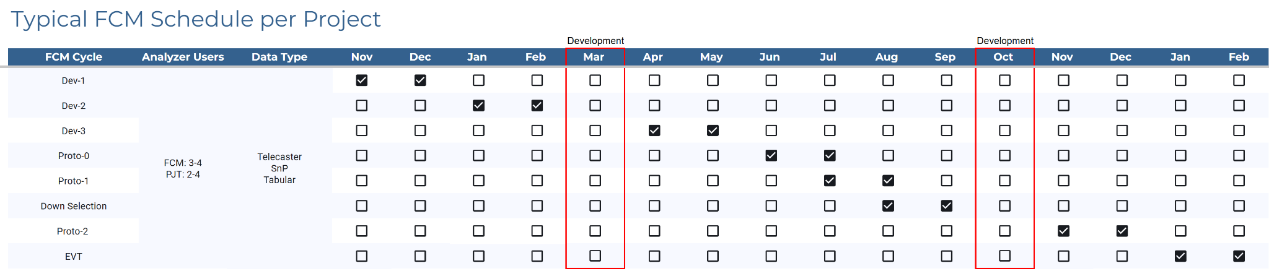
  - Latest Status:
    - 08/17/2026:
      - Gray and Mitchell raised the initial request. Also Mitchell marked 10/02/2026 for Chao and Gray to define the scope for s-param calculations. After that, align on the development and evaluation schedule.
      - (Yu Han) Initial quick minimum investments estimate
        - An API gateway
        - A new TUDAS backbone handler on top of a high enough spec h/w container
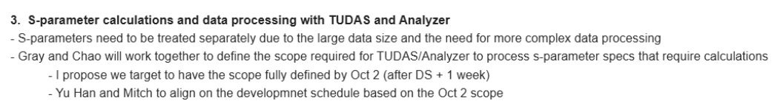

- (Kin Lum/YuHan) Evaluate New Proposal “WDAC (WSD Data Access Co-Pilot)” (In Progress)
  - 09/08/2026
    - V1: LLM + Deterministic SW hybrid with Sandbox Confirmation
    - V2: Typed Schedma + OpenAPI Contract as Agent Tools
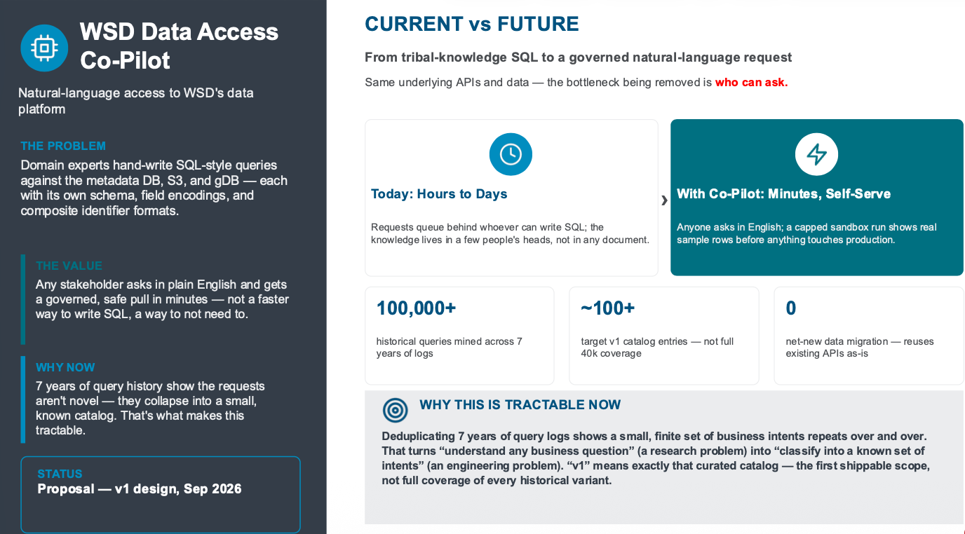
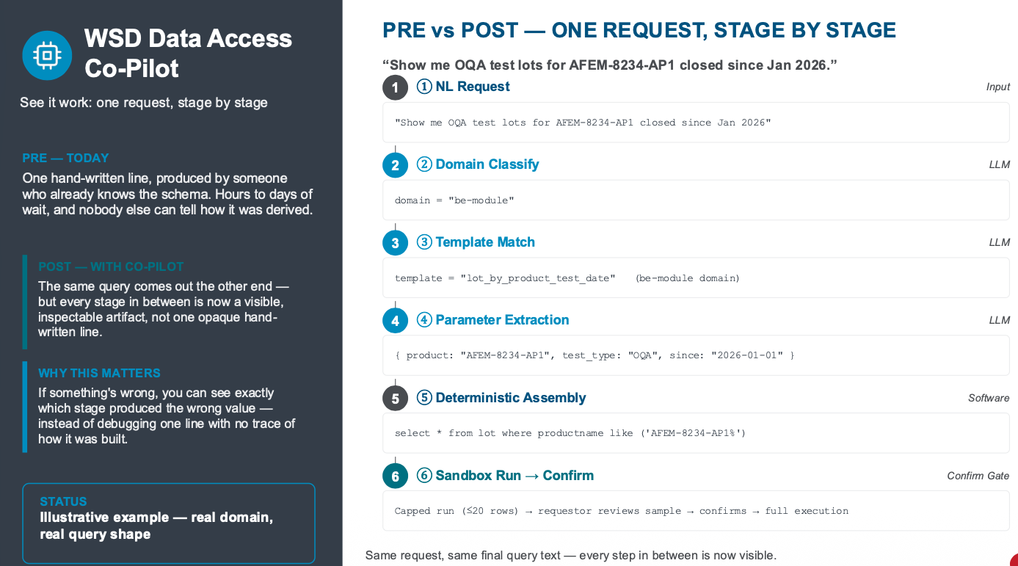
  - 09/22/2026
    - Pending for further brain-stromining and analyze WUDAS query history (100K + queries) to segment feature templates then evaluate technical feasibility
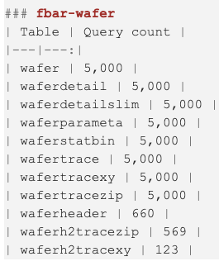
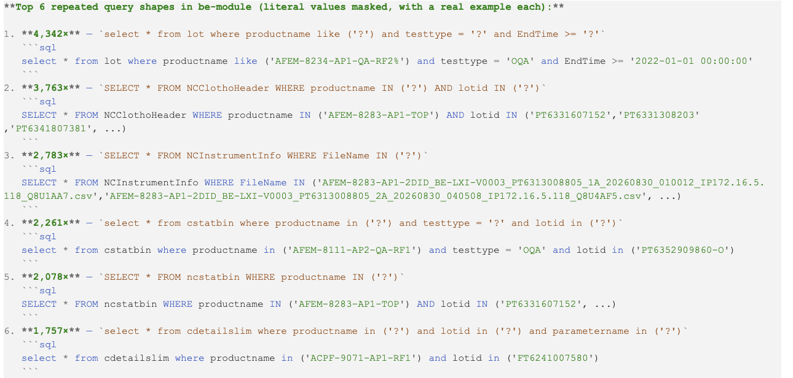

- (Ken/KinLum) Evaluate New Request “Backend AVI Wafer Maps Collection and Access” (In Progress)
  - 06/20/2026
    - Per Chung Sik request
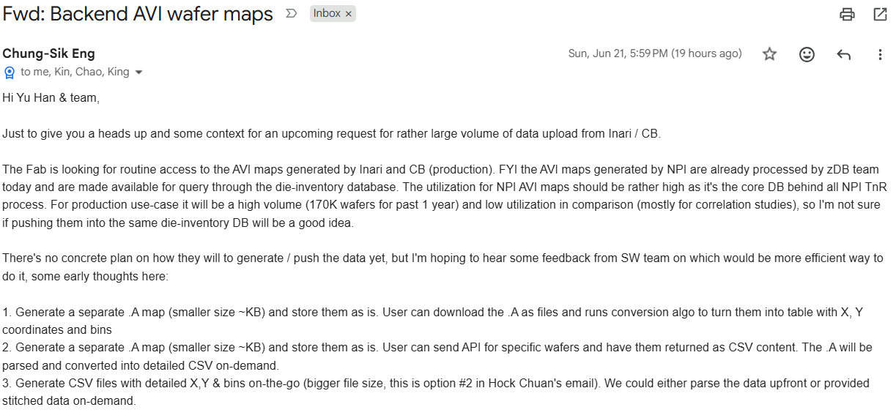
  - 06/30/2026
    - (Kin Lum) Discussion with Chung Sik:
      - The request is actually to collect Production AVI .A files from CB/Inari
      - NPI AVI .A files are now uploaded through Die Inventory because they needs parsed and for Die Inventory usage purpose
      - The Production AVI .A files are not needed by Die Inventory
      - Highlighted to Chung Sik that there is already type-16 reserved for AVI _IAP.A file
    - Assign Ken as owner
  - 09/01/2026:
    - Chung Sik “AVI Map Access (Production) alignment
      - The proposal is to build an enhanced “Zip access API” with in-the-fly .A conversion
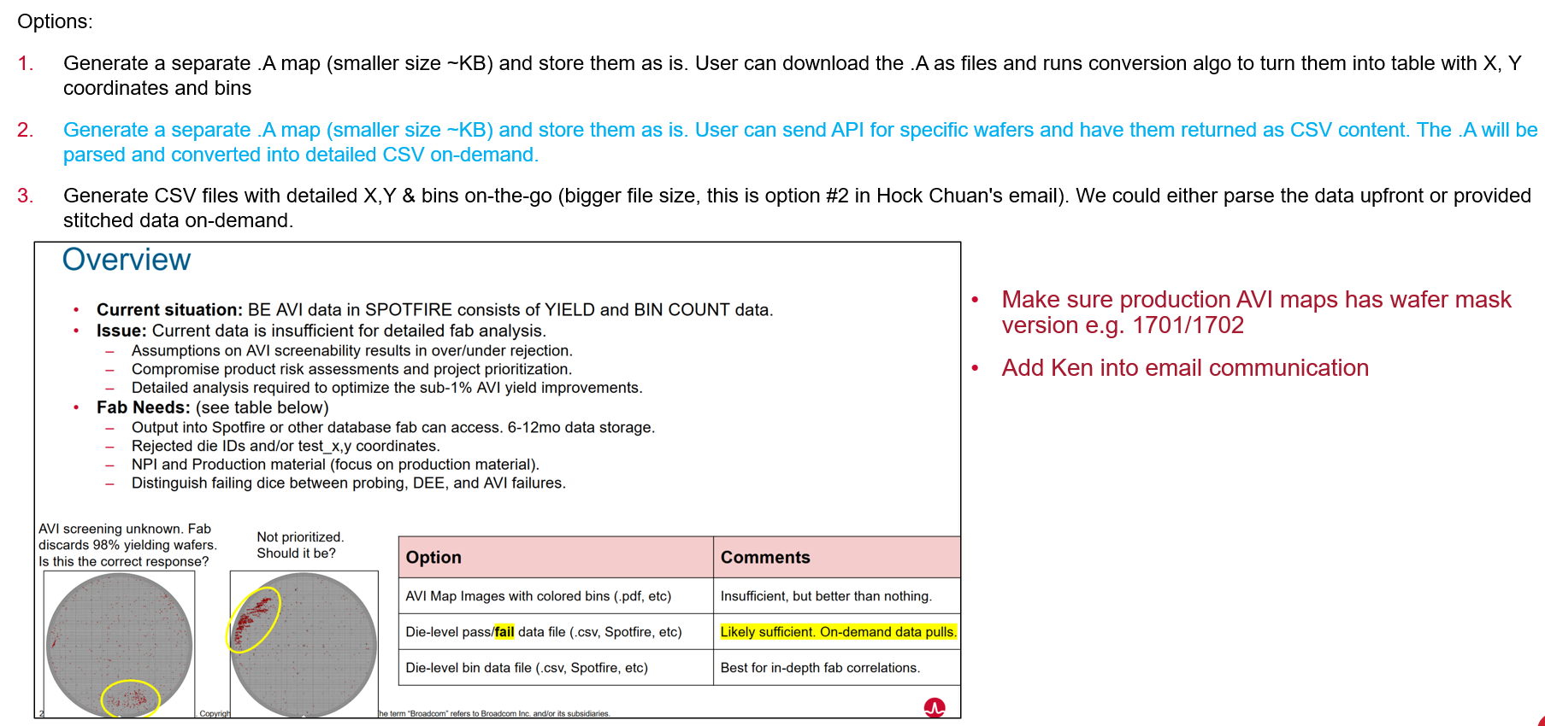
  - 09/22/2026:
    - Sync between Chris team and Chung Sik
    - The direction is clear and NO MUST timeline, so hold in the queue

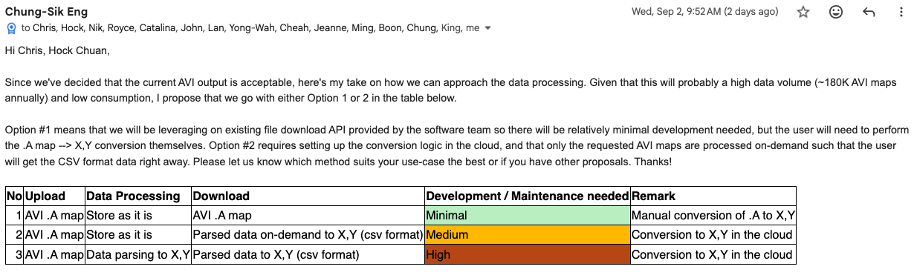
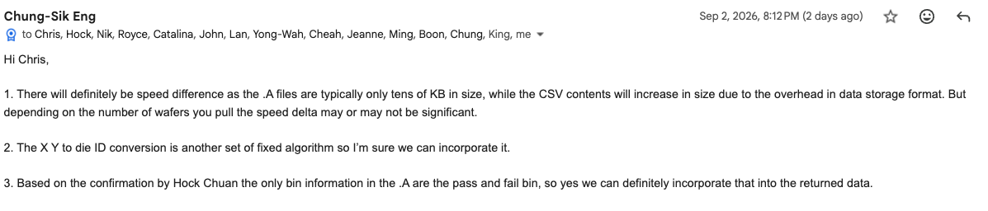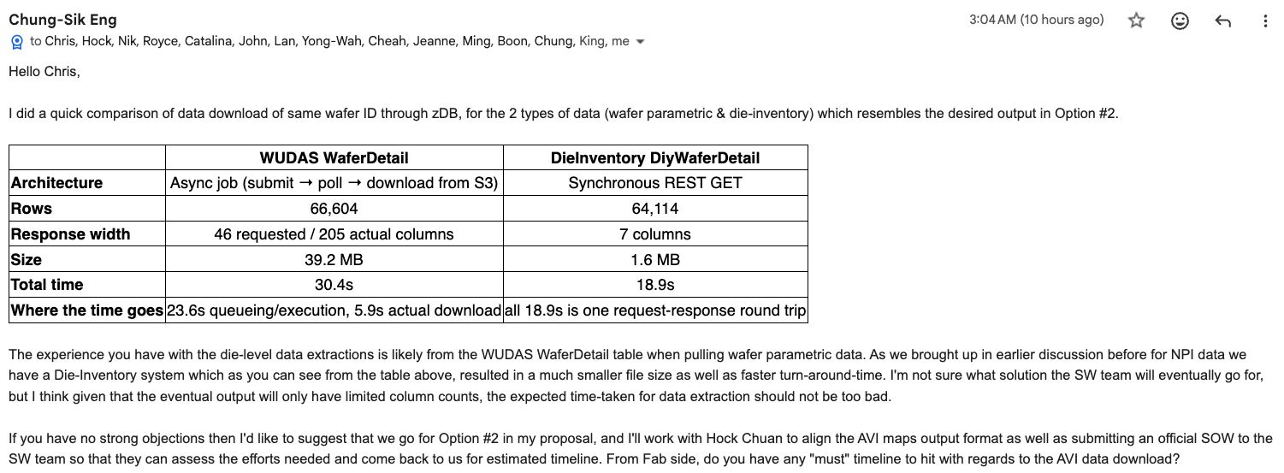

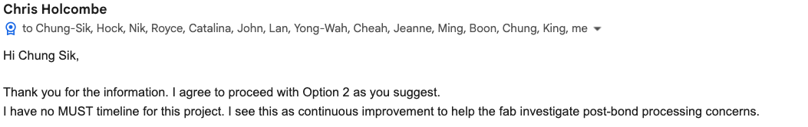

- (SW Team) Tech Sync with Snowflake (In Progress)
  - Snowflake Summit Topics
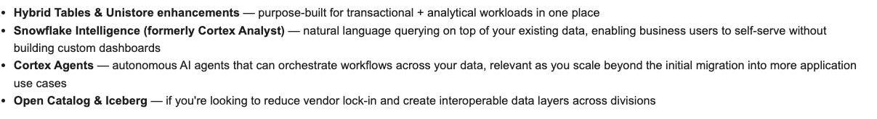
  - (I) Snowflake Adaptive Compute (up to 30% cost reduction) (In Progress)
    - 07/29/2026: Pre shared by Snowflake contact ron.fryer@snowflake.com and joshua.purayampallil@snowflake.com
      - https://bit.ly/4yQg9gc
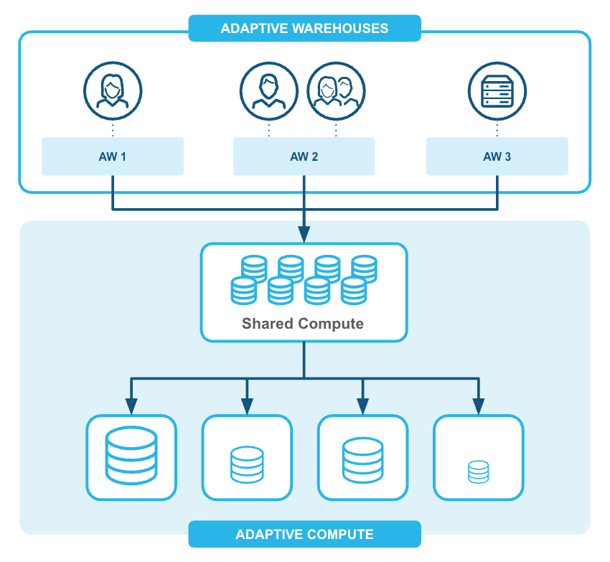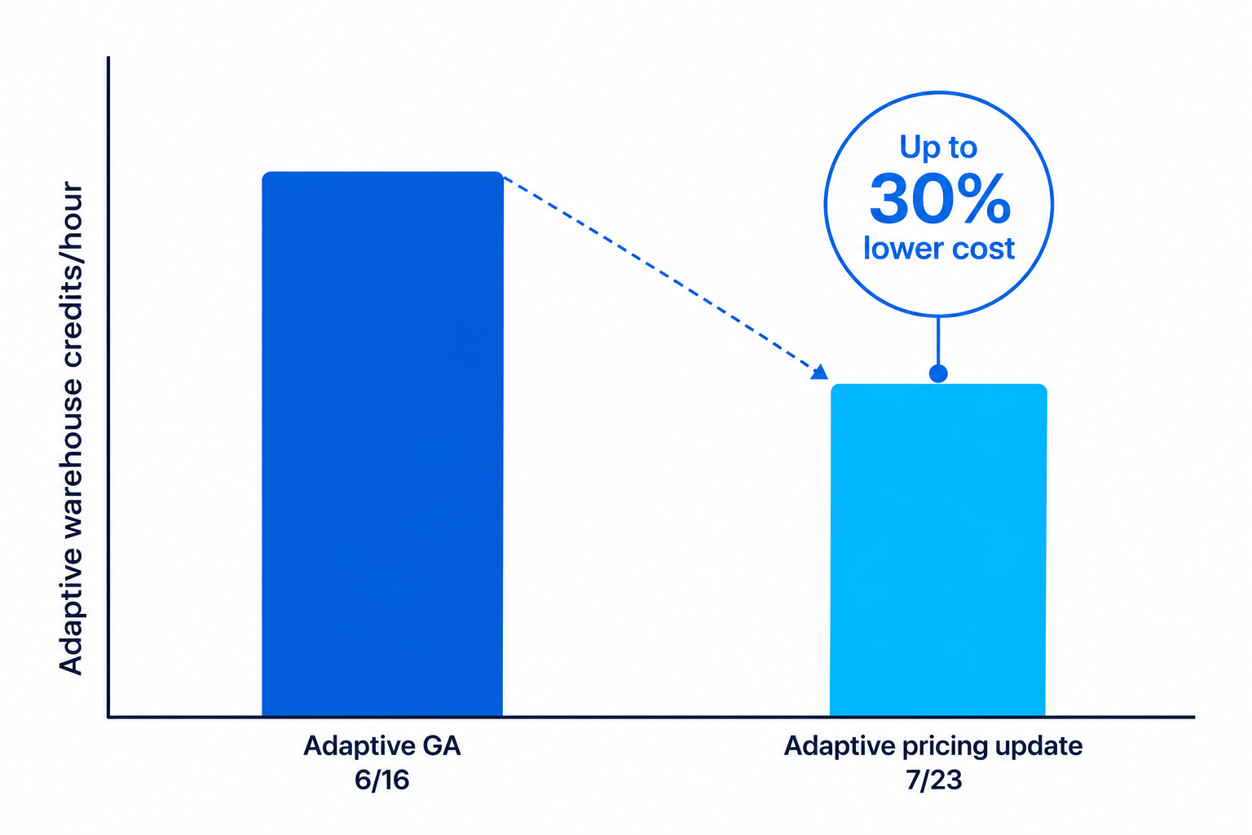
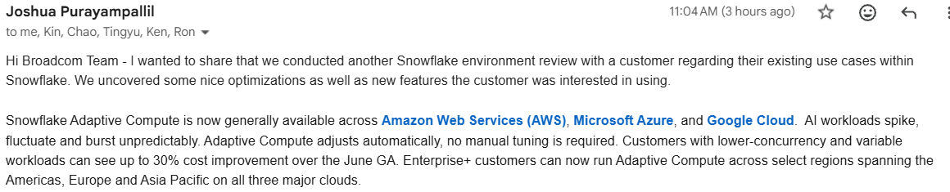
    - 08/03/2026:
      - Run the sync session with Snowflake
      - The proposal is to migrate from existing Type I warehouse to Type II warehouse, but this is not a simple clone, technical gaps are expected.
    - 09/22/2026:
      - Pending for bandwidth to further evaluate Pro vs Con before enable this feature
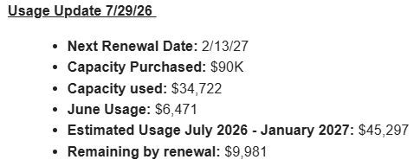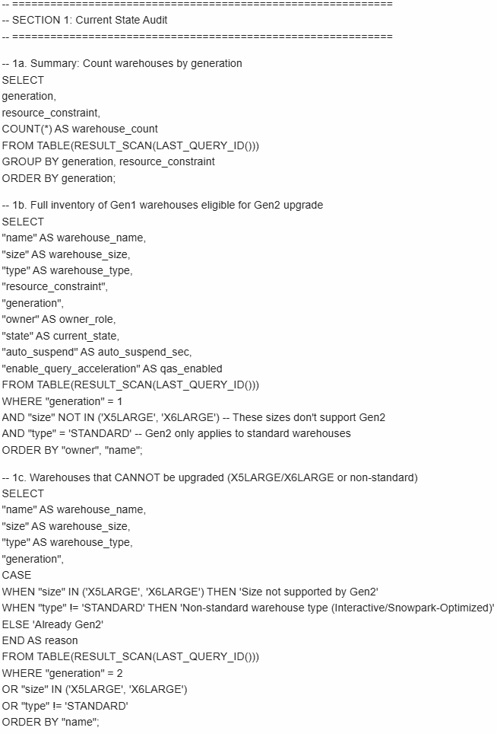
  - (II) Snowflake Cortex Analyst/Cortex Code:
    - A text-to-SQL service that lets business users query structured data using natural language.
    - Use natural language for data engineering, analytics, machine learning, and agent development, directly in Snowsight or via the command line.
    - 09/22/2026:
      - Agreed w/ Snowflake to arrange follow-up session for deep-dive
  - (III) Dynamic Table
    - https://www.snowflake.com/en/blog/whats-new-dynamic-tables-faster-flexible/
    - custom incremental refresh, dbt materializations, and pipeline simplification on top of Streams & Tasks.
    - Snowflake product team can pick one existing job or pipeline, rebuild it as a Dynamic Table
    - 09/22/2026:
      - Shared @ meeting:
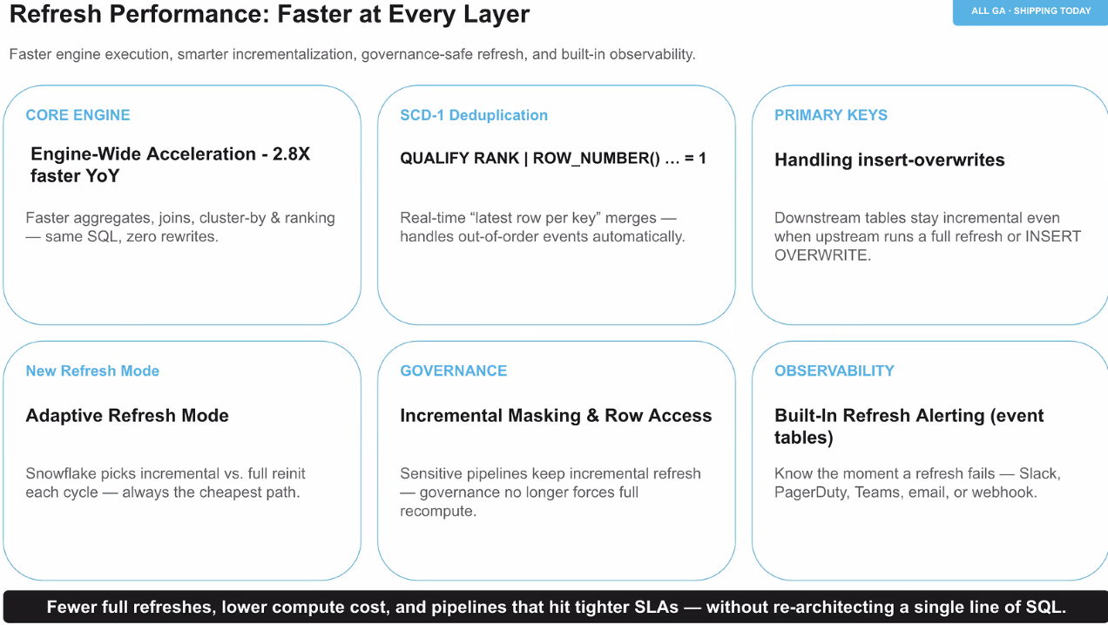
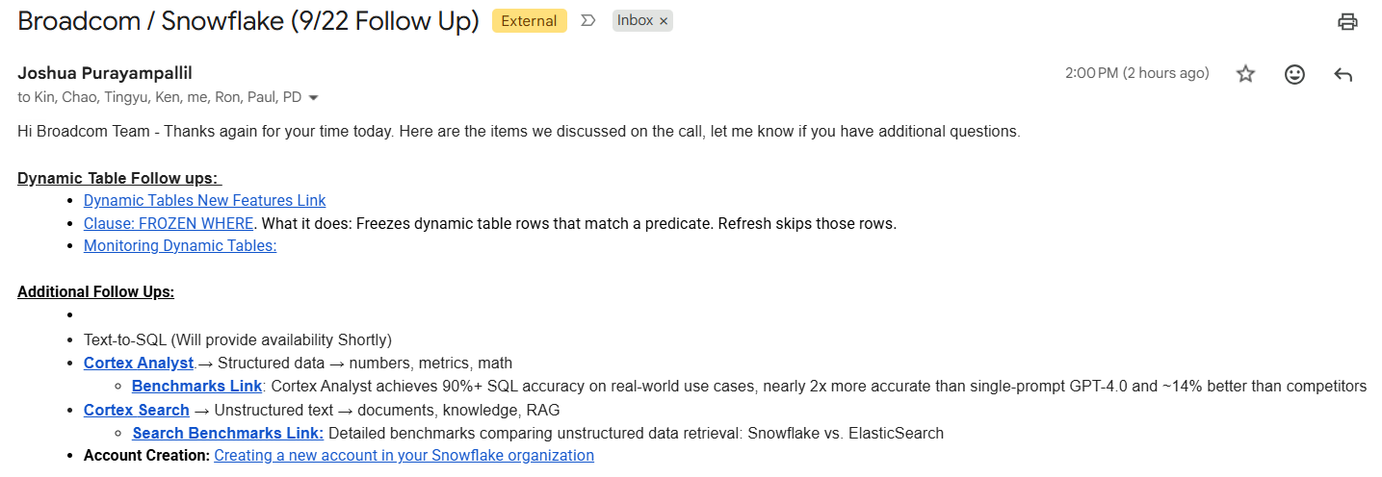

- (SW Team) Evaluate New Request “Extractor Traceability” (Hold)
  - From Chung Sik’s Aug 2026 SJ Trip, one of multiple topics
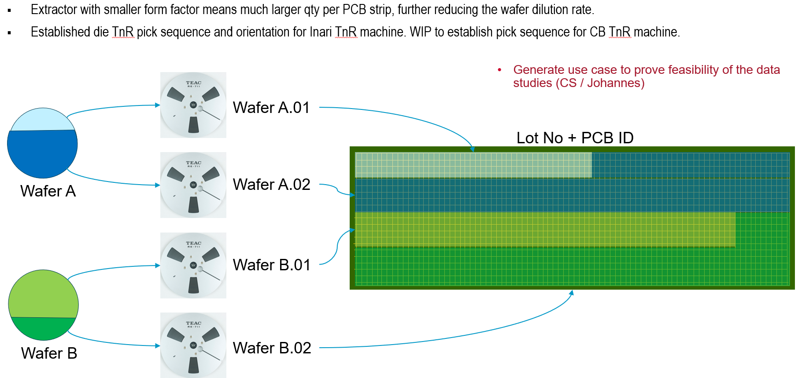
  - SW team recommend to find a solid use case (MUC) as Vehicle to justify

- (SW Team) Evaluate New Proposal “Cloud-Native Scheduler” from Ken (Hold)
  - 08/25/2026:
    - Initial proposal from Ken
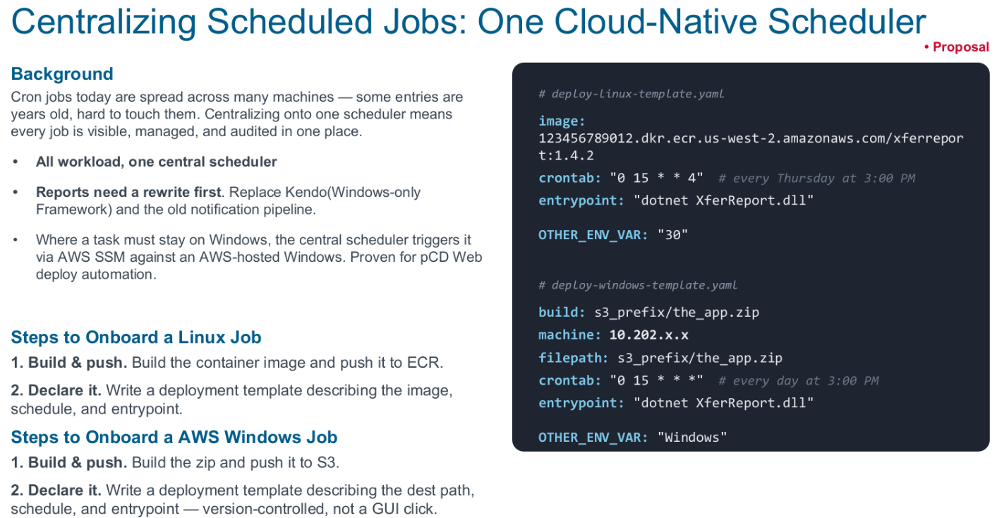
  - Yu Han request team comments due to
    - (a) scheduler mechanism was widely used in our data infra, including ATA, transfer, feeder, Spotfire, RT alarms;
    - (b) scheduler mechanism is one of these schema-driven topics, need make sure no conflict

- (Kin Lum) Evaluate New Request “change GU Cal File Parsing Logic” (Hold)
  - 07/17/2026.
    - Requested by choonchin.koay@broadcom.com
    - (Kin Lum) In further clarification
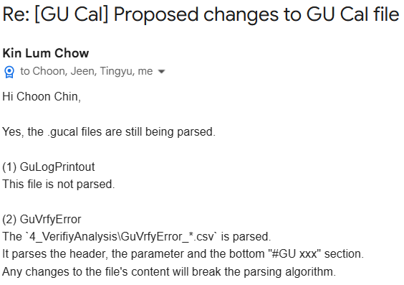
- 09/01/2026:
    - Pending for further alignment

- (Ken) Support GTO certificate migration to Keyfactor to Automate the certificate lifecycle (Hold)
  - Context as shared by CISO
    - CAB forum (Apple, Google etc.) was shortening the cert validity length of certificates based on the threat of quantum computing coming fast which treat cert and related encryption (is expected to be decrypted in minutes instead of years)
    - Goal: Move cert validity from current to 200 days 2026, 100 days 2027 and 47 days in 2029
    - Broadcom approved CISO’s KeyFactor project to help to automate this certificate lifecycle and minimize service disruption, instead of manually managing the cert
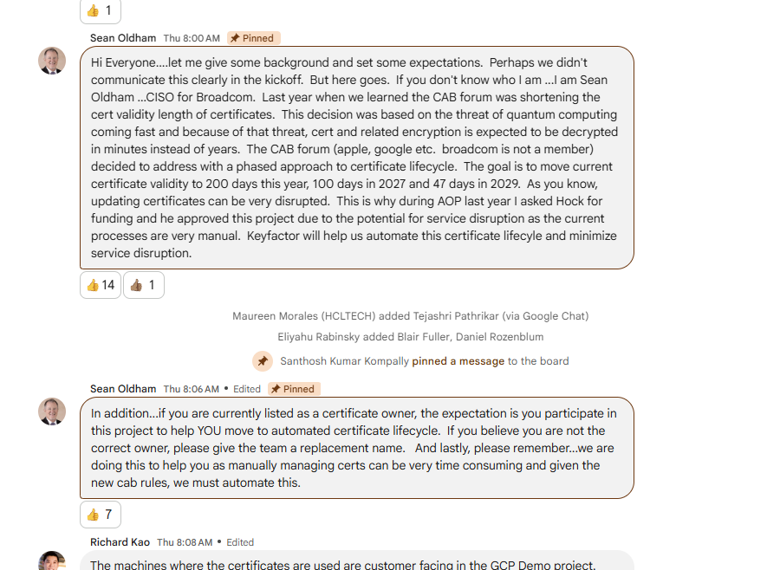
  - Schedule

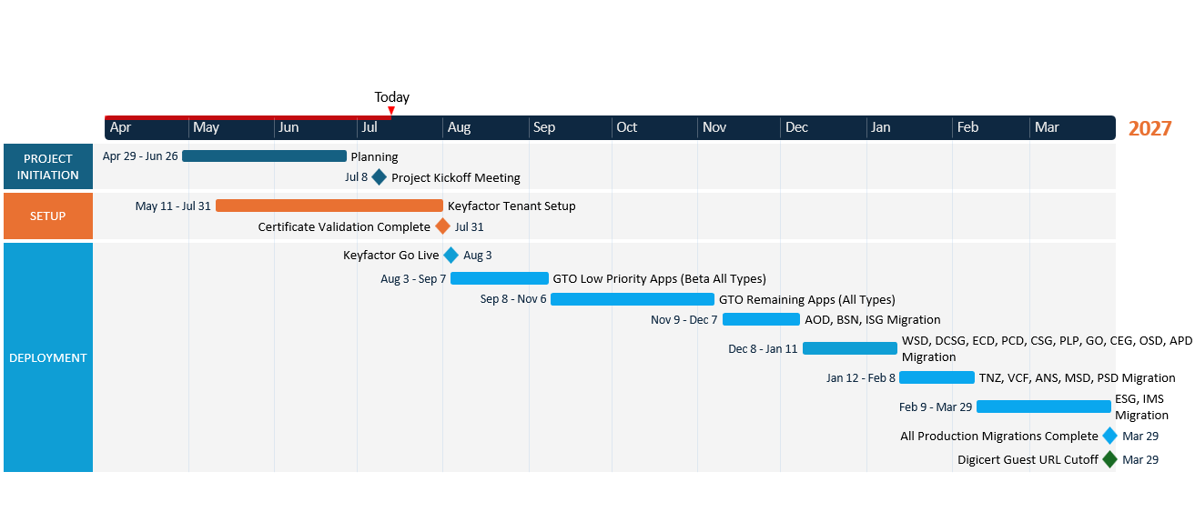
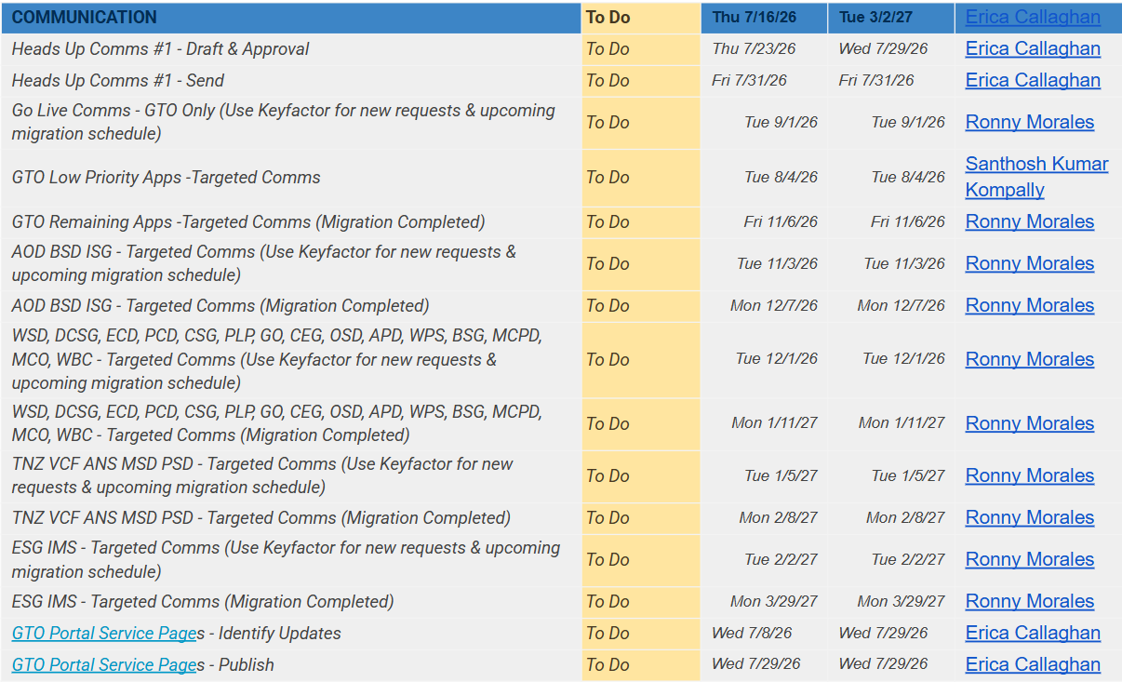

  - 07/13/2026:
    - SW Team members have certificates
      - Ken, Kin Lum, Jiapeng, YK
  - 07/28/2026:
    - Need complete Certificate Owner Validation
      - (Done) Kin Lum, Ken, Jiapeng, YK

- (KinLum/YK/Choo-Yau) Preliminary sharing from TDG about "PAD Dynamic Sampling Test” (hold)
  - This is very early preliminary sharing from Taer Ming and JJ, book-keeping here, no need move further
    - https://docs.google.com/presentation/d/1Z_7m31QuyL84_wfmRgBC6wshhOa5sLSw3AfEnBZui-E/edit?usp=sharing_eil&ts=69fd3cad
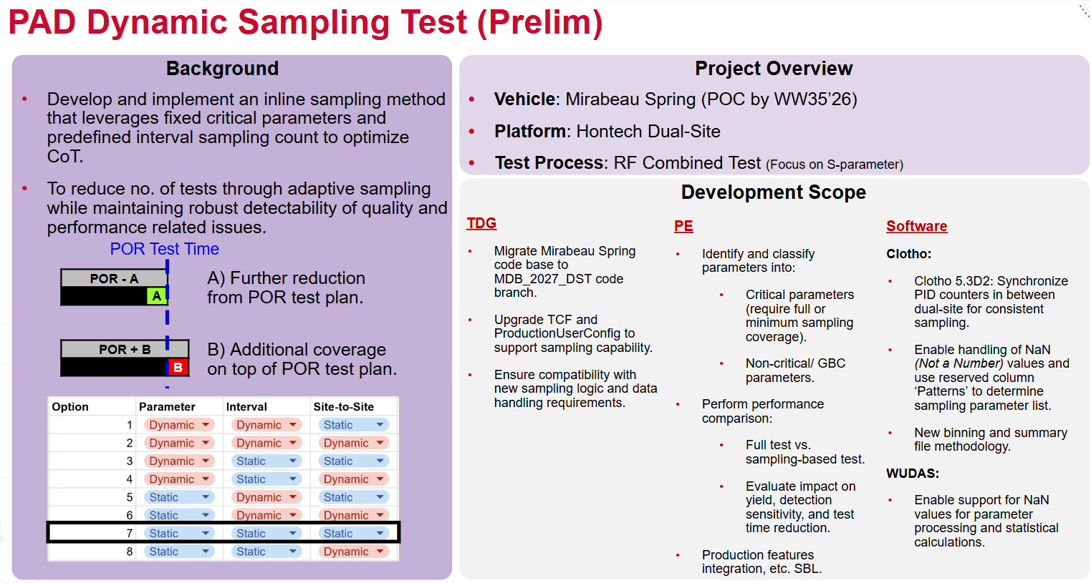
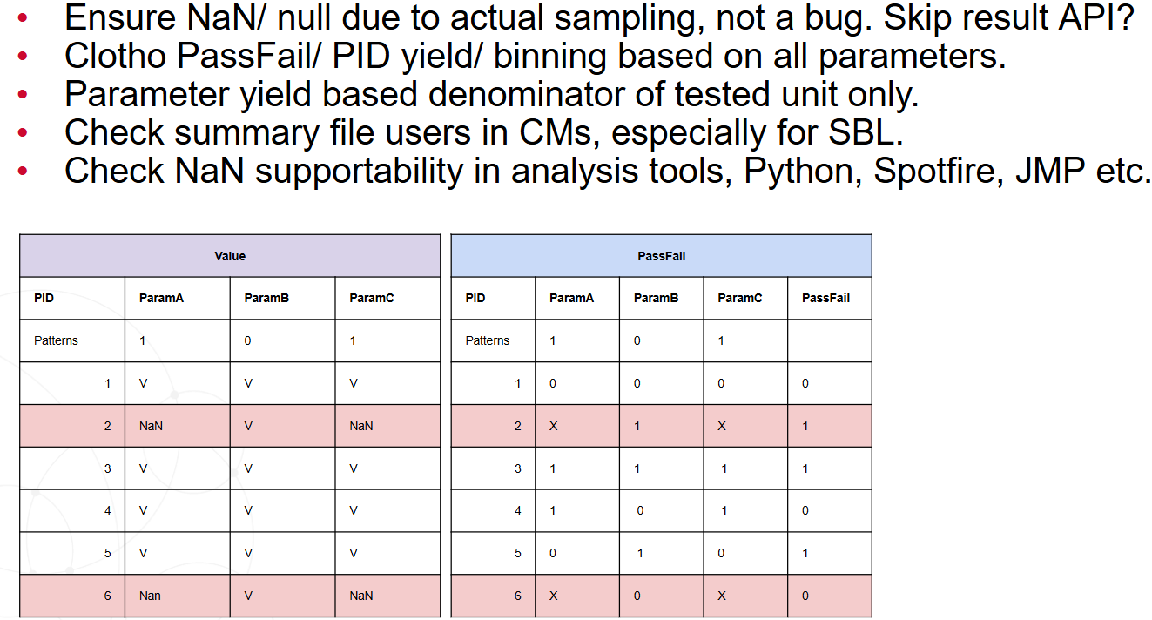
  - (Yu Han) Current assumption
    - Not urgent or high priority
    - Prefer minimum Clotho change, achieve DT goal inside test plan code (by using existing Clotho features)

- FlexPlot Phase II - ideas stage (Ken)
  - Propose ACL and User management strategy for users review
    - Shared pool
      - Each uploaded file (global unique name)
    - User specific
      - Plots, filter, category, dataset all saved as configuration
      - configuration can be shared between users
      - file management
  - Support advance filtering and grouping
    - null values filtering
    - flexible ranges
    - more complex filter logic
  - SJ Wafer data expansion

- (KinLum) MLOps Upgrade Request Understanding (In Progress)
  - 01/15/2026: Request come from Jen Seng, Rebecca. 2 topics:
  - Goal I) Instead of continuing previously agreed Phase II “Segmentation” expansion (Step 6/7/8), only need build an API to expose Phase I “Classification” results
Pending for detailed SOW from Rebecca and Jen Seng

  - Goal II) Try new model, which requires higher spec GPU power
Pending for further clarification from Rebecca.
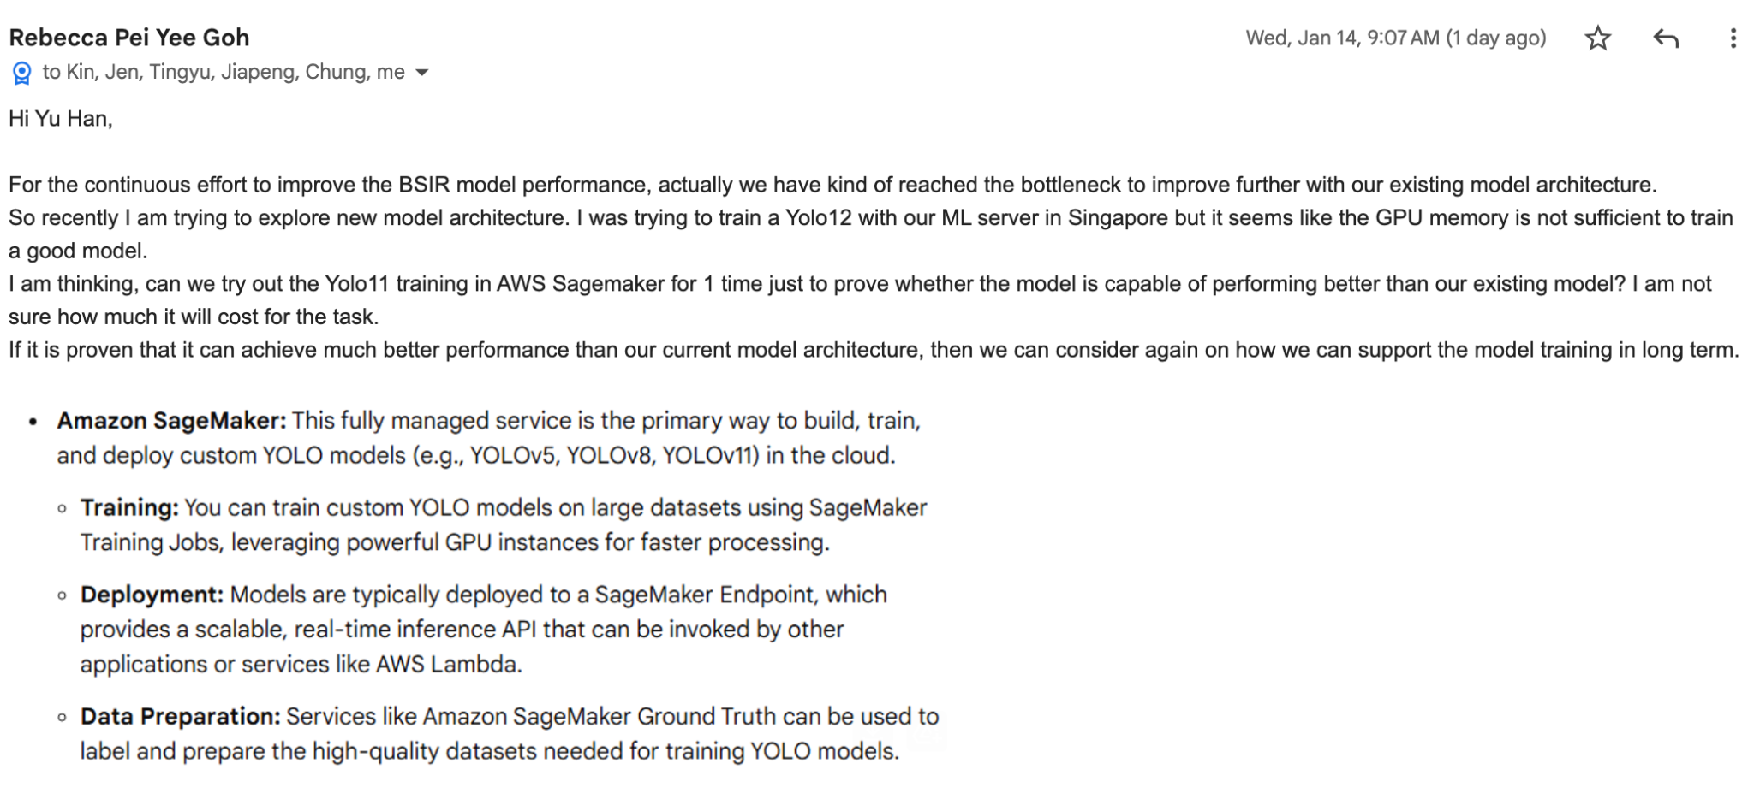
  - 02/03/2026:
Chung Sik requested follow-up sync with requirements changed
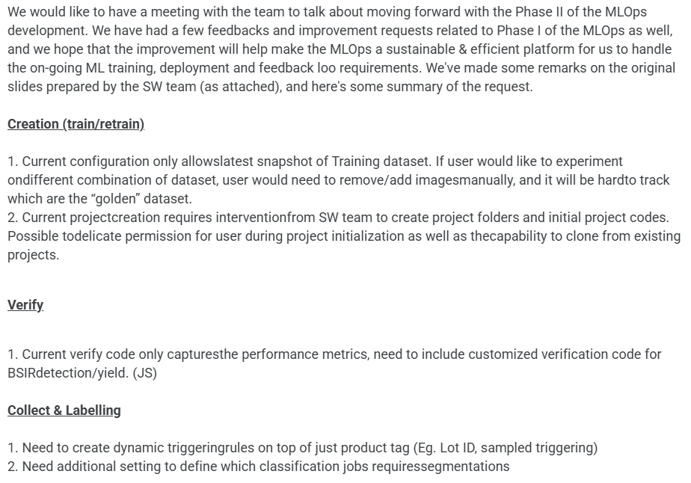
Per latest check, the MLOPs pipeline utilization is pretty low, so need justification of ROI
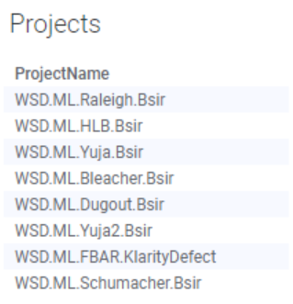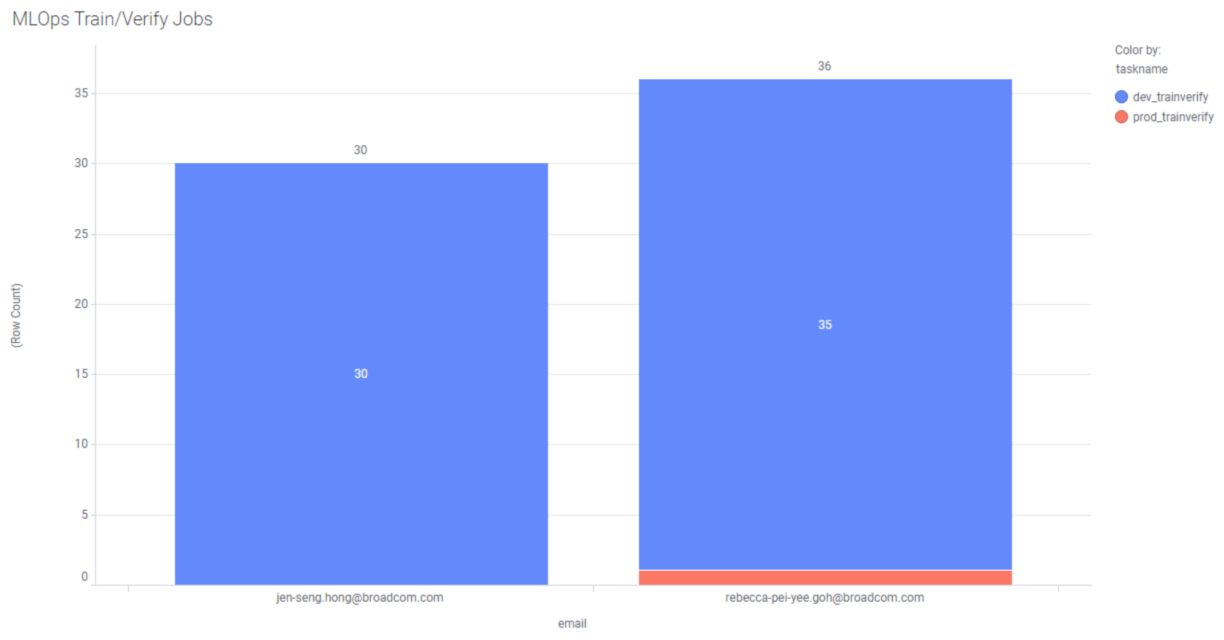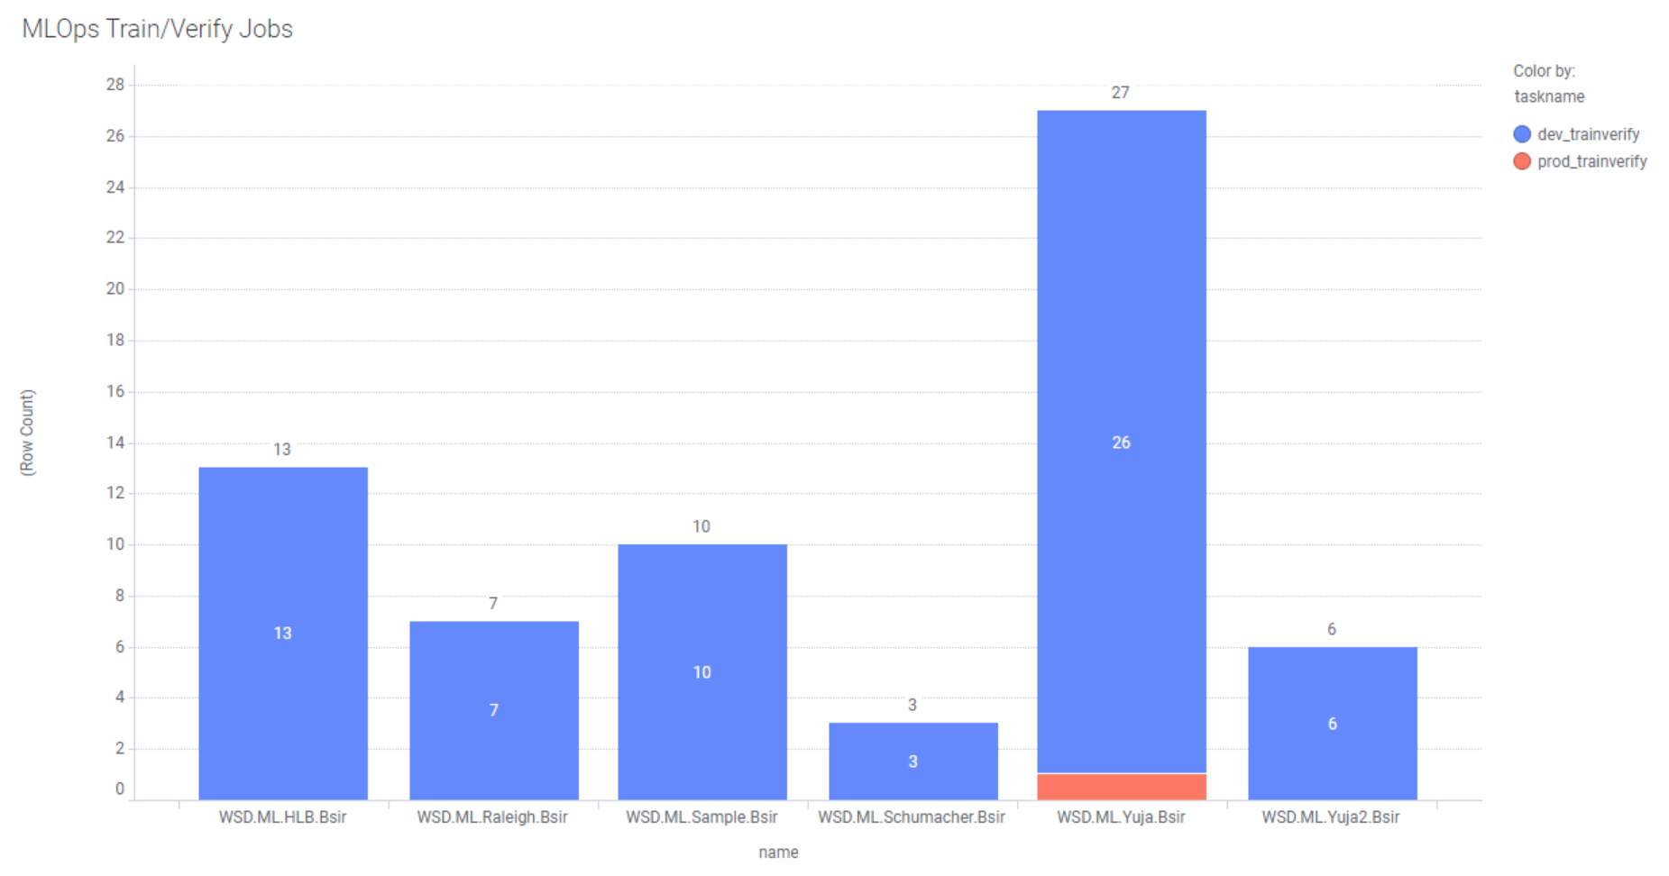

- (Jiapeng/Tingyu/Chao) TUDAS: Large JSON file TUDAS Processing Spike Memory Consumption (Hold)
  - Tracking
https://docs.google.com/spreadsheets/d/14hc72o9zWV8dRxEI7MX2ke7bU477KN9aSaEWGLu87XM/edit?gid=1902958118#gid=1902958118
  - Context
Issues to resolve: OOM caused by >1M row FCM Telecaster data processing
      - JSON serialization/de-serialization trigger momental memory spike (not the final consumed memory), which caused system down
        - 100X MB => 14 GB

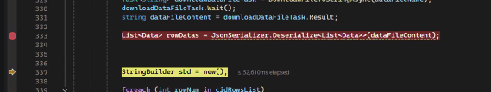
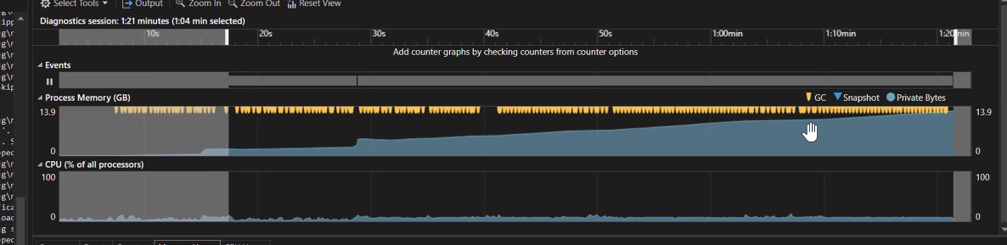

Proposed Candidates:
      - MemoryMappedFile vs Sqlite.

  - Golden Data Set
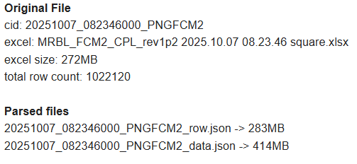
  - Data Structure and Processing Logic
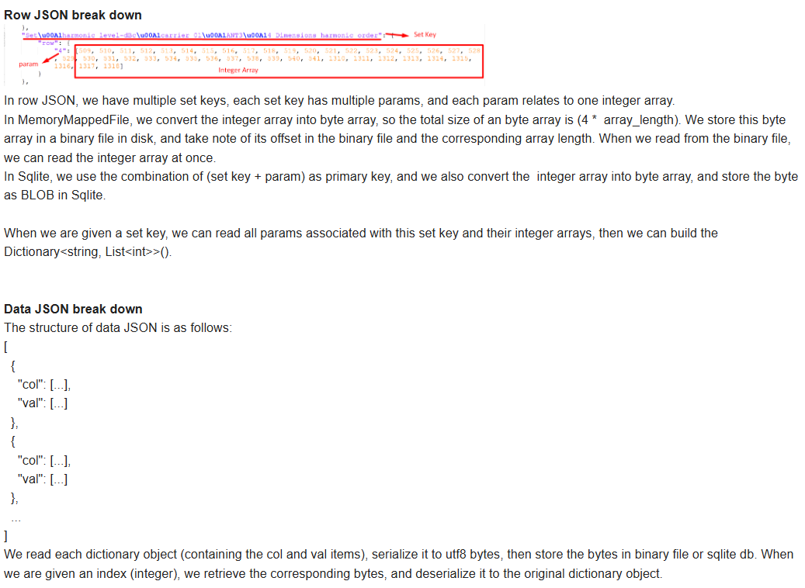
  - Performance @ Row and Data JSON
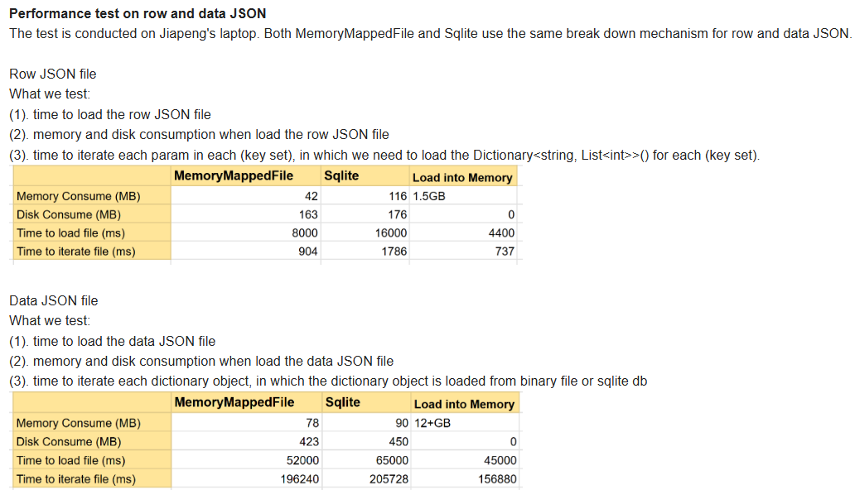
  - Larger Picture
Though initial result shows MemoryMappedFile better, but team actually prefer Sqllite option due to a large picture of fundamental parsing logic change for TUDAS
      - Each TUDAS file => 1 Sqllit DB
        - => 2 tables: data, row
          - => set + param => byte array
Pending for team to justify with more details, but some quick-thought reasons
      - (a) Different from WUDAS parsing (binary is one-time written, then never update, only read), TUDAS parsing need keep updating the byte array
      - (b) When handling very large TUDAS file, loading into memory with overhead of serialization/de-serialization will cause OOM
    - (Chao) modify TAP feeder code to write parsing results into Sqlite DB instead of json files. (In Progress)
  - Hold until NXG TUDAS upgrade cycle

- (SW Team) WSD/AWS Resiliency Improvement Discussion (In Progress)
  - (Yu Han) Due to the recent AWS us-east-1 down issue and our major workloads being deployed @ SG region, which is relatively old (though not as OG as us-east-1), I request AWS to start this discussion to evaluate any realistic way WSD can improve resiliency.
  - Some history topic for “Internal Production Resiliency and Cybersecurity Improvements” to kick start
https://docs.google.com/spreadsheets/d/111c8dFnvZdA22NXeBveX7UKfj5109z4biifDWT9ffUE/edit?gid=658832670#gid=658832670
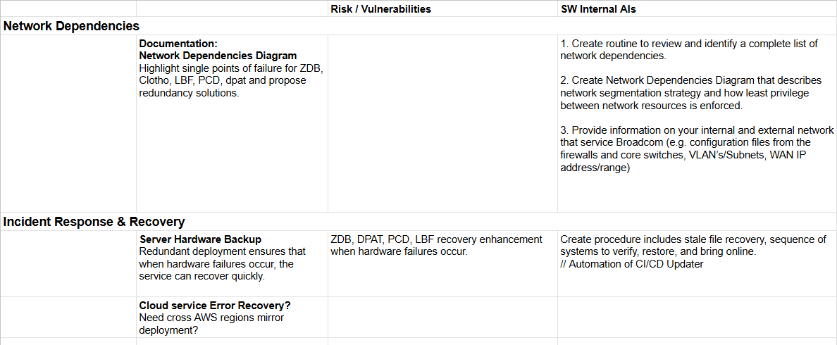
  - 11/17/2025:
Kin Lum drive the initial round sharing using pCD as pilot
  - 12/30/2025:
Pending for AWS follow-up updates
Pending for SW team find BW to do deep-dive researching @
      - S3 (mutil-region replication)
      - API GW (route53 multi-region smart routing)
      - Aurora (dynamic Postgres SQL (global endpoint) which can visit different region replicates)
      - EC2 (multi-region mirror AMIs)
  - Need recognize other mission critical projects to go through the similar process
Cloud SFTP (YK/Choo-Yau) -- In Progress
AppRunner (Jiapeng, TUDAS)
ECS/ECR (PRDA/DPAT, Kin Lum)
Snowflake (Kin Lum, pick a project)
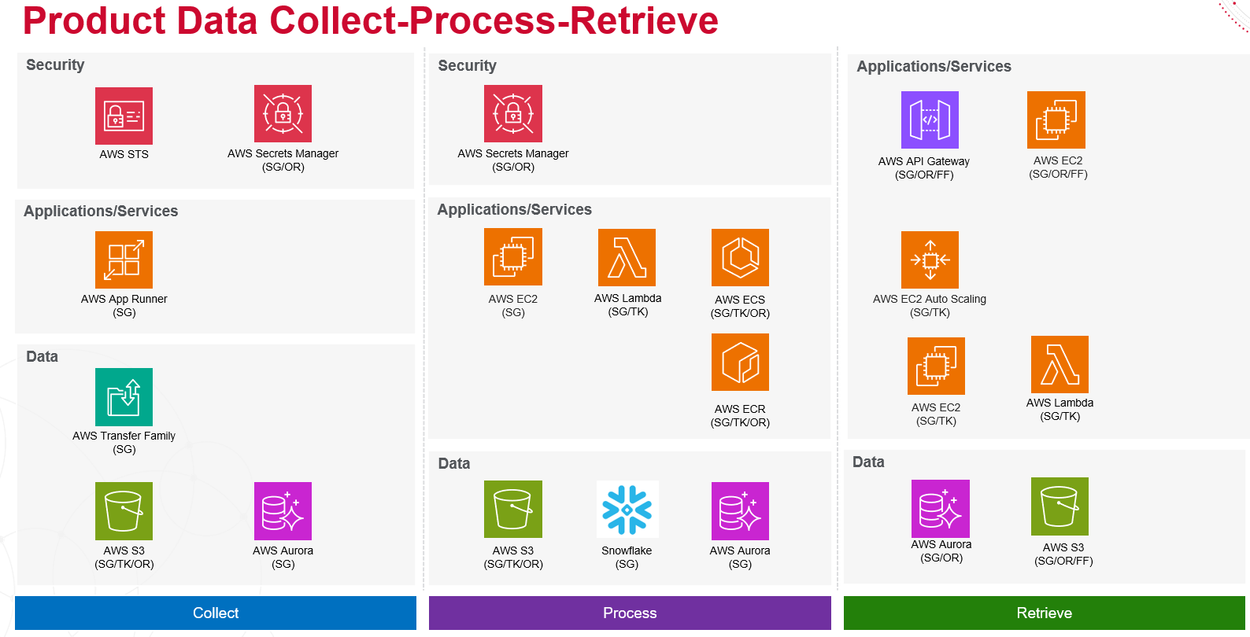
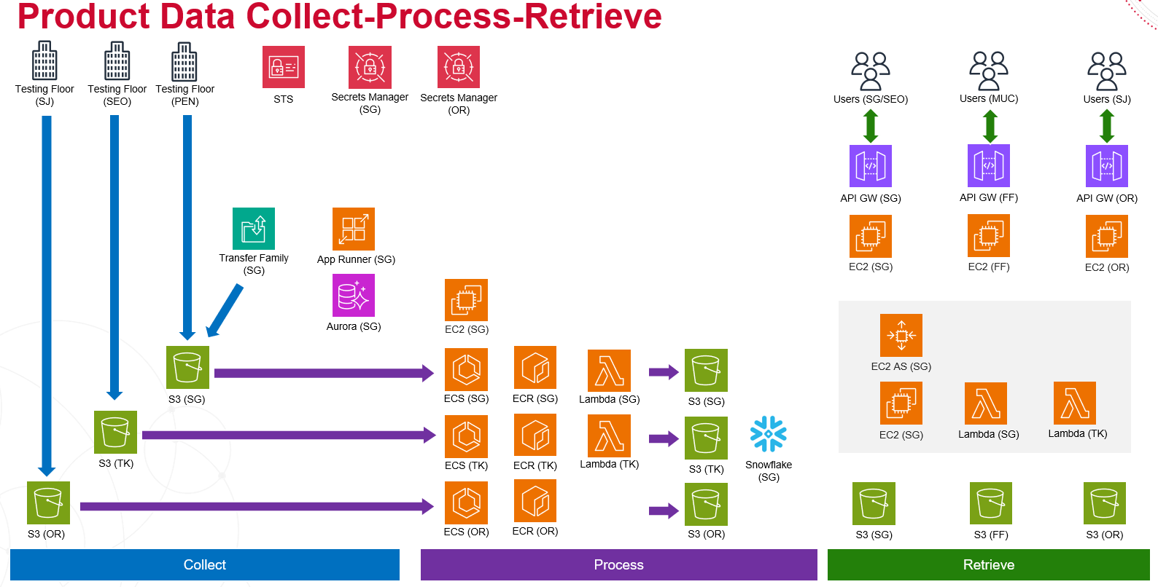

- (Yu Han) Investigate: Improve Large Zip File zDB Data Collection Efficiency and Integrity (In Progress)
  - This issue “unexpected out-of-ranges files “ showed up during Ken’s File Access API Enhancement investigation for Type 23 .fmtrace, 37 .bsi, 53 .wbsi, and 57 .wavi
    - Especially for Type 53, large size of .wbsi files, particularly those in the 4-12 GB range, is putting extreme pressure on data collection. This severely impacts the fairness, efficiency, and integrity of the process, consuming significant bandwidth to collect data that may be corrupted.
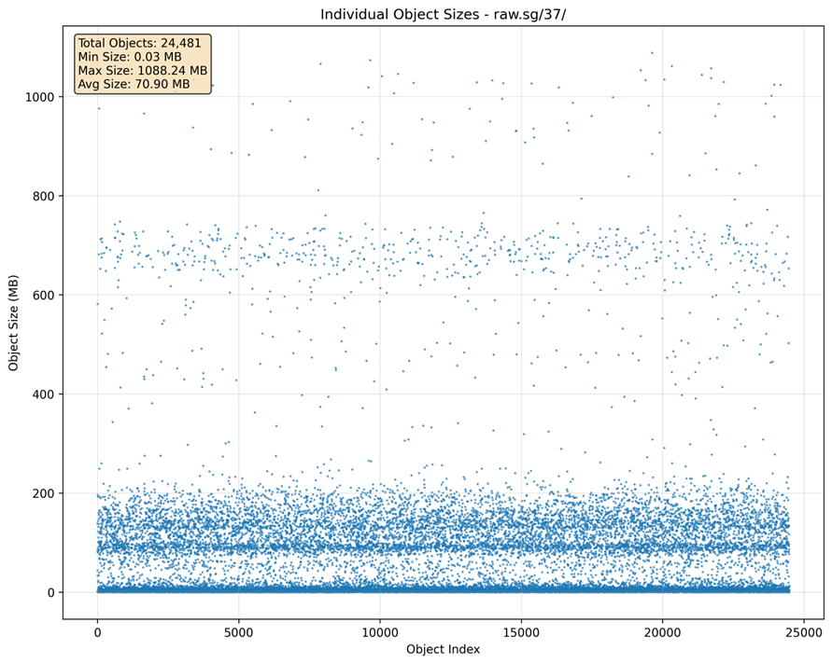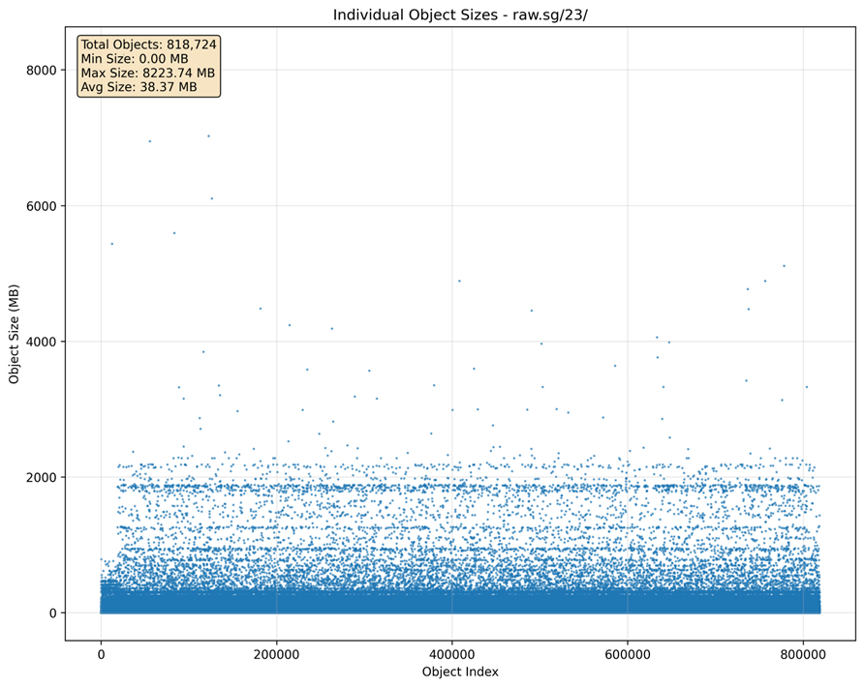
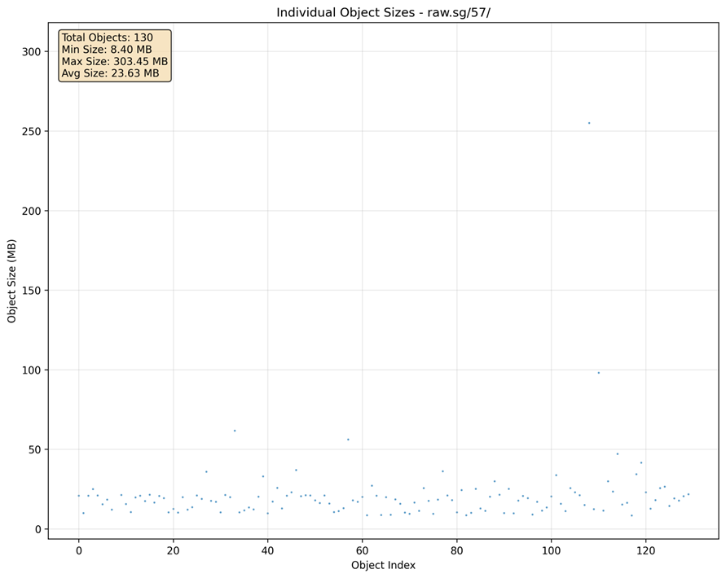
  - Chung Sik shared context runs NPI/PE side investigation and drive file size reduction by compress image files
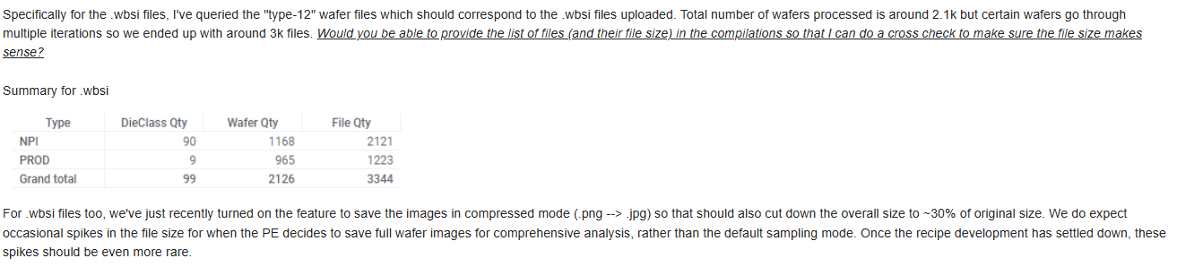
  - Yu Han propose to put hard CAP for specific types to reject them from zDB RTDC Data Flow
To address the recurring "unexpected" issue of out-of-range files, I propose to enforce a hard CAP check in the zDB RTDC collector end, to reject problem files from the dataflow rather than drag overall data collection health into risk, and I assume it's difficult to control this at the file-creation stage.
  - Chung Sik’s comment to highlight the “Necessity” of large size file
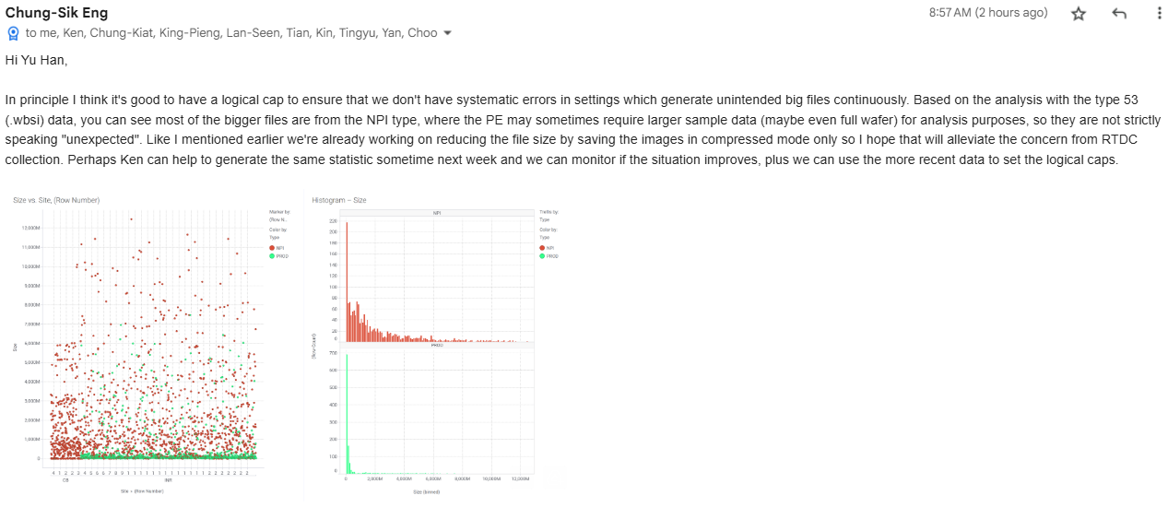
  - Yu Han propose to split NPI vs Production and enforce caching @ both Backend and Client end
How about split Production vs NPI collection, e.g., keep production WBSR as 53, mark NPI WBSINPI as type 60 or even 63 (we can agree on "always keep offset 10 between production vs NPI" to avoid future wondering)? … PE/NPI can define different CAPs so we can enable a count monitoring mechanism.
SW team will surely enforce caching in backbone, PE/NPI can also consider doing some caching from client end (not sure in data function or dashboard itself, I need consult YK/Choo-yau), to avoid waste computation power or bandwidth @ repeated request, anyway we are dealing with 11GB single file or a single file which might contain >60K entries.
  - 11/04/2025:
Pending for PE response

- (Tingyu) Support Request: PCB Cu Post data parsing Enhancement (In Progress)
  - Per Chung Sik request, to enable statistic calculation during such parsing.
  - (Kin Lum) Original request (refer to yellow area) came from Oct 2024, was hold during BW issue of SW team. Now it’s time to finish it.
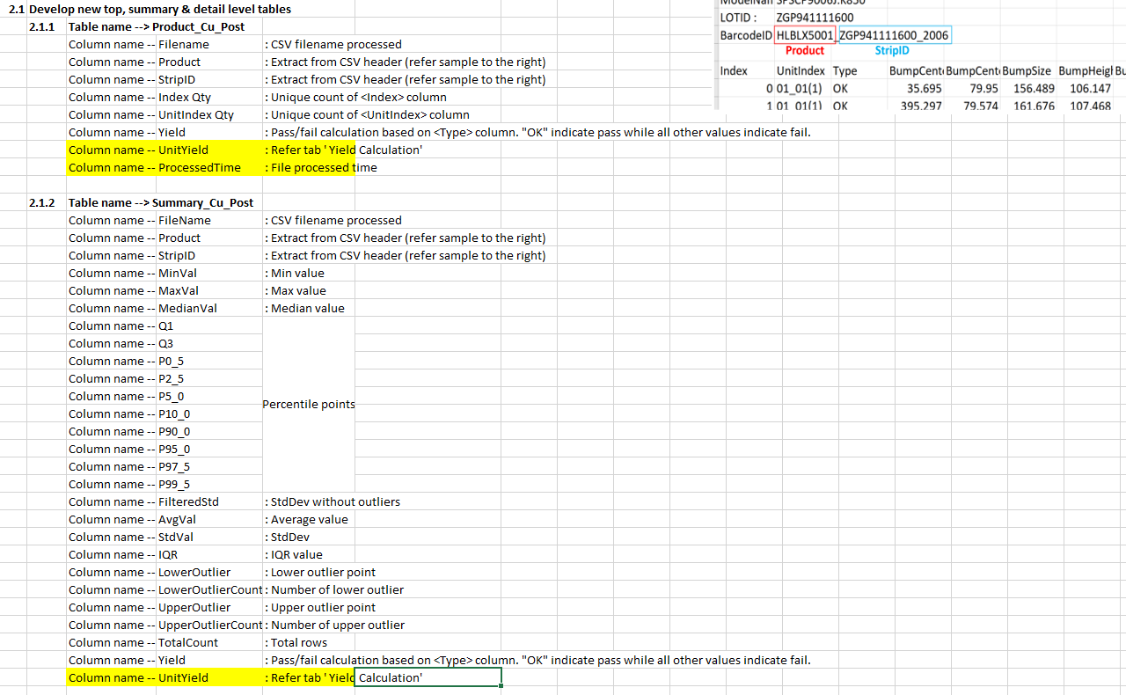
  - 01/21/2025:
Analyze PcbCu SOW V2.2 and new requests (by Seoul team) and discuss w/ Kin Lum, Chung Sik (Completed)
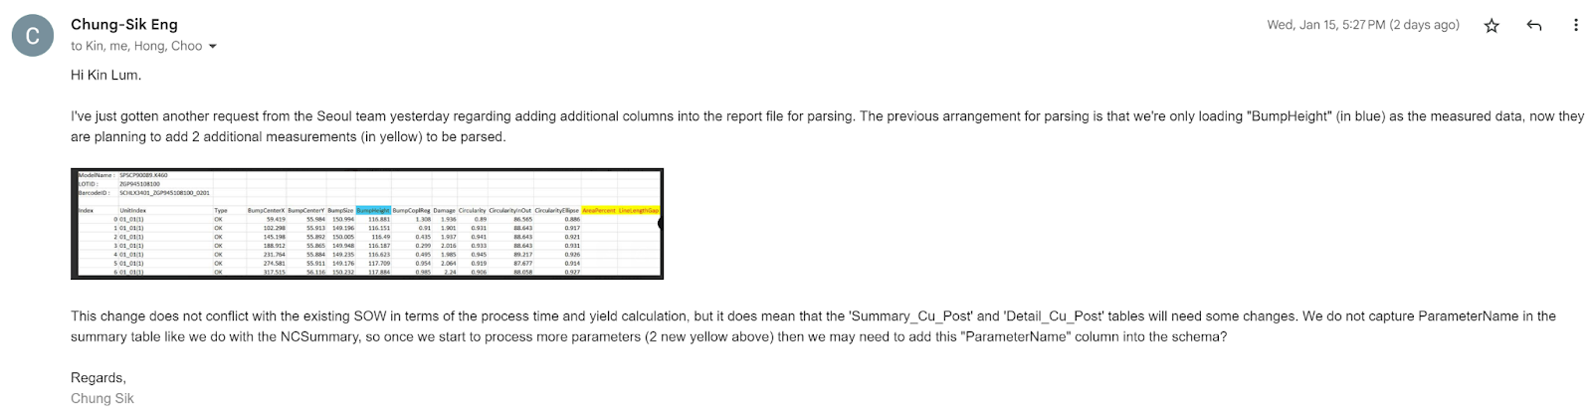
  - 02/15/2025:
Waiting for Chung Sik new full SOW V2.3 (In Progress)
  - 10/16/2025:
Chung Sik bring back this topic, including 2 separate requests in the recent SOW:
      - To include 2 additional columns for parsing, rather than just a single parameter column in the past.
        - The request actually came from the Korean team, and will check with them on the urgency to get these columns in.
      - To include the file processing timestamp to tell whether and when a new file is being uploaded by LGIT, in order to perform sorting and also trigger ATA if needed. This is very helpful to enable automation from our end.
  - 10/17/2025:
KinLum/Tingyu share the utilization on the WUDAS API for PCB Cu related tables
      - Pretty low utilization
  - 10/26/2025:
SW internal sync marks this as 3 weeks workload, straightforward upgrade
  - 10/27/2025:
Chung Sik helped to clarify the urgency and mark as “non-urgent”
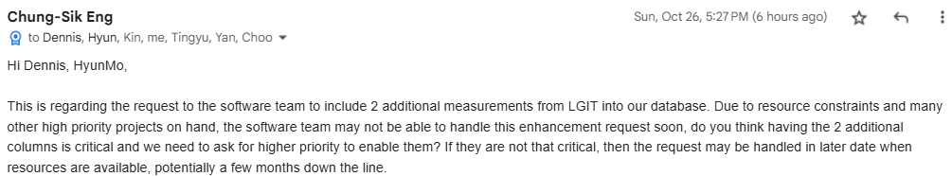
  - 10/28/2025:
(Yu han) Hold until Jan 2026 for a quick handling

- (Tingyu/KinLum) Upgrades to enable full automation of Credential Rotation (Pending)
  - cicddm.brcm
Deployed @ 36x instances
Plan to upgrade as “Dual-Updater” automated upgrade
  - CI/CD Jenkins pipeline upgrade to support human to manually adjust Assembly Version to trigger the CI/CD process
Tingyu already have a version for TAP XFer using PostBuild event
CM Daemons
      - Deployed @ 30x instances
      - (3) dpatdaemon.akr; dpatdaemon.brcm; dpatdaemon.inr
      - (6) pcddaemon.akr; pcddaemon.amr; pcddaemon.brcm; pcddaemon.cb; pcddaemon.inr; pcddaemon.snx
      - (1) user.devproto.cmdaemon
      - (1) user.wsdmlops.cmdaemon
      - (4) workflowdaemon.brcm; workflowdaemon.cb; workflowdaemon.inr; workflowdaemon.snx
      - (1) cmuser.xfer
Notification
      - notificationsdk.akr; notificationsdk.amr; notificationsdk.aws; notificationsdk.brcm; notificationsdk.cb; notificationsdk.inr; notificationsdk.semco; notificationsdk.snx
      - user.wsdnotification.clientsdk
user.generic.zdbdpro.configro.maprw
      - ATA SDK, for S3 access raw files
user.pcd.client
workflow.creator
workflow.runner
  - (Ken) Enhancement EC2 deployment to make following account Credential Rotation Automated (Hold)
report.cleadausage; report.dausage; report.s3usage; report.transfer
Move to EC2 with a role
Because currently shared with other services on an EC2 which already attached another role, prefer not to bring up a new EC2 only for this light workload purpose. Hold when other similar needs show up.
  - 10/10/2025:
Scope & Approach clarified. Pending for project vehicle to start relevant upgrade

- (Yu Han) Investigate Options to Accelerate “Octa-site Wafer Probe Testing Data Collect & Process" (Idea)
  - 09/05/2025: From KP
Octasite wafer probe testing might change the data generation/collection requirements.
      - Currently 4~5 hours to complete one wafer testing, collect trace data by ~10 minutes plus Cloud processing, expect >30 mins latency before data available in WUDAS
      - In the future, ~1 hour to complete one wafer testing, need finish full wafer data collection (including trace data) much faster (<3 minutes???)
      - Plus potential coverage of wafer result date writing into file (or streaming?)
  - 09/09/2025: Sync (Yu han & Chung Sik)
(Chung SIk) With the TDG team working on improving the wafer probing with hardware improvement (eg. Octa Site), we should look into the prospect of refining the data transfer and processing method we're using today to see if there's improvement we can achieve, either by improving speed of data availability or enabling new capabilities.
(Yu Han) 3 Potential areas for improvement based on discussion with Chung Sik
      - Data Collection
        - Assume wafer trace data (per die) is generated independent of CSV
        - Instead of collecting whole wafers’s 60K dies trace data as a single zip (current behavior), change to small spike higher frequency batch collection. E.g., set 50MB as limit, each time find accumulated new dies’ trace files > limit, zip then collect.
        - This will change current low frequency High Spike collection mode to new high frequency Smaller Spike style
        - Latency improvement:
          - From last minute 60K dies’ trace files zip into single 5GB zip then collect
          - At the last moment, 50MB (5x dies) zip collect
        - Follow-up sync (SW owner Tingyu)
      - Cloud Processing
        - Assume WUDAS and zDB can process each die’s trace file independent of primary CSV
        - As soon as small 50MB die trace files’ zip @ S3, zDB/WUDAS can process each die’ trace; As soon as the final CSV show up in S3, process CSV to finally enable the WUDAS query
        - Latency improvement:
          - From 60K dies’ processing + csv processing
          - To final CSV processing time
        - Follow-up sync (SW owner Kin Lum)
      - Local Post-Processing
        - Just a suggestion to use a standalone Edge computation node (side by side with the huge wafer history data share folder) to accept each local tester’s post-processing request and publish the result through API
        - Assume post processing only need access history CSV data, no need history trace data
        - Latency Improvement:
          - From: local tester search, allocated and grab the required history CSV to local storage, run post-processing logic, then push new csv back to share folder and collect into zDB/WUDAS through zDB share folder
          - To: Call API to start post-processing, poll API to get post-processing result back, new csv can be collected right away to zDB
        - Bonus: Make pCD-V wafer Clotho V7 much easier since only need upgrade Edge node for post-processing logic
  - 09/30/2025:
Pending for TDG/PE to further clarification to decide the action items for SW Team
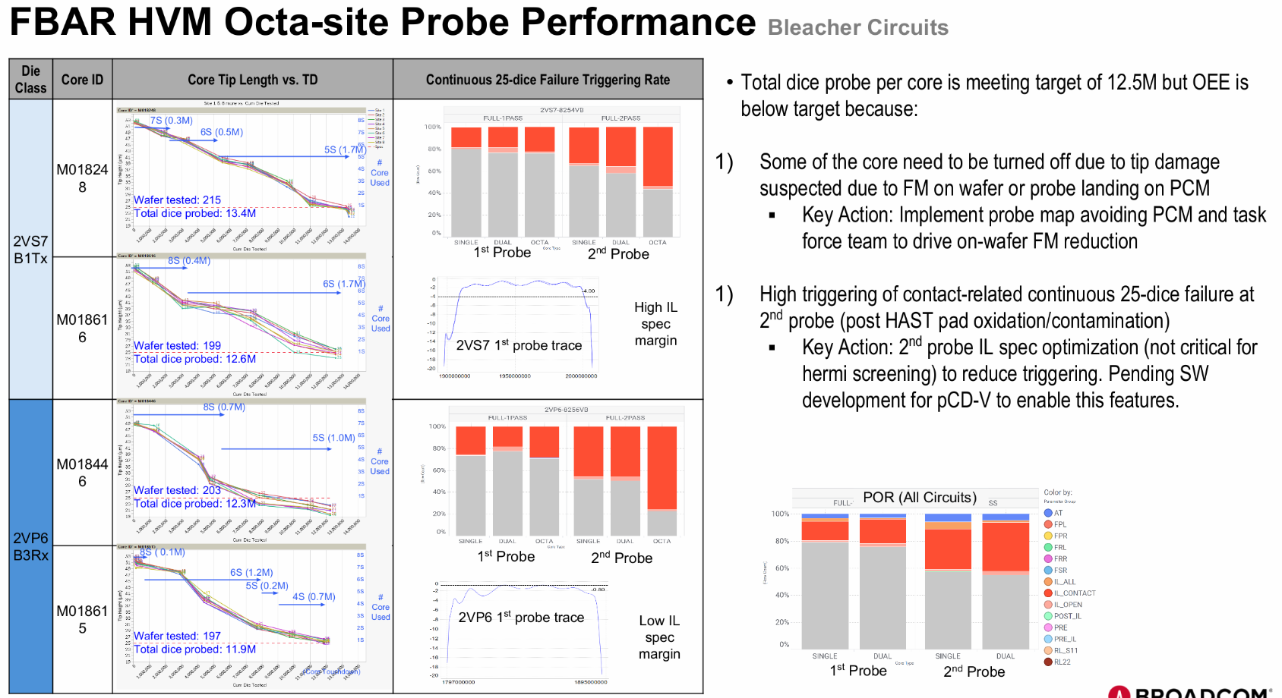

- (Kin Lum/YK) Investigate solution to Keep Aurora (Private) IP Address No Change when Upgrade/Maintenance (Hold)
  - 06/13/2024: AWS share potential ENI/EIP solution approaches
  - Kin Lum and team investigation ENI/EIP approach with more Qs to AWS
    - Could not find any ENI configuration setting while modifying the Aurora cluster
  - Comments from Nael:
    - "It is crucial to understand that these methods can be useful for retaining a static IP address, but they cannot promise that the IP address will stay the same after a reboot or failover." Did you mean that even with this ENI approach, there is still no guarantee that the IP will be persisted in some circumstances?
    - There’s no guarantee the ip address will not change if there’s an underlying hardware issue. If the hardware that’s hosting the RDS experiences an issue, it will have to be migrated to another droplet, which means a new ip address. Extreme case.
  - (Yu Han) Anyway we will have to work with BRCM IT to prepare firewall whitelisting for either changed private IP cases or newly reserved private IP cases, plan to start pushing ENI solution after completed IP Tunnel set up and RDS Certificate Rotation
  - AWS Satya shared another “prebook private IPs”, “minimum ip block sizing for rds proxy” idea @ https://docs.aws.amazon.com/AmazonRDS/latest/UserGuide/rds-proxy-network-prereqs.html,
  - (Yu Han) Need book a 1~2 weeks window to deep dive this topic. Either find a valid solution or confirm can’t do so we need align with GTO

- (SW Team) Technical Investigation of Misc. Topics (In Progress)
  - (Chao) HTTP pulling module (CLEADA) Improvement
      - Few network round trips
      - Server side can decide the “best” duration to wait for next check
        - How can server side define “best” duration?
      - Especially for “Long time job cause HTTP timeout” case -- Use 302 Redirect
    - Plan to call a follow-up discussion session to decide whether applying to NXG WUDAS
=>
  - (Tingyu/YK/Choo-yau) Integrate Automated UI Testing into CI/CD
    - Need enable necessary Jenkins plug-in
    - Need bring up an on-premise Jenkins server to cover Clotho/PPYCC auto testing.
  - (YK) Documentation for Docfx – Generate online documentation from custom JSON
    - Example for G-DB
      - http://wsdsgsvc03.sgn.broadcom.net:8080/GenealogyDB.DocFx/
      - Github: WSD.ATMHybridSolutions/tree/new-ws-queries/CustomTools/GenealogyWebService.DocFx
  - DPAT
    - (Kin Lum) To enable “Timeout or Failed or Hanged” Task auto detection with auto error recovery (Kill then Restart new task), might be a generic ECS monitor instead of service based ER service
      - AWS ECS is not bulletproof
  - pCD
    - (YK) Intentionally exclude all Clotho system DLLs from pCD Coverage
      - To avoid DLL version conflicts
  - LBF
    - (KinLum/YK) LBF Error Recovery Enhancement
      - https://docs.google.com/presentation/d/1DyNwclCRS-aqEhhdUO8PEbvvnklpqrpr/
      - Make IBF files dual copies, so as soon as LBF server is UP, the system can continue process the new coming data together with the Input BF history data (internal) then generate output BF data for Clotho to access (which IP doesn’t need change)
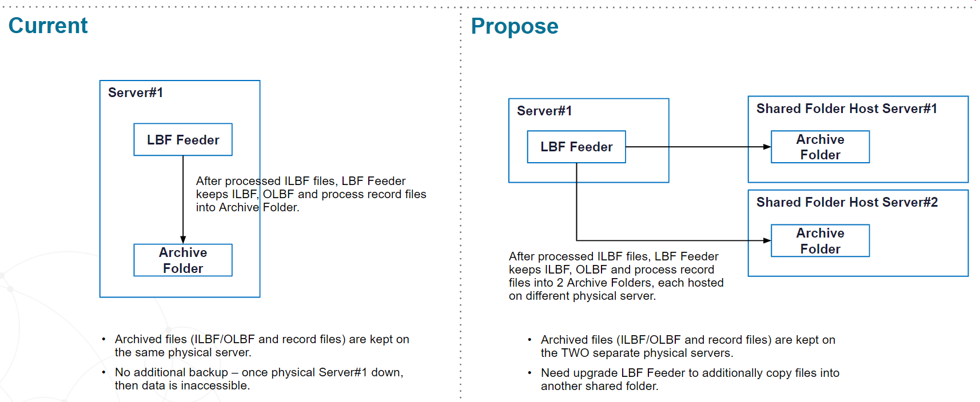

- (KinLum/Tingyu) Per-Type File Format Checker “Playground” style service for end user to self evaluate data compatibility (Hold)
  - This proposal is triggered by rounds of “File Format Issue Causes Parsing Failure” communications between data creator (possibly 3rd-party), PE and SW team, to allow wasting all parties’ time
  - The scope should cover all file types which has ETL logic decided and agreed by all parties
  - The design need enforce code reuse across production deployment and Playground use to minimize duplicated workload
  - 07/18/2025:
    - Comments from Chung Sik
  - 08/05/2025:
    - Goal: Enable raw file content checking done by stakeholders themselves (TDG/PE/etc.)
    - Proposal from Kin Lum:
      - Modularize feeder code into building block for reusability
      - Generalize parser for most common generic raw file format with configurable document definition using same parser algo
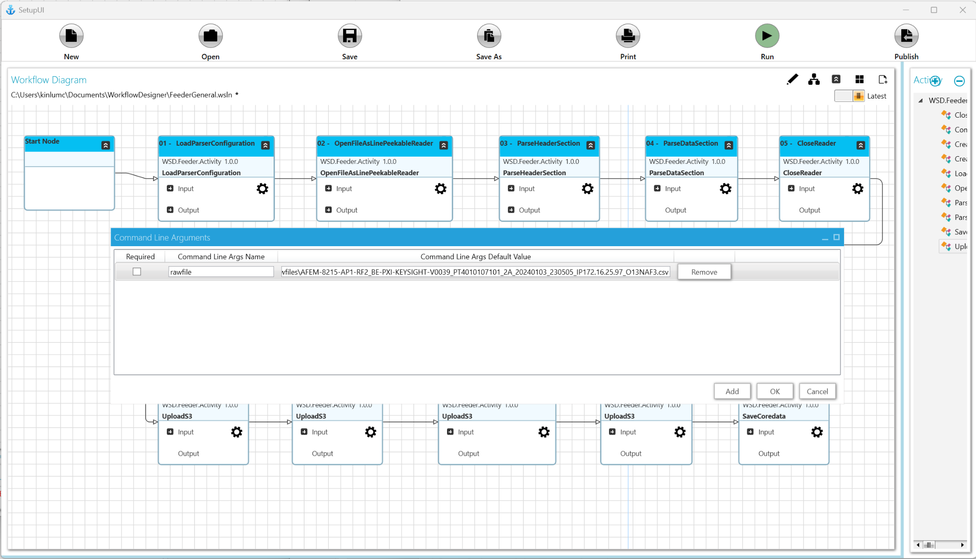
    - Proposal from Tingyu

  - (Yu Han) Either complete this item within minimum workload, or use the design proposal when NXG WUDAS upgrade cycle is active

- (KinLum/Tingyu/Jiapeng) MLOps Pipeline Onboarding APC “Klarity Defect Classification w/ ViT-T2T” (Hold)
  - Background:
    - APC’s duties are fault detection and classification, defect classification, automated recipe tuning among others. The APC group's work revolves around programmatically ensuring wafer quality - which lately has become a very AI centric field.
  - Project “Klarity Defect Classification” (Asude Baykal)
    - Goal:
      - Increase the number of classified defects
      - Catching die killer defects faster through auto image classification
      - Speeding up defect source identification and containing the defect source to reduce impact to product - put tools down faster
      - Preventing low quality product shipping to the customer
      - Nearing release to the fab)
    - Current state
      - NO specific procedure to when and which wafer defect would be manually classified by the yield engineers
      - Nearly 0% of the defect images are classified. For example:
        - 40 images per wafer, there are ~24 wafers in a lot → ~ 960 images per lot
        - In a single day, ~ 360 wafers were inspected
        - 14240 images in total were taken per tool => 4 tools means ~60K images
        - None were classified
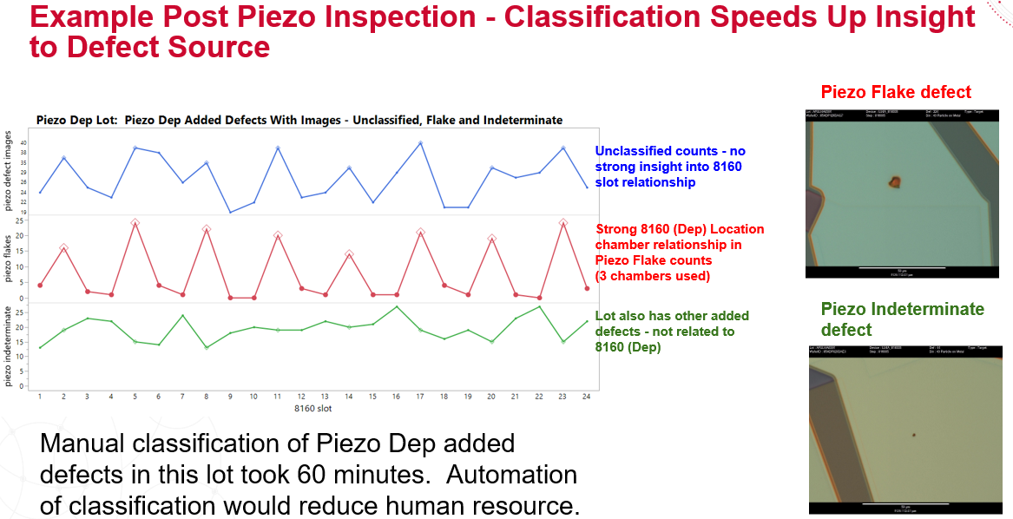
    - Current Progress of Project & Future Plan of T2T-ViT
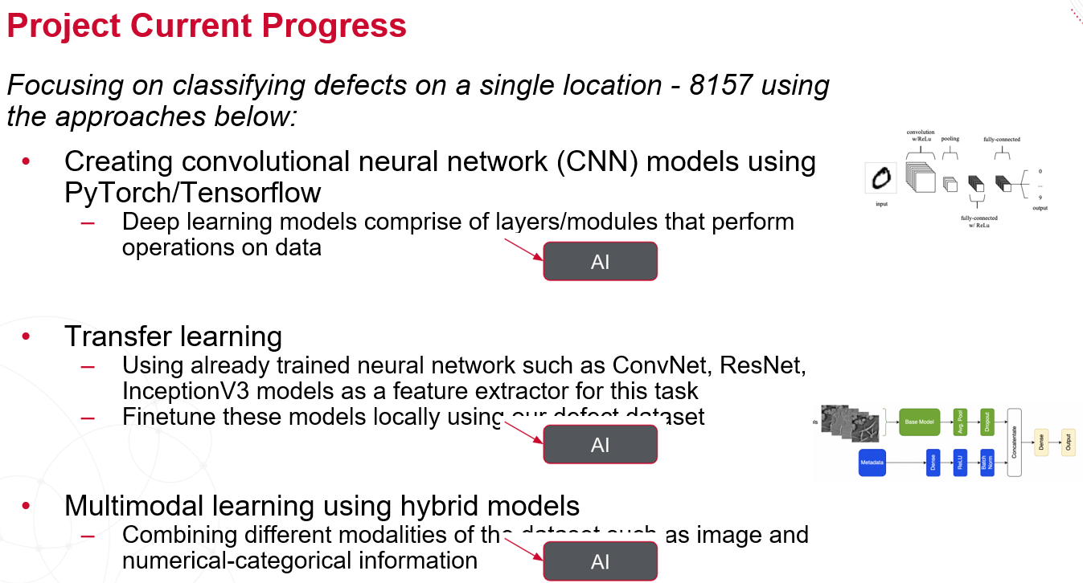
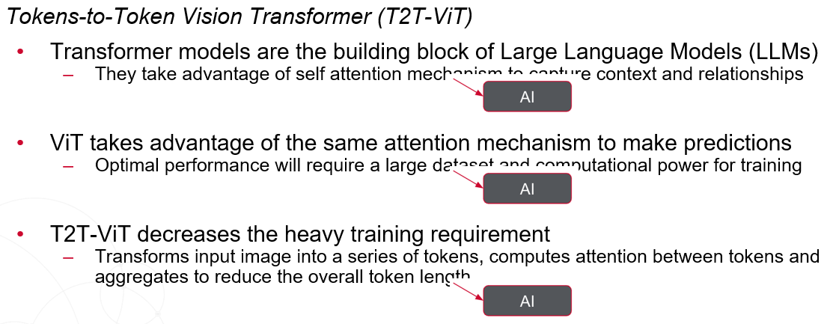
    - Concept of T2T-ViT
      - Transform for Vision (Image) Classification (ViT) & Tokens-to-Token (T2T)
      - T2T-ViT
        - https://arxiv.org/pdf/2101.11986
      - ViT (An image is worth 16x16 words)
        - https://arxiv.org/abs/2010.11929
      - Attention is all you need
        - https://arxiv.org/pdf/1706.03762
      - Token Fusion ViT
        - https://arxiv.org/pdf/2403.10030v3
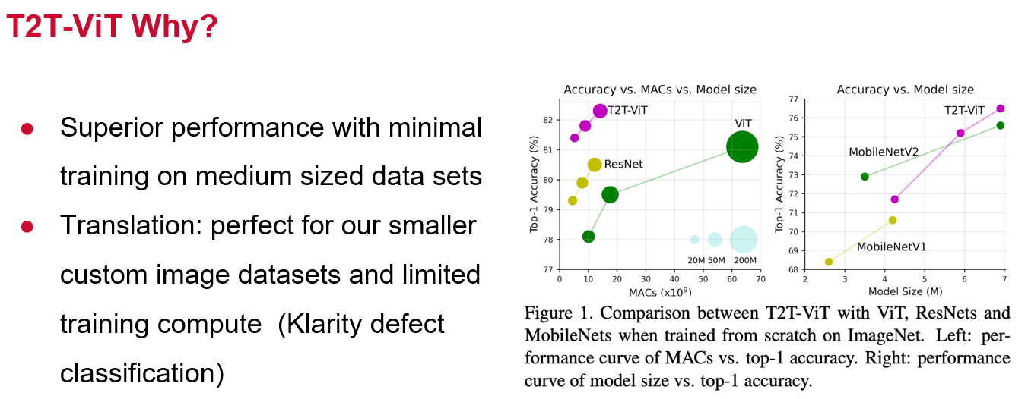
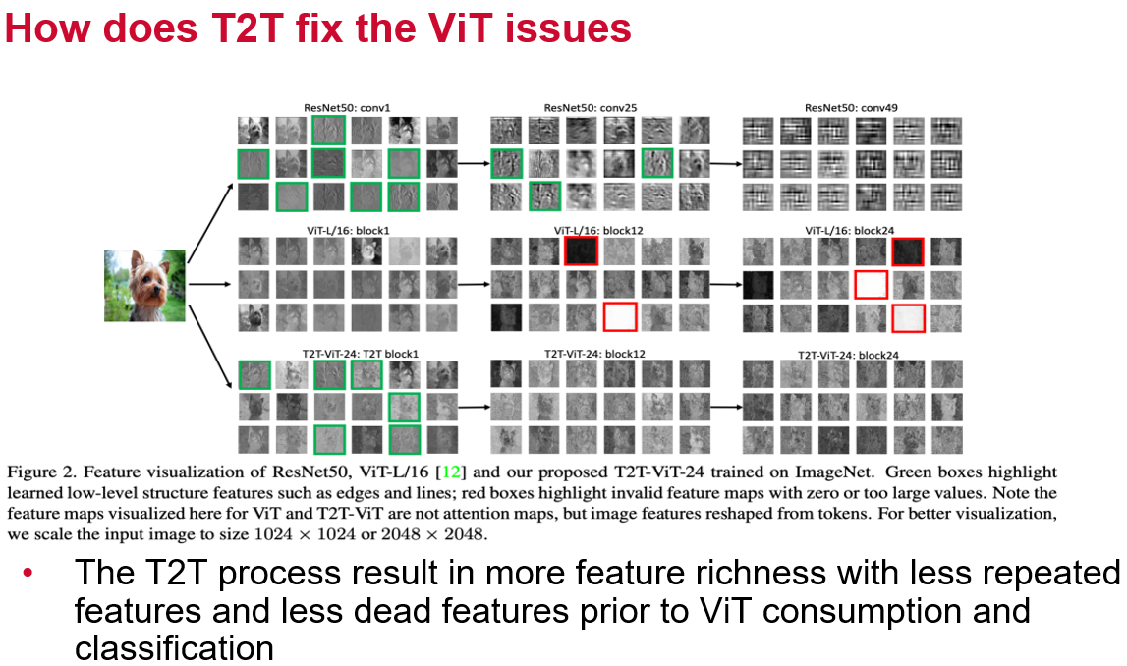
  - (Kin Lum) Share docs on WSD MLOps built for the Penang team to run model training, verification then release the model to CMs. We have our own WSD GitHub Enterprise which is not part of the GTO Enterprise GitHub. We use GTO JFrog to store the images dataset for model training and verification running on AWS EC2 instances with GPU.
    - To access, from Broadcom OKTA dashboard, search "WSD Atropos", enter the Atropos portal
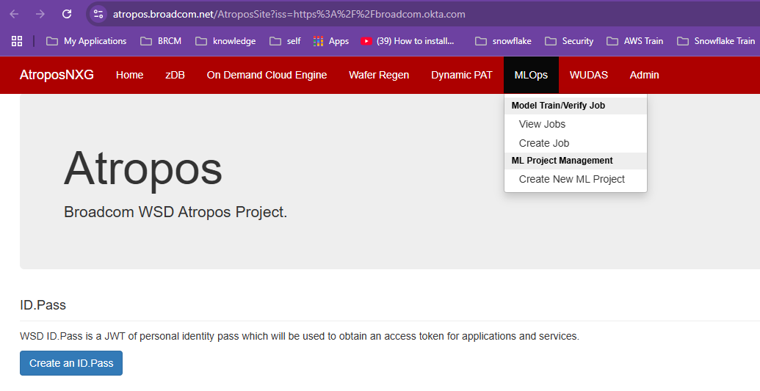
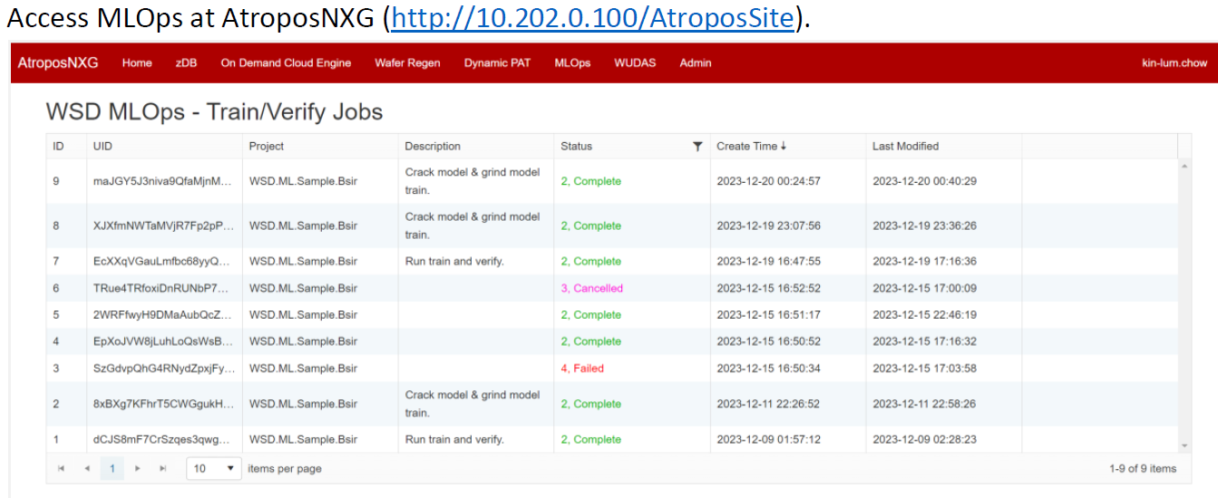
  - 04/24/2025:
    - Sync meeting between SW team and APC team
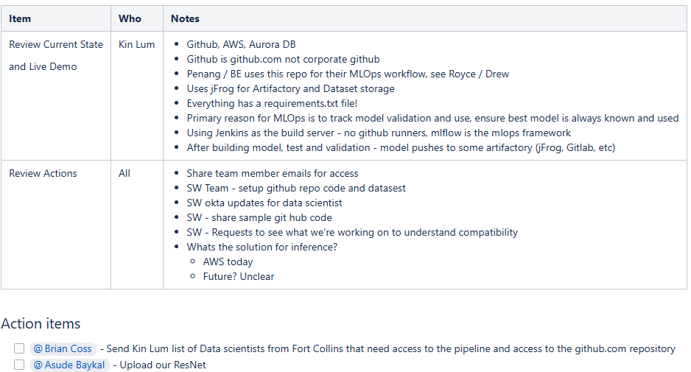
  - 04/29/2025:
    - (Chao) Add APC team into wsd-broadcom github. (completed)
    - (Kin Lum) Create github APC-ML team and grant access to ML git repository. (completed)
    - (Kin Lum) Add APC team members into OM_WSD_DATASCIENTIST OKTA group. (completed)
    - (Tingyu) Grant APC team members with access to MLFlow. (completed)
  - 05/06/2025:
    - Potential next-to-do
      - Set up Git Repository for APC team
      - Deplay zDB XFer @ FtC
      - Check Algo fully comply with existing MLOps workflow
    - Based on the latest update from Brain, the Karity project completion status is only 20%, so push to “holding pool” instead of handling as an active high priority item.
      - https://athos.ftc.broadcom.net/fast/mes/project/index.php?action=view_project&project_id=5468
  - 07/08/2025:
    - (KinLum) Setup Git Repo per Asude (APC) request (complete)
      - Code repo: https://github.com/wsd-broadcom/WSD.ML.FBAR.KlarityDefect.Code.git
      - Dataset repo for classify model training: https://github.com/wsd-broadcom/WSD.ML.FBAR.KlarityDefect.Data.classify.git
      - Dataset repo for verify: https://github.com/wsd-broadcom/WSD.ML.FBAR.KlarityDefect.Data.verify.git

- MLOps to Support BSIR - Phase II: A2I Labelling + Retrain Automation (KinLum/Tingyu/Jiapeng)
  - Target date: ??
    - Precondition: DS/PE need confirm resources to cover manual Labelling workload
  - Goal:
    - As PE completed exercise of synthesized crack images into Raleigh ML model training and improve crack detectability from 60% to 80%; Plus PE + SW developed Amazon Augmented AI (A2I) human review workflow to govern integrity of BSIR ML solution, now need build a WSD MLOps
      - Build an Automated ML Pipeline to achieve full Traceability & Comparison of history results, full Reproducibility (Code + Data) to any history run, plus count engineers’ Annotations into Retraining
  - Latest Status:
    - 09/05/2023:
      - (Kin Lum/Tingyu/Jiapeng) Complete draft SRS for internal review (in progress)
        - A2I labeling (done)
          - Exploring A2I Human-Review-Workflow job complete event - CloudWatch and EventBridge. Created EventBridge rule and was able to capture the Human Loop status changes event then triggered lambda.
// Workflow #3: Dual-Stage A2I Labeling + Retraining (Might be Split as Phase II)
// Support both Auto Trigger Labelling and Human Trigger Labelling
// 1st Stage (Classification)
// Trigger 2nd Stage within completion event handler of 1st stage
// after dual-stages completed, update dataset to trigger retraining
Note #1: EventBridge rule @ https://us-west-2.console.aws.amazon.com/events/home?region=us-west-2#/eventbus/default/rules/A2IHumanLoopStatusChanges
Lambda log:
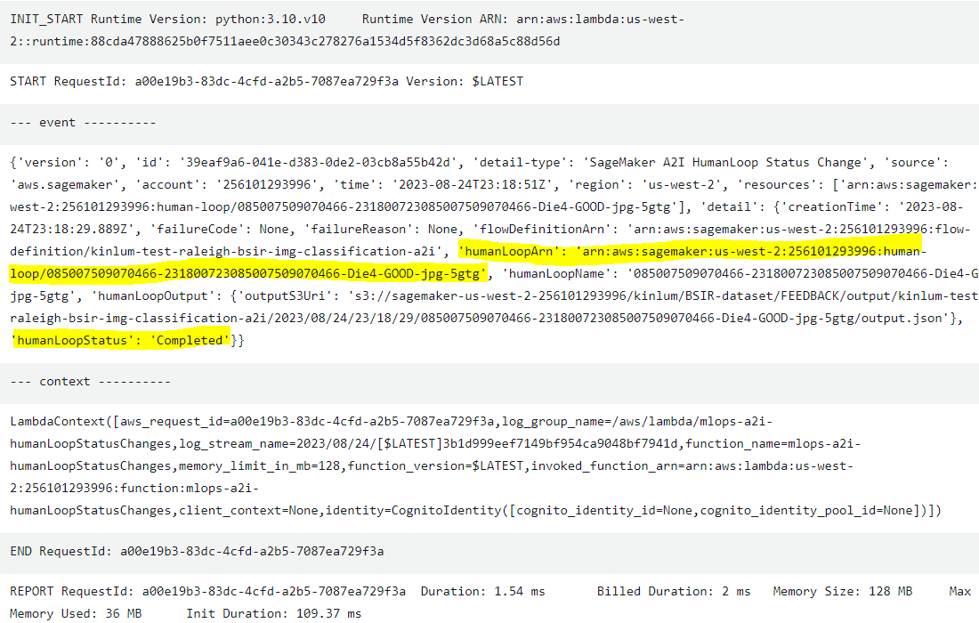
Note #2: still sync with DS to define how to handle “previous cycle not full complete within expiration window”. If ignore, engineer might only label small fraction of all labelling data set, waste; If enforce next cycle to redo previous cycle “not completed” images, it might cause next cycle workload too heavier. TBD.
Note #3: Since PE/DS can’t decide resources to cover “Labeling” workload, to avoid wasting bandwidth, plan to cut MLOps to Phase I and Phase II, phase II covers A2I workflow
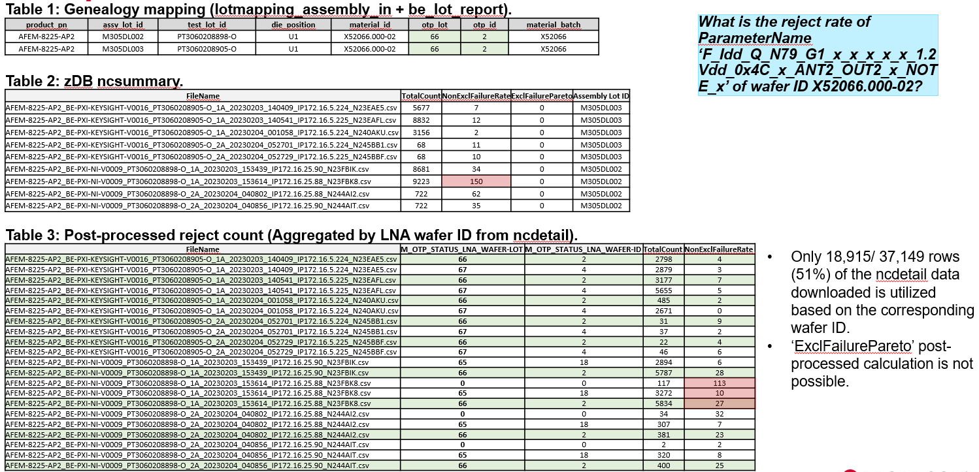

  - Use case #3 (Sadowsky H2 Down-binning)
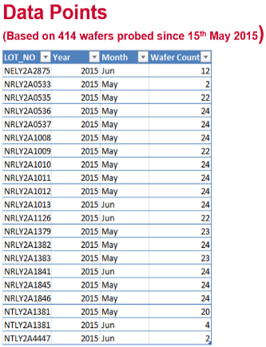
    - 2PF7 Yield Simulation
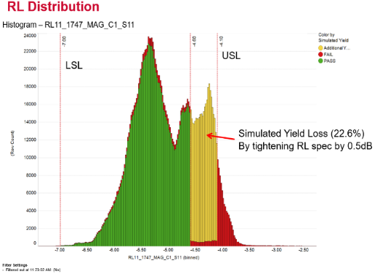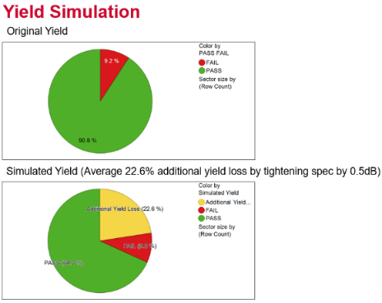
  - 04/04/2023
    - (Yu Han) Need sync w/ Chung Sik for ROI justification and understand more details about requirements to prepare SOW no later than early June. Assigned POC check to Chao and Kin Lum
    - (Chao) Reading requirement document from Chang Sik, study use cases provided - in progress

- (Choo-Yau/YK) Improve handling to “Genealogy Data Reporting Duplicated file Name” (Initiating)
  - 11/07/2022:
    - Great Proposal (From Chung Sik and Suraya)
      - Based on the assumption that newly uploaded reports (with the same name) are expected to contain up-to-date information, we should automatically process them and remove the older entries of the same name. This will ensure that we do not miss out updates from CM which they somehow did not inform us up-front, while at the same time relieve the S/W team from manually handling the data reprocessing task.
      - Since the upload of the reports with the same name are out-of-normal scenarios, we would like to receive email notifications when such scenarios occur so that we can verify them. In the event that a newly uploaded report contains wrong info then we can request the CM to reupload with the same filename. With the implementation from item #1 the S/W team will not need to handle these wrong data entries manually since they should be automatically replaced when the CM reproduces the correct report again
      - With the implementation of item #2 then we will have some statistics to work with the CM to drive improvement and reduce the occurrence of wrong report generation in the long run.
        - Plan to add a column “# of loading times”
    - (Yu Han) Plan to implement this during dev-proto-data-infra or gDB-migration topic to save unnecessary engineers workload to manually handle such exception cases
  - 11/29/2022:
    - Synced with requestor to confirm ROI of this item, plan to schedule into next round upgrade. Need clarify the scope and more detailed to-Do.

- (??) Build Desktop UI Application to support Advanced and Flexible dev-proto Data Exercise on top of heterogeneous Data-Sources (API + S3 + BRCM Sharefolder + Local) (Hold)
  - Might use Roey’s proposal as base, plus Steven’s comments for more flexibility to allow “hybrid-mode volume batch data processing”
    - Both Cloud data, local data and share folder data
    - Both Production or DP modes, or even local development data
    - As long as they can be filtered by key criteria, we can execute stitching, processing, and visualization (?)
  - Might cover Steven’s “Data auto comparison for different BOM” needs:
    - Auto data comparison with different header (different BOM) at early NPI stage to compare large qty BOM to BOM performance difference
    - Cloud/Local data filtering/parsing/ Charting.
    - Must-Have & NICE-to-Have features:
      - (1) allow “key criteria match" to enable analysis instead of requiring “all criteria match”
      - (2) enable stitching across multiple result entities
      - (3) Might need relax the data source location requirements, allowing local, share folder in addition to S3 (which requires pre-parsing). NOTE data files should already used TL, so actually Production format compatible
      - (4) Allow multiple level “drill-down” data filtering
      - (5) Draw multiple charts with Scale synced across all charts
  - Consider to extend original Picasso architecture as flexible open platform to support more future needs
    - Make Data Query, Limited Parsing, Stitching as core module by SW team
    - Make data analysis algo as “Open Framework” to allow PE/NPI to load in whatever new processing mechanism, in addition to core analysis flow SW team prepared
    - Make Charting as “Open Framework” to allow PE/NPI to load in whatever new charting mechanism, in addition to core charting options SW team prepared
  - 12/07/2022:
    - (Yu Han) Split this out from “dev-proto infra” based on Chung Sik’s SOW as separate work item
  - Attach Roey’s request and other teams’ inputs as below for reference.
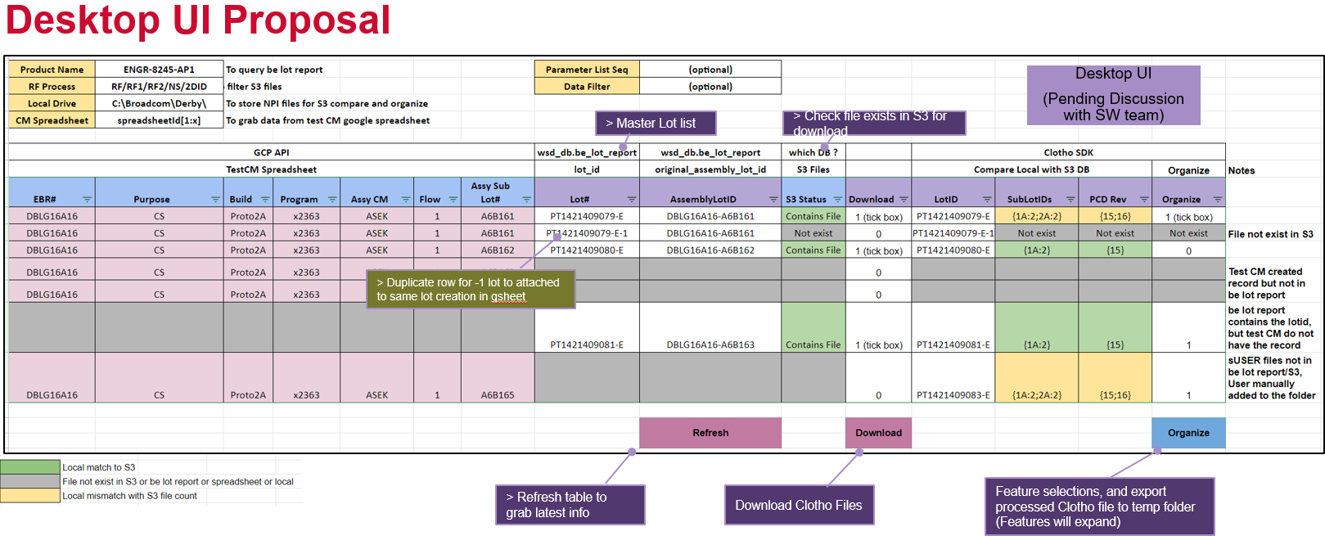

- (SW Team) Sync Item “PCB Mapping”
  - Background:
    - To consider a CI/CD enabled containerized deployment, we might need to repackage the source code or current ATA algo instead of 100% reuse. For mid/long term we might upgrade ATA platform to make it containerized and transparent for future large scale deployment, but for short term (before Q2'23) we need to re-package the code with some workload
  - (From Chung Sik):
    - Expected to enable through ATA for the beginning. We're still not really sure what will be the trigger rate and success rate of the triggering, so will not want to risk wasting the S/W team's resources before we are certain we need to create and deploy a solution to more products.
  - (SW Team) Adjust the SW Team involvement as Q1’23

- (Chao) Support zDBUI Request to enable “Range or Wild Char” Cntrace files query/access (Hold)
  - WW35:
    - Request from Yeok Ping:
      - “User might not know what are the available PIDs with trace saved in the database that could be downloaded. For Cntrace File Request, is it possible to put in a range of PID (eg. 1-1000) so that user can download any PIDs from PID1-PID1000 that have cntrace? This is the case where users do not have any specified PID in mind that want to download any cntrace available for that particular lot? ”
    - (DaWang/Chao) Quick research:
      - Typically for a LOT there are 200-300 pids with cntrace files, however the "pid" is not continuous (1,2,3....). E.g: for lot PT2352809531 of product AFEM-8231-AP1-RF2, there are 264 cntrace files, with 264 totals pid ranging from 35 to 4643.
        - 35,36,71,106,107,141,142,176,177,211,....., 4500,4531,4535,4567,4571,4603,4606,4638,4643.
    - Possible solutions for next upgrade:
      - Upgrade api file access backend and zdbui to allow range query.
    - (Yu Han Q & A)
      - (1) Need an estimate how long query will take, how much data volume will be triggered under worst case?
        - If we allow query search and do not have a limit, for a specific LOT, there will be 200-300 files downloaded.
      - (2) Wonder whether this is valid case: PE don't know PIDs but want to "blind query"?
        - PE confirms "sometimes" this happens.
      - (3) Assume "list of limited # PIDs" are more reasonable than a large range.
  - 09/06/2022:
    - (Da Wang) One viable solution is that we list available pid numbers at zdbui then PE can type in the pid number shown then download. This will involve both Jiapeng's backend API upgrade and also UI upgrade, we may consider adding them for next phase upgrade.

- PPYCC-III (Process Optimization)
  - KP mentioned this “process optimization” @ 03/03/2021, mark here for future reference

- (Yu Han) Sublot-based dynamic spec adjustment during real time testing @ tester Investigation (Pending)
  - 09/17/2020:
    - Since Mike clarified that we go with "sublot-based", we only need figure out an optimized solution for #3, either upgrade the existing Clotho/pCD/zDB ecosystem or bring up a new one to allow "multiple test-limits or medians" bound with a single raw result file.
      - Current raw result file can ONLY record 1 High/Low limit pair. Here we need to store multiple High/Low limits (or Median), each effective to a specific range of PIDs.
      - We need either a new separate meta file to record "Limits/Medians plus PID ranges", or need guarantee "all ranges can be 'union' as a single continuous range", so overall only 1 range (plus Clotho need rewrite file head rows after all testing done as current format is Text, not Binary).
      - Though not a difficult change @ Clotho ends, the cascading changes would be populated to full Clotho/pCD/zDB eco-system, including data access/analysis logics. So we might need to start a separate eco-system (for the new products) with the new data formats to avoid interfering with the existing architecture.
    - Pending for Wayne's investigation result to check which is more “Production” meaningful

- (YK/KinLum) Support Request "ILBF & OLBF Improvements" (Hold)
  - 02/21/2022:
    - Chor Ming initiated the request
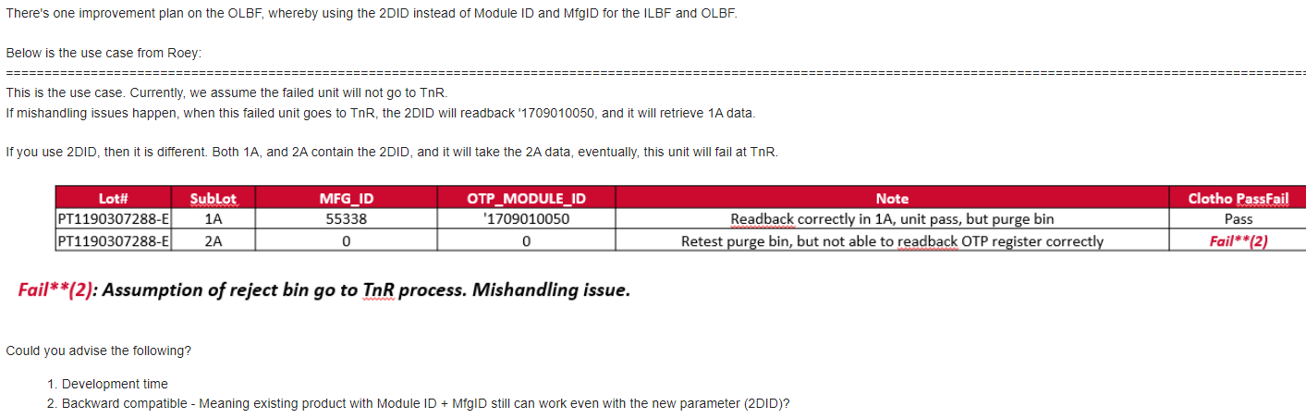
    - YK synced with Roey with clarifications
      - This request is to further improve the OTP Removal process, which likely will not be needed/adopted until 2023
      - Depending on different modes of backward compatibility needed, there could be many scenarios to consider and further discuss.
  - 02/28/2022:
    - Chor Ming updated to “Put it on hold”
      - Reason: there's a potential of a 2DID readback issue when retesting the purge bin, which could be a similar situation.

- (Chao) HoneyBee-TLG upgrade for Test Limit batch update page (Hold)
  - 01/18/2022:
    - Regina requested minor changes in HoneyBee-TLG, Test Limit batch update page
    - Released beta version with short term features to Regina for testing. As below:
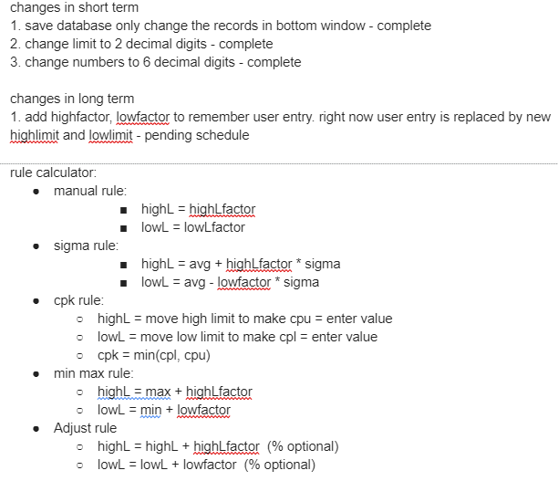
  - 02/15/2022:
    - Estimate ~2 weeks for Long Term Change workload and started.
  - 03/15/2022: Quick support for HoneyBee-Tzero
    - JunLan reported Honeybee-X import failed due to too many headers.
      - suggest to use reduce header file when import data – complete
  - 04/05/2022:
    - Low priority for now to upgrade HoneyBee-TLG since workable solution has been provided.
      - New HoneyBee-TLG - in progress
        - Add “HighL Input” and “LowL Input” into database, UI and use the new field to calculate high limit and low limit - in progress
      - Need check whether OK to close this item since it doesn’t look MUST-HAVE now

- (Chao Sun) Investigating New Request for HoneyBee Upgrade to support Production Level Data (Investigating)
  - 12/29/2020: Pooi Heong
    - Since current the HoneyBeeX is widely used in all sites on Tzero analysis, one of the limitations of HoneyBeeX we found out is the # of rows that the tool can handle. … errors when > 500 . … need handles more rows data / more units (one row is the data for 1 unit)
  - 01/05/2021: Chao:
    - Get request to enhance HoneyBee-Tzero to increase PID #. The Tzero was designed for early stage testing for R&D and NPI team, with small amount of units and many parameters. But now it is widely used on production sites, which have many units and many parameters (Kin-Lum told me, one file can have 30K-60K PIDs). but Tzero uses PID as columns. it cannot handle 500+ PIDs due to SQLite database limitation. right now they have a work around by partitioning data - break down one large file into multiple smaller files.
    - Will schedule a meeting to collect more details with Pooi and Steven

- Dynamic Parametric Aggregation W/ CI/CD (Jiapeng/Chao)
  - Target for ???
  - Goal:
    - (Chung Sik) Calculate and return aggregated value of large number of wafer/modules, based on dynamic algorithm/formula
    - ~20 users involved
  - Scope:
    - FBAR wafer Dynamic parametric aggregation
    - Module Dynamic parametric aggregation
    - Non-FBAR wafer Dynamic parametric aggregation

- (Yu Han) “Early Stage, Low Volume” Requests Collection (In Progress)
  - Mike/KP
    - Establish data infrastructure and analysis tools to enable module level test outliers identification/ elimination at early development phase (Dev-Proto) with small build quantity to surface up potential excursion throughout the physical part mfg & test process. First time right design capability has improved significantly but we will not be able to deliver good quality physical parts to customers without early detection of potential excursion in the EBR process to truly realize the vision of first time right design in our customer perspective
  - Yu Han:
    - The data sources between "large volume Production stage" and "low volume early stage" are very different. Unless we can route all low volume early stage data into existing WUDAS or some kind of CTT/SPC/XYZ database, big gaps there.
(1) Lea-Teng:  Check for “EBR automation for Penang” whether overlap with SJ needs | (Chung Sik)  - 2 different contexts in the EBR automation  - EBR document creation and submission  - Automation for EBR build and test data analysis  - The one shared in review session is more for the latter  - We tried to standardize the format of the EBR build matrix (as of now still generated manually by PE), and request CM (Inari) to encode the build variants info in the assembly lot ID, which will in turn be propagated to the test report. That way we can easily trace the origins of test data automatically without manual inputs from PE.
(2) Chris:  Check possibility to apply PCB Mapping @ PCB thickness improvements | (Chris)  - Tool on PCB mapping per ATE data will be really useful for Wei Shun and Anna’s effort on PCB thickness improvement related efforts. Not sure yet how easy it is to generate the analysis from ATE. This may look to come from the different world than PKG engineering but please think about any specific area we may need to express request if there is any.  - What is needed boundary condition to enjoy this feature during NPI stage development? Including Cheddar this year, there are some cases we see hiccup around the release time, mostly with extractors case. If we can do this in each big sample build or some build in controlled manner, it would be really helpful for production PCB spec. definition.  - ... If we prepare some missing link of DB, it may be doable. And can be used for future development, too.  - For short term, we may need that from Inari. Longer term ones, if it happens with NPI tester, it will be final goal to catch improvement AI in early phase.  (Wei shun)  - .. Suggestion about the data collection and application. Currently we do not have any data collection on the CM EBR build yield summary and defect pareto. If we can set up a template, similar to the PCB COC file from LGIT, we can utilize Spotfile to generate EBR build reports and defect pareto per CM and projects. It will be very useful to analyze the CM build performance. Regarding the mapping thickness data to the PCB, it is more useful when LGIT can scan much more dta print across the panel or strip.  (Chung Sik)  - The data download and visualizations are all enabled through a single Spotfire dashboard (WSD_PROD\Module Analysis Dashboard - PCB Monitoring), and should be applicable to both extractors and PAD products, since we allow user to specific the assembly house & PCB row/column configurations. It’s also worth mentioning that in order to plot the PCB mapping we need either the OTP_MODULE_ID or the 2DID readback data from the parametric, as that's how we locate the exact location of the module on the PCB.  - At the moment it's being set up to pull data out from zDB, which means any test data tested at Inari/ASEKr/AMKOR should be available for query. If we're talking about test data in-house then we will need to make some slight adjustment to make use of offline data.
(3) Yi Yuan:  Check whether QRE “EBR” style Dashboard can reuse some of existing EBR works | (Yi Yuan)  - QRE team working on a lightweight dashboard, consists mainly of linking Ft. Collins data <---> CM data <---> SJC test data, and generating + tracking Rel tests at SJC. It sounds like there is overlap between this and the EBR Assembly and Test Data Integration … additional details on this  (Yu Han)  - 07/29/2022: Quick sync with Yi Yuan, Gary, Greg and Aruna  - Need build something for “QRE” EBR, majority data should be the same as EBR used (when collected from CM), and WUDAS has already done the "stitching" work.  - Not sure whether all data sources are covered by current EBR, and need more flexibility of "formats" due to early stage exploration.  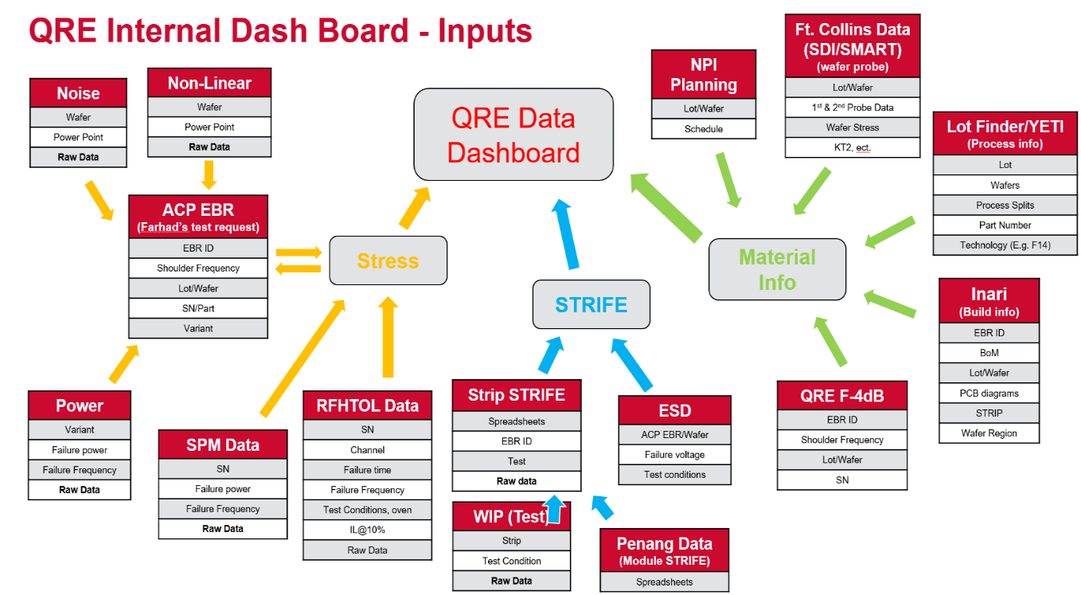
(4) Steven:  Data auto comparison for different BOM | (Steven) Auto data comparison with different header (different BOM) at early NPI stage to compare large qty BOM to BOM performance difference  (Yu Han)  Shared "WUDAS TDG UI" which JJ is working on  HoneyBee or another app upgrade for powerful Cloud/Local data filtering/parsing/ Charting.  Must-Have & NICE-to-Have features:  (1) allow “key criteria match" to enable analysis instead of requiring “all criteria match”  (2) enable stitching across multiple result entities  (3) Since this is for "early stage small volume", relax the data source location requirements, allowing local, share folder in addition to S3 (which requires pre-parsing). Since you mentioned the data files already used TL, so it's actually Production format compatible, expect no issue  (4) Allow multiple level “drill-down” data filtering  (5) Draw multiple charts with Scale synced across all charts
(5) Steven:  Auto data analysis to identify any abnormality (outliers, bi-model, tail, and etc) | (Steven)  Current reports generate >10K pages, hard for human to catch important info.  Looking for a tool to “catch and summarize the parameters (and categories, including lot info) which has any abnormality (outlier, bimodal, tail and etc) from thousands of parameters and/or plots”  (Yu Han)  Considering migrating the CTT (used for Production “outlier” parameter catching) mechanism to NPI/R&D for early stage use by re-directing data sources  (Roey) About CTT Stopping  (Roey) About NPI PADMA Plotting  Box link: 3 slides stored here.  https://broadcom.ent.box.com/folder/167745538328?s=i7tierw0sci3j0tfwll370wjdpoxpglh  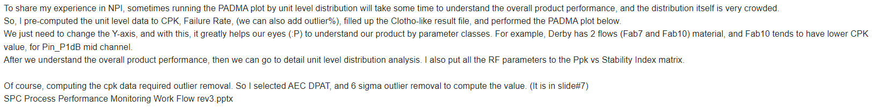  (Steven)  a) Based on each parameter  b) Auto catch that parameter which has outliers, tails, lot to lot big variation, bimodal distribution. (regardless of the spec we set, as it's just for early stage data analysis)  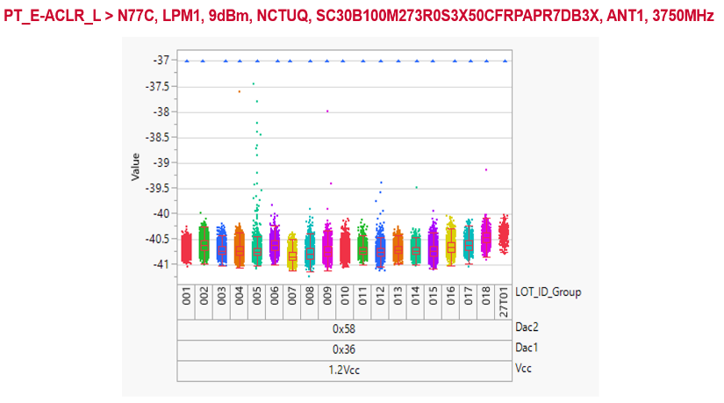  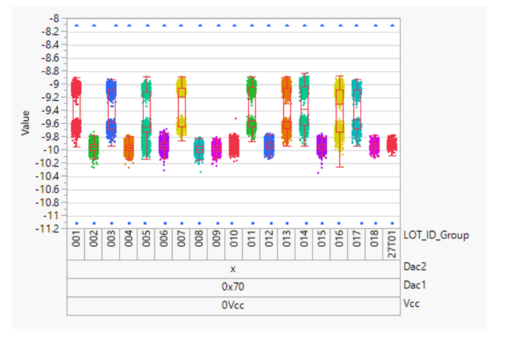  (Roey)  The 3 distributions that you put in may need to be handled separately.  First of all, the distribution depends on LOT_ID_Group  1. Outliers  Use the AEC DPAT formula to calculate the outlier%. The AEC DPAT was introduced in production to catch outliers, and study showed that it is good to handle not normal distribution.  2. Mean variation  1 way Anova test to check the p value. https://brownmath.com/stat/anova1.htm  3. Bimodal  Modality test, like Dip test.  I believe jmp can do all these tests, but we need to study first.
(6) Steven:  Auto wafer map with failure items  or bin category, and identify dies with test number | Help failure analysis to identify failed dies

- (KinLum/Tingyu/YuHan) Investigation: Kafka Deployment & Performance in CM (Hold)
  - Latest Status (by 01/30/2024)
    - (Yu Han) A minimal dry-run using Podman + Kafka + Zookeeper images @ local machine and confirmed topics/producers/consumers working well
      - https://broadcom.ent.box.com/file/1407969199083
    - (Kin Lum) Run kafka under the Podman rootless machine plus Kadeck Monitoring
      - https://broadcom.ent.box.com/file/1401245675619
      - The document also describes running multiple kafka brokers within the Podman containers.
        - Multiple Kafka brokers on containers
        - Simulate test result publishing and consuming
          - Simulate tester published result (producer)
          - Simulate processed messages by 3 consumers
        - Simulate heartbeat reporting
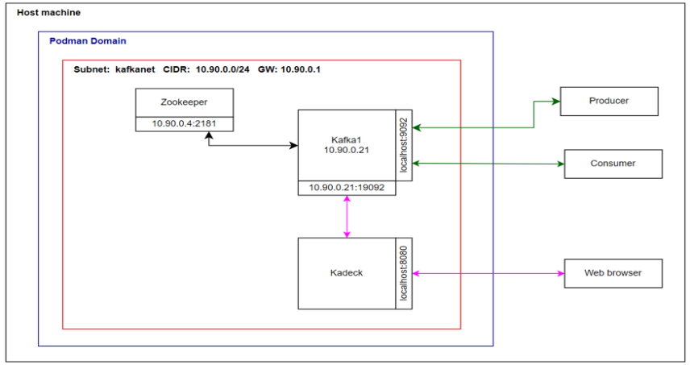
    - (Kin Lum) Also tried running a zdb feeder within podman containers as self-learning on Podman
      - https://broadcom.ent.box.com/file/1401370876335
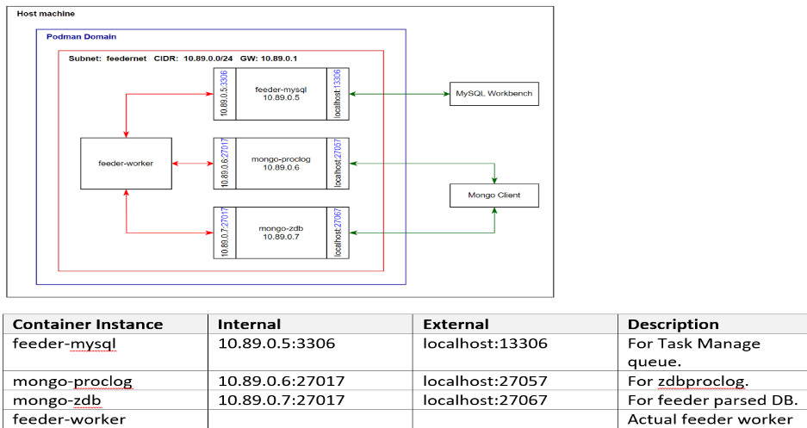
    - (Ken) Another way to run podman commands:
      - Turn the commands into a declarative docker-compose.yml. Then `podman compose up`. If have Podman Desktop ready, you can see everything was set up.
    - (Kin Lum/YK) Simulated OEE (Without Tester’s UPH Calculation)
      - Running overall yield, site yield, and top failure parameters.
        - Simulate a tester by using a result file and publish the pid result.
          - Git: Wsd.Swteam.Poc/tree/main/kafka/kafka_net/kafka-tester-sim
        - Simulate consumers to run calculations.
          - Git: Wsd.Swteam.Poc/tree/main/kafka/kafka_net/kafka-tester-consume-sim
    - (Kin Lum) To-Do:
      - Need to run a performance check within LAN. Using a server within a LAN as Kafka server then runs a performance check simulating testers producing messages by each PID result (20k-30k parameters)
    - (Tingyu) AWS-MSK Performance Eval as reference to local Kafka
      - Based on 10MB message size
      - Summarized results and analysis @ https://ent.box.com/s/3z58evls5holazzkdiuvk6hmk51njxrn
      - Initial goal is to lower the message latency (initial goal).
        - By more producers and more brokers/partitions, lower the message latency to ~750ms.
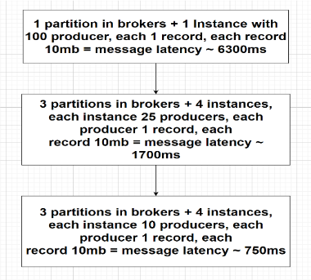
        - With ack=-1, each c5.4xlarge ec2 instance producer bottleneck is >= 120mb/s, 3x kafka.m7g.xlarge brokers with topic having 3 partitions bottleneck >= 300mb/s
    - (Yu Han) Notes about DEC2 “Use Scenario”
      - 10MB is the MAX size of single DUT result a tester can send out, and each producer maps to a tester (extremely 1 Producer/EC2), and produce messages to Kafka by some pace (e.g., 5s per DUT testing, <10 testers send result to 1 topic at the same time), within some latency budget. Also need check more relaxed scenarios
        - E.g., drag existing DPAT power (not OEE power) from Cloud back to Production floor, or real time analysis some critical parameters, message size might be <1MB (up to 512 parameters), but multiple topics will exist (assume < 10), then "CAPS" are different case from case.
  - 02/07/2024: Notes from KP 1:1:
    - Custom deployment of Kafka in CM is technically and workload challenging, especially considering HA/HR & ER as critical MUST-HAVE in WSD’s production scenarios and current SW team queued work items.
    - For now, might consider MQTT CM migration (Clotho v5.x) plus necessary misc upgrades (Clotho v4.x). In parallel KP will check leading industry popular solution providers to consider "buy" vs. "build" solution.
    - So hold this discussion until “buy” option cannot be justified.

- (KinLum/YuHan) Support Dynamic Sampling Test Revisit (Hold)
  - (JJ) Updates from JJ
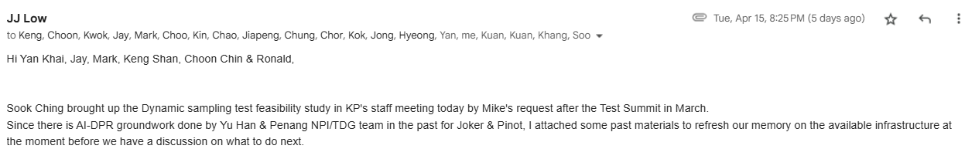
  - (Yu Han) 3 available options for Dynamic sampling test
    - Adaptive Sampling Testing (in-situ)
    - AI-DPR (large volume batch)
    - CTT (7 days windows trend analysis to catch outlier)
  - (Yu Han) Deep-dive details of AI-DPR (for Joker & Pinot)
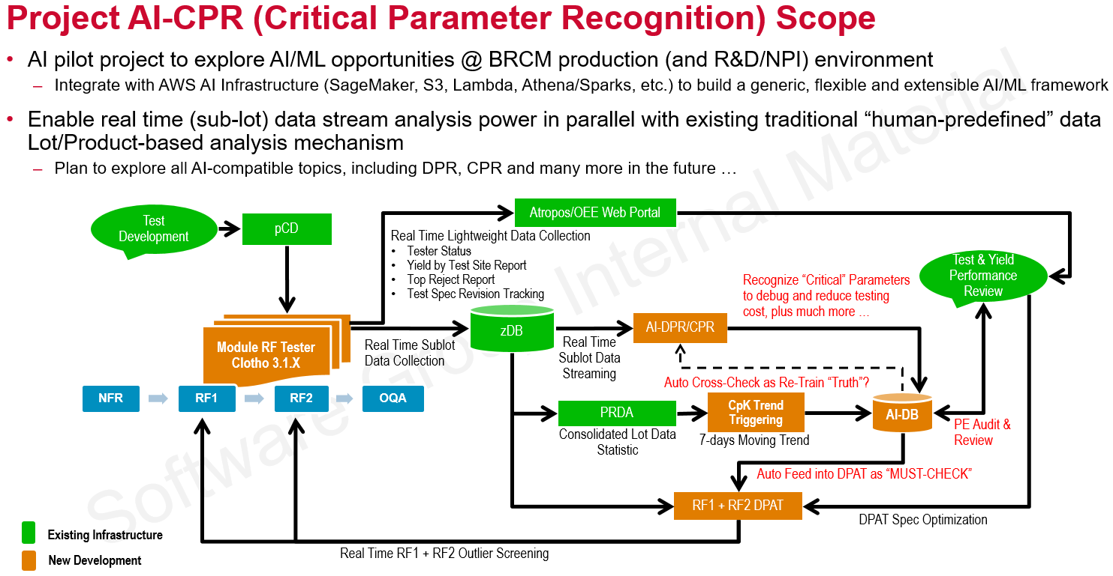
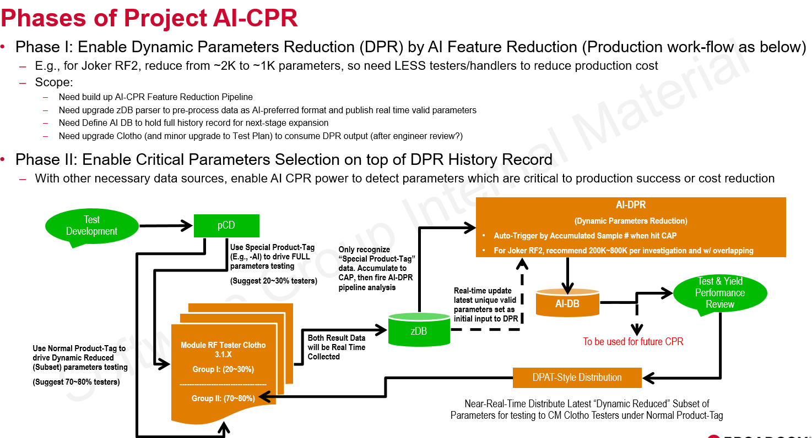
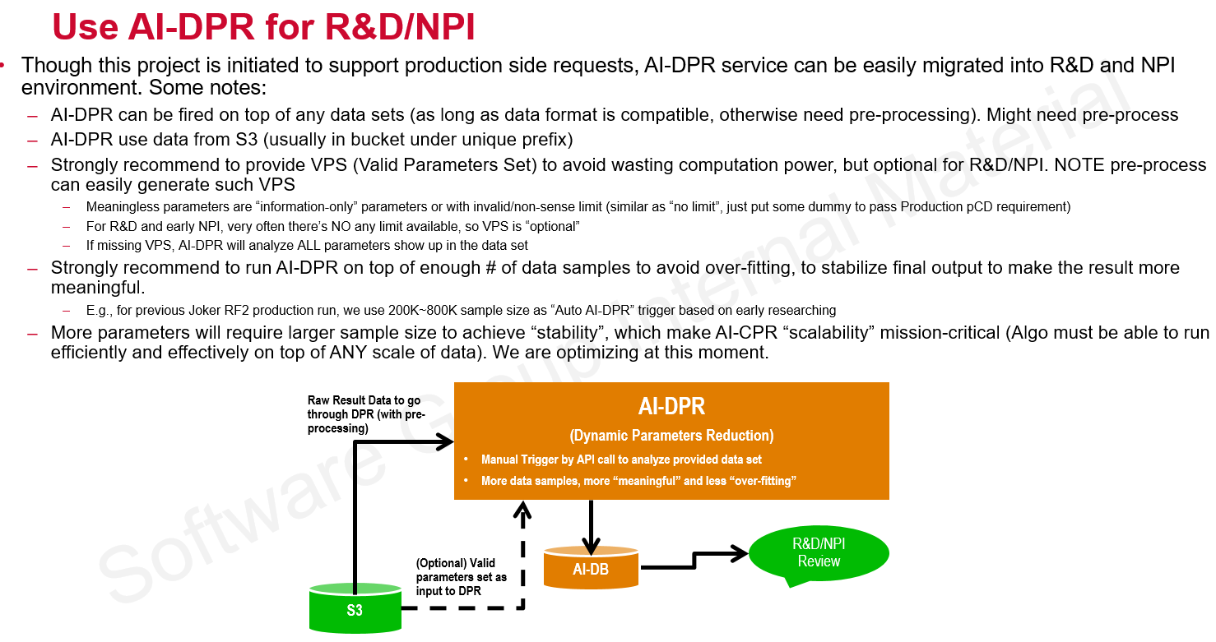
  - (Yu Han) The key to further improvement AI-DPR is JJ’s Proposal to “Objectifying Test Parameters”
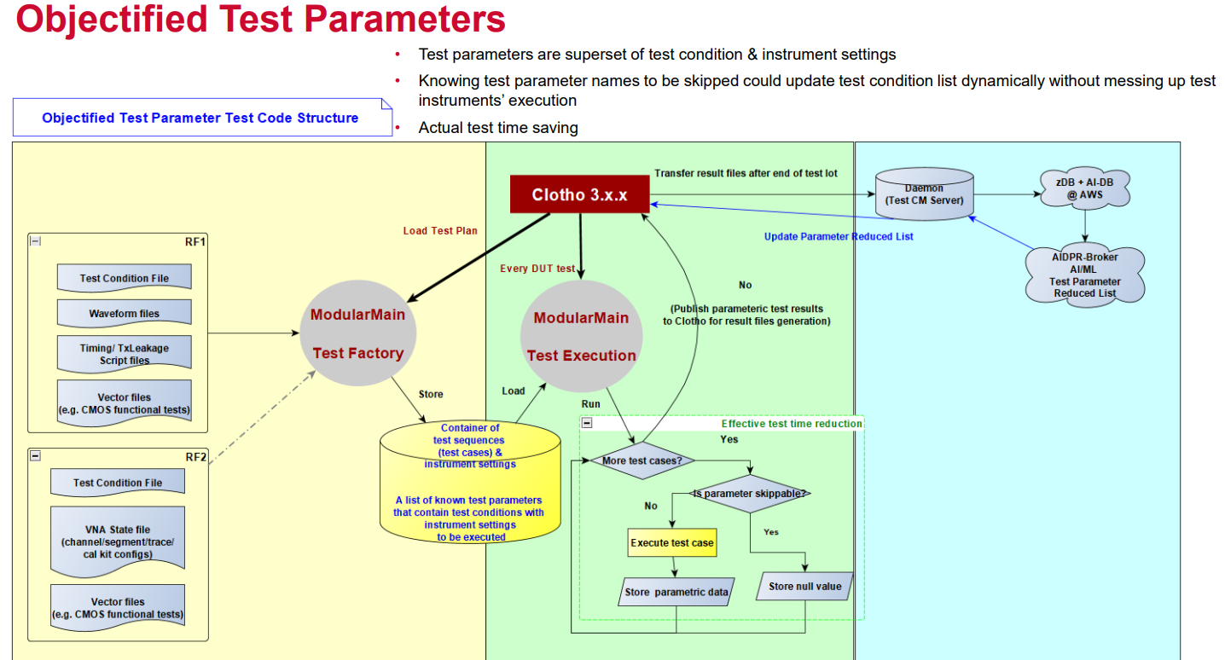
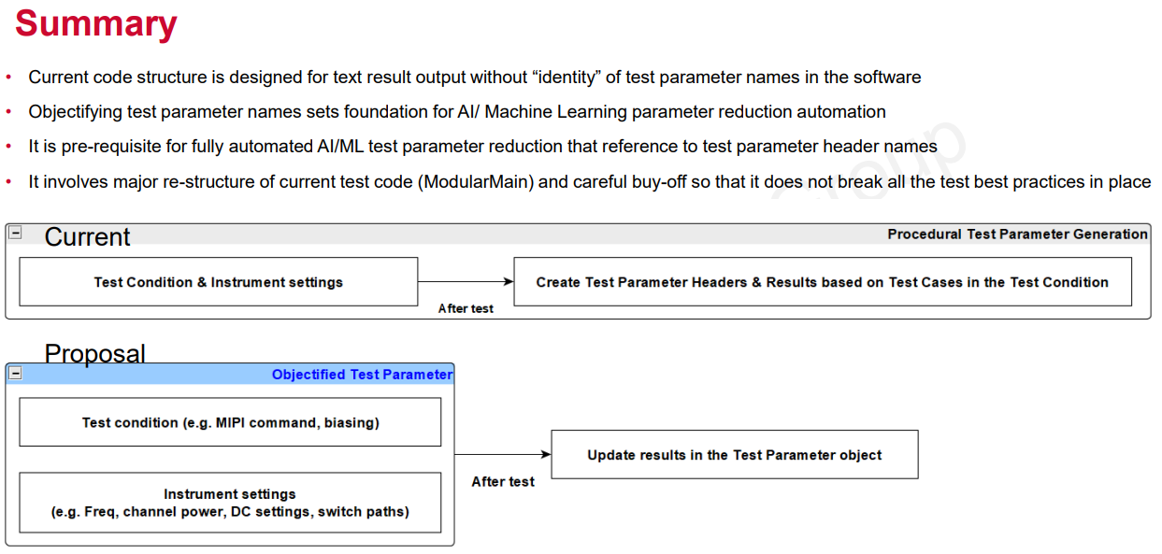
  - 05/06/2025:
    - Pending for further sync/requests

