MVM Counterfactual Methodology
Executive summary
The purpose of this method is to estimate how much guest count (GC) is protected by maintaining healthy foundation conditions. It is most useful for Restaurant Foundation and Commercial BAU domains, where value often shows up as avoided loss rather than obvious incremental growth.
At this stage, this is an interim counterfactual module rather than the full MVM. We fit a regression focused on foundation protection, use realistic weak thresholds instead of extreme outliers, score the same business under two scenarios (current foundation vs. weak foundation), and call the difference protected GC. External context and growth momentum are estimated in separate modules later and reconciled in the full MVM.
Method in 6 steps: 1) Define weak thresholds, 2) Validate the weak tail, 3) Fit the foundation counterfactual regression, 4) Build paired scoring datasets, 5) Score current vs. weak scenarios, 6) Attribute protected GC back to foundation domains.
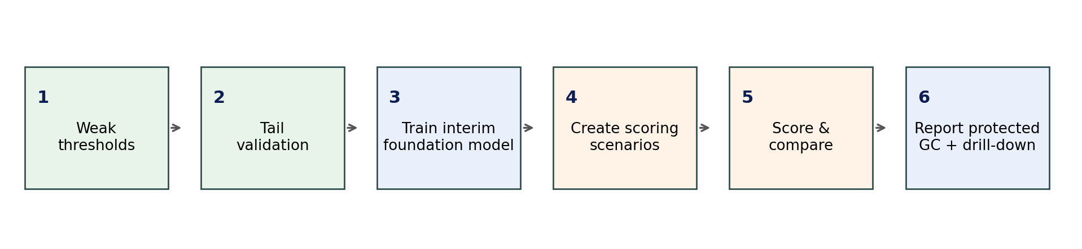
Figure 1. Simplified workflow for the interim foundation counterfactual module.
The full MVM contribution view should separate three types of estimates: foundation protection, external context, and growth momentum. Foundation protection uses counterfactual avoided loss. External context uses long-term-history actual-versus-normal model. Growth momentum uses prior-informed incrementality estimates and later reconciliation in the final MVM.

Counterfactual Estimation Steps:
Step 1. Define weak-foundation thresholds
For each foundation KPI, choose a weak but realistic value. The threshold should come from an empirical tail such as P90 when higher is worse (for example speed or stockouts) or P10 when lower is worse (for example satisfaction or uptime). The goal is to represent poor operating conditions while avoiding one-off extreme outliers.
Thresholds should have enough historical observations. A practical starting point is the latest 104 weeks of restaurant-week data, with segment-specific thresholds when markets, formats, or dayparts have very different distributions.
Synthetic example: weak-foundation thresholds
KPI | Group | Weak direction | Reference value | Weak threshold
Speed of service | Restaurant Foundation | Higher is worse | Current: 122 sec | Weak: P90 = 195 sec
CSAT | Restaurant Foundation | Lower is worse | Current: 4.47 / 5 | Weak: P10 = 3.7 / 5
Out-of-stock rate | Restaurant Foundation | Higher is worse | Current: 1.2% | Weak: P90 = 4.8%
Technology uptime | Restaurant Foundation | Lower is worse | Current: 99.5% | Weak: P10 = 97.8%
Pricing adoption | Commercial BAU | Lower is worse | Current: 95% | Weak: P10 = 88%
Base media support | Commercial BAU | Lower is worse | Current: $4.0M | Weak: P10 = $3.5M

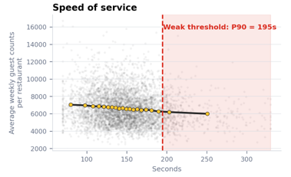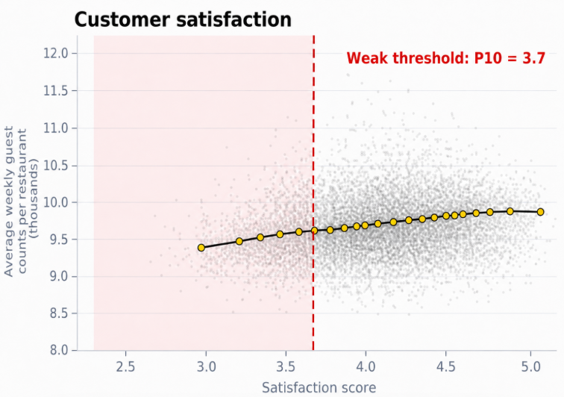

Step 2. Validate that weak-tail weeks actually perform worse
A percentile threshold is only useful if it has business meaning. Validate each weak tail by comparing guest counts in weak-tail restaurant-weeks versus normal restaurant-weeks. The weak tail should have enough observations and should directionally underperform. If it does not, revisit the threshold, segment the KPI, or exclude the KPI from the official scenario.
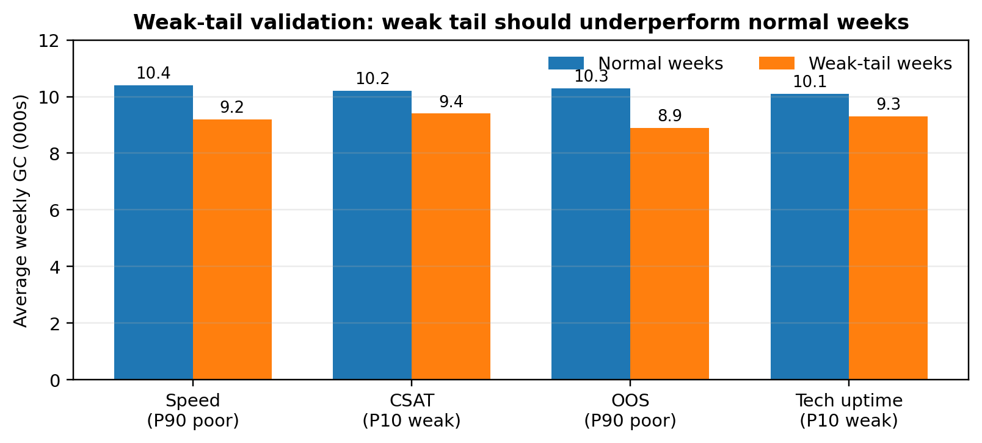
Figure 2. Synthetic validation example. CSAT is shown on a 1-to-5 scale in the threshold table; weak CSAT weeks have lower guest counts.
Step 3. Train the interim foundation counterfactual regression
The model should be an interim foundation counterfactual model, not the final MVM, using the latest two years of weekly restaurant-level data. The target can be GC or log(GC). The model should include foundation variables, Commercial BAU variables, external context controls, fixed effects, and any available growth controls.
The reason for including external and available growth controls is to reduce omitted-variable bias. If promo, media, LTO, pricing changes, weather, or competitor pressure are missing, the foundation variables may accidentally absorb those effects. However, these controls are not used as the final growth-momentum attribution engine; that comes later through prior-informed analysis and final MVM reconciliation.
Recommended interim model specification
Model element | Recommended setup | Reason
Target | Weekly restaurant-level log(GC) or GC | Log target usually stabilizes variance; convert back for GC output.
Time window | Latest 104 weeks / 2 years | Long enough for variation; short enough to reflect current operations.
Foundation features | Speed, CSAT, OOS, uptime, staffing, hours | Main variables for protected-base estimate.
Commercial BAU features | Pricing adoption, base media, loyalty base, delivery access | Always-on commercial system that protects demand.
External controls | Weather, macro, competition, calendar | Prevent foundation coefficients from absorbing external effects.
Available growth controls | Promo, LTO, campaign media, delivery growth | Include if available to reduce omitted-variable bias; not final attribution.
Fixed effects | Restaurant / market FE and week / month FE | Control for unit and time differences.

Illustrative regression output (synthetic coefficients only)
Variable | Illustrative coefficient | Interpretation
Speed of service (sec) | -0 | Slower speed lowers GC
CSAT (1–5) | 0.05 | Higher satisfaction supports GC
Out-of-stock rate (%) | -0.03 | More stockouts reduce GC
Technology uptime (%) | 0.01 | Higher uptime supports conversion
Pricing adoption (%) | 0 | Better execution supports baseline demand
Base media spend ($M) | 0.01 | Always-on support protects awareness

Step 4. Build paired scoring datasets, not paired training datasets
Build the paired datasets for scenarios’ scoring. Using the trained model from Step3 with the same fitted coefficients and score two versions of the same restaurant-week portfolio.
The scoring datasets are used after the model is fitted to evaluate two scenarios:
- Current foundation scenario
What GC would we expect if foundation KPIs stay at their current / maintained levels?
- Weak foundation scenario
What GC would we expect if foundation KPIs deteriorate to weak but realistic thresholds?
The difference between these two predictions becomes the estimated protected foundation contribution.
For the foundation-protection view, the recommended setup is to hold external context and growth momentum at a reference or average setting. This creates a pure protected-base estimate. If we use current external and current growth values instead, the estimate is still valid but becomes conditioned on the current quarter; it can be harder to separate foundation protection from weather, macro, LTO, promo, or media effects.
Illustrative current-foundation scoring sample
Restaurant-week | Current speed (sec) | Current CSAT (1–5) | Current OOS (%) | Current uptime (%) | Current pricing adoption (%) | Current base media spend ($M) | External context controls | External / growth controls
Store 101 | Week 06 | 121 | 4.5 | 1.1 | 99.6 | 95 | 4 | Avg / normal | Avg / normal
Store 245 | Week 06 | 126 | 4.42 | 1.5 | 99.4 | 96 | 4.1 | Avg / normal | Avg / normal
Store 388 | Week 06 | 119 | 4.55 | 0.9 | 99.7 | 94 | 3.9 | Avg / normal | Avg / normal

Illustrative weak-foundation scoring sample
Restaurant-week | Weak speed (sec) | Weak CSAT (1–5) | Weak OOS (%) | Weak uptime (%) | Weak pricing adoption (%) | Weak base media spend ($M) | External context controls | External / growth controls
Store 101 | Week 06 | 175 | 4.02 | 4.8 | 97.8 | 88 | 3.5 | Avg / normal | Avg / normal
Store 245 | Week 06 | 175 | 4.02 | 4.8 | 97.8 | 88 | 3.5 | Avg / normal | Avg / normal
Store 388 | Week 06 | 175 | 4.02 | 4.8 | 97.8 | 88 | 3.5 | Avg / normal | Avg / normal

Step 5. Score current/reference foundation vs weak foundation
Use the same fitted regression coefficients to score both datasets. The current-foundation score represents the business under actual foundation conditions. The weak-foundation score represents the same business under weakened foundation conditions. The difference is the protected GC estimate.
This is the core formula: Protected GC = Predicted GC under current foundation – Predicted GC under weak foundation.
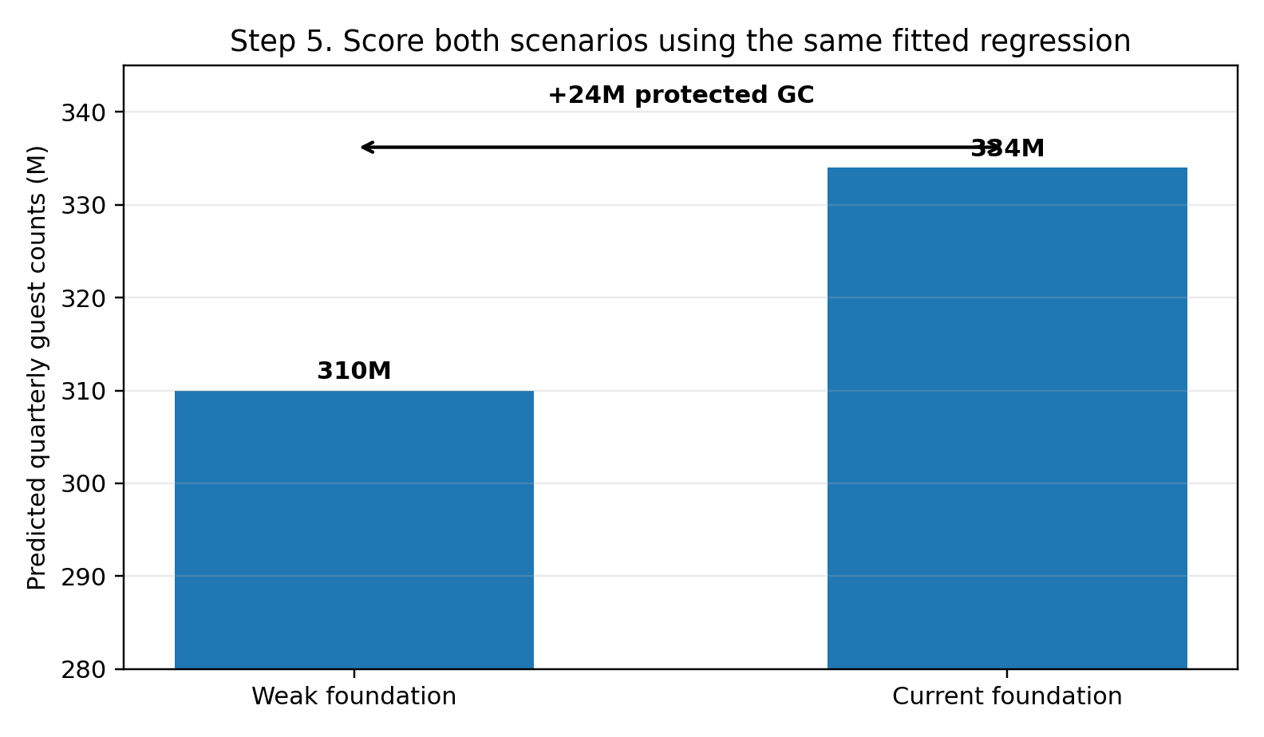
Figure 4. Synthetic scenario-scoring result. The foundation protects 24M GC versus the weak-foundation scenario.
Step 6. Assign protected-base credit back to foundation domains
After estimating total protected GC, allocate the result back to domains. The approach is one-feature-at-a-time scenario replacement: change one foundation feature from weak to reference/current while holding the rest constant, then measure the prediction difference. Sum or normalize the feature-level effects to create domain-level credit.
This attribution should be reported as protected GC or avoided loss, not as pure incremental growth. Also report confidence levels because the interim model has prediction error and may not fully capture every omitted factor.
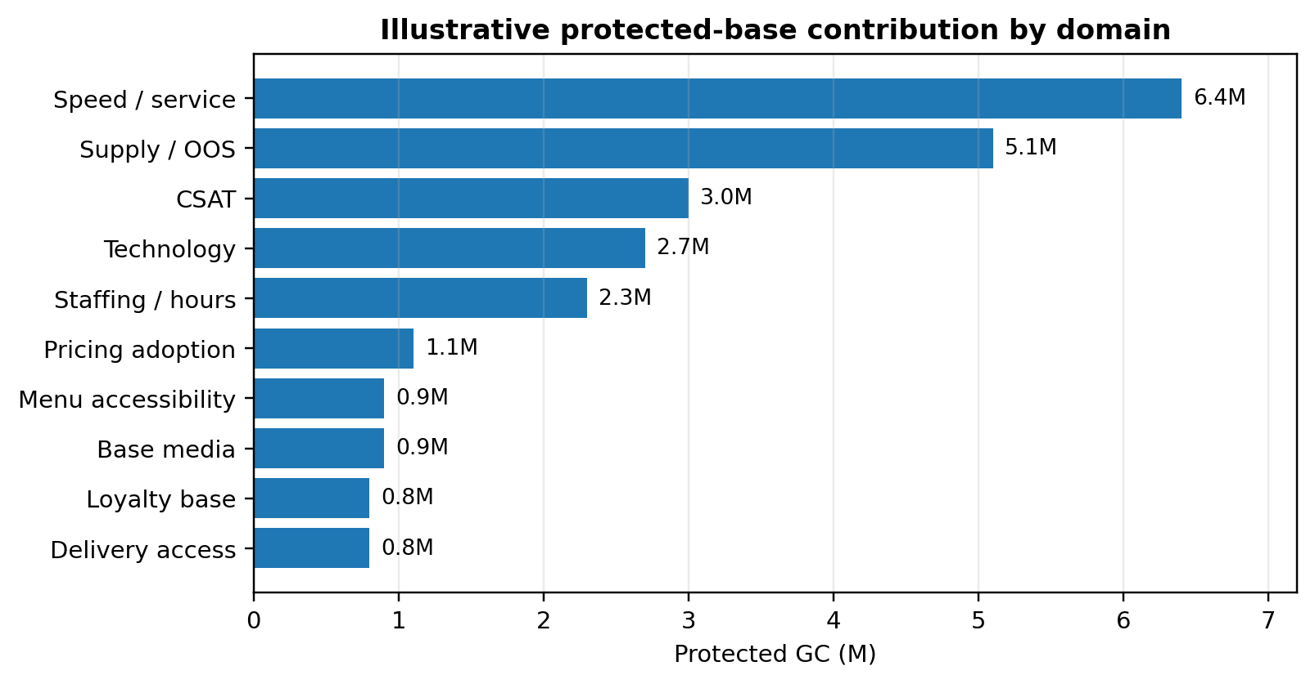
Figure 5. Synthetic domain split of protected guest counts. Total protected GC = 24M.
Extension A. Estimate external context contribution
External context should be estimated separately from protected foundation. These drivers include weather, macro / consumer pressure, competition, industry traffic, calendar, and other market conditions outside direct restaurant execution.
The recommended approach is to build a long-term external-context model, ideally using up to 10 years of history when definitions are consistent. A longer window is useful because external factors often need more historical variation to estimate reliably. For example, weather shocks, economic cycles, competitor pressure, and industry traffic shifts may not have enough variation in only two or three years of data.
The external-context model should estimate the relationship between GC and external drivers while controlling for seasonality, market / restaurant fixed effects, and available foundation or growth controls where possible.
The contribution should be calculated by comparing:
Actual external context versus Normal / reference external context
The normal context should be defined using a practical benchmark, such as same-market average, same-season historical average, prior-year baseline, or planning assumption.
Simple formula:
External contribution = Predicted GC under actual external context − Predicted GC under normal external context
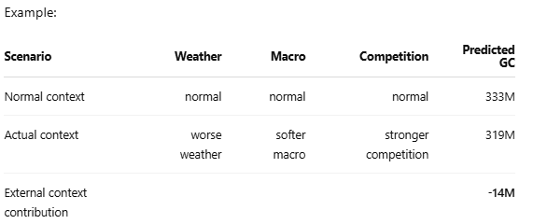
This means external context created a -14M GC headwind versus normal conditions.
The default should be one combined external-context model covering weather, macro, competition, industry, and calendar effects. However, separate external sub-models may be used when data grain, history, or business logic differs materially. For example, weather may use store-week or market-week data, while macro variables may use market-month data. Competition may also require a separate model if the data is only available for certain markets or time periods.
In summary, the external-context model estimates the coefficients, but the contribution comes from the difference between actual conditions and normal/reference conditions. This prevents external pressure from being incorrectly credited to restaurant foundation, commercial BAU, or growth momentum.
Simple example: weather contribution
Assume we build a long-term external-context model and estimate the impact of severe weather days on guest counts.
Feature: Severe weather days
Coefficient: -0.45M GC per additional severe weather day
Business meaning: Each severe weather day above normal is associated with about 0.45M fewer guest counts.
To calculate the contribution, we compare actual weather conditions against a normal/reference weather benchmark.
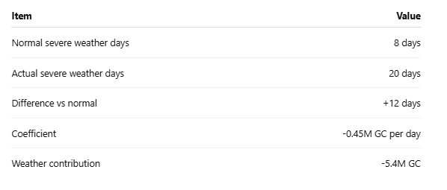

Extension B. Estimate growth momentum contribution using priors
Growth momentum should rely more heavily on prior evidence because many incremental actions have existing evidence from experiments, MMM, QBRs, campaign studies, price elasticity work, LTO analyses, CRM tests, or business cases. These priors should produce an expected range, not a single forced answer.
The working estimate can be selected within the prior range using recent execution, feature movement, and available model evidence. Later, the final prior-informed MVM should reconcile these estimates with foundation protection and external context to avoid double counting.
Synthetic example: growth momentum priors and working estimates
Growth driver | Prior source | Prior range | Working estimate
Pricing | Pricing elasticity study / prior MVM / QBR | +7M to +11M | +9M
Promo / value | Promo lift studies / offer analytics | +5M to +9M | +7M
Media | MMM / campaign measurement | +4M to +8M | +6M
LTO / menu | Launch analysis / matched markets | +3M to +6M | +4M
Digital / CRM | CRM tests / offer response | +2M to +4M | +3M
Delivery | Channel analysis / delivery promo studies | +2M to +5M | +3M

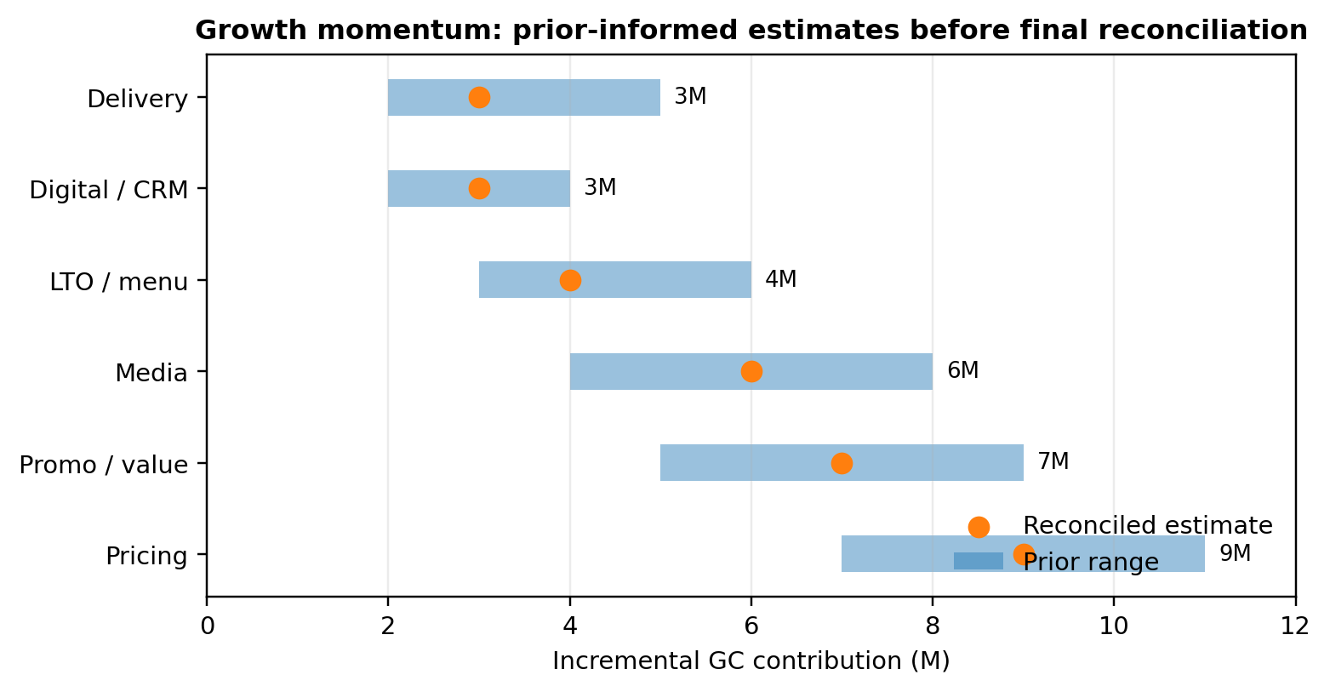
Figure 7. Synthetic prior ranges and reconciled working estimates for growth momentum.
Final reconciliation and reporting
Synthetic final contribution bridge
Waterfall component | Synthetic GC impact | Meaning
Weak foundation base | 310M | Counterfactual starting point
Foundation protection | +24M | Reference/current foundation vs weak foundation
Protected BAU base | 334M | Base after foundation protection
External context | -15M | Actual external context vs normal context
Context-adjusted base | 319M | Base after market pressure
Growth momentum | +32M | Prior-informed incremental actions
Residual / data gap | -1M | Unexplained or unreconciled movement
Actual GC | 350M | Observed result

The foundation module estimates protected GC by comparing reference/current foundation conditions with a weak-foundation scenario. External context and growth momentum are estimated separately, then reconciled into the final contribution view. This keeps the waterfall understandable and avoids over-crediting any one domain.
Guardrail: If growth variables are unavailable in the interim model, do not automatically treat the model residual as foundation impact. Label it as missing growth momentum, data gap, or residual until prior analysis or the final MVM can reconcile it.

