Lucy Toelcke
April 7, 2026
ECNS_460: Data Analysis
Abortion Data Visualization
Abortion Policy and Socioeconomic Outcomes: A Descriptive and Difference-in-Differences Analysis
This project examines whether abortion bans implemented after 2022 are associated with changes in fertility-related outcomes and socioeconomic indicators. The primary motivation is to understand whether restricting abortion access influences the number of children individuals have and how this may relate to broader economic outcomes such as wage income.

The dataset used is individual-level survey data containing demographic and economic variables including age, sex, race, state of residence (STATEFIP), number of children (NCHILD), and wage income (INCWAGE) obtained from the IPUMS website. Policy variation across states is used to distinguish between abortion-ban states (treated) and non-ban states (control), with a pre/post 2022 time split.

The data were processed and cleaned by first merging the policy dataset using state identifiers (STATEFIP) in order to assign each observation a treatment status. The sample was then restricted to females only to ensure alignment with fertility-related outcomes. Next, the analysis was limited to individuals aged 12 to 19 to focus specifically on adolescents. Finally, observations with missing or invalid values in key variables such as INCWAGE, NCHILD, and AGE were removed to ensure data
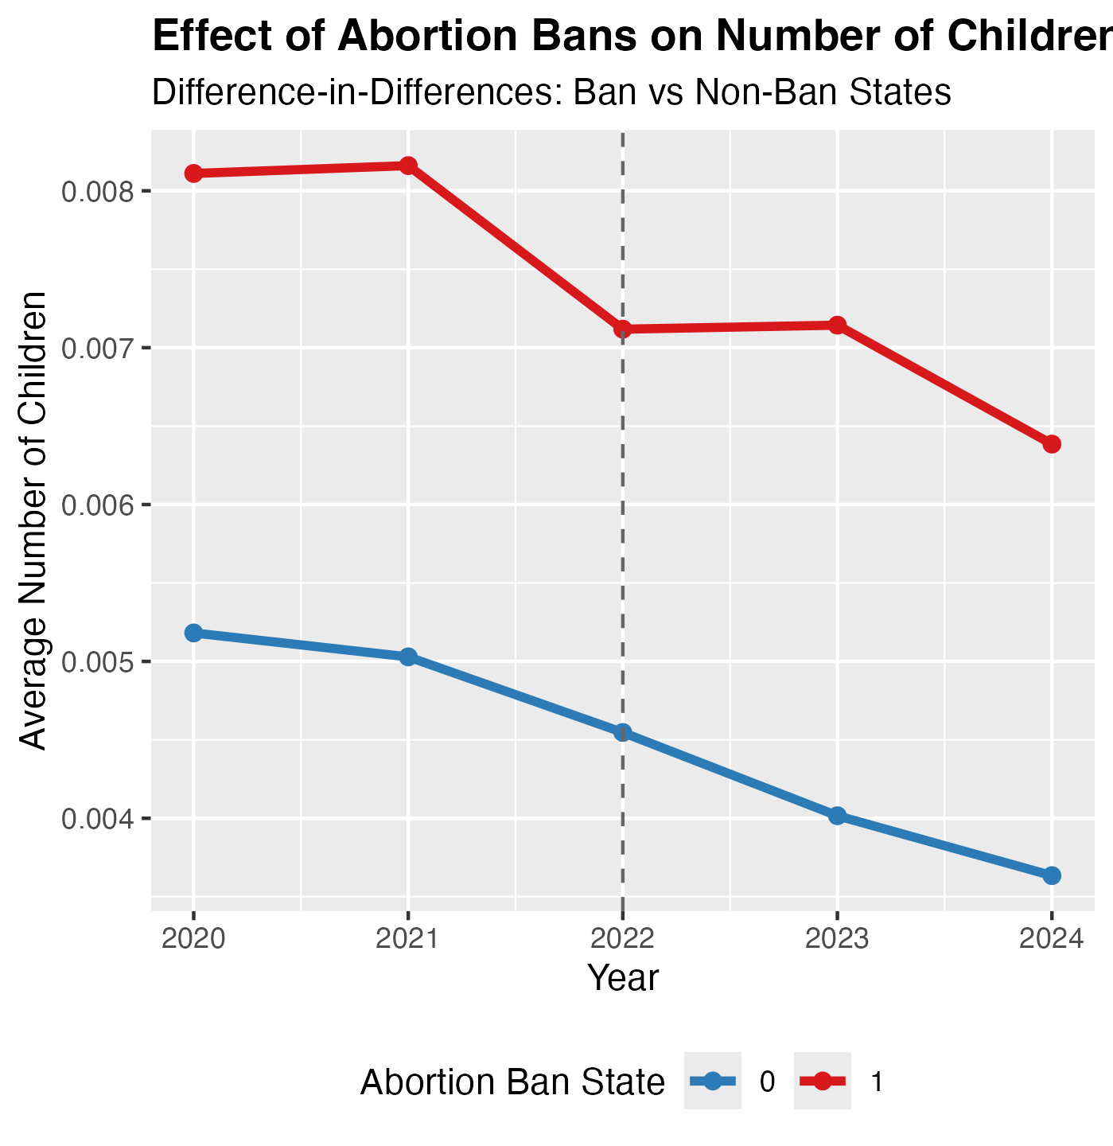
The purpose of this graph is to show the difference in fertility rates before and after 2022 when Roe V. Wade was overturned. It shows the average number of children born to teenagers in banned/hostile states and non-banned states for 2 years before and 2 years after the decision.
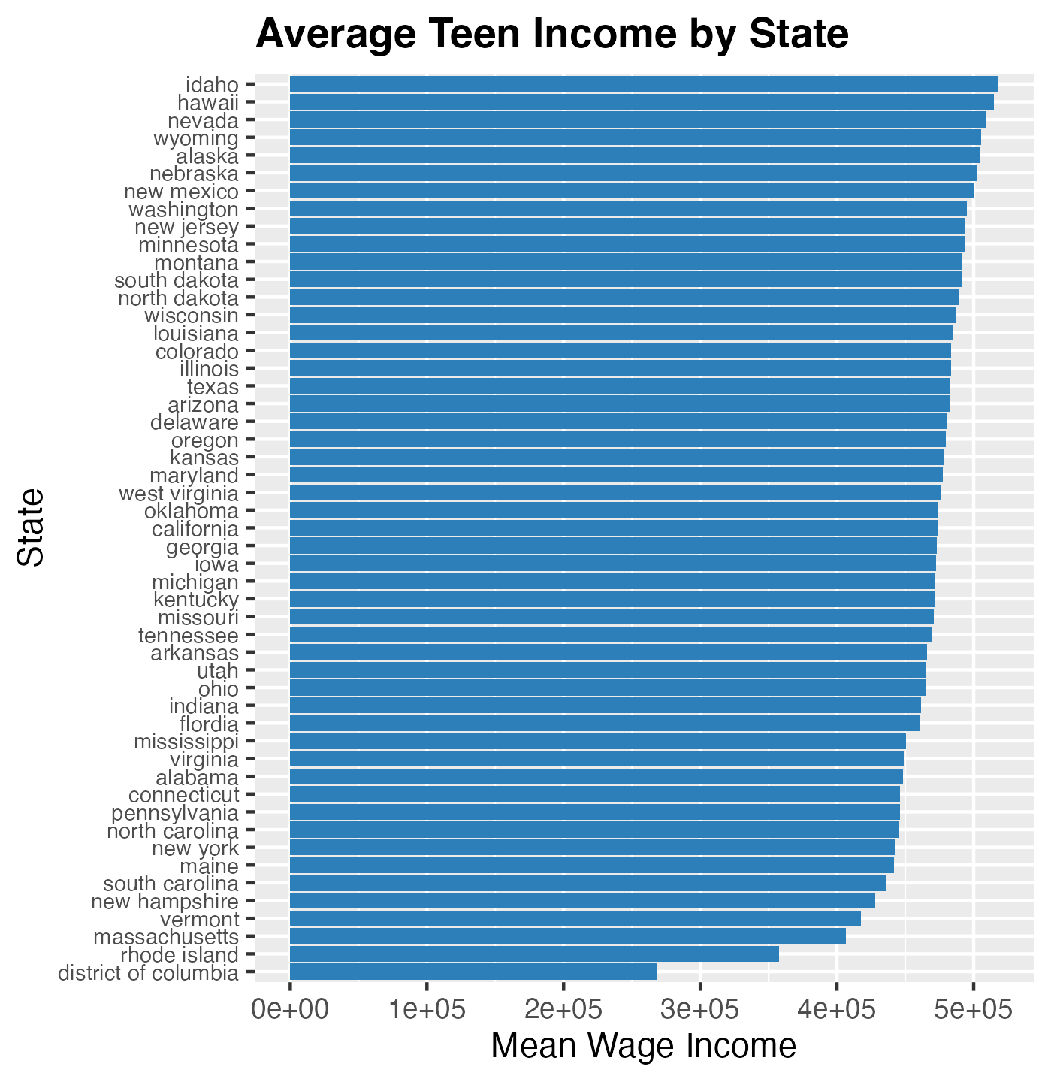
This graph illustrates the average wage income among teenagers across different states, highlighting variation in teen earnings at the state level.
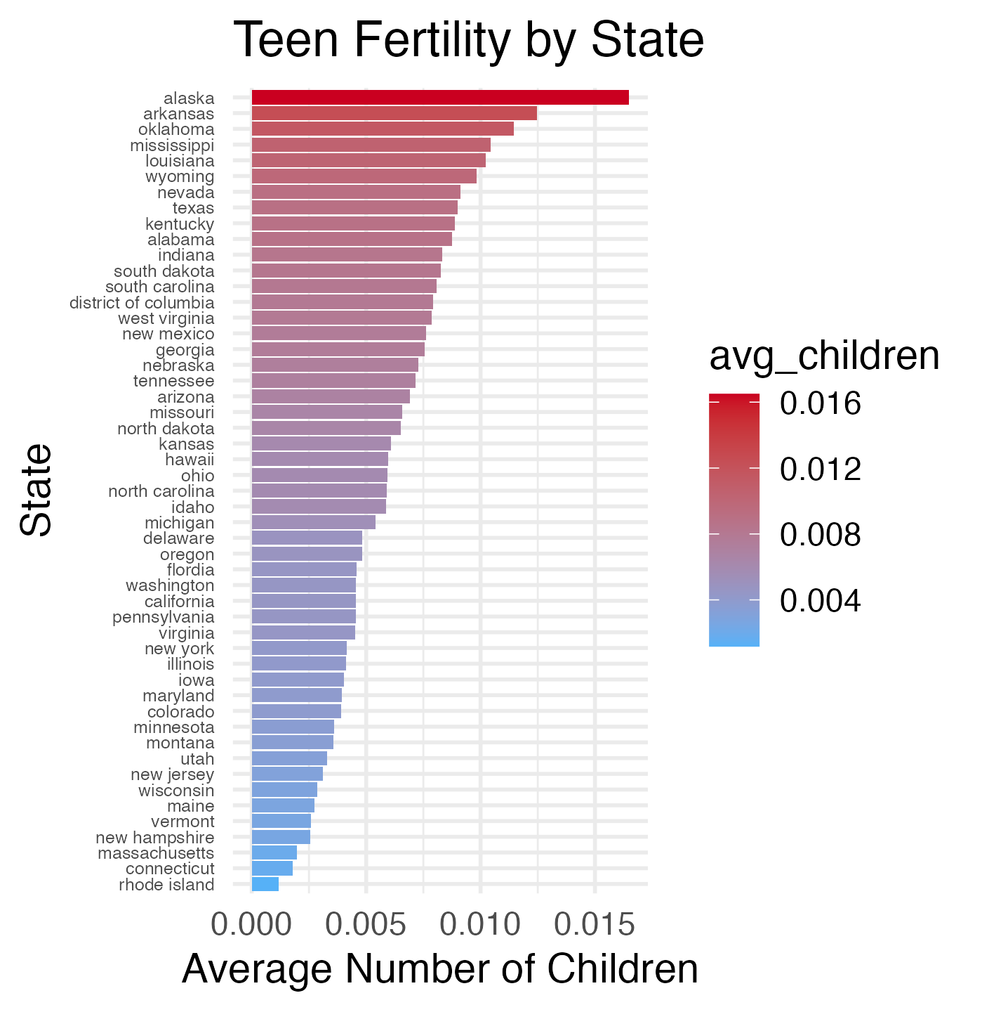
This graph displays the average number of children born to females aged 12–19 across states, highlighting geographic variation in adolescent fertility rates. The purpose of this visualization is to compare teen birth outcomes by state and identify patterns or differences that may be associated with underlying social, economic, or policy factors.
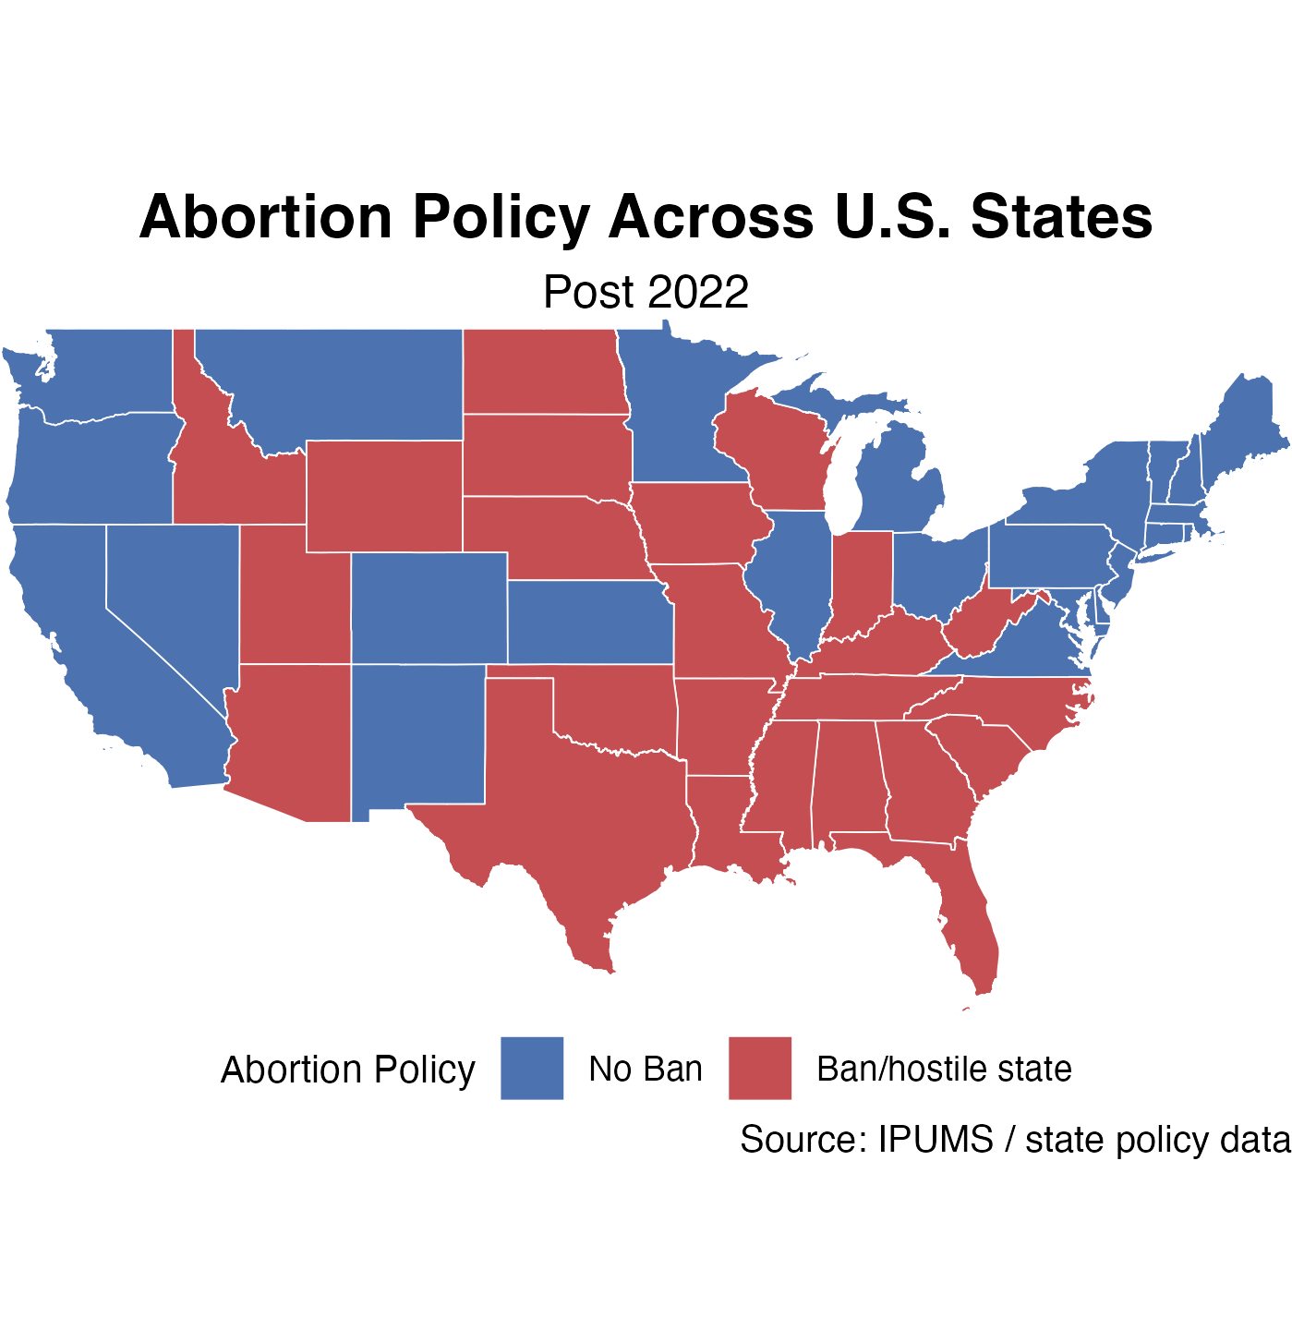
The map above shows which states restricted or banned abortion access following the overturning of Roe v. Wade. The purpose of this visualization is to clearly illustrate the geographic distribution of abortion policy changes across the United States, allowing for easier comparison between states with differing levels of reproductive healthcare access.

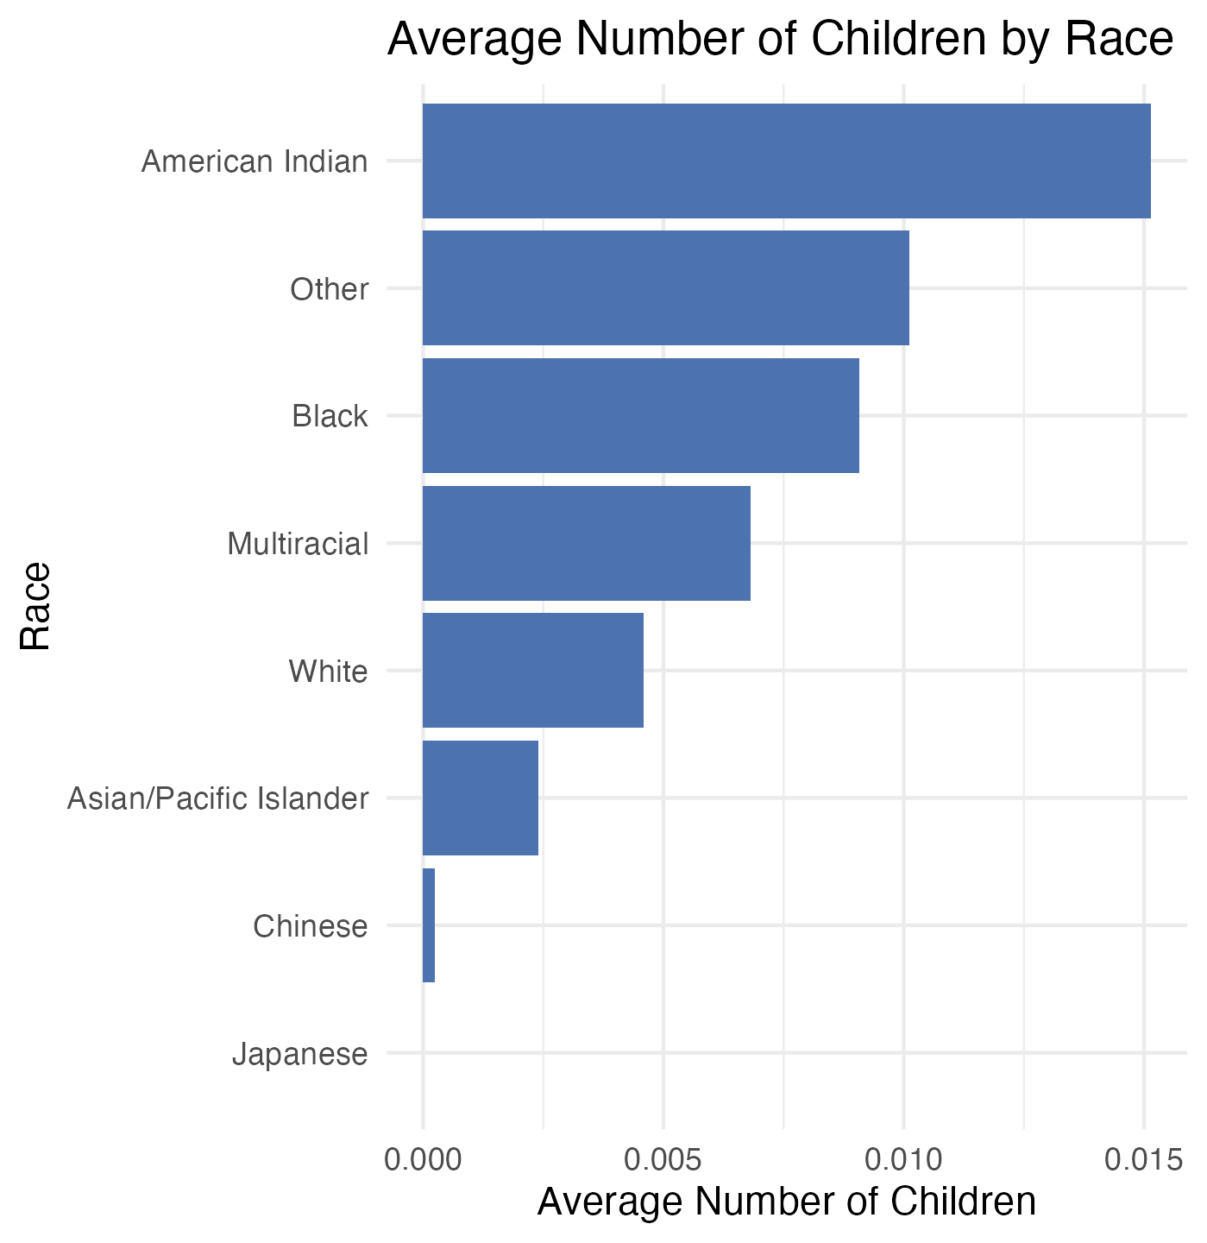
This bar graph displays the average number of children by race, showing differences in fertility outcomes across racial groups. The purpose of this visualization is to compare teen fertility by race and identify potential disparities that may reflect underlying social, economic, or demographic factors.

