

2017

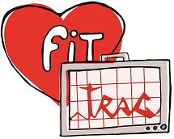

FitTrac Software

Project Design &

Status Report

CMSC 495 7980

Ryan Carnes

Anabelle Báez Rodríguez

Gregory Fraser

Aaron Smith

Professor Howard

Spring 2 2017

UMUC

Table of Contents

1. Introduction 2

1.1 Objectives 2

1.2 Background 2

1.3 Scope 2

1.4 References 2

2. Project Goals 2

3. Technical Design 3

3.1 Project Features 3

4. Status Report 4

5. Schedule Update 7

# 1. Introduction

## 1.1 Objectives

The objective of this document is to provide further information about the program design of the FitTrac project. This document will also include a status report that specifies the progress of the project so far. In addition, any changes to the original project schedule that were made due to time constraints or project scalability will be included in this document as well.

## 1.2 Background

As explained in previous documents, our project’s objective is to create a fitness tracking system that users can use to create user-defined Exercise Activities (EA) and metrics. In addition, the system will be able to track and analyze the user’s EAs and metrics information.

## 1.3 Scope

This document will include the following information:

Project Goals - Section 2

Technical Design - Section 3

Status Report - Section 4

Schedule - Section 5

## 1.4 References

References for the software Design and Status Report specifications include:

1. Software Project Management Plan (SMP) for FitTrac
2. Software Test Plan (STP) for FitTrac
3. JISC Progress Report Template - Full. (2011, February). Retrieved April 2, 017, from <http://www.uwe.ac.uk/its-staff/public/jisc/progress%20report%20may%202012.pdf>

# 2. Project Goals

The goal of our project is to create a fitness tracking system called FitTrac that will provide users with a user-friendly tool which will allow them to create, track, and analyze one or more defined Exercise Activities (EA) and metrics. The system should be able to allow the user to adjust the EA metrics to fit the user’s needs and goals. For that reason, flexibility of the system will be an additional goal of this project.

# 3. Technical Design

The software design is straightforward. A UI managed java database solution to fitness exercise data tracking providing the individual users with their own database, managed through a UI that provides the user with the ability to create, update and analyze user data.

## 3.1 Project Features

FitTrac will include the following features:

|  |  |
| --- | --- |
| Feature | Description |
| User Creation | Each user will be able to create a user record. If the user does not have a user record, they will need to create one. On the other hand, if the user has an existing record, the user can select their record. |
| EA Creation | Users can create their own personalized exercise activity records. The user will be allowed to select the metrics that they want to include in the record in order to keep track of their personal fitness goals. |
| Exercise Log Selection | Once the user has selected their user record and created an EA metric, they can select their EA log to modify, display, or delete it. |
| Exercise Log Modification | The user will be able to modify certain metrics of their EA log. |
| Exercise Log Display | The user will be able to display information about their EA log. |
| Exercise Log Deletion | The user will be able to delete the EA logs that they consider to be unnecessary. |

# 4. Status Report

|  |  |
| --- | --- |
| **Project Name** | *FitTrack* |
| **Course** | CMSC 495 7980 |
| **Report compiled by** | Ryan Carnes,  Anabelle Báez,  Gregory Fraser, and  Aaron Smith |
| **Reporting period** | *03-13-17 to 09-04-17* |
| **Section One: Summary** | |
| The overall progress of the project has been satisfactory. Our group has started the process of creating UI prototypes, as well as database scripts in order to begin the coding process. Once we have made some significant progress in the project code, we will start the testing process. | |
| **Section Two: Activities and Progress** | |
| **Week 1: Team Organization – Completed (100%)**  All the activities of the first week of the project were completed successfully.  **Week 2: Project Planning – Completed (100%)**  All the activities of the second week of the project were completed successfully.  **Week 3: High Level Test Plan, Test Plan Documentation – Completed (100%)**  **Coding, Testing, 1st Customer Review, Design & Develop UI, Develop Users Guide,**  **Develop Exercise Activity, Develop Exercise Log, and Develop Basic Prototype – On schedule (45%)**  So far, we have completed the high-level test plan and test plan document. Other milestones such as customer review, UI design, and coding are still in process.  **Week 4:** **Develop Exercise Log, Develop basic prototype, Coding, Testing, Project Design,**  **Extend Exercise Activities, Develop Exercise Plans, Develop Extended Functionality,**  **Write Low Level Test Cases – On schedule (40%)**  The activities scheduled for week 4 are still in process.  **Week 5: Coding, Testing,** **Extend Exercise Plans, 2nd Customer Review, Test 1st Phase Source,**  **1st Phase Source Delivered, Develop Import/Export Functionality, Develop Reports & Graphs,**  **Update Test Documentation After Review 2– On schedule (20%)**  The activities scheduled for week 5 are still in process.  **Week 6:** **Coding, Testing, Develop Extended Functionality, Write Low Level Test Cases,**  **Develop Import/Export Functionality, Develop Reports & Graphs, Update Test Documentation**  **After Review 2, Test 2nd Phase Source, 2nd Phase Source Delivered, Update Design**  **Documents After Review 2, Update Code After Review 2, Update Users Guide – On schedule (20%)**  The activities scheduled for week 6 are still in process.  **Week 7: Coding, Testing, Update Design Documents After Review 2,**  **Update Code After Review 2, Update Users Guide, Test 3rd Phase Source,**  **3rd Phase Source, Delivered, Stretch Goals – On schedule (20%)**  The activities scheduled for week 7 are still in process.  **Week 8: Coding, Testing, Update Users Guide, Stretch Goals, Update Design**  **Documents After Review 3,Update Code After Review 3, Update Test**  **Documentation After Review 3, 3rd Customer Review, Final Testing,**  **Final Program Delivered – On schedule (20%)**  The activities scheduled for week 8 are still in process. | |
| **Section Three: Institutional & Project Partner Issues** | |
| So far, there have not been any issues or inconveniences during the production of our product. The communication among group members has been consistent and the collaboration very active. | |
| **Section Four: Outputs and Deliverables** | |
| **Group Documents:**  Project Plan – Delivered on March 26, 2017  Plans and Specifications (Group Discussion) Delivered on March 25, 2017  Test Plan – Delivered on April 2, 2017  Peer Review 1 (Individual Delivery) – Delivered on April 2, 2017  **Project Material Deliveries:**  Project Proposal – Created on March 16, 2017  Software Design Concept – Created on March 18, 2017  Project Brainstorm – Created on March 20, 2017  Data Flow Diagrams – Created on March 23, 2017  Database Normalization - Created on April 1, 2017  Exercise Log Prototype – Created on April 1, 2017  Database Concept Script – Created on April 3, 2017  Program Logo – created on April 6, 2017  Code Files (Java Classes) – Created on April 5, 2017 | |
| **Section Five: Outcomes and Lessons Learned** | |
| Thanks to the implementation of multiple IEEE documents as base models for our project documents, we have been able to effectively organize and document our progress and procedures. Furthermore, the peer reviews that we did in order to create a constructive critic for our classmates’ projects have helped us to understand which areas of our project we can improve. | |
| **Section Six: Evaluation** | |
| Awaiting professor feedback on peer evaluation of FitTrac Project. | |
| **Section Seven: Dissemination** | |
| Access to our project files and progress are available on:  <https://github.com/Xavyor/FitTrac> | |
| **Section Eight: Risks, Issues and Challenges** | |
| So far, we have not encountered any of the issues and risks mentioned in the Project Plan of FitTrac. These risks include the customer requiring additional data functionality stand alone, wanting a web based interface, adding additional features that were not previously discussed, and software/hardware incompatibility with the software. | |

|  |
| --- |
| **Section Nine: Collaboration and Support** |
| Team member’s collaboration and support:   * Ryan Carnes   + Project Proposal   + Project Plan document   + Team Role Organization   + Test Case document   + Work Activity Schedule * Anabelle Báez   + Project Plan document   + Test Case document   + Software Design and Status Update document   + Data flow Structure   + Logo Concept * Gregory Fraser   + Project Plan document   + Test Case document   + Program Structures System   + Software Design and Status Update document   + Work Activity Schedule * Aaron Smith   + Project Proposal   + Program Specifications   + Project Plan document   + Test Case document   + Software Design and Status Update document |
| **Section Ten: Next Steps** |
| Our next step is to proceed with the development of the UI, as well as completing the program code and database structure. Further activities include documenting the low level test cases, developing all the import export functionalities, completing the graphs, and updating the project documents. |

# 5. Schedule Update

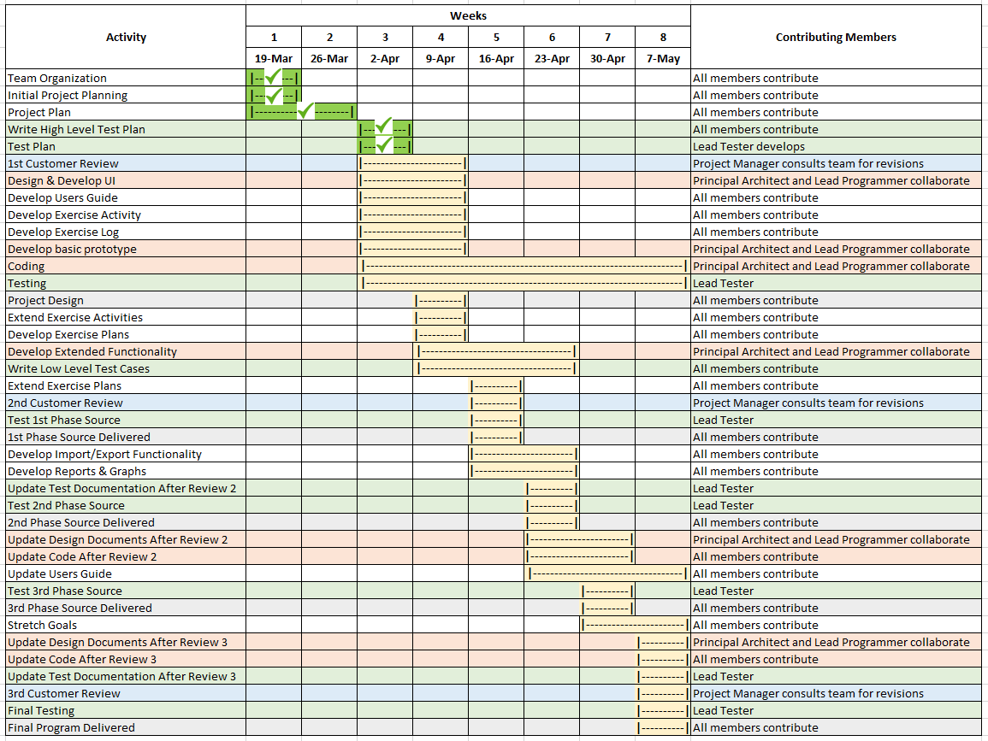After a few adjustments to the project’s specifications, we have decided to make some changes to the project schedule that account for current completion of each task.