Joshua Filer

Jordan Geddes

Nick Martin

Vy Dinh

04/07/2017

CMSC 495

Project Status Report

Group 2

Periodic Table Program

**Updated Schedule:**

The following updated schedule from our project plan depicts how our group is completing the project plan. Most of our group formations, project plans, and test plans have already been complete. All GUI design components are set, while our design document and the rest of the project documentation and design are in the works as of right now (final implementation is included in the works as well). All phase 1-3 parts will be done altogether at this time as to provide improvement for our design as we progress. Phase 1 is about 80% complete and should be done by next week. On another note, none of us have reviewed our first peer review as none of the peer reviews have been presented. Once the peer reviews have been viewed by the group, we will commence with reviewing each other’s peer review. Note: The percentages may change over time as new status reports are formed.

**Schedule Status:**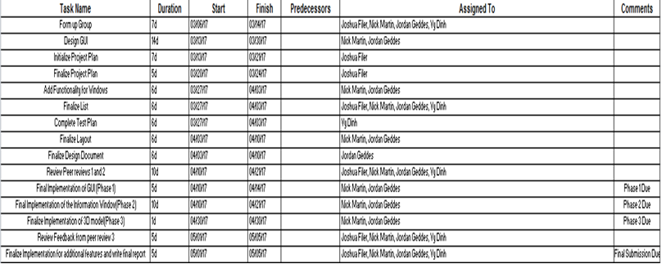

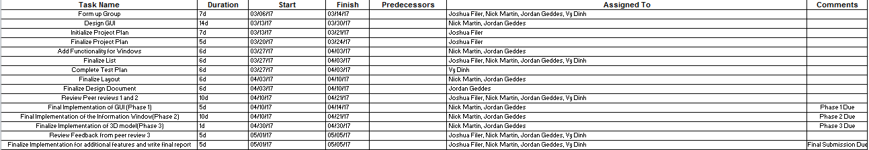

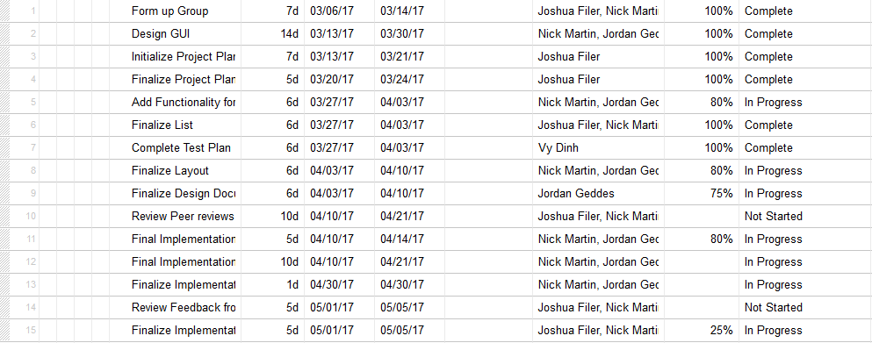

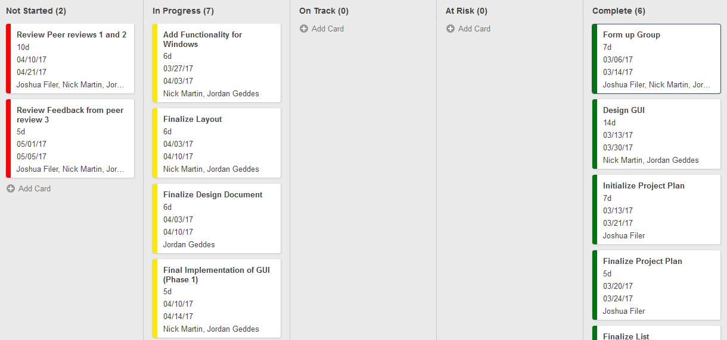

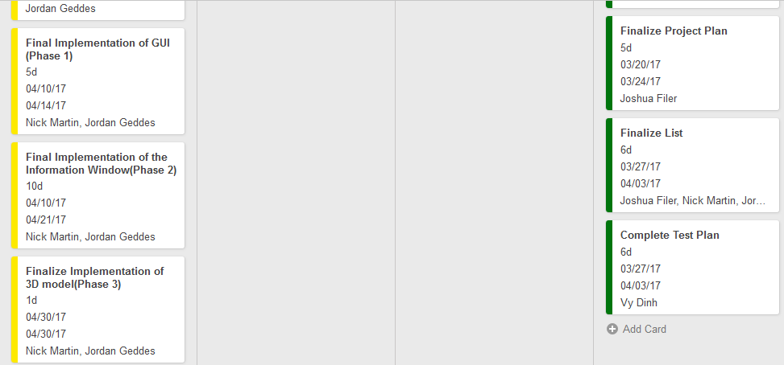

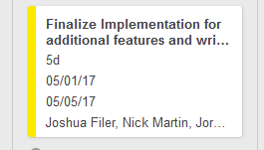

**Updated Schedule:**

**Legend:**

**Green: Completed**

**Yellow: In Progress**

**Red: Not Started**

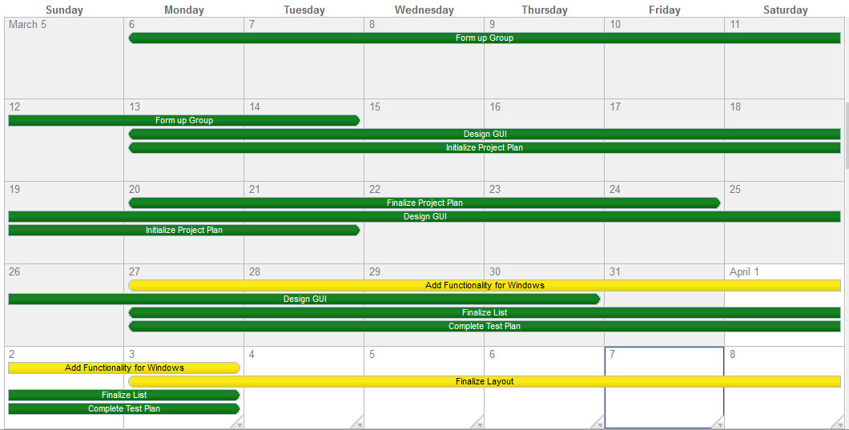

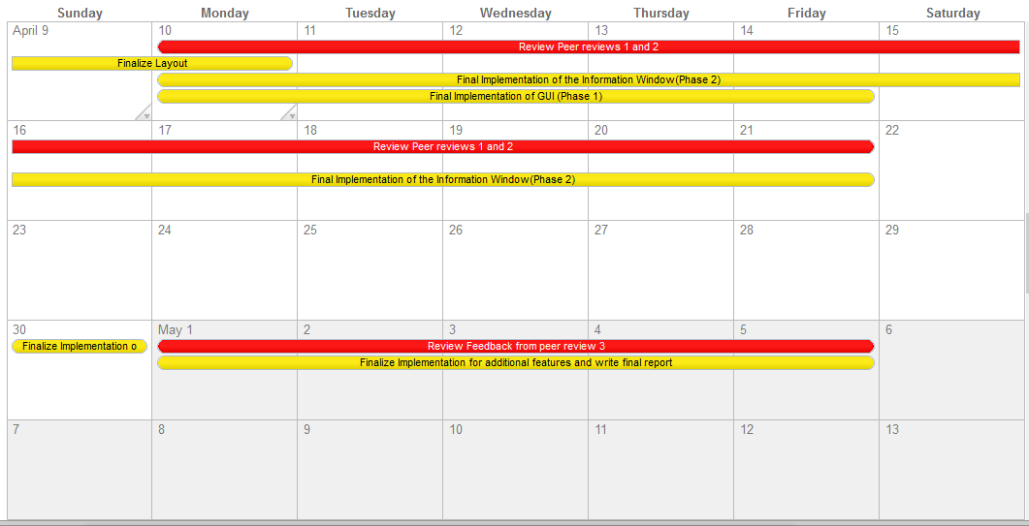

**Project Statement:**

All members of this group are contributing well in the early developing stages of the Periodic Table program. Nick Martin and Jordan Geddes, you are well honored for an elegant design for the periodic table program at hand. No one else we have known in the class but you two have ever come up with such interesting 3D designs and unique user interaction settings. Based on your research from real world applications of interactive periodic tables, we have a very unique program to give for everybody to have an interactive experience with learning the elements that make up our Earth. Keep up the good work.

For Vy Dinh and myself (Joshua Filer), we also have done well to bring the best documentation for the project plan, user guide, and test plan. Jordan Geddes and Nick Martin are also great contributors towards edits and recommendations toward the project plan and test plan as well. Without your edits and recommendations, the project plan and test plan would have ultimately failed. We all appreciate your cooperation in keeping the documentation on track and ensuring that all material meets the requirements. Jordan Geddes also is credited towards creating the software design and precisely explaining how the whole project design works. Without your contributions, it would make it difficult to understand everything this team is trying to accomplish in terms of creating a valuable scientific tool. Vy Dinh on the other hand is also credited towards making the test classes and testing each new feature for the duration of the project to make sure everything is on track. Without your test implementations, it would make it very difficult to make sure the project works as planned. Thank you Vy for your contribution for testing and continue to provide appropriate testing as we go with finalizing the project.

Everyone so far has made contributions towards outlining the whole design and completing a complex periodic table program for future use of those interested in studying the elements for any scientific field. As long as we keep up with the formats and proper design implementations going forward, our project compared to other projects should be better than ever before. Thank you everybody for all of your hard work up to this point.

Keep up the good work, and let’s finish this project with a Bang!

Regards,

**Joshua Filer: Lead Documenter**