

Java VT100 Terminal Emulator

Design and Status Report

Group Three

CMSC 495

Professor Howard

09 April 2017

**Table of Contents**

Overview

Scenarios

Non-goals

UML Design

Status Report

Summary for the week ending April 9th.

Accomplishments

Challenges

Moving Forward

Milestone Report

# **Overview**

J-VT100 is a Java terminal emulator that allows users to interface with all sorts of devices that utilize the ANSI standard for ASCII text formatting.

This specification document is not complete. The code and design will likely be revised several times throughout the course of development. This is meant to be a starting point for programmers to reference for development purposes.

# **Scenarios**

These are a few scenarios to help the developers visualize how the customer will use the program:

**Scenario 1:**

Joe is a hardware technician. He needs a platform independent application that allows him to connect to his antenna’s controller which utilizes an RS-232-C serial connection. The antenna controller outputs a stream of data including time and position in ASCII with ANSI formatting. Joe needs to view the data and be able to interact with the antenna controller to position the antenna and other functionality.

**Scenario 2:**

Adele is an engineer at a research and development firm. She needs an application that runs on the JVM to read ASCII data sent from a serial device. She occasionally needs to numerical ASCII data out the same serial port from a 15 key pad which also possesses an enter key and directional keys.

**Scenario 3:**

Haley needs a tool that scans her computer for serial ports and allows her to select one from a list. She also needs to be able to safely disconnect from the port upon successful connection.

# **Non-goals**

This version of software will not support the following features:

* Enumeration of system ethernet devices
* All-character recognition
* File output features

# **UML Design**

This is a high level diagram of the classes and methods making up the J-VT100 application:

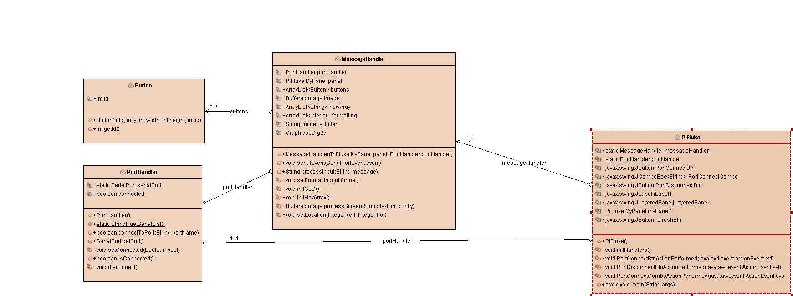

As is evident from above, the application will contain four classes. The PortHandler class is responsible for enumerating the system’s serial ports. The Button class defines the buttons that are created in the display area. The PiFluke class is the UI and graphics class. The MessageHandler class is the workhorse of the application. It is responsible for interpretation of the ASCII data and ANSI escape sequences that come across the serial port.

**Implementation Model**

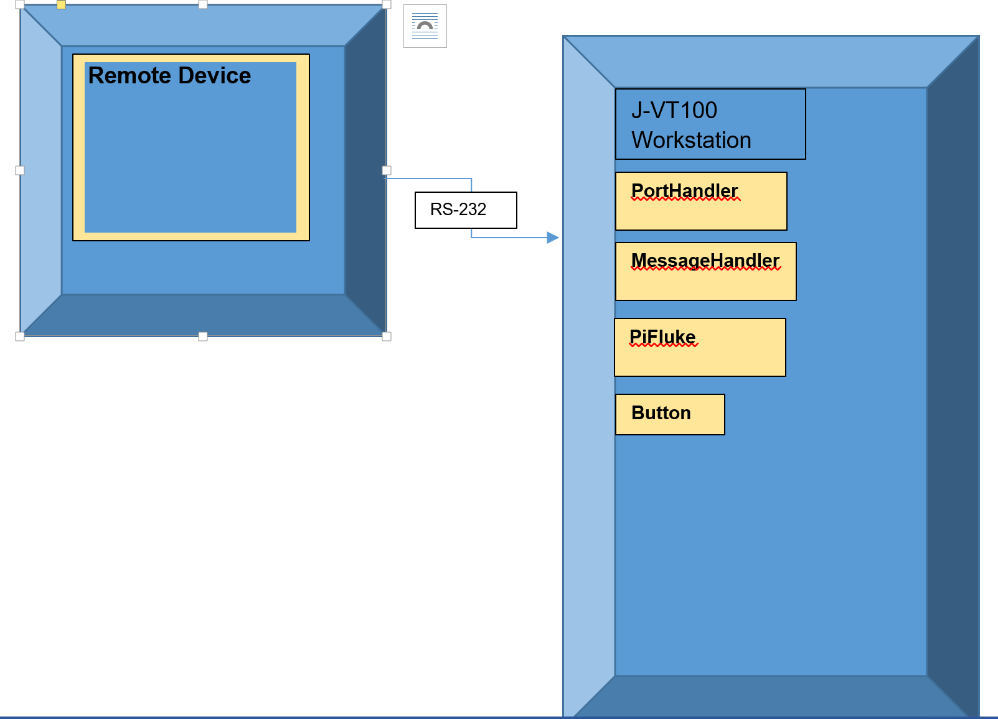

**UI Design**

This is the GUI that the user will use to run the program:

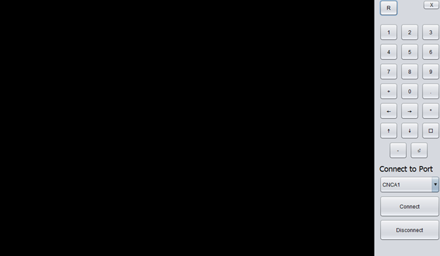

# **Status Report**

# **Summary for the week ending April 9th.**

This was a productive week for team three. The code development is well underway and has reached a runnable level. No testing has been done as of yet, but starting 10 April, preliminary testing will commence.

# **Accomplishments**

* Designed and implemented 4 classes that possess the basic functionality specified in the project plan.
* Designed and implemented a UI providing the features specified.
* Imported JSSC library which provides serial port interfacing capability within Java.
* Created the design and status report.

# **Challenges**

* Sourcing freeware to simulate com ports on a Windows machine has proved difficult. Alternatively, USB to serial converters are not easily sourced.
* Not all ANSI escape sequences have been accounted for in the MessageHandler class.
* Possible issue with resource consumption due to g2d usage.
* GitHub use as intended is proving to be a challenge. In the interim, code has to be uploaded manually and tracked by project lead to ensure collaboration requirements.

# **Moving Forward**

* This coming week commencing 10 April we will begin testing the code and identifying problems.
* Work will begin on modifying the code to allow read-in from a .txt file for testing purposes.
* Functionality through serial port will be tested by Joseph Bowe as he possesses a USB to serial converter and requisite software. Functionality will be recoded and demonstrated by the same.
* Escape sequences will be added to MessageHandler class when identified.
* Investigate resource consumption issue in an attempt to boost code efficiency.
* Troubleshoot GitHub to get working as intended.

# **Milestone Report**

According to our milestone report, which is provided weekly with our GANTT Chart, we were on time with our project plan report. In addition, we each created our accounts on GitHub and are using Google Docs as well. Communication occurs through the Gmail and each member doing his/her task. Joseph Bowe, is our project manager and is responsible for coding and communications with the professor. He also sends all of us emails and reports our project scope weekly. Adele creates the Milestone Report and is also jointly responsible for documentation. Additionally she offered to create the logo which developers will use on the GUI and design the HTML file which includes all documentation, project plan, and project design.

The following is the schedule to which we shall adhere:

|  |  |  |  |
| --- | --- | --- | --- |
| Task | Start Date | Duration | End Date |
| Team Organization | 3/13/2017 | 7 | 3/19/2017 |
| Project Review Objective | 3/15/2017 | 7 | 3/22/2017 |
| Project Plan Specification | 3/19/2017 | 7 | 3/26/2017 |
| Project Plan | 3/19/2017 | 7 | 3/29/2017 |
| Test Plan | 3/26/2017 | 7 | 4/2/2017 |
| Peer Review 1 | 3/27/2017 | 6 | 4/2/2017 |
| Information Requirement for System Design | 4/2/2017 | 7 | 4/9/2017 |
| Project Design Report | 4/2/2017 | 7 | 4/9/2017 |
| Develop and Design System | 4/9/2017 | 28 | 5/7/2017 |
| Coding | 4/9/2017 | 28 | 5/7/2017 |

This is our progress to date: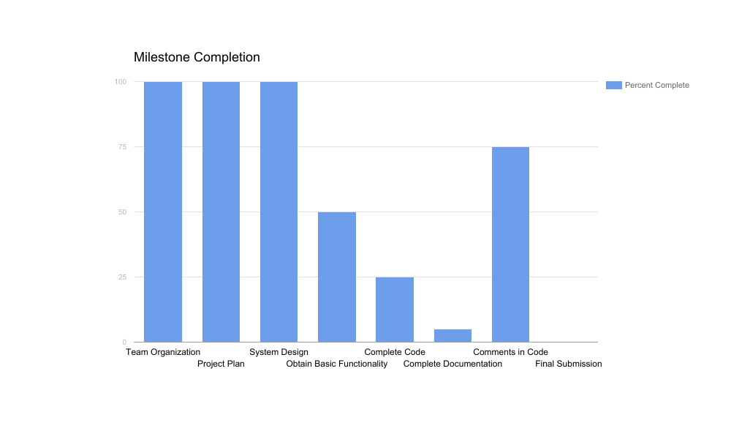

# **Team Contributions**

The following is a chart reflecting each member’s contributions to each project/milestone so to date:

|  |  |  |  |
| --- | --- | --- | --- |
| Contribution % | Project Plan | Test Plan | Code and Design |
| Joseph Bowe | 60% | 50% | 60% |
| Adele Janlou | 30% | 45% | 30% |
| Haley Adams | 9% | 5% | 10% |
| Andrew Rudnev | 1% | 0% | 0% |