All code mentioned in the document can be found at the github:

<https://github.com/ludan1214/java-fsd-phase4/tree/main/restaurant-frontend>

1. Project Setup:

As this project contains no backend, the only dependencies are a modern browser and an internet connection that will be used to import the libraries necessary for bootstrap.

1. Project Overview

As this is a front-end project, all webpages are served locally.

* Every page features a navbar which takes the user to either the Home, Menu, or Contact pages.
* A CTA button is located under the carousel which will take the user to the Menu page. The button also features an interactive tooltip implemented with JavaScript that displays when the user hovers over it with their mouse.
* <div class="carousel-inner">
* ...
* ...
* </div>
* <div class="menu-btn">
* <button type="button" onclick="location.href='menu.html'" class="btn btn-secondary" data-toggle="tooltip" data-placement="right" title="Check out our tasty menu!">
* Check out our menu!
* </button>

    <script type="JavaScript">

      $(function () {

        $('[data-toggle="tooltip"]').tooltip()

      })

    </script>

* The menu features a grid that displays menu items and prices. Several class tags were used to style the bootstrap, for example:
* <div class="col-sm-6 col-md-6 col-lg-5">
* <h1 class="display-0">$6.99</h1>
* Steamed Buns
* <img src="images/steamedbuns.jpg" class="img-fluid"></div>
* <div class="col-sm-6 col-md-6 col-lg-5">
* There is a copyright footer featured on the index page.
* <footer class="page-footer font-small indigo">
* <!-- Copyright -->
* <div class="footer-copyright text-center py-3">Ming's © 2021 Copyright:
* <a href="https://github.com/ludan1214/java-fsd-phase4"> GitHub Source Code</a>
* </div>
* <!-- Copyright -->
* </footer>
* There is a contact form that currently just acts as a dummy form.

1. Project Demo

A simple homepage features a carousel that displays a slideshow of food images.

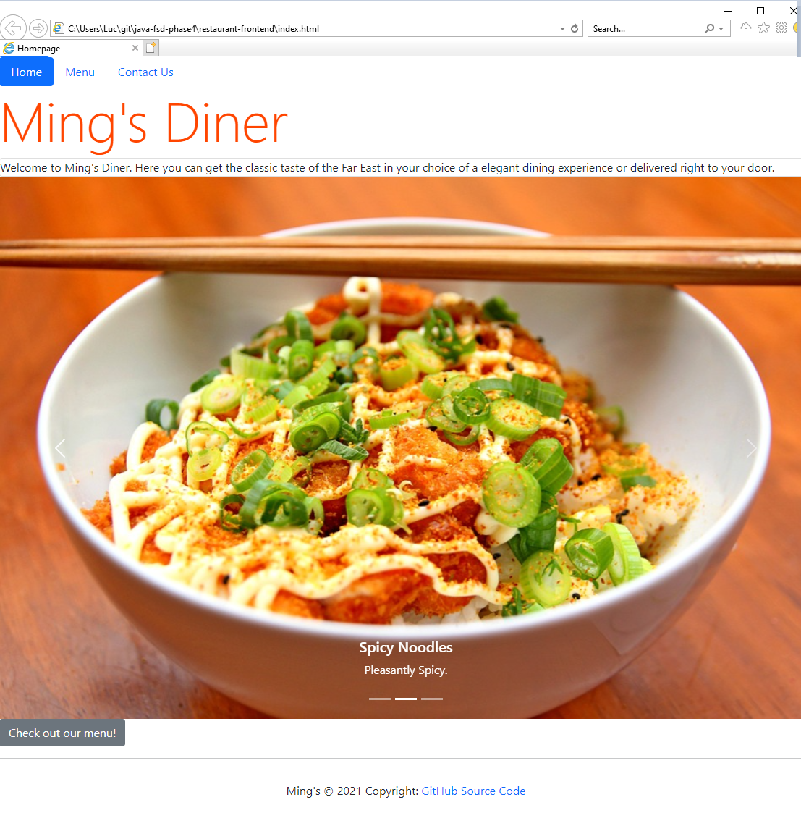

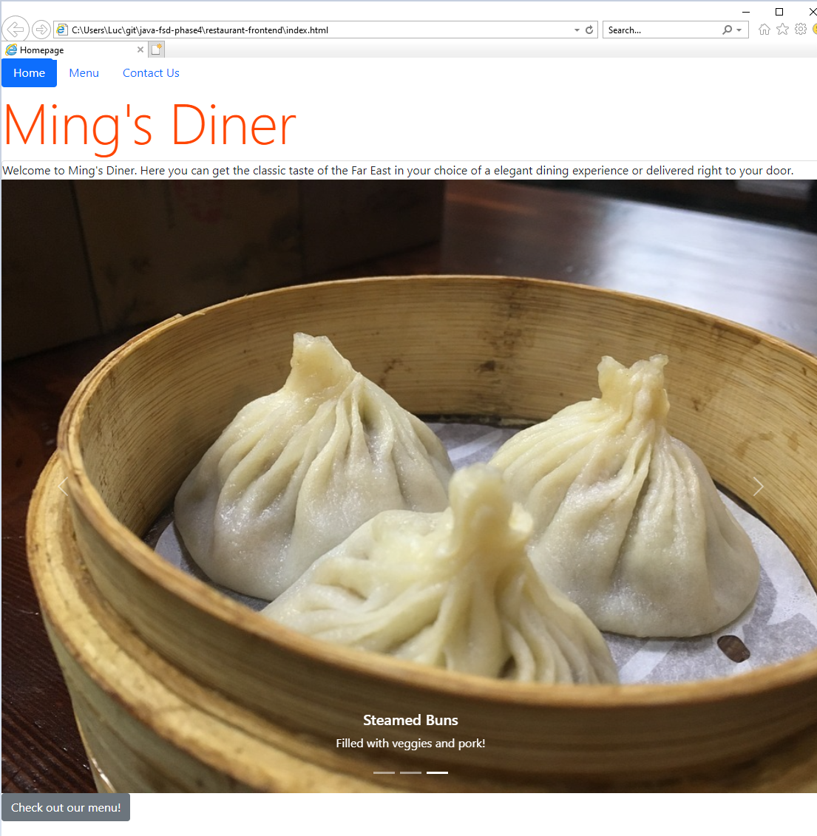

The menu features a grid with some images of food and prices

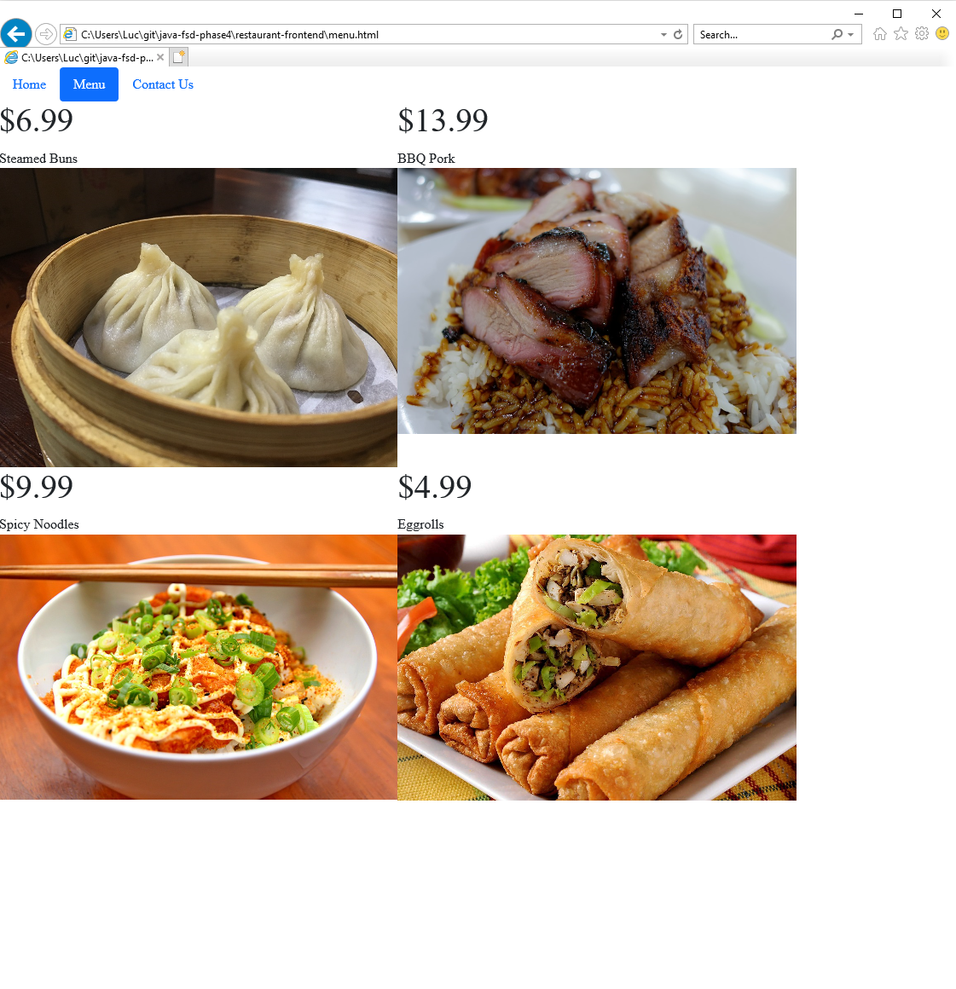

A contact form allows customers to contact the restaurant.

