Bathala Slot Prototype Analysis
1. DESIGN & DEVELOPMENT PROCESS
Lucky888 was developed as a Bathala simulation twin for mathematical analysis and game design evaluation. The prototype reconstructs the reference game’s observable 6×5-reel structure, symbol set, tumble mechanic, Bathala elimination skill, Scatter behaviour, Free Game behaviour, and multiplier system. Gameplay rules that can be directly verified through observation have been reproduced as closely as possible. However, as the underlying probabilities and gameplay parameters cannot be directly verified, the simulation twin uses configurable datasets (JSON & CSV files) that can be easily imported, adjusted, and exported out via the HTML5-based workbench.

DESIGN METHODOLOGY
The simulation twin’s development involved four key stages: Observation, Reconstruction, Simulation, and Appraisal. These development steps crystallized into 2 final outputs:
- A playable simulation prototype with tools to track, input, and export session-based configuration inputs and spin outcomes · http://lucky888.ludoai.xyz/
- A dashboard with file upload functions and structured reporting · http://lucky888.ludoai.xyz/dashboard/

A. OBSERVATION
- Specific rules, mechanics and hidden parameters such as the minimum number of matching symbols required for a win were directly replicated from observable gameplay.
- Values such as internal symbol probabilities, exact feature-entry weights, and multiplier probabilities cannot be verified simply by observing the game. All parameters that cannot be verified have still been implemented with easily modifiable weights for iterative testing.
SYMBOL WEIGHTS AND PAYOUT DATA MULTIPLIER WEIGHTS
Symbol | Weight | minCount | maxCount | Payout |  | Multiplier | Weight
L1  (Low-1) | 180  (16.38%) | 8 | 9 | 0.25× |  | 2× | 1000  (18.27%)
 |  | 10 | 11 | 0.75×
 |  | 12 | 30 | 2× |  | 3× | 900  (16.44%)
L2  (Low-2) | 170  (15.47%) | 8 | 9 | 0.4×
 |  | 10 | 11 | 0.9× |  | 4× | 800  (14.61%)
 |  | 12 | 30 | 4×
L3  (Low-3) | 160  (14.56%) | 8 | 9 | 0.5× |  | 5× | 700  (12.79%)
 |  | 10 | 11 | 1×
 |  | 12 | 30 | 5× |  | 6× | 600  (10.96%)
L4  (Low-4) | 150  (13.65%) | 8 | 9 | 0.8×
 |  | 10 | 11 | 1.2× |  | 8× | 450  (8.22%)
 |  | 12 | 30 | 8×
L5  (Low-5) | 140  (12.74%) | 8 | 9 | 1× |  | 10× | 350  (6.39%)
 |  | 10 | 11 | 1.5×
 |  | 12 | 30 | 10× |  | 12× | 250  (4.57%)
H1  (High-1) | 90  (8.19%) | 8 | 9 | 1.5×
 |  | 10 | 11 | 2× |  | 15× | 180  (3.29%)
 |  | 12 | 30 | 12×
H2  (High-2) | 75  (6.82%) | 8 | 9 | 2× |  | 20× | 120  (2.19%)
 |  | 10 | 11 | 5×
 |  | 12 | 30 | 15× |  | 25× | 80  (1.46%)
H3  (High-3) | 60  (5.46%) | 8 | 9 | 2.5×
 |  | 10 | 11 | 10× |  | 50× | 30  (0.55%)
 |  | 12 | 30 | 25×
H4  (High-4) | 45  (4.09%) | 8 | 9 | 10× |  | 100× | 10  (0.18%)
 |  | 10 | 11 | 25×
 |  | 12 | 30 | 50× |  | 250× | 3  (0.055%)
SCATTER | 24  (2.18%) | N/A | N/A | N/A
MULTIPLIER | 5  (0.45%) | N/A | N/A | N/A |  | 500 | 1  (0.018%)
- Core mechanics and reel logic specific to the Bathala Slot machine game were carefully observed. Crucially, the game does not use paylines and instead rely on tumbling symbols to generate wins.

TUMBLE MECHANIC  - After a win, winning symbols are removed. Remaining symbols fall into place, and new symbols drop in from above.  - The grid is then checked again for another win. Tumbles continue until no new win is formed. | BATHALA SKILL (SYMBOL ELIMINATION)  - After each winning Tumble, one Low Pay Symbol (L1 to L5) is selected and removed from the reels.  - Removal does not award a payout by itself.  - Remaining symbols fall into place, new symbols drop in, and the next Tumble is evaluated.
SCATTERS  - Scatter Symbols pay anywhere on the reel.  - 4 Scatters: 3× Total Bet  - 5 Scatters: 5× Total Bet  - >6 Scatters: 100× Total Bet  - Landing ≥4 Scatters in the Base Game awards 15 Free Spins.  - Note: Scatter Symbols are evaluated after all Tumbles have finished. | FREE SPINS  - Landing ≥4 Scatters in the Base Game awards 15 Free Spins.  - Landing ≥3 Scatters during Free Spins awards 5 additional Free Spins.  - Multipliers collected from winning Tumbles are added together and carried forward for the remainder of the Free Spins feature.
MULTIPLIERS  - When a winning Tumble contains one or more Multiplier Symbols, their values are added together and applied to the win.  - During Free Spins, collected multipliers are added to the current feature multiplier and accumulate into subsequent tumbles.  - Note: Multiplier Symbols are collected only when they appear on a winning Tumble. | MAX WIN  - Maximum Win: 10,000× Total Bet  - Highest Multiplier Symbol: 500×

B. RECONSTRUCTION & SIMULATION
- Observable gameplay was translated into a simulation engine that could reproduce Spin behaviours.
- The simulation engine was designed to trigger the known reel logic: symbol generation, win evaluation, multiplier handling, symbol eliminations, symbol refill, Scatter evaluation, and Free Game resolution.


SYMBOL SET

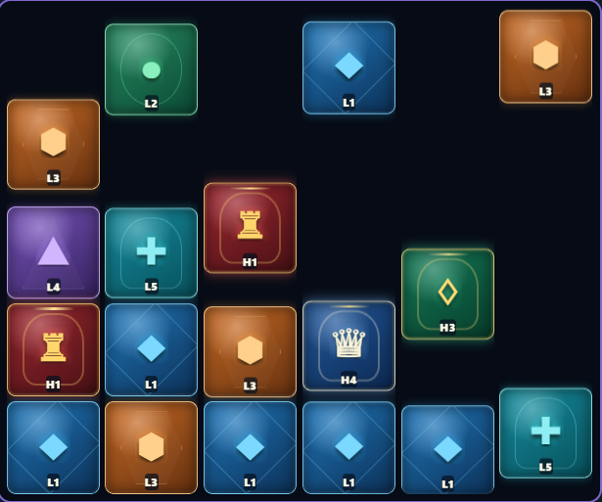
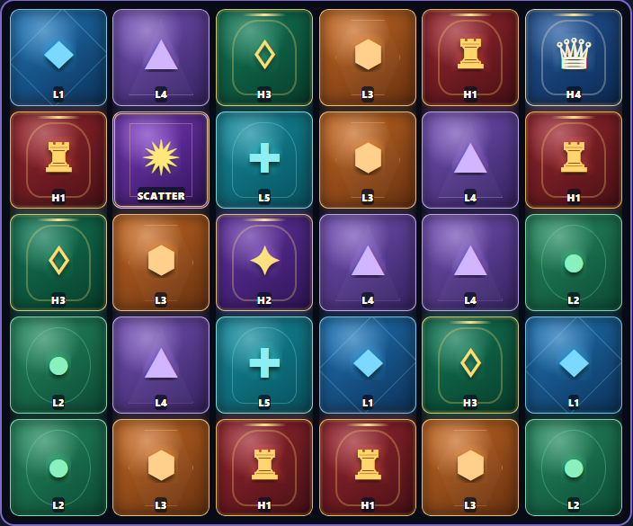
GAME BOARD (6×5 REEL) SYMBOL REFILL TUMBLE LOGIC

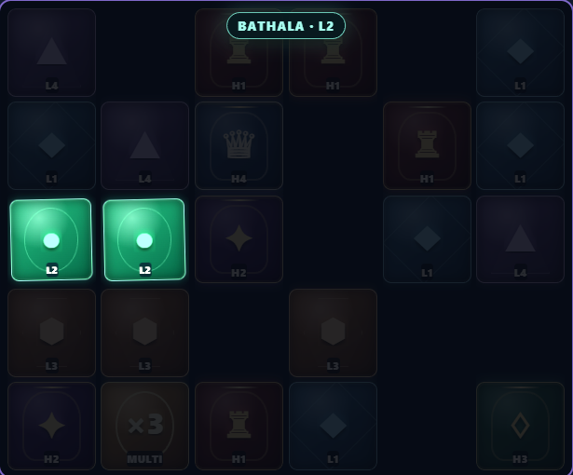
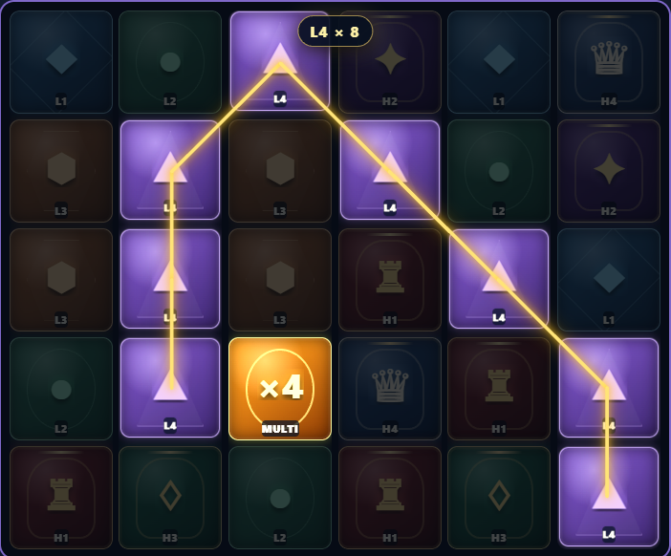
TUMBLE WIN: (L4 X 8) with x4 MULTIPLIER POST-WIN ELIMINATION TRIGGER: (L2 X 2)

- The simulation prototype updates session metrics in real-time whilst allowing each spin’s inputs and outputs to be inspected independently.
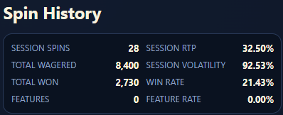
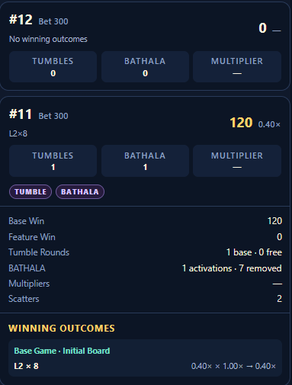
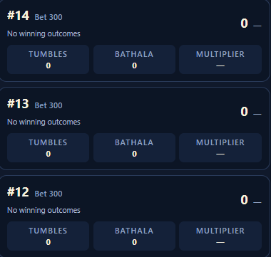
AGGREGATED DATA INDIVIDUAL SPIN DATA SPIN HISTORY

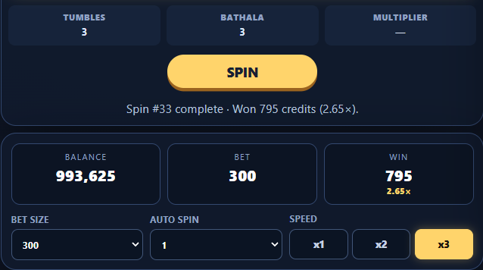

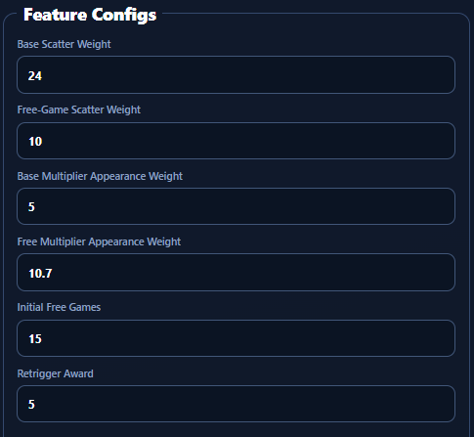
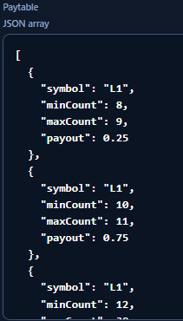
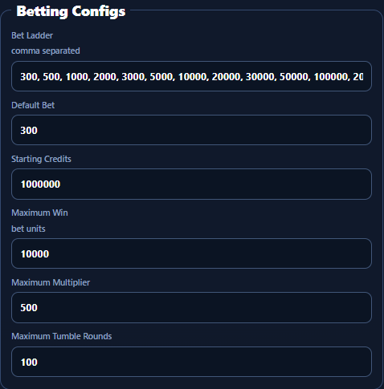
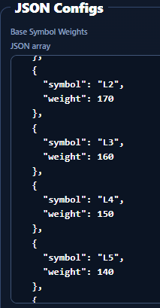
- Betting configs, feature configs, symbol weights and paytables can be modified, imported, tested and exported on a per session basis.

C. APPRAISAL
- To evaluate the game’s mathematical profile, a standalone Monte Carlo simulation script was developed to generate large volumes of synthetic spin data.
- Deterministic random seeds allow results to be reproduced and validated at-scale, thereby providing greater confidence in the observed RTP, volatility, win rate, and feature performance.
- npm run math:simulate -- --spins 1000000 --seed 2026

- scripts/simulate.ts
├─ Read --spins
├─ Read --seed
├─ Load math config
├─ Validate config
└─ Create deterministic RNG

- SyntheticAccumulator
├─ Credited RTP
├─ Win Frequency
├─ Feature Frequency
├─ Tumble Statistics
├─ Elimination Statistics
├─ Scatter Statistics
├─ Multiplier Statistics
├─ Volatility Profile
├─ Payout Distribution
└─ RTP Components
- runSimulation(...)
└─ resolveSpin(...) × 1,000,000
├─ Generate 6×5 Reel
├─ Evaluate for Regular Wins
├─ Resolve Multiplier (compound)
├─ Remove Winning Symbols
├─ Apply Elimination
├─ Collapse / Refill Symbols
├─ Repeat Tumbles
├─ Resolve Scatter
└─ Resolve Free Games

Output JSON file

- In order for the simulation data to be successfully evaluated, a math dashboard with a file ingestion pipeline was created to process the aggregated Spin data (JSON or CSV) into performance metrics.

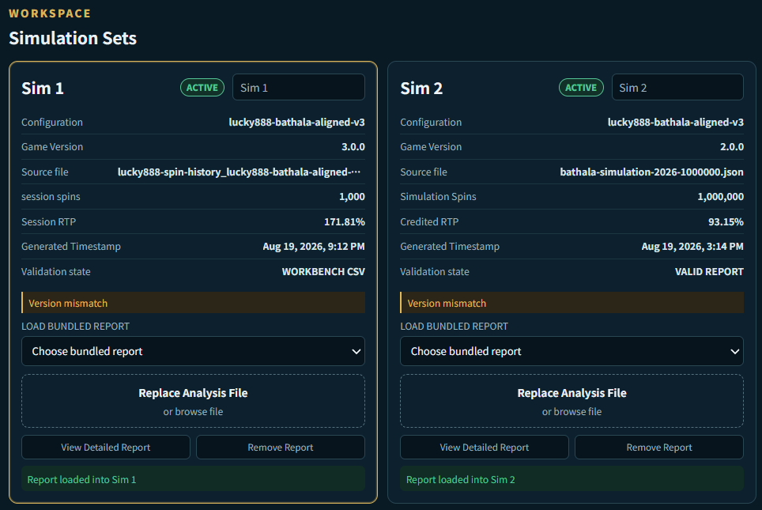
FILE INGESTION WORKSPACE

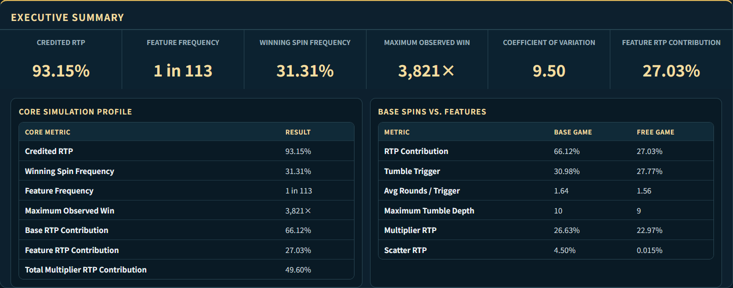
DASHBOARD SUMMARY

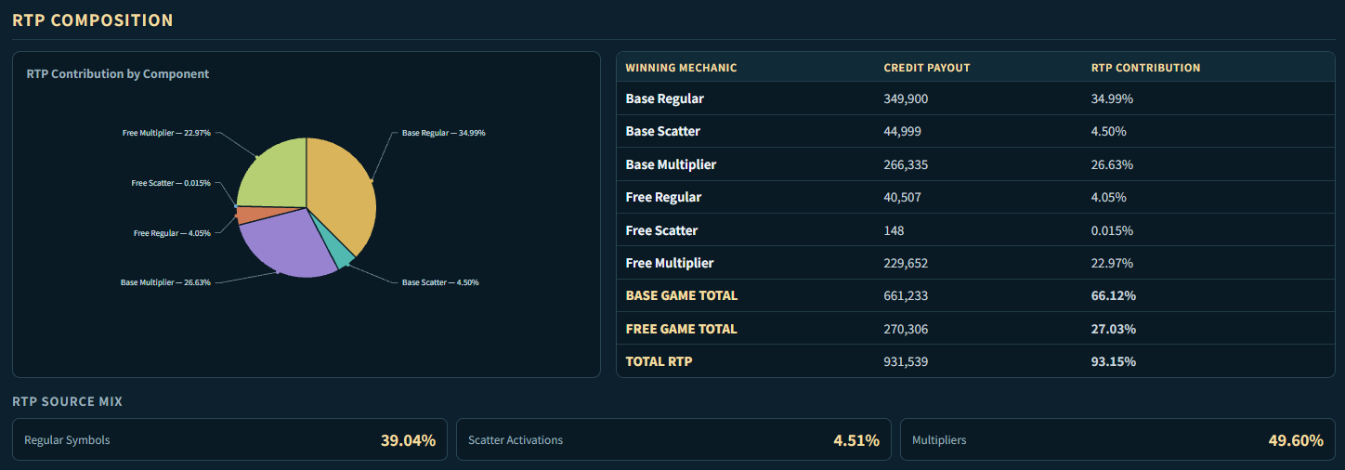
RTP COMPOSITION

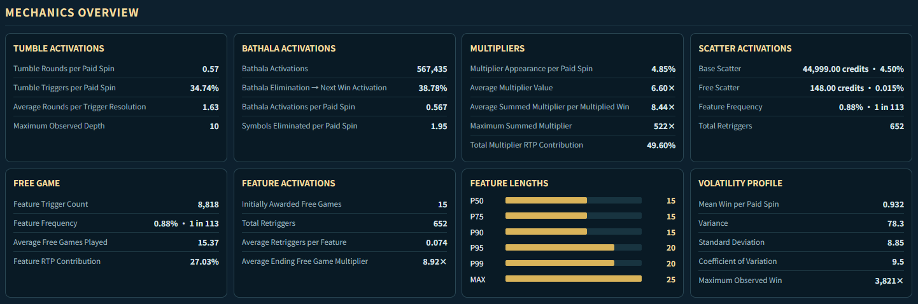
MECHANICS OVERVIEW



2. SUMMARY OF OBSERVATIONS
HEADLINE FINDINGS
93.15%  Credited RTP | 31.31%  Winning Spin Frequency (≈1 winning outcome per 3.2 paid spins)
0.882%  Feature Frequency (≈1 per 113 paid spins) | 53.24%  Multiplier Payout as share of Credited RTP
3,821×  Maximum Observed Win | 91.42 - 94.89%  ~3.47% RTP Confidence Width

A. CORE OBSERVATIONS
- Credited RTP: 93.15%
  - The default configuration produced an overall RTP of 93.15%, which means the game operates within a commercially plausible range. However, how that return is distributed between ordinary wins, multipliers, Scatters, and Free Games matter more for user engagement and monetization.
- Winning Spin Frequency: 31.31% (≈1 in 3.2 paid spins)
  - The default configuration provides relatively frequent positive feedback despite the game’s high-volatility profile. The result suggests that volatility is being generated less through low hit frequency, and more through substantial variation in the size of winning outcomes.
- Feature Frequency: 0.88% (≈1 in 113 paid spins)
  - Free Games contribute approximately 29% of the game’s total RTP. So, while the majority of RTP still comes from the Base Game, the feature is large enough to influence the player's overall risk-and-reward experience.
- Multiplier RTP Contribution: 49.60% (or 53.24% of Credited RTP)
  - Multipliers are the single largest source of returned value in the current configuration.
  - This makes the game a multiplier-led experience where relatively small changes to multiplier frequency and payout weighting can substantially alter RTP and volatility.

B. MULTIPLIER FREQUENCY & RTP
- Free Game Multiplier RTP: 22.97% (out of 27.03% Feature RTP)
  - Approximately 85% of Free Game RTP is generated by multiplier uplift. This indicates that Free Game is fundamentally an accumulation and multiplier-led feature, rather than a feature driven by additional spins and regular wins.
- Base Game Multiplier RTP: 26.63% (out of 66.12% Base Game RTP)
  - Multipliers are not only important during Free Games. They account for roughly 40.2% of Base Game return as well. This means multiplier behaviour affects the entire game economy rather than functioning solely as a bonus-feature enhancement.
- Multiplier Frequency: 4.85% (≈1 in 20.6 paid spins)
  - Multipliers appear relatively infrequently yet generate half of total RTP, demonstrating how leveraged the mechanic is. Basically, whenever multipliers interact with winning combinations and tumbles, they produce a disproportionately large payout effect.
- Mean Multiplier vs. Summed Multiplier vs. Maximum Observed : 6.60x vs. 8.44x vs. 522x
  - At 6.60x, most multiplier interactions seem to occur at relatively modest values.
  - However, the large gap between the average and maximum observed summed multiplier is characteristic of a design where multiplier events provide constant engagement while rare combinations create headline win potential.

C. SYMBOL ELIMINATION (BATHALA SKILL)
- Elimination Conversion Rate: 38.78%
  - Approximately 4 in 10 symbol eliminations result in the refilled board immediately producing a winning combination.
  - This observation confirms that the elimination effect is not merely a visual event but is in fact a continuation mechanic by virtue of regularly extending winning sequences.
- Elimination Activations: 56.74% (≈1.95 symbols eliminated per paid spin)
  - The elimination effect changes the reel composition frequently, allowing for more variance.
  - Even when elimination does not immediately create another win, the mechanic boosts the number of refills and winning frequency, making it a core mechanic rather than a bonus event.

D. TUMBLE MECHANIC
- Tumble Frequency & Average Depth: 34.74% & 1.63 rounds
  - While roughly 1/3 of paid spins produce a tumble, the average tumble sequence remains relatively short. These sequences serve to provide continuation without long cascades dominating gameplay.
  - Regardless, the maximum observed tumble depth of 10 indicates that players do occasionally encounter extended sequences.
- Base Game Tumble vs. Free Game Tumble: 30.98% vs. 27.77%
  - Free Games do not appear to derive more RTP from either deeper or more frequent tumbles.
  - Instead, the feature's additional RTP is primarily generated through the accumulating multiplier mechanic. This is useful because it clearly separates the role of the two mechanics: tumbles provide cadence, while multipliers provide feature and payout escalation.

E. VOLATILITY & PAYOUT
- Payout Tail: 10× 1 in 68 paid spins (or 1 in 21 winning spins)
  - 95% of winning spins remain below 10×, while ≥100× outcomes represent only about 0.34% of winning spins.
  - Moreover, only 34 out of 1 million paid spins triggered ≥500× outcomes.
  - This means that ordinary wins serve to maintain session activity and user engagement, while the most memorable wins remain genuinely coveted.
- Mean Win per Paid Spin vs. SD vs. CoV: 0.932 vs. 8.85 vs. 9.5
  - The contrast between the mean win and a standard of deviation of 8.85 suggests that individual outcomes vary widely around the average.
  - Since SD is approximately 9.5 times the mean RTP, a large proportion of RTP is concentrated on a handful of very high value wins rather than being distributed evenly. Therefore, this volatility profile is considered high.

3. EVALUATION & RTP TUNING
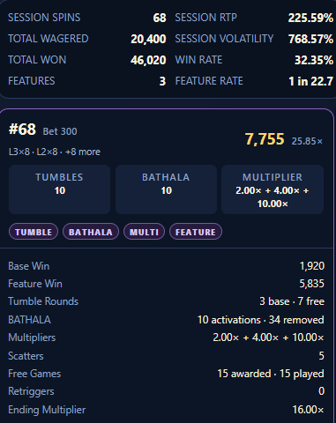
A. VOLATILITY PROFILE ANALYSIS
The current default setup in the simulation twin is a multiplier-led profile. In this setup, whilst some players will get to see more extravagant wins, the typical player will often only see outcomes around the average. This is further confirmed by a CoV of 9.5.
- From a qualitative experience standpoint, the 2 screenshots on the right show Spins #68 and #55 accumulate several multipliers, spiking session RTP to 225% and volatility to a staggering 7.69.
- One reason why the multipliers were able to accumulate so quickly was because of 3 feature activations within 68 spins. Typically, this would be a very rare occurrence because the default config triggers 1 feature approximately every 120 paid spins.
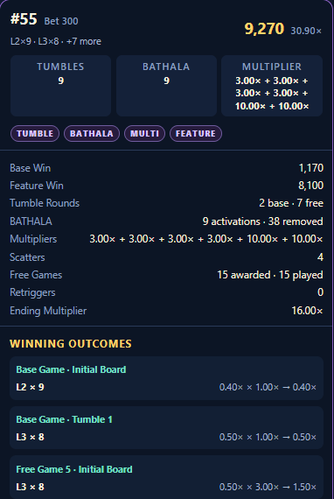
Upon closer analysis of the exported CSV, over 80% of the session's total returns came from just 4 specific spins:
- Spin #40 (Free Game Trigger 1): 21.60x total win
- Spin #44 (Base Game Outlier): 46.60x total win
- Spin #55 (Free Game Trigger 2): 30.90x total win
- Spin #68 (Free Game Trigger 3): 25.85x total win

For a Slot machine and RMG operator, such variance is unsustainable.
- One way to resolve the volatility spikes is to replace the existing multiplier-led math profile with a tumble-led math profile, where engagement and RTP are primarily derived from symbol eliminations, longer tumble sequences, and medium-sized wins.
- The main KPI target is to reduce CoV to between ~4.5 and 6.

PROFILE COMPARISON BY CHARACTERISTICS
Characteristic | Existing Profile (Multiplier-led) | Proposed Profile (Tumble-led)
Multipliers | Primary accelerator & Core mechanic | Occasional/Tertiary mechanic
Coefficient of Variation (CoV) | Current: ~7.5 to 9.5 | Target: ~4.5 to 6
Small Wins | Frequent but relatively weak | More frequent with slightly larger wins
Medium Wins | Less frequent and relatively weak | Core winning mechanic
Extreme Wins | Key RTP contributor | Much rarer with lower caps
Free Games | Enhanced by Multiplier mechanic | Enhanced by premium Symbols
Engagement Design | Powerful Multiplier spikes | Frequent clusters and tumbles
Player Experience | “Nothing… nothing… BOOM” | Win Tumble Medium payouts

- To achieve this proposed profile, there are 4 key areas that must be tuned:
Tuning Area | Proposed Changes
Multiplier Weights | Move concentration from High Multipliers to Low Multipliers
Base Game Symbol Weights | Move concentration towards Low-Symbol distribution
Free Game Symbol Weights | Concentrate weightage towards premium Symbols (High-Symbols)
Cluster Paytable Payout Adjustments | Dampen the payout cliffs observed in High-Symbols, while raising the overall payouts for Low-Symbols
B. MULTIPLIER TUNING
DEFAULT MULTIPLIER STATISTICS
6.57×  Mean Multiplier | 11.13×  Multiplier Standard Deviation
4.46%  ≥20× Frequency (≈1 per 22.4 paid spins) | 0.80%  ≥50× Frequency (≈1 per 125 paid spins)
0.26%  ≥100× Frequency (≈1 per 384 paid spins) | 0.073%  ≥250× Frequency (≈1 per 1370 paid spins)

Firstly, the multiplier distribution is very dispersed and requires radical tuning. A mean multiplier of 4.5× should be the hard cap, while multiplier SD should be below 3×. This change requires dampening the existing lottery mechanic and turning it into a progression amplifier. The two tables below illustrate the scale and impact of the new configuration.
MULTIPLIER WEIGHTS MULTIPLIER STATISTICS
Multiplier | Default Config | New Weights |  | Statistic | Default Config | Targets
2× | 1000  (18.27%) | 1500  (23.09%) |  | Mean Multiplier | 6.57× | 4.43×
3× | 900  (16.44%) | 1350  (20.79%) |  | Multiplier SD | 11.13× | 2.75×
4× | 800  (14.61%) | 1200  (18.48%) |  | ≥10× Frequency | 18.70% | 6.08%
5× | 700  (12.79%) | 950  (14.63%) |  | ≥20× Frequency | 4.46% | 0.46%
6× | 600  (10.96%) | 700  (10.78%) |  | ≥50× Frequency | 0.80% | 0.03%
8× | 450  (8.22%) | 400  (6.16%) |  | ≥100× Frequency | 0.26% | 0.00%
10× | 350  (6.39%) | 220  (3.39%)
12× | 250  (4.57%) | 100  (1.54%)
15× | 180  (3.29%) | 45  (0.69%)
20× | 120  (2.19%) | 20  (0.31%)
25× | 80  (1.46%) | 8  (0.12%)
50× | 30  (0.55%) | 2  (0.03%)
100× | 10  (0.18%) | 0  (0.00%)
250× | 3  (0.055%) | 0  (0.00%)
500× | 1  (0.018%) | 0  (0.00%)

While 100×, 250× and 500× have been made redundant, lower volatility does not mean more boring gameplay. The changes to the multiplier curve simply replaced volatility with event frequency.
- So, while ≥10× multipliers have decreased very significantly, multipliers between 2× and 6× have increased by a noticeable margin themselves.
- So statistically speaking, even though the major payouts have become even more rare, players will experience the lower multiplier events more frequently than ever before.

C. PAYTABLE TUNING
The default volatility profile has a fairly linear frequency curve for the 9 regular Symbols. However, this game is special in the sense that the regular Symbols are split into 2 distinct groups: 5 Low Symbols, and 4 High Symbols. This grouping matters because of the Bathala Symbol Elimination Skill, where a randomly selected Low Symbol is eliminated after a regular Symbol Win. High Symbols are not able to benefit from this elimination.
- Due of this exclusion, Low Symbols actually add more to engagement than High Symbols, simply because Eliminations from Low Symbols can trigger recursive wins.
- Therefore, one way to noticeably reduce volatility while maintaining engagement is to shift both symbol frequency weightage and payouts from High Symbols (H1H4) to Low Symbols (L1L5).

NEW PAYTABLE PAYOUTS
Base & Free  Symbol | minCount | maxCount | Current Payout | New  Payout
L1  (Low-1) | 8 | 9 | 0.25× | (+60%) 0.4×
 | 10 | 11 | 0.75× | (+7%) 0.8×
 | 12 | 30 | 2× | (-25%) 1.5×
L2  (Low-2) | 8 | 9 | 0.4× | (+25%) 0.5×
 | 10 | 11 | 0.9× | (+11%) 1×
 | 12 | 30 | 4× | (-50%) 2×
L3  (Low-3) | 8 | 9 | 0.5× | (+20%) 0.6×
 | 10 | 11 | 1× | (+20%) 1.2×
 | 12 | 30 | 5× | (-50%) 2.5×
L4  (Low-4) | 8 | 9 | 0.8× | (-6.25%) 0.75×
 | 10 | 11 | 1.2× | (+25%) 1.5×
 | 12 | 30 | 8× | (-59%) 3.25×
L5  (Low-5) | 8 | 9 | 1× | (-10%) 0.9×
 | 10 | 11 | 1.5× | (+20%) 1.8×
 | 12 | 30 | 10× | (-60%) 4×
H1  (High-1) | 8 | 9 | 1.5× | (-60%) 1.25×
 | 10 | 11 | 2× | (+25%) 2.5×
 | 12 | 30 | 12× | (-58%) 5×
H2  (High-2) | 8 | 9 | 2× | (-25%) 1.5×
 | 10 | 11 | 5× | (-40%) 3×
 | 12 | 30 | 15× | (-53%) 7×
H3  (High-3) | 8 | 9 | 2.5× | (-20%) 2×
 | 10 | 11 | 10× | (-55%) 4.5×
 | 12 | 30 | 25× | (-60%) 10×
H4  (High-4) | 8 | 9 | 10× | (-70%) 3×
 | 10 | 11 | 25× | (-72%) 7×
 | 12 | 30 | 50× | (-68%) 16×

- As a key point of note, the default H3 has a huge payout cliff. At (H3 x 8), the payout is 2.5× which then scales rapidly to 10× at (H3 x 10), and then 25× at (H3 x 12). For a basic mechanic, such exponential payouts are unnecessary. Therefore, my suggested paytable has reduced these to 2.5×, 4.5× and 10× respectively.
- Similarly, the default L5 went from a payout of only 1.5× at (L5 x 10) to 10× at (L5 x 12). I have suggested reducing (L5 x 12) from 10× to just 4×.
- In fact, I have compressed most of the payout cliffs from L3, L4, L5, H1, H2, H3, H4 which will help us to free up payout allocations to L1 and L2. So for example, the suggested payout at (L1 x 8) should increase by 60%. Performing these adjustments will materially reduce standard deviation.

D. SYMBOL WEIGHTAGES
In conjunction with higher payouts for Low Symbols, we can also improve their weight frequency. This will noticeably improve player experience because players will be able to see more 8-9 Symbol Wins, which could then lead to more Tumbles, more Symbol Eliminations, more Symbol Refills, and recursive wins thereafter.

In fact, the frequency weights for Base Game Symbols and Free Game Symbols should be modified independently from one another as they impact RTP differently.

NEW BASE GAME SYMBOL WEIGHTS NEW FREE GAME SYMBOL WEIGHTS
BASE GAME  SYMBOL | DEFAULT  CONFIG | NEW  WEIGHTS |  | FREE GAME  SYMBOL | DEFAULT  CONFIG | NEW  WEIGHTS
L1 | 180  (16.38%) | (+30) 210  (19.34%) |  | L1 | 170  (16.03%) | (+10) 180  (16.30%)
L2 | 170  (15.47%) | (+25) 195  (17.78%) |  | L2 | 160  (15.08%) | (+5) 165  (14.95%)
L3 | 160  (14.56%) | (+10) 170  (15.50%) |  | L3 | 150  (14.14%) | (-5) 145  (13.13%)
L4 | 150  (13.65%) | (-5) 145  (13.22%) |  | L4 | 140  (13.20%) | (-20) 120  (10.87%)
L5 | 140  (12.74%) | (-20) 120  (10.94%) |  | L5 | 130  (12.26%) | (-30) 100  (9.06%)
H1 | 90  (8.19%) | (-10) 80  (7.29%) |  | H1 | 95  (8.96%) | (+55) 150  (13.59%)
H2 | 75  (6.82%) | (-10) 65  (5.93%) |  | H2 | 80  (7.54%) | (+40) 120  (10.87%)
H3 | 60  (5.46%) | (-10) 50  (4.56%) |  | H3 | 65  (6.13%) | (+5) 70  (6.34%)
H4 | 45  (4.09%) | (-10) 35  (3.19%) |  | H4 | 50  (4.71%) | (-10) 40  (3.62%)
SCATTER | 24  (2.18%) | 24  (2.19%) |  | SCATTER | 10  (0.94%) | 10  (0.91%)
MULTIPLIER | 5  (0.45%) | (-2) 3  (0.27%) |  | MULTIPLIER | 10.7  (1.01%) | (-6.7) 4  (0.36%)

For Base Game Symbols, I have intentionally shifted weightage from L4, L5, H1, H2, H3 and H4 in favor of L1, L2 and L3. Doing so increases the probability of triggering at least one ≥8 regular Symbol cluster from ~32% to ~49% using this distribution method.
  - At the same time, I have reduced the frequency of multipliers by about 40% (from 0.45% to 0.27%).
  - So as a result, instead of waiting for a multiplier event for engagement, the player will now expect:
≥8 REGULAR SYMBOL BATHALA ELIMINATION REFILL ≥8 REGULAR SYMBOL REACTIVATION

On the other hand, I would recommend making Free Game Symbol weightage premium-leaning. So for example, increase H1 from 9.0% to 13.6%, while increasing H2 from 7.5% to 10.9%.
    - This might create an interesting psychological effect where Free Games become perceived as a premium variant due to the frequency of High-Symbols.

E. FINAL EVALUATION
Core Metric | Sim1 (Multiplier-led) | Sim2 (Tumble-led) | Delta
Win Cadence | 31.3% | 45.6% | +14.3%
Tumbles | 34.7% | 49.1% | +14.4%
Multiplier RTP | 49.6% | 24.4% | -25.2%
Volatility (CoV) | 9.50 | 3.68 | -61.2%
Max Observed Win | 3,820× | 616× | -83.9%

    - Sim2 (Tumble-led) delivers a much more active core loop. Win Cadence rose from 31.3% to 45.6% and Tumbles increased from 34.7% to 49.1%, meaning players encountered continuation mechanics far more frequently.
    - Sim2 (Tumble-led) is significantly less multiplier-dependent. Multiplier RTP fell from 49.6% to 24.4%, so Sim2 shifts more of its payout value towards regular and tumble-driven outcomes instead of multiplier spikes.
    - Sim2 (Tumble-led)’s volatility is dramatically compressed. CoV fell from 9.50 to 3.68, with Maximum Observed Win falling from 3,820× to 616×. This indicates a much narrower payout distribution, with fewer extreme tail outcomes and a more consistent player experience.

Metrics | Sim1 (Multiplier-led) | Sim2 (Tumble-led) | Delta
Simulation Overview
Simulation Spins | 1,000,000 | 1,000,000 | N/A
Credited RTP | 93.15% | 94.00% | +0.85%
95% RTP Confidence | 91.4% to 94.9% | 93.3% to 94.7% | N/A
Winning Spin Frequency | 31.31% | 45.59% | +14.3%
Feature Frequency | 1 in 113 | 1 in 111 | +1.9%
Tumbles & Bathala Elimination Skill
Tumble Frequency | 34.74% | 49.12% | +14.4%
Tumble Depth (per spin) | 0.567 | 0.91 | +60.3%
Tumble Depth (per trigger) | 1.633 | 1.852 | +13.4%
Symbol Elimination → Win | 38.78% | 46.01% | +7.2%
RTP Composition
Base RTP Contribution | 66.12% | 82.53% | +16.4%
Feature RTP Contribution | 27.03% | 11.47% | -15.6%
Base Regular RTP | 34.99% | 59.60% | +24.6%
Base Multiplier RTP | 26.63% | 18.07% | -8.6%
Free Game Regular RTP | 4.05% | 5.12% | +1.1%
Free Game Multiplier RTP | 22.97% | 6.33% | -16.6%
Total Multiplier RTP | 49.60% | 24.40% | -25.2%
Volatility & Payout Tail
Coefficient of Variation | 9.50 | 3.68 | -61.2%
Standard Deviation | 8.85 | 3.46 | -60.9%
Average Win / Winning Spin | 2.98× | 2.06× | -30.7%
Average Multiplier Value | 6.60× | 4.42× | -33.1%
Max Summed Multiplier | 522× | 55× | -89.5%
Maximum Observed Win | 3,820× | 616× | -83.9%
≥100× Occurrence | 1 in 1,080 | 1 in 3,509 | -69.2%
≥250× Occurrence | 1 in 8,333 | 1 in 250,000 | -96.7%
≥500× Occurrence | 1 in 41,667 | 1 in 1,000,000 | -95.8%
≥1,000× Occurrence | 1 in 125,000 | Nil | N/A

