Installing Xubuntu for Guest usage

1) Boot from USB Key then click « Try Xubuntu ».
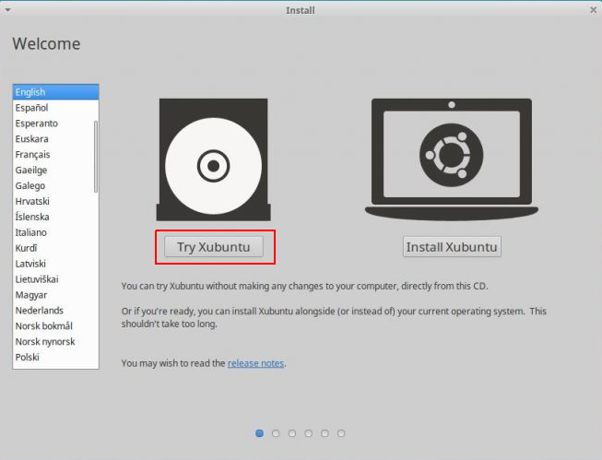

2) When on Desktop, connect to the internet.
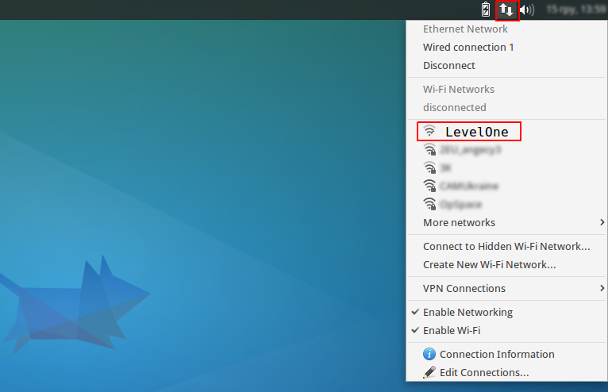
3) After being connected to the internet double click « Install Xubuntu 16.04 LTS ».
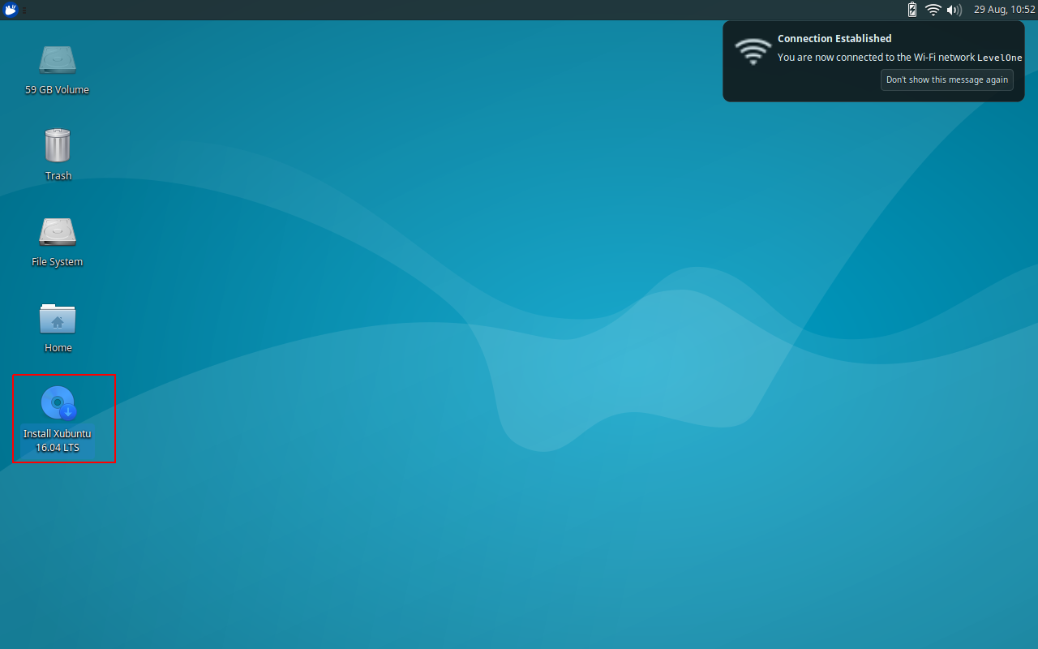
4) Select your language and click « Continue ».
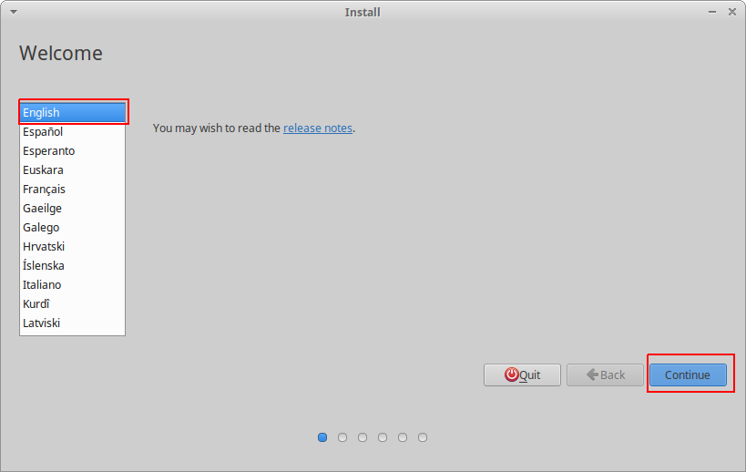
5) Do not select anything (it will be done after reboot) and click « Continue ».
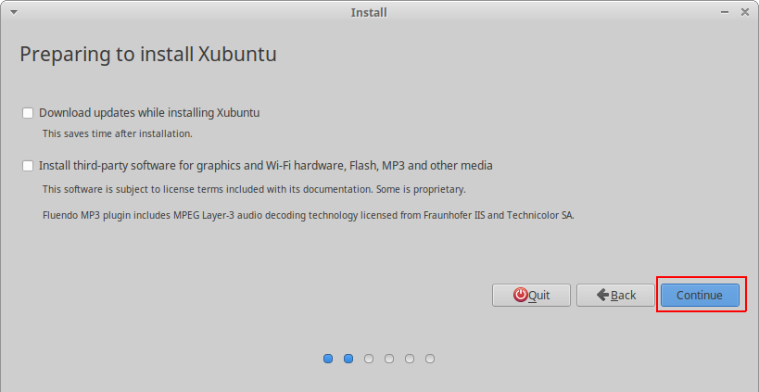
6) Select « Erase disk and install Xubuntu » and click « Install now ».
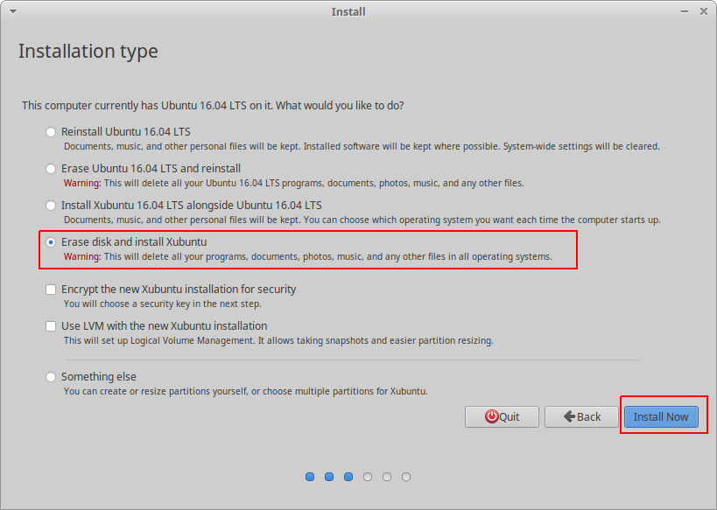
7) Click « Continue ».
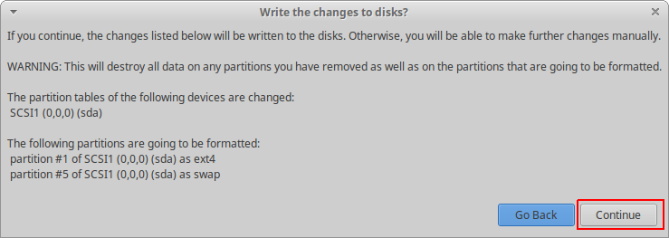
8) Select where you are and click « Continue ».
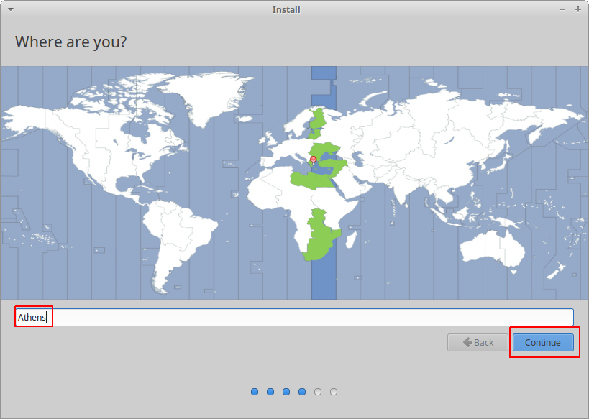

9) Select your kind of keyboard and click « Continue ».
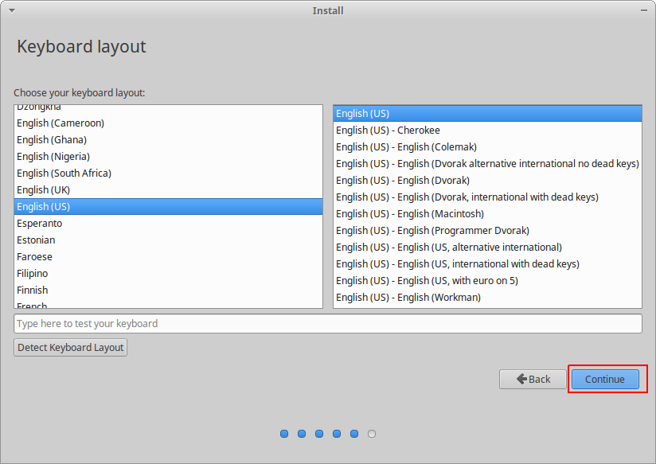
10) Connection details (N.B. Linux is case sensitive) ...

- Do not fill your name.

- Fill in your computer's name.

- Pick a Username in lowercase (e.g. « melidoni »).

- Choose and confirm a password (upper, lower, special characters, whatever … but remember it !).

- Select « Require my password to log in ».

- Click « Continue ».

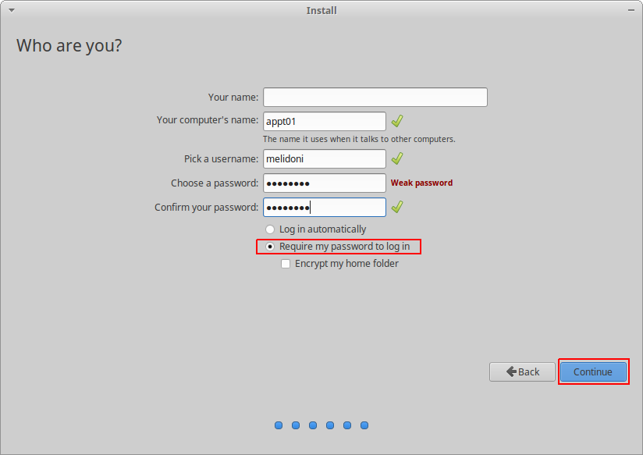

11) Take a cofee.
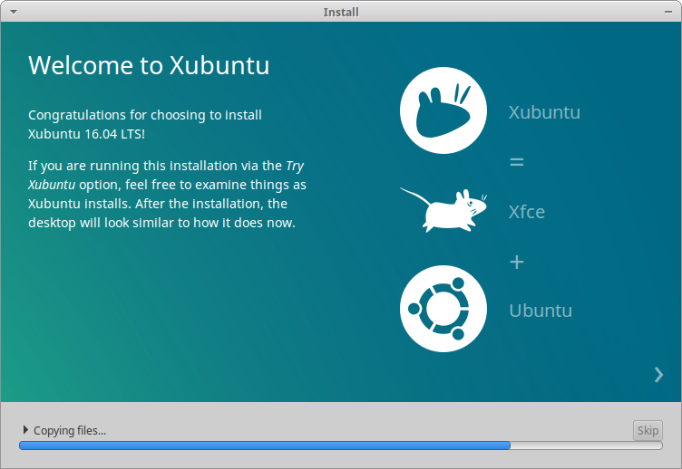
12) Reboot.
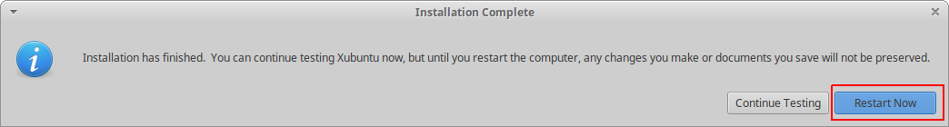

Post installation

Post installation can be done at any time.

1) Login to the system with user credentials that were created during Xubuntu installation.
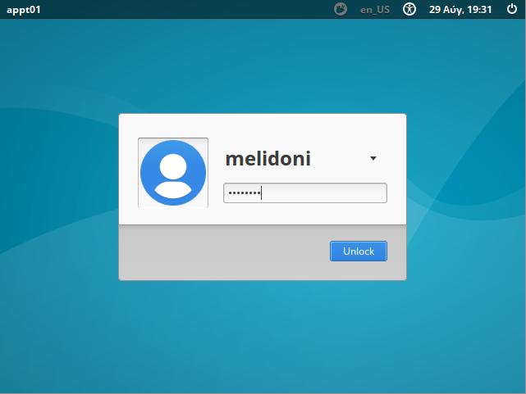

2) Open a Web Browser.
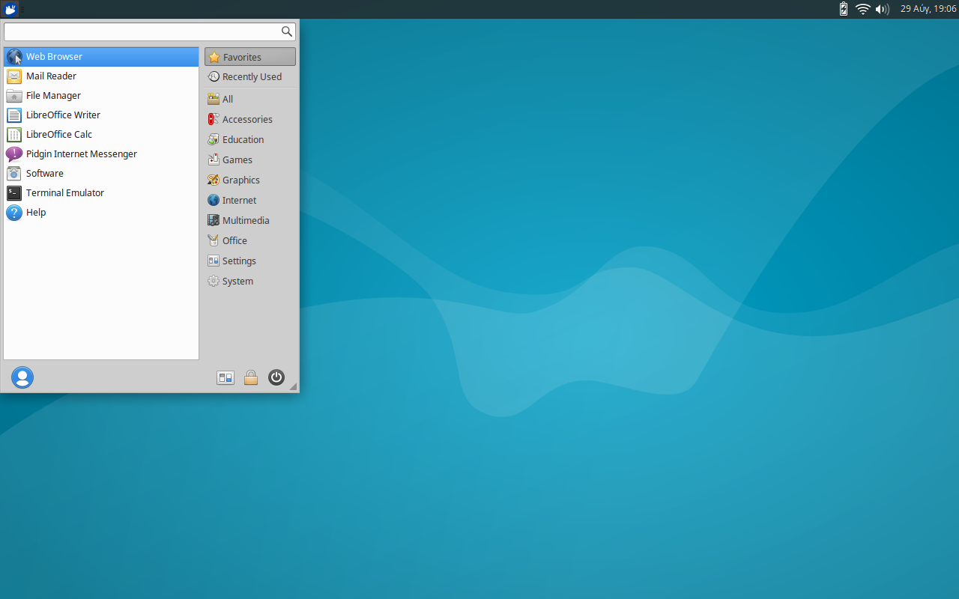
3) Go to https://github.com/ludojmj and click on the link « xubuntu-postinstall ».
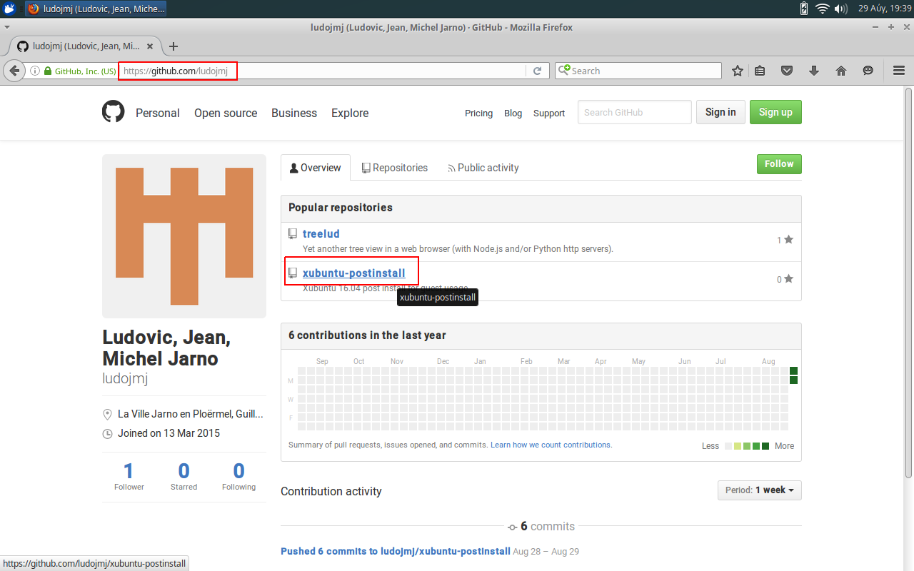
4) Click « Clone or download » and select « Download ZIP ».
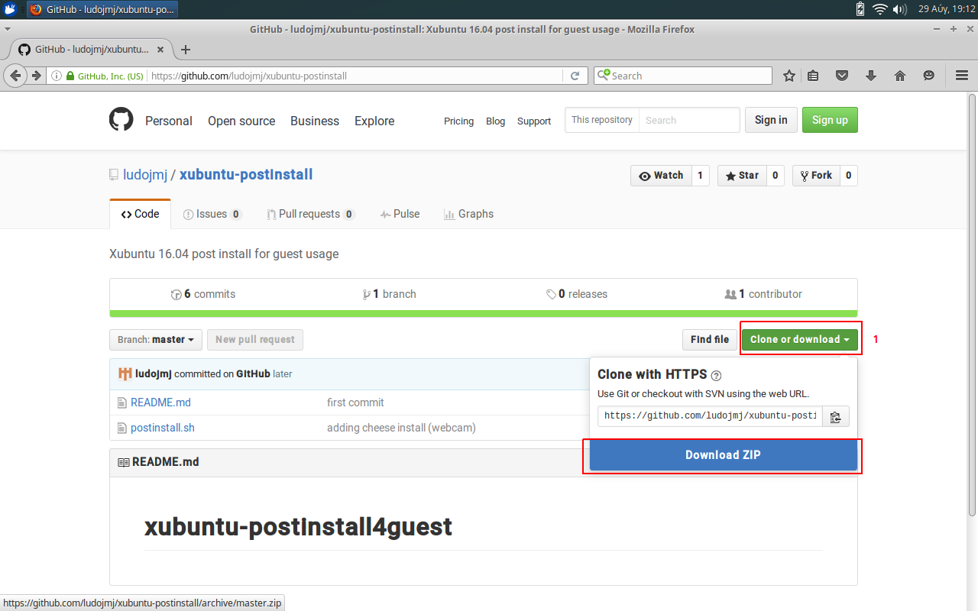
5) Once downloaded, just press «ENTER » or click « OK ».
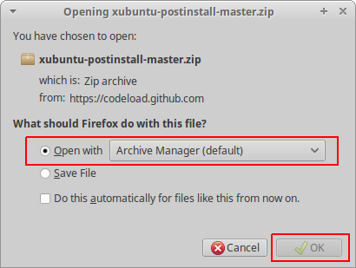
6) Double click on the root folder to open it.
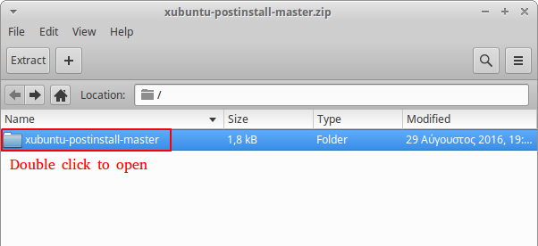

7) Right click to only extract the file « postinstall.sh ».
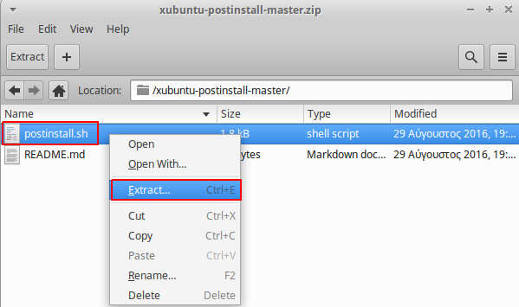
8) Just press «ENTER » or click « Extract ».
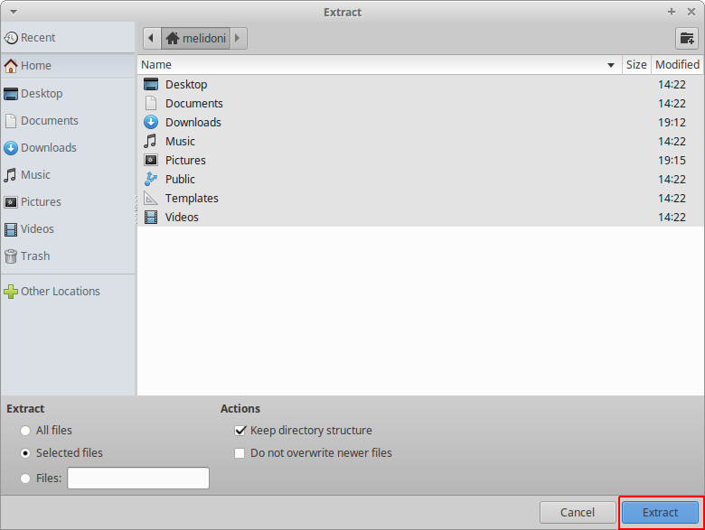
9) Click « Quit » to exist the archive manager.
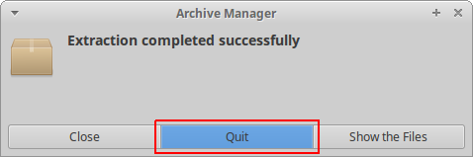
10) Open a Terminal Emulator.
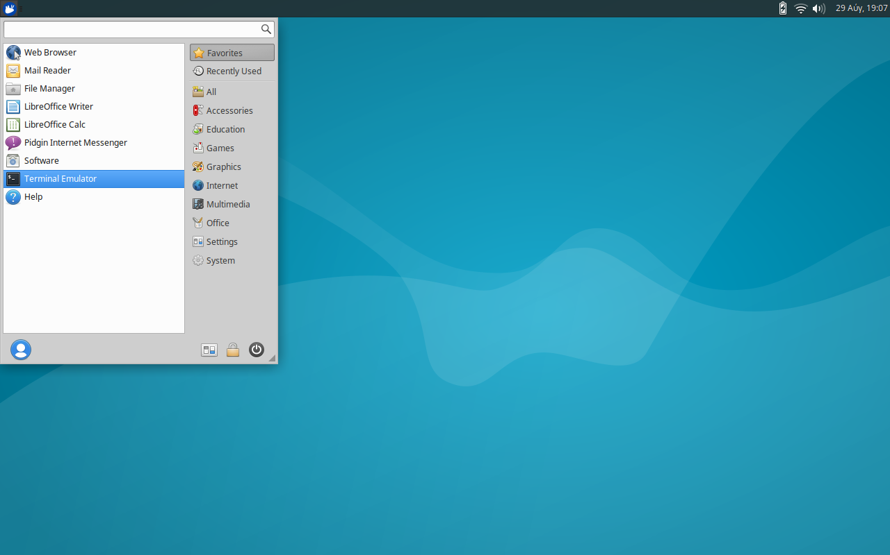
11) Enter « bash postinstall.sh » and fill in your password followed by « ENTER » when asked.
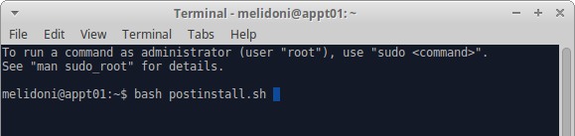
The Password is never shown and the cursor never moves.

12) The End.

In case of mistake, the script can be interrupted (Ctrl+C) and lauched many times.

N.B.1. In the terminal all the commands typed once can be recalled many times with UP and DOWN arrow keys.

N.B.2. The « copy-paste » shortcuts inside the terminal (and terminal only) are « Shift+Ctrl+C » and « Shift+Ctrl+V » instead of usual « Ctrl+C » and « Ctrl+V ».

