Most of the coding references are mentioned in the relevant code document, php docs, html docs and the stylesheet dock. These references have been commented out and almost always put next to the code it references.



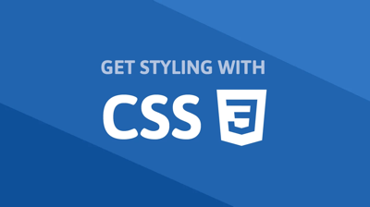

General

<https://www.w3schools.com/> - Useful tutorials used for this project in general, providing html and css information, but also subjects I didn’t feel too confident about going into this project. More on PHP and SQL below.



PHP

<https://www.w3schools.com/php/default.asp> A PHP Tutorial Including how to install and run it, PHP Syntax, PHP Data Types and strings.

The full Tutorial includes: Home, Intro, Install, Syntax, Comments, Variables, Echo/Print, Data Types, Strings, Numbers, Math, Constants, Operators, if…Else…Elseif, Switch, Loops, Functions, Arrays, Superglobals and Regex.

The PHP Forms guide has also been incredibly useful. Especially Form Validation – Required and Form Handling. This guide also includes Form URL/E-mail and Form Complete.

 

MySQL

Lastly for PHP handling and how to set it up using MySQL Database: <https://www.w3schools.com/php/php_mysql_intro.asp>

This tutorial provides a guide on how to set up a database, how to connect to it, how to create tables and how to work with prepared statements and order the data. For the profile pages where we select data from tables these two statements came in extra handy.

The SELECT statement is used to select data from one or more tables:

SELECT column_name(s) FROM table_name

or we can use the * character to select ALL columns from a table:

SELECT * FROM table_name

Useful video tutorials



## Dani Krossing

<https://www.youtube.com/watch?v=XBj_le81sAc> Introduction to PHP, a beginner’s guide.

<https://www.youtube.com/watch?v=ILyf16MEvHM> A guide on how to connect to a database using PHP.

<https://www.youtube.com/watch?v=LC9GaXkdxF8&t=5s> How to create a Login System in PHP, a beginner’s guide.

<https://www.youtube.com/watch?v=HLx-zbl6siM> Error message and handling in PHP.