**Folders included and their content:**

Deliverables Project list document.

Presentation – YouTube Link.

Assets – Adobe stockphotos, Client pictures, Design pictures and Video.

Database – fitwithfriendsDatabase(Needed to set up the project) and Database creation document.

Design protypes – Clickable prototypes(Mobilefitwithfriends, Wireframes(Wireframeswebpage).

Storyboard & Brainstorm (Brainstormsession.jpg and Storyboardpromovideo.jpg)

**How to set up the project:**

This project is mainly created using .php files.

Download XAMPP and make sure Modules: Apache and MySQL are both running.

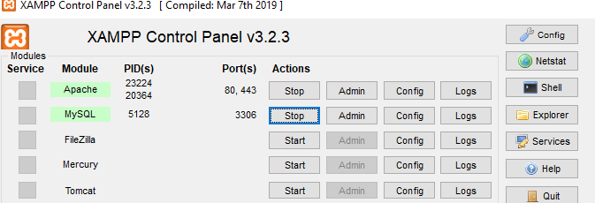

1. **Go to This PC.**



1. **Select the main driver, in this case system SSD (C:)**

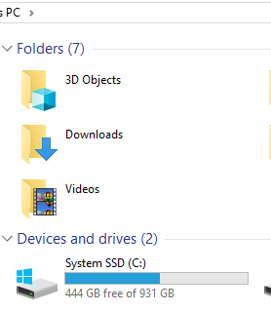

1. **Find the xampp folder.**



1. **Locate the htdocs folder.**



1. **Make sure to add fitwithfriendproject to the htdocs folder.**



1. **In the XAMPP Control Panel, make sure to click “Admin” Module-MySQL then Actions. This will open up the local host database.**

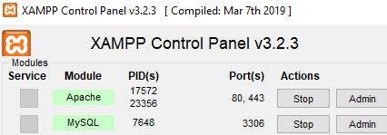

1. **Make sure to click import, to be able to import the “fitwithfriends sql file” that is included in the hand in file.**

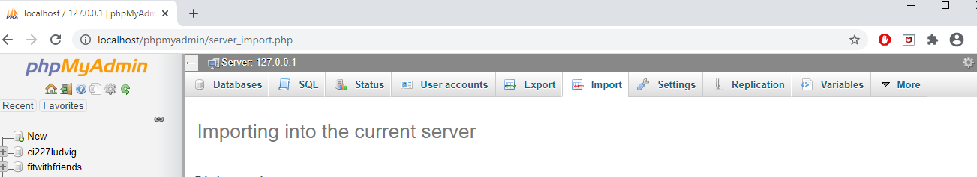

**The SQL file will look like this:**

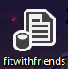

1. **Typing localhost in the url, when the database has been imported will generate this.**

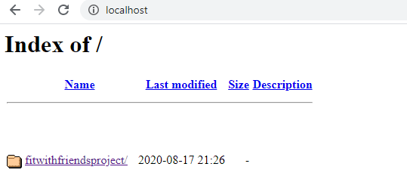

1. **Click fitwithfriendsproject to be able to access the project web page.**

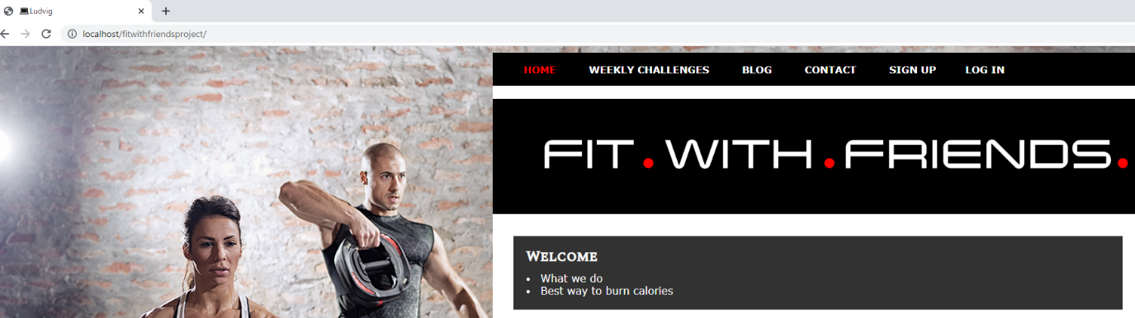

1. **Access the users LOG INS with this information.**

**Username/Email:** jonathan

**Password:** 123

**Username/Email:** ludvig

**Password:** 123

**Username/Email:** martin

**Password:** 123

