System overview
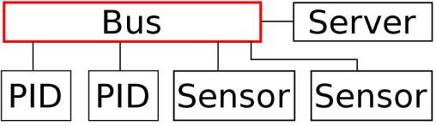

PID controller:
- Proportional–integral–derivative controller (PID controller). In this example the PID is implemented as a software(Pseudocode). Instead of using a feedback loop the outputs are generated at a specific rate. This is necessary due to fact that the PID a spatially divided from the sensors.
- One of the PID is controlling a heater that is heating the vessel depending on the average temperature of top and bottom. The other one is controlling a mixer, that is activated if there is a temperature difference of the top and bottom sensor
- Kp,Kd,Ki, setpoint and sample rate are set by the server

Sensors:
- The two sensors are collecting temperatures values from a vessel with a fluid
- One is measuring on the bottom the other one measures on the top
- The reported temperature is the average of many samples taken at different time points
- Only samples within defined thresholds are accepted for the average
Server:
- Server is collecting values from the sensors
- If there is a difference between the top and the bottom temperature the two PID are activated
- Before the system starts operating a configuration is read over an interface. The configuration also sets-up the PID controller(Kp,Ki,Kd values).
Bus(simple)
- The bus is routing the data depending on the requested address
- Only the server is allowed to start a transaction
- Each transaction starts with a request consisting of address, data, mode(read/write) and is ended by a resp(acknowledge, data)
- If the server starts a transaction the interconnect will request the corresponding slave and waits for the response of the slave and forwards it the master. The bus is blocked until the master has read the response.

Bus(complex)
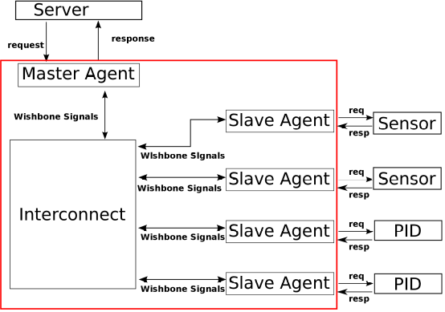
- In this implementation the Wishbone protocol is used to implement the bus transactions.
- Instead of having just an entity “bus”, that forwards the request to the slave, we have a bus system that takes care of the transactions
- A request from the Server is handled by the Master Agent. The Agents takes care of the bus protocol.
- Same applies for the Slave Agents, they act as a Wishbone Slave and have a regular blocking interface to the sensor/PID

