Alex Ludwig
CS350
9/13/2026
HW 1 ERD
ExoProtect 5 Requirements:
- Each computer can have multiple software packages installed on it, and each software package can be installed on multiple computers.
- An employee can be certified to use several software packages, and a software package can have several employees certified to use it.
- Each employee is assigned exactly one computer, and each computer is assigned to at most one employee.
- An employee may be responsible for maintaining multiple computers, but each computer is maintained by only one employee.
- Employees may possess multiple skills, and this list of skills must be tracked for each employee.
ExoProtect ERD:
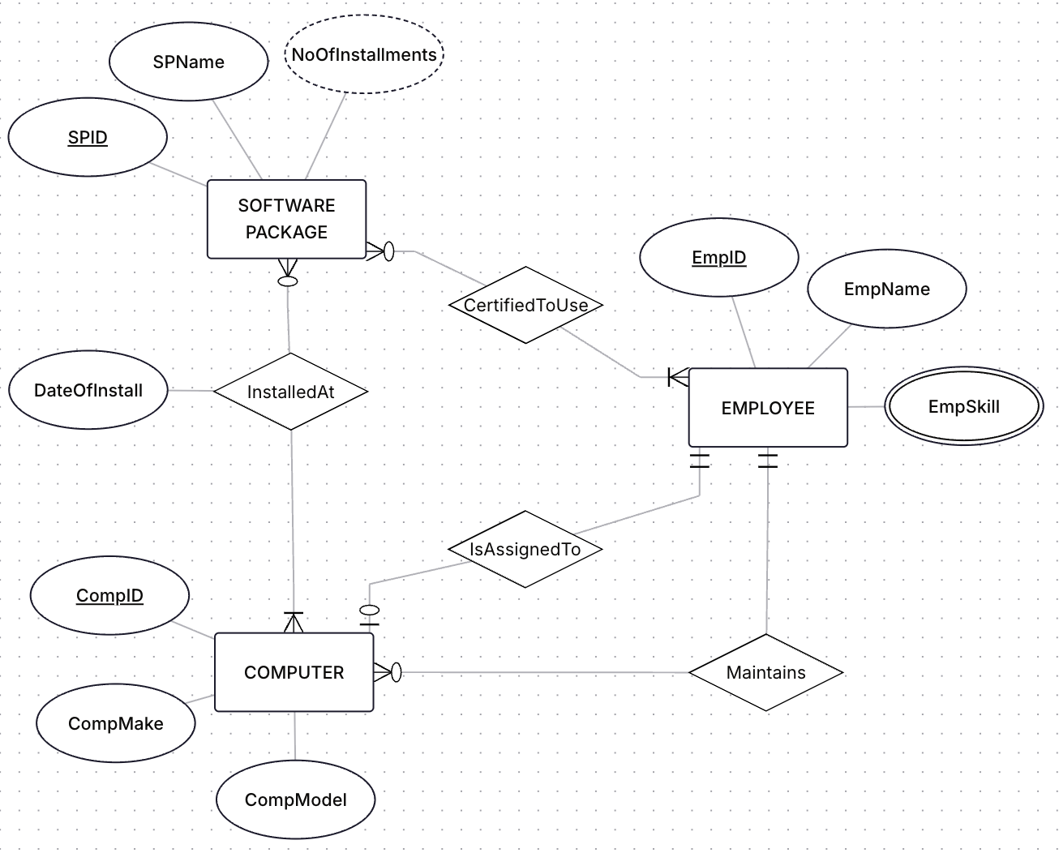
ExoProtect Relational Schema:
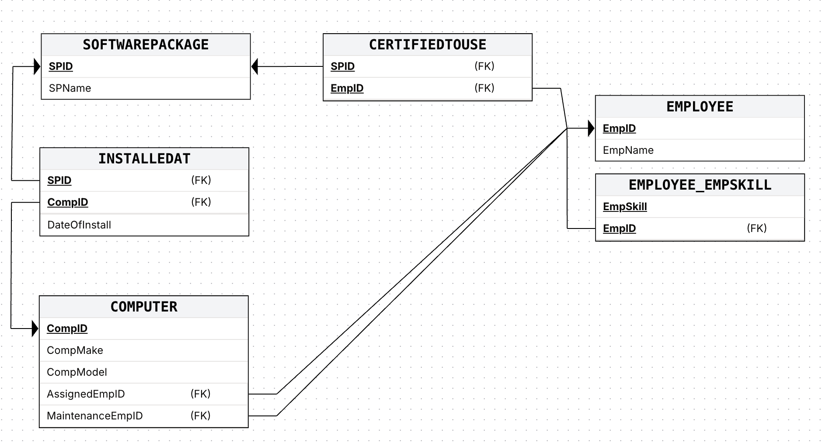
ExoProtect SQL:
CREATE TABLE SOFTWAREPACKAGE
(
SPName CHAR(20) NOT NULL,
SPID INT NOT NULL,
PRIMARY KEY (SPID)
);

CREATE TABLE EMPLOYEE
(
EmpID INT NOT NULL,
EmpName CHAR(20) NOT NULL,
PRIMARY KEY (EmpID)
);

CREATE TABLE COMPUTER
(
CompID INT NOT NULL,
CompMake CHAR(20) NOT NULL,
CompModel CHAR(20) NOT NULL,
AssignedEmpID INT NOT NULL,
MaintenanceEmpID INT NOT NULL,
PRIMARY KEY (CompID),
FOREIGN KEY (AssignedEmpID) REFERENCES EMPLOYEE(EmpID),
FOREIGN KEY (MaintenanceEmpID) REFERENCES EMPLOYEE(EmpID)
);

CREATE TABLE INSTALLEDAT
(
DateOfInstall DATE NOT NULL,
SPID INT NOT NULL,
CompID INT NOT NULL,
PRIMARY KEY (SPID, CompID),
FOREIGN KEY (SPID) REFERENCES SOFTWAREPACKAGE(SPID),
FOREIGN KEY (CompID) REFERENCES COMPUTER(CompID)
);

CREATE TABLE CERTIFIEDTOUSE
(
SPID INT NOT NULL,
EmpID INT NOT NULL,
PRIMARY KEY (SPID, EmpID),
FOREIGN KEY (SPID) REFERENCES SOFTWAREPACKAGE(SPID),
FOREIGN KEY (EmpID) REFERENCES EMPLOYEE(EmpID)
);

CREATE TABLE EMPLOYEE_EMPSKILL
(
EmpSkill INT NOT NULL,
EmpID INT NOT NULL,
PRIMARY KEY (EmpSkill, EmpID),
FOREIGN KEY (EmpID) REFERENCES EMPLOYEE(EmpID)
);

