Report

ZuoyunJin

16825

What I have accomplished :

Registering of Students for courses and their ongoing attendance for courses

Managing Student contact and personal identifying information

Tracking of Academic Progress of students (results for assignments and exams)

Tracking Payment of fees – including partial payments

Tracking of Exams, Assignments and dates and results (uploading not required)

Teacher can access details relevant to them (i.e. only their students):

Student’s Grade Book (Assignment results)

Student’s Attendance

Contact detail of students for tutors only.

Students can login and see all details relevant to them.

Displaying college

I have implemented the following :

1. Administrator Login with Super Privileges for creating courses, timetables etc.
2. Faculty Login with Privileges pertaining to their students
3. Student Login with privileges that only permits the to see details pertaining to them.
4. Manage Student Registration and Enrolment.

I also complete 6 following features:

1. Manage Exams, Assignments and Results.
2. Manage Student Attendance.
3. Manage Network – Adding more branches.
4. Manage Course Lesson Plan.
5. Manage Time Table.
6. Management of fees paid

Completion of 8 task

1. UML program
2. Entity relationship model.
3. A working version of software
4. Complete and deliver an sql file to enable project can be recreated
5. All projects should be submitted to github and sql code is part of my github project.
6. A short report explaining my project.
7. Readme file
8. database configuration is stored as a constant .

I have used concepts as below:

Inheritance



Functions

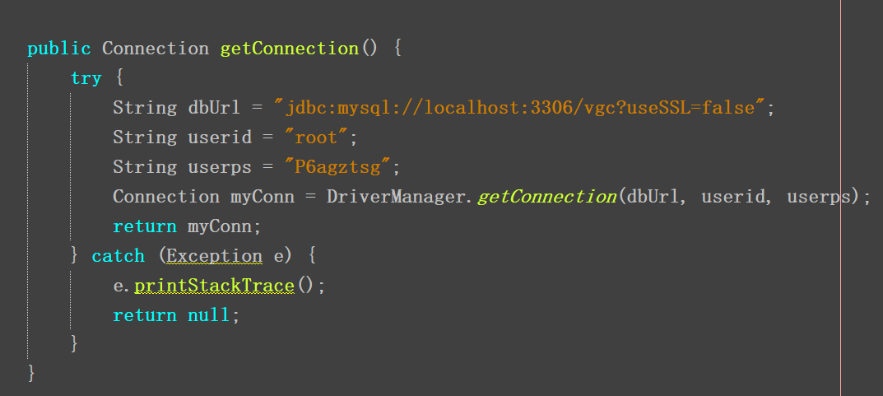

Polymorphism ,

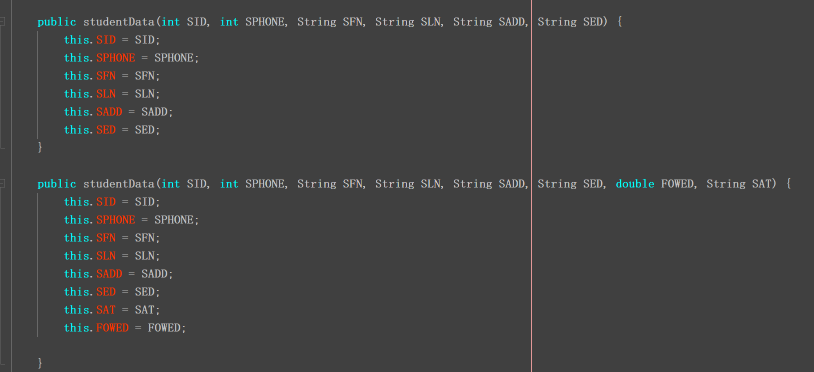

Interfaces

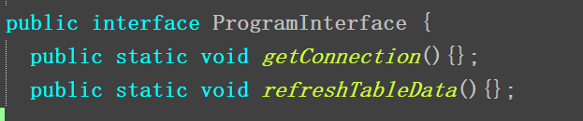

Arrays and ArrayLists

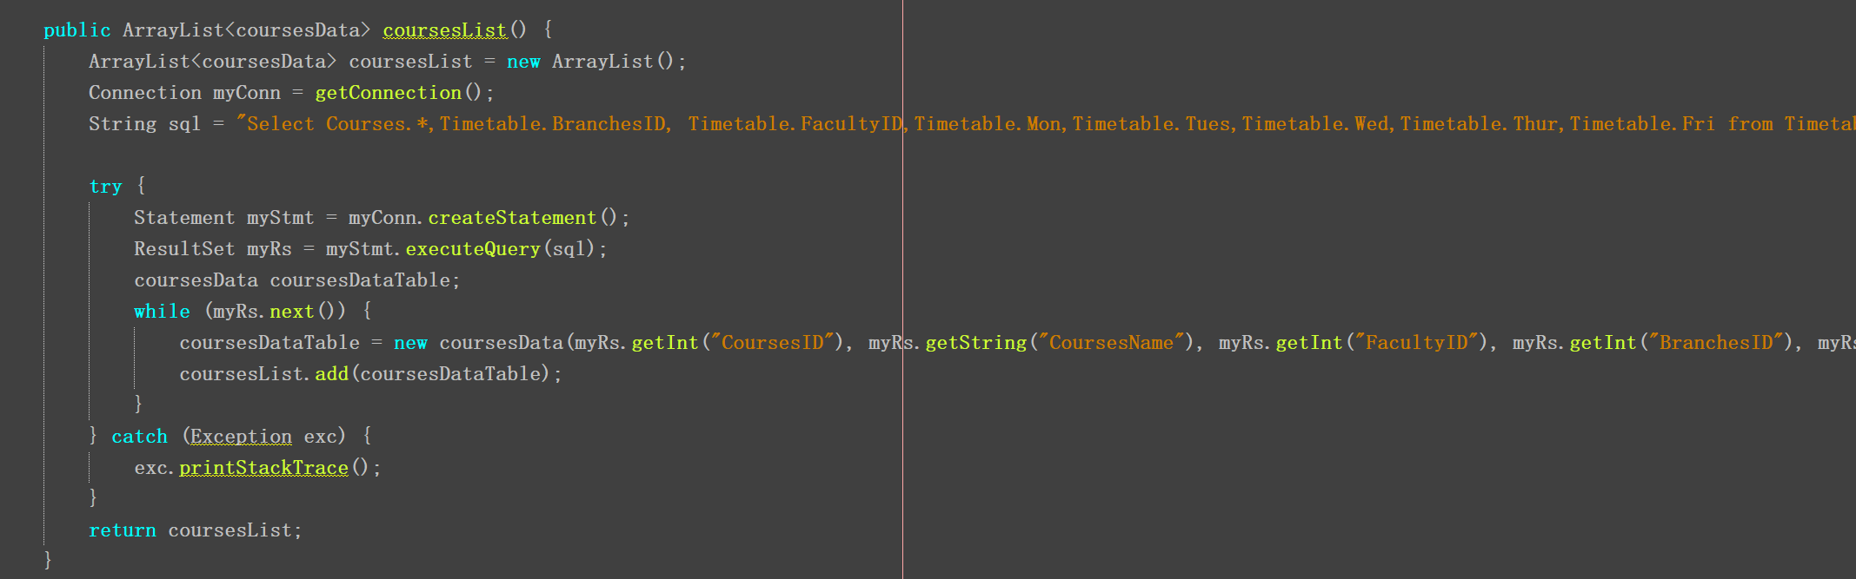

Strings, Characters and Regular Expressions

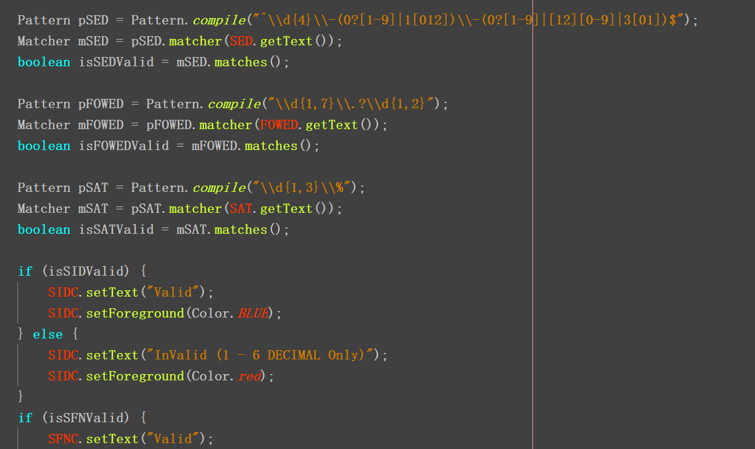

Files,

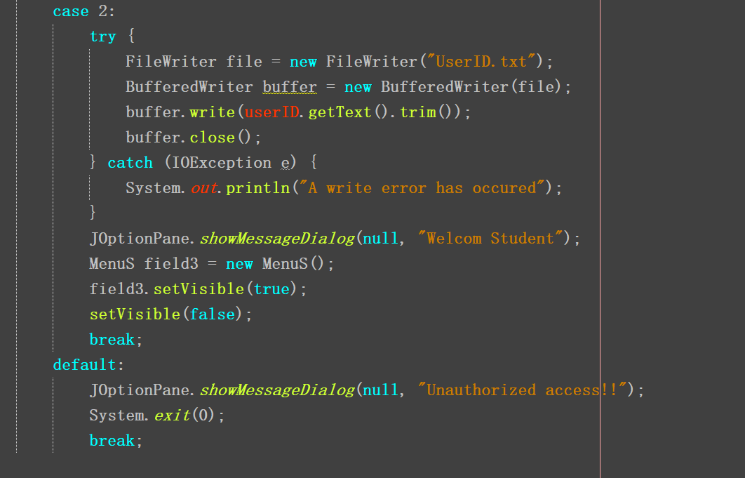

GUI Components: Jpanel, JComboBox, Layout Manager for example.



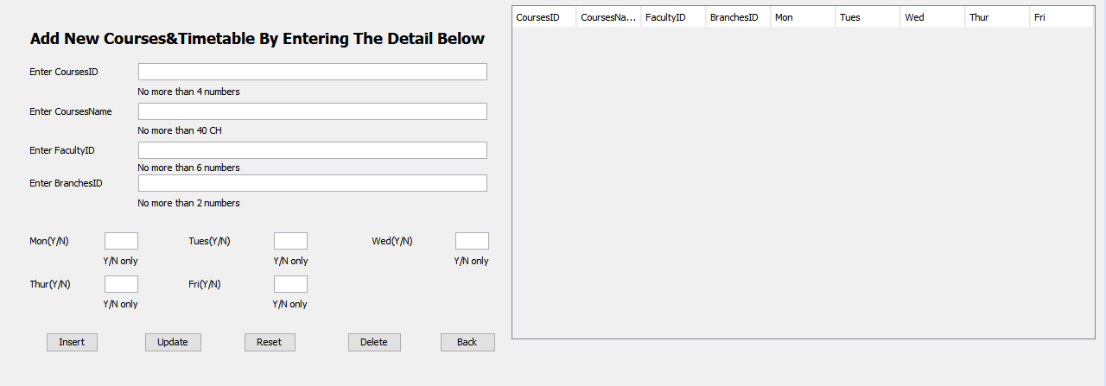

Generic Collections: Lists, Stacks and Queues

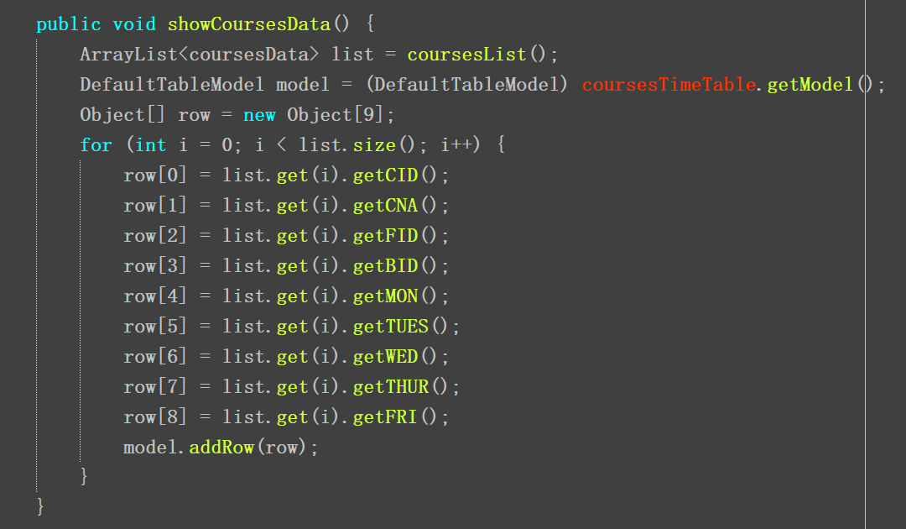

Custom Generic Data Structures

What I haven’t accomplished

I haven’t used concepts as below:

Threading

Abstract Classes, Concreate Classes,

Searching and Sorting

Streams and Object Serialization