**I/O Design**

FH Mobile Application

Version 1.0

Prepared by

Omar Rivera

Andrew Poirier Daven Amin

Rick Rejeleene

Table of Contents

1.0 Introduction 3

2.0 Test Cases 3

2.2.1 User Interface 3

2.2.1.1 Description 3

2.2.1.2 I/O Screen Shots 3

2.3.1 Booting up and Authentication 4

2.3.1.1 Description 4

2.3.1.2 I/O Screen Shots 4

2.4.1 Test User Platform 5

2.4.1.1 Description 5

2.4.1.2 I/O Screen Shots 5

2.5.2 Test User Authentication – Login Name 6

2.5.2.1 Description 6

2.5.2.2 I/O Screen Shots 6

2.5.3 Test User Authentication – Password 7

2.5.3.1 Description 7

2.5.3.2 I/O Screen Shots 7

2.8.1 User Information Fields (Database) 8

2.8.1.1 Description 8

2.8.1.2 I/O Screen Shots 8

3.0 Conclusion 8

# 1.0 Introduction

This purpose of this document is to demonstrate a few major test cases for the application to run and function. The test cases are based on all aspects of the design of the Fitness Health Application. We will test logging in, changing data, and submitting data to the application along with the database. The numerical numbering in this document refers back to the test cases in the TestPlan-1.0.pdf document previously submitted. These test cases will have I/O screen shots of the test’s being demonstrated.

# 2.0 Test Cases

This section will contain the test cases with I/O screen shots. The section numbering’s will correlate to the test cases in the TestPlan-1.0.pdf Document. Please refer to that document for the full test case. Only brief descriptions and screen shots will be included in this document.

## 2.2.1 User Interface

### 2.2.1.1 Description

All users shall be able to access the mobile application using a GUI provided by the application.

### 2.2.1.2 I/O Screen Shots

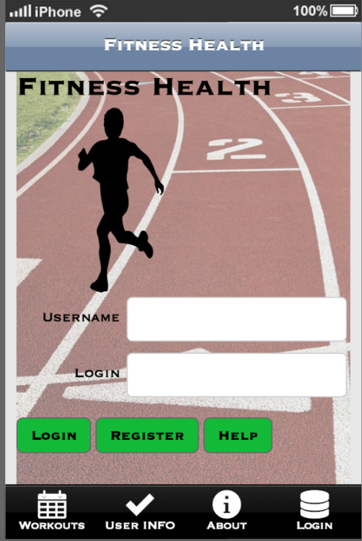

## 2.3.1 Booting up and Authentication

### 2.3.1.1 Description

Users shall be able to log in to the application and received confirmation in less than 5 seconds (< 5 sec).

### 2.3.1.2 I/O Screen Shots

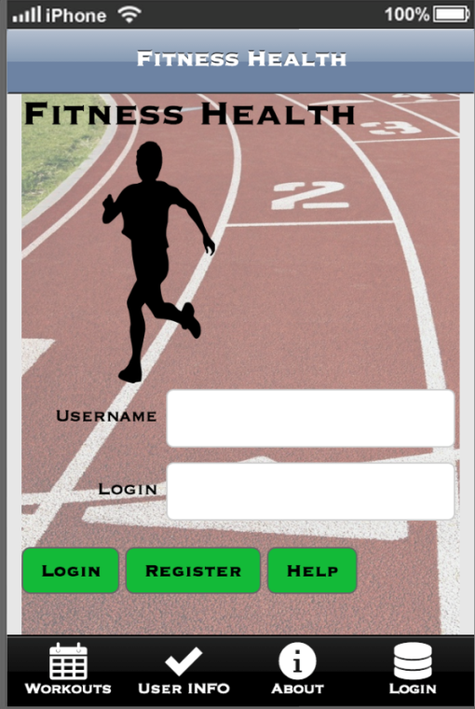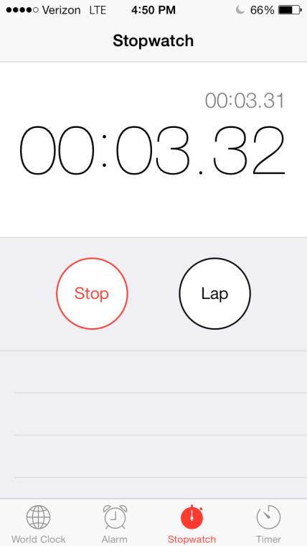INSERT MAIN SCREEN HERE !!!!

## 2.4.1 Test User Platform

### 2.4.1.1 Description

The User platform is to be tested by using a device with an Android Operating System.

### 2.4.1.2 I/O Screen Shots

This screen shot shows when the user is installing the application on a virtual android device.

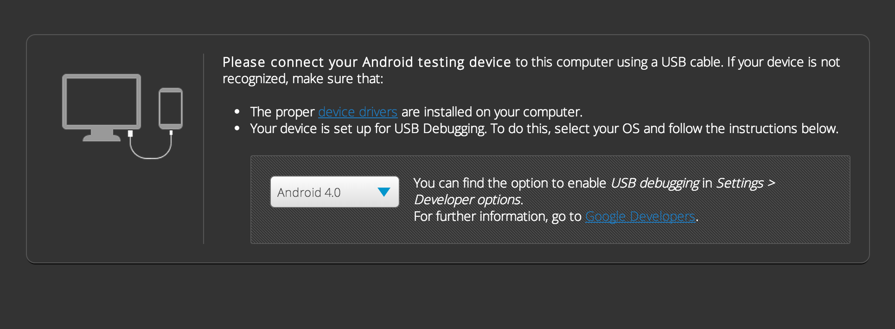

INSERT AFTER INSTALL PAGE HERE ALONG WITH ONE FROM A FAIL ON ANDROID 3.0

## 2.5.2 Test User Authentication – Login Name

### 2.5.2.1 Description

The User account form needs to be verified for testing, the login name is tested here.

### 2.5.2.2 I/O Screen Shots

This screen shot simulates if the user tries to login with the user name field empty

#### 2.5.2.2.1 Input: 2.5.2.2.2 Output:

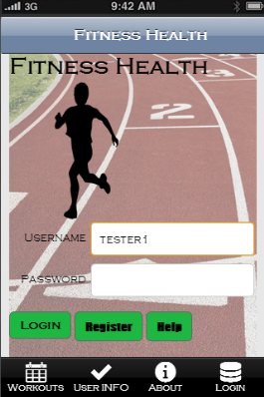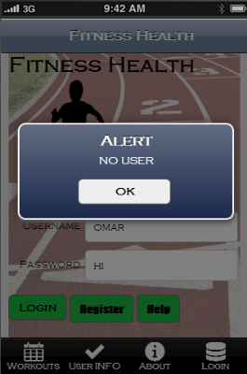

## 2.5.3 Test User Authentication – Password

### 2.5.3.1 Description

The User account form contains a password and the password field is tested here.

### 2.5.3.2 I/O Screen Shots

This screen shot simulates when a user tries to log in and forgets to put in a password.

#### 2.5.3.2.1 Input: 2.5.3.2.2 Output:

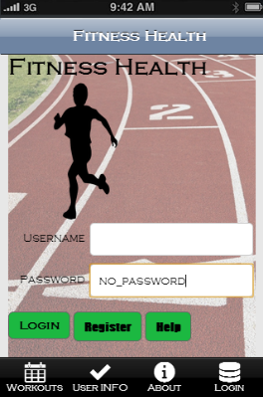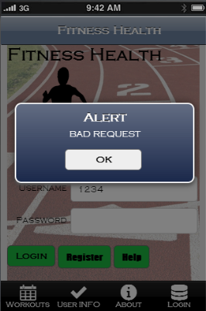

## 2.8.1 User Information Fields (Database)

### 2.8.1.1 Description

Users shall have access to input information into Use profile information fields. This is the code that runs on the back end of the application when the user hits the submit information. This is passed/ran on the SQL database server where all the data is stored.

### 2.8.1.2 I/O Screen Shots

#### 2.8.1.2.1 Input

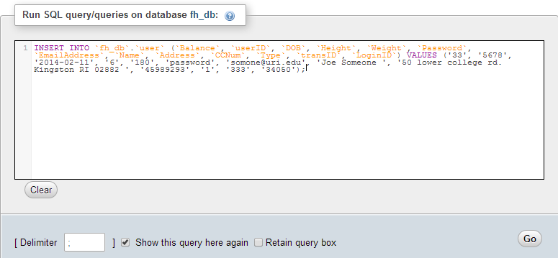

#### 2.8.1.2.2 Output

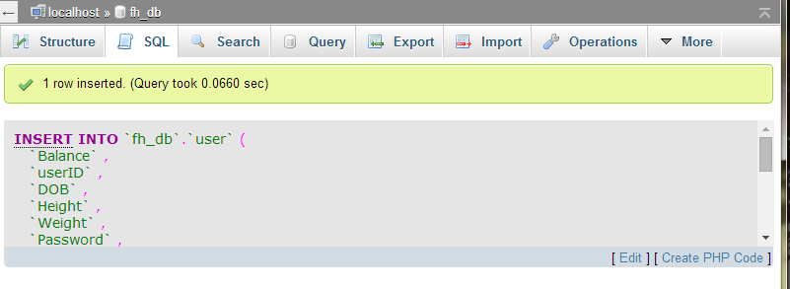

# 3.0 Conclusion