Object Sequence Diagram

FH Mobile Application

Version 1.2

Prepared by

Omar Rivera
Andrew Poirier
Daven Amin
Rick Rejeleene
Introduction & Description

The following diagrams are the UML Sequence diagrams for the Fitness Health Mobile Application. The first one is a sequence diagram for the whole system. This describes all of the features and methods that are included in our system. After the system overview we provided diagrams that outline all of the different activities that happen inside our applications. All of the diagrams are labeled with the appropriate title for the function they are describing. In the diagrams we first start with the user logging into the system and then performing different actions. We also included the action of the facilitator logging in to validate a workout.

Figure Table

Figure Number | Name | Description
1.0 | Log In | The log in diagram starts with the user logging into the client system. The client connects to the server and receives a session object.
2.0 | Create New User | The new user will register with the client. After the client gets all of the information it will send it to the server to record it. The server adds it to the database and returns a session object to the client. The client will reply back to the user if the registration was a success or failure.
3.0 | Change Password | Assuming a successful login, the user can request a password reset in the client. The client sends the change request to the server, which updates the database and then send a success or failure on the change. After that is completed the client will tell the user if the password was updated or not.
4.0 | Create New Workout | The user creates a workout in their user information. The created workout class is added to the user information, and is then sent to the server for storage. The success or failure of the store is sent back to the user information and user.
5.0 | Validate Workout | The user requests the list of workouts of other users which they can validate from their user information. The user information gets the list from the server and presents it to the user. The user then selects which workout they wish to validate, which is sent to the server. The server responds whether the validation was successful or not.
6.0 | View Balance | The user requests their balance from their user information. The user information queries the server to get the balance. The information is sent back to the user.
7.0 | View Workout | The user requests the list of their workouts from their user information, which queries the server for workouts associated with the user. The server responds with the workouts. The workouts are then displayed to the user.
8.0 | Add Balance | The user updates their user information with the balance they wish to add. The updated information object notifies the server to update the user’s balance. The server responds with the updated balance. The profile notifies the user of its updated state.
9.0 | Missing Activities | This is a scheduled activity that will be set to run by the system whether or not the user is logged in. The server requests the database for stored users and their workout information, and then checks for missed activities. The server updates balance according to the missed activities, it can either add or deduct from the user’s balance.

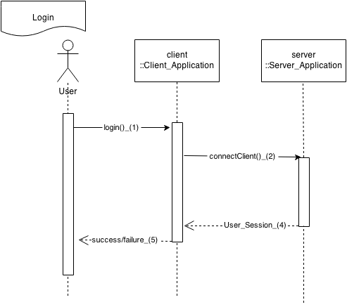
Figure 1.0
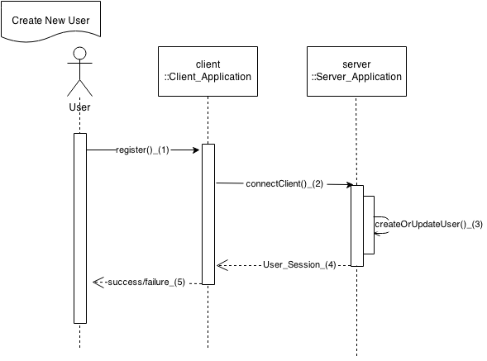
Figure 2.0
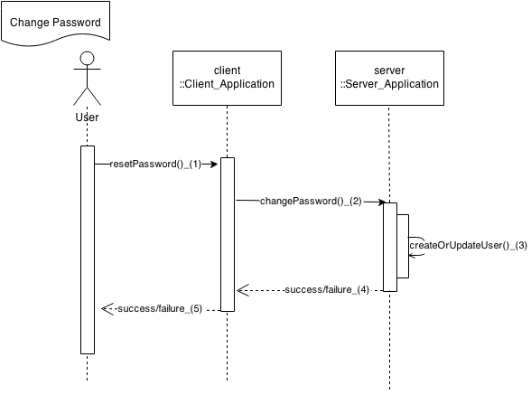
Figure 3.0
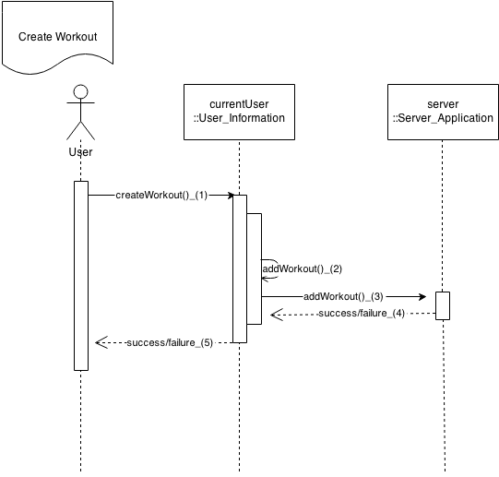
Figure 4.0
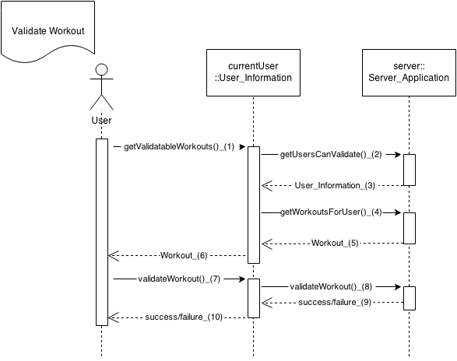
Figure 5.0
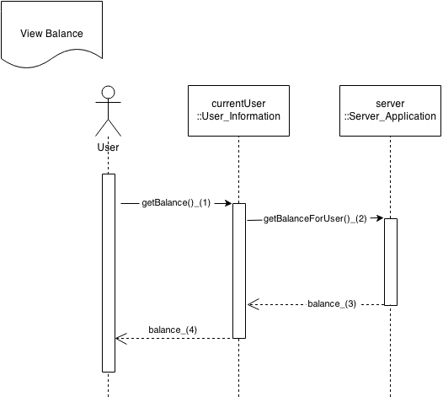
Figure 6.0
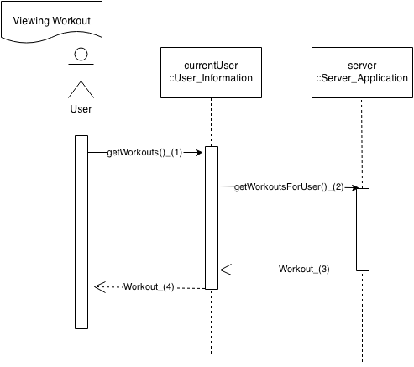
Figure 7.0
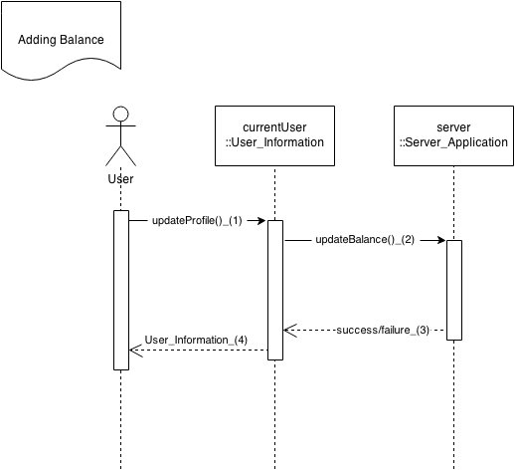
Figure 8.0
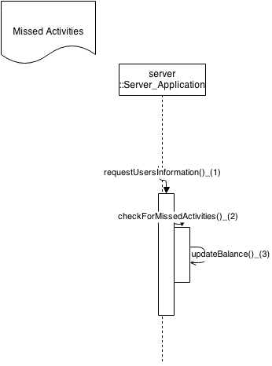
Figure 9.0

