Code Metrics

FH Mobile Application

Version 1.0

Prepared by

Omar Rivera
Andrew Poirier
Daven Amin
Rick Rejeleene

Code Metrics

- Software Design Metrics

  - Cyclomatic Complexity – This metric was computed counting the number of decisions statements in each one of the modules and adding one to the result. Base on the book sources research [McCabe], a good software design must have modules with a complexity lower than 10.
Note: This Cyclomatic complexity is treating any requests of the modules to connect or disconnect from the database as a decision statement (adding +1 for every DB query).

Module Name | Module Description | Cyclomatic Complexity | Is < 10 ?
Redirect.php | Loads client/server session basic info | 7 | PASS
Config.php | Connect the client with the server | 3 | PASS
Adduser.php | Register users to the system | 6 | PASS
writeWorkout.php | Write workouts in the database | In process | PASS
TrainerData.php | Loads trainer info to the app | 5 | PASS
Activities.php | Load activity info to the app | 2 | PASS
workoutData.php | Loads workout data to the client app | 7 | PASS
Loglogin.php | Log user accessing the system. | 2 | PASS
Table -Server Code Cyclomatic Complexity

- Development Process/Coding Metrics

  - Lines of Code (LOC) – Basic lines of codes without comments and non-black lines only.

System Element | LOC
Server Code | 165
Client Code | 3917
Data Base | 85
Total LOC | 4167
Table - Lines of code (LOC)

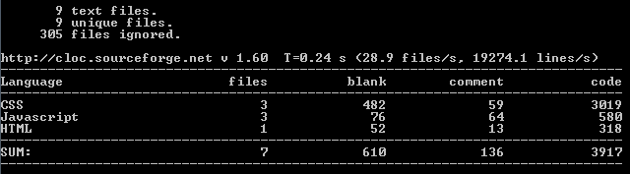
Image -Output of Lines of code - CLIENT(LOC)

  - Halstead complexity – For the Halstead metrics we apply the same unique operators (N1) logic to a client/server paradigm counting as a unique operator the databases queries and server session calls. Given that most available examples are in C/C++ and in modular programming scheme, our metric try to estimate the operator/operands metric taking in consideration the additional level of interaction between the server and the database.
Module Name | Operators  (N1) | Operands  (N2) | Estimate Length  N1 * log₂ N1 + N2 * log₂ N2
Redirect.php | 17 | 32 | 229.48
Config.php | 10 | 17 | 102.70
Adduser.php | 16 | 22 | 162.10
writeWorkout.php | 6 | 13 | 63.61
TrainerData.php | 11 | 8 | 62
Activities.php | 11 | 13 | 86.15
workoutData.php | 10 | 12 | 76.23
Loglogin.php | 14 | 13 | 101.40
Total Length: |  |  | 883.67
Table --Halstead Complexity Estimated Lenght

