AN ITEM RESPONSE ANALYSIS OF STATISTICS USE IN THE WORKPLACE

John A Harraway and Dalton F Andrade
University of Otago, New Zealand
Federal University of Santa Catarina, Brazil
jharraway@maths.otago.ac.nz

Training in statistics at university should be informed at least in part by what graduates will have to do with acquired statistical knowledge after graduation. A sample of 977 employed graduates with PhD and Masters degrees in seven specialties with statistics pre-requisites at university identifies which of 46 statistics based techniques (the items) they use in their work. A two parameter item response model uses 32 of the 46 items to build a scale measuring the extent of statistics use in the workplace and creates a value for each graduate which is used to summarize differences between the use of statistics in the seven specialties. Implications for syllabus construction to better prepare graduates for the workplace are discussed.

INTRODUCTION
Statistical activities and research methods which graduates encounter in the workplace can be useful for planning academic curricula that are aligned with primary workplace needs. This study quantifies the extent of use of statistics in the workplace. Harraway & Barker (2005) collated information from 977 New Zealand university PhD and Masters graduates in statistics, economics, marketing, the biological sciences, nutrition, food science and psychology. Of the 977 respondents, 98% were employed or recently employed indicating opinions expressed represented the views of employed graduates with higher degrees.
The 46 statistical techniques and research methods nominated in the survey and listed in Harraway & Barker (2005) are the 46 items for an item response analysis. For each respondent the value 1 indicates an item is used by that respondent in the workplace while the value 0 indicates the item is not used. The data matrix has binary entries with 977 rows and 46 columns. The item response analysis creates a scale for the extent of statistics use in the workplace, places each item in a position on this scale indicating how much that item is used in the workplace, and compares statistics use for all graduates in each of the seven specialties.

METHOD
Items for building the scale of extent of statistics use in the workplace are identified using the two parameter item response function

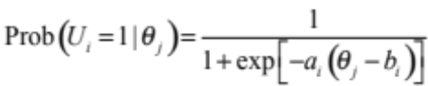

where U_{i} is a binary random variable with value 1 when item i is used in the workplace, 0 otherwise and θ_{j} represents the level of the extent of statistics use in the workplace of individual respondent j. The two parameters and are the “discrimination” and “difficulty” parameters of item i respectively (Lord, 1980 or Andrade et.al., 2000). All calculations are carried out using the software BILOG-MG (Zimowski, et. al., 1996), based on the scale with mean 0 and standard deviation 1.
A high value for suggests item i is difficult, which in the context of this study indicates that the particular item is not widely used in the workplace. A high value for suggests item i will discriminate well between use and no use in the workplace and therefore will be important in the development of the extent of statistics use in the workplace scale.
The item parameters are estimated by the marginal maximum likelihood method. Items that present a value for the discrimination parameter greater than or equal to 0.65 are selected for construction of the scale. This identifies 32 items (statistical topics or research methods). Using the estimates of the item parameters so obtained, empirical Bayesian estimates are found for the extent of use value for each respondent (Baker & Kim, 2004). These estimates are rescaled to have mean 50 and standard deviation 15 with most of the values therefore varying from 0 to 100. The results ordered by item use are shown in Table 1.
In order to interpret the extent of statistics use scale we define anchoring levels (Beaton & Allen, 1992) of 5, 20, 35, 50, 65, 80, 95 and 110 on the scale and identify an anchoring item by the following definition: if X and Y are two consecutive anchoring levels define item i to be an anchoring item for level Y if and only if
(i) 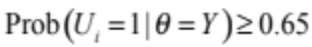
(ii) 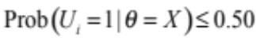
(iii)
That is, respondents at level Y are using the item and respondents at level immediately before X are not using the item.

RESULTS
The 32 item parameters and scale probabilities for each item are shown in Table 1. The levels where an item i can be considered as an anchoring item are highlighted using brackets. Since a reasonable number of items do not satisfy this definition we further define items for quasi anchoring if they are close to these defined levels. We consider these to be anchoring. They are also in brackets.

Table 1. Item parameters and levels on extent of use scale

 | Item Parameters |  |  | Levels of the scale (50,15)
Item | a_{i} | b_{i} | 5 | 20 | 35 | 50 | 65 | 80 | 95 | 110
GRAPHS | 0.0825 | 39.21 | 0.06 | 0.17 | 0.41 | (0.71) | 0.89 | 0.97 | 0.99 | 1.00
TESTS | 0.1156 | 49.72 | 0.01 | 0.03 | 0.15 | 0.51 | (0.85) | 0.97 | 0.99 | 1.00
SLREG | 0.1164 | 50.26 | 0.01 | 0.03 | 0.14 | 0.49 | (0.85) | 0.97 | 0.99 | 1.00
ANOVA | 0.1375 | 54.92 | 0.00 | 0.01 | 0.06 | 0.34 | (0.80) | 0.97 | 1.00 | 1.00
POSTHOC | 0.1114 | 61.53 | 0.00 | 0.01 | 0.05 | 0.22 | (0.60) | 0.89 | 0.98 | 1.00
MULTREG | 0.1135 | 61.78 | 0.00 | 0.01 | 0.05 | 0.21 | 0.59 | (0.89) | 0.98 | 1.00
FACTDES | 0.0854 | 69.31 | 0.00 | 0.01 | 0.05 | 0.16 | 0.41 | (0.71) | 0.90 | 0.97
PCA | 0.1301 | 69.48 | 0.00 | 0.00 | 0.01 | 0.07 | 0.36 | (0.80) | 0.97 | 0.99
MANOVA | 0.0959 | 69.81 | 0.00 | 0.01 | 0.03 | 0.13 | 0.39 | (0.73) | 0.92 | 0.98
NONLREG | 0.0939 | 70.00 | 0.00 | 0.01 | 0.04 | 0.13 | 0.38 | (0.72) | 0.91 | 0.98
REPMEAS | 0.0917 | 70.22 | 0.00 | 0.01 | 0.04 | 0.14 | 0.38 | (0.71) | 0.91 | 0.97
LOGREG | 0.0830 | 71.84 | 0.00 | 0.01 | 0.04 | 0.14 | 0.36 | (0.66) | 0.87 | 0.96
POWER | 0.0800 | 73.84 | 0.00 | 0.01 | 0.04 | 0.13 | 0.33 | (0.62) | 0.84 | 0.95
THEORY | 0.0458 | 74.15 | 0.04 | 0.08 | 0.14 | 0.25 | 0.40 | (0.57) | 0.72 | 0.84
NONPREG | 0.0954 | 74.21 | 0.00 | 0.01 | 0.02 | 0.09 | 0.29 | (0.63) | 0.88 | 0.97
RANDEFTS | 0.1111 | 74.39 | 0.00 | 0.00 | 0.01 | 0.06 | 0.26 | (0.65) | 0.91 | 0.98
CLUSTER | 0.0780 | 74.48 | 0.00 | 0.01 | 0.04 | 0.13 | 0.32 | (0.61) | 0.83 | 0.94
BLOCKING | 0.0782 | 75.30 | 0.00 | 0.01 | 0.04 | 0.12 | 0.31 | (0.59) | 0.82 | 0.94
DISCRIM | 0.1093 | 76.79 | 0.00 | 0.00 | 0.01 | 0.05 | 0.22 | (0.59) | 0.88 | 0.97
LGLINMOD | 0.0805 | 77.30 | 0.00 | 0.01 | 0.03 | 0.10 | 0.27 | 0.55 | 0.81 | 0.93
COMPINT | 0.0597 | 79.27 | 0.01 | 0.03 | 0.07 | 0.15 | 0.30 | 0.51 | 0.72 | 0.86
EXPLORFA | 0.0734 | 79.84 | 0.00 | 0.01 | 0.04 | 0.10 | 0.25 | 0.50 | (0.75) | 0.90
CANCORR | 0.1076 | 80.96 | 0.00 | 0.00 | 0.01 | 0.03 | 0.15 | 0.47 | (0.82) | 0.96
MDS | 0.0876 | 81.02 | 0.00 | 0.00 | 0.02 | 0.06 | 0.20 | 0.48 | (0.77) | 0.93
CORRESP | 0.1082 | 81.85 | 0.00 | 0.00 | 0.01 | 0.03 | 0.14 | 0.45 | (0.81) | 0.95
PATHANAL | 0.0715 | 81.89 | 0.00 | 0.01 | 0.03 | 0.09 | 0.23 | 0.47 | (0.72) | 0.88
CROSSOV | 0.0608 | 84.96 | 0.01 | 0.02 | 0.05 | 0.11 | 0.23 | 0.43 | (0.65) | 0.82
MRKRECAP | 0.0574 | 87.09 | 0.01 | 0.02 | 0.05 | 0.11 | 0.22 | 0.40 | 0.61 | 0.79
SURVANAL | 0.0648 | 87.65 | 0.00 | 0.01 | 0.03 | 0.08 | 0.19 | 0.38 | (0.62) | 0.81
META | 0.0584 | 88.91 | 0.01 | 0.02 | 0.04 | 0.09 | 0.20 | 0.37 | 0.59 | 0.77
BAYESIAN | 0.0634 | 90.43 | 0.00 | 0.01 | 0.03 | 0.07 | 0.17 | 0.34 | 0.57 | 0.78
STOCHAST | 0.0532 | 94.56 | 0.01 | 0.02 | 0.04 | 0.09 | 0.17 | 0.32 | 0.51 | 0.69

The values of place the 32 items i in order of use. The numbers of respondents reaching the levels on the extent of statistics use scale are calculated. Table 2 reports the frequency and percentage for each one of the seven specialties considered and also the total.

Table 2. Frequency (percentage) of respondents by specialty

Specialty |  | Level of Statistics Use |  |  |  |  | Total
 |  | 20 | 35 | 50 | 65 | 80
Stat | Count(%) | 30(25) | 33(27) | 35(29) | 19(16) | 4(3) | 121(100)
Econ | Count(%) | 10(12) | 32(38) | 32(38) | 11(13) | 0(0) | 85(100)
Mark | Count(%) | 28(34) | 33(40) | 15(18) | 4(5) | 2(2) | 82(100)
Biosci | Count(%) | 71(21) | 80(23) | 101(29) | 73(21) | 20(6) | 345(100)
Foodsc | Count(%) | 7(23) | 14(47) | 4(13) | 4(13) | 1(3) | 30(100)
Nutrit | Count(%) | 7(23) | 4(13) | 13(42) | 6(19) | 1(3) | 31(100)
Psych | Count(%) | 70(25) | 80(28) | 77(27) | 54(19) | 2(1) | 283(100)
Total | Count(%) | 223(23) | 276(28) | 277(28) | 171(18) | 30(3) | 977(100)

It follows that values over 80 for suggest that the matching item is not widely used while low values indicate extensive use in the workplace of the item. For example the values for Level 50 and Level 65 show that GRAPHS, TESTS, SLREG, ANOVA and POSTHOC are relatively widely used while the values of Level 95 indicate EXPLORFA, CANCORR, MDS, CORRESP, PATHANAL, CROSSOV, SURVIVAL are not used much relatively.
We can also conclude that only 3% (30 out of 977) reached Level 80 indicating that only 3% of the respondents use the items MULTREG, FACTDES, PCA, MANOVA, NONREG, REPMEAS, LOGREG, POWER, NONPREG, RANDEFTS, CLUSTER, BLOCKING and DISCRIM. As none of the respondents reached Level 95, we can further conclude that the items EXPLORFA, CANCORR, MDS, CORRESP. PATHANAL, CROSSOV and SURVANAL are not used by the respondents.

DISCUSSION
The scale reported in Table 1. and the percentages reported in Table 2. show that graphs, introductory testing procedures, simple linear regression, analysis of variance and posthoc tests are widely used. These are the main topics in introductory courses on statistical methods and this study confirms a need for students in the specialties reviewed to be taught these items to prepare them for the workplace. On the other hand survival analysis, meta analysis, Bayesian statistics and stochastic processes are not used. These topics are rarely taught in service statistics courses and since the specialties with the majority of respondents have only service statistics needs these conclusions may not be accurate for the graduates in statistics.

Table 3. Percentage of respondents that reached the level

Specialty | Level of Statistics use
 | 20 | 35 | 50 | 65 | 80 | 95
Stat | 100 | 75.21 | 47.93 | 19.01 | 3.31 | 0.00
Econ | 100 | 88.24 | 50.59 | 12.94 | 0.00 | 0.00
Mark | 100 | 65.85 | 25.61 | 7.32 | 2.44 | 0.00
Biosci | 100 | 79.42 | 56.23 | 29.96 | 5.80 | 0.00
Foodsc | 100 | 76.67 | 30.00 | 16.67 | 3.33 | 0.00
Nutrit | 100 | 77.42 | 64.52 | 22.58 | 3.23 | 0.00
Psych | 100 | 75.27 | 47.00 | 19.79 | 0.71 | 0.00

In Table 3. the percentages of the respondents in each of the seven specialties who reached the designated levels of statistics use are reported. The clear downward trend for each specialty is shown in Figure 1. Inspection of the values for Level 65 shows there is greater use of statistics in the sciences than in the business areas and this should be reflected in the amount of statistics included in the different specialties at university. There are significant differences between the specialties at Level 50.

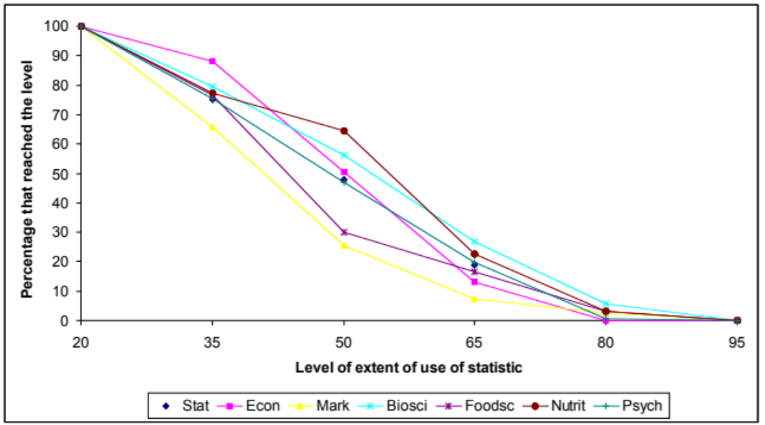

Figure 1. Specialty percentage by extent of use

Further research could focus on statistics graduates in particular with an even more comprehensive list of statistics topics and research methods surveyed. Students who had completed both undergraduate and postgraduate statistics degrees could be included. This should provide insight into the statistical items we should be teaching in our courses for statistics specialists in order to prepare them for the workplace. An analysis of statistics software use in the workplace is also currently underway. Again this will suggest the most useful statistics software to include in our teaching.

REFERENCES
Andrade, D. F., Tavares, H. R., & Valle, R. C. (2000). Teoria da Resposta ao Item: conceitos e aplicacoes. Sao Paulo: Associacao Brasileira de Estatistica. (in Portugese) www.inf.ufsc.br/~dandrade/tri
Baker, F. B., & Kim, Seock-Ho. (2004). Item Response Theory: Parameter Estimation Techniques. Statistics, Dekker Series of Textbooks and Monographs. New York.
Beaton, A. E., & Allen, N. L. (1992). Interpreting scales through scale anchoring. Journal of Educational Statistics, 17, 191-204.
Harraway, J. A., & Barker, R. J. (2005). Statistics in the workplace: a survey of use by recent graduates with higher degrees. Statistics Education Research Journal, 4(2), 43-58, http://www.stat.auckland.ac.nz/serj
Lord, F. M. (1980). Applications of item response theory to practical testing problems. Hillsdale: Lawrence Erlbaum Associates Inc.
Zimowski, M. F., Muraki, E., Mislevy, R. J., & Bock, R. D. (1996). BILOG-MG: Multiple-Group IRT Analysis and Test Maintenance for Binary Items. Chicago: Scientific Software Inc.

