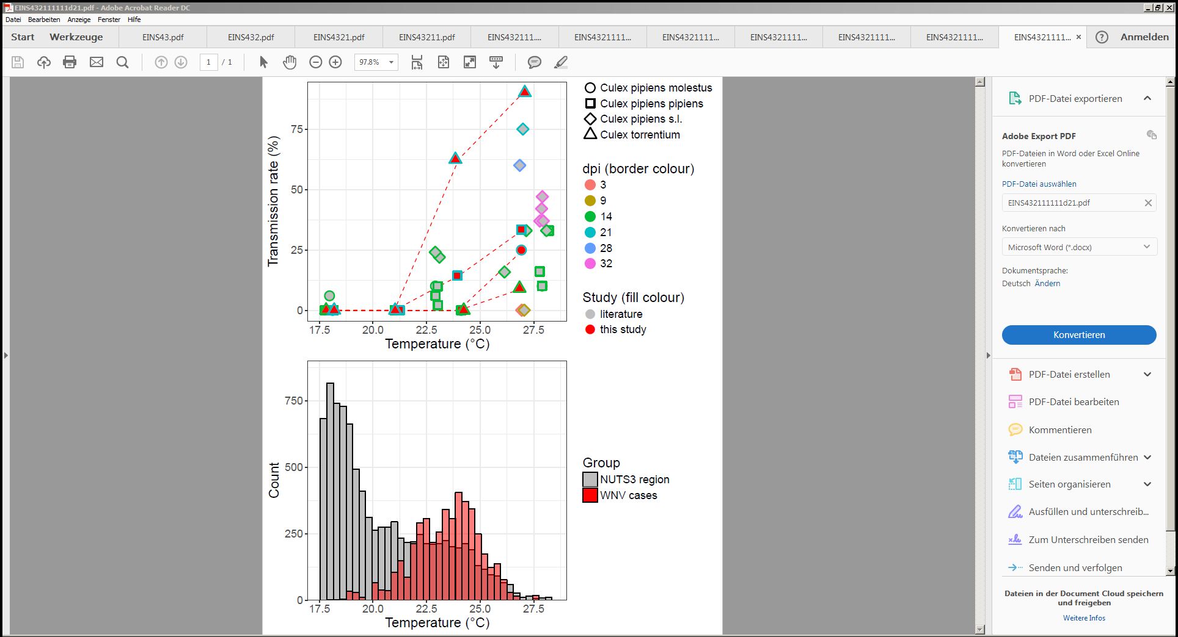

**Figure 3: A:** Transmission rate of *Culex pipiens* s.l./*torrentium* experimentally infected with West Nile virus at different temperatures and days post infection in comparison to previous published vector competence studies with European populations of the same species. A small horizontal jitter was added to the points to prevent overlapping points. **B:** Annualaverage temperature (July/August) of European regions (2011-2017) and for each detected human WNV case (2011-2017). Only temperatures between 17.5 °C and 28.5 °C are shown (see supplementary figure X for the complete temperature range).