ISO/IEC JTC 1/SC 29
Date: 2013-11-01
ISO/IEC DIS 23008-10
ISO/IEC JTC 1/SC 29/WG 11
Secretariat:
Information technology — High efficiency coding and media delivery in heterogeneous environments — Part 10: MPEG Media Transport Forward Error Correction (FEC) codes
Élément introductif — Élément central — Partie 10: Titre de la partie

Warning
This document is not an ISO International Standard. It is distributed for review and comment. It is subject to change without notice and may not be referred to as an International Standard.
Recipients of this draft are invited to submit, with their comments, notification of any relevant patent rights of which they are aware and to provide supporting documentation.

Copyright notice
This ISO document is a Draft International Standard and is copyright-protected by ISO. Except as permitted under the applicable laws of the user's country, neither this ISO draft nor any extract from it may be reproduced, stored in a retrieval system or transmitted in any form or by any means, electronic, photocopying, recording or otherwise, without prior written permission being secured.
Requests for permission to reproduce should be addressed to either ISO at the address below or ISO's member body in the country of the requester.
ISO copyright office
Case postale 56 • CH-1211 Geneva 20
Tel. + 41 22 749 01 11
Fax + 41 22 749 09 47
E-mail copyright@iso.org
Web www.iso.org
Reproduction may be subject to royalty payments or a licensing agreement.
Violators may be prosecuted.

Contents Page
Foreword iv
Introduction v
1 Scope 1
2 Normative references 1
3 Terms, definitions, symbols and abbreviated terms 1
3.1 Terms and definitions 1
3.2 Symbols and abbreviated terms 2
3.3 Conventions 3
4 Overview 3
5 FEC Code Points 4
6 Specification for Reed-Solomon Codes 5
6.1 Introduction 5
6.2 Generator matrix 5
7 Specification for Structured Low-Density Parity-Check (S-LDPC) Codes 6
7.1 Introduction 6
7.2 Structured LDPC Codes 6
7.3 Creating Parity-Check Matrix 7
7.4 Encoding Algorithm 8
7.5 Decoding Algorithm 9
7.6 Base matrix 9
8 Specification 6330 code and RaptorQ LA code 12
8.1 Introduction 12
8.2 6330 code 12
8.3 RaptorQ LA 13
9 Specification for FireFort Low Density Generate Matrix (FireFort-LDGM) codes 18
9.1 Introduction 18
9.2 FireFort Low Density Generator Matrix (FireFort-LDGM) Codes 18
9.3 Layer-Aware FireFort-LDGM (LA FireFort-LDGM) Codes 29
10 Specification for FEC code algorithms in SMPTE 2022-1 30
Bibliography 31

Foreword
ISO (the International Organization for Standardization) and IEC (the International Electrotechnical Commission) form the specialized system for worldwide standardization. National bodies that are members of ISO or IEC participate in the development of International Standards through technical committees established by the respective organization to deal with particular fields of technical activity. ISO and IEC technical committees collaborate in fields of mutual interest. Other international organizations, governmental and non-governmental, in liaison with ISO and IEC, also take part in the work. In the field of information technology, ISO and IEC have established a joint technical committee, ISO/IEC JTC 1.
International Standards are drafted in accordance with the rules given in the ISO/IEC Directives, Part 2.
The main task of the joint technical committee is to prepare International Standards. Draft International Standards adopted by the joint technical committee are circulated to national bodies for voting. Publication as an International Standard requires approval by at least 75 % of the national bodies casting a vote.
Attention is drawn to the possibility that some of the elements of this document may be the subject of patent rights. ISO and IEC shall not be held responsible for identifying any or all such patent rights.
ISO/IEC 23008-10 was prepared by Joint Technical Committee ISO/IEC JTC 1, Information technology, Subcommittee SC 29, Coding of audio, picture, multimedia and hypermedia information.
ISO/IEC 23008 consists of the following parts, under the general title Information technology — High efficiency coding and media delivery in heterogeneous environments:
- Part 1: MPEG media transport (MMT)
- Part 2: High efficiency video coding (HEVC)
- Part 3: 3D Audio
- Part 10: MPEG media transport forward error correction codes (MMT FEC Codes)
- Part 11: Composition Information
Introduction
This part of ISO/IEC 23008 specifies application level forward error correction (FEC) codes which may be used with application level-forward error correction (AL-FEC) framework of ISO/IEC 23008-1 MPEG Media Transport (MMT) to provide reliable delivery in IP network and non IP network environments that are prone to packet losses.

Information technology — High efficiency coding and media delivery in heterogeneous environments — Part 10: MPEG Media Transport Forward Error Correction (FEC) codes

Scope
This part of ISO/IEC 23008 specifies application level forward error correction (FEC) codes which may be used with AL-FEC framework of ISO/IEC 23008-1 MPEG Media Transport to provide reliable delivery in IP network and non IP network environments that are prone to packet losses.

Normative references
The following documents, in whole or in part, are normatively referenced in this document and are indispensable for its application. For dated references, only the edition cited applies. For undated references, the latest edition of the referenced document (including any amendments) applies.

ISO/IEC 23008-1, “High efficiency coding and media delivery in heterogeneous environments — Part 1: MPEG media transport (MMT)”, ISO/IEC 23008-1.
IETF RFC 5170, “Low Density Parity Check (LDPC) Staircase and Triangle Forward Error Correction (FEC) Schemes,” June 2008.
IETF RFC 5510, “Reed-Solomon Forward Error Correction (FEC) Schemes,” April 2009.
IETF RFC 6330, "RaptorQ Forward Error Correction Scheme for Object Delivery," August 2011.
SMPTE2022-1, “Forward Error Correction for Real-Time Video/Audio Transport Over IP Networks”.

Terms, definitions, symbols and abbreviated terms
For the purposes of this document, the following terms and definitions apply.

Terms and definitions

code rate
the ratio between the number of source symbols and the number of encoding symbols.

encoding symbol
unit of data generated by the encoding process.

encoding symbol block
set of encoding symbols from the encoding process of a source symbol block.

FEC code
an algorithm for encoding data such that the encoded data flow is resilient to data loss.

FEC payload ID
an identifier that identifies the contents of a MMT packet with respect to the MMT FEC scheme.

repair symbol
encoding symbol that is not a source symbol.

repair symbol block
set of repair symbols which can be used to recover lost source symbols.

source symbol
unit of data used during the encoding process.

source symbol block
set of source symbols which is used to generate repair symbol block by FEC code.

systematic code
any error correction code in which the source symbols are part of output encoded symbols.

Symbols and abbreviated terms
For the purpose of this document, the symbols and abbreviated terms given in the following apply:

AL-FEC application layer (level) forward error correction
FEC forward error correction
LA layer aware
LA-FEC layer aware forward error correction
LDGM low density generator matrix
LDPC low density parity check
MMT MPEG media transport
RS Reed-Solomon
S-LDPC structured low density parity check

Conventions
The following conventions apply in this document:
- The Big Endian number representation scheme is used.

Overview
This part of ISO/IEC 23008 specifies application level forward error correction (FEC) codes. All codes specified in this part are systematic codes.
This specification defines six FEC code algorithms which each FEC code algorithm shall generate a repair symbol block from a source symbol block as shown in Figure 1. The source symbol block consists of K source symbols of size T (in bytes) and the repair symbol block consists of P repair symbols of size T (in bytes).

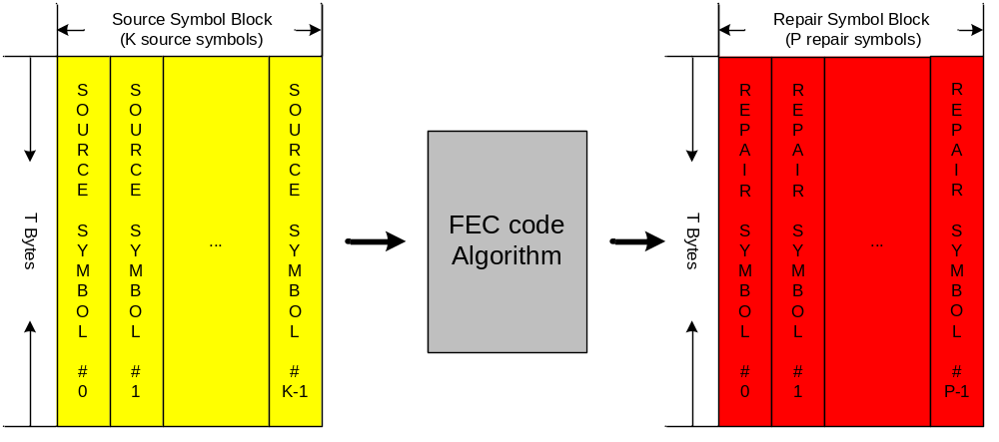
Figure 1 - Input and Output of FEC code

FEC Code Points
Table 1 specifies the code points for the FEC code algorithms specified in this part of ISO/IEC 23008. The FEC code algorithms themselves are specified in clauses 6 ~ 10.
Table 1 — FEC Code Algorithms and Its Code Point
Code Point | FEC Code Algorithm
0 | Reserved for ISO use
1 | RS code (sub-clause 6)
2 | S_LDPC code (sub-clause 7)
3 | 6330 code (sub-clause 8.2)
4 | RaptorQ LA code (sub-clause 8.3)
5 | FireFort-LDGM code (sub-clause 8)
6 | FEC code algorithm in SMPTE 2022-1 (sub-clause 9)
7 ~ 255 | Reserved for ISO use

NOTE When one of the FEC code algorithms specified in this specification is used for MMT AL-FEC framework, fec_code_id_for_repair_flow field in Annex C.6 as defined in ISO/IEC 23008-1 is set to its corresponding code point as specified in Table 1.

Specification for Reed-Solomon Codes

Introduction
In this clause, the following notations are used.
- K: number of source symbols in a source symbol block
- P: number of repair symbols in a repair symbol block
- G = [I; A]: a systematic generator matrix for [K+P, K]-RS code where I is the identity matrix of order K and A is a K× P matrix.
A (N, K) Reed–Solomon code is a linear block code of length N (over Galois Field F) with dimension K and minimum Hamming distance N – K + 1. The Reed–Solomon code is optimal in the sense that the minimum distance has the maximum value possible for a linear code of size (N, K); this is known as the Singleton bound. Such a code is also called a maximum distance separable (MDS) code.
The clause 8 of IETF RFC5510 gives full specification of the RS code for the erasure channel and especially, the clause 8.2.1 of IETF RFC5510 gives encoding principle for RS encoding algorithm. The generate matrix G perfectly characterizes the RS code. In this specification, it specifies only the case when m = 8 (over GF(2⁸)) with the generator matrix given in the sub-clause 6.2. Therefore, an encoding symbol block shall be generated from a source symbol block by the given generator matrix in the sub-clause 6.2 and this FEC code shall output the repair symbol block of the encoding symbol block.

Generator matrix
The generator matrix G has the form G = [I; A] where I is an identity matrix of size K and A is a K × P matrix, (K + P) ≤ 255. Let α be the root of the polynomial 1 + x² + x³ + x⁴ + x⁸ which is the primitive polynomial of degree 8 given in sub-clause 8.1 of IETF RFC5510. The non-zero elements of the finite filed GF(2⁸) are generated by a primitive element α and the elements of GF(2⁸) are represented by bytes (group of 8 bits), using the polynomial base representation, with (α⁷, α⁶, α⁵, α⁴, α³, α², α, 1) as a basis. The root α is thus represented as: α = 00000010. For RS code specified in this specification, the matrix A is a Cauchy matrix which shall have entries
A_{i,j} = 1/(x_{i} + y_{j}) for 0 ≤ i < K and 0 ≤ j < P
where x_{i} and y_{j} are elements in GF(2⁸) and are defined as:
x_{i} = α^{254 – i}, and y_{j} = α^{j}.
Therefore, the matrix A is given by
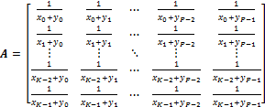.

NOTE that any submatrix of the Cauchy matrix is invertible.

Specification for Structured Low-Density Parity-Check (S-LDPC) Codes

Introduction
A Low-Density-Parity-Check (LDPC) code is a linear block code defined by its parity-check matrix. In this specification, we use a special case of LDPC codes, called structured LDPC (S-LDPC) codes, which have an efficient encoding algorithm and adopted as an FEC code in standardizations such as IEEE 802.16e and 801.11n.
In this document, we use the following notations.
- K: number of source symbols in a source symbol block
- K’: number of source symbols in an extended source symbol block
- P: number of repair symbols in a repair symbol block
- P’: number of repair symbols in an extended repair symbol block
- S(i): the i-th source symbol in a source symbol block (0 ≤ i < K). It can be represented as a binary column vector of length 8T or a column vector of length T over GF(2⁸)
- R(i): the i-th repair symbols in a repair symbol block (0 ≤ i < P). It can be represented as a binary column vector of length 8T or a column vector of length T over GF(2⁸)
- H: a sparse parity-check matrix of an S-LDPC code.

Structured LDPC Codes
In this clause, S-LDPC codes are described by parity-check matrices which consist of circulant permutation matrices or the zero matrix.
Let Q be the L × L permutation matrix given by

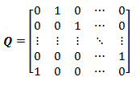

Note that Q^{i} is just the circulant permutation matrix which shifts the identity matrix I to the right by i times for any integer i, 0 ≤ i < L. For simple notation, Q∞ denotes the zero matrix.
Let H be the P' by K' + P' matrix defined by

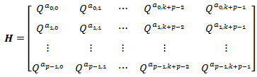

where p and k are given by p = P' / L and k = K' / L, respectively and a_{i,j} ∈ {0, 1, …, L–1, ∞}. If the locations of 1’s in the first row of the i-th row block
are fixed, then the locations of other 1’s in H_{i} are uniquely determined.

Creating Parity-Check Matrix
For efficient encoding, it restricts the parity part of H to an almost lower triangular matrix with additional constraints as follows:

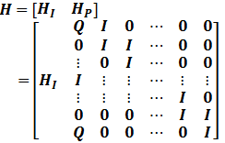

In the first column block of H_{P}, I is placed only at the ceil(p/2)-th row block , H_{ceil(p/2)–1} , where ceil(x) is the smallest integer not less than x.
Let BM be a mother matrix having 400 column blocks and 20 row blocks with L = 16, i.e. the matrix BM has 6400 columns and 320 rows. Each column block and row block of BM has exactly 7 and 140 circulant permutation matrices of size 16, respectively. The remaining part of BM is filled with zero matrices of size 16. The i-th row block of BM can be represented as a sequence of pairs (t_{i,j}, e_{i,j}) where t_{i,j} is the index of column block corresponding to the j-th circulant permutation matrix and e_{i,j} is its exponent. The BM matrix supports various values of K and P with techniques called scaling down and row splitting. The resulting matrix is used as H_{I} for encoding process.
In order to support short source symbol blocks efficiently, the matrix BM is scaled down by a scaling factor S₁. The resulting matrix is composed of circulant permutation matrices and zero matrices of size 16/S₁, i.e. it has 6400/S₁ columns and 320/S₁ rows. The scaling factor can be obtained as S₁ = 2ª where a is the largest integer satisfying K ≤ (400 ∙ 16) / 2ª. Note that the resulting matrix can be represented as the sequence of pairs (t_{i,j}, e_{i,j} mod (16/S₁)) since the size of circulant permutation matrices and zero matrices are reduced from 16 to 16/S₁.
As mentioned above, the matrix BM has 320/S₁ rows after downscaling. It means that the number of repair symbols P is 320/S₁ at maximum. To support larger values of P, we extend the matrix BM by splitting its rows. In this process, each row block is splitted into S₂ row blocks. For given repair symbol block length P and the scaling factor S₁, the row splitting factor S₂ can be obtained as S₂ = ceil(P/(320/S₁)).
The matrix H_{I} is obtained from the matrix BM as follows. Let BM_{i} = {(t_{i,0}, e_{i,0}), (t_{i,1}, e_{i,1}),…, (t_{i,139}, e_{i,139})} be the ordered sequence of pairs (t_{i,j}, e_{i,j}) representing the i-th row block of BM. Let S₁ and S₂ be the scaling factor and the row splitting factor, respectively. They are determined uniquely by K and P. Then the (S₂ × i + j)-th row block of H_{I} can be represented as follows:
T_{(S2×i)+j} = {(t_{i,k}, e_{i,k} mod (16/S₁)) | k mod (S₂₎ = (S₂ – 1 – j), 0 ≤ k < 140}
Note that the matrix H_{I} has 400 column blocks and S₂×20 row blocks with L = 16/S₁, i.e., it has (6400/S₁) columns and (S₂×320/S₁) rows.
Finally, the parity-check matrix H is obtained by augmenting the matrix H_{P} with appropriate size to the matrix H_{I}. H has 400 + S₂×20 column blocks and S₂×20 row blocks with L = 16/S₁, i.e. H consists of (6400 + S₂∙320)/S₁ columns and (S₂∙320/S₁) rows.

Encoding Algorithm
The encoding of an S-LDPC code is performed based on the following p'×L' by (k'+p')×L' parity-check matrix:

where L' = 16/S₁, p' = S₂×20 and k' = 400. It has P' = S₂×320/S₁ rows.
The H is divided into the form

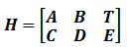

where A is (p' – 1)×L by k'×L, B is (p' – 1)×L by L, T is (p' – 1)×L by (p' – 1)×L, C is L by k'×L, D = Q is L by L and E is L by (p' – 1)×L. Let c = (s, r₁, r₂) be a codeword specified by H, that is Hc^{T} = 0^{T} where s is the systematic part, p₁ and p₂ are the parity parts which have length L and (p' – 1)×L, respectively. That is s = [S(0),…, S(K'–1)], r₁ = [R(0),…, R(L–1)] and r₂ = [R(L),…, R(P'–1)]. Note that S(K), S(K+1) ,…, S(K'–1) denote K'–K padded source symbols, which are set to all zero bits and not delivered. Furthermore, R(P),…, R(P'–1) denote the repair symbols to be punctured, i.e. their values are calculated but not contained in the corresponding repair symbol block.
Then, the detailed operations for encoding of an S-LDPC code defined by H are as follows:
Step 1) Compute As^{T} and Cs^{T}.
Step 2) Compute ET^{–1} As^{T} = [I … I] As^{T}
Step 3) Compute r₁^{T} by r₁^{T} = ET^{–1} As^{T} + Cs^{T}
Step 4) Compute r₂^{T} by Tr₂^{T} = As^{T} + Br₁^{T}
Therefore, when a source symbol block s is input, this FEC code shall output the repair symbol block [R(0),…,R(P-1)] of c which satisfies the equation Hc^{T} = 0^{T}.

Decoding Algorithm
S-LDPC codes are one family of LDPC codes. Therefore any decoding algorithm for conventional LDPC codes can be applied without any modification. Consideration on the decoding algorithm of LDPC codes can be found in IETF RFC5170.

Base matrix
The S-LDPC codes can be fully described by the base matrix BM and algorithms to calculate the scaling factor and the row splitting factor. The i-th row block of BM can be represented as a sequence of pairs T_{i} = {(t_{i,0}, e_{i,0}), (t_{i,1}, e_{i,1}),…, (t_{i,139}, e_{i,139})} where t_{i,j} is the index of column block corresponding to the j-th circulant permutation matrix and e_{i,j} is its exponent for 0 ≤ j < 140.
T₀ = {(1,8), (2,8), (3,10), (5,12), (6,8), (7,12), (9,8), (12,4), (14,12), (15,0), (19,0), (20,9), (26,4), (34,8), (35,1), (38,0), (45,13), (46,0), (48,13), (56,9), (57,3), (62,1), (63,8), (71,12), (75,8), (77,3), (78,2), (82,13), (83,13), (85,9), (88,1), (90,15), (92,4), (93,12), (97,0), (99,15), (104,5), (107,14), (110,13), (111,15), (116,9), (117,7), (120,9), (121,8), (125,15), (127,14), (128,15), (129,9), (131,5), (134,12), (150,12), (152,13), (156,1), (158,9), (159,13), (161,7), (163,5), (164,4), (165,13), (168,11), (171,9), (172,12), (175,12), (177,13), (180,5), (185,9), (193,1), (194,8), (195,9), (199,3), (200,9), (202,9), (204,3), (207,13), (212,13), (213,1), (214,13), (217,3), (223,13), (224,14), (226,10), (227,5), (228,7), (232,5), (236,14), (240,7), (241,7), (245,9), (250,12), (251,5), (255,5), (260,5), (267,4), (268,4), (272,4), (273,4), (275,9), (276,6), (278,5), (284,8), (288,1), (289,6), (291,2), (292,4), (297,12), (299,4), (302,4), (309,5), (310,4), (311,3), (312,5), (326,0), (330,10), (334,9), (335,4), (337,1), (338,6), (340,14), (342,10), (343,1), (347,4), (349,9), (350,1), (351,4), (357,14), (361,8), (364,0), (365,12), (367,6), (369,2), (373,4), (375,12), (376,12), (377,0), (379,0), (383,0), (384,1), (388,4), (389,0), (391,3)}
T₁ = {(2,4), (5,0), (8,9), (10,8), (12,8), (13,4), (14,8), (17,1), (23,12), (24,13), (29,9), (30,12), (33,9), (37,4), (45,0), (46,12), (47,8), (56,4), (60,0), (65,13), (73,13), (77,13), (78,12), (81,13), (89,12), (94,5), (99,5), (100,9), (102,9), (107,4), (111,5), (112,13), (117,4), (125,0), (127,12), (128,5), (133,12), (134,1), (136,1), (137,0), (138,12), (141,12), (143,4), (155,0), (157,12), (158,9), (160,0), (161,0), (163,8), (169,9), (170,12), (174,8), (176,4), (177,4), (178,8), (180,8), (182,8), (186,12), (187,8), (188,8), (189,8), (191,8), (192,1), (196,0), (198,8), (199,8), (200,0), (202,1), (204,4), (207,8), (210,1), (214,4), (217,2), (221,9), (224,0), (226,12), (228,9), (233,1), (236,8), (239,0), (241,0), (246,1), (249,1), (251,5), (256,8), (257,9), (259,9), (263,0), (264,1), (266,0), (267,1), (270,5), (271,9), (280,8), (282,0), (285,12), (286,1), (291,0), (292,8), (295,5), (302,12), (305,12), (306,9), (308,5), (309,4), (311,1), (312,13), (315,13), (316,1), (321,12), (322,5), (323,1), (324,5), (327,13), (328,5), (338,1), (342,12), (343,5), (346,13), (347,5), (349,0), (356,13), (361,1), (363,5), (367,5), (369,5), (372,5), (373,13), (374,4), (376,1), (380,4), (382,1), (387,5), (389,13), (390,5), (392,5), (393,1), (394,8), (395,9), (397,5)}
T₂ = {(1,2), (2,14), (3,3), (5,3), (6,10), (12,11), (13,3), (15,0), (19,13), (20,13), (21,6), (22,11), (33,10), (36,13), (38,6), (39,5), (40,12), (43,0), (44,3), (46,15), (47,3), (48,13), (51,7), (53,14), (57,15), (58,8), (59,6), (61,11), (70,7), (71,10), (73,10), (74,14), (79,1), (85,7), (86,14), (88,5), (89,5), (90,2), (92,10), (95,6), (99,14), (103,4), (104,6), (105,6), (111,10), (115,8), (128,3), (130,12), (133,4), (136,2), (139,6), (142,11), (145,14), (155,0), (156,14), (160,7), (168,5), (171,10), (176,12), (182,12), (183,8), (185,12), (186,9), (191,6), (193,15), (199,10), (204,0), (205,8), (207,5), (213,1), (217,4), (224,0), (226,0), (228,0), (230,4), (233,0), (234,12), (236,1), (238,8), (239,1), (240,3), (246,13), (247,12), (248,1), (249,8), (250,4), (251,1), (253,9), (254,0), (258,5), (262,3), (264,7), (268,6), (270,4), (271,1), (274,8), (277,5), (280,2), (286,11), (287,1), (293,3), (294,12), (296,7), (297,5), (299,7), (301,7), (302,11), (304,11), (306,3), (308,11), (309,15), (314,15), (315,8), (316,14), (317,10), (322,10), (325,11), (326,8), (327,15), (331,11), (333,1), (334,5), (335,9), (345,0), (348,13), (351,9), (358,9), (360,1), (362,15), (363,3), (371,3), (375,9), (376,7), (378,2), (379,1), (387,1), (389,11), (394,13), (396,15), (399,13)}
T₃ = {(2,4), (3,15), (4,7), (7,13), (9,8), (14,6), (15,5), (18,3), (22,4), (29,12), (30,7), (32,4), (36,14), (40,5), (50,5), (53,1), (54,11), (55,8), (60,8), (64,15), (68,12), (70,5), (71,9), (75,14), (77,2), (81,5), (85,10), (90,8), (91,11), (95,9), (96,11), (100,8), (101,5), (103,0), (104,4), (105,15), (107,13), (108,13), (109,13), (110,5), (111,9), (113,9), (116,0), (121,12), (123,12), (124,13), (131,9), (132,11), (133,1), (136,12), (137,11), (140,9), (144,12), (145,9), (149,0), (152,6), (155,7), (159,5), (162,0), (164,12), (166,6), (167,1), (168,9), (171,12), (174,5), (176,0), (180,5), (181,6), (182,0), (183,10), (184,11), (188,1), (189,1), (190,9), (197,6), (199,15), (203,6), (209,11), (213,15), (215,6), (223,3), (232,0), (234,6), (235,2), (240,10), (244,2), (247,6), (248,0), (253,6), (254,2), (255,2), (256,0), (257,10), (260,7), (265,2), (266,4), (274,0), (278,0), (280,4), (281,2), (286,2), (288,10), (291,2), (292,10), (294,1), (295,4), (297,0), (299,15), (301,2), (304,2), (306,3), (314,7), (321,1), (322,11), (325,10), (327,0), (334,11), (336,6), (338,8), (346,3), (348,3), (351,9), (352,8), (353,1), (355,11), (364,10), (366,10), (369,15), (370,14), (371,15), (373,13), (374,6), (376,15), (377,14), (382,5), (386,3), (387,2), (389,7), (396,8), (399,10)}
T₄ = {(0,0), (1,5), (5,9), (16,9), (17,1), (18,0), (19,0), (21,1), (26,0), (28,9), (29,8), (31,1), (34,7), (36,1), (37,5), (39,0), (40,15), (44,13), (50,9), (55,0), (56,0), (58,7), (67,15), (72,11), (73,1), (74,11), (76,5), (78,3), (80,3), (81,2), (84,0), (87,8), (89,5), (93,7), (96,2), (99,7), (107,14), (108,2), (110,0), (114,3), (117,1), (118,10), (119,10), (120,15), (123,11), (125,11), (128,10), (132,0), (138,10), (140,3), (143,2), (147,2), (152,14), (155,13), (164,13), (167,6), (171,2), (173,11), (174,8), (175,10), (180,7), (181,4), (182,14), (188,10), (191,2), (195,10), (199,9), (200,3), (204,14), (206,15), (207,0), (208,12), (211,6), (212,7), (213,7), (217,0), (218,15), (222,4), (223,2), (228,12), (230,9), (231,12), (241,6), (242,14), (249,15), (253,6), (254,1), (255,8), (256,1), (257,6), (259,11), (261,7), (262,12), (264,7), (265,15), (268,8), (269,12), (275,15), (277,11), (278,15), (280,11), (285,3), (286,13), (289,11), (293,13), (295,0), (297,3), (298,4), (300,12), (307,11), (311,1), (315,1), (316,6), (318,5), (320,4), (324,5), (326,9), (338,8), (339,13), (342,13), (346,5), (347,13), (348,7), (356,4), (357,2), (358,13), (359,2), (360,5), (361,0), (363,1), (364,8), (365,0), (368,13), (371,3), (375,8), (385,1), (388,3), (389,0), (393,5), (398,11)}
T₅ = {(1,14), (6,9), (8,11), (12,3), (18,10), (19,14), (21,9), (24,15), (25,10), (31,14), (34,11), (35,10), (37,8), (38,6), (40,7), (41,9), (43,3), (44,4), (45,14), (49,7), (53,7), (59,5), (61,13), (65,0), (72,11), (76,10), (83,15), (84,5), (86,11), (88,12), (101,5), (105,14), (108,5), (109,6), (113,6), (114,14), (115,13), (117,3), (119,0), (121,8), (122,7), (124,4), (129,1), (131,14), (132,1), (135,9), (136,8), (137,10), (139,3), (141,8), (142,15), (144,0), (148,12), (151,7), (154,11), (159,12), (166,1), (169,15), (175,3), (176,0), (183,13), (184,1), (186,3), (193,13), (194,3), (195,4), (196,3), (197,4), (205,4), (209,15), (210,0), (214,5), (217,10), (218,14), (219,4), (222,3), (223,0), (225,5), (227,9), (228,9), (229,9), (232,5), (235,5), (236,3), (241,1), (243,8), (245,0), (247,4), (248,5), (250,0), (262,8), (263,8), (266,5), (267,1), (272,1), (274,10), (275,1), (278,15), (281,0), (282,8), (287,15), (288,14), (291,14), (294,10), (298,1), (300,11), (303,10), (308,2), (309,10), (313,8), (317,0), (319,0), (325,2), (327,1), (329,2), (332,4), (333,2), (335,2), (336,0), (338,11), (350,10), (351,4), (353,3), (354,5), (355,5), (356,10), (359,6), (360,1), (362,15), (363,2), (366,2), (368,14), (373,6), (376,10), (378,12), (379,6), (383,1), (385,7), (388,14), (398,15)}
T₆ = {(4,8), (6,3), (7,10), (11,15), (13,11), (15,3), (16,11), (22,5), (27,3), (28,12), (31,12), (33,1), (34,13), (36,13), (38,13), (42,8), (43,12), (44,1), (54,14), (55,11), (57,12), (69,9), (70,1), (71,9), (73,14), (75,9), (76,8), (78,10), (80,8), (81,1), (84,9), (86,10), (87,13), (88,13), (93,0), (95,11), (101,0), (102,1), (103,1), (104,9), (107,1), (110,4), (111,1), (112,9), (114,9), (117,2), (119,1), (120,1), (122,8), (130,1), (131,1), (134,4), (135,10), (138,9), (139,15), (147,0), (149,3), (150,11), (153,2), (155,10), (165,13), (168,7), (170,11), (171,3), (173,8), (180,11), (185,3), (188,0), (193,10), (196,3), (198,1), (201,10), (203,11), (205,7), (207,14), (208,13), (211,4), (215,2), (216,7), (217,8), (220,3), (227,14), (229,5), (231,5), (233,14), (234,0), (237,6), (241,6), (242,6), (248,0), (258,6), (261,3), (262,14), (263,5), (264,2), (266,1), (268,12), (269,6), (273,14), (279,2), (283,14), (287,15), (288,0), (290,6), (292,2), (294,1), (295,10), (296,4), (300,4), (302,11), (308,12), (313,10), (317,6), (321,14), (325,1), (326,0), (332,10), (336,4), (341,10), (342,7), (343,7), (355,13), (356,1), (358,11), (365,7), (369,9), (370,3), (371,3), (377,2), (385,2), (387,4), (388,2), (390,7), (391,8), (392,5), (395,2), (396,1), (397,5), (398,7), (399,3)}
T₇ = {(0,15), (1,1), (3,6), (4,8), (10,9), (15,15), (17,10), (18,14), (20,9), (22,8), (25,14), (27,14), (31,4), (33,10), (36,3), (38,14), (41,10), (45,11), (48,0), (52,14), (55,10), (59,3), (62,12), (63,14), (64,3), (66,14), (69,0), (74,6), (77,5), (80,2), (82,4), (84,0), (87,6), (99,8), (103,2), (107,13), (108,10), (110,1), (118,12), (121,2), (122,7), (125,3), (129,6), (131,7), (132,7), (137,10), (138,6), (139,1), (142,15), (145,7), (146,3), (147,5), (148,11), (151,2), (153,9), (154,10), (157,0), (165,3), (168,0), (173,11), (175,15), (179,9), (183,8), (184,3), (185,1), (186,2), (187,2), (189,6), (194,9), (196,4), (203,11), (204,3), (205,11), (206,5), (209,1), (215,6), (219,1), (222,1), (224,0), (225,1), (226,1), (229,3), (231,7), (232,13), (234,0), (237,2), (238,2), (242,10), (243,11), (245,5), (247,1), (248,9), (250,2), (251,3), (253,0), (255,9), (256,4), (259,1), (262,9), (263,0), (267,3), (268,1), (269,0), (270,9), (271,8), (276,9), (281,9), (285,9), (286,10), (289,11), (290,8), (292,5), (293,10), (297,1), (306,0), (308,1), (309,1), (314,0), (317,3), (318,12), (320,13), (322,12), (324,12), (328,9), (336,12), (339,13), (340,7), (341,0), (346,15), (347,15), (348,11), (360,10), (367,0), (368,5), (372,11), (375,3), (378,6), (382,4), (390,6), (396,11)}
T₈ = {(2,8), (3,13), (8,11), (11,9), (16,14), (24,3), (25,1), (26,4), (28,12), (31,4), (33,5), (34,2), (39,4), (44,0), (50,3), (51,8), (52,14), (54,8), (56,7), (57,2), (58,8), (60,1), (63,12), (64,2), (66,3), (67,1), (68,12), (69,5), (70,7), (72,7), (80,9), (83,12), (90,9), (95,13), (97,3), (98,4), (99,12), (100,8), (101,2), (103,8), (105,2), (108,8), (109,5), (118,4), (119,5), (126,11), (127,5), (130,2), (133,0), (138,9), (140,4), (145,0), (147,1), (149,6), (151,6), (152,14), (156,1), (158,14), (161,4), (162,2), (163,1), (166,1), (169,1), (170,10), (177,2), (178,8), (179,0), (181,2), (186,4), (190,0), (193,3), (196,14), (201,2), (202,1), (203,0), (205,0), (207,11), (209,2), (211,2), (214,3), (227,3), (231,9), (233,9), (239,10), (241,2), (242,6), (243,8), (244,14), (245,13), (247,9), (251,0), (254,8), (257,0), (268,7), (276,10), (277,8), (282,10), (284,10), (285,3), (288,7), (292,4), (295,0), (304,12), (305,14), (307,13), (308,10), (310,7), (312,6), (314,12), (317,14), (318,13), (323,11), (324,11), (328,6), (329,10), (330,11), (335,11), (340,13), (344,14), (345,5), (346,7), (347,6), (350,13), (352,7), (354,3), (355,4), (357,3), (361,14), (365,5), (367,3), (370,12), (372,9), (376,4), (377,7), (380,12), (382,6), (386,2), (389,9), (392,0), (394,7)}
T₉ = {(1,2), (3,11), (4,1), (5,15), (9,7), (10,0), (20,2), (21,2), (25,8), (26,1), (32,6), (33,10), (37,4), (46,2), (53,7), (54,8), (58,3), (62,5), (68,0), (70,0), (72,0), (73,9), (74,3), (80,10), (81,2), (82,10), (84,13), (86,6), (89,0), (91,4), (92,5), (96,10), (97,5), (99,2), (102,13), (111,1), (115,5), (116,5), (118,4), (123,10), (132,6), (138,8), (139,2), (141,7), (143,7), (146,14), (149,2), (152,4), (154,4), (157,3), (158,1), (159,13), (162,0), (167,0), (170,6), (171,4), (172,4), (174,1), (175,1), (177,9), (178,14), (181,4), (184,12), (190,9), (195,8), (196,0), (198,12), (199,0), (200,0), (201,0), (202,12), (204,14), (207,3), (208,5), (216,15), (220,8), (226,0), (229,15), (230,12), (233,6), (235,8), (237,8), (246,15), (247,1), (248,7), (252,10), (255,12), (257,7), (258,3), (263,2), (264,14), (265,11), (267,2), (269,0), (270,8), (271,11), (272,8), (275,10), (279,6), (286,2), (293,0), (296,10), (298,14), (302,2), (307,7), (311,3), (313,15), (316,8), (319,14), (320,2), (330,10), (331,13), (332,8), (333,2), (335,6), (339,9), (340,2), (344,6), (345,10), (346,6), (350,10), (351,10), (362,14), (363,4), (366,14), (367,4), (368,1), (369,2), (373,0), (375,1), (377,3), (378,11), (380,0), (384,11), (387,4), (390,10), (392,3), (394,1), (395,0), (397,11)}
T₁₀ = {(0,10), (3,2), (4,6), (6,11), (8,0), (9,10), (10,0), (11,4), (13,12), (16,14), (17,0), (18,2), (30,10), (31,6), (34,8), (38,2), (42,7), (43,0), (45,2), (49,0), (50,8), (51,12), (52,6), (53,6), (58,10), (60,2), (61,8), (62,6), (67,0), (69,8), (74,2), (79,2), (87,4), (88,0), (91,6), (92,8), (93,2), (97,0), (98,10), (101,14), (104,2), (108,10), (111,10), (112,2), (115,2), (116,10), (122,2), (124,14), (126,8), (129,8), (130,0), (133,10), (135,2), (143,0), (144,8), (145,8), (150,8), (151,10), (156,10), (157,0), (158,10), (159,10), (161,0), (165,8), (170,2), (171,8), (173,4), (174,2), (182,14), (184,2), (191,14), (192,14), (198,4), (204,0), (206,15), (209,2), (216,12), (219,6), (220,6), (222,2), (226,6), (228,2), (232,8), (237,2), (240,14), (244,12), (245,0), (252,14), (253,10), (255,8), (257,10), (258,14), (259,4), (262,8), (267,2), (273,14), (278,6), (279,8), (290,10), (292,2), (296,6), (299,10), (301,2), (303,14), (310,6), (315,0), (319,6), (320,6), (323,8), (324,2), (326,6), (330,4), (331,4), (332,0), (333,8), (336,8), (337,10), (339,0), (340,0), (343,4), (344,4), (349,0), (352,8), (358,8), (366,8), (367,14), (372,0), (376,4), (377,14), (378,12), (379,4), (381,10), (383,12), (388,0), (389,8), (391,8), (393,6), (394,0), (397,12), (399,4)}
T₁₁ = {(4,2), (6,8), (10,10), (13,10), (15,10), (16,2), (18,10), (20,10), (23,6), (30,0), (32,10), (37,2), (39,14), (42,14), (45,0), (48,12), (49,2), (51,7), (52,6), (57,11), (59,11), (61,1), (66,0), (73,3), (75,14), (78,11), (82,3), (83,2), (87,13), (90,10), (92,11), (93,11), (95,1), (96,15), (97,3), (98,5), (106,7), (108,0), (109,3), (113,4), (115,7), (116,1), (119,1), (126,7), (130,14), (131,3), (135,5), (138,1), (142,7), (144,5), (146,9), (147,11), (148,0), (149,1), (150,3), (151,3), (153,3), (154,3), (159,1), (164,9), (166,11), (167,3), (168,3), (169,7), (170,9), (178,3), (180,1), (181,5), (183,1), (186,5), (192,3), (193,3), (197,3), (198,5), (202,3), (203,13), (210,9), (212,9), (213,3), (215,1), (217,1), (218,15), (219,5), (220,3), (221,1), (225,1), (226,3), (227,6), (229,12), (230,8), (231,2), (233,2), (235,10), (238,2), (239,1), (244,6), (246,5), (249,11), (250,9), (256,1), (262,7), (265,2), (275,2), (276,8), (279,14), (280,0), (283,8), (286,1), (291,0), (296,2), (300,2), (303,2), (309,0), (311,0), (312,0), (317,0), (318,12), (319,0), (323,0), (327,0), (329,0), (336,0), (345,8), (348,8), (354,8), (358,8), (359,12), (360,8), (364,0), (367,10), (371,4), (373,0), (374,0), (375,8), (388,1), (390,10), (391,10), (394,2), (397,0), (398,10)}
T₁₂ = {(1,3), (7,3), (8,1), (11,13), (14,2), (16,1), (22,11), (23,0), (24,15), (27,8), (28,9), (30,11), (44,9), (45,7), (46,3), (48,7), (50,3), (59,1), (62,3), (63,3), (64,3), (65,7), (66,7), (70,2), (76,1), (80,3), (82,5), (83,7), (84,9), (85,11), (86,5), (94,11), (97,5), (98,9), (100,15), (101,1), (102,3), (109,0), (112,9), (113,9), (114,7), (117,5), (120,1), (121,1), (123,1), (124,3), (127,11), (128,1), (134,3), (140,9), (141,9), (142,5), (152,1), (160,5), (162,3), (163,9), (165,1), (167,11), (172,5), (176,1), (177,0), (178,1), (179,6), (180,2), (181,1), (185,0), (187,7), (189,0), (190,2), (192,15), (198,6), (202,8), (206,2), (208,10), (218,0), (219,2), (221,4), (224,3), (225,0), (227,6), (233,6), (239,3), (240,2), (241,0), (242,0), (243,6), (249,4), (250,4), (251,8), (252,8), (254,8), (256,0), (259,1), (260,1), (263,4), (265,0), (270,1), (272,0), (273,4), (277,2), (278,2), (284,4), (287,2), (290,2), (293,6), (301,10), (307,10), (311,2), (312,6), (313,12), (316,10), (321,10), (322,12), (323,12), (324,0), (325,0), (330,8), (331,2), (334,10), (335,10), (336,8), (337,10), (341,14), (344,10), (347,10), (349,6), (350,4), (353,8), (355,0), (358,2), (359,12), (360,1), (369,2), (380,4), (383,14), (384,11), (391,3), (392,2), (393,13), (397,3)}
T₁₃ = {(5,3), (7,0), (9,1), (11,11), (12,3), (13,1), (15,1), (23,3), (24,3), (25,3), (27,1), (31,9), (33,9), (35,9), (36,9), (41,11), (42,3), (43,3), (47,1), (48,7), (49,11), (51,13), (52,1), (53,3), (58,5), (65,15), (69,13), (71,1), (81,3), (85,9), (86,9), (88,7), (94,11), (96,3), (97,2), (102,7), (104,15), (106,7), (113,10), (114,2), (115,3), (120,2), (122,1), (123,3), (125,5), (127,1), (129,1), (130,4), (140,3), (142,11), (144,1), (146,3), (147,5), (148,15), (152,3), (154,0), (156,2), (157,9), (160,10), (162,6), (165,12), (166,14), (173,8), (175,8), (176,2), (179,11), (183,6), (190,9), (192,10), (193,4), (195,7), (199,0), (205,2), (206,1), (208,6), (209,0), (210,10), (212,2), (213,8), (214,0), (216,10), (218,1), (221,10), (222,0), (223,8), (224,10), (229,10), (230,0), (231,2), (236,2), (243,9), (246,0), (249,13), (261,10), (266,4), (271,0), (273,6), (276,10), (281,6), (282,0), (283,0), (284,8), (289,12), (290,0), (293,2), (298,10), (300,0), (304,8), (305,8), (307,4), (312,0), (314,4), (315,0), (316,2), (318,10), (319,12), (320,8), (325,12), (329,0), (334,1), (338,3), (342,4), (347,9), (350,1), (351,2), (352,2), (353,0), (354,11), (361,9), (364,13), (365,11), (368,9), (371,3), (372,0), (380,3), (382,4), (384,0), (385,1), (386,1), (399,4)}
T₁₄ = {(0,8), (6,0), (12,0), (19,2), (20,0), (25,8), (26,10), (29,0), (30,2), (32,0), (34,0), (40,8), (41,0), (47,0), (49,0), (51,2), (52,2), (54,8), (55,0), (58,2), (60,0), (63,0), (64,0), (66,3), (69,1), (72,8), (75,9), (77,0), (78,0), (79,5), (81,9), (82,12), (87,4), (90,1), (91,15), (92,11), (94,1), (95,0), (100,11), (105,10), (106,10), (109,11), (110,2), (112,15), (115,1), (118,9), (120,3), (124,13), (125,0), (126,15), (132,3), (133,11), (135,3), (140,11), (141,2), (143,9), (145,9), (146,11), (153,7), (155,1), (161,11), (163,7), (167,8), (172,1), (175,15), (178,1), (183,0), (184,8), (186,1), (187,11), (194,3), (197,11), (201,3), (206,3), (208,13), (211,3), (216,3), (219,1), (223,3), (225,11), (235,9), (237,9), (238,3), (240,3), (246,11), (252,9), (259,1), (264,3), (273,2), (274,9), (275,9), (276,5), (277,11), (280,9), (282,9), (287,1), (289,5), (293,9), (294,0), (298,2), (300,3), (301,1), (310,1), (313,0), (315,10), (316,12), (318,0), (319,12), (320,8), (321,10), (322,1), (327,1), (328,2), (330,0), (331,0), (334,2), (337,4), (339,0), (340,2), (359,1), (362,8), (365,5), (368,8), (370,10), (371,1), (372,2), (374,2), (379,1), (381,8), (382,8), (384,4), (386,4), (387,0), (388,4), (391,3), (393,0), (395,2), (396,2), (398,10), (399,0)}
T₁₅ = {(2,2), (4,10), (8,8), (11,0), (13,0), (16,0), (21,8), (26,2), (27,10), (28,2), (29,0), (32,3), (36,0), (38,2), (39,11), (42,1), (51,2), (54,10), (56,0), (59,0), (61,0), (63,1), (65,3), (67,11), (68,0), (71,3), (72,3), (74,10), (79,1), (82,0), (84,8), (87,1), (88,3), (94,8), (102,1), (106,9), (112,11), (116,8), (118,0), (121,11), (124,3), (126,9), (127,1), (131,9), (132,0), (134,1), (135,1), (136,1), (139,1), (140,1), (142,1), (149,1), (150,1), (156,1), (157,1), (158,3), (159,1), (162,11), (163,1), (165,9), (166,2), (172,0), (173,1), (174,3), (179,1), (181,1), (184,1), (185,1), (189,1), (191,3), (194,9), (195,9), (197,0), (201,1), (203,3), (208,1), (209,8), (212,8), (214,3), (215,11), (218,11), (219,8), (221,1), (227,11), (230,3), (232,3), (234,3), (243,9), (244,11), (252,2), (253,1), (260,0), (261,11), (265,9), (271,11), (272,1), (273,1), (281,10), (282,2), (283,9), (285,8), (288,10), (289,8), (291,11), (294,2), (303,3), (306,10), (310,2), (317,2), (318,11), (319,9), (323,3), (329,1), (330,1), (333,2), (337,8), (338,2), (339,2), (341,10), (342,0), (343,2), (344,0), (345,0), (349,10), (350,0), (353,8), (356,0), (359,0), (362,3), (366,8), (370,0), (374,10), (377,0), (379,10), (381,8), (383,8), (384,0), (390,2), (391,8), (395,0)}
T₁₆ = {(7,4), (11,5), (17,3), (19,6), (22,5), (27,6), (29,6), (30,7), (35,14), (42,6), (47,14), (54,4), (55,4), (56,2), (63,1), (64,6), (66,0), (67,2), (71,13), (72,0), (73,0), (75,12), (76,10), (77,4), (79,0), (80,0), (85,7), (89,6), (90,4), (93,6), (94,3), (96,5), (98,4), (100,0), (106,2), (113,14), (116,4), (118,2), (122,2), (126,12), (128,6), (133,6), (136,10), (137,14), (141,2), (144,14), (147,4), (148,2), (150,0), (151,0), (153,14), (155,2), (157,2), (162,2), (163,7), (164,2), (167,1), (169,3), (176,1), (182,12), (185,4), (187,3), (189,0), (190,1), (191,11), (197,1), (203,5), (210,12), (211,0), (212,0), (216,0), (218,3), (220,11), (224,4), (225,7), (228,10), (232,3), (235,8), (236,0), (237,1), (238,9), (244,7), (245,1), (252,0), (256,1), (258,3), (260,7), (261,1), (265,7), (266,1), (269,5), (270,1), (275,3), (276,2), (277,5), (279,0), (280,7), (284,7), (285,9), (288,1), (290,1), (295,7), (297,9), (298,1), (299,3), (300,3), (301,0), (302,1), (303,1), (304,3), (305,1), (308,1), (311,0), (313,1), (315,1), (321,5), (325,2), (326,5), (328,5), (331,10), (332,13), (334,1), (335,7), (337,5), (341,5), (344,4), (355,4), (356,5), (357,5), (358,4), (362,6), (366,5), (373,4), (374,4), (381,1), (385,1), (386,13), (395,4), (397,5), (398,6)}
T₁₇ = {(0,1), (2,5), (7,2), (12,1), (14,5), (19,1), (21,5), (22,5), (23,7), (24,3), (27,2), (28,9), (32,1), (35,13), (37,1), (39,1), (40,1), (41,0), (43,1), (44,10), (46,1), (47,0), (53,5), (57,1), (62,11), (64,5), (65,5), (68,5), (77,7), (79,1), (83,2), (85,1), (86,4), (91,1), (92,3), (94,4), (95,4), (103,3), (104,0), (105,4), (106,8), (107,5), (109,7), (112,7), (113,2), (119,5), (120,7), (126,1), (135,1), (143,2), (144,4), (145,12), (146,13), (153,5), (154,5), (160,4), (164,6), (168,0), (169,2), (172,0), (177,13), (178,4), (179,7), (188,0), (190,4), (192,8), (194,8), (195,4), (196,0), (200,0), (201,5), (213,11), (215,4), (229,1), (230,4), (231,0), (235,0), (242,4), (243,0), (244,4), (246,6), (247,4), (249,4), (252,4), (253,4), (254,4), (258,0), (264,0), (266,4), (269,7), (271,0), (272,0), (274,4), (281,2), (283,0), (284,0), (287,6), (289,2), (298,7), (299,10), (304,1), (305,3), (306,4), (307,7), (309,6), (320,14), (321,1), (322,7), (327,7), (328,6), (329,2), (331,10), (333,6), (343,0), (345,3), (346,0), (351,1), (352,11), (353,5), (354,2), (357,2), (359,1), (362,0), (363,3), (364,7), (365,6), (368,5), (369,5), (374,0), (378,5), (381,2), (382,7), (383,3), (384,12), (385,6), (386,0), (390,3), (393,3), (396,1), (399,1)}
T₁₈ = {(0,2), (9,3), (10,6), (14,2), (17,6), (23,7), (24,7), (26,2), (28,5), (29,12), (35,5), (39,4), (41,5), (43,3), (47,7), (48,3), (49,4), (50,0), (60,2), (61,2), (62,4), (65,0), (66,5), (67,14), (68,2), (69,4), (70,4), (74,4), (75,6), (76,2), (79,2), (89,6), (91,4), (93,6), (98,7), (100,4), (103,4), (106,1), (114,0), (122,4), (123,6), (124,14), (125,14), (128,0), (129,4), (130,4), (134,6), (136,4), (137,4), (143,5), (146,5), (148,4), (150,5), (154,0), (160,4), (161,4), (164,0), (170,4), (173,0), (174,1), (177,4), (182,5), (187,1), (188,6), (191,0), (192,1), (200,7), (202,0), (210,3), (211,9), (215,1), (216,1), (220,0), (221,1), (222,5), (223,3), (225,0), (234,5), (238,0), (239,5), (254,0), (255,5), (257,1), (260,13), (261,7), (267,7), (268,1), (272,5), (274,3), (277,3), (278,5), (279,1), (281,1), (283,6), (285,3), (287,0), (290,1), (294,1), (296,1), (297,1), (303,1), (304,0), (305,5), (307,5), (310,0), (313,2), (314,1), (323,3), (326,1), (328,2), (329,0), (332,1), (337,0), (341,0), (342,3), (343,3), (344,1), (348,1), (349,1), (352,1), (353,2), (354,1), (356,9), (357,0), (360,1), (361,13), (363,1), (366,0), (370,5), (375,0), (378,5), (380,1), (381,4), (385,0), (386,5), (387,4), (392,6), (393,7), (396,5), (398,5)}
T₁₉ = {(0,4), (5,12), (8,4), (9,8), (10,12), (14,8), (17,0), (18,10), (20,4), (21,9), (23,13), (25,5), (32,9), (35,12), (37,0), (40,12), (41,8), (42,0), (46,1), (49,1), (50,13), (52,12), (55,9), (56,0), (57,6), (59,14), (60,4), (61,10), (67,0), (68,0), (76,4), (78,6), (83,0), (89,6), (91,8), (96,0), (98,0), (101,8), (102,6), (105,1), (110,2), (114,5), (117,15), (119,1), (121,10), (123,5), (127,15), (129,0), (134,7), (137,9), (139,10), (141,1), (148,13), (149,4), (151,9), (153,4), (156,10), (158,11), (160,1), (161,11), (166,1), (169,12), (172,2), (179,11), (187,6), (188,9), (189,2), (194,5), (197,0), (198,1), (200,7), (201,13), (205,2), (206,13), (210,9), (211,1), (212,3), (214,11), (220,1), (221,2), (222,1), (234,1), (236,7), (237,8), (238,1), (239,3), (240,1), (242,7), (245,13), (248,13), (250,5), (251,7), (258,5), (259,3), (260,7), (261,14), (263,13), (269,5), (270,9), (274,0), (279,5), (282,6), (283,4), (284,0), (291,5), (295,3), (296,11), (299,5), (301,6), (302,2), (303,5), (305,4), (306,5), (310,9), (312,4), (314,13), (324,5), (332,12), (333,6), (339,7), (340,13), (341,14), (345,13), (348,12), (349,0), (352,12), (354,0), (355,1), (357,8), (361,0), (364,13), (370,13), (372,14), (379,12), (380,4), (381,11), (383,5), (392,10), (394,10), (395,8)}

Specification 6330 code and RaptorQ LA code

Introduction
This clause specifies FEC code point 3, the 6330 code, and FEC code point 4, the Layer-Aware extension of 6330 code, RaptorQ LA.
If FEC code point 4 (RaptorQ LA) is used with fec_coding_structure==0011 in 23008-1, for FEC flows protecting the base layer the FEC code point 3 (6330 code) shall be signaled and for FEC flows protecting enhancement layers, the FEC code point 4 (RaptorQ LA) shall be signaled.

6330 code
The 6330 code is defined in IETF RFC 6330.
The relevant definitions that document the interfaces to the 6330 code encoding and decoding are provided
- Source block: a block of K source symbols that are considered together for encoding and decoding purposes.
- Symbol: a unit of data. The size, in octets, of a symbol is known as the symbol size T. The symbol size is always a positive integer.
- Source symbol: the smallest unit of data used during the encoding process. All source symbols within a source block have the same size T.
- Encoding symbol: a symbol that can be sent as part of the encoding of a source block. The encoding symbols of a source block consist of the source symbols of the source block and the repair symbols generated from the source block. Repair symbols generated from a source block have the same size T as the source symbols of that source block.
- Repair symbol: the encoding symbols of a source block that are not source symbols. The repair symbols are generated based on the source symbols of a source block.
- Encoding Symbol ID (ESI): information that uniquely identifies each encoding symbol associated with a source block for sending and receiving purposes. For a source block with K source symbols, the ESIs for the source symbols are 0, 1, 2, ..., K-1, and the ESIs for the repair symbols are K, K+1, K+2, ....

If FEC code point 3 is signaled, then for a source block of size K, a repair symbol with any ESI >= K shall be generated as defined in clause 5.3 of IETF RFC 6330.

RaptorQ LA
RaptorQ LA extends the 6330 code for efficient support of LA-FEC as defined in ISO/IEC 23008-1.
This sub-clause extends “5.3.3 First Encoding Step: Intermediate Symbol Generation” and sub-clause “5.3.4 Second Encoding Step: Encoding” of IETF RFC 6330. Relevant terminology and algorithms are specified in IETF RFC 6330 with the following additional definitions:
K_{x} is the number of source symbols in the source block of media layer x (cf. K in sub-clause 5.1.2 in IETF RFC 6330).
K'_{x} is the number of source symbols in the extended source block of media layer x (cf. K’ in sub-clause 5.1.2 in IETF RFC 6330).
P_{x} is the number of parity symbols of media layer x.
L_{x} denotes the number of intermediate symbols for a single extended source block of media layer x (cf. L in sub-clause 5.1.2 in IETF RFC 6330).
C_{x} denotes an array of intermediate symbols, C_{x}[0], ... C_{x}[L_{x}-1], of media layer x
Enc[K', C ,(d, a, b, d1, a1, b1)] denotes an encoding symbol generator (cf. sub-clause 5.3.5.3 in IETF RFC 6330).
ISI is the internal symbol ID (cf. sub-clause 5.3.1 in IETF RFC 6330).
ESI is the encoded symbol ID (cf. sub-clause 5.3.1 in IETF RFC 6330).
G_ENC_{m_LA_z} is the LA-FEC z-th extension matrix of the G_ENC matrix of media layer m.
Matrix A is the constraint matrix in calculation process of intermediate symbols in the first encoding step of the 6330 code process as used for the code point in sub-clause 8.2 (cf. Figure 5 in sub-clause 5.3.3 in IETF RFC 6330). Matrix A is illustrated in Figure 2.
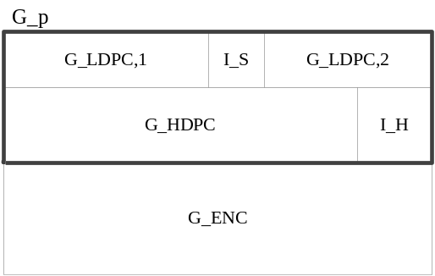
Figure 2 - Constraint Matrix A (cf. Figure 5 in sub-clause 5.3.3 in IETF RFC 6330)
Matrix A consists of six submatrices, ‘G_LDPC,1’, ‘I_S’, ‘G_LDPC,2’, ‘G_HDPC’, ‘I_H’ and ‘G_ENC’. The construction of those submatrices is described in sub-clause 5.3.3 in IETF RFC 6330.
We define the submatrix G_p as the submatrix which contains all submatrices for precoding.
G_p =
Hence, matrix A consists of G_p and G_ENC:
A =
The intermediate symbols C can then be calculated from the source symbols D as:
C=(A^^-1) D
If FEC code point 4 is signaled, then for all source blocks of the LA-FEC process of a target media layer x_target of size K₁,K₂,…,K_{x_target}, a repair symbol with any ESI >= K_{x_target} shall be generated as defined in sub-clause 8.3.1 and 8.3.2.

RaptorQ LA First Encoding Step – Intermediate symbol generation
This sub-clause specifies the intermediate symbol generation for RaptorQ LA for a given media layer 2 that depends on media layer 1. Media layer 1 represents the base layer with dependency_id = 0 and media layer 2 represents the enhancement layer with dependency_id = 1 as shown in Figure 14 in the AL-FEC Framework in ISO/IEC 23008-1.
With RaptorQ LA, matrix A is extended for integration of all media layers in a constraint matrix A__{LA_L} in a way to preserve the systematic behavior of the code as shown in the two layered example in Figure 3. 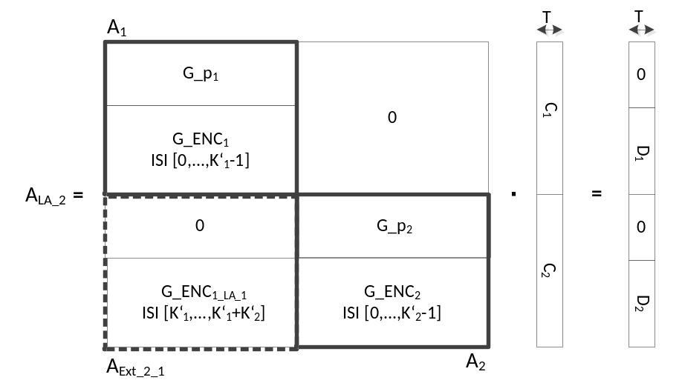
Figure 3 - Encoding process with Layer-Aware RaptorQ constraint matrix ALA_2 for 2 media layers
In the given example in Figure 3, matrix A_{LA_2} consists of the matrices A₁, A₂, the LA-FEC extension matrix A_{Ext_2_1} and a zero matrix.
A₁ and A₂ are generated as described in sub-clause 5.3.3 in IETF RFC 6330 with the constraint that the symbol size of all source and intermediate symbols T is equal in all cases which may result in different number of source symbols K₁, K₂. the matrices denoted by ‘0’ are zero matrices of respective sizes.
The LA-FEC extension matrix B_{1_LA} comprises the continuation matrix G_ENC_{1_LA_1} and a zero matrix. G_ENC_{1_LA_1} is the continuation of the G_ENC₁ matrix of media layer l=1, which is part of the A₁ matrix. The continuation matrix G_ENC_{1_LA_1} is generated in a way that each row is unique in G_ENC₁ and G_ENC_{1_LA_1}. It is generated in the same way as G_ENC₁ by function Enc, which is described in sub-clause 5.3.3.4.2 in IETF RFC 6330. While G_ENC₁ is generated from ISIs [0: K’₁-1], G_ENC_{1_LA_1} is generated from ISIs [K’₁,…,K’₁+K’₂-1].
We describe the LA-FEC continuation matrix as B_{1_LA_1}=[0; G_ENC_{1_LA_1}], the matrix A_{LA_2} of Layer-Aware RaptorQ is described for media layer l=2 by:
A_{LA_2} =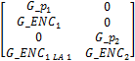=
The intermediate symbols C₁ and C₂ can then be calculated from source symbols D₁ and D₂ as:
[C₁C₂] = (A_{LA_2}^^-1) ∙[D₁D₂]
This concept can further be extended for the x-th media layer as shown by matrix A_{LA_x}:
A_{LA_x}=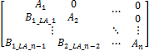
A_{Ext_i_j} is the j-th continuation matrix of G_ENC_{i} generated from ISIs [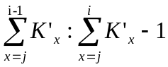].
The intermediate symbols C_{1,}C₂,…,C_{x} can then be calculated from source symbols D_{1,}D₂,…,D_{x} as:
[C₁C_{2…}C_{x}] = (A_{LA_x}^^-1)*[D₁D₂…D_{x}]
For solving the equation an efficient decoding process as described by the example FEC Decoder in sub-clause 5.4 in IETF RFC 6330 can be applied.

Layer-Aware RaptorQ Second Encoding Step
The second encoding steps generates the repair symbols E_{x} of media layer x from the intermediate symbols C.
In the following we consider the case with n media layers with the intermediate symbols C=[C₁C_{2…} C_{n}] and describe the encoding process for generation of repair symbols E_{x_target} of media layer x_target with x_target being the target layer for which repair symbols should be encoded.
The generation of the repair symbols E from intermediate symbols C is described in sub-clause 5.3.4 in IETF RFC 6330. The repair symbols E_{x_target} are generated from all intermediate symbols C^{(x_target)}=[C₁C_{2…} C_{x_target}]. The process for generation of the non-systematic encoding symbols is described in the following pseudo code:
For (i=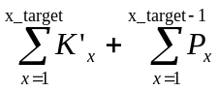; i<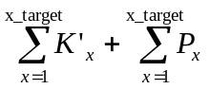; i++)
E_{x_target} [i] = 0;
for layer 1:x_target
E_{x_target} [i]= E_{x_target} [i] XOR Enc(K’_{layer}, C_{layer}, (d,a,b,d1,a1,b1))
end
end

Layer-Aware RaptorQ Decoding
The decoding process is performed analogously to the encoding process of a set of received encoding symbols represented by tuples R_{x} with the related ISIs [R_{x}] of the involved FEC flows of media layers x=1,…,n. The decoding process for decoding all layers together is similar to the encoding process (sub-clause 8.2.1). The difference is that for the first encoding process the matrix G_ENC₁ and G_ENC₂ are generated from ISI [R₁] and ISI [R₂] and G_ENC_{1_LA_1} is generated from ISI [R₂(+K’₁)] of all received encoded symbols R₂, where (+K’₁) denotes that each element in R₂ is incremented by (+K’₁).
Note that layers used for prediction, e.g. base layer, can also be decoded independently of predicting layers, e.g. enhancement layer, and that the FEC flow of media layer x=1 is generated with FEC code point 3.
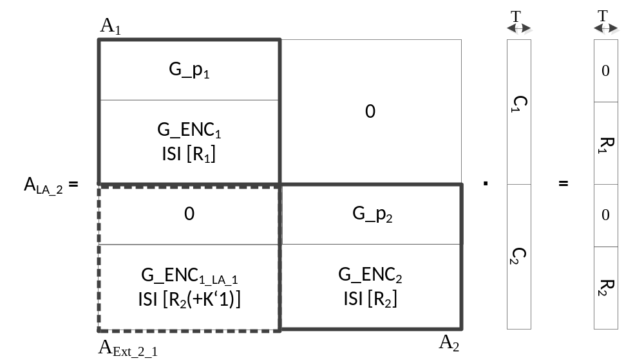
Figure 4 - Decoding process with Layer-Aware RaptorQ constraint matrix ALA_2 for 2 media layers
An exemplary decoder for solving the decoding process is specified in sub-clause 5.4 of IETF RFC 6330.
The second encoding process is analogously to the process described in 8.3.2 with C=[C₁C₂] as input from the first encoding process.

Specification for FireFort Low Density Generate Matrix (FireFort-LDGM) codes

Introduction
FireFort-LDGM (FF-LDGM) code is a special case of irregular repeat–accumulate codes that are well known as LDPC staircase in IETF RFC 5170. The specified FF-LDGM codes can support packet-division scheme and structured interleaving. Also the difference of the specified FF-LDGM code and LDPC staircase in IETF RFC 5170, the specified FF-LDGM codes can use optimized parity check matrixes for low complexity message passing decoding algorithm. Furthermore, Layer-Aware FF-LDGM codes that consist of FF-LDGM codes are suitable to support Layer-Aware FEC coding structure. This clause provides full specification of FF-LDGM/Layer-Aware FF-LDGM codes, which works on the same code point.

FireFort Low Density Generator Matrix (FireFort-LDGM) Codes

Definition
- H_{P’,N’} : denotes a sparse parity check matrix with P’ rows and N’ columns.
- G_{i}: denotes a mother matrix.
- G’_{P’,K’} : denotes a punctured sparse matrix with P’ rows and K’ columns.
- T_{P’} : denotes a P’-by-P’ staircase matrix.
- W_{N’} : denotes N’ Encoding multiple symbols.
- S_{K’} : denotes K’ multiple source symbols.
- C_{P’} : denotes P’ multiple repair symbols
- K : denotes a number of source symbols
- P : denotes a number of repair symbols
- D : denotes division number of one source symbol
- K’ : denotes a number of multiple source symbols K*D
- P’ : denotes a number of multiple repair symbols P*D
- MK’ : number of mother matrix columns
- MP’ : number of mother matrix rows
- V_{P’} : denotes a P’ intermediate multiple repair symbols

FF-LDGM-Specific Elements
The following elements shall be defined with the FF-LDGM codes.
- N1m3 : an integer between 0 and 255 inclusive. The FF-LDGM scheme supports two target numbers of “non-zero elements” per column in the left side of the parity check matrix, N1 and N2. N1m3 is related to N1 which equals N1m3 + 3. The default value of N1m3 is set to 0.
- N2m4 : an integer between 0 and 255, inclusive. N2m4 is related to N2, which equals N2m4 + 4. The default value of N2m4 is set to 3.
- R : an integer between 0 and 255, inclusive. R indicates ratio between # of N1 columns (‘#N1) and # of N2 columns (#N2). R is equal to Ceil[#N2/(#N1+#N2)*255]. The default value of R is set to 48.
- Dm1 : an integer between 0 and 255, inclusive, indicating division number of one source symbol. The division number D equals Dm1 + 1. The default value of Dm1 is set to 0.
- GC: an integer between 0 and 255, inclusive, indicating number of Galois field elements for each column.
- MKm9 : an integer between 0 and 15, inclusive, indicating maximum number of mother matrix columns. The MK equals MKm9 + 9 and it is used in rate-adaptive mode only.
- MPm4 : an integer between 0 and 15, inclusive, indicating maximum number of mother matrix rows. The MP equals MPm4 + 4 and it is used in rate-adaptive mode only.
- RES : a reserved field for future use.
- M : a flag indicating use of rate-adaptive mode.
- L : an integer between 0 and 3, inclusive. L indicates target girth on Progressive Edge-Growth (PEG) algorithm. The default value of L is set to 2.
When the code point 5 is used for MMT AL-FEC Framework, the FF-LDGM specific elements are described in private field of AL-FEC message in ISO/IEC 23008-1 and the format is written as follows:

0 1 2 3
0 1 2 3 4 5 6 7 8 9 0 1 2 3 4 5 6 7 8 9 0 1 2 3 4 5 6 7 8 9 0 1
+-+-+-+-+-+-+-+-+-+-+-+-+-+-+-+-+-+-+-+-+-+-+-+-+-+-+-+-+-+-+-+-+
| N1m3 | N2m4 | R | Dm1 |
+-+-+-+-+-+-+-+-+-+-+-+-+-+-+-+-+-+-+-+-+-+-+-+-+-+-+-+-+-+-+-+-+
| GC | MKm9 | MPm4 | RES |M| L | private |
+-+-+-+-+-+-+-+-+-+-+-+-+-+-+-+-+-+-+-+-+-+-+-+-+-+-+-+-+-+-+-+-+
Figure 5 — Structure of FF-LDGM parameters.

Parity Check Matrix of FF-LDGM Scheme
FF-LDGM codes are one type of linear code; the parity check matrix contains mostly 0’s and only a small number of non-zero's. The parity check matrixes of FF-LDGM codes consist of 2 parts: one is sparse matrix G’ and the other is staircase matrix T and it given by
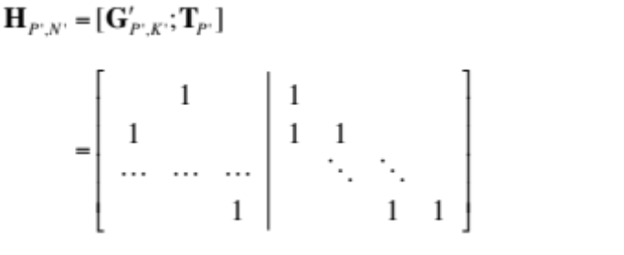 (1)
where G’ is a P’-by-K’ sparse matrix and T_{P’} is a P’-by-P’ square staircase matrix. In the case of rate-adaptive mode, sparse matrix G’ is generated from mother matrix G.

Creating a Sparse Matrix
Sparse matrix G ‘ and mother matrix G are generated by using the following procedure which is shown in Table 2.
Table 2 - Procedure of creating a sparse matrix
Procedure of creating a sparse matrix
void BigGirthMatrix(K’, P’, N1, N2, R, L, GC)
{
/* This function assumes that two empty matrixes, one is P’ * (K’+P’) matrix H’ and the other is P’ * K’ matrix G’. The matrix_insert_entryH(), matrix_resetH(), connectedNodes() and connectedNodes_clear() functions can access H’, and the matrix_insert_entryG(),permutation_matrixG() and nonbinary_matrixG() functions can access G’. The pmms_rand() shall be used in IETF RFC 5170 in clause 5.7 with PRNG seed=0x600DC0DE. In the case of rate-adaptive mode, mother matrix G is generated by using MK and MP parameters and then the K’ is set to 2^^MK and P’ is set to 2^^MP. */

reset_counter = -1;
reset_flag = -1;
/* make stair matrix */
FOR i = 0 to P’-1
matrix_insert_entryH(i,i);
IF (i != 0) THEN
matrix_insert_entryH(i,i-1);
ENDIF
row_weights[i]=2;
ENDFOR
row_weights[0]--;

FOR j=0 to K‘-1
tgt_gitch = L*2+2;
ITER:
ConnectedNodes_clear(); /* Clears all ConnectedNode values. */
IF (j < K‘-floor(K‘*R/255)) THEN
weight_cols = N1;
ELSE{
weight_cols = N2;
ENDIF
FOR w=1 to weight_cols
min = infinity;
FOR i=0 to P‘-1
IF ((row_weights[i] < min)AND(ConnectedNodes(i) == 0))
min = row_weights[i];
ENDIF
ENDFOR
max_index_length = 0;
FOR i = 0 to P‘-1
IF ((row_weights[i] == min)AND(ConnectedNodes(i) == 0)) {
index[max_index_len] = i;
max_index_len += 1;
ENDIF
ENDFOR
ret = pmms_rand(max_index_len);
/* This function returns random integer between 0 and max_index_len-1.*/
IF (w != weight_cols)THEN
IF (reset_flag !=1 )THEN
ConnectedCheckNode(index[ret],tgt_girth, j, p);
/* This function finds a minimum non-empty subset of unreachable check nodes from the target node via from 3 to less than tgt_girth edges.*/
sum ← Sum of all ConnectedNodes values
IF (sum == P‘) THEN
IF (tgt_girth >= 4) THEN
tgt_girth -= 2; goto ITER;
ELSEIF (tgt_girth < 4) AND (reset_counter==j)THEN
reset_flag = 1; goto ITER;
ELSE
reset_counter = j;
matrix_resetH(j); goto ITER;
/* This function clears values of columns form P’ to j on H’. */
tgt_girth = L*2+2; goto ITER;
ENDIF
ENDIF
ELSE
Set of all ConnectedNodes are zeros.
ENDIF
ENDIF
ENDFOR
matrix_insert_entryH(index[ret],j+p);
matrix_insert_entryG(index[ret],j);
row_weights[index[ret]]++;
ENDFOR
permutation_matrixG(K’, P’, R);
/* This function permutes columns of a matrix G’. */
IF (GC!=0) THEN
nonbinary_matrixG(K', P’, GC);
/* This function enhance a binary matrix to a non-binary matrix. */
ENDIF
}

The procedure of permutation operation in Table 2 is shown in Table 3 and the procedure of nonbinary_matrixG in Table 2 is shown in Table 4.
Table 3 - Procedure of generating a permutation matrix
Procedure of generating a permutation matrix
void permutation_matrixG(K’, P’, R)
{
/* This function permutes columns of a sparse matrix G’. Before permutation, the sparse matrix G’ is constructed with non-uniform weight distribution of columns.*/

nN1 = floor(K’*R/255);
nN2 = K’-nN1;
n1 = nN1;
n2 = nN2;
N1_counter = N2_counter = counter = 0;

FOR i=0 to nN2
interval = floor((n1+n2+1)/(n2+1));
FOR j=0 to interval-1
IF (j!=interval-1) THEN
randperm[j+counter] = N1_counter;
N1_counter = N1_counter+1;
ELSE
IF (i!=nN2) THEN
randperm[j+counter] = nN1+N2_counter;
N2_counter = N2_counter+1;
ENDIF
ENDIF
counter = counter + interval;
n1 = n1-(interval-1);
n2 = n2-1;
ENDFOR
ENDFOR
FOR i=0 to K’-1
change_colums(i,randperm[i]);
/*This function changes two columns (i and randperm[i]) of G’. */
ENDFOR
}

Table 4 - Procedure of enhancing a binary matrix to a non-binary matrix
Procedure of enhancing a binary matrix to a non-binary matrix
void nonbinary_matrixG(K', P’, GC)
{
/* This function enhances a binary matrix G’ to a non-binary matrix G’. However, if GC is set to 0, this function does not applied.*/
FOR i = 0 to K’-1
GC_counter = 0;
FOR j = P’-1 to 0
IF (return_matrixG_value(j,i)) AND (GC_counter<GC) THEN
/* This function returns value of element in i-th row and j-th column of a matrix G’. */
ret = pmms_rand(255);
matrix_insert_nonbinary(j,i,ret+1);
/* This function inserts nonbinary value (ret+1) of element in j-th row and i-th column of a matrix G’. */
GC_counter++;
ENDIF
ENDFOR
ENDFOR
}

Creating a Punctured Sparse Matrix
In the case of rate-adaptive mode, the systematic part of parity check matrix is a punctured sparse matrix, which is created by a mother matrix. In this mode, MK’ should be set to larger than K’. The punctured matrix is created as follows:
- Step1) Removing (MK’-K’) columns of mother matrix from right side. (Figure 6 Step 1)
- Step1’) In the case of MP’ is smaller than P’, generating intermediate sparse matrix with MP’ *2^ceil(Log2(P'/MP’)) rows and K’ columns.
- Step2) Puncturing (MP’*2^ceil(Log2(P'/MP’)) -P’) rows of intermediate sparse matrix from topside. This puncturing operation is a simple sum operation of two rows over GF(2) in the case of GC is set to 0 or GF(256) in the case of GC is not set to 0. (Figure 6 Step 2)

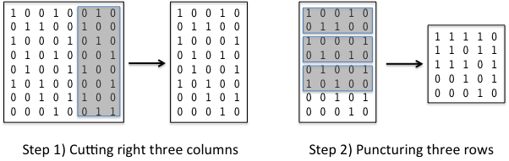
Figure 6 — Puncture operation example to generate punctured matrix (MK=8, K’=5, P’=5, GC=0 case)

After puncturing process, the P’ by K’ punctured space matrix G’ is generated. The detail of a puncture algorithm to generate a puncture sparse matrix is provided in Table 5.

Table 5 - Procedure of creating a puncture matrix
Procedure of creating a punctured matrix
void puncture_matrix(K’, P’, MK’, MP’)
{
delete_columns(MK’-K’);
CP = MP’;
while (1){
IF (CP<P’) TEHN
prepare_new_matrixG(CP*2, K’);
/* This function prepares CP*2-by-MK' matrix G'. The initial values of odd columns are copied from CP-by-MK’ matrix.*/
FOR i=0 to CP-1
count = 0;
FOR j=0 to K’-1
IF matrix_has_value(2^i-1, j)
IF count%2 == 1
move_value(j,2^i-1, 2^i);
/* This function moves value of matrix G’(2^i-1,j) to G’(2^i,j). */
ENDIF
count +=1;
ENDIF
ENDFOR
ENDFOR
CP *=2;
ELSEIF
break;
ENDIF
}
count = 0;
WHILE (1) {
IF (P’ >= ceil(CP/2)) TEHN
NP = P’;
ELSE
NP = ceil((CP/2));
ENDIF
FOR i=0 to CP-NP-1
puncture_rows(i*2^^(count+1),i*2^^(count+1)+2^^(count));
/* This function squashes two rows. */
ENDFOR

IF (P’ == NP) THEN
break;
ENDIF
count++;
CP = NP;
}
FOR i=0 to CP-P’-1
pickout_row(i*2^^(count+1));
/* This function reconstructs a punctured sparse matrix from intermediate matrix. */
ENDFOR
FOR j=0 to P’-i-1
pickout_row(i*2^^(count+1)+j*2^^(count));
ENDFOR
}

Source symbol division scheme

The source symbol splitter divides one source symbol to D multiple source symbols (Figure 7). The division number of D is a parameter number and it should be satisfied with T%D=0. If T%D is not equal 0, the last source symbol is padded with zero. Then, the K’ multiple source symbols are generated.
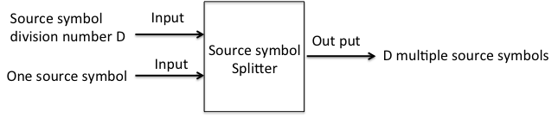
Figure 7 —Source symbol splitter process

Structured interleaving and de-interleaving scheme

Before encapsulation, the generated multiple repair symbols are interleaved. The interleaving just changes the index of its symbols. Let Sj be the j-th multiple repair symbol and always j starts 1 for each block and is incremented by 1. The interleaved new index is given by

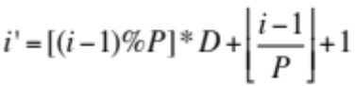 (2)

where [(i-1)%P] returns the value of modulo arithmetic and floor[*] returns the value of cutoff arithmetic. After structured interleaving process (Figure 8 Step 1), i-th multiple repair symbol is mapped to i’-th symbol (Figure 8 Step2). After this process, repair symbols are regenerated.

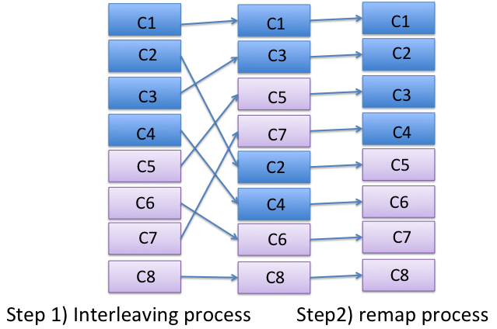
Figure 8 — Example of structured interleaving process in the case of P=2 and D=4.
In the opposite of interleaving, the de-interleaving process is remap operation from i’-th index to i-th index.

FF-LDGM code Encoding Algorithm

Briefly, at the encoder side, the FF-LDGM coder calculates each parity packet as multiplication operation of sparse matrix G’ and the K’ multiple source symbols. In the case of Galois field mode which GC is not set to 0, FF-LDGM codes use the primitive polynomial 1 + x² + x³ + x⁴ + x⁸ in GF(256). From definition of linear code, the K’ multiple source symbols and the P’ multiple repair symbols are related as follows:

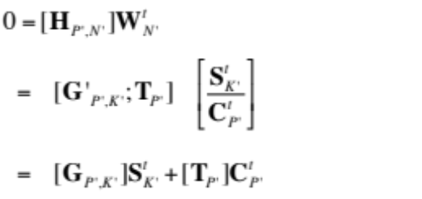(3)

The multiple repair symbols, C_{P’}, can be written as

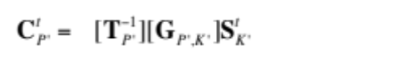. (4)
From above equation, the encoding operation can be divided into two steps:

Step 1) compute intermediate multiple repair symbols V_{m} = [G_{P’,K’}]S^{t}_{K’},
Step 2) pass intermediate multiple repair symbols V_{m} through an accumulator to create C^{t}_{m}.

These processes are written as
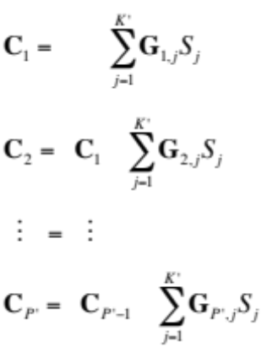 (5)
Where G_{P’,j} are the matrix elements of each column. From above equation, the P’ multiple repair symbols C_{P’} can be computed in linear time.

FF-LDGM code Decoding Algorithm
On the decoder side, if packet losses are frequent, source symbols and repair symbols are divided into multiple source and repair symbols, which are then de-interleaved in multi repair symbols part. This process avoids burst multiple repair symbol errors and multiple repair symbols losses do not neighbor each other. After above processing, the decoding of the proposed FF-LDGM codes recover erasure multiple symbols by using message passing algorithm (MPA) and/or Gaussian elimination algorithm (GEA). Since the FF-LDGM codes is linear code, it is possible to write as follow:

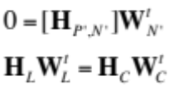 (6)
where H_{L} is parity check matrix corresponding to erasure multiple symbols W_{L}, and Hc is parity check matrix corresponding to correct multiple symbols W_{C}. In the above left equation, if the decoder finds one erasure symbol in one row, the erasure multiple symbol is recovered by sum of all corrected symbols in same row equation.

Finally, the decoded source symbols are reconstructed again and the decoding process is finished.

Layer-Aware FireFort-LDGM (LA FireFort-LDGM) Codes

Specification of the LA FF-LDGM Scheme

Layer-Aware FF-LDGM Codes allow the source symbols for the enhancement layers to be used in the base (or lower) layer; this increases the total block length and raises the probability of recovering the base layer. The layer-Aware FF-LDGM codes are made by combining several sparse matrixes. The layer-Aware FF-LDGM codes are defined by
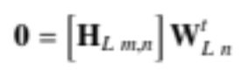 (7)
where the H_{L m,n} is layered sparse matrix, which uses Layer-Aware FF-LDGM codes, and the W_{L} is received multiple symbols, which include each layer's data. H_{L m,n} and W_{L n}, are given by

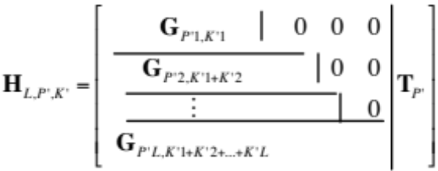 (8)
. (9)

Table 6 shows multiple source and repair symbols assigned at base layer and enhancement layers.
Table 6 - Multiple souce symbols and corresponding repair symbols at each layer
 | Source symbol | Corresponding repair symbol
Base layer | Sk1 | Cm1
Enhancement layer 1 | Sk2 | Cm2
… | … | …
Enhancement layer L-1 | SkL | CmL

Encoding Algorithm
The encoding algorithm is same process as the basic FF-LDGM codes described in sub-clause 8.2.8

Decoding Algorithm
The decoding of the Layer-Aware FF-LDGM codes is carried out by MPA algorithm of the basic FF-LDGM codes described in sub-clause 8.3.1 according to the eq. (9). The tanner graph of the Layer-Aware FF-LDGM codes is illustrated in Figure 9. From Figure 9, we can see that received symbols for the base layer are connected to those of enhancement layers. It is clear that the proposed structure yields the valuable characteristic that the base layer is protected by more parity symbols, and so is very suitable for layered video data. Furthermore, the Layer-Aware FF-LDGM code supports partial decoding.
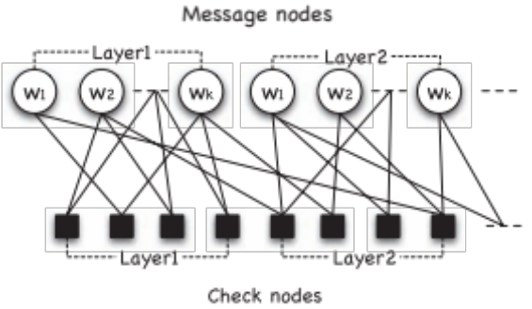
Figure 9 - Corresponding to tanner graph of Layer-Aware FF-LDGM codes.

Specification for FEC code algorithms in SMPTE 2022-1
Refer to FEC code algorithms which are specified in SMPTE 2022-1.

Bibliography
- M. P. C. Fossorier, “Quasi-Cyclic Low-Density Parity-Check Codes,” in Proc. ISIT 2003, Yokohama, Japan, June/July 2003, p. 150.
- S. Myung, K. Yang, and J. Kim, "Quasi-cyclic LDPC codes for fast encoding," IEEE Transactions on Information Theory, vol. 51, pp. 2894-2901, Aug. 2005.

