Prediction Model for Progression-Free Survival in Breast Cancer Patients
P8106 Data Science II — Midterm Project
Fangchi Lu (fl2714), Meitong Zhou (mz3084), Jiawa Zhang (jz3900)
Spring 2026
Part I: Prediction Model for the 1990–1995 Cohort
1.1 Model Training
Because all 2,000 patients in datA were followed until disease progression or death with no censored observations, the log-transformed PFS can be treated as a fully observed continuous outcome. Survival analysis methods (e.g., Cox regression) are designed for censored data and offer no advantage here; standard linear regression-based models are therefore appropriate. The outcome log(PFS) was approximately normally distributed (see Figure 1), with mean 2.20 (SD = 0.78), further supporting this choice.

All 15 predictor variables were included as candidate predictors, spanning demographics (age, menopausal status, race, BMI), tumor characteristics (tumor size, grade, lymph node count, ER, PR, HER2 status, Ki-67, clinical stage), and initial treatment (surgery type, chemotherapy, hormonal therapy). This decision reflects the primary goal of clinical interpretability rather than parsimony: excluding predictors based on univariate screening or automated selection can introduce bias, and the full set of variables represents established clinical factors for PFS prediction in breast cancer. Regularization within Elastic Net penalizes uninformative predictors implicitly, and the GAM smooth terms adaptively allocate complexity, so over-fitting risk is managed by the modeling framework rather than by variable exclusion. Categorical variables were factor-coded with reference levels set to White race, pre-menopausal status, well-differentiated tumor grade, Stage I, receptor-negative status, breast-conserving surgery, no chemotherapy, and no hormonal therapy.

Exploratory analysis (Figures 2–4) identified two features motivating the candidate model set. First, tumor size and lymph node count were strongly collinear (Pearson r = 0.71), inflating variance under OLS and motivating penalized regression. Second, LOESS curves revealed non-linear associations of log(PFS) with BMI, tumor size, and lymph node count, motivating flexible additive models.

Four candidate models were trained in R using the caret package (v6.0) with set.seed(1) applied before every stochastic operation. Model evaluation used 10-fold cross-validation repeated 5 times (50 resamples total), specified via trainControl(method = "repeatedcv", number = 10, repeats = 5). Predictors were centered and scaled using preProcess = c("center", "scale") applied inside each CV fold (not on the full training set before splitting), ensuring no data leakage into the validation folds. The same 50-resample index was used across all caret models for paired comparison via resamples().
Model 1 — OLS fit a standard multiple linear regression with all 16 predictors, serving as the interpretable baseline.
Model 2 — Elastic Net combined L1 and L2 penalties via the objective min ‖y − Xβ‖² + λ[(1−α)‖β‖² + α‖β‖₁]. The mixing parameter α was searched over {0, 0.1, …, 1} and λ over 50 log-uniformly spaced values in [0.001, 1]. Optimal hyperparameters were selected by minimizing CV-RMSE.
Model 3 — MARS searched over degree ∈ {1, 2} and number of retained terms ∈ {2, …, 20}. The optimal model selected degree = 1, indicating no two-way interaction improved out-of-sample performance.
Model 4 — GAM was fitted using mgcv::gam() with REML smoothness estimation. Penalized thin-plate regression splines were placed on each continuous predictor; categorical predictors entered linearly. CV-RMSE for the GAM was obtained via a single 10-fold split (not repeated) using the same seed.
1.2 Results
As shown in Table 3, all four models yielded nearly identical CV-RMSE values (range: 0.6975–0.7035). The absolute differences between models are small (< 0.006 RMSE units) and likely not practically significant given the inherent predictive ceiling of 16 baseline clinical variables. GAM was selected as the final model for the following reasons: (1) it achieved the lowest CV-RMSE (0.6975) and highest CV-R² (0.2068); (2) the LOESS-identified non-linearities provided empirical justification for smooth terms; and (3) MARS selecting degree = 1 confirmed that no interaction term improved prediction, validating the additive structure. The final selected model is a Generalized Additive Model of the form:

log(PFS)_{i} = β₀ + s(age) + s(BMI) + s(tumor_size) + s(lymph_nodes) + s(Ki67) + X_{i}ᵀγ + ε_{i}

where s(·) denotes a penalized thin-plate regression spline estimated by REML, Xᵢ is the vector of categorical predictors entering linearly with coefficient vector γ, and εᵢ ~ N(0, σ²) is the error term. The effective degrees of freedom for each smooth term are determined by the data.

The parametric coefficient estimates are presented in Table 3a, and smooth-term significance is summarized in Table 3b. Significant predictors included: ER-positive status (+0.234 log-months, p < 0.001), HER2-positive status (−0.174, p < 0.001), poorly differentiated grade (−0.162, p = 0.006), and hormonal therapy (+0.133, p < 0.001). All smooth terms were significant, with BMI showing the strongest non-linearity (edf = 4.00; Table 3b). Partial effects are shown in Figure 5.

The final GAM had a training RMSE of 0.690 and training adjusted R² of 0.214; cross-validated RMSE was 0.698 and CV-R² was 0.207 (Table 3c). The negligible gap between training and CV metrics confirms that overfitting was not a concern.
Part II: Generalizability to the 2000–2005 Cohort
2.1 Cohort Comparison
The 2000–2005 cohort (datB) differed substantially from datA on both outcome and predictors (Tables 4–6). Mean log(PFS) increased from 2.196 to 2.742 (Welch t-test, p < 2.2 × 10⁻¹⁶; Figure 6), consistent with advances in treatment, earlier detection, and changing screening practices. The datB cohort showed a higher proportion of Stage I disease (34.6% vs. 25.2%), greater chemotherapy (64.9% vs. 55.2%) and hormonal therapy use (57.0% vs. 46.7%), and lower mean tumor size and lymph node count.
2.2 External Validation of Model A
The datA GAM was applied directly to datB using predict() with no model updating. Generalizability was assessed against two practical heuristic criteria: external RMSE ≤ 110% of internal CV-RMSE (allowing at most a 10% degradation in precision) and external R² ≥ 90% of internal CV-R² (allowing at most a 10% degradation in explained variance). These thresholds are not derived from formal theory but represent reasonable benchmarks for applied clinical prediction models, balancing the expectation of some performance loss on a new population against the requirement for a usable model.

Both criteria failed (Table 8). External RMSE was 0.844 (vs. CV-RMSE of 0.698, a 21% increase) and external R² was 0.162 (vs. 0.207, a 22% decrease; Tables 7–8). The mean prediction bias was +0.500, meaning the model systematically underpredicted log(PFS) in datB by approximately half a log-month. The quintile calibration table (Table 8a) and calibration plot (Figure 7) reveal that this error has the structure of a systematic intercept shift: observed log(PFS) exceeded predictions by a nearly constant offset (~0.50) across all five quintiles of predicted values, with the slope of observed-on-predicted being approximately correct (Figure 8). This pattern indicates that the model's relative risk ordering and association structure are preserved, but the absolute level of PFS has shifted upward in the later cohort—a distributional shift rather than full model misspecification. The model therefore does not generalize in absolute terms, but the association structure remains informative.
2.3 Refitted Model in datB
The same four-model training pipeline was applied to datB with identical preprocessing, seed, and resampling. As shown in Table 9, GAM again achieved the best performance (CV-RMSE = 0.669, CV-R² = 0.177), confirming that the nonlinear additive structure is the appropriate model class for this outcome. The refitted GAM improved substantially over the transported model: RMSE fell from 0.844 to 0.669 and MAE from 0.686 to 0.534 (Table 10).
2.4 What Changed in Prediction
Comparison of parametric coefficients and smooth-term significance between the two GAMs reveals meaningful shifts (Tables 11–12). Most notably, HER2 status reversed: in datA it was significantly associated with worse PFS (estimate = −0.174, p < 0.001); in datB the coefficient was near zero and non-significant (estimate = +0.034, p = 0.35), likely reflecting wider access to HER2-directed therapy in the early 2000s. Hormonal therapy's benefit strengthened (datA: +0.133; datB: +0.209, both p < 0.001). Conversely, the effect of poorly differentiated grade attenuated (datA: −0.162, p = 0.006; datB: −0.089, p = 0.13) and age became non-significant in datB (p = 0.10). Among smooth terms, Ki-67 gained significance (datB p = 0.007 vs. 0.050 in datA) and lymph node count showed greater non-linearity (edf: 1.00 → 1.69; Figure 9).

In summary, the best model class, GAM with smooth terms on continuous predictors, remained consistent across cohorts. However, the fitted prediction function shifted materially, primarily driven by the population-level increase in PFS and the changing predictive role of HER2. The systematic underprediction in datB reflects an intercept shift rather than structural misspecification; re-estimating the model in datB fully corrected this shift and produced materially better predictions.

Appendix: Tables and Figures
Table 1. Summary statistics of continuous variables in datA (1990–1995).
Variable | Mean | SD | Median | Min | Max
Age (years) | 54.99 | 11.65 | 55.00 | 25.00 | 85.0
BMI (kg/m²) | 26.06 | 4.56 | 26.05 | 16.00 | 42.6
Tumor size (cm) | 3.38 | 1.71 | 3.10 | 0.30 | 8.3
Lymph nodes (count) | 2.62 | 2.59 | 2.00 | 0.00 | 16.0
Ki-67 (%) | 21.85 | 11.58 | 21.60 | 1.00 | 62.3
log(PFS) (months) | 2.20 | 0.78 | 2.19 | −0.53 | 5.1

Table 2. Frequency distribution of categorical variables in datA (1990–1995).
Variable | Level | n (%)
Menopausal status | Pre-menopausal | 689 (34.5%)
 | Post-menopausal | 1311 (65.5%)
Race/ethnicity | White | 1284 (64.2%)
 | Black | 289 (14.4%)
 | Asian | 176 (8.8%)
 | Hispanic | 251 (12.6%)
Tumor grade | Well differentiated | 383 (19.1%)
 | Moderately differentiated | 871 (43.5%)
 | Poorly differentiated | 746 (37.3%)
Clinical stage | Stage I | 504 (25.2%)
 | Stage II | 893 (44.6%)
 | Stage III | 603 (30.1%)
ER status | Positive | 1281 (64.0%)
PR status | Positive | 961 (48.0%)
HER2 status | Positive | 444 (22.2%)
Surgery type | Breast-conserving | 986 (49.3%)
 | Mastectomy | 1014 (50.7%)
Chemotherapy | Yes | 1105 (55.2%)
Hormonal therapy | Yes | 934 (46.7%)

Table 3. Cross-validated performance of four candidate models on datA (10-fold CV × 5 repeats). Performance differences are small (< 0.006 RMSE) and not practically significant; GAM was selected for its lowest CV-RMSE and empirically justified non-linearity.
Model | CV-RMSE | CV-R²
GAM (selected) | 0.6975 | 0.2068
Elastic Net | 0.7016 | 0.1996
MARS | 0.7031 | 0.1979
OLS | 0.7035 | 0.1951

Table 3a. Parametric coefficient estimates from the final GAM (datA). Reference levels: White, pre-menopausal, well-differentiated, Stage I, receptor-negative, BCS, no chemotherapy, no hormonal therapy.
Term | Estimate | SE | t-value | p-value
(Intercept) | 2.013 | 0.078 | 25.98 | <0.001
Age | (smooth — Table 3b) |  |  | 0.029
Menopausal: Post | 0.038 | 0.047 | 0.81 | 0.416
Race: Black | 0.038 | 0.045 | 0.84 | 0.400
Race: Asian | 0.067 | 0.056 | 1.19 | 0.234
Race: Hispanic | −0.042 | 0.048 | −0.87 | 0.386
BMI | (smooth — Table 3b) |  |  | <0.001
Tumor size | (smooth — Table 3b) |  |  | 0.006
Grade: Moderate | −0.045 | 0.046 | −0.97 | 0.332
Grade: Poor | −0.162 | 0.059 | −2.74 | 0.006
Lymph nodes | (smooth — Table 3b) |  |  | <0.001
ER: Positive | 0.234 | 0.052 | 4.53 | <0.001
PR: Positive | −0.006 | 0.039 | −0.14 | 0.885
HER2: Positive | −0.174 | 0.039 | −4.49 | <0.001
Ki-67 | (smooth — Table 3b) |  |  | 0.050
Stage: II | 0.085 | 0.056 | 1.52 | 0.128
Stage: III | 0.095 | 0.104 | 0.91 | 0.364
Surgery: Mastectomy | −0.008 | 0.033 | −0.25 | 0.803
Chemotherapy: Yes | −0.001 | 0.032 | −0.04 | 0.965
Hormonal therapy: Yes | 0.133 | 0.040 | 3.33 | <0.001

Table 3b. Smooth-term significance in the final GAM (datA). edf > 1 indicates non-linearity.
Smooth Term | edf | Ref. df | F | p-value
s(Age) | 1.001 | 1.001 | 4.74 | 0.029
s(BMI) | 3.995 | 4.988 | 7.07 | <0.001
s(Tumor size) | 2.121 | 2.729 | 4.55 | 0.006
s(Lymph nodes) | 1.002 | 1.004 | 46.35 | <0.001
s(Ki-67) | 1.001 | 1.002 | 3.83 | 0.050

Table 3c. Performance metrics for the final GAM (datA). The negligible train–CV gap indicates no overfitting.
Metric | Value
Training RMSE | 0.6899
10-fold CV-RMSE (5 repeats) | 0.6975
Training R² (adjusted) | 0.2145
CV-R² | 0.2068

Table 4. Comparison of log(PFS) between cohorts (Welch t-test, p < 2.2 × 10⁻¹⁶).
Cohort | n | Mean log(PFS) | SD | Median
datA (1990–1995) | 2000 | 2.196 | 0.783 | 2.191
datB (2000–2005) | 2000 | 2.742 | 0.738 | 2.744

Table 5. Continuous predictor comparison between cohorts (Welch t-test).
Variable | datA Mean (SD) | datB Mean (SD) | Diff (B−A) | p-value
Age (years) | 54.99 (11.65) | 56.05 (11.22) | +1.06 | 0.004
BMI (kg/m²) | 26.06 (4.56) | 27.44 (5.05) | +1.38 | <0.001
Tumor size (cm) | 3.38 (1.71) | 3.08 (1.68) | −0.31 | <0.001
Lymph nodes | 2.62 (2.59) | 2.32 (2.53) | −0.31 | <0.001
Ki-67 (%) | 21.85 (11.58) | 20.37 (11.71) | −1.48 | <0.001

Table 6. Treatment and stage distribution between cohorts.
Variable | datA (%) | datB (%)
Stage I / II / III | 25.2 / 44.6 / 30.1 | 34.6 / 41.4 / 24.0
Chemotherapy (Yes) | 55.2 | 64.9
Hormonal therapy (Yes) | 46.7 | 57.0
Mastectomy | 50.7 | 44.1

Table 7. External validation performance of the datA GAM on datB versus internal CV performance. The large positive bias (+0.500) reflects a systematic intercept shift rather than structural misspecification.
Setting | RMSE | MAE | R² | Mean Bias
Internal CV on datA | 0.6975 | — | 0.2068 | —
External validation on datB | 0.8436 | 0.6862 | 0.1617 | +0.5003

Table 8. Generalizability criteria applied to the datA GAM. Thresholds (≤110% RMSE degradation; ≥90% R² retention) represent practical heuristics, not formal bounds.
Criterion | Threshold | Observed | Result
External RMSE ≤ 110% of internal CV-RMSE | ≤ 0.7673 | 0.8436 | Fail
External R² ≥ 90% of internal CV-R² | ≥ 0.1861 | 0.1617 | Fail
Overall conclusion | — | — | Does not generalize

Table 8a. Quintile-based calibration of the datA GAM in datB. The nearly constant gap (~0.64) across quintiles confirms an intercept shift rather than slope distortion.
Quintile of predicted value | Mean predicted log(PFS) | Mean observed log(PFS) | Difference | n
1 (lowest) | 1.691 | 2.329 | +0.638 | 400
2 | 2.051 | 2.544 | +0.493 | 400
3 | 2.275 | 2.758 | +0.483 | 400
4 | 2.480 | 2.951 | +0.471 | 400
5 (highest) | 2.713 | 3.131 | +0.418 | 400

Table 9. Cross-validated model performance on datB (10-fold CV × 5 repeats). GAM again achieves the lowest CV-RMSE; differences across models remain small.
Model | CV-RMSE | CV-R²
GAM (selected) | 0.6693 | 0.1772
Elastic Net | 0.6726 | —
MARS | 0.6731 | 0.1707
OLS | 0.6735 | 0.1691

Table 10. Performance of the transported datA GAM versus the refitted datB GAM.
Model | RMSE | MAE | R²
Transported GAM from datA | 0.8436 | 0.6862 | 0.1617
Refitted GAM on datB | 0.6693 | 0.5337 | 0.1772

Table 11. Parametric GAM coefficients: datA vs. datB. Asterisk (*) denotes p < 0.05. The HER2 reversal and strengthening of hormonal therapy are the most clinically meaningful changes.
Term | Est. (datA) | p (datA) | Est. (datB) | p (datB)
(Intercept) | 2.013 | <0.001* | 2.520 | <0.001*
Menopausal: Post | 0.038 | 0.416 | −0.034 | 0.446
Race: Black | 0.038 | 0.400 | −0.040 | 0.319
Race: Asian | 0.067 | 0.234 | −0.039 | 0.427
Race: Hispanic | −0.042 | 0.386 | 0.094 | 0.027*
Grade: Moderate | −0.045 | 0.332 | 0.079 | 0.063
Grade: Poor | −0.162 | 0.006* | −0.089 | 0.126
Stage: II | 0.085 | 0.128 | −0.004 | 0.934
Stage: III | 0.095 | 0.364 | 0.026 | 0.807
ER: Positive | 0.234 | <0.001* | 0.142 | 0.012*
PR: Positive | −0.006 | 0.885 | 0.064 | 0.081
HER2: Positive | −0.174 | <0.001* | 0.034 | 0.350
Surgery: Mastectomy | −0.008 | 0.803 | −0.017 | 0.602
Chemotherapy: Yes | −0.001 | 0.965 | −0.020 | 0.559
Hormonal therapy: Yes | 0.133 | <0.001* | 0.209 | <0.001*

Table 12. Smooth-term comparison between datA and datB GAMs. s(Ki-67) gained significance and s(lymph_nodes) became more non-linear in datB.
Smooth Term | edf (datA) | p (datA) | edf (datB) | p (datB)
s(Age) | 1.001 | 0.029* | 1.001 | 0.103
s(BMI) | 3.995 | <0.001* | 3.645 | <0.001*
s(Tumor size) | 2.121 | 0.006* | 2.142 | 0.010*
s(Lymph nodes) | 1.002 | <0.001* | 1.691 | 0.005*
s(Ki-67) | 1.001 | 0.051 | 1.001 | 0.007*

Figures
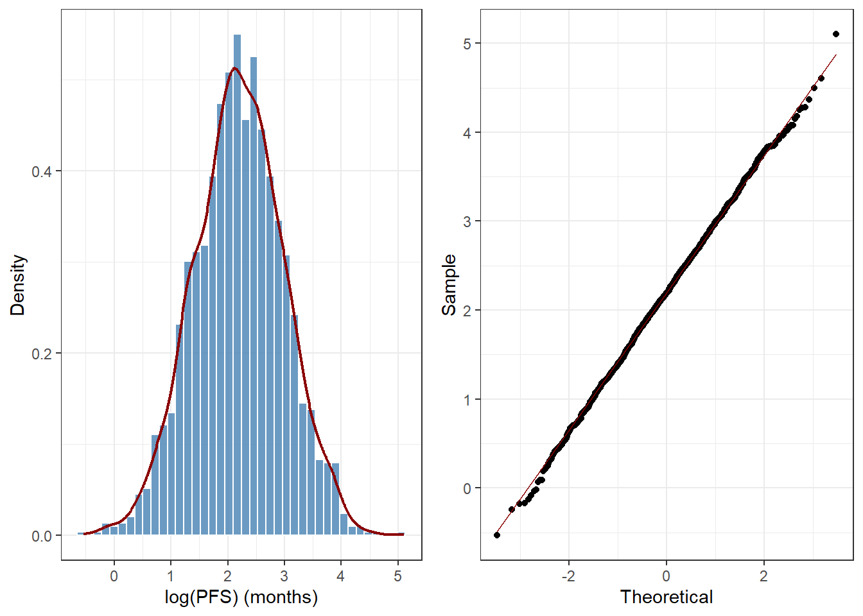
Figure 1. Distribution of log(PFS) (histogram + density overlay) and normal Q-Q plot for datA. The approximately normal distribution supports linear regression-based modeling without survival analysis.

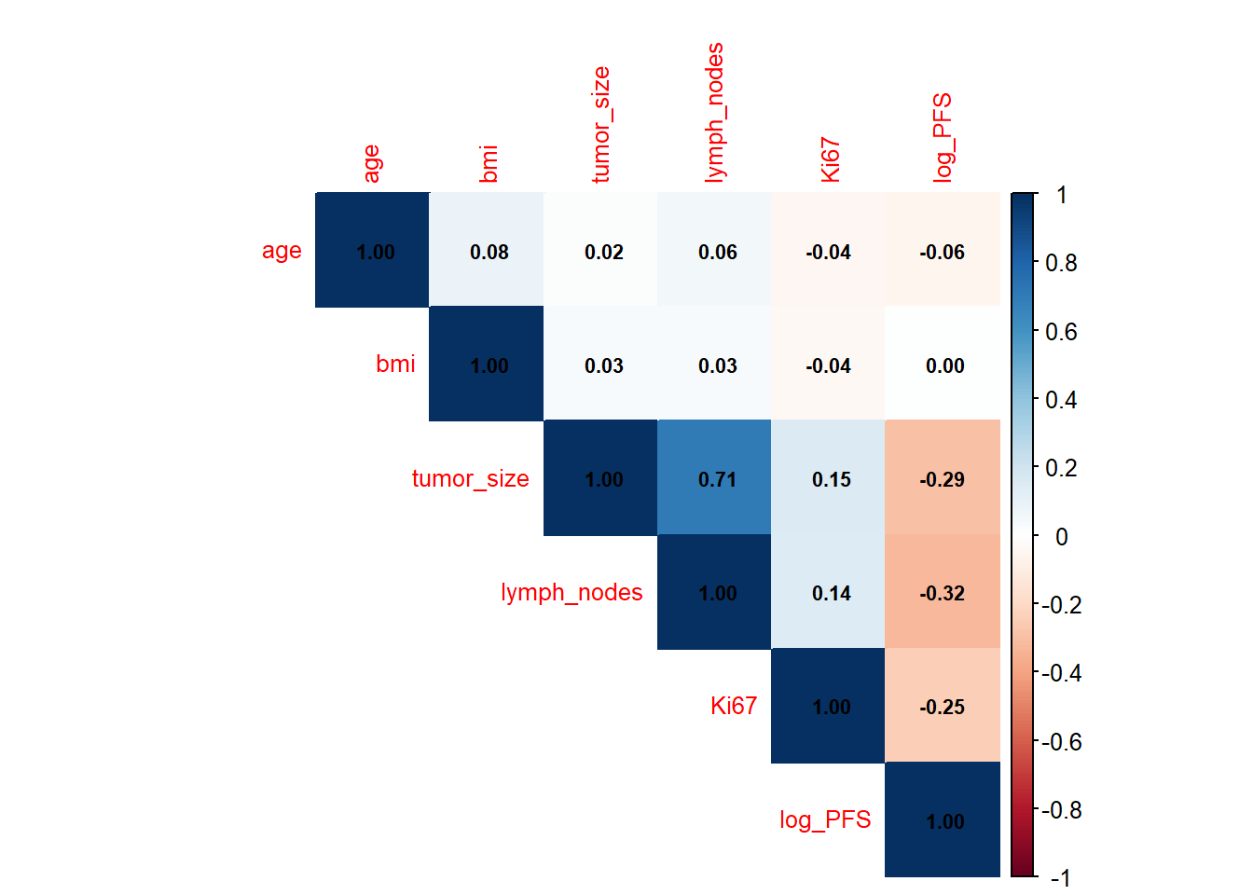
Figure 2. Correlation matrix of continuous predictors in datA. Tumor size and lymph node count are strongly collinear (r = 0.71), motivating Elastic Net regularization.

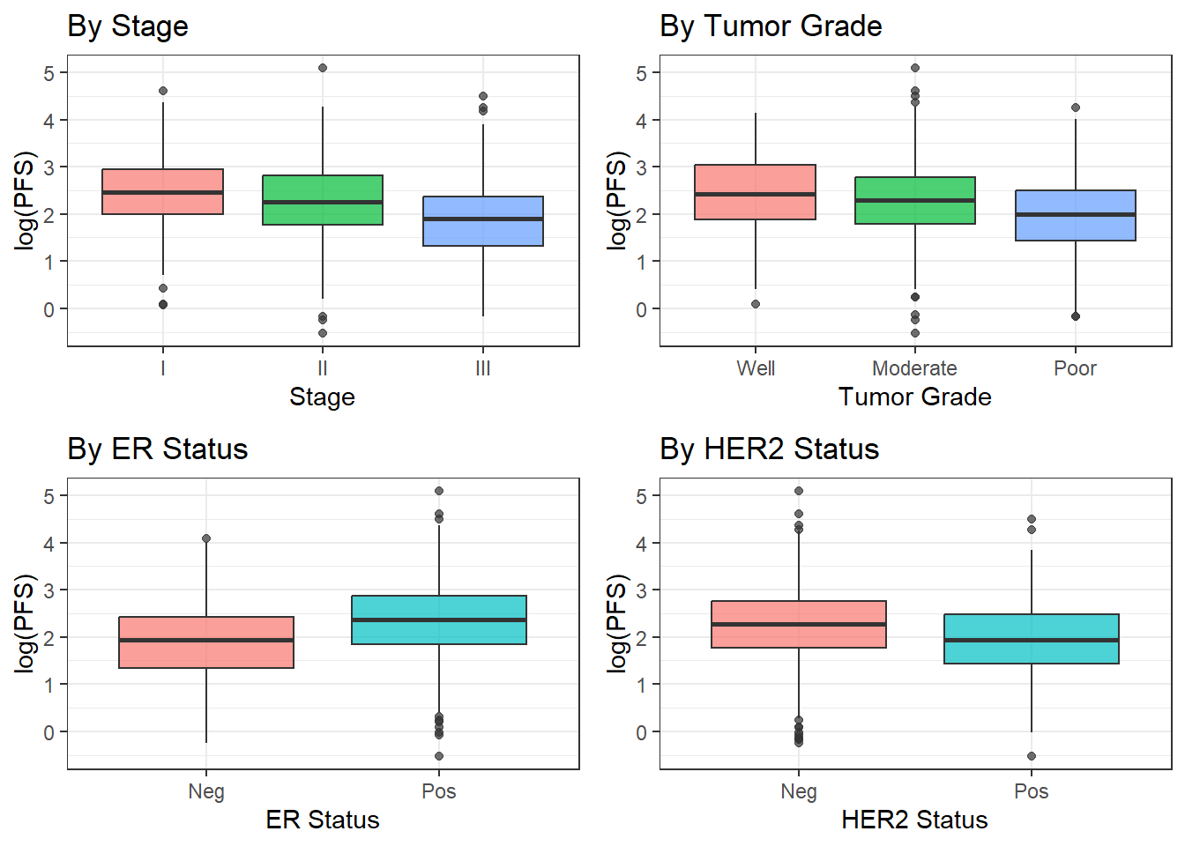
Figure 3. Boxplots of log(PFS) by clinical stage, tumor grade, ER status, and HER2 status in datA.

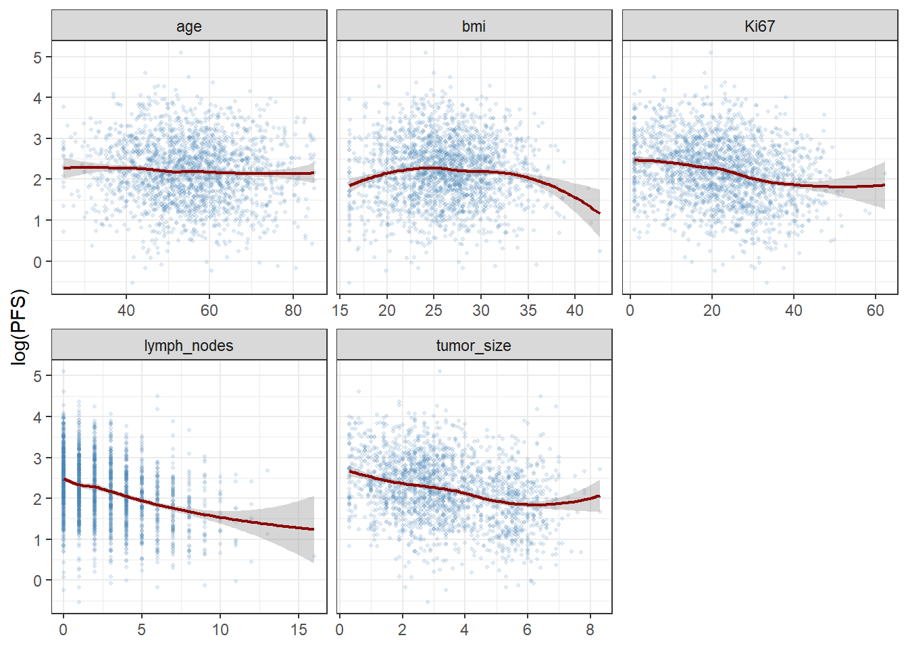
Figure 4. LOESS scatterplots of log(PFS) against each continuous predictor in datA. Non-linear trends are evident for BMI, tumor size, and lymph node count.

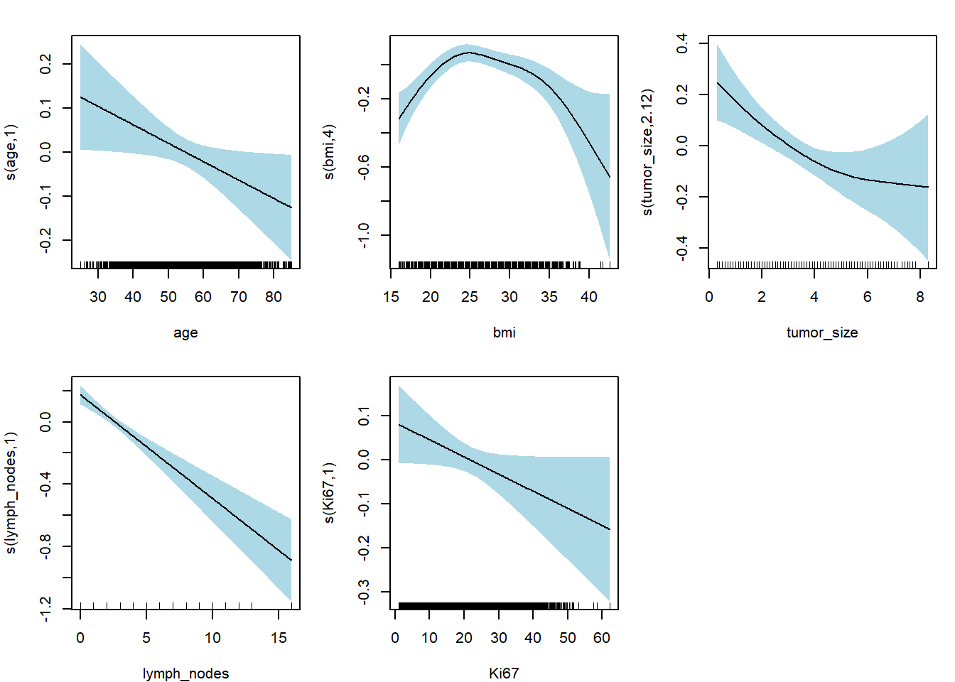
Figure 5. Partial effects of smooth terms in the final datA GAM. Shaded bands represent 95% credible intervals; rug marks indicate data density.

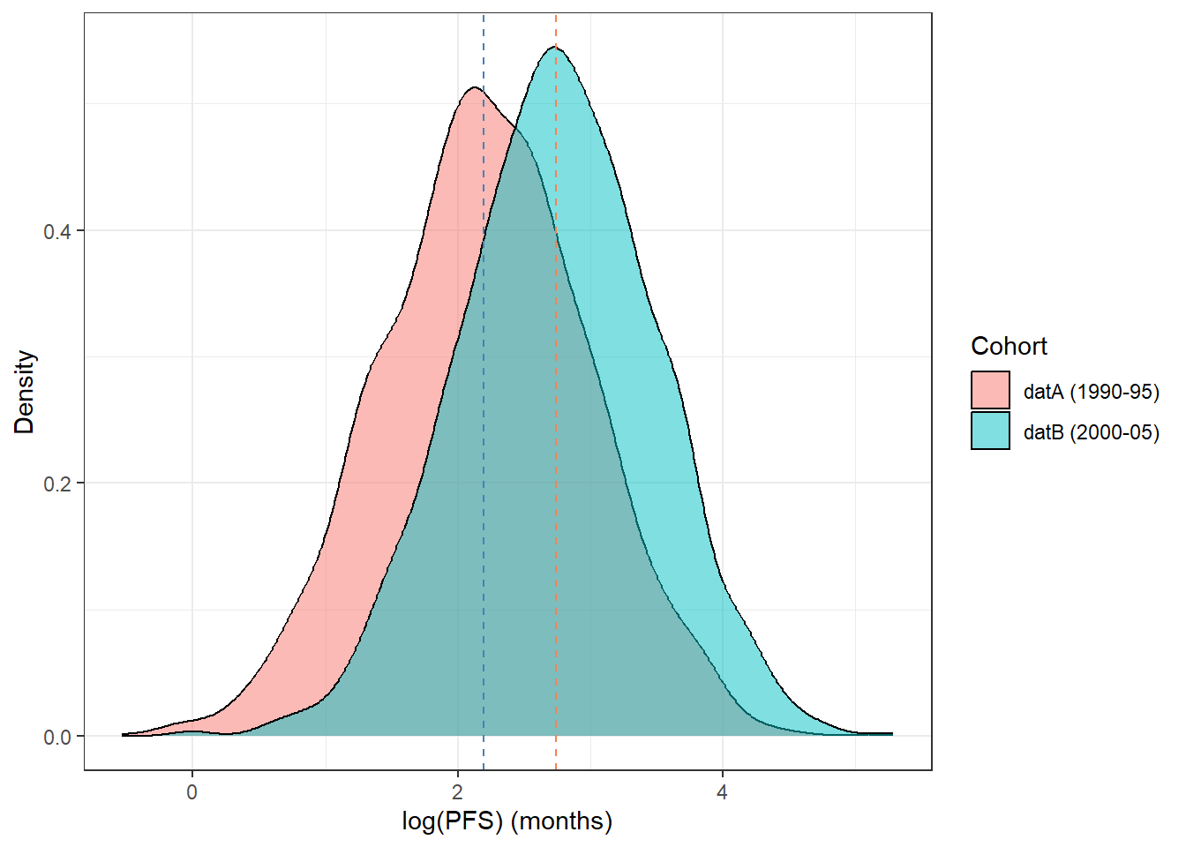
Figure 6. Density of log(PFS) in datA (1990–1995) versus datB (2000–2005). The rightward shift reflects improvements in treatment outcomes over the decade.

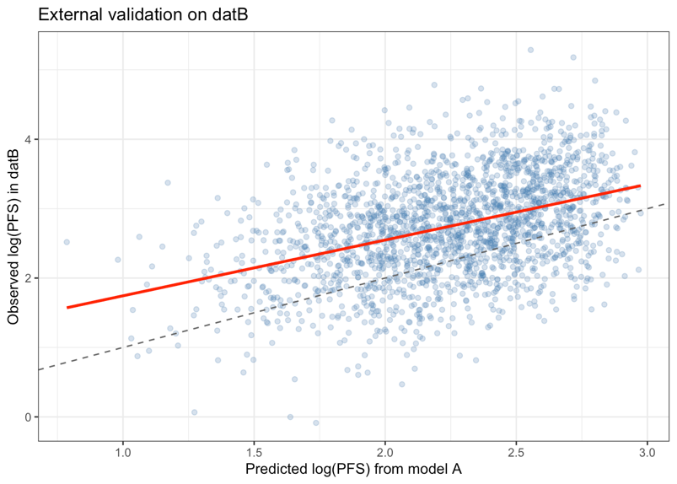
Figure 7. Quintile-based calibration plot: datA GAM applied to datB. The near-constant vertical gap (~0.50 log-months) across all quintiles confirms a systematic intercept shift rather than slope distortion.

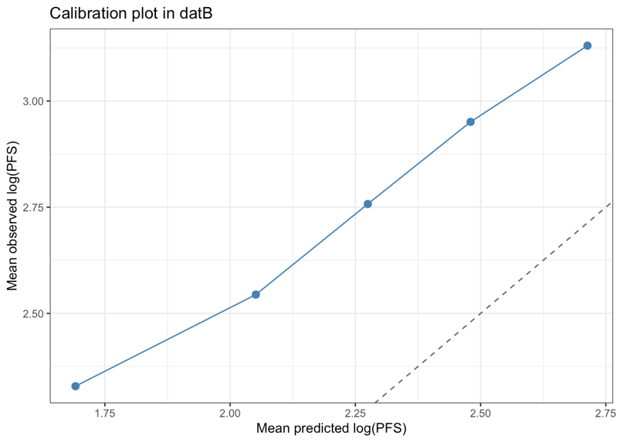
Figure 8. Observed-vs-predicted log(PFS) in datB using the datA GAM. The fitted regression line (red) lies below the 45° reference (dashed), confirming systematic underprediction consistent with an intercept shift.

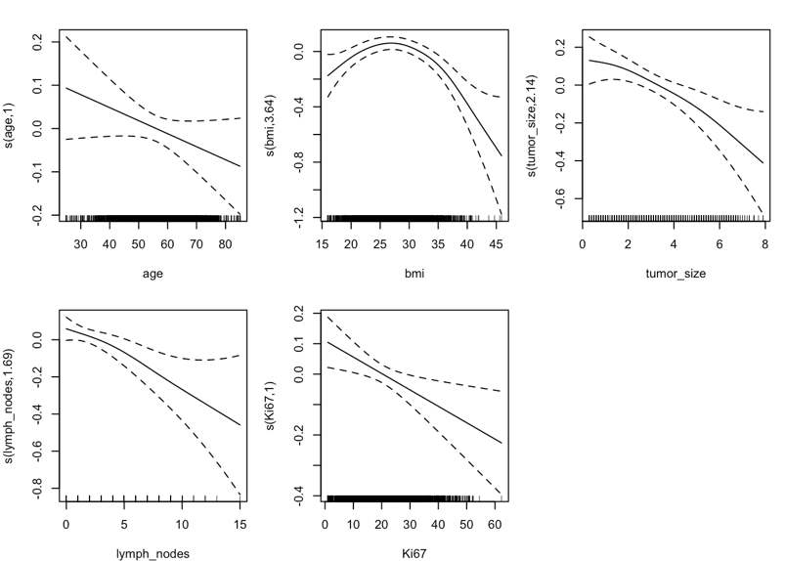
Figure 9. Partial effects of smooth terms in the refitted datB GAM. Compared with Figure 5, s(lymph_nodes) shows greater non-linearity (edf = 1.69 vs. 1.00) and s(Ki-67) displays a clearer negative linear trend.

