**Personal Portfolio Template**

(GROUP - 44)

(Ang Wei Jie Abastain– n9972366)

( [**lufee84**](https://github.com/lufee84)/GROUP-44)

**Artefact 1** – (Transport)

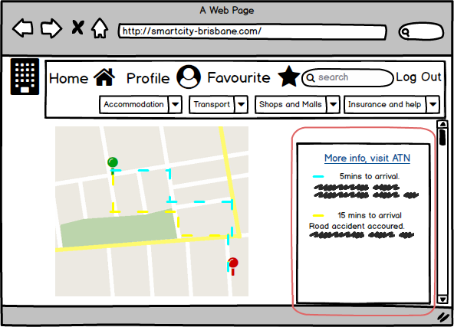

Design easier transport viewing

-Portray number of bus routes in their rows starting with the least time taken in time estimation.

The implementation will help convince the user to take not of the different routes to choose from through a better view on the page.

This helps to magnify fast and understandable choices on different route to an extent for the user to view road conditions between his location and the destination.

**Artefact 2** – (FeedBack form)

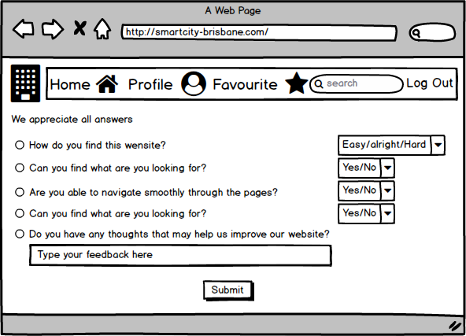

Customer care and data collection for further improvements.

This would help us in our long run as we start providing our users with our services.

The implementation can help us collect useful and ideas from users who find some places that may let them have a better experience in their usage through our website.

Providing this function will help the developers understand user frequent visits and issues relating to our website in a manner to further facilitate their activities.

**Artefact 3** – (Hover-Over search tool bar)

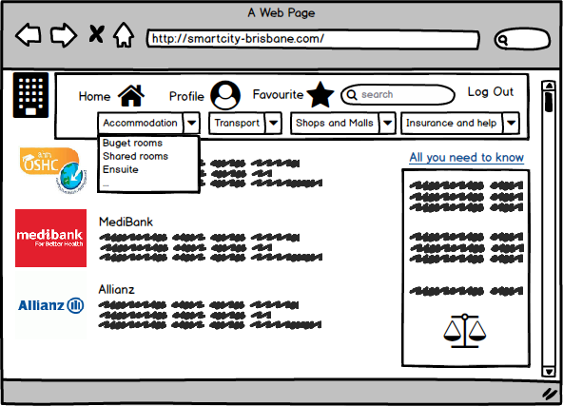

The quick navigation would help users to venture in a safe and time saving manner.

The Hover-Over dropdown search toolbar would help user to have easier navigation for what they are looking for.

his helps them by not going through too many pages that would give more of a friendly experience when roaming in our website.

**Artefact 4** – (Use-Case Diagram)

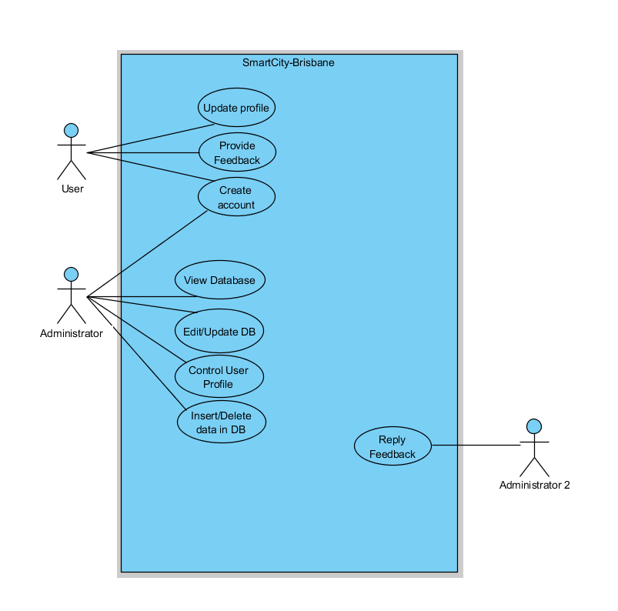

The Use-case Diagram provides a description on the roles and accessibility for the activities in the database.

This gives a clean description on the focussed roles that each user and admin has access to.

2 administrators are assigned.

Administrator 1 is assigned to insert, update, delete on database accounts and details web design.

Administrator 2 is assigned to maintain feedback responses from customer feedbacks that would help improve the website.

https://github.com/lufee84/GROUP-44/blob/master/UI/usecase%20diagram.PNG

**Artefact 5** – (ER Diagram)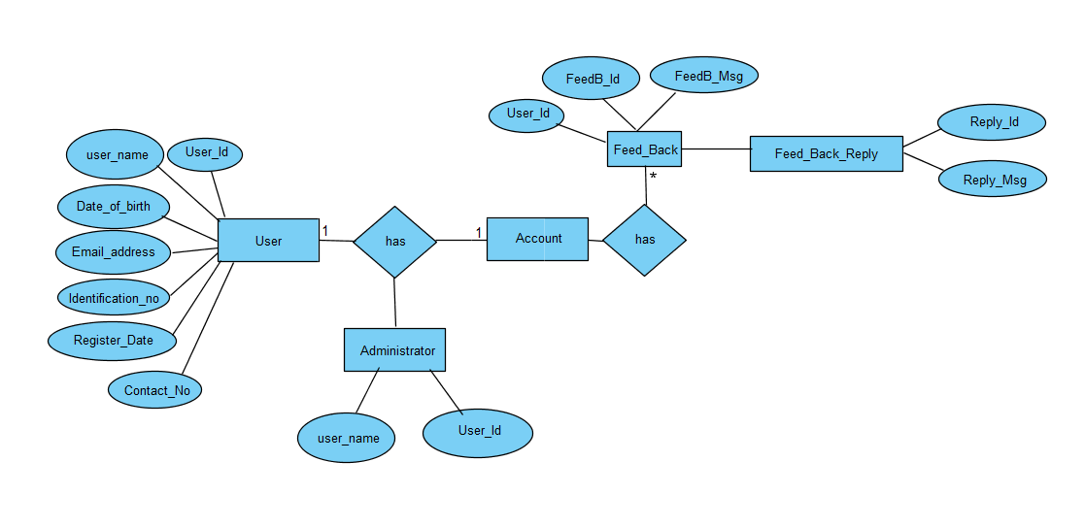

The ER-Diagram show cases the importance of having a clear flow chart for our Database.

This structure is based on the relationship for the user’s attributes and the entities that they will be related with, that is between the administration and user accounts.

The administrator and the user can provide feedback to each other that helps to relates messages between the two.

https://github.com/lufee84/GROUP-44/blob/master/UI/ER%20diagram.PNG