Zapatos deportivos
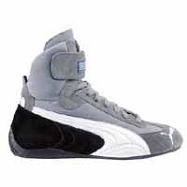 | Calzado deportivo Piloti DTM  Precio Inc IVA : 155 EUR (25,870.32 Pta.) |  | Calzado Piloti  Precio Inc IVA : 147 EUR (24,477.63 Pta.)
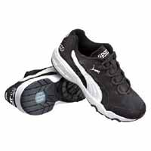 | Calzado deportivo Piloti  Precio Inc IVA : 155 EUR (25,870.32 Pta.) |  | Zapato PitCat  Precio Inc IVA : 73 EUR (12,119.85 Pta.)
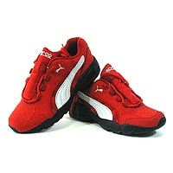 | Zapato PitCat  Precio Inc IVA : 73 EUR (12,119.85 Pta.) |  | Zapato Replica HIGH  Precio Inc IVA : 98 EUR (16,233.01 Pta.)
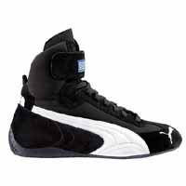 | Zapato Replica HIGH  Precio Inc IVA : 98 EUR (16,233.01 Pta.) | 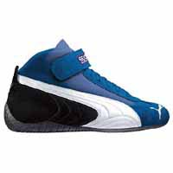 | Zapato Replica MID  Precio Inc IVA : 92 EUR (15,332.84 Pta.)
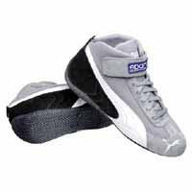 | Zapato RepliCat MID  Precio Inc IVA : 92 EUR (15,332.84 Pta.) | 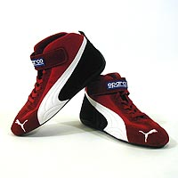 | Zapato Replica MID  Precio Inc IVA : 92 EUR (15,332.84 Pta.)
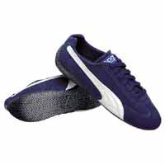 | Zapato SpeedCat  Precio Inc IVA : 88 EUR (14,607.38 Pta.) | 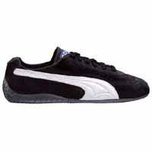 | Zapato SpeedCat  Precio Inc IVA : 88 EUR (14,607.38 Pta.)
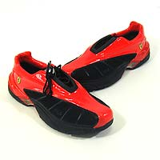 | Calzado Fila Ferrari  Precio Inc IVA : 173 EUR (28,855.35 Pta.) | 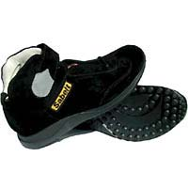 | Zapato Escuderia Ferrari  Precio Inc IVA : 104 EUR (17,221.37 Pta.)
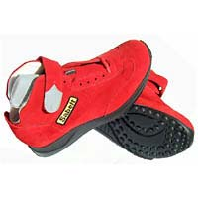 | Zapato Escuderia Ferrari  Precio Inc IVA : 104 EUR (17,221.37 Pta.) | 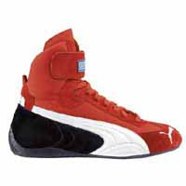 | Zapato Replica HIGH  Precio Inc IVA : 98 EUR (16,233.01 Pta.)
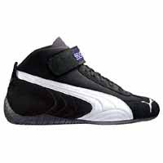 | Zapato Replica MID  Precio Inc IVA : 92 EUR (15,332.84 Pta.)

Zapatilla para dama
Productos+ | Precio
Alessia in nero | 170.52EUR | 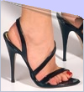
Alessia in rosso | 110.49EUR | 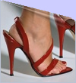
Barbara | 110.49EUR | 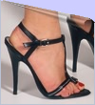
Cecilia | 134.85EUR | 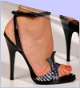
Chiara | 171.16EUR | 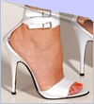

Productos+ | Precio
Agostina | 128.24EUR | 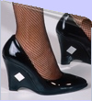
Arianna | 129.40EUR | 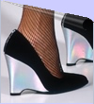
Giuliana | 94.25EUR | 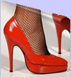
Michela | 192.04EUR | 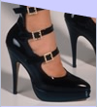

Productos+ | Precio
Beatrice | 121.80EUR | 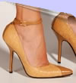
Caterina | 140.36EUR | 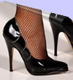
Enrica | 169.65EUR | 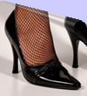
Erica | 98.60EUR | 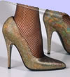
Gloria in nero | 168.20EUR | 