Outcome include:

1. **“Roboteq Controller KBL1xxx”** Labview driver
2. **“Pump Controller”** Labview 2017 examples and tests project

# 1 “Roboteq Controller KBL1xxx” Labview driver

Should be copying to Labview instrumentation driver’s folder.

For example: *c:\Program Files (x86)\National Instruments\LabVIEW 2017\instr.lib*

**Workflow** (common for all instrument Labview drivers):

VISA Resource name → Initialize.vi → Controller.ctl (Type Def)

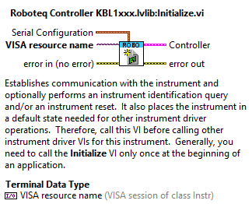

Using Controller “reference” execute commands and acquire parameters.

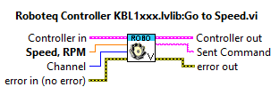

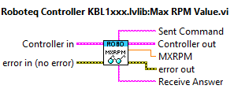

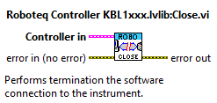

Driver features can be extended

# 2 “Pump Controller” Labview 2017 examples and tests project

Include several Low and High level examples and tests VIs.

# Example Read MXRPM.vi

To use “G - Go to Speed” command in Closed Loop Speed mode it is necessary to know maximum speed that is stored in the MXRPM configuration parameter.

Please execute **Example Read MXRPM.vi** test VI, enter valid **Controller VISA resource name** and provide **Receive Answer** from controller.

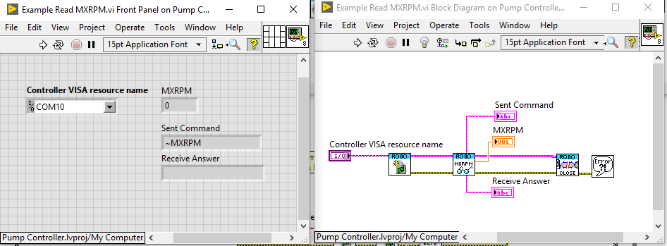

# Example Go to Speed.vi

This example use **MXRPM=1000** (will be modified to read the real value)

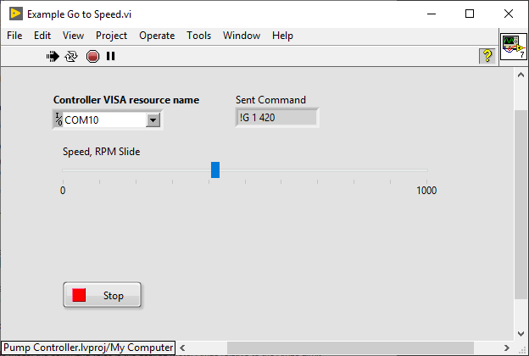

# Example Set Flowrate.vi

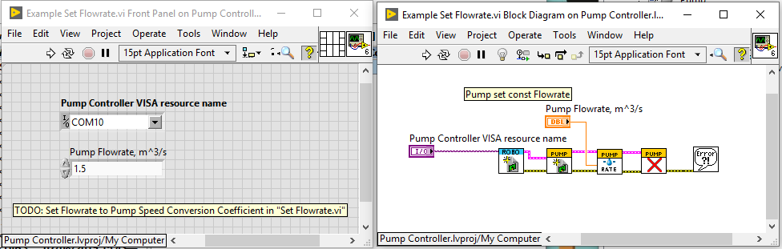

To test flowrate control it is need to set Flowrate to Pump Speed Conversion Coefficient in **Pump Controller.lvlib:Pump\Set Flowrate.vi** (see below)

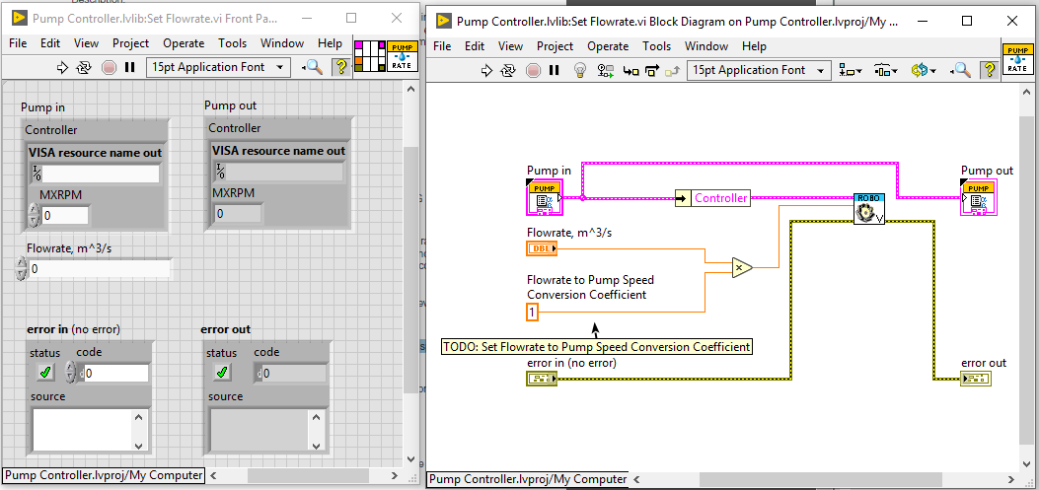

# Example Pressure Control.vi

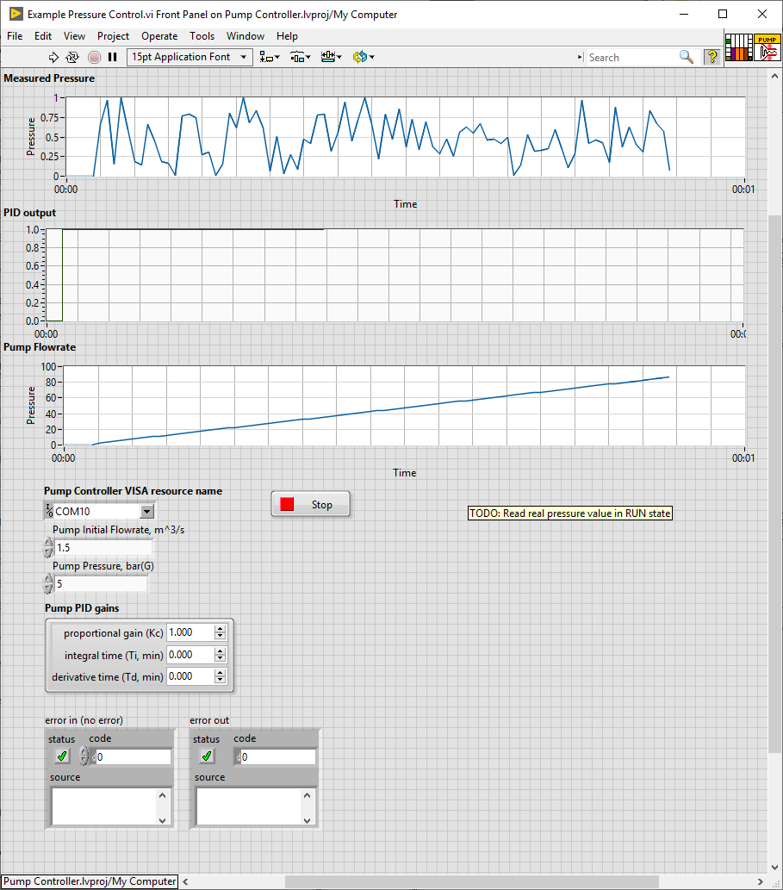

You need to select **Pump Controller VISA resource name**, enter **Pump Initial Flowrate, m^3/s** and required **Pump Pressure, bar(G)**. Change **Pump PID gains** if required.

Example works using State Machine pattern. There is thee states: Init, Run and Stop.

On **Init state** program creates Controller reference, Pump reference and sets initial flowrate value.

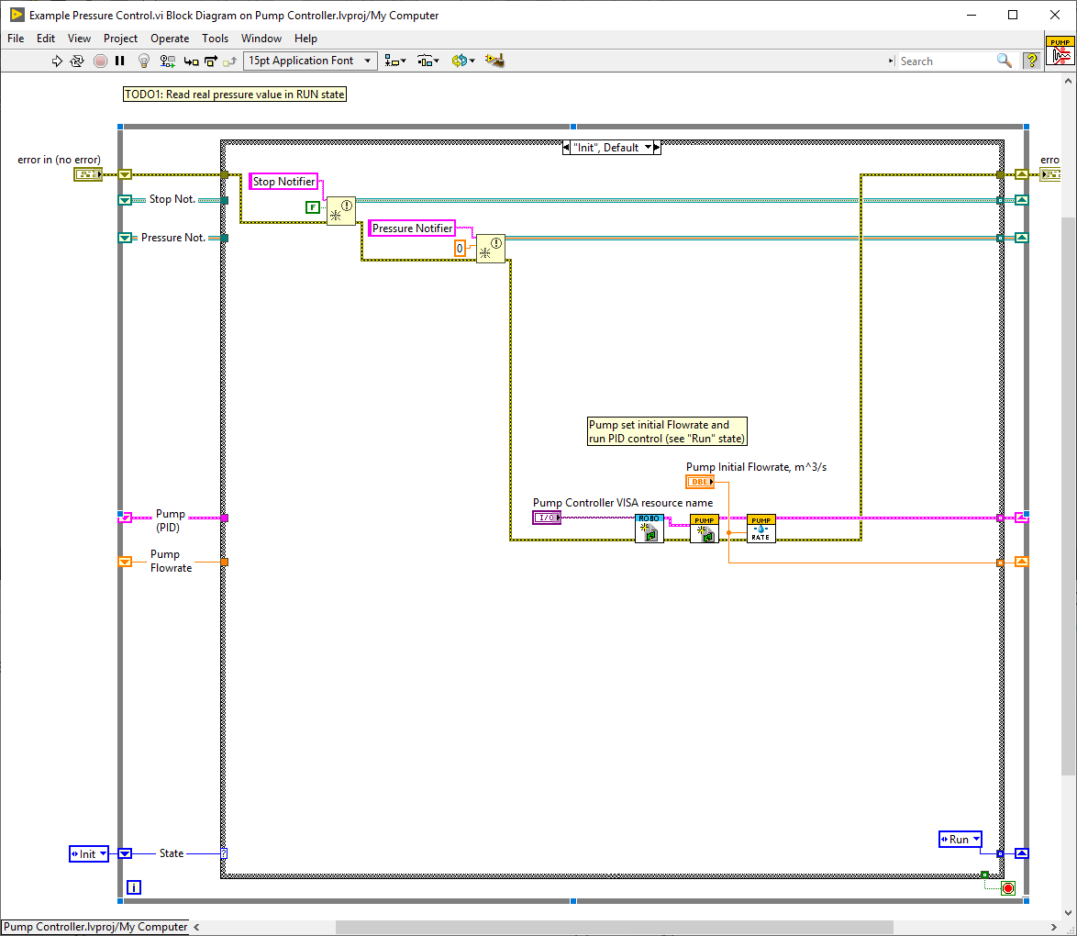

On **Run state** program perform pressure measurement (with pause) and control pump flowrate using PID.

