# Installation

Using VI PM you need to install:

1. JKI HTTP REST Client

2. JKI State Machine

# Mock REST API server

For running REST API server based on Json-Server (<https://github.com/typicode/json-server>) you need to have **node.js** and **npm**.

Can be downloaded from here <https://nodejs.org/en/>

# Labview source code

Program use JKI State Machine template. If you want to know more please visit: <https://github.com/JKISoftware/JKI-State-Machine>

For change REST API server go to “**REST API: Create**” state

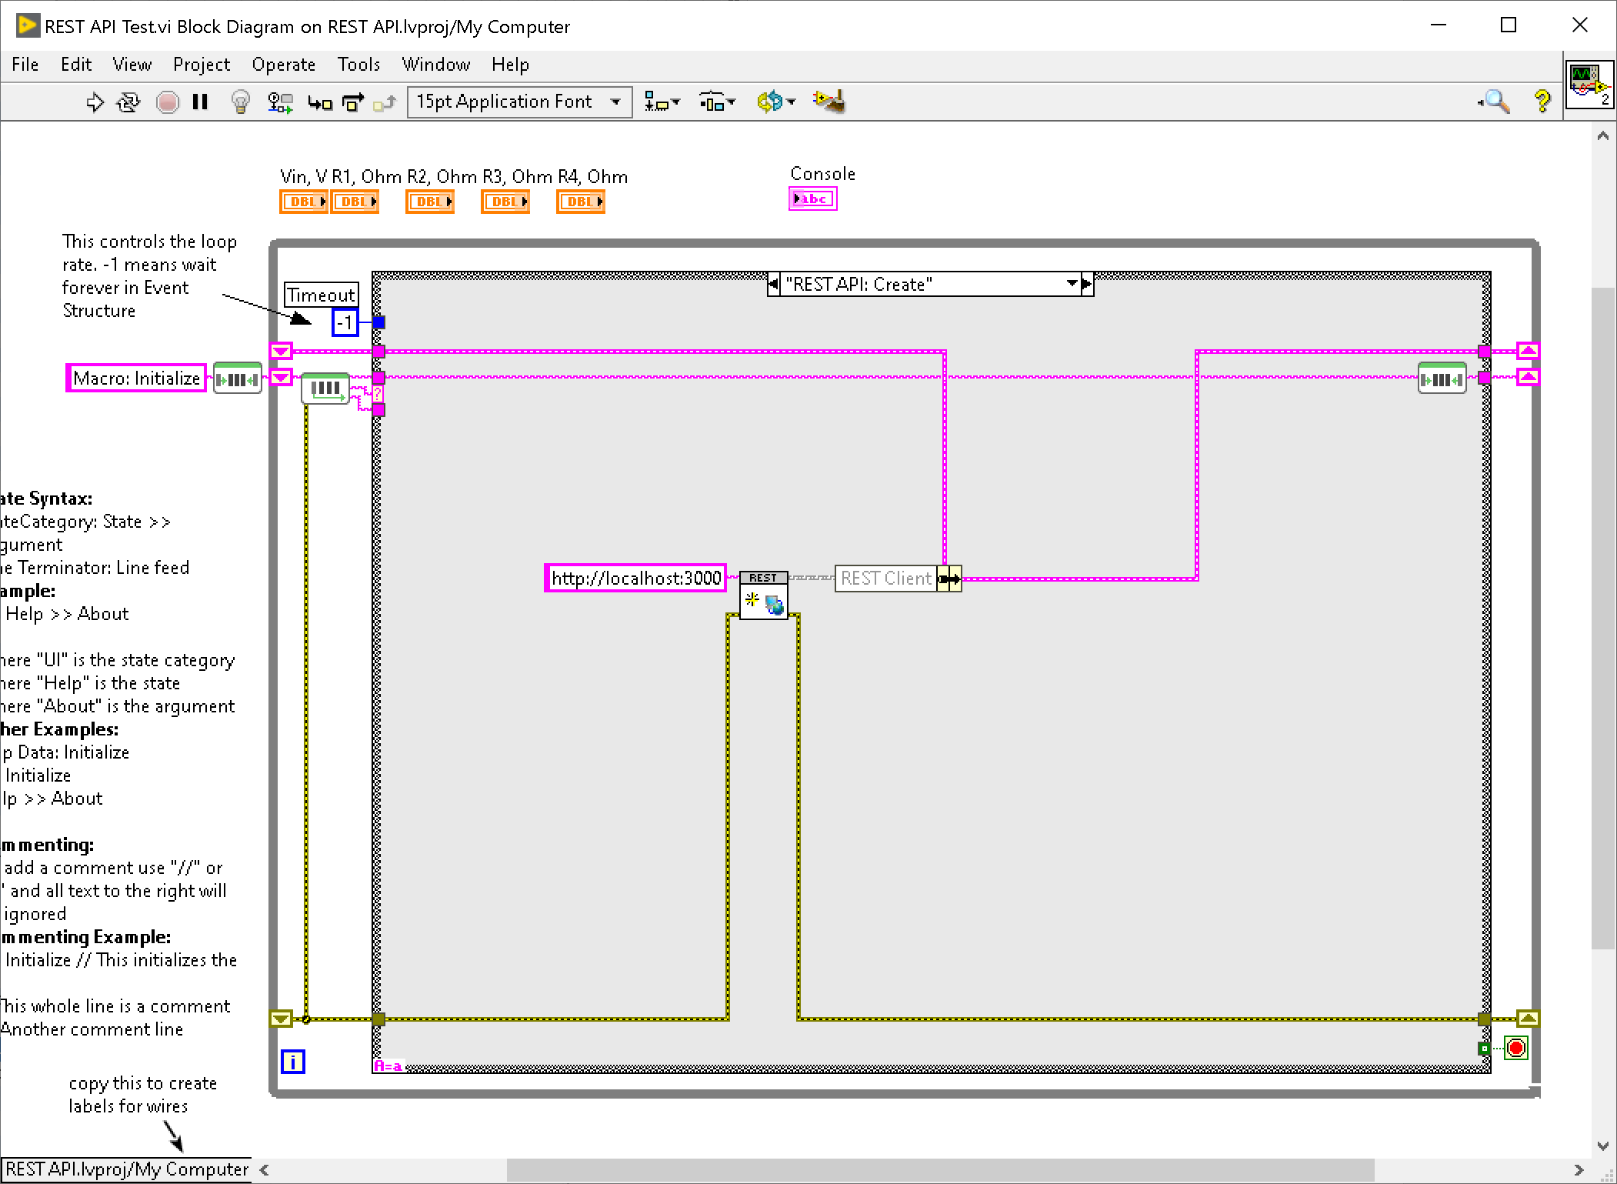

Requests endpoints can be changed in "**REST API: Get**" and "**REST API: Post**" states