# Solar Cell Stand

# 1 Labview

To run project you need:

* Labview 2016 x86 (32-bit) or newer. NI ELVISmx is not supported in LabVIEW (64-bit). For full programmatic functionality with LabVIEW and NI ELVISmx, you must have LabVIEW (32-bit) installed on a Windows 8.1/7/Vista (64-bit) operating system.
* NI ELVISmx 17.0 driver (<http://www.ni.com/download/ni-elvismx-17.0/6639/en/>).

Download Link: <http://download.ni.com/support/softlib/multifunction_daq/nielvis/17.0/NIELVIS1700.zip>

Download and Extract the zip file into a temporary location.

Launch setup.exe

To open project **SolarCellStand** open in Labview project file **SolarCellStand.lvproj**. You should see a Project Explorer window on the screen:

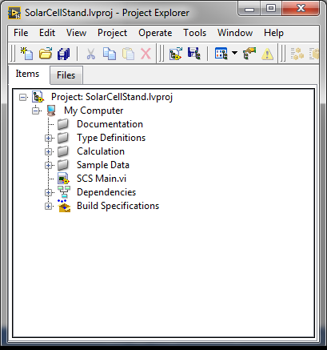

To open main VI click to **SCS Main.vi** file. You should see a SCS Main.vi **Front Panel** on the screen:

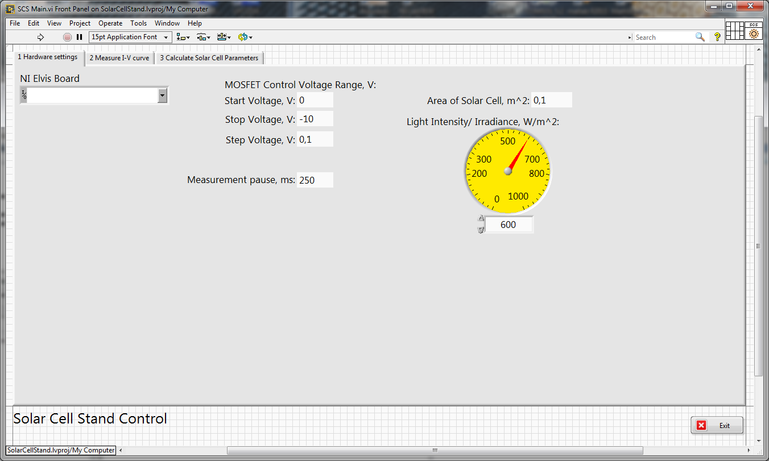

To show **Block Diagram** click **Windows->Show Block Diagram** or press **Ctrl + E.**

To start execution click **Operate->Run** or arrow button on toolbar or press **Ctrl + R**.

Program consists of three parts (tabs):  
1. Hardware settings (connect to NI Elvis board, measurement settings, MOSFET control settings etc.)  
2. Measure I-V curve  
3. Calculate Solar Cell Parameters (Efficiency (%), Fill Factor, Isc, Vos, etc.)  
  
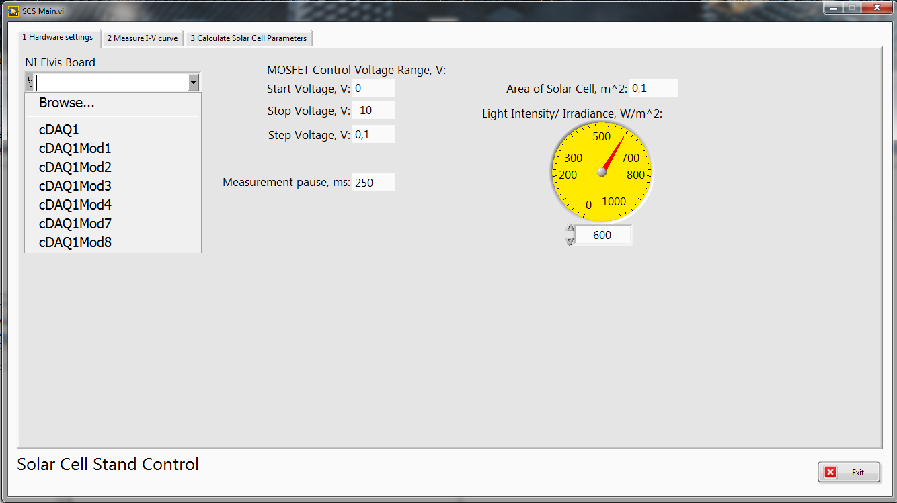

In Tab **1 Hardware settings**

Connect NI Elvis board via USB to PC and select reference to your board in **NI Elvis Board** list.

Enter area of your solar cell in m2 in **Area of Solar Cell, m^2** field

Enter value of light Intensity/irradiance of your light source in W/m2 in **Light Intensity/ Irradiance, W/m^2** field.

In Tab **2 Measure I-V curve**

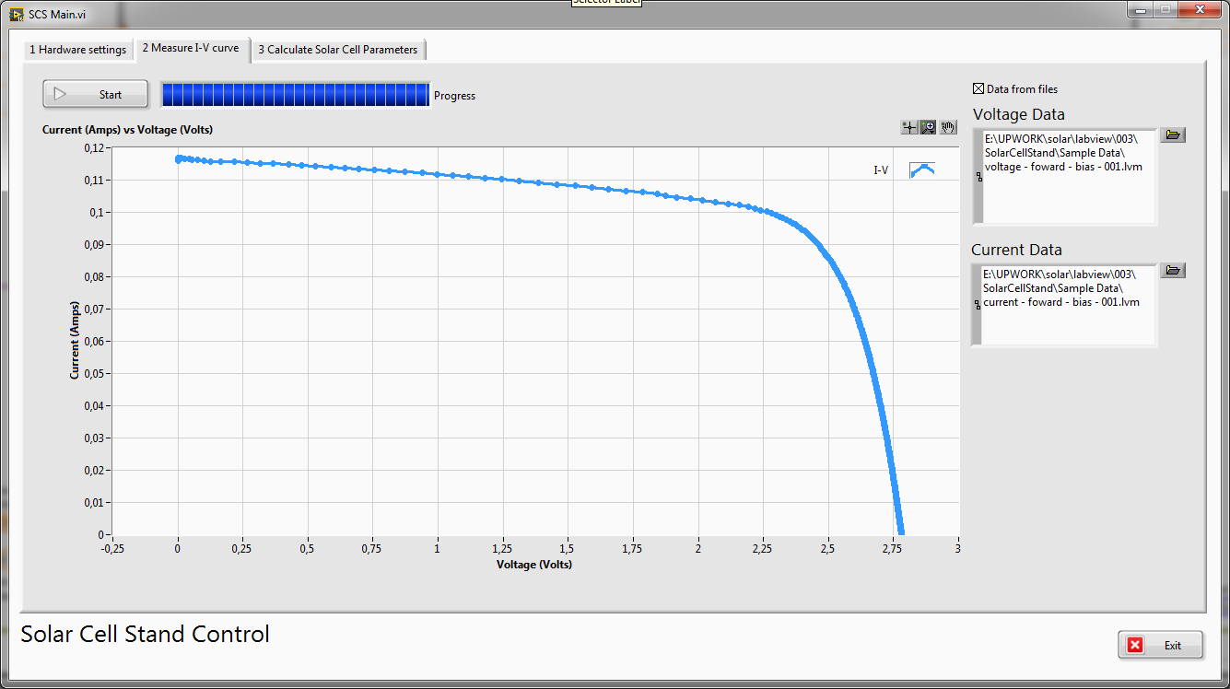

For read Voltage/Current data from sample file check **Data from file** checkbox and select Voltage/Current data files in the appropriate fields.

If **Data from file** checkbox is unchecked program will work with NI Elvis board for obtain measured data.

Click to **Start** button for I-V curve measurement.

In next picture your can see Block Diagram for Solar Cell I-V curve measurement using NI ELVISmx Express Virtual Instruments (VIs).

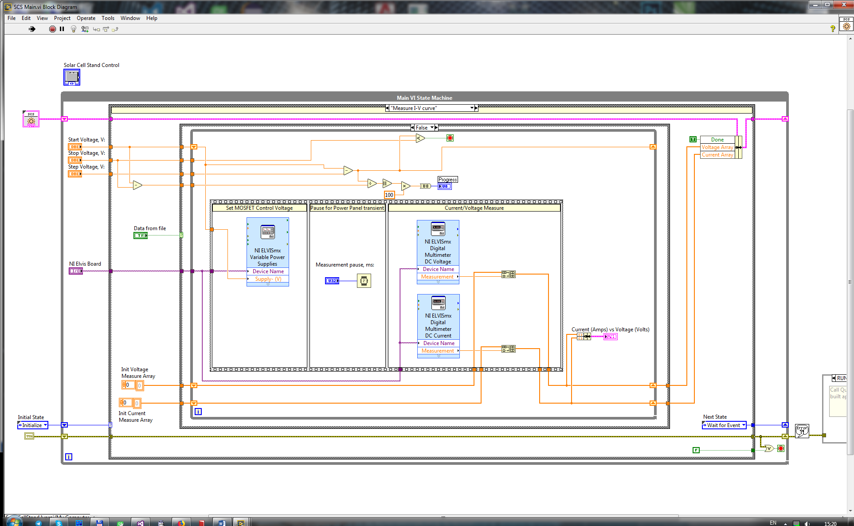

In next picture your can see Block Diagram for getting sample Voltage and Current data from file.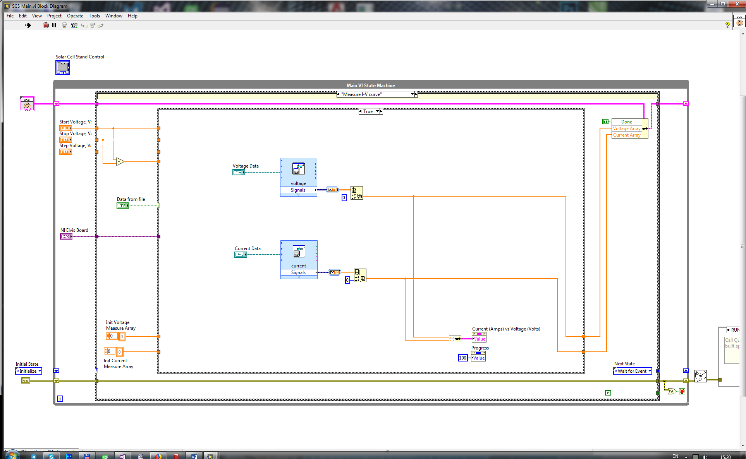

In Tab **3 Calculate Solar Cell Parameters**

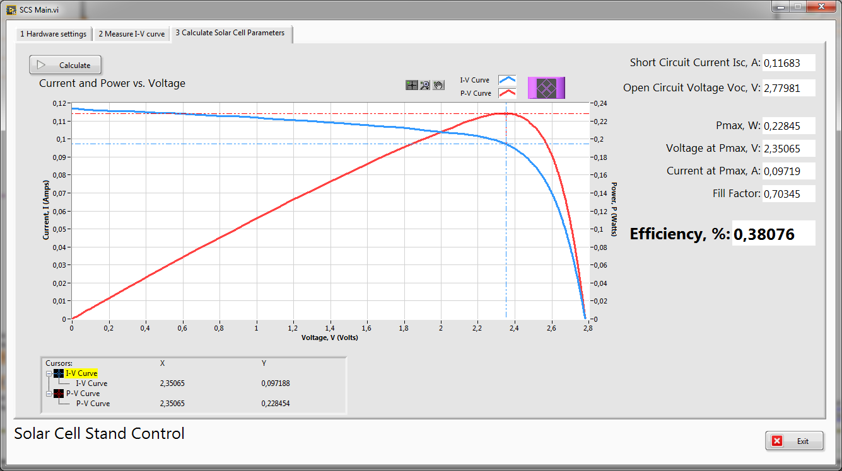

Click to **Calculate** button for solar cell parameters calculation

In next picture your can see Block Diagram for Calculation Solar Cell Parameters:

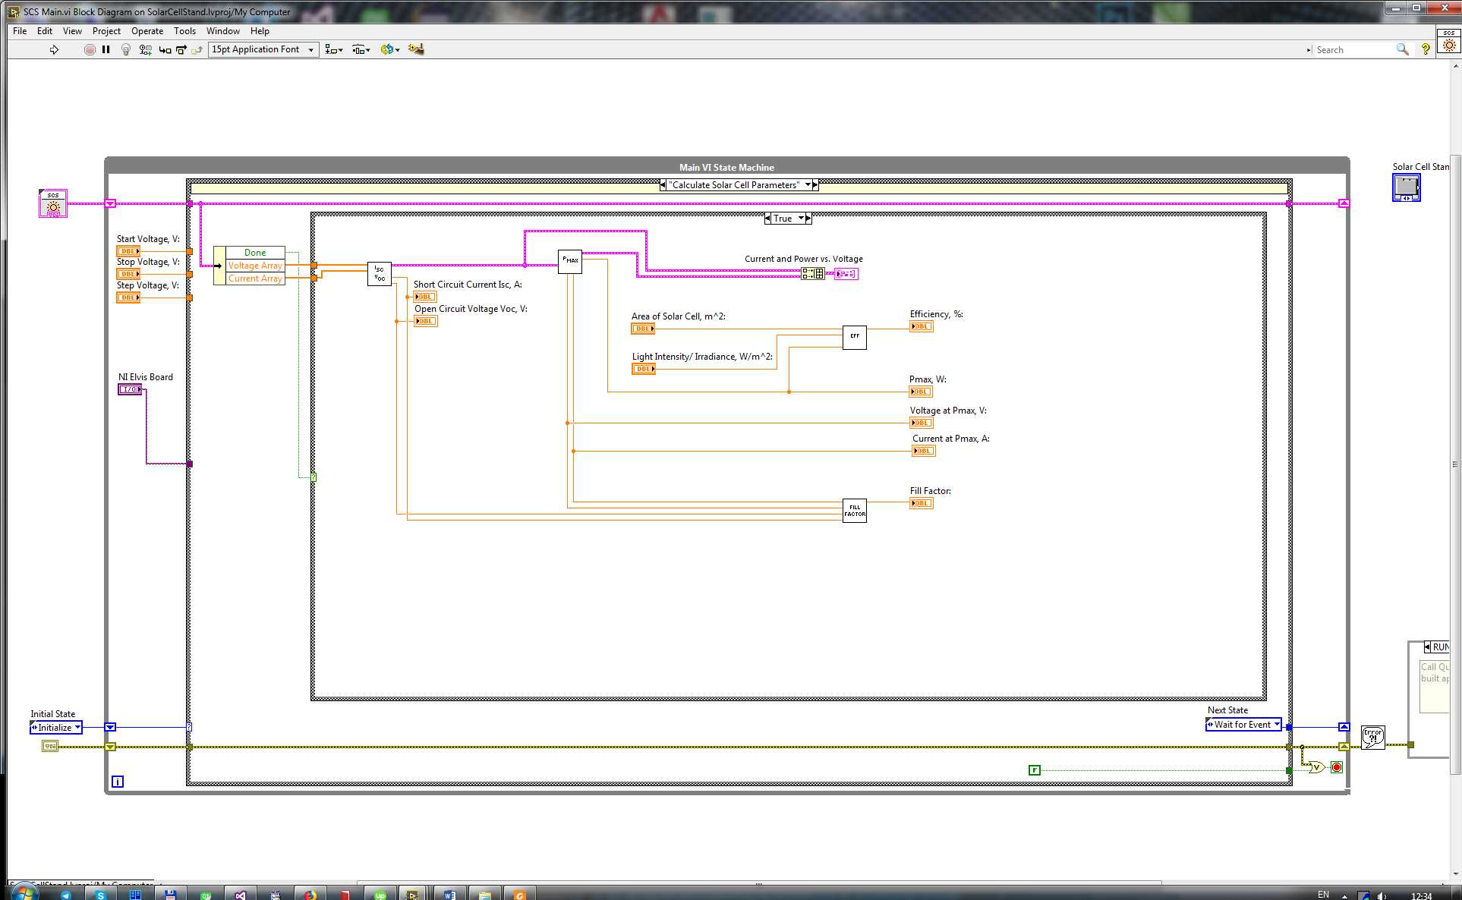

For parameters calculation are used subVis from **Calculation** folder:

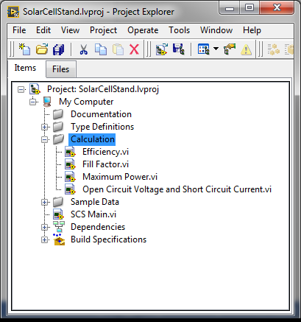

**Open Circuit Voltage and Short Circuit Current** subVI

Two arrays (Voltage and Current values) are fed into the input.

SubVI computes Short Circuit Current ISC and Open Circuit Voltage VOC. Also subVI finds maximum current and maximum voltage values. Open Circuit Voltage is found where the Current is zero and the short circuit current is found where the voltage is equal to zero. Maximum current and maximum voltage are the maximum values found in each array only in the power quadrant.

In next picture your can see Front Panel of **Open Circuit Voltage and Short Circuit Current** subVI:

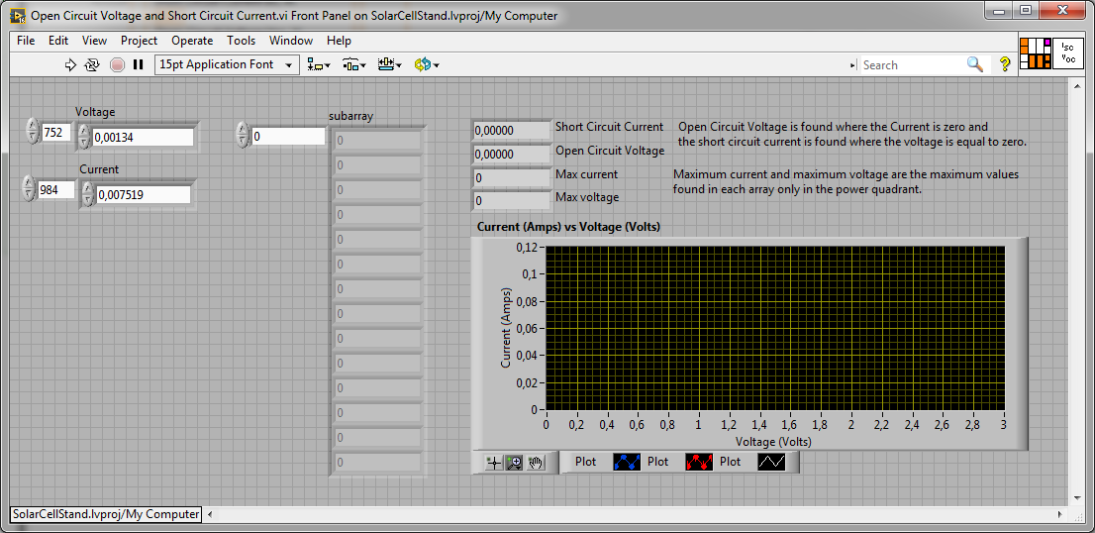

In next picture your can see Block Diagram of **Open Circuit Voltage and Short Circuit Current** subVI:

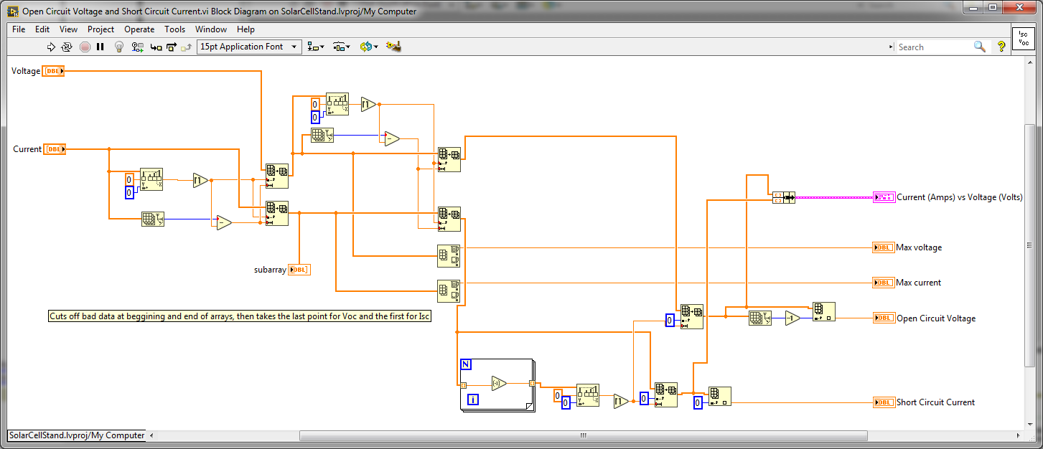

**Maximum Power** subVI

SubVI searches for the maximum power value PMAX and provide Voltage UMP and Current IMP in maximum output power point. In addition, subVI computes data for Power (Watts) vs Voltage (Volts) plot (P-V curve).

In next picture your can see Front Panel of **Maximum Power** subVI:

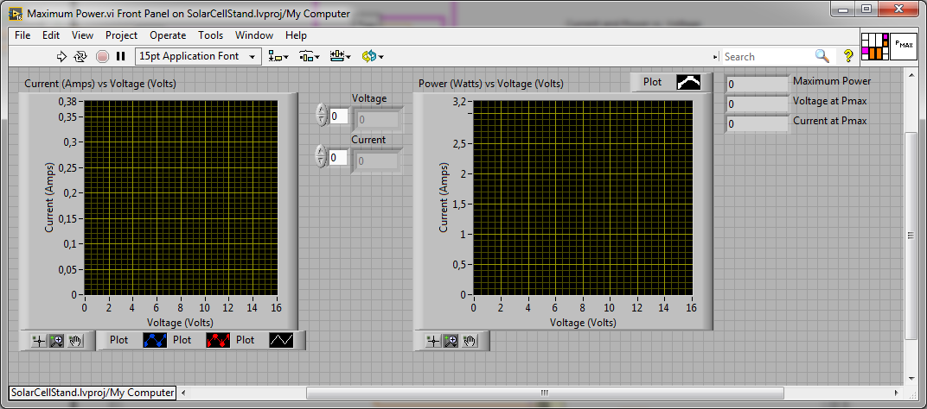

In next picture your can see Block Diagram of **Maximum Power** subVI:

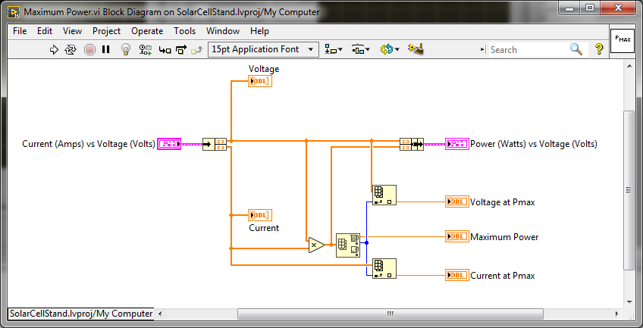

**Fill Factor** subVI

Fill factor (FF) is calculated by comparing the maximum power to the theoretical power (PT) that would be output at both the open circuit voltage and short circuit current together. FF can also be interpreted graphically as the ratio of the rectangular areas depicted in next picture.

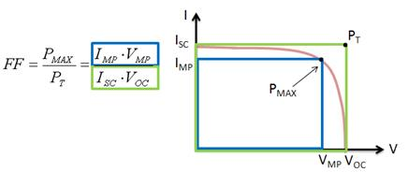

In next picture your can see Front Panel of **Fill Factor** subVI:

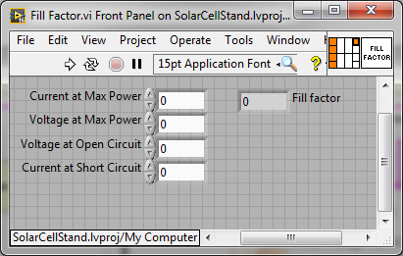

In next picture your can see Block Diagram of **Fill Factor** subVI:

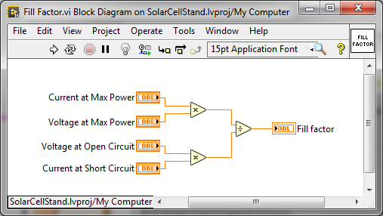

**Efficiency** subVI

In next picture your can see Front Panel of **Efficiency** subVI:

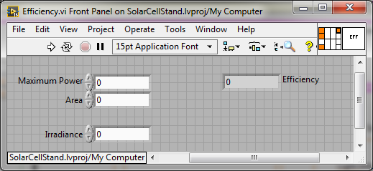

In next picture your can see Block Diagram of **Efficiency** subVI:

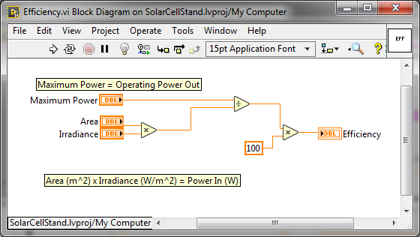

Project contains samples of real solar cells measured data for further study and demonstration

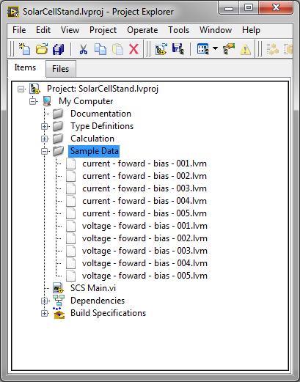

2 Another solar Cells examples

2.1.

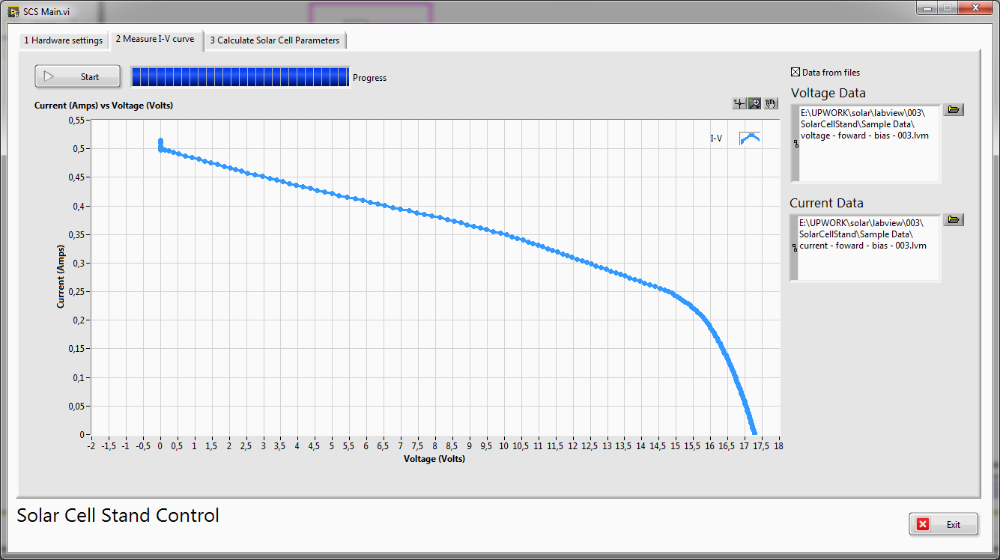

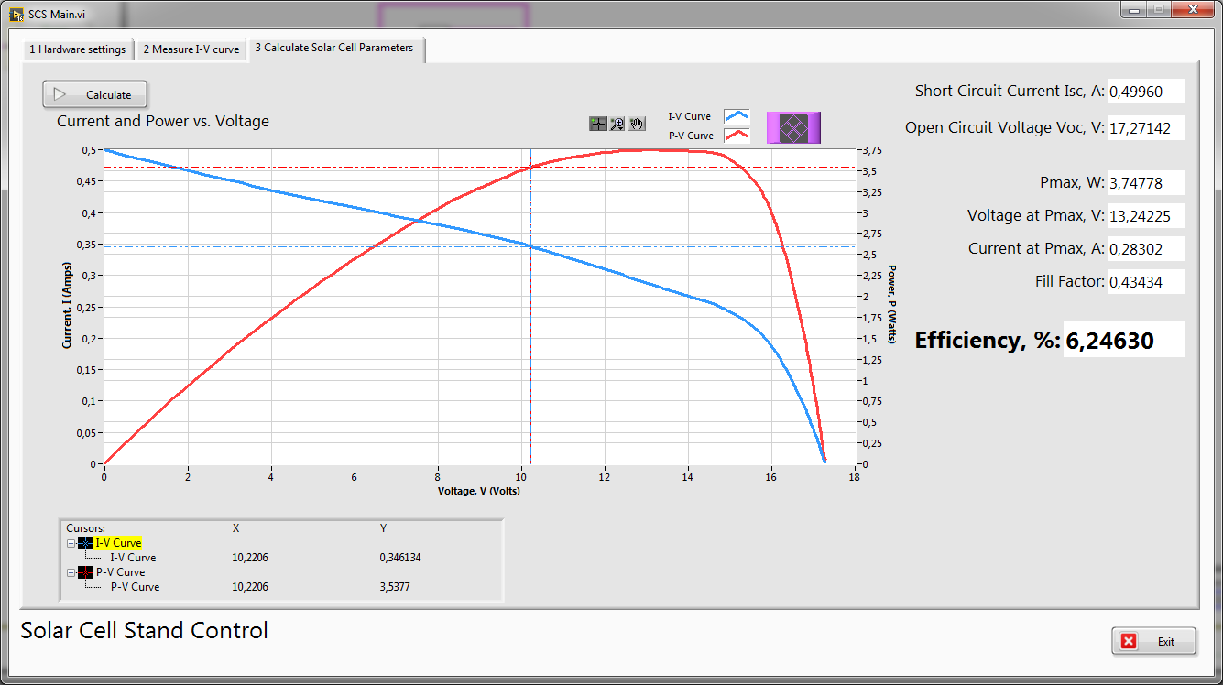

2.2.

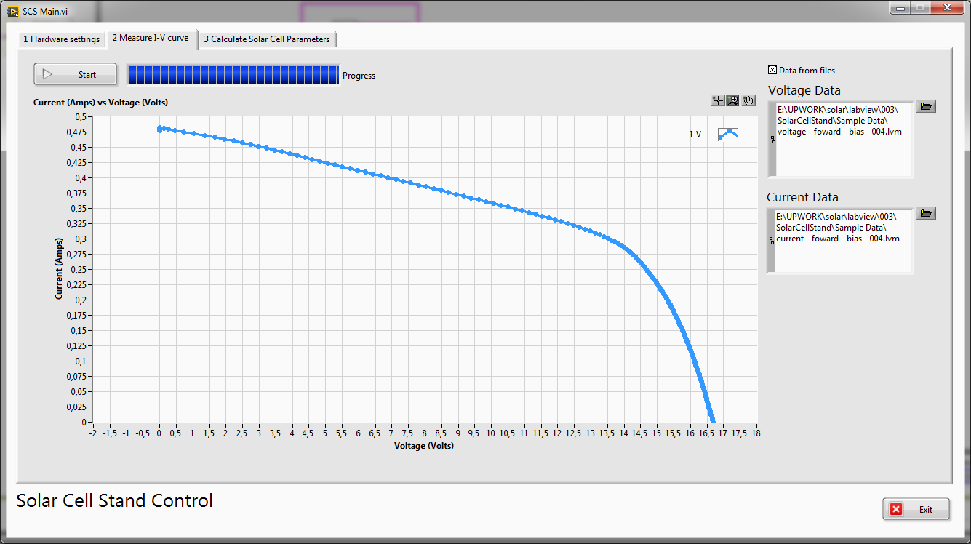

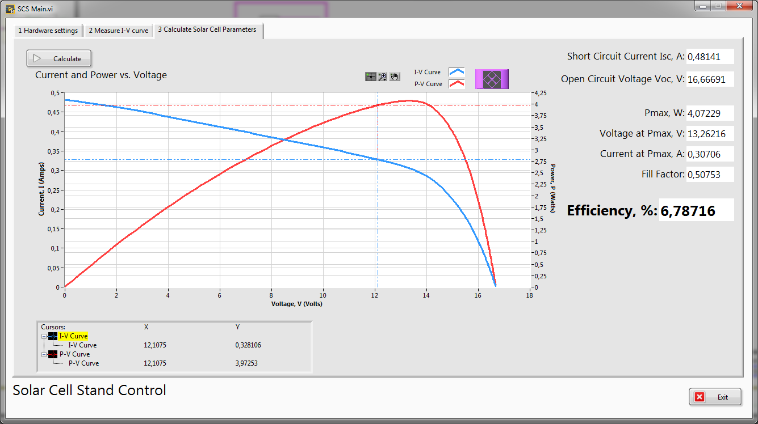

# 2.3.

# 

# 

# 2.4.

# 

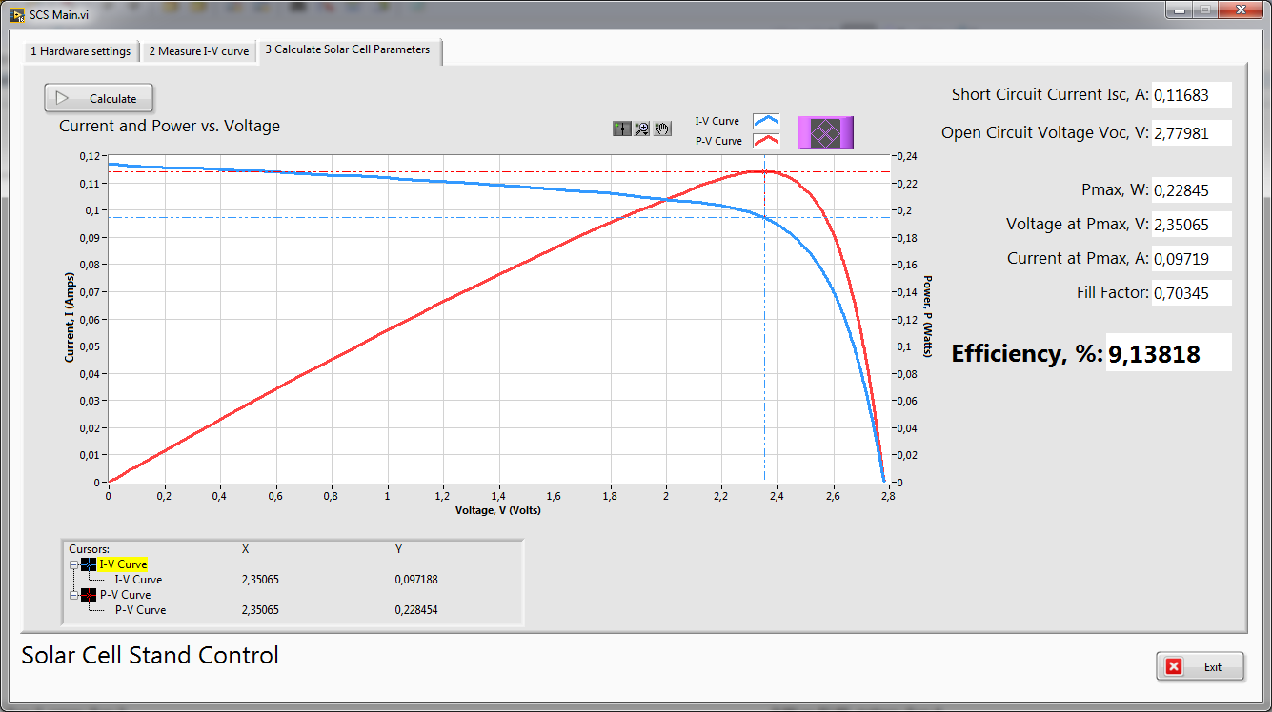

# 3 Control element

P-Channel power MOSFET

Model: IRF9540N

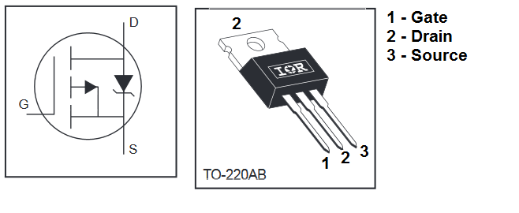

Key parameters:

|  |  |  |
| --- | --- | --- |
| Gate Threshold Voltage | VGS(th) | -2.0…-4.0 V |

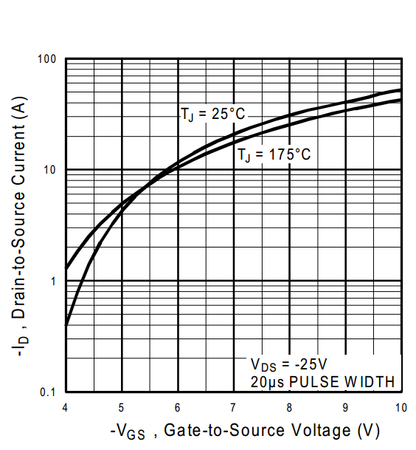

IRF9540N Typical Transfer Characteristics

# 4 Measurement circuit

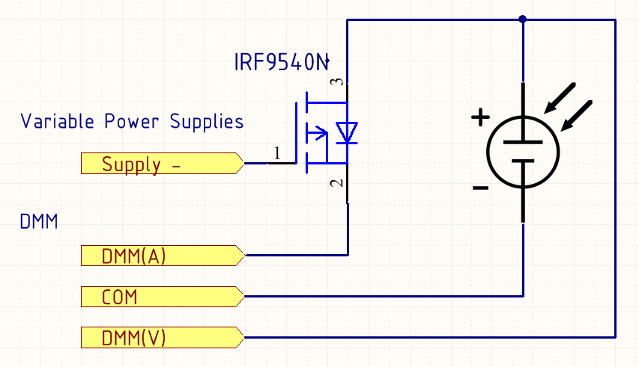

Measuring circuit diagram

# 5 USER MANUAL

Here the voltage range for MOSFET control is set.

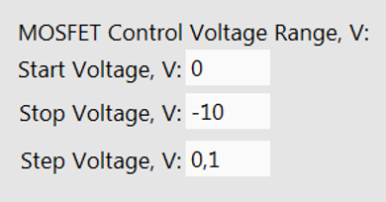

Number of measuring points

NPOINTS=(VSTOP-VSTART)/VSTEP

Here the delay between setting a new value of the MOSFET control voltage and measuring is set

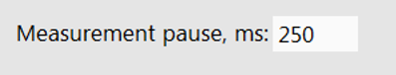

For Efficiency (%) calculation we need to know solar cell area

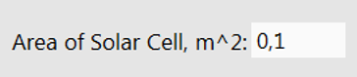

Also we need to know light intensity/Irradiance of the light flux incident on solar cell

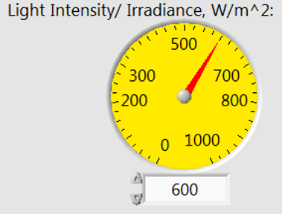

# 6 Literature

<https://www.re-innovation.co.uk/docs/pv-i-v-curve-tracer/>

<https://www.researchgate.net/profile/Jose_Andujar_Marquez/publication/224445394_Different_methods_to_obtain_the_I-V_curve_of_PV_modules_A_review/links/5572a70e08ae7536374e0511/Different-methods-to-obtain-the-I-V-curve-of-PV-modules-A-review.pdf>