

REPORT
Course Project

Author: Vladyslav Pavlenko
Lecturer: Ernestas Miknevicius

2025
Gym Management Database Report
1. Database Design
The database models a Gym Management System, with tables for Members, Trainers, Membership Types, Training Sessions, and their relationships. Below is the Entity-Relationship (ER) design:
  - Tables and Attributes

1.Members
- MemberID – Primary Key, auto-increment.
- FullName – Full name of the member, required.
- Phone – Contact number.
- Email – Unique email address.
- DateJoined – Date of joining (default to current date).

2. Trainers

- TrainerID – Primary Key, auto-increment.
- TrainerName – Trainer’s name, required.
- Specialization – Area of expertise.
- Phone – Contact number.

3. MembershipTypes

- MembershipID – Primary Key, auto-increment.
- MembershipName – Name of the membership (e.g., Basic, Premium, VIP), required.
- MonthlyPrice – Cost per month.
- DurationMonths – Duration of membership in months.

4. MemberMemberships

- MemberMembershipID – Primary Key, auto-increment.
- MemberID – Foreign Key referencing Members.
- MembershipID – Foreign Key referencing MembershipTypes.
- StartDate – Start of membership.
- EndDate – End of membership.

5. TrainingSessions

- SessionID – Primary Key, auto-increment.
- SessionName – Name of session (e.g., Yoga, Boxing), required.
- TrainerID – Foreign Key referencing Trainers.
- SessionDate – Date and time of session.

6. MemberSessions

- MemberID – Foreign Key referencing Members.
- SessionID – Foreign Key referencing TrainingSessions.
- Composite Primary Key (MemberID, SessionID) ensures unique attendance.

7. MemberLog (for triggers)

- LogID – Primary Key, auto-increment.
- MemberID – ID of the member affected.
-Action – Description of the action (e.g., New Member Added).
- LogDate – Date of action, default to current date.

Visualization of joints:
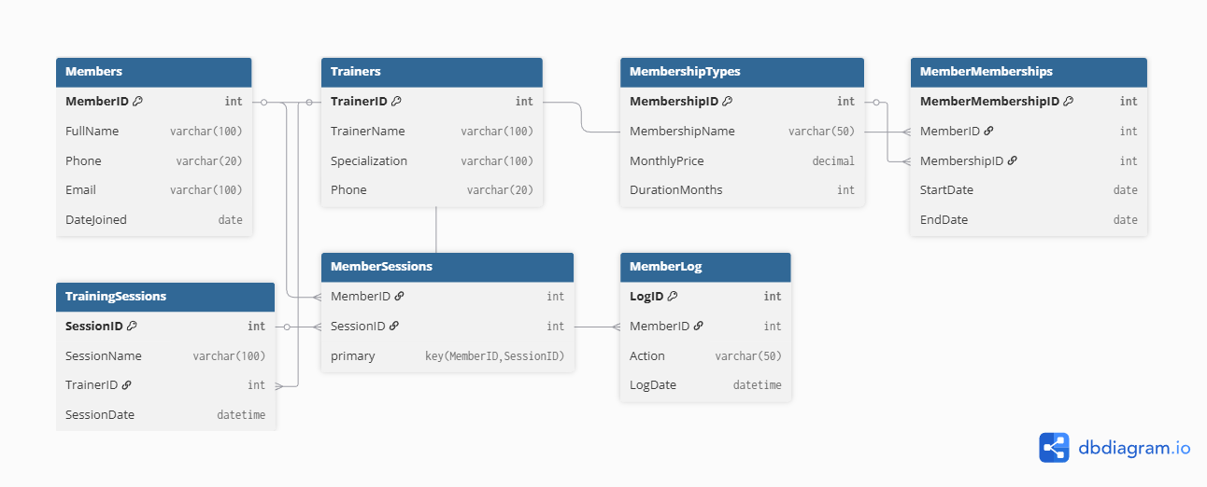

2. Key Features
Primary Keys & Identity Columns
- Auto-increment IDs ensure uniqueness for members, trainers, memberships, and sessions.
- Foreign Keys
- Enforce referential integrity between:
- Members → MemberMemberships
- MembershipTypes → MemberMemberships
- Trainers → TrainingSessions
- TrainingSessions → MemberSessions
- Members → MemberSessions
- Indexes
- IX_Members_Email – Ensures emails are unique and quickly searchable.
- IX_TrainingSessions_Date – Optimizes queries filtering sessions by date.
- IX_MemberMemberships_MemberID – Optimizes queries filtering memberships by member.
- Data Constraints

- NOT NULL ensures essential information is provided.
- UNIQUE prevents duplicate emails.

- Default Values

- DateJoined in Members defaults to the current date using GETDATE().
- LogDate in MemberLog defaults to the current timestamp.

- Stored Procedures

- AddMember allows insertion of a new member safely using parameters.

- User-Defined Functions

- CountSessions(@MemberID) returns the total number of sessions attended by a member.

- Triggers

- trg_MemberAdded automatically logs every new member into MemberLog.

- Transactions

- Demonstrates manual transaction handling with commit and rollback on errors.

- Views

- View_MemberSessions combines Members, Trainers, and Sessions for reporting.

3. Data Insertion
Members, Trainers, Membership types, MemberMemberships, TrainingSessions, MemberSessions tables data:
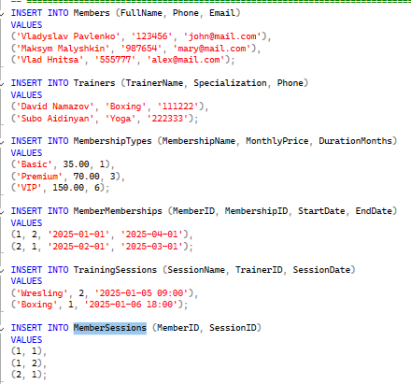

4. Queries and Examples
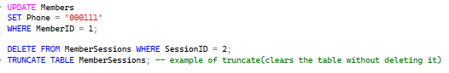
4.2 Aggregation
Count Members per Membership
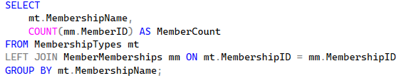
Total Revenue per Membership
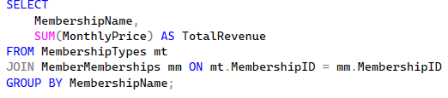
4.3 Pagination
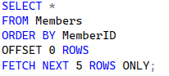
4.4 Joins
Members and their Memberships
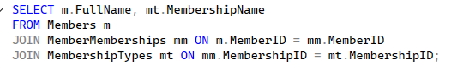
Trainers and Sessions
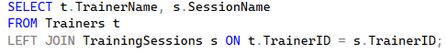
Members and Sessions
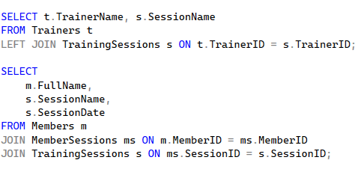

4.5 Views
Create View for Member Sessions
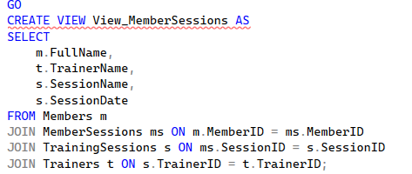
Query the View
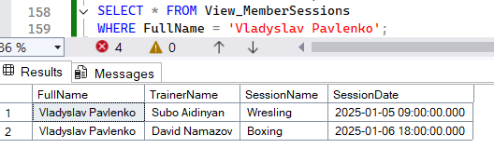
4.6 Stored Procedure and its execution
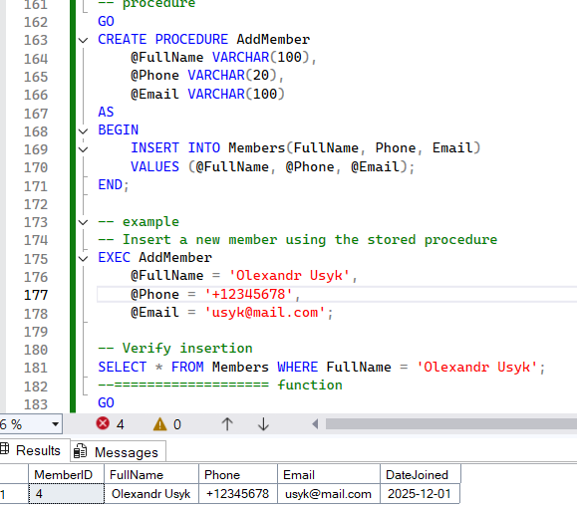
4.7 User-Defined Function
Count Member Sessions
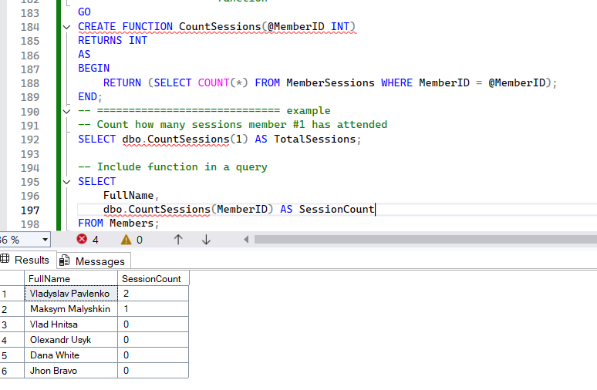
4.8 Trigger
Log New Members
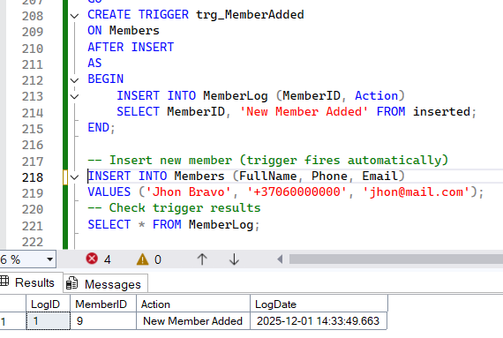

4.9 Transactions
Manual Transaction Example
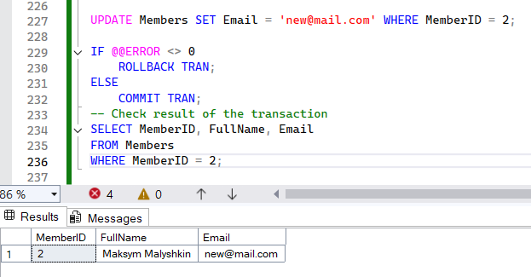

Summary
- This database supports member management, trainer assignment, session scheduling, membership tracking, and reporting.
- Key features include relationships, constraints, indexes, views, stored procedures, functions, triggers, and transactions.
- It can scale for a real gym management system with additional features like billing, attendance tracking, and reporting.

