National University of Computer and Emerging Sciences

FSE Project Iteration 1
GearShift
Group Members:
Name | Roll Number
Nauman Iqbal | L24-2565
Afras Shahnawaz | L24-2547
Saaif Suleman | L24-2606

Spring 2026
Department of Computer Science
FAST-NU, Lahore, Pakistan

GearShift – Sprint 1 Deliverable
Group Members:
- Nauman Iqbal – Developer, Architect, Tester
- Afras Shahnawaz – Requirement Engineer, UI/UX Designer
- Saaif Suleman – Lead Developer, Tester

1. Project Description
Project Title: GearShift
Description:
GearShift is a hybrid automotive platform (responsive web + mobile companion) designed to connect car owners with verified mechanics and vendors while providing AI-driven diagnostics, transparent pricing, and service history tracking. Many car owners struggle with diagnosing issues, finding trustworthy mechanics, and sourcing affordable spare parts. Sprint 1 focused on building the foundation layer: authentication, schema deployment, admin management, profile setup, optimization, and documentation.

2. Sprint 1 Backlog
Module Selected for Sprint 1: Core Foundation Module
Features included:
- User Registration & Login (JWT authentication, 24-hour expiry)
- Google OAuth Integration (secure login flow)
- Database Schema & Deployment (users, roles, services)
- Admin Account Management (role-based access control)
- Profile Management (bio + URL setup)
- Database Optimization & Integrity (indexes, constraints)
- README Documentation (overview, setup, contribution notes)

3. User Stories

Story ID: US 01 Story Title: User Registration & Login
Priority: High
Estimated Hours: 8
User Story:
As a user, mechanic, or admin, I want to register and log in with my credentials so that I can access platform features specific to my role.
Description:
This story covers the creation of secure registration and login flows with JWT authentication, role assignment, and error handling.
Sub User Stories:
- As a user, I want to register with my name, email, password, and role.
- As a user, I want to log in with valid credentials and receive a JWT.
Acceptance Criteria:
- Registration requires name, email, password, and role.
- Email must be unique; duplicate returns 400 with message “User with this email already exists.”
- Password must meet minimum security rules (min 6 characters).
- Role defaults to user on registration; admins can later assign mechanic or admin.
- Successful registration returns HTTP 201 with user object and JWT (24-hour expiry).
- Login returns HTTP 200 with JWT and user object; invalid credentials return 401 with message “Invalid credentials.”
- Suspended accounts must return 403 FORBIDDEN on login attempts.

Story ID: US-02 Story Title: Google OAuth Integration
Priority: High
Estimated Hours: 6
User Story:
As a user, I want to log in using my Google account so that I can securely access GearShift without managing separate credentials.
Description:
This story implements Supabase OAuth login, token exchange, and secure JWT issuance.
Sub User Stories:
- As a user, I want to trigger Google OAuth from the login screen.
- As a user, I want my role and token expiry included in the JWT.
Acceptance Criteria:
- Clicking “Continue with Google” triggers OAuth flow.
- On success, JWT is issued with role and expiry.
- Unauthorized or failed attempts return 401 UNAUTHORIZED.
- Token payload includes userId, role, iat, exp, email.

Story ID: US-03 Story Title: Database Schema & Deployment
Priority: Medium
Estimated Hours: 5
User Story:
As a developer, I want a clean schema for users, mechanics, vendors, and services so that the system runs consistently across environments.
Description:
This story defines the database schema, constraints, and deployment scripts.
Sub User Stories:
- As a developer, I want reproducible schema deployment.
- As a developer, I want constraints to prevent duplicate emails.
Acceptance Criteria:
- Schema supports accounts, roles, and service records.
- Deployment scripts ensure reproducible setup.
- Unique constraints prevent duplicate emails.

Story ID: US-04 Story Title: Admin Account Management
Priority: High
Estimated Hours: 7
User Story:
As an admin, I want to manage user accounts so that I can oversee platform activity.
Description:
This story covers admin-only routes for viewing, suspending, reactivating, deleting, and updating user roles.
Sub User Stories:
- As an admin, I want to suspend or reactivate accounts.
- As an admin, I want to delete accounts permanently.
- As an admin, I want to update user roles.
Acceptance Criteria:
- Admin JWT required for account management routes.
- Admin can view, suspend, reactivate, delete, and update roles.
- Unauthorized roles return 403 FORBIDDEN.
- Successful updates return 200 with updated user object.

Story ID: US-05 Story Title: Profile Management
Priority: Medium
Estimated Hours: 6
User Story:
As a user, I want to set up and edit my profile so that others can view my information.
Description:
This story enables profile viewing and editing with JWT-secured updates.
Sub User Stories:
- As a user, I want to view my profile details.
- As a user, I want to edit my first and last name.
Acceptance Criteria:
- Profile includes first name, last name, email, role, status, and membership date.
- Users can edit first/last name via PUT /api/users/profile.
- Updates require valid JWT; invalid tokens return 401 UNAUTHORIZED.
- Success returns 200 with updated profile; errors return descriptive messages.

Story ID: US-06 Story Title: Database Optimization & Integrity
Priority: Medium
Estimated Hours: 4
User Story:
As a developer, I want optimized schema and indexes so that subscriptions and profiles remain consistent under load.
Description:
This story ensures database integrity and scalability with indexes and constraints.
Sub User Stories:
- As a developer, I want compound indexes to prevent duplicates.
- As a developer, I want schema support for subscription tiers.
Acceptance Criteria:
- Compound indexes prevent duplicate subscriptions.
- Schema supports tier and subscription models.
- Constraints enforce data integrity across tables.

Story ID: US-07 Story Title: README Documentation
Priority: Medium
Estimated Hours: 3
User Story:
As a contributor, I want a professional README so that the project is easy to set up and grade.
Description:
This story covers writing and maintaining the README file with clear instructions.
Sub User Stories:
- As a contributor, I want setup instructions documented.
- As a contributor, I want contribution guidelines included.
Acceptance Criteria:
- README includes overview, structure, setup instructions, and contribution notes.
- Commit history shows documentation updates.
- README is clear, concise, and professional.

4. Structured Specifications
US-01: User Registration & Login
Type | Specification
Functional | Registration must require name, email, password, and role.
Functional | Email must be unique; duplicate returns 400 with message “User with this email already exists.”
Functional | Password must meet minimum security rules (min 6 characters).
Functional | Role defaults to user on registration; admins can later assign mechanic or admin.
Functional | Successful registration returns HTTP 201 with user object and JWT (24-hour expiry).
Functional | Login returns HTTP 200 with JWT and user object; invalid credentials return 401 with message “Invalid credentials.”
Functional | Suspended accounts must return 403 FORBIDDEN on login attempts.
UX | Error messages must be clear and not reveal sensitive details.

US-02: Google OAuth Integration
Type | Specification
Functional | Clicking “Continue with Google” must trigger OAuth flow via Supabase.
Functional | On success, JWT must be issued with role and expiry.
Functional | Unauthorized or failed attempts must return 401 UNAUTHORIZED.
UX | OAuth button must show spinner while redirecting.
Performance | Token exchange must complete within 2 seconds under normal conditions.

US-03: Database Schema & Deployment
Type | Specification
Functional | Schema must support accounts, roles, and service records.
Functional | Unique constraints must prevent duplicate emails.
Reliability | Deployment scripts must ensure reproducible setup across environments.
Scalability | Schema must support tier and subscription models.

US-04: Admin Account Management
Type | Specification
Functional | Admin JWT must be required for account management routes.
Functional | Admin can view, suspend, reactivate, delete, and update roles.
Functional | Unauthorized roles must return 403 FORBIDDEN.
Reliability | Successful updates must return 200 with updated user object.
UX | Admin dashboard must provide search and role dropdowns.

US-05: Profile Management
Type | Specification
Functional | Profile must include first name, last name, email, role, status, and membership date.
Functional | Users must be able to edit first/last name via PUT /api/users/profile.
Functional | Updates must require valid JWT; invalid tokens return 401 UNAUTHORIZED.
UX | Profile view must show avatar initials and role badge.
Reliability | Success must return 200 with updated profile; errors must return descriptive messages.

US-06: Database Optimization & Integrity
Type | Specification
Functional | Compound indexes must prevent duplicate subscriptions.
Functional | Constraints must enforce data integrity across tables.
Scalability | Schema must handle growth in users and subscriptions without degradation.

US-07: README Documentation
Type | Specification
Functional | README must include overview, structure, setup instructions, and contribution notes.
Reliability | Commit history must show documentation updates.
UX | README must be clear, concise, and professional.

5. Scrum Board (Trello)
Snapshot 1
- Backlog: Profile Management, Database Optimization & Integrity, Admin Account Management, READme Documentation.
- In Progress: Database Schema & Deployment, Google OAuth Integration, User Registration & Login
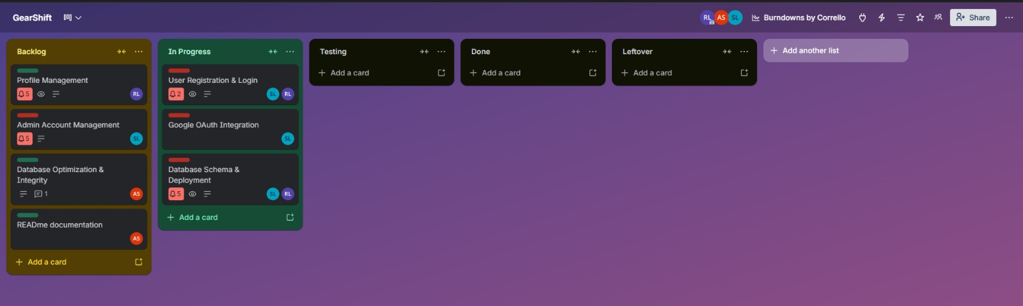
Snapshot 2
- Backlog: Profile Management, READme documentation, Database Optimization & Integrity
- In Progress: Admin Account Management
- Testing: User Registration & Login, Google OAuth Integration
- Done: Database Schema & Deployment

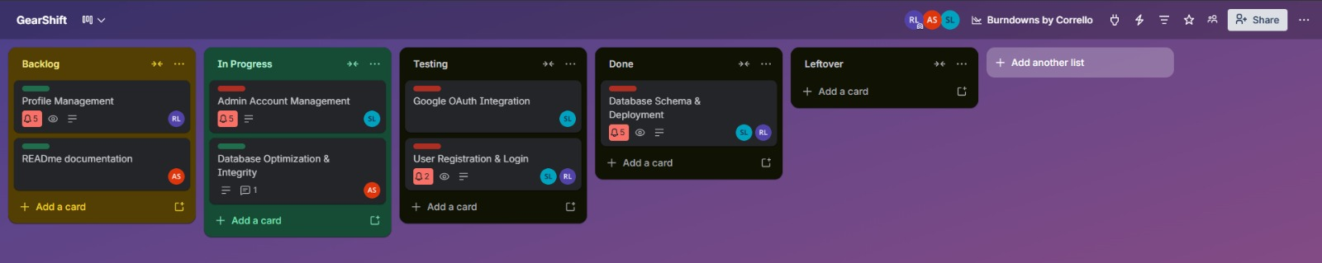

Snapshot 3
- In Progress: Profile Management, READme documentation
- Testing: Admin Account Management
- Done: Database Schema & Deployment, Database Optimization & Integrity, Google OAuth Integration, User Registration & Login
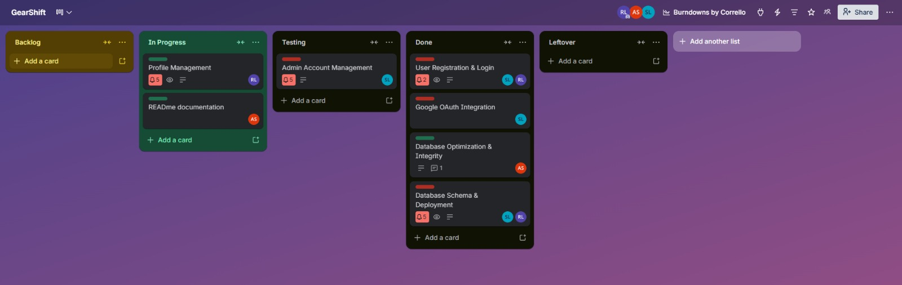

Snapshot 4
- Done: Database Schema & Deployment, Database Optimization & Integrity, Google OAuth Integration, Admin Account Management, User Registration & Login, README Documentation.
- Leftover: Profile Management.

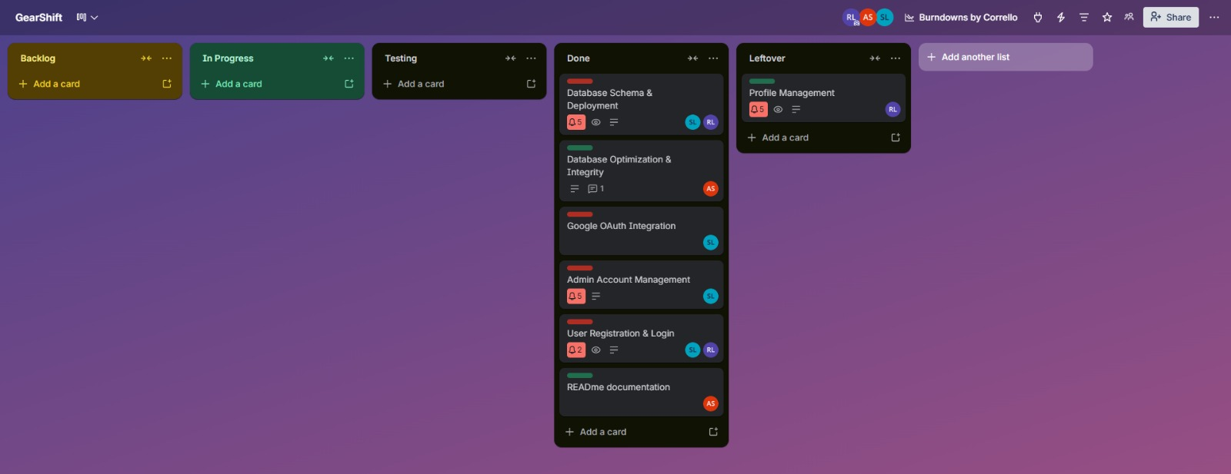

6. Burndown Chart
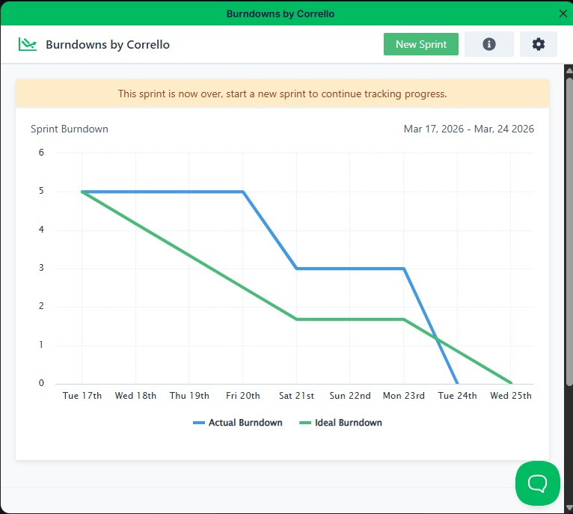
- Blue represents actual burndown
- Green represents ideal burndown

7. Non-Functional Requirements
1. Performance The system should maintain secure and efficient authentication and API interactions. JWT tokens must be issued with a 24-hour expiry and validated on every protected route. Passwords must be hashed using bcrypt. Login attempts must be rate limited to prevent brute force attacks. Supabase token exchange must validate email confirmation before issuing JWT. API responses should remain stable under normal usage conditions without noticeable latency.
2. Usability The platform should be intuitive and easy to use for car owners, mechanics, and vendors. A new user must be able to register, verify their email, and access the dashboard within 10 minutes. The interface should provide clear error messages, logical navigation, and responsive layouts across devices. Documentation (README) must guide contributors to set up the project quickly and consistently.
3. Scalability The system should efficiently handle growth in users, mechanics, vendors, and service records. The database schema must support tiered subscriptions and multiple roles. Indexes and constraints must ensure integrity even as the dataset expands. The architecture should allow future expansion, such as adding modules for shop finder, analytics, or service history.
4. Reliability The system should operate consistently without unexpected failures. All API inputs must be validated using express-validator schemas. Standardized error responses must be returned in JSON format with proper HTTP status codes. Role-based access control must be enforced; unauthorized access attempts must return 403 FORBIDDEN. Repository commits must maintain clean history and attribution to ensure collaborative transparency.
5. Responsiveness All user interactions should feel immediate and smooth. Login, registration, and profile updates must provide feedback within 1 second under normal conditions. Admin dashboard actions (suspend, reactivate, delete, role update) must reflect changes instantly after execution. UI changes such as navigation or theme updates must apply without requiring a full page reload.
6. Compatibility The platform should function consistently across modern browsers (Chrome, Firefox, Edge) and mobile devices. JWT authentication and API endpoints must behave uniformly regardless of client platform. Installation and setup must be straightforward on standard development environments (Windows 10+, Ubuntu 20.04+). The user experience should remain uniform across supported platforms.

8. Work Division
Team Member’s Name | Assigned Work
- Nauman Iqbal | Frontend, Backend Setup, UI design, Trello board setup
- Afras Shahnawaz | Documentation, testing, Frontend assistance
- Saaif Suleman | Backend programming, OAuth integration, admin management, schema

