National University of Computer and Emerging Sciences

FSE Project Iteration 1
GearShift
Group Members:
Name | Roll Number
Nauman Iqbal | L24-2565
Afras Shahnawaz | L24-2547
Saaif Suleman | L24-2606

Spring 2026
Department of Computer Science
FAST-NU, Lahore, Pakistan

GearShift – Sprint 2 Deliverable

Group Members:
- Nauman Iqbal – Developer, Architect, Tester
- Afras Shahnawaz – Requirement Engineer, UI/UX Designer
- Saaif Suleman – Lead Developer, Tester

1. Project Description
Project Title: GearShift
Description:
GearShift is a hybrid automotive platform (responsive web + mobile companion) designed to connect car owners with verified mechanics and vendors while providing AI-driven diagnostics, transparent pricing, and service history tracking. Sprint 2 focused on building the core feature layer on top of the authenticated foundation established in Sprint 1: shop discovery, mechanic matchmaking, profile management, and service history tracking.

2. Sprint 2 Backlog
Module Selected for Sprint 2: Core Features Module

Features included:
- Shops Locator (High Priority)
- Mechanic Matchmaking (High Priority)
- Service History Tracker (Medium Priority)
- Cost and Value Insights (Medium Priority)
- Profile Management (Low Priority – carried over from Sprint 1)
- Analytics Dashboard (Low Priority)
- Smart Suggestions (Low Priority)

3. User Stories

Story ID: US 08 Story Title: Shops Locator
Priority: High
Estimated Hours: 8

User Story:
As a car owner, I want to search for and locate nearby verified mechanic shops so that I can quickly find reliable service close to my location.

Description:
This story covers the implementation of a map-based shop discovery feature, allowing users to search by location, filter by services offered, and view shop details including ratings and availability.

Sub User Stories:
- As a user, I want to see mechanic shops near my current location on a map.
- As a user, I want to filter shops by service type, rating, or distance.
- As a user, I want to view a shop's details including address, rating, and available services.

Acceptance Criteria:
- Shop search must support location-based queries using GPS or manual input.
- Map view must display verified shops with distance indicators.
- Filter options must include service type, minimum rating, and radius.
- Shop detail page must show name, address, rating, services, and contact info.
- Unverified or suspended shops must not appear in search results.
- Results must load within 2 seconds under normal conditions.

Structured Specifications – US 08: Shops Locator
Type | Specification
Functional | Shop search must support GPS and manual location input.
Functional | Only verified, active shops must appear in results.
Functional | Filter options must include service type, rating, and radius.
Functional | Shop detail page must display name, address, rating, services, and contact info.
UX | Map view must update dynamically as filters are changed.
Performance | Search results must load within 2 seconds under normal conditions.
Reliability | Suspended or unverified shops must be excluded from all search results.

Story ID: US 09 Story Title: Mechanic Matchmaking
Priority: High
Estimated Hours: 9

User Story:
As a car owner, I want to be matched with a suitable verified mechanic based on my vehicle type and issue description so that I can get relevant, expert help quickly.

Description:
This story implements an AI-assisted matchmaking system that analyzes the user's issue description and vehicle profile to recommend the most relevant available mechanics.

Sub User Stories:
- As a user, I want to describe my car issue and receive a list of matched mechanics.
- As a user, I want to view a mechanic's profile, specialization, and rating before booking.
- As a user, I want to request a service appointment with a matched mechanic.

Acceptance Criteria:
- Matchmaking must consider vehicle type, issue category, mechanic specialization, and location.
- Matched mechanics must be returned ranked by relevance score.
- Mechanic profile must display name, specialization, rating, and availability.
- Users must be able to send a service request directly from the match result.
- Unavailable or suspended mechanics must be excluded from results.
- Matching algorithm must return results within 3 seconds.

Structured Specifications – US 09: Mechanic Matchmaking
Type | Specification
Functional | Matchmaking must factor in vehicle type, issue category, and mechanic specialization.
Functional | Results must be ranked by relevance score.
Functional | Mechanic profile must show name, specialization, rating, and availability.
Functional | Users must be able to send a service request from the match result page.
Functional | Suspended or unavailable mechanics must be excluded from results.
UX | Match results must display clearly with visual rating indicators.
Performance | Matching results must be returned within 3 seconds.
Reliability | Service request submissions must be confirmed with a success response.

Story ID: US 05 Story Title: Profile Management
Priority: Low
Estimated Hours: 5

User Story:
As a user, I want to set up and edit my profile so that others can view my information. (Carried over from Sprint 1)

Description:
This story enables profile viewing and editing with JWT-secured updates, completing the leftover item from Sprint 1.

Sub User Stories:
- As a user, I want to view my full profile details.
- As a user, I want to edit my first and last name.
- As a user, I want to see my role badge and membership date on my profile.

Acceptance Criteria:
- Profile must include first name, last name, email, role, status, and membership date.
- Users must be able to edit first/last name via PUT /api/users/profile.
- Updates must require a valid JWT; invalid tokens return 401 UNAUTHORIZED.
- Profile view must display avatar initials and a role badge.
- Success returns 200 with updated profile; errors return descriptive messages.

Structured Specifications – US 05: Profile Management
Type | Specification
Functional | Profile must include first name, last name, email, role, status, and membership date.
Functional | Users must be able to edit first/last name via PUT /api/users/profile.
Functional | Updates must require valid JWT; invalid tokens return 401 UNAUTHORIZED.
UX | Profile view must show avatar initials and role badge.
Reliability | Success must return 200 with updated profile; errors must return descriptive messages.

Story ID: US 10 Story Title: Service History Tracker
Priority: Medium
Estimated Hours: 7

User Story:
As a car owner, I want to view and manage the complete service history of my vehicle so that I can track maintenance, costs, and upcoming service needs.

Description:
This story implements a per-vehicle service history log where users can view past services, add manual entries, and track costs over time.

Sub User Stories:
- As a user, I want to view all past services for my vehicle in chronological order.
- As a user, I want to add a manual service entry with date, description, and cost.
- As a user, I want to see a summary of total maintenance costs for my vehicle.

Acceptance Criteria:
- Service history must be scoped per vehicle and per user.
- Each entry must include date, service type, mechanic (if applicable), and cost.
- Users must be able to add, edit, and delete their own service entries.
- History must be displayed in reverse chronological order by default.
- Total cost summary must aggregate all entries for the selected vehicle.
- Unauthorized access to another user's history must return 403 FORBIDDEN.

Structured Specifications – US 10: Service History Tracker
Type | Specification
Functional | Service history must be scoped per vehicle and per authenticated user.
Functional | Each entry must include date, service type, mechanic (optional), and cost.
Functional | Users must be able to add, edit, and delete their own service entries.
Functional | Unauthorized access to another user's history must return 403 FORBIDDEN.
UX | History must be displayed in reverse chronological order with a cost summary.
Reliability | All CRUD operations must return appropriate HTTP status codes and messages.
Scalability | Schema must support multiple vehicles per user and large entry volumes.

5. Diagrams
Use case diagram representing the actors and the use cases, as well as associations:
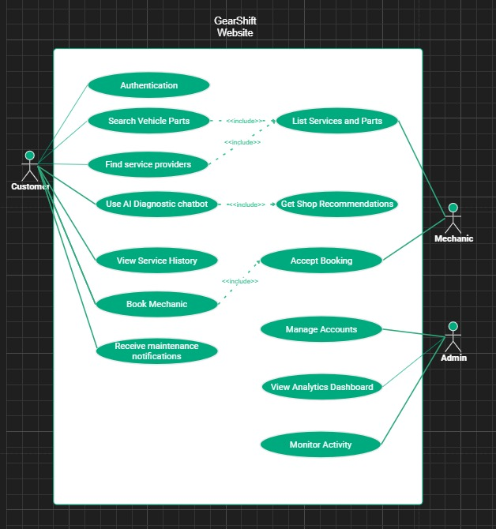

UML Class Diagram representing different objects in the system:
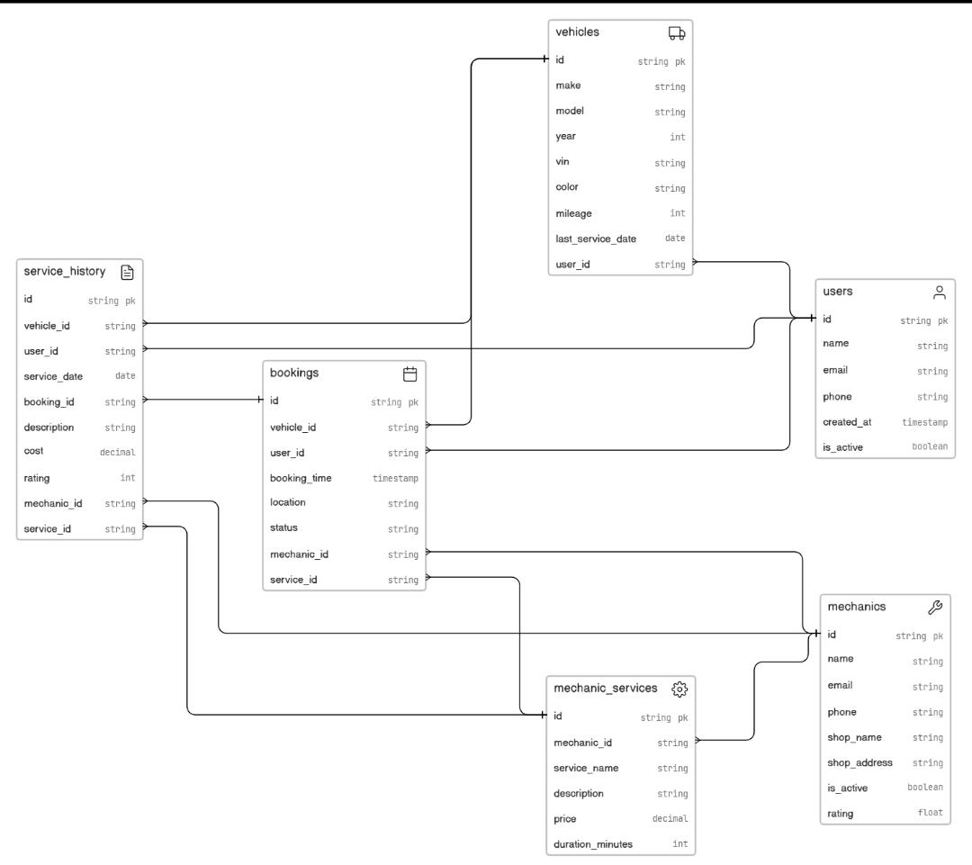

Activity Diagram showing the work flow in an easy to comprehend way:
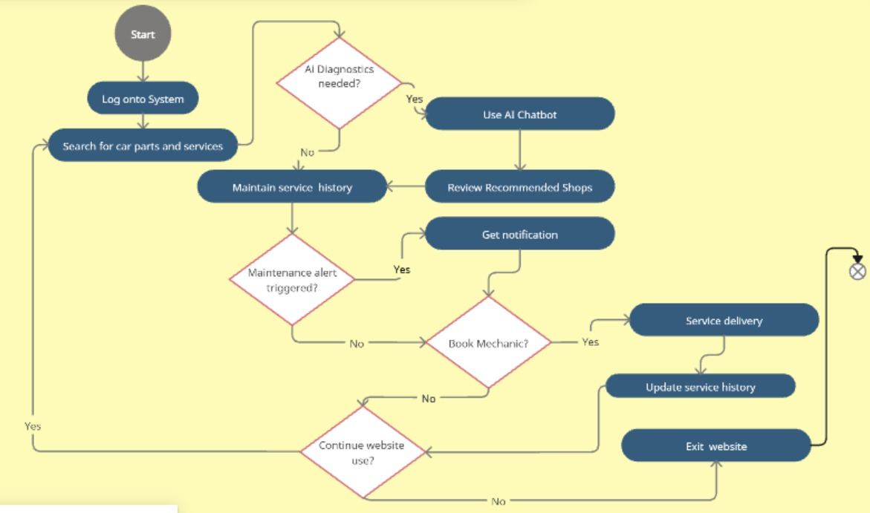

Sequence diagram showcasing the sequence of events, the requests and the responses:

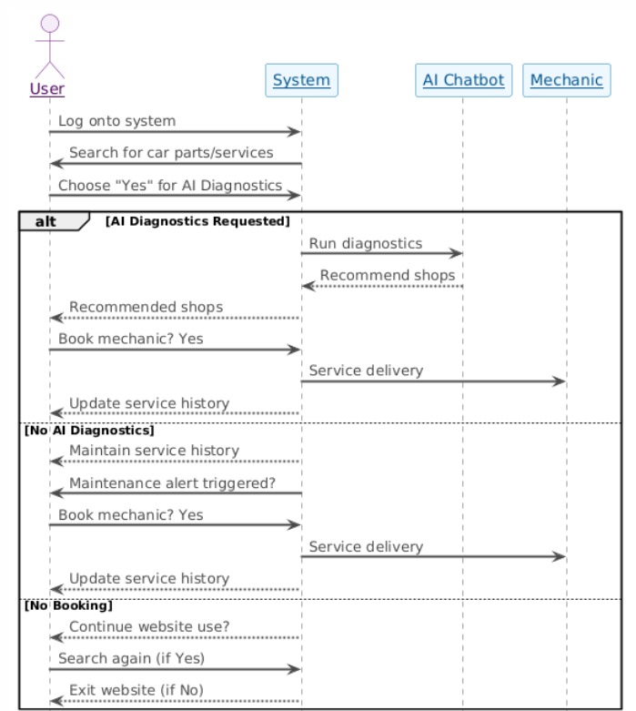

5. Scrum Board (Trello)
Snapshot 1 – Sprint Start
- Backlog: Shops Locator (High), Mechanic Matchmaking (High), Analytics Dashboard (Low), Service History Tracker (Medium), Cost and Value Insights (Medium), Profile Management (Low), Smart Suggestions (Low)
- In Progress: (none)
- Testing: (none)
- Done: (none)
- Leftover: (none)

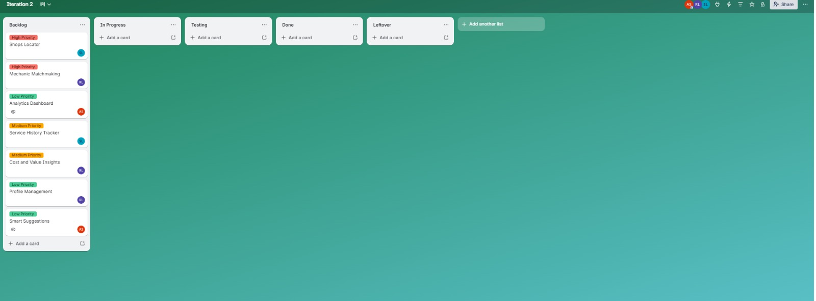

Snapshot 2
- Backlog: Analytics Dashboard (Low), Cost and Value Insights (Medium), Smart Suggestions (Low)
- In Progress: Shops Locator (High), Mechanic Matchmaking (High), Service History Tracker (Medium), Profile Management (Low)
- Testing: (none)
- Done: (none)
- Leftover: (none)
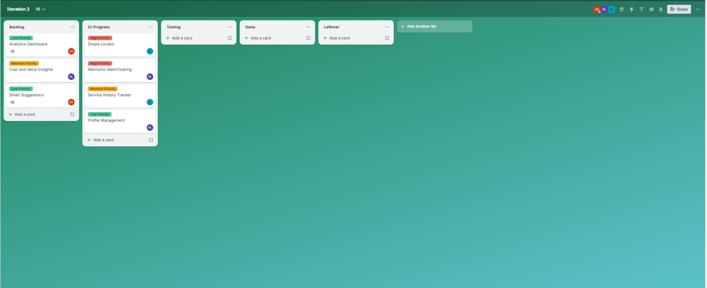

Snapshot 3
- Backlog: (empty)
- In Progress: Analytics Dashboard (Low), Cost and Value Insights (Medium), Smart Suggestions (Low)
- Testing: Shops Locator (High), Mechanic Matchmaking (High), Service History Tracker (Medium), Profile Management (Low)
- Done: (none)
- Leftover: (none)

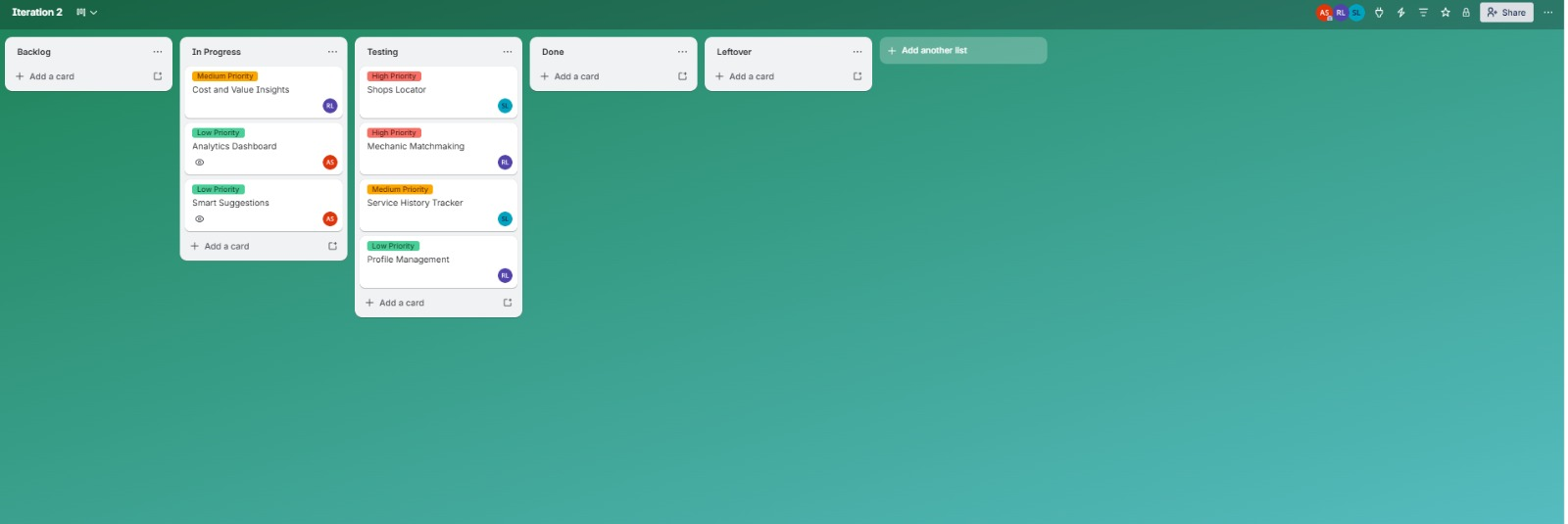

Snapshot 4 – Sprint End
- Backlog: (empty)
- In Progress: (empty)
- Testing: (empty)
- Done: Shops Locator (High), Mechanic Matchmaking (High), Service History Tracker (Medium), Profile Management (Low)
- Leftover: Cost and Value Insights (Medium), Analytics Dashboard (Low), Smart Suggestions (Low)

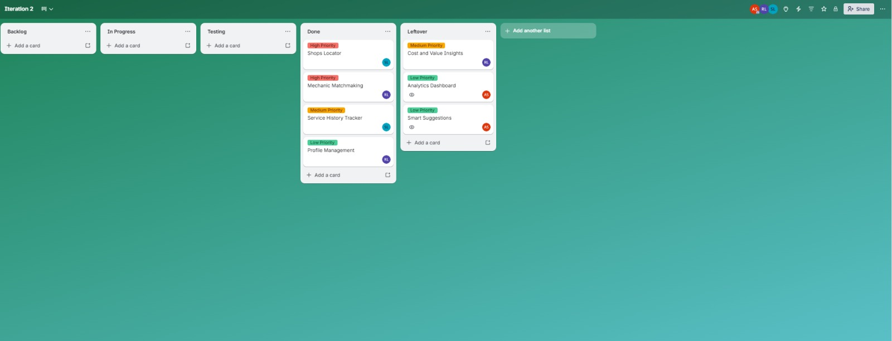

6. Burndown Chart
The burndown chart tracks story point completion across Sprint 2. Blue represents actual burndown; green represents ideal burndown.
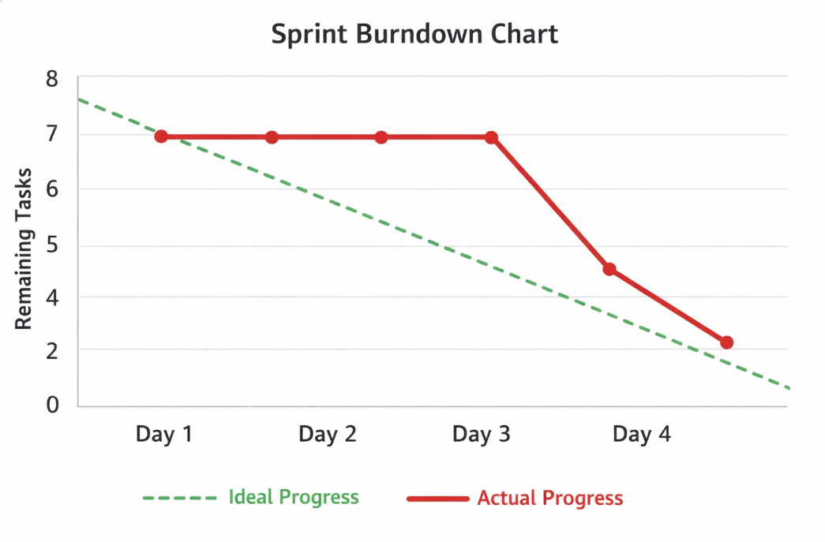

7. Non-Functional Requirements
1. Performance
Shop search and mechanic matchmaking must return results within 2–3 seconds under normal load. Service history queries must remain responsive as entry volume grows. Map rendering and filter updates must execute without noticeable lag. JWT validation must remain performant on all protected routes.

2. Usability
The shops locator map must be intuitive with clear filter controls and readable shop cards. Mechanic match results must present key information at a glance with visual rating indicators. Profile editing must provide immediate inline feedback. Service history must use a clear chronological layout with a visible cost summary.

3. Scalability
The schema must efficiently support multiple vehicles per user and growing service history entries. Shop and mechanic indexes must sustain performance as the dataset expands. The matchmaking algorithm must remain effective as mechanic profiles scale. The architecture must support future modules such as AI diagnostics, cost analytics, and smart suggestions.

4. Reliability
All API inputs must be validated using express-validator schemas. Standardized error responses must be returned in JSON format with proper HTTP status codes. Role-based access control must remain enforced across all new routes; unauthorized access must return 403 FORBIDDEN. Service history entries must be protected from cross-user access.

5. Responsiveness
Shops Locator map interactions, filter changes, and detail views must respond within 1 second. Service history CRUD operations must reflect changes immediately. Profile updates must confirm success or failure within 1 second. All new UI components must render correctly on both desktop and mobile viewports.

6. Compatibility
All new features must function consistently across modern browsers (Chrome, Firefox, Edge) and mobile devices. Map components must degrade gracefully if geolocation is unavailable. JWT authentication and API endpoints must behave uniformly regardless of client platform.

8. Work Division
Team Member | Assigned Work
Nauman Iqbal | Frontend development, UI design for Shops Locator and Matchmaking, Trello board management
Afras Shahnawaz | Documentation, testing, Profile Management frontend assistance, Sprint 2 report
Saaif Suleman | Backend programming, Shops Locator API, Mechanic Matchmaking logic, Service History Tracker schema and endpoints

