AI POWERED STUDENT PERFORMANCE AND SUCCESS PREDICTION SYSTEM

DEPARTMENT : COMPUTER SCIENCE & ENGINEERING
ACADEMIC YEAR : 2025 – 2029
TEAM MEMEBERS
2510030087 – M RUCHEE
2510030093 – K POOJASRI REDDY
25100300 – ODDIRAJU SRIDHRUTHI

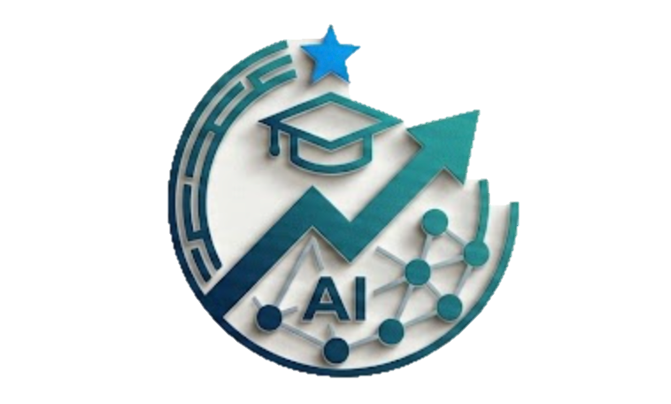

GUIDE NAME: DR. SUSHAMA DUTTA

UNIVERSITY: KLH DEEMED TO BE UNIVERSITY

GIST OF 5 RECENT RESEARCH PAPERS

NO. | TITLE OF THE PAPER | NOVELTY | BENEFIT | ALGORITHM APPLIED
1 | A temporal attention-based hybrid deep learning model for student performance and academic risk prediction — 2026 | Combines student learning behavior over time with regular student information. It identifies which time periods are most important for predicting academic risk. | Helps find at-risk students early and shows when they are most likely to face problems | Bi-LSTM + Temporal Attention + MLP + SoftMax. The paper also compares against Logistic Regression, Random Forest, SVM, XGBoost, LightGBM and MLP.
2 | Predicting student academic performance using Bi-LSTM: a deep learning framework with SHAP-based interpretability and statistical validation — 2025 | Combines Bi-LSTM and SHAP to predict student performance and explain why the student gets that prediction. | Helps teachers find at-risk students and understand why they are at risk. | Bi-LSTM + SHAP. The study also compares Bi-LSTM with CatBoost, XGBoost, Hist Gradient Boosting and LightGBM and uses statistical tests for validation.
3 | Application of deep learning to the development of a prediction model for college students’ learning outcomes — 2025/2026 | Combines academic, behavior and student background data instead of using only marks. It also considers study habits, attendance and participation. | It predicts student performance using study habits, attendance and participating helping teachers provide early and personalized support. | Hybrid Deep Learning, including ResNet and LSTM components.
4 | Evaluation of early student performance prediction given concept drift — 2025 | Checks how changes in student behavior over time can reduce model accuracy and helps the model stay reliable when student patterns change. | Makes the system more reliable when student behavior changes over time. | LASSO, Linear Regression and Machine Learning pipelines, with analysis of concept/data drift.
5 | An explainable AI-based approach for predicting undergraduate students academic performance — 2025 | Uses multiple ML models together and SHAP + LIME to explain the prediction. | Predicts student performance and explains why, helping teachers make better decisions. | Stacking Ensemble + SMOTE + SHAP + LIME with multiple ML classifiers and hyperparameter tuning.

PAPER LINKS
- PAPER 1 - https://shorturl.at/D7eB9
- PAPER 2 - https://shorturl.at/oL2jo
- PAPER 3 - https://shorturl.at/Yvuq0
- PAPER 4 - https://shorturl.at/BRdAm
- PAPER 5 - https://shorturl.at/8OafY

PROBLEM STATEMENT

Existing student-performance systems mainly predict marks or dropout, but they do not effectively combine academic, behavioural and learning-activity data over time. They also have limited ability to explain why a student is at risk and how the risk changes with new learning behaviour.
This research proposes an Explainable Temporal AI system that predicts student success early, detects changing risk patterns and identifies the key factors causing the risk. The system will also generate personalized intervention recommendations to help students improve before academic failure occurs.

NOVELTY OF THE PROPOSED WORK

NO. | NOVELTY | EXPLANATION
1 | Counterfactual Student Success Analysis | The system does not only predict whether a student is at risk. It answers “What needs to change for this student to succeed?” It can simulate changes such as improving attendance or assignment completion and estimate how the student's success probability would change.
2 | Student Digital Twin for Academic Simulation | Creates a virtual model of each student's learning behaviour. The system can simulate different future situations and estimate possible academic outcomes before an actual intervention is made.
3 | Personalized Risk-Transition Modelling | Instead of only predicting Pass/Fail, the system tracks how a student moves through different risk levels: Safe → Warning → At-Risk → Critical → Recovered. This provides a more realistic picture of the student's academic journey.
4 | Intervention Impact Attribution | The system does not simply recommend an intervention. It evaluates whether the intervention actually helped by comparing the student's expected outcome with the outcome observed after intervention

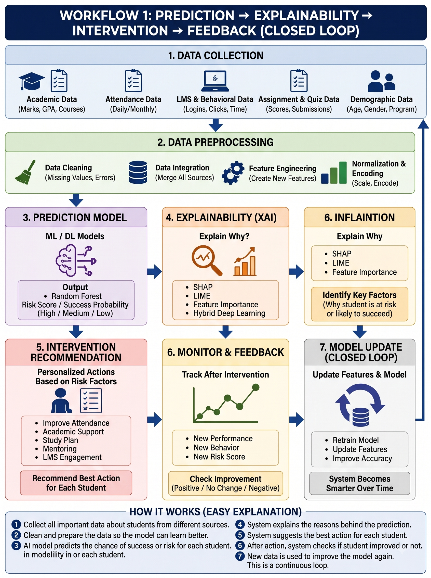

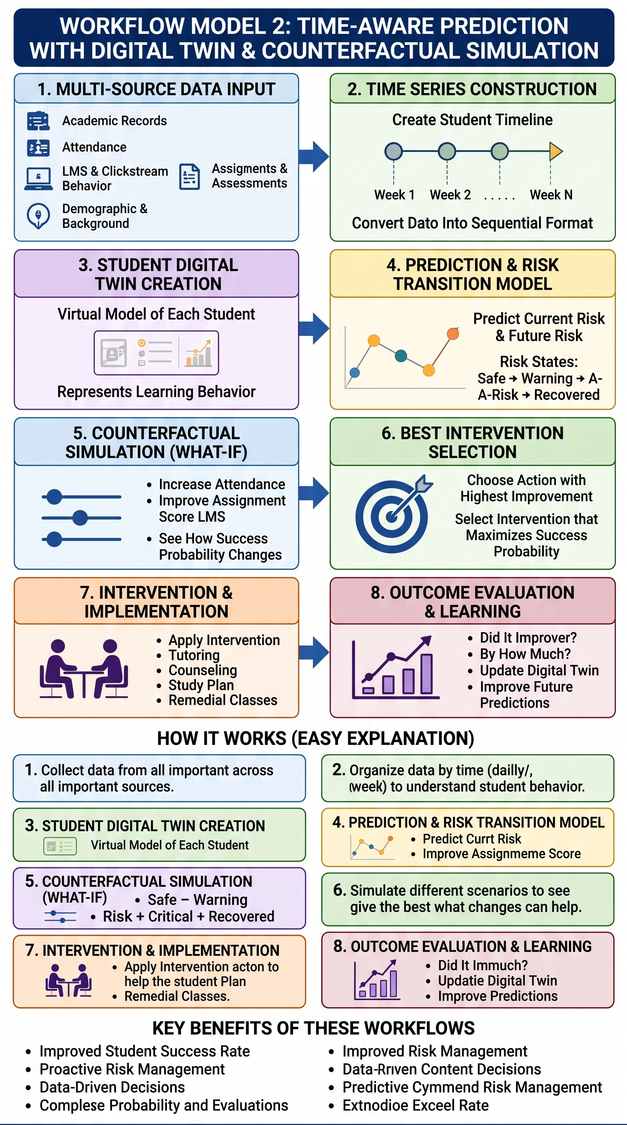
DATASETS SUPPORTING THE PROBLEM STATEMENT
No. | Dataset | What it Contains | How We Use It in Our Project | Why It Is Useful
1 ⭐ | OULAD – Open University Learning Analytics Dataset | Student details, marks, assignments, LMS/VLE clicks and learning activity over time. 32,593 students. | Track student behaviour week by week, predict risk, create a Student Digital Twin and perform “What-if” analysis. | Best dataset for our time-based and behavioural research.
2 | UCI – Predict Students' Dropout and Academic Success | 4,424 students with academic, demographic and socio-economic information. Outcomes: Dropout, Enrolled, Graduate. | Predict whether a student is likely to drop out, continue or graduate. | Best for student success and risk prediction.
3 | UCI – Student Performance | 649 students with grades, study time, school, family, social and demographic information. | Predict student performance/grades and compare our model with traditional ML models. | Good for benchmarking and model comparison.
DATASET LINKS :
- Dataset 1 - https://research.stem.open.ac.uk/ouanalyse/dataset/
- Dataset 2 -https://archive.ics.uci.edu/dataset/697/predict+students+dropout+and+academic+success
- Dataset 3 - https://uci-ics-mlr-prod.aws.uci.edu/dataset/320/student+performance

